# MyProject

## .Net system in which three types of data can be registered.Devices: water meters, electricity and gateways.

Made by: Carlos Lima López

# Structure

Consists of four fully-decoupled elements:

* 2 Front-ends:
  + GatewayWeb(.NetFramework) - request the registration of gateways to the api
  + CounterWeb(.NetFramework) - request the registration of counters to the api
* Back-end:
  + Api (.NetCore) - receives, validates and inserts the two types of devices (counters and) in the database
    - Api.Infrastructure – ORM .NetFrameworkCore
* Database:
  + SQL Server - Stores inserted data from counters and gateways

# 

# Publication and Deployment

## First – Config Database

1. Open SQL Server Management Studio (download <https://docs.microsoft.com/en-us/sql/ssms/download-sql-server-management-studio-ssms?view=sql-server-ver15>)
2. Attach database from {ProjectDirectory}\DevicesDatabase\Database.mdf
3. Add login to your windows user setting Defualt database the previous attach dtabase.

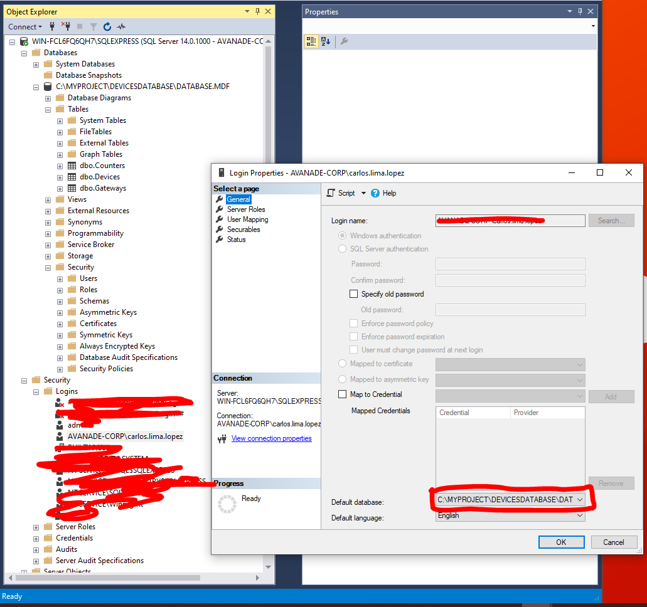

## Second – Publish Api

1. From Visual Studio, right click Api project -> Publish -> Edit -> TargetLocation -> Select {YourApiLocation}
2. Donwload and install .NetCore Runtime for IIS - <https://dotnet.microsoft.com/download/dotnet-core/thank-you/runtime-aspnetcore-2.2.5-windows-hosting-bundle-installer>
3. Create Site in IIS

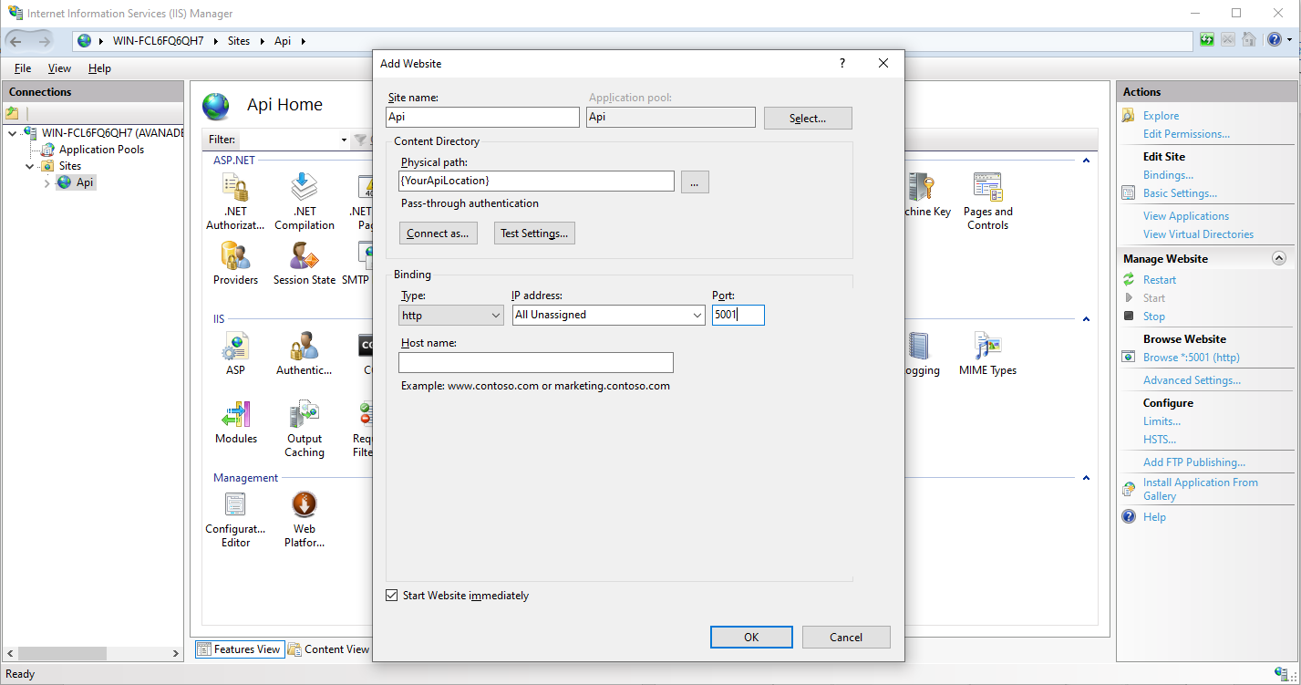

* I recommend using port 5001 so as not to have to modify the web.config of the Webs

FAQ -> <https://www.youtube.com/watch?v=iaFBQcd26HE>

1. Change identity windows user autentication in the “Api” Pool to use User Windows Authentication

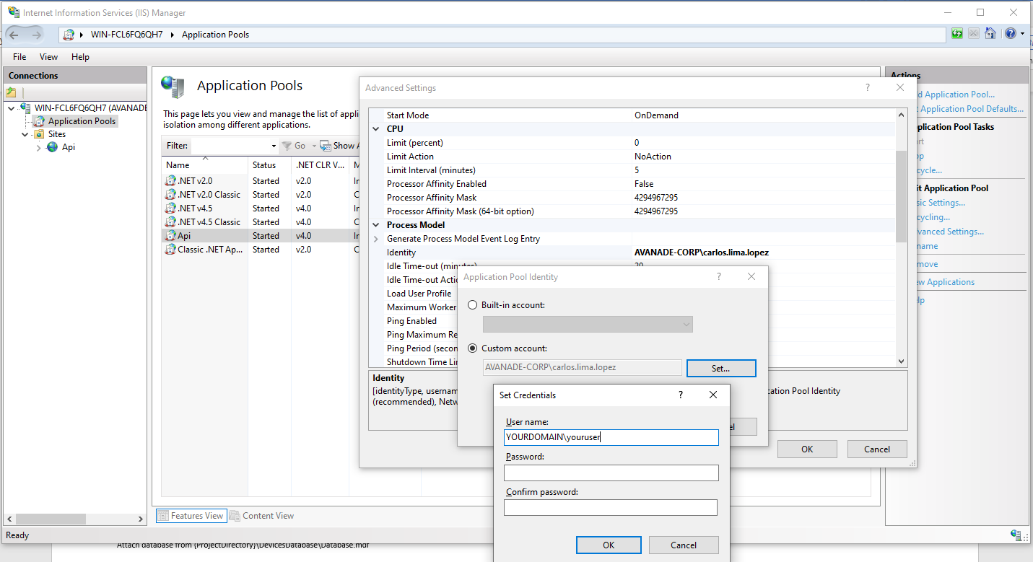

1. Chech DataSource of Connection string in appsettings.json from { YourApiLocation }
2. Restart Api Pool and Api Site.
3. Browse tu <http://localhost:5001/swagger/index.html>

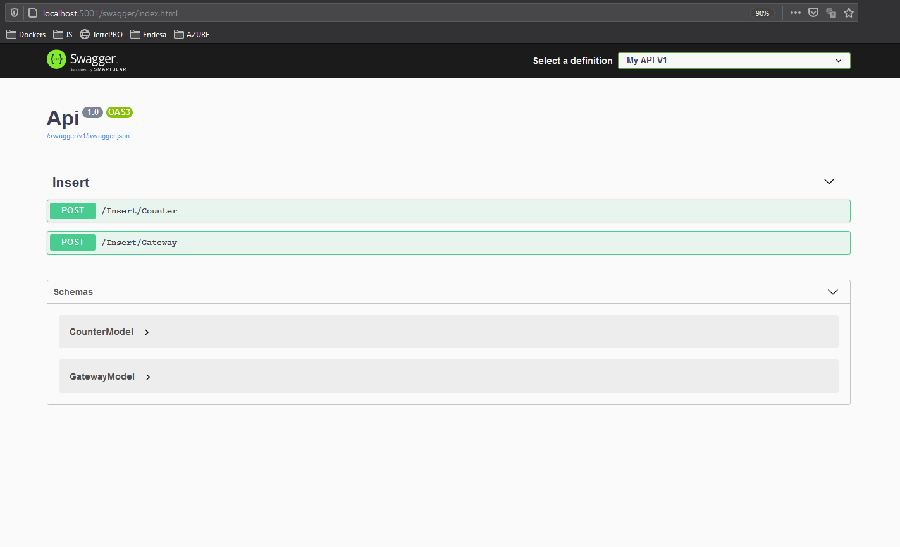

## Third – Publish CounterWeb

1. From Visual Studio, right click CounterWeb project -> Publish -> Edit -> TargetLocation -> Select {YourCounterWebLocation}
2. Create Site in IIS

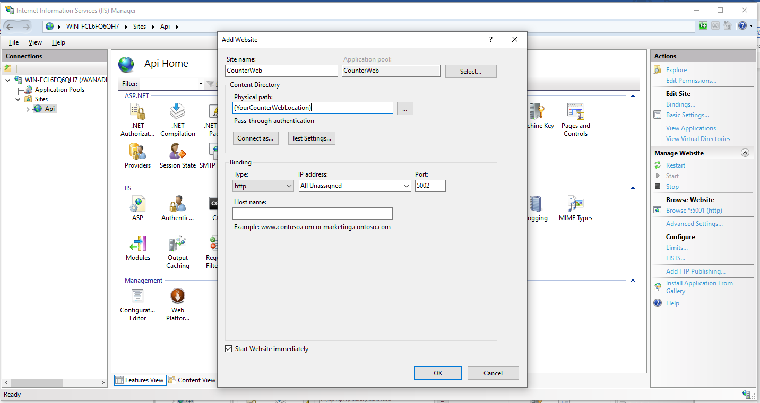

1. Navigate to <http://localhost:5002/>

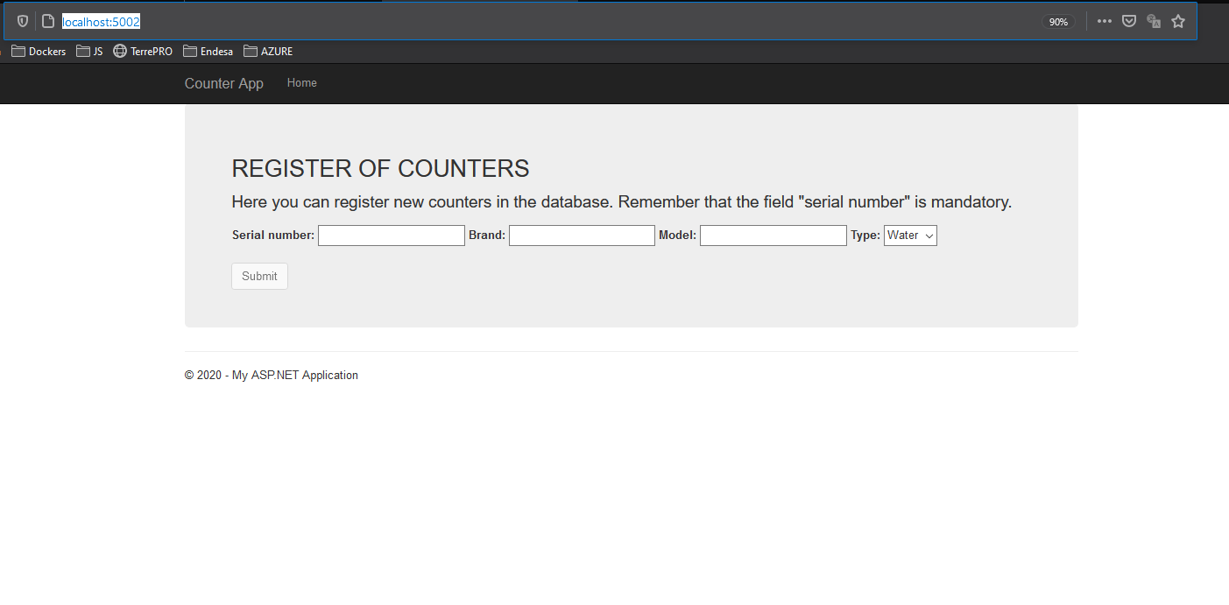

1. Insert a Counter

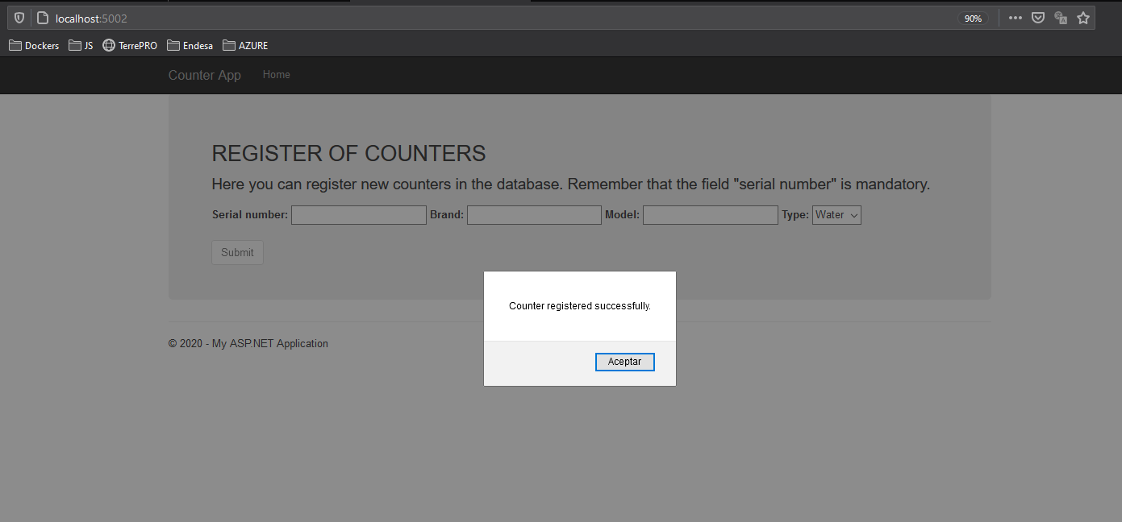

## Fourth – Publish GatewayWeb

1. From Visual Studio, right click GatewayWeb project -> Publish -> Edit -> TargetLocation -> Select {YourGatewayWebLocation}
2. Create Site in IIS

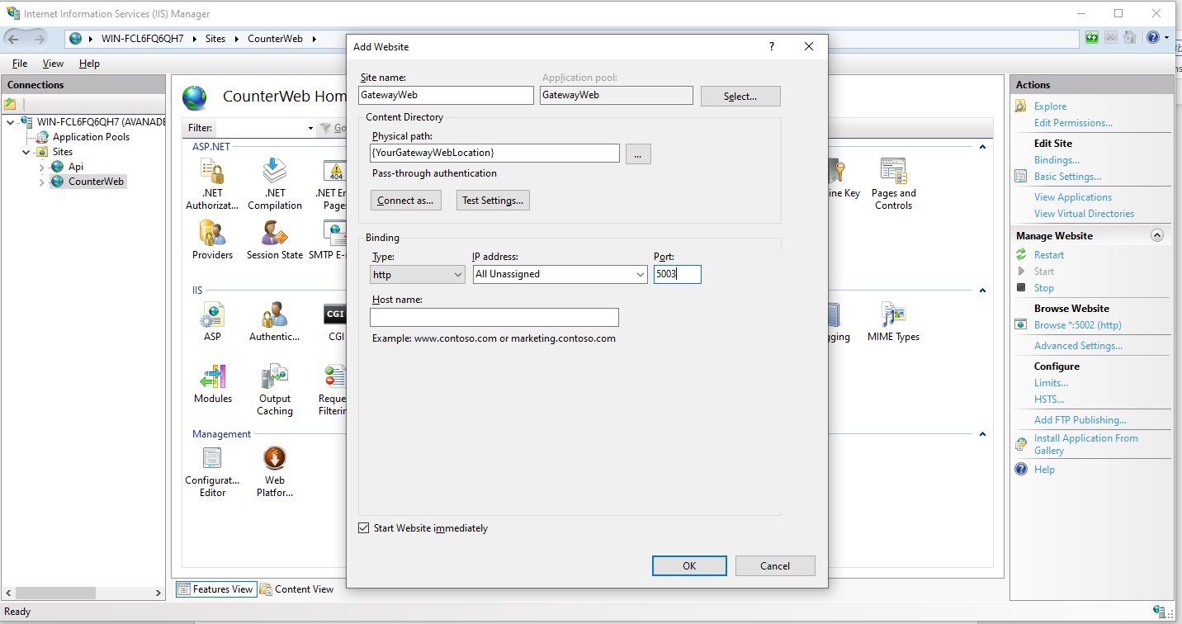

1. Navigate to <http://localhost:5003/>

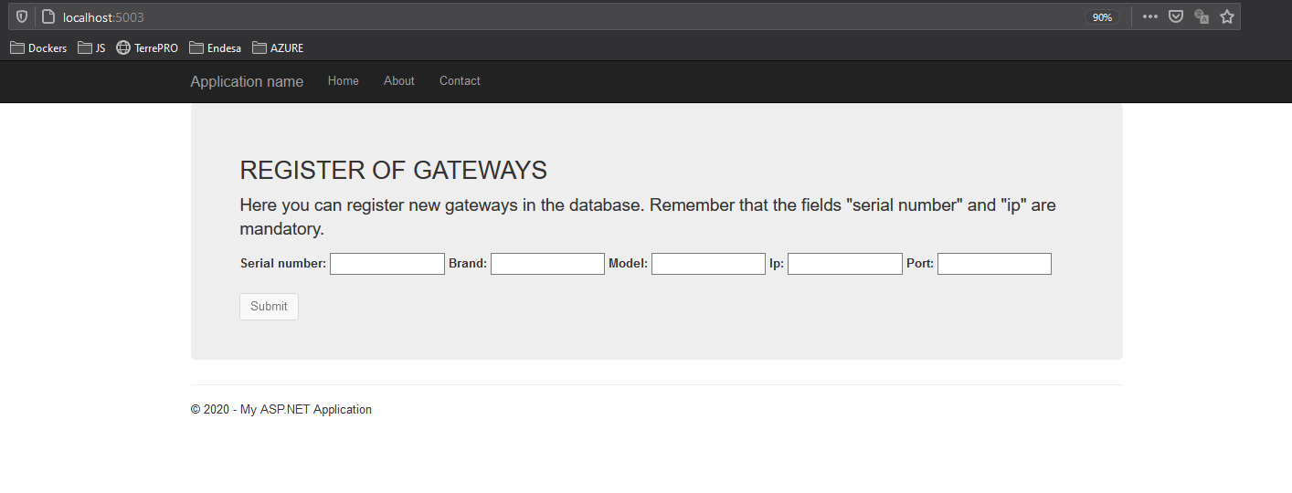

1. Insert a Gateway

