Transform many files at once

Thursday, August 27, 2020

9:52 AM

Add the folder you want to transform to your project

1. Right-click on the project in the Project pane and then click on **Add Folder..**

Machine generated alternative text:
Project 
emo.xpr 
al de 
C 
New 
Add 
Add Files... 
Open 
Show in 
Copy Location 
Paste 
Refactoring 
Refresh 
Ctrl+V 

1. Navigate to the folder with the metadata you'll be converting and click **Choose**

Make sure the transformation is saved as a Transformation Scenario

1. I'm using PubMed here, so I'll open one of the files and the pubmed\_to\_mods stylesheet.
2. With the XML file open, click the Transformation scenarios button

Machine generated alternative text:
A-BioRisk 14.xml IC:XUsersXrachel.donahueXDocumentsXLocalTempXMetadataXtestXPubMedXone-eachXA-BioRisk 14.xml) - eoXygen,6 XML Editor 
File Edit Find Project Options Tools Document Window Help 
XPath 2.0 • •Execute XPath on 'Current File' 
Project 
demo.xpr 
a 
jats to_mods 30.xsl 
MOOS to NALMODS.xsl 
nal-journal-admin.xsd 
• A-BioRisk_14.xml X • pubmed to mods.xsl x 
2 
3 
C ?xml version:" I D" encoding:" UTE—B"» 
! DOCTYPE Articles-t 
PUBLIC "—//NLM//DTD PubMe 2. 7//EN" "https://dtd.nlm.nih.gov/ncbi/pubmed/in/pubMec 
Set 

1. Select Saxon EE and fill in the parameters as usual.

Machine generated alternative text:
Configure Transformation Scenario(s) 
Type filter text 
Association 
Scenario 
project (1) 
Edit scenario 
Name: PubMed to MODS 
Storage: Project Options C) Global Options 
L FO Processor Output 
XML URL: *urrentFileURL) 
XSL URL: ments/LocalTemp/GitHub/AMB-Metadata- 
More about curre 
Use "xml-stylesheet" declaration 
Type 
Configure parameters 
Type filter text 
archiveFile 
workingDir 
originalFilename 
x 
XPath 
Delete 
in/ pubMed . 
Value 
'Demo Scenario' 
'file 
saxon :system- id() 
Edit 
Associated scenarios 
PubMed to MOOS X 
Transformer: Saxon-E 
Paramete 
Extensio 
Additional XSLT 
Ap 
Unset 
Name of source vendor and filename being processed. 
ystem ID: 
Ile : / C : / Users/ rachel. donahue/ Documents/ LocalTemp/GitHub/A MB-Metadata-Team/commons/ params. xsl 

1. Go to the **Output** tab and deselect **Show in results view as.. XML** to avoid having a bunch of results windows open

Machine generated alternative text:
Edit scenario 
Name: PubMed to MODS 
Storage: Project Options C) Global Options 
x 
Cancel 
XSLT FO Pr 
Output file 
Output 
C) Prompt for file 
Save as 
Open in Browser/System Application 
Saved file 
Other location 
Open in Editor 
Show in results view as 
XML 
XHTML 
Image URLs are relative to: 

1. Click **OK**  and then **Save and close**

Batch transform the files

1. In the **Project Pane**, make sure the folder with the XML files to be transformed is open.
2. Click the *first* file, then **hold shift** and click the *last* file.

Machine generated alternative text:
Project 
demo.xpr 
a 
PubData NAL-mods2marc21slim.xsl 
a 
pubmed to mods.xsl 
README.md 
a 
rsc to mods.xsl 
submissions-2mods.xslt 
n one-each 
A-BioRisk 14.xml 
A-Comparative-cytogenetics 41. 
A-International-Journal-of-Myriapodology 4.xml 
A-Journal-of-Hymenoptera-Research_23.xm 
A-MycoKeys_8.xml 
A-Nature-consen.'ation 5. 
A-NeoBiota 23.xml 
A-PhytoKeys_23.xml 
e A-ZooKeys_271. 
one-each.zip 

1. **Right-click** the selected files and select **Transform** -> **Transform with..**

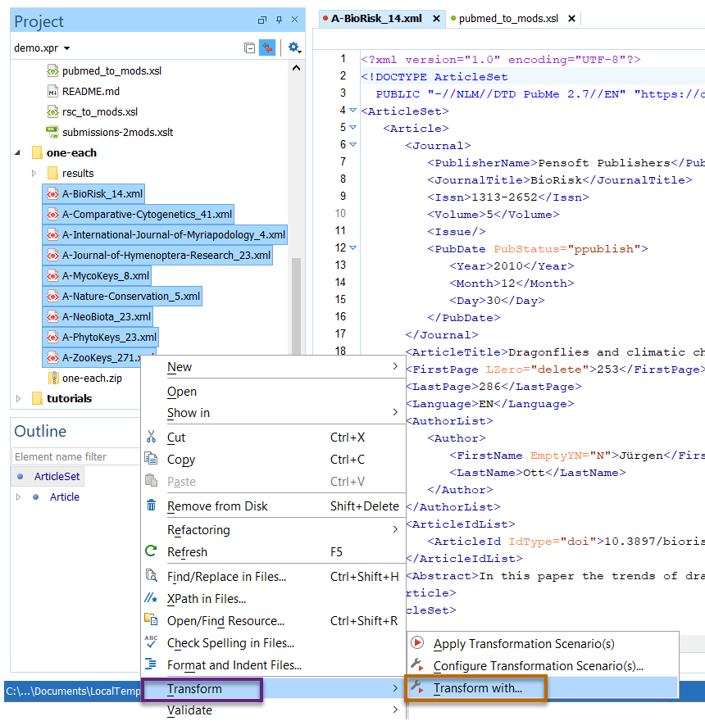

1. Select the appropriate Transformation Scenario and then click **Apply selected scenarios**

Machine generated alternative text:
Transform with 
Type filter text 
Scenario 
project (3) 
Consyn to MODS 
JATS to MOOS 
PubMed to MOOS 
Apply selected scenarios (1) 
x 
Type 
XML with XSLT 
XML with XSLT 
XML with XSLT 
Cancel 

1. A box will pop up showing the progress of the transformation

Machine generated alternative text:
Transformation 
Transform C2 of 
C: N... N MetadataNtestNPubMedNone-eachXA-Comparative-Cytogenetics_41 .xml 
Cancel 
x 

1. When complete, the status bar at the bottom of the window will say Transformation successful or the Transformation Problems view will appear with a list of errors (it's possible for only some of the files to transform.)

C:\AA315725\7E733662-A70D-4842-A97E-37E18F13AA48_files\image009.png

1. **Refresh** the folder in the **Project Pane** to make sure all of your files will show up.

Machine generated alternative text:
one-each 
A-In 
New 
Open 
Show in 
Cut 
Copy 
Copy Location 
Paste 
Remove from Disk 
Rename 
Refresh 
Ind/Replace In Files. 
7 
Ctrl+X 
Ctrl+C 
Ctrl+V 
Shift+Delete 
Outline 
C 

1. Congrats! All of your files are transformed!

Machine generated alternative text:
Project 
demo.xpr 
A-A-BioRisk 14 1.xml 
A-A-Comparative-cytogenetics 41_1.xml 
A-A-International-Journal-of-Myriapodology_ 
A-A-Journal-of-Hymenoptera-Research 23_1 
A-A-MycoKeys_8_1 .xml 
A-A-Nature-conservation 5_1.xml 
.xml 
A-A-PhytoKeys_23_1 .xml 
A-A-ZOOKeys_271 1.xml 
N-A-BioRisk 14 1.xml 
N-A-Comparative-Cytogenetics 41_1.xml 
N-A-International-Journal-of-Myriapodology_ 
N-A-Journal-of-Hymenoptera-Research 23_1 
.xml 
N-A-Nature-Conservation 5_1.xml 
.xml 
N-A-PhytoKeys_23 1.xml 
N-A-ZooKeys_271 1.xml 