 | WetSAT-ML Version 1.0 | 
 | Wetlands flooding extent and trends using SATellite data and Machine Learning Version 1.0

📘 User Manual – WetSAT v1.0
Wetlands flooding extent and trends using SATellite data and Machine Learning by Stockholm Environment Institute (SEI)

Objective

Develop a manual or user guide for the correct and efficient use of the WetSAT version 1.0 tool, through five (5) instructions or guidelines. Similarly, this manual seeks to offer technical support to users if errors, bugs, or inconsistencies are identified or arise during the execution of the Random Forest (RF) and K-means (K) models.

Introduction to WetSAT

WetSAT-ML (Wetlands flooding extent and trends using SATellite data and Machine Learning) version 2.0, It consists of an open-source algorithm integrated with Google Colab and Scikit Learn. The tool processes radar satellite data from the Sentinel-1 mission to generate wetland flooding extent maps, water permanence maps, and quantify key hydrological parameters, including flooded area time series, hydroperiods, and intra- and inter-annual wetland area trends. The algorithm will use machine learning models (Random Forest and K-means) to characterize the scattering behavior of the radar signal for different wetland flooding conditions, enabling a pixel-level water detection in the satellite images.
⚠️ Important information only for researchers, programmers, and developers ⚠️​
The SEI team for Latin America (SEI-LA) has created comprehensive and detailed documentation for the WetSAT tool on GitHub Repositories. Please note the following considerations:
- There are two versions of the WetSAT tool code available in R and Python languages.

- WetSAT in Python Language: GitHub - sei-latam/WETSAT_v2: Wetlands flooding extent and trends using SATellite data and Machine Learning v2.0
- WetSAT in R Language: GitHub - sei-latam/WETSAT: What the Package Does (One Line, Title Case)

- If you wish to make modifications or adjustments to the master codes of the Random Forest and K-means models, please fork or clone the repositories of Python or R.

- Master code of Random Forest Model in Google Colab: WETSAT_v2/2_Modelling_WETSAT_Google_Colab/Master_Random_Forest_WetSAT.ipynb at main · sei-latam/WETSAT_v2 · GitHub
- Master code of K-means Model in Google Colab: WETSAT_v2/2_Modelling_WETSAT_Google_Colab/Master_Kmeans.ipynb at main · sei-latam/WETSAT_v2 · GitHub

- Contributions are accepted and welcome, if they are made through issues or pull requests within the repository.

- Contributions and Pull Request: Pull requests · sei-latam/WETSAT_v2 · GitHub

- Before making any modifications to the master codes, please check for available updates to the Scikit Learn Framework.

- Scikit -Learn Official Repository: scikit-learn · GitHub

- We recommend following the flowchart and architecture of the WetSAT tool.

DESIGN of RF and K

- There may be future updates or releases of WetSAT by the SEI-LA team, so we recommend periodically synchronizing the repository.

📘 User Manual – WetSAT v1.0

Prerequisites and Python files
Random Forest Model
- Download ⬇️ the Python 3 file with the. ipynb extension (User_Random_Forest_WetSAT.ipynb):
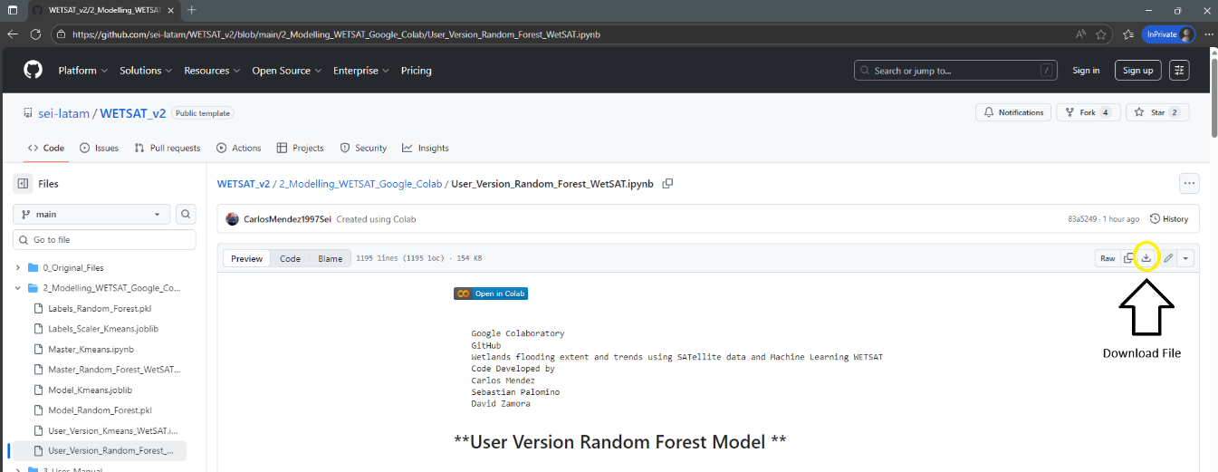
K-means Model
- Download ⬇️ the Python 3 file with the .ipynb extension (User_Kmeans_WetSAT.ipynb):

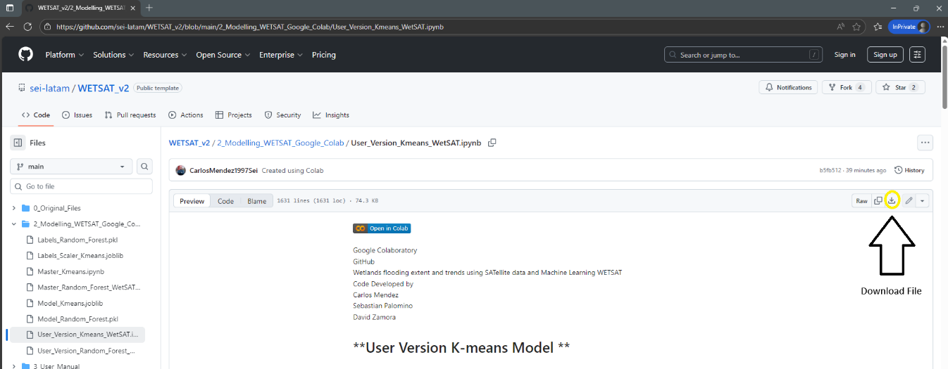

Configure Workspace and Dependences

Open or import the Python 3 files downloaded previously (User_Random_Forest_WetSAT.ipynb or User_Kmeans_WetSAT.ipynb) in your preferred Integrated Development Environment (IDE) (Google Colab, PyCharm, Visual Studio Code, Jupyter Notebook, etc.) and install the libraries and packages used in WetSAT.
If you want to use Google Colab, please click the button labeled “Open in Colab” or open the following URLs and then login or signup:
Random Forest:
User_Version_Random_Forest_WetSAT.ipynb - Colab
K-means:
User_Version_Kmeans_WetSAT.ipynb - Colab

Install Libraries and Packages used in WetSAT:

By default, all libraries and packages used in WetSAT are encoded in Google Colab scripts. The libraries and packages, mainly of the Scikit-Learn Framework are briefly described below.

2.1.1 Libraries and Packages of Random Forest

###################################### Artificial Intelligence Frameworks
# scikit-learn Framework
!pip install scikit-learn
###################################### Data, Geoprocessing and Graphics libraries
!pip install rasterio
!pip install matplotlib
!pip install numpy
!pip install contextily

## AI packages
from sklearn.ensemble import RandomForestClassifier
from sklearn.model_selection import GridSearchCV
from sklearn.model_selection import train_test_split
from sklearn.metrics import classification_report, confusion_matrix, accuracy_score
from sklearn.impute import SimpleImputer
from sklearn.multioutput import MultiOutputClassifier
from sklearn.preprocessing import LabelEncoder
from sklearn.exceptions import UndefinedMetricWarning
from sklearn.base import BaseEstimator, TransformerMixin
from sklearn.pipeline import Pipeline

## Geoprocessing packages
import rasterio
from rasterio.features import rasterize
from matplotlib.colors import ListedColormap
import numpy as np
import geopandas as gpd
import pandas as pd
import matplotlib.pyplot as plt
import matplotlib.colors as mcolors
import gc # Garbage collector to free memory
import os
import glob
import contextily as ctx
from shapely.geometry import box
import seaborn as sns
import joblib
import urllib.request
import warnings
from collections import Counter
from google.colab import files
from google.colab import data_table

2.1.2 Libraries and Packages of K-means
###################################### Artificial Intelligence Frameworks
# scikit-learn Framework
!pip install scikit-learn
###################################### Data, Geoprocessing and Graphics libraries
!pip install rasterio
!pip install matplotlib
!pip install numpy
!pip install contextily
!pip install pandas
## AI packages
from sklearn.cluster import KMeans
from sklearn.metrics import silhouette_score, davies_bouldin_score, calinski_harabasz_score
from sklearn.preprocessing import RobustScaler
## Processing packages
import os # Provides functions to interact with the operating system (paths, directories).
import re # Regular expressions for pattern matching filenames.
import random # Random number generation (used for sampling pixels)
import warnings # To manage warning messages.
from glob import glob # Utility to find files matching a pattern in directories.
import matplotlib.pyplot as plt
import joblib # For saving/loading Python objects (scaler, KMeans model).
import numpy as np # Numerical computing library (arrays, math).
import pandas as pd # Data manipulation library (tables, CSV export).
import rasterio # Library to read/write raster (GeoTIFF) files.
from rasterio.errors import NotGeoreferencedWarning # Specific warning type to suppress.
warnings.filterwarnings("ignore", category=NotGeoreferencedWarning)
from collections import Counter
from google.colab import files
from google.colab import data_table
import urllib.request

Prepare Inputs and Data

Import VV and VH Images
The import or upload of VH and VV images for the Random Forest and K-means models is performed manually by the user using the following button:
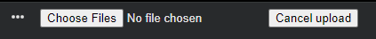
The user must select “Choose files” to initially upload the VH images and then the VV images. Considering that this step is performed by the user, it is recommended to follow these instructions:
- Only upload raster images with the (.tif) or (.geotiff) extension, as the RF and K models were trained using this file extension.
- The number of VV and VH images must be the same in size and location (area of interest).
- There is no limit or maximum number of VH and VV images to be classified. However, if you want to perform mass or large-scale classifications, it is recommended to work in batches or small groups.
- If you encounter any problems uploading images, we recommend canceling the process and running it again.
A successful image upload process should appear as follows:
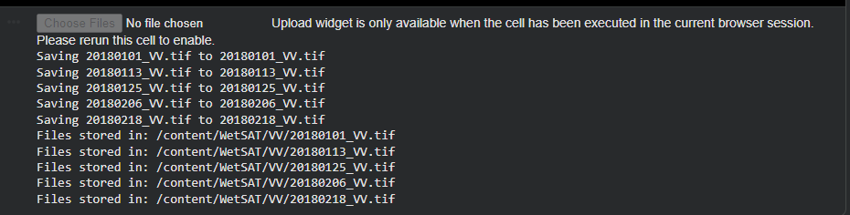

Creation of the dual Polarimetric Radar index (PR)

The dual Polarimetric Radar index (PR), it’s a common index using in studies of remote sensing and Sentinel-1 imageries. In general way, the PR calculate the difference between the ratio of vertically transmitted and horizontally received (VH) backscatter to the vertically transmitted and vertically received (VV) backscatter. Usually, PR index provide information about surface properties (vegetation, land, water, weather, etc.).
$$Polarimetric Radar index \left(PR\right)=(VH-VV)$$
The PR index is calculated automatically once the user has uploaded the VH and VV images from the previous step. This means that the user should have three folders (VH, VV, and PR) in their work environment, as shown in the following example:
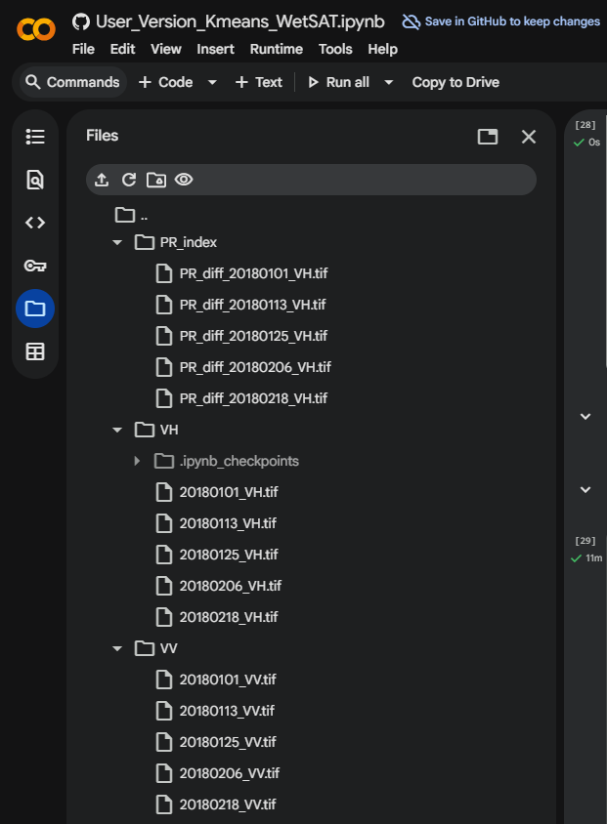

Run and Compile Random Forest or K-means models
In this phase, the compilation and execution of the Random Forest and K-means models were carried out in three completely different processes, due to the fact that each model has a different functioning and operation. The Random Forest model is categorized as a supervised model. Meanwhile, the K-means model is categorized as an unsupervised model. The three processes for the Random Forest and K-means models are briefly;

Run process Random Forest.
- Import the pre-trained Random Forest model from GitHub: WETSAT_v2/2_Modelling_WETSAT_Google_Colab/Model_Random_Forest.pkl at main · sei-latam/WETSAT_v2 · GitHub

- Import the labels and marks from GitHub: WETSAT_v2/2_Modelling_WETSAT_Google_Colab/Labels_Random_Forest.pkl at main · sei-latam/WETSAT_v2 · GitHub.

- Start classifications:
The model and labels in Random Forest from GitHub allow you to access the default settings with which the model was developed during the master code. In this section, the objective is to be able to use the information stored in the pickle file (.pkl), such as the hyperparameters {‘max_depth’: 10, ‘max_features’: ‘sqrt’, ‘min_samples_leaf’: 2, ‘min_samples_split’: 5, ‘n_estimators’: 200} and the data distribution (70% training and 30% validation) of the original model to perform new classifications, such as in a new area of interest or images of different temporalities.
The expected results of the random forest model include multiband raster images, composed from the stacking of the three images (VH, VV, and PR) with classification according to the six categories proposed by the SEI Latin America research team.
'e11': '#A7D98D', # Non-water – Sparse vegetation
'e12': '#E8D8A8', # Non-water – No vegetation
'e13': '#2E7D32', # Non-water – Dense vegetation
'e21': '#76C9CC', # Water – Sparse vegetation
'e22': '#1E88E5', # Water – No vegetation (open water)
'e23': '#006D6F' # Water – Dense vegetation

4.2 Run process K-means.
- Import the pre-trained K-means model from GitHub: WETSAT_v2/2_Modelling_WETSAT_Google_Colab/Model_Kmeans.joblib at main · sei-latam/WETSAT_v2 · GitHub

- Import the scalers from GitHub: WETSAT_v2/2_Modelling_WETSAT_Google_Colab/Labels_Scaler_Kmeans.joblib at main · sei-latam/WETSAT_v2 · GitHub

- Start classifications:

The K-means model and scalers imported from GitHub, as in the Random Forest model, allow access to the default configuration with which the model was developed during the master code, which is stored in a joblib file (.joblib) with important information {Maximum of 50,000 pixels sampled per image, maximum of 1,000,000 to 3,000,000 pixels sampled in all images, K-minimum of 5, K-maximum of 8, random state of 42, and maximum sample of 200,000 metrics}. Likewise, a number of clusters of 6.
The expected results of the K-means model include multiband raster images, composed of the stacking of the three images (VH, VV, and PR) with classification according to the five categories proposed by the SEI Latin America research team.
SPACE TO INSERT 5 CATEGORIES IN K-means

Classification maps, create reports and export data

Random Forest Model
K-means Model

