# Automatic testing with Selenium

## Goal

Elaborate a Java project to test the Auto Quick Quote available at <https://www.touring-assurances.be/auto/quick-quote/>.

## Deliverable

The source code of the exercise must be available on GitHub and send the link to the repository to:

* Bernat [bernat.bautista@axa-groupsolutions.com](mailto:bernat.bautista@axa-groupsolutions.com)
* Sergi [sergi.bono@axa-groupsolutions.com](mailto:sergi.bono@axa-groupsolutions.com)

## Deadline

You have 1 week to deliver it once you receive the email.

## Requisites

The Java project must be created using Maven and use the following technologies:

* Selenium Web Driver (Firefox driver it is enough).
* Junit or TestNG.

The source code must be uploaded in GitHub.

## Bonus track (optional)

Instead of Junit use TestNG framework which must provide the test results report.

## Exercise details

### Page #1

To test/check with Selenium:

* Check that the previous question value appears in the back button.
* Fill the field with the value “25” and continue.

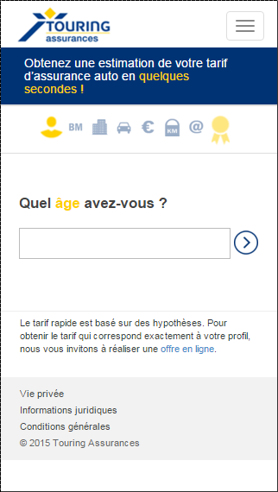

### Page #2

To test/check with Selenium:

* Check that the previous question value appears in the back button.
* Click on “0 ou moins” and continue.

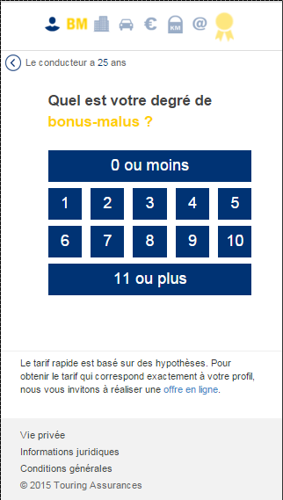

### Page #3

To test/check with Selenium:

* Check that the previous question value appears in the back button.
* Fill the field with “1000” and continue.

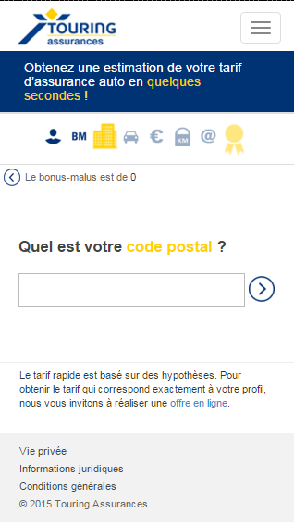

### Page #4

To test/check with Selenium:

* Check that the previous question value appears in the back button.
* Click on “+” and select “TACK”.

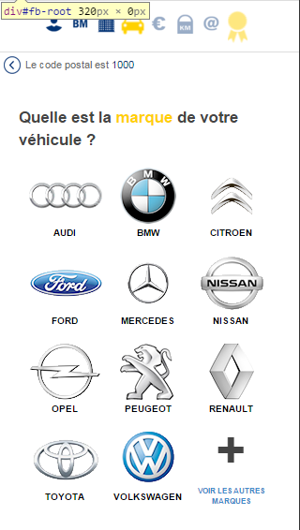

### Page #5

To test/check with Selenium:

* Check that the previous question value appears in the back button.
* Fill the field with “25000”and continue.

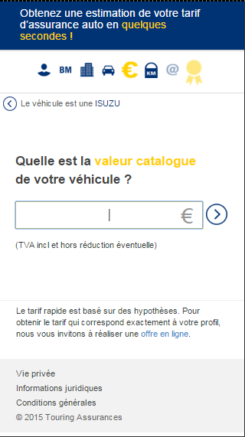

### Page #6

To test/check with Selenium:

* Check that the previous question value appears in the back button.
* Click on “5000 KM” and continue.

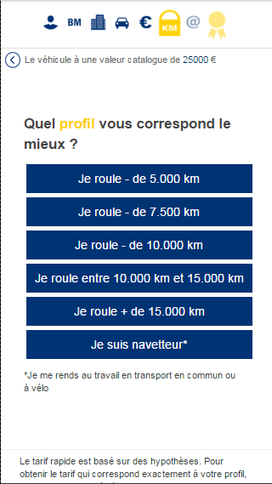

### Page #7

To test/check with Selenium:

* Check that the previous question value appears in the back button.
* Enter your email address and continue.



### Page #8

Check with Selenium that the prices on the screenshot below are the same ones in your test.

