|  |  |
| --- | --- |
| **Name:** Carlos Ramiro Zapata De la Cruz | **Enrollment:** 3001282 |
| **Course name:** Diseño de aplicaciones web | **Teacher's Name:** José Ricardo Zapata Solis |
| **Module:** 1 | **Assignment:** Activity 1 |
| **Date:**  01/18/24 | |
| **Bibliography:**   * Lasso, I. (2013, septiembre 18). Qué es Markdown, para qué sirve y cómo usarlo. Genbeta.com; Genbeta. https://www.genbeta.com/guia-de-inicio/que-es-markdown-para-que-sirve-y-como-usarlo | |

**Instructions:**

1. For this first activity, you will install XAMPP on your personal computer. Therefore, you must review the installation guide presented in topic 1 explanation, or you can follow this official guide by clicking **here**.

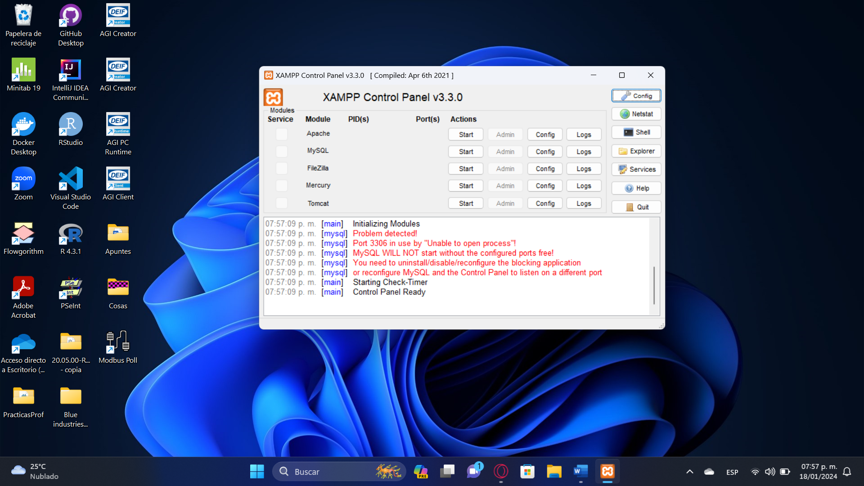

1. Then, create an account on **GitHub** with your institutional email account (preferably), then do the following:

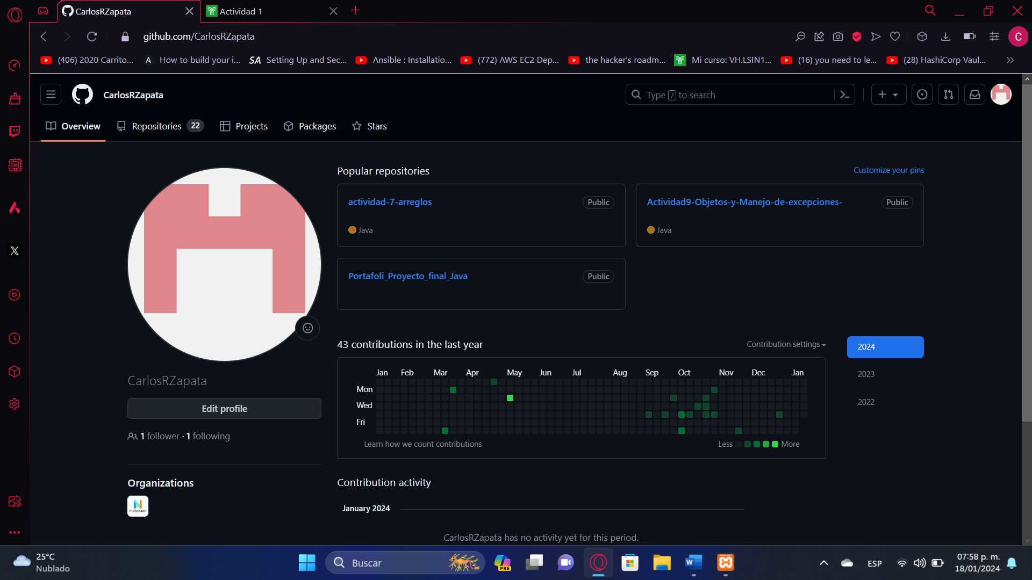

* 1. Create a remote repository called "Application-Web-Design", leave it public.

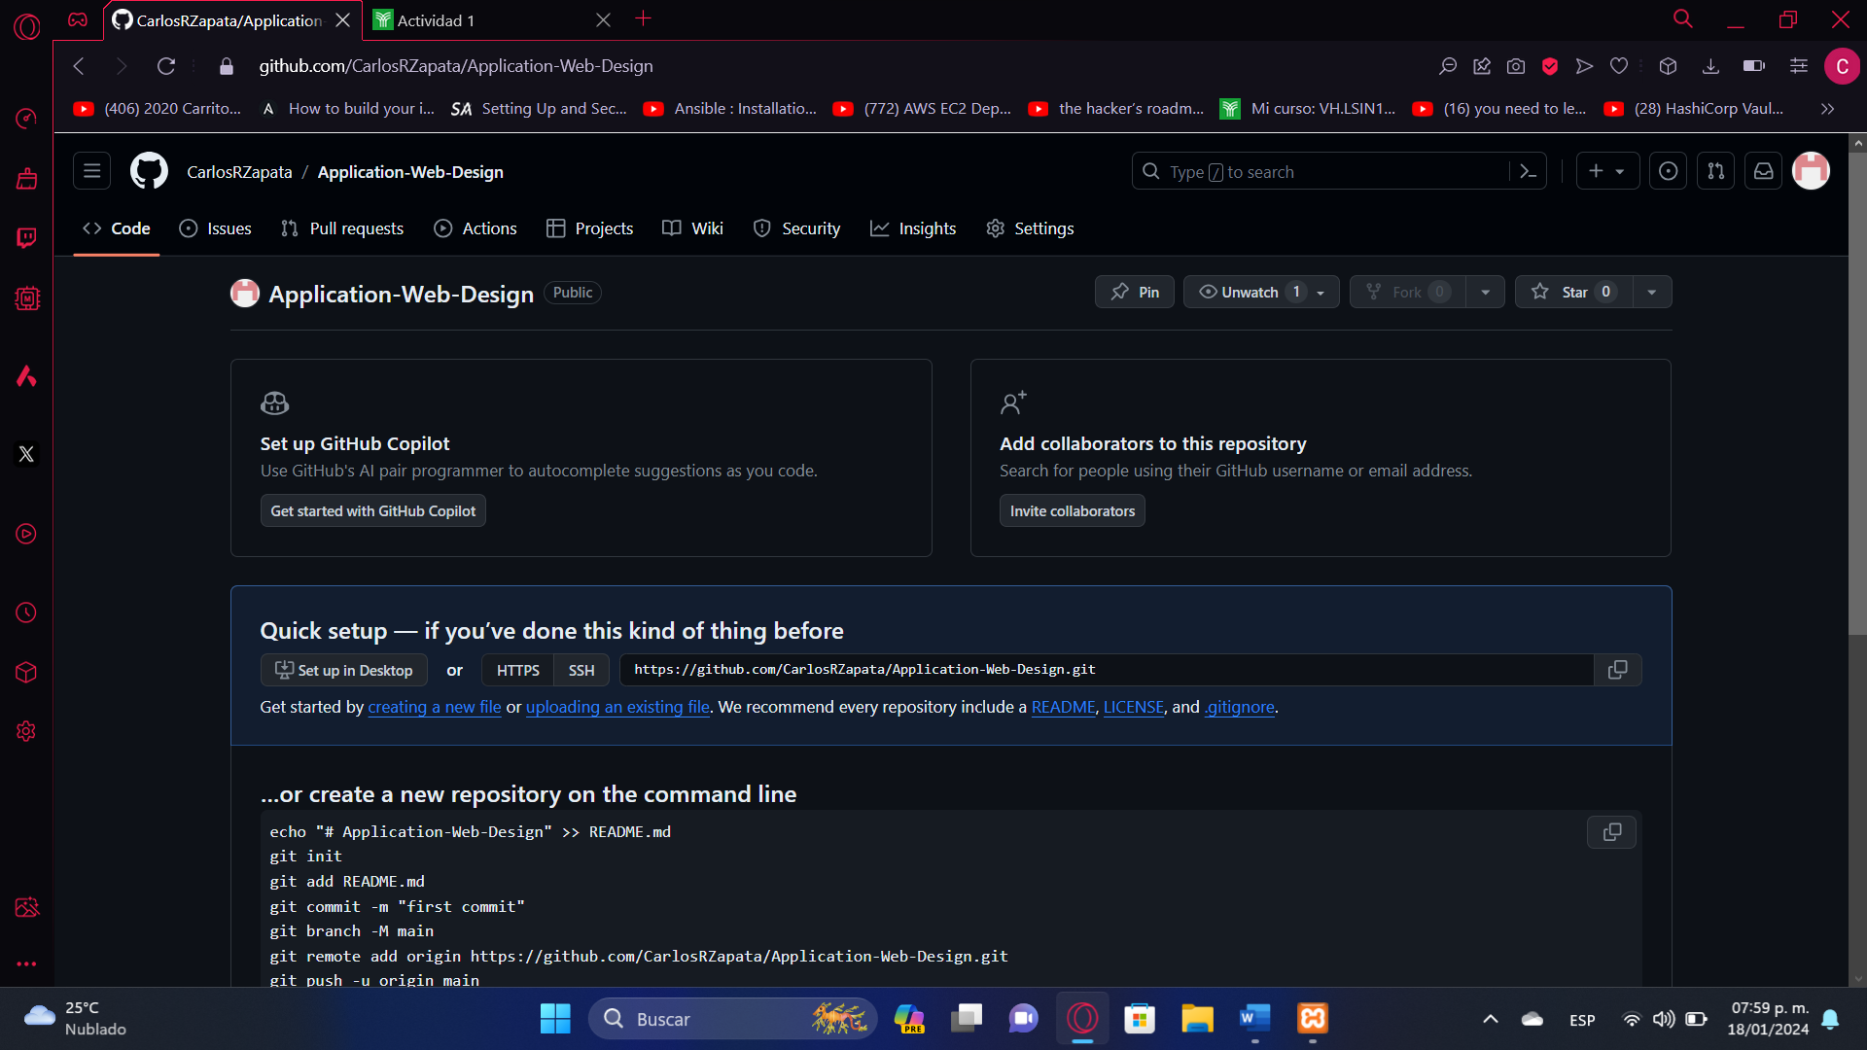

* 1. Once the repository is created, follow the on-screen instructions (quick setup) to do the following on your personal computer:
     1. Start a project in Git with the command line in Cmder. To do this, you will need to select a folder on your computer.
     2. Create the "main" branch.
     3. Create a file named README.md.

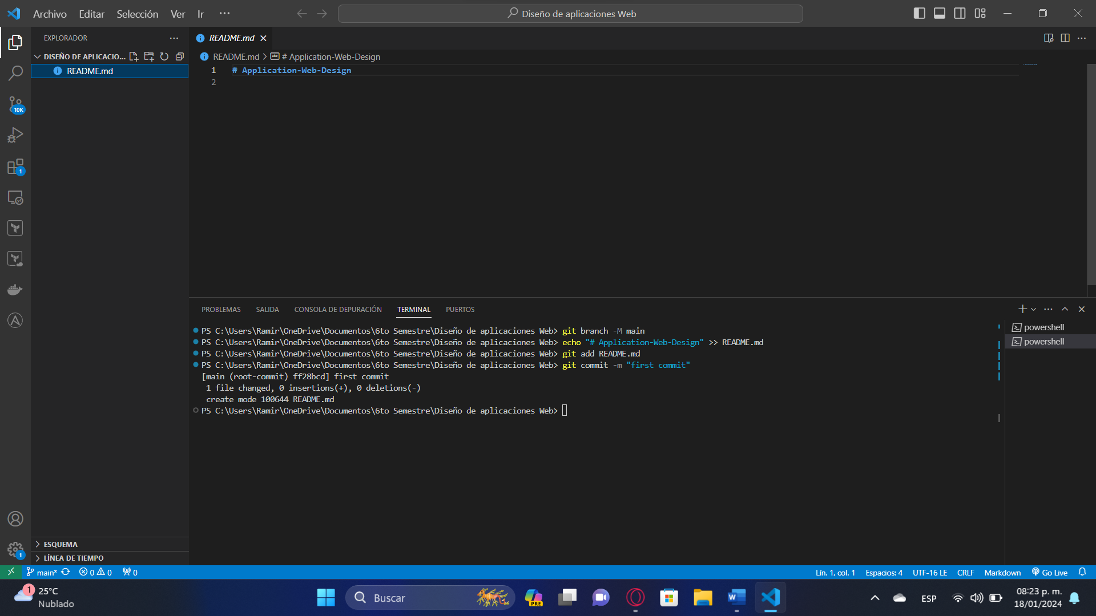

* + 1. Look for a tutorial on the markup language “Markdown” in the README.md file and inside of it put your data (name, registration number, degree, semester), the data of your subject (name of the subject and the professor who teaches it), and a text describing what Markdown is used for. Save the changes.

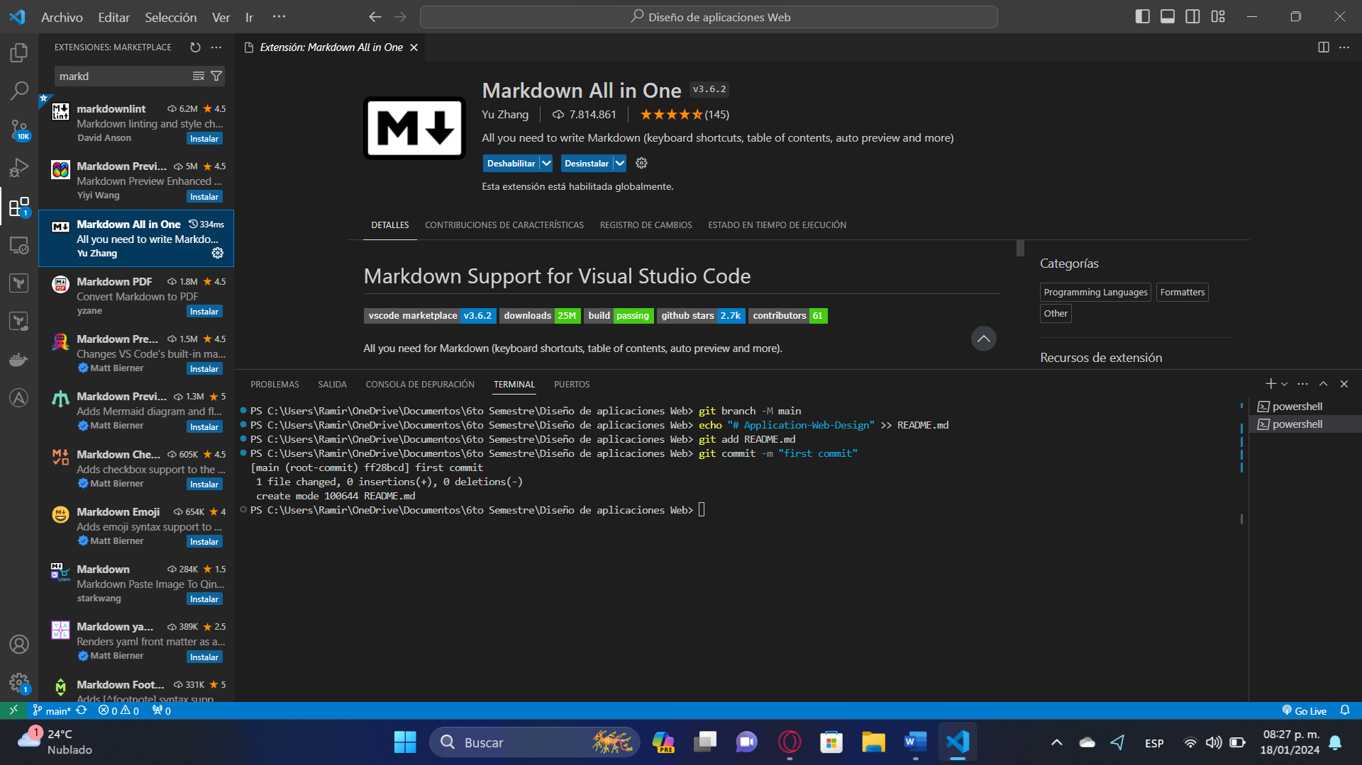

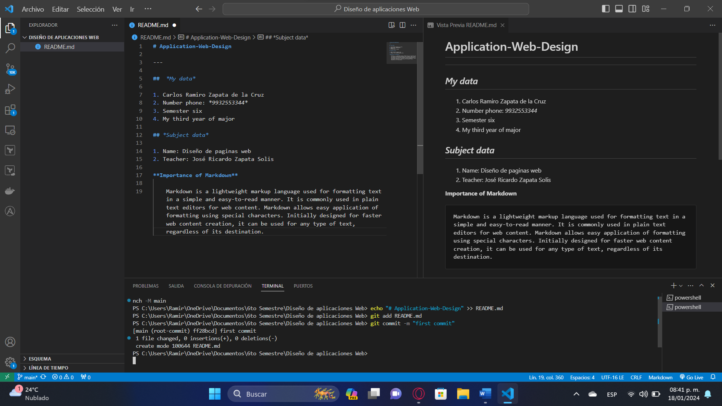

* + 1. Add the remote repository you created on GitHub.

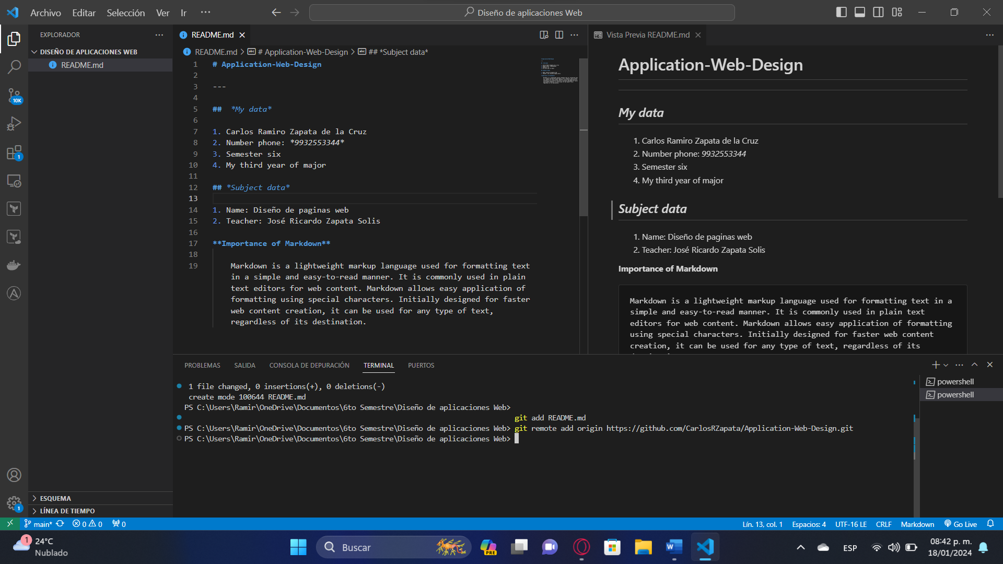

* + 1. Add the file with the saved changes in “Stage.”
    2. Create a “commit” by writing in a descriptive way what that first “commit” is about.
    3. Do a “push” in your remote repository.

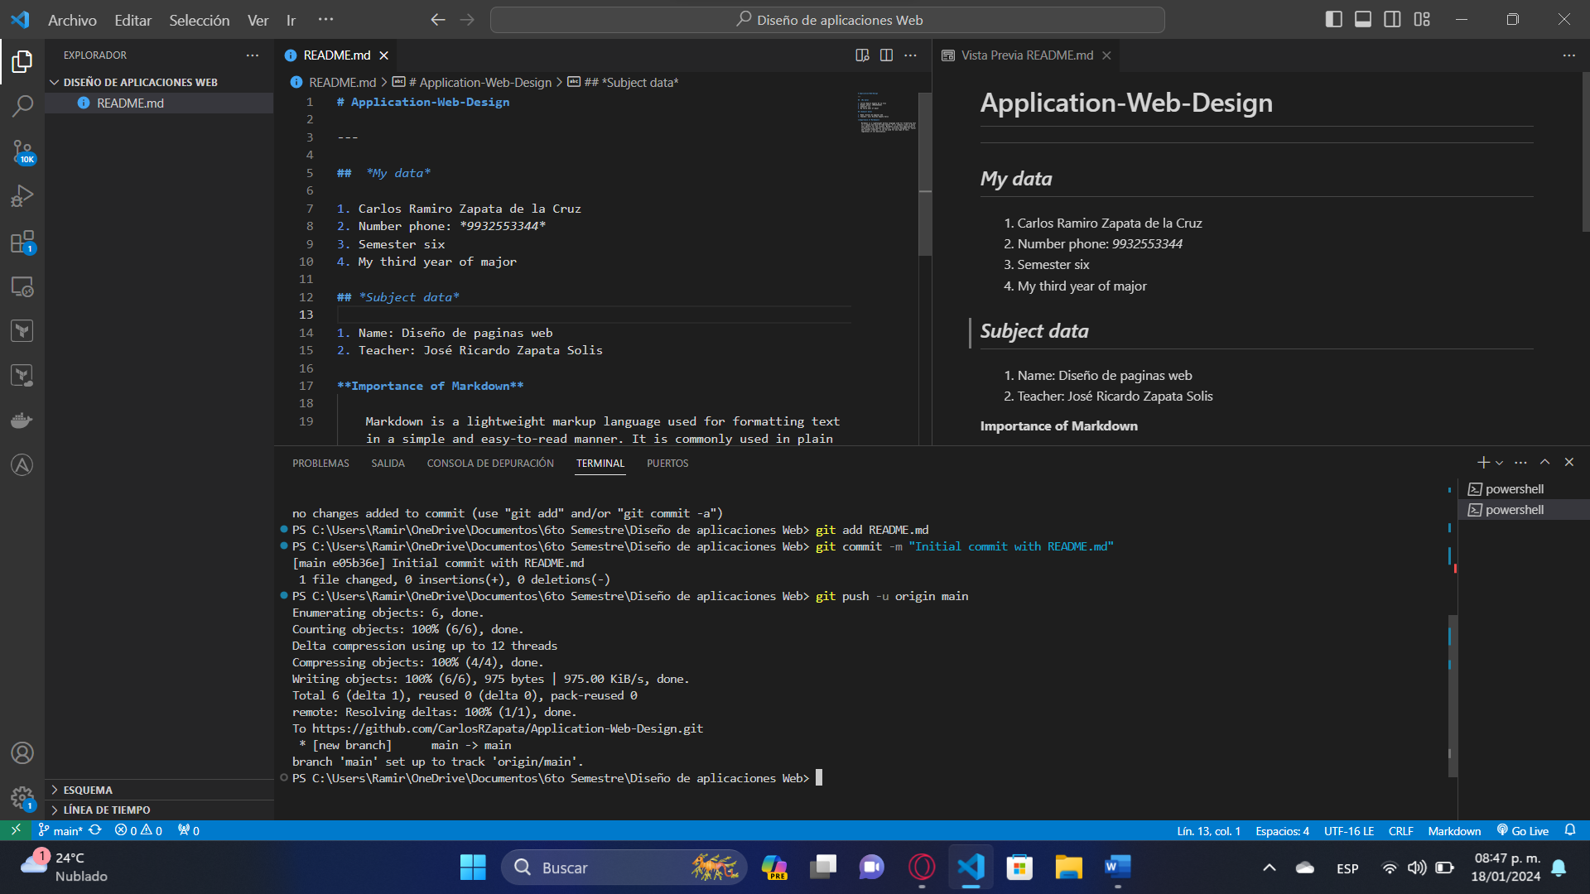

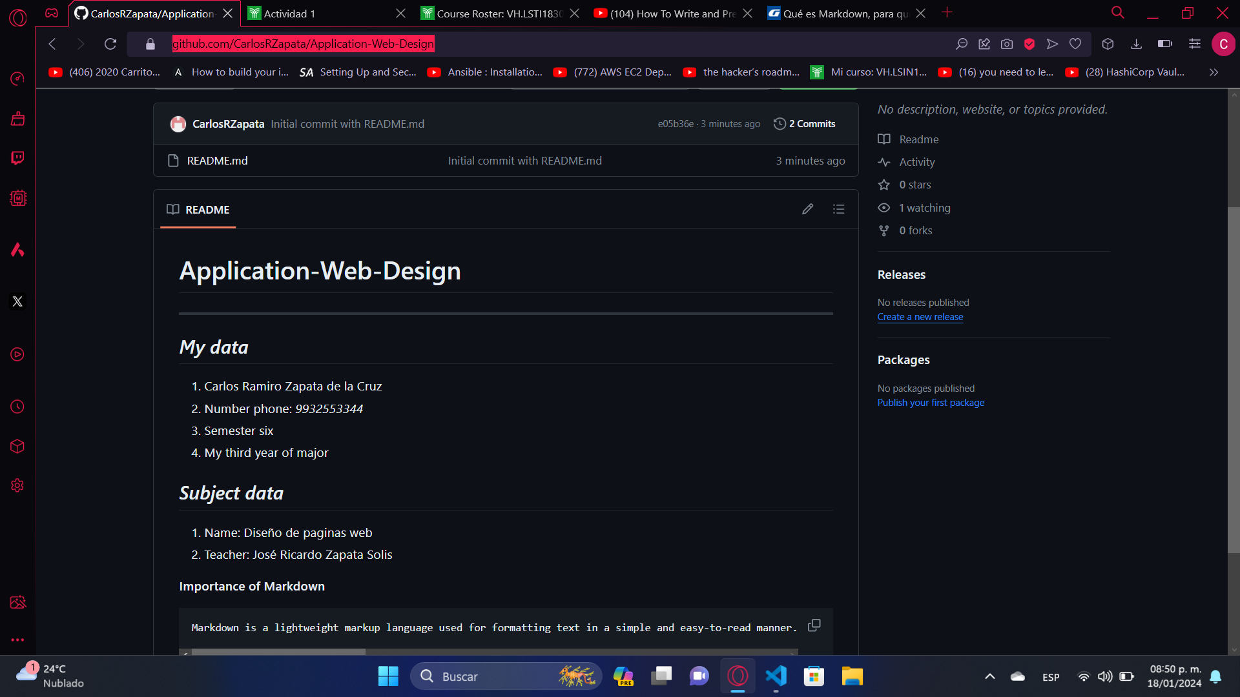

Deliverable(s)

Screenshots of the software installed on your computer, and of the command terminal with the commands you entered. Attach everything to a document in report format along with the URL of your GitHub repository.

**Link of repository:** [**https://github.com/CarlosRZapata/Application-Web-Design**](https://github.com/CarlosRZapata/Application-Web-Design)