CS 148 Database Design for the Web Fall 2014

Colin Luther and Carlos Rodrigo Garcia

Final Project

Time Sheet

Version <1.0>

|  |  |  |  |
| --- | --- | --- | --- |
| Time Log | | | |
| Date | Time Spent (in hours) | Description | Author |
| 11/5/14 | 0.5 | Discussing project ideas. | Rodrigo, Colin |
| 11/6/14 | 1.0 | Sketching project ideas. | Rodrigo |
| 11/7/14 | 0.5 | Project decision, register for UVM CS fair. | Rodrigo, Colin |
| 11/8/14 | 1.0 | Setting up GitHub repository, creating document specifications file. | Colin |
| 11/12/14 | 1.0 | Creating rough ER diagram and site storyboard. | Rodrigo |
| 11/16/14 | 7.0 | Finish ER Diagram, creating schema, more work on document specifications file, creating project index. | Rodrigo, Colin |
| 11/17/14 | 2.0 | Minor changes to schema and ER diagram. Creation of data dictionary. | Colin |
|  |  |  |  |
|  |  |  |  |
|  |  |  |  |
|  |  |  |  |
|  |  |  |  |
|  |  |  |  |
|  |  |  |  |

Table Of Contents

Software Requirements Specifications 4

Introduction 4

Purpose 4

Scope 4

Definitions, acronyms, and abbreviations 4

Overview 4

Overall Description 5

Story Board 5

Specific requirements 6

# Software Requirements Specifications

## Introduction

### Purpose

The purpose of this document is to describe the Time sheet website that we will be building. The intended audience for this document is the prospective developers of this site.

### Scope

**The website to be created will be designed to allow a company’s employees to log hours spent on assigned projects via a MySQL database. Project managers will be able to assign other employees to projects and monitor their hours.**

### Definitions, acronyms, and abbreviations

HTML – Hypertext markup language

CSS – Cascading Style Sheets

W3 Validation – refers to both Html and CSS validation tool provided by the W3c.org. the html validator is located at:

<http://validator.w3.org/>

with the CSS validator located at:

<http://jigsaw.w3.org/css-validator/>

### Overview

**The website will consist of a home page with a navigation bar with links to other pages. Visitors to the site will have to register in order to access the rest of the site. Visitors may try to register as an employee, employer, or admin. Current Admins will have to approve of their choice. Once registered, users may be able to log hours, and monitor and assign projects.**

**Overall Description**

**Any visitor to the site will be able to access the home page which will contain text summarizing the website and how to use it. Visitors may also access another page to register or sign in. Users will be required to click the link in a confirmation email, which will direct them to a confirmation page. Once signed in, users may access other pages of the site depending on their permissions.**

**Project managers may access the project monitoring, assigning, and editing pages. There they may manage the projects they’ve assigned.**

**Project assignees will only be able to enter the hour logging page when signed in. There they may log the hours worked on every project assigned to them.**

**Another page will allow site admins to manually manipulate the website’s database.**

**Users may also change their passwords if they no longer wish to use the password randomly assigned to them by the admin(s).**

Story Board

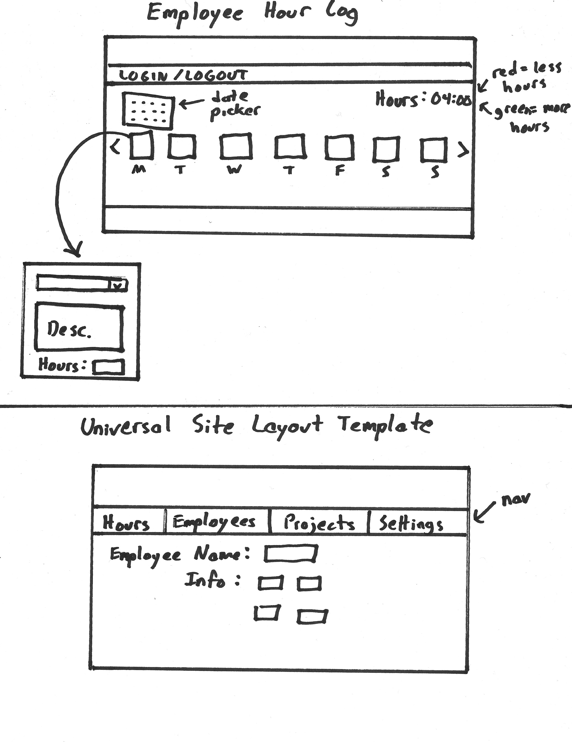

## Specific requirements

The final project can be done in a group of 1,2 or 3 people. Notify me asap whom your group partners are going to be. It is a fairly open ended project to allow for creativity. Keep in mind if you do the minimum then you get a minimum grade. You will be developing a complete Graphical User Interface using PHP for customers, clients and management to access your database information. You must have at least 3 tables plus their relationship tables as needed.

Consider entering your project (bonus points of course!) in the [CS Fair](http://www.uvm.edu/%7Ecsfair/2014) being held in Dec.

1. Create a design specification (External documentation) for this project (pdf or web page).   
     
   [Sample Project Specification Document](https://rerickso.w3.uvm.edu/education/blackboard/2014_Fall/cs148/assignments/sampleSpec.docx) (MS Word).  
     
   [Sample Project Specification Document](https://rerickso.w3.uvm.edu/education/blackboard/2014_Fall/cs148/assignments/sampleSpec.pdf) (pdf). NOTE: you will need to edit the document and save as a pdf).
   1. cover page
   2. time log
   3. table of contents
   4. Introduction
   5. Purpose
   6. Scope
   7. Definitions, acronyms, and abbreviations
   8. Overview
   9. Overall Description
   10. Data Dictionary
   11. Entity Relationship Diagram
   12. Schema
   13. Story Board
   14. Specific requirements
2. You need a minimum one form
   1. insert data into at least two tables.
   2. include one text box for a users email address.
   3. include two additional text boxes.
   4. include one list box.
   5. include three check boxes.
   6. include three radio buttons.
   7. include Submit button.
   8. Field sets and legends as needed
   9. data should be validated for not missing, valid format etc as needed with php, appropriate error messages will be displayed
   10. form should email the person who filled it out
   11. form data should be saved to your database (one form needs to save to more than one table at once).
3. Your interface should be easy to follow and understand.
4. Your interface needs to allow the administrator to do the following (for all tables):
   1. Add new records (populating relation tables automatically)
   2. Update Existing records
   3. Delete records (deleting relational records automatically)
   4. Be sure to validate all information
5. Use git and github to version your project.
6. You may present your project to the class (up to 10 points bonus) if we have time.
7. Minimum of six web pages.
8. As always be sure to:
   1. validate your html and CSS (w3c.org).
   2. have the following Meta tags: author, content, description.
   3. have a link on your main index page to this assignment.

You may create a web site for:

* Business.
* Non-profit Organization.
* Personal
* Site can Fictional or real (however latin text is not allowed).