**How to run the solution**

The solution was coded using Visual Studio 2015 Update 3 and Framework 4.6.2.

1. The solution is in my Git Repository, so it is necessary to download o clone the code into a local folder from:

[**https://github.com/CarlosVV/amcro.git**](https://github.com/CarlosVV/amcro.git)

1. Locate and open the solution located in the folder root:

**.\cleaning_robot\MyQ.CleaningRobot.sln**



1. Rebuild the solution in Visual Studio 2015 to update all packages

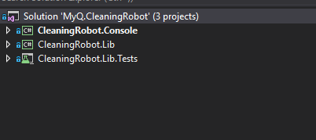

1. Execute the Unit Tests to see the execution.

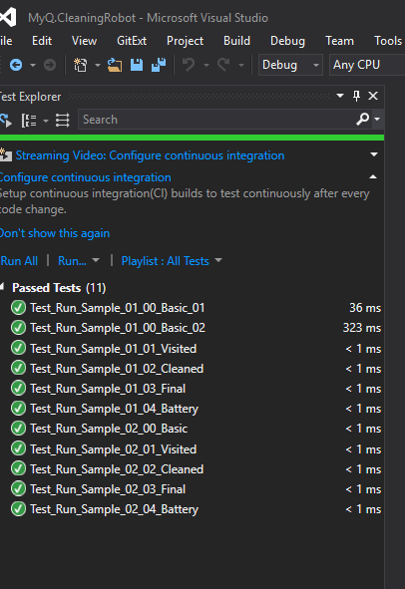

1. Open the command line to execute the program in the folder:

**.\cleaning_robot\bin\debug\**

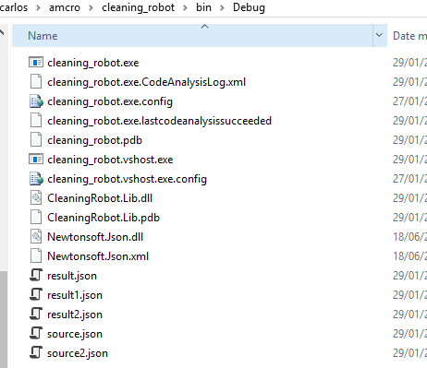

Using the following line:

**cleaning_robot source.json result1.json**

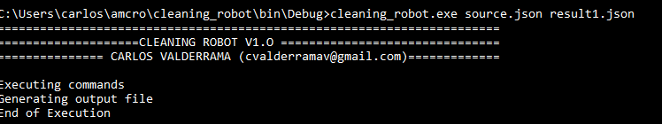

1. The result file result1.json will be like this:

