NEUROPSYCHOLOGICAL PROFILE OF EMBERA CHAMÍ ADULTS

Cross-Sectional Study

Resguardo Honduras, Embera Chamí
Florencia, Caquetá, Colombia

Analysis Date: 2026-05-25
N = 88 bilingual adults

EXECUTIVE SUMMARY

Key Findings:

1. EDUCATION: Dominant predictor (12/13 models significant, β = 0.25-0.69)
- Strongest effects: SDMT (β=0.69), BTA (β=0.58), Rey Recall (β=0.55)
- Explains up to 65% of variance in attention

2. L1/L2 DOMINANCE: Novel finding (3/13 significant, ALL negative)
- HVLT Delayed: β = -0.236, p = 0.036
- Phonological Fluency: β = -0.209, p = 0.018
- BTA: β = -0.210, p = 0.009
- Interpretation: Higher Embera (L1) dominance → worse performance
- Implication: Balanced bilingualism is protective

3. GENDER, AGE, ACCULTURATION: Minimal effects after controlling education

Table 4. Multiple Regression Results
Standardized β coefficients with 95% CI and p-values

Multiple regression models (N=88). *** p<.001, ** p<.01, * p<.05, † p<.10
Outcome | Age | Education | Gender | L1L2_Dominance | Acculturation | R2_adj | f2_Cohen
HVLT Total Recall | -0.22 (0.065†) | 0.34 (0.010**) | -0.09 (0.348) | -0.03 (0.779) | -0.02 (0.890) | 0.235 | 0.387
HVLT Delayed Recall | 0 (0.996) | 0.37 (0.005**) | 0.05 (0.574) | -0.24 (0.036*) | 0.05 (0.679) | 0.255 | 0.424
HVLT Recognition | 0.05 (0.679) | 0.25 (0.078†) | -0.02 (0.828) | -0.08 (0.525) | 0.13 (0.361) | 0.074 | 0.146
Rey Figure Recall | -0.01 (0.914) | 0.55 (<.001***) | -0.15 (0.088†) | 0 (0.971) | 0.09 (0.419) | 0.398 | 0.764
Rey Figure Copy | -0.12 (0.300) | 0.32 (0.008**) | -0.11 (0.222) | -0.18 (0.083†) | 0.12 (0.302) | 0.346 | 0.623
Phonological Fluency | 0.08 (0.405) | 0.52 (<.001***) | -0.23 (0.003**) | -0.21 (0.018*) | 0.12 (0.205) | 0.544 | 1.329
Semantic Fluency | -0.12 (0.221) | 0.44 (<.001***) | -0.14 (0.092†) | -0.17 (0.058†) | 0.11 (0.299) | 0.497 | 1.107
Brief Test of Attention | -0.09 (0.285) | 0.58 (<.001***) | 0 (0.966) | -0.21 (0.009**) | 0.07 (0.427) | 0.626 | 1.837
Symbol Digit Modalities | 0.05 (0.595) | 0.69 (<.001***) | 0.07 (0.364) | -0.11 (0.201) | 0.06 (0.565) | 0.521 | 1.213
Trail Making Test A | -0.15 (0.163) | 0.52 (<.001***) | -0.1 (0.238) | -0.04 (0.714) | -0.02 (0.855) | 0.394 | 0.752
Trail Making Test B | 0 (0.974) | 0.55 (<.001***) | -0.08 (0.407) | -0.03 (0.747) | 0.04 (0.709) | 0.335 | 0.597
Wisconsin Card Sorting | -0.17 (0.112) | 0.46 (<.001***) | 0 (0.954) | -0.13 (0.178) | 0.06 (0.555) | 0.432 | 0.868
Stroop Color-Word | -0.15 (0.132) | 0.41 (<.001***) | -0.12 (0.130) | -0.09 (0.305) | 0.2 (0.053†) | 0.499 | 1.119

FIGURES

Figure 1. Correlation Matrix with Hierarchical Clustering
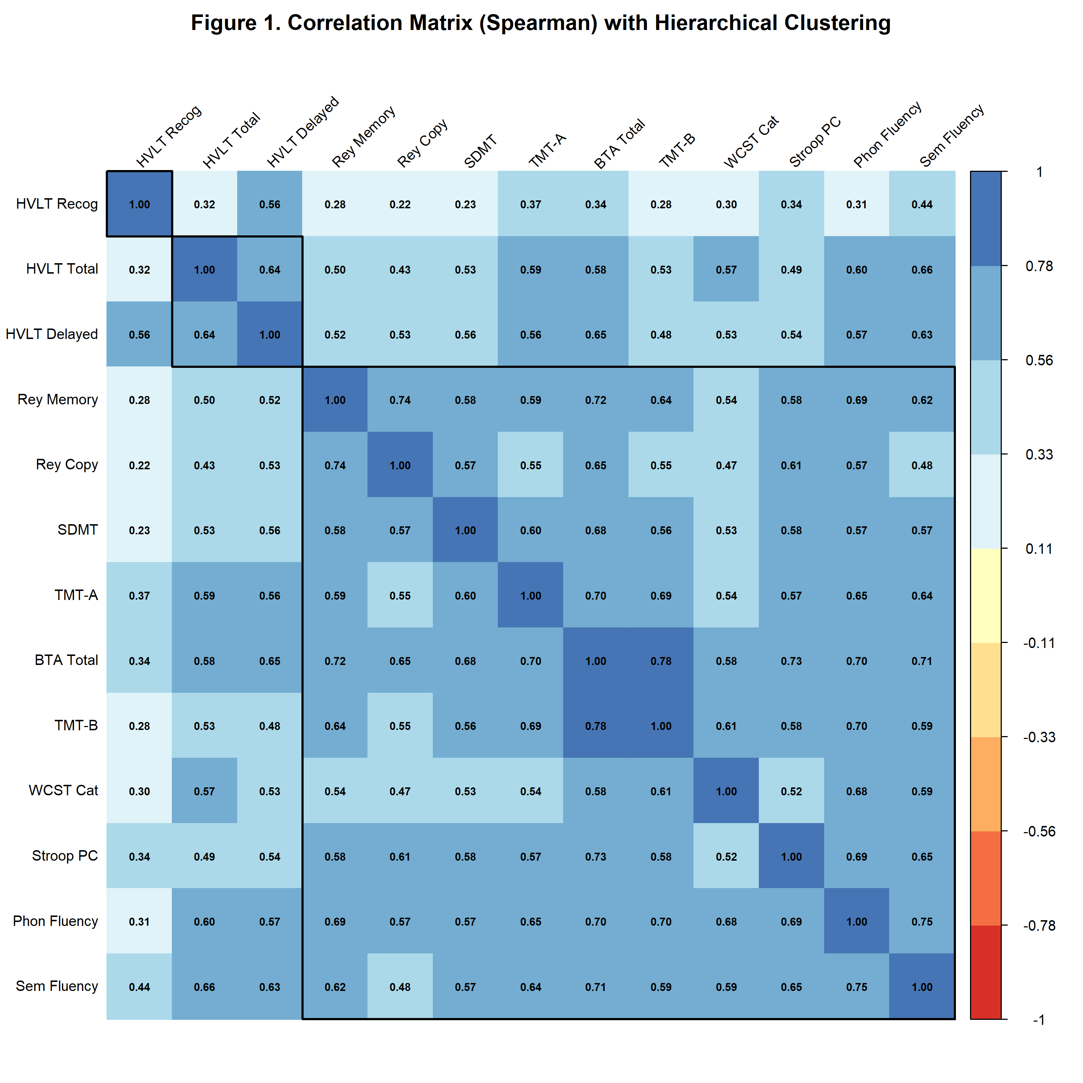

Spearman correlations among 13 neuropsychological indicators (N=88). Three clusters identified: (1) Verbal memory (HVLT), (2) Mixed (visuospatial + speed + attention + executive), (3) Verbal fluency.

Figure 2. Forest Plot of Standardized Regression Coefficients
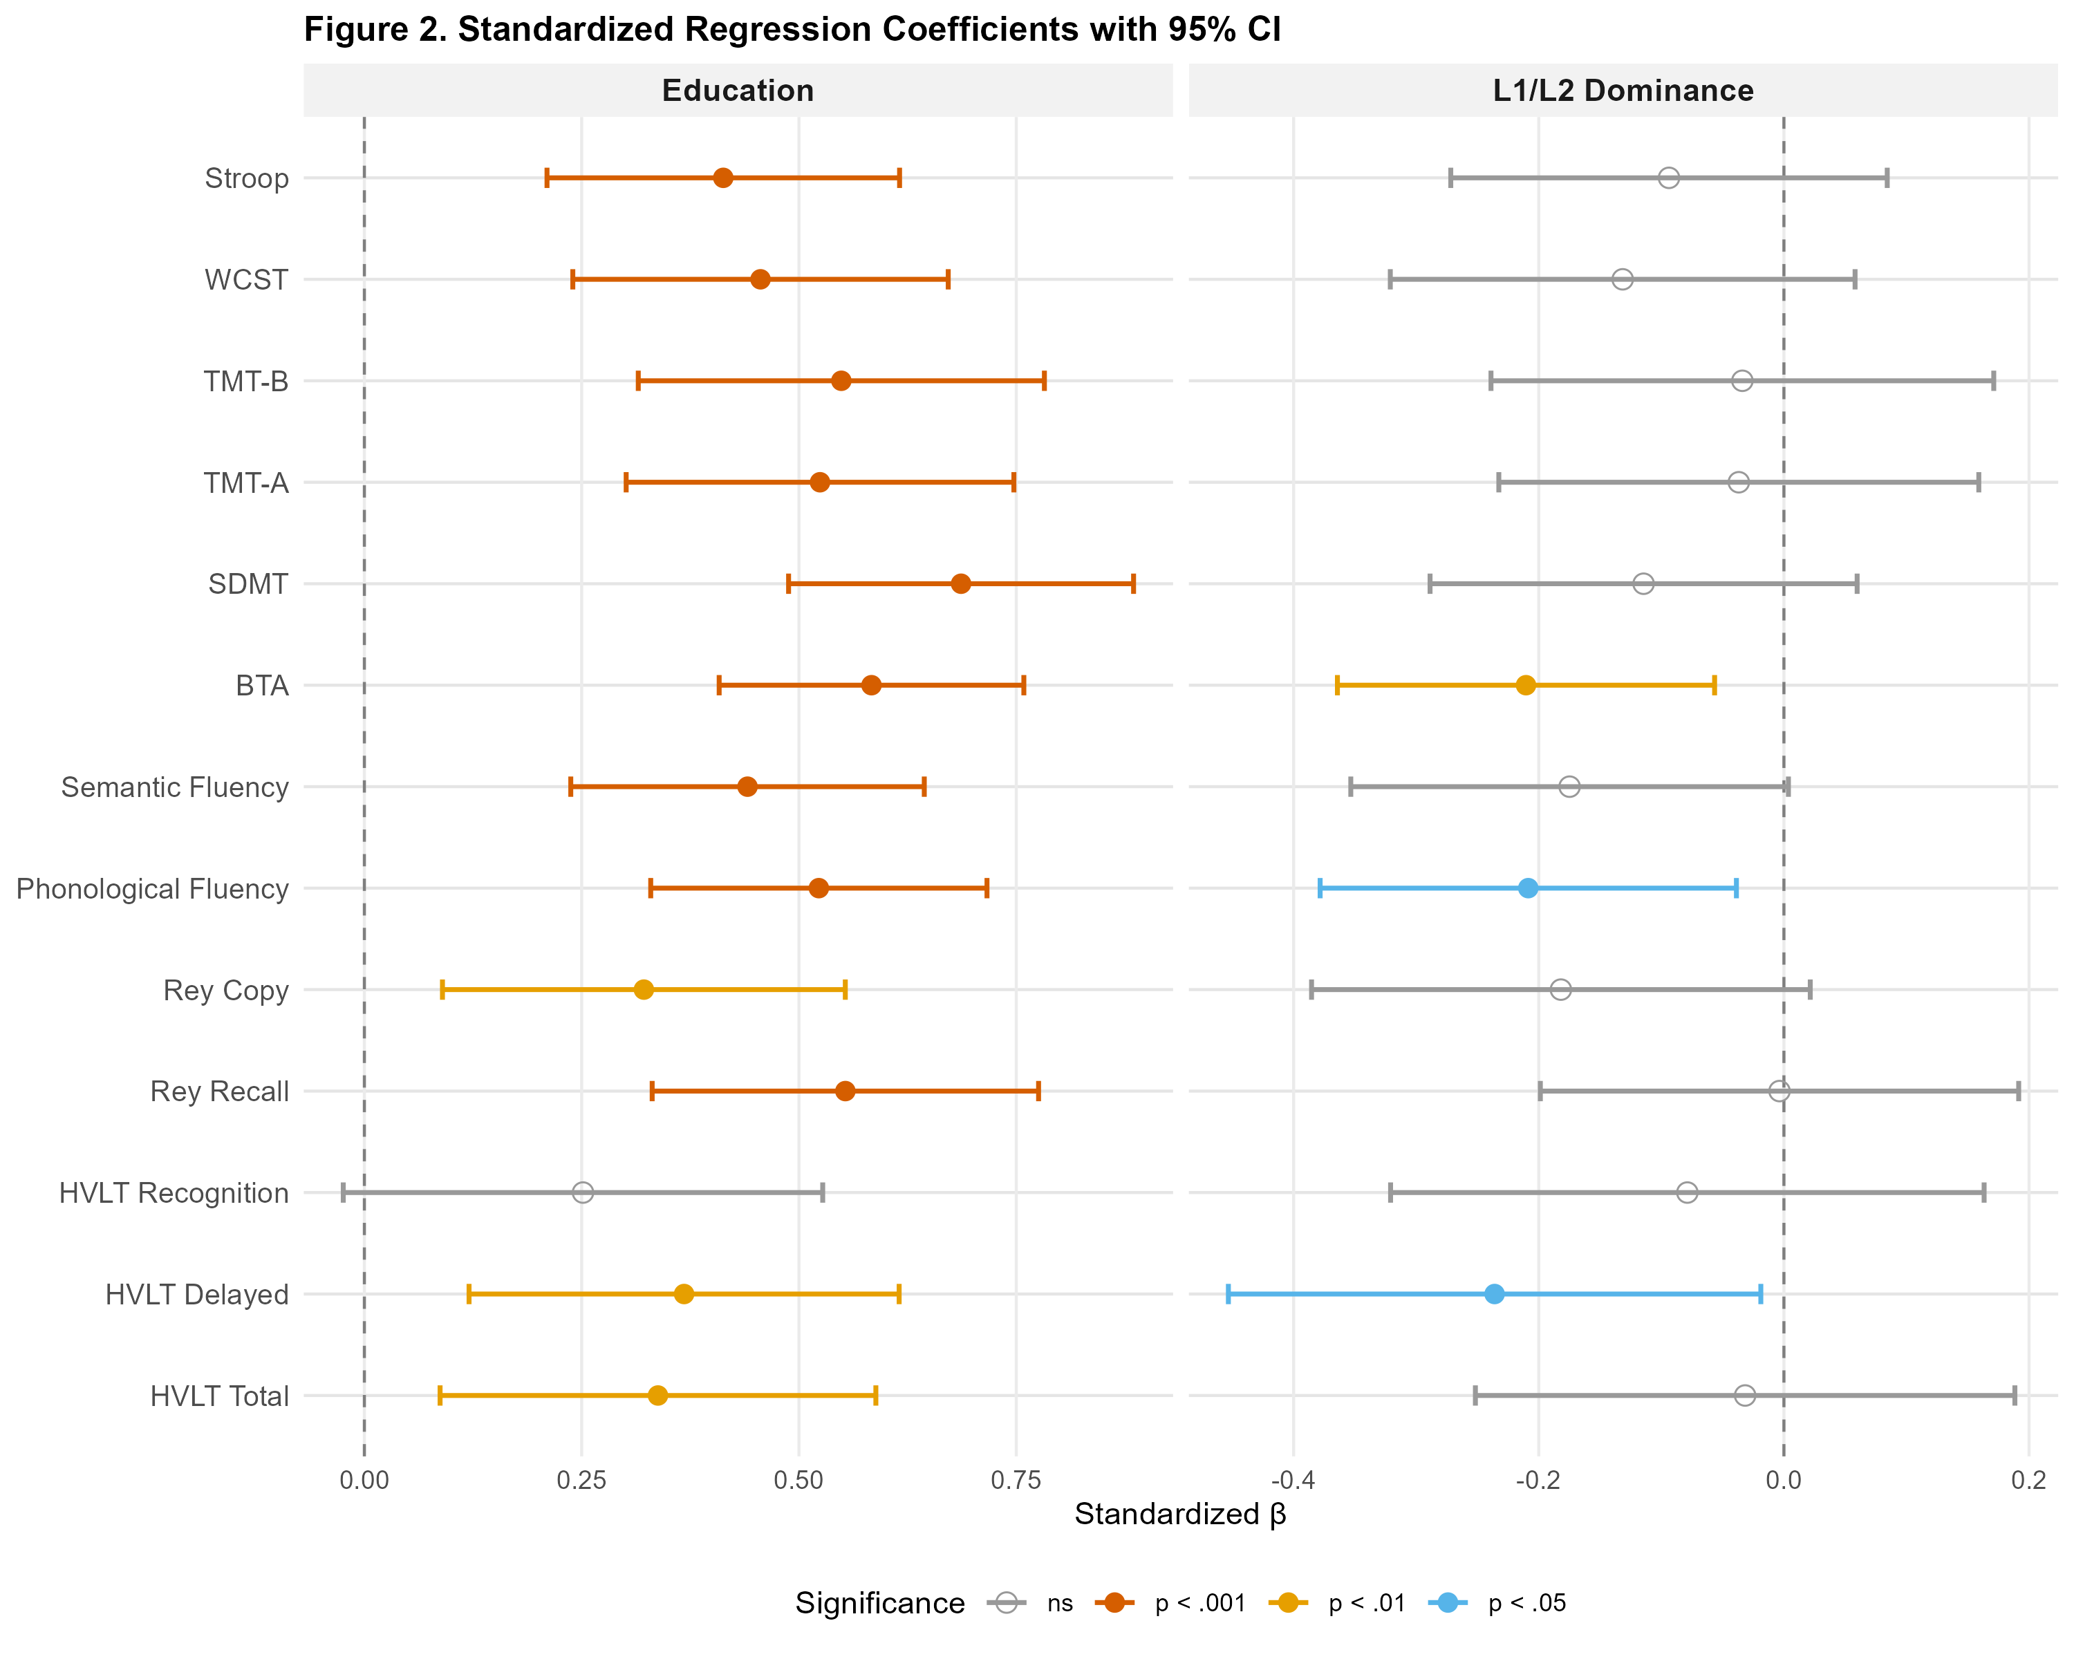

Standardized β coefficients with 95% CI for Education and L1/L2 Dominance predictors across 13 neuropsychological outcomes. Education shows consistent positive effects (left panel). L1/L2 Dominance shows negative effects on verbal memory, fluency, and attention (right panel).

Figure 3. Cognitive Profile by Education Level
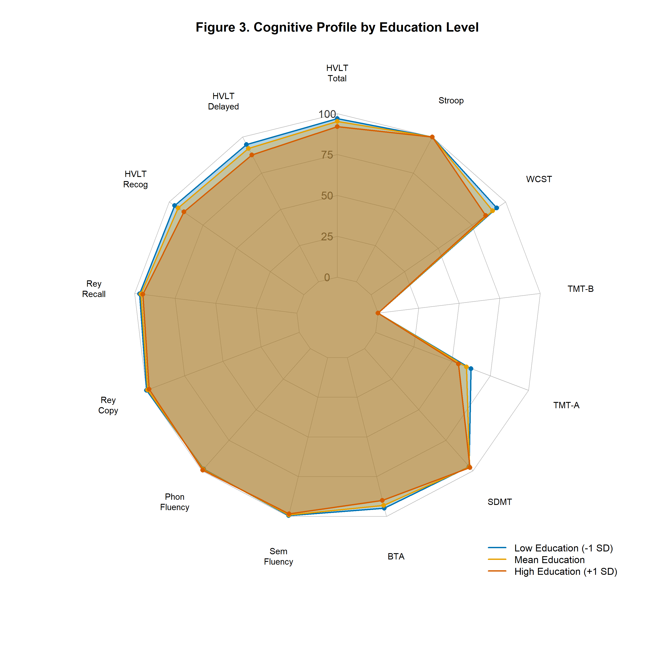

Radar plot showing predicted neuropsychological performance for three education levels: Low (-1 SD), Mean, and High (+1 SD). Higher education is associated with better performance across all cognitive domains.

SENSITIVITY ANALYSIS

Models re-fitted excluding 5 univariate outliers (|z| > 3):

Original N = 88 vs. Sensitivity N = 83

Results:
• Education: ROBUST (12/13 significant maintained)
• L1/L2 Dominance: ROBUST (2/3 strengthened, 1 marginal)
• R² changes: <±0.05 in most models

Conclusion: Main findings are robust to outlier exclusion.

STROBE CHECKLIST

STROBE checklist for cross-sectional studies
Item | Section | Topic | Status
1 | Title | Title informativo | PENDING
2 | Abstract | Abstract estructurado | PENDING
3 | Background | Contexto y rationale | PENDING
4 | Objectives | Objetivos específicos | PENDING
5 | Methods | Study design | READY
6 | Methods | Setting | READY
7 | Methods | Participants | READY
8 | Methods | Variables | READY
9 | Methods | Data sources | READY
10 | Methods | Bias | READY
11 | Methods | Study size | READY
12 | Methods | Quantitative variables | READY
13 | Methods | Statistical methods - descriptive | READY
14 | Methods | Statistical methods - models | READY
15 | Methods | Statistical methods - missing | READY
16 | Methods | Statistical methods - sensitivity | READY
17 | Results | Participant flow | READY
18 | Results | Descriptive data | READY
19 | Results | Outcome data | READY
20 | Results | Main results | READY
21 | Results | Other analyses | READY
22 | Discussion | Interpretation/Limitations | PENDING
23 | Funding | Funding sources | PENDING

