Carlos Lopez

George Catlin (July 26,1796 – December 23, 1872) was an American artist, he was a painter, author, and traveler. Catlin was known for his portraits of Native Americans in the old west, some would even say he specialized in in the artistic preservation of the natives of North America. Through his career, mainly in 1830, Catlin traveled through the American West 5 times. Catlin is known to be the first white man to show the Plains Indians in their native territory. In his career Catlin produced two major portfolios, which were a collection of paintings of Americans Indians. He also published a series of books about his travels with the people of the North, Central and South America.

George Catlin was born on July 26, 1796 in Wilkes – Barre, Luzerne County, Pennsylvania. Catlin spent most of his childhood in Pennsylvania hunting, fishing, and looking for American Indian artifacts. He was raised in a time period that destroyed the land of the indigenous people because of the American frontier, which was moving further and further out west. His fascination with Native Americans can be credited to his mothers. Catlin had a good relationship with his mother and she kindled his interest in Native Americans. She would often tell Catlin stories of the western frontier and how she and her mother were captured by a tribe when she was a young girl. His obsession grew, when later a group of Native Americans made an impression on him when they came through Philadelphia dressed up in their colorful outfits. Catlin was also influenced by his On-o-gon-way, who was a Native American. His relationship with his friend helped Catlin see that despite society views the local Indians were not savage and animalistic.

Despite his own interest Catlin began studying to be a lawyer, he did this to please his family. By 1823 he would abandon being a lawyer to become a portrait painter. Five years later Catlin married Clara Bartlett Gregory, who was from a wealthy family, and they had four children. Catlin’s early work included engravings which were inspired by nature found along the Erie Canal in New York State. Many of his pieces were published in [Cadwallader D. Colden](https://en.wikipedia.org/wiki/Cadwallader_D._Colden)'s *Memoir, Prepared at the Request of a Committee of the Common Council of the City of New York, and Presented to the Mayor of the City, at the Celebration of the Completion of the New York Canals*, which was one of the first printed books to use lithography. The book was published in 1825 and included images of the city of Buffalo.

Soon after his brief career as an attorney Catlin released two major collections of paintings of the American Indians and published a series of books. His books followed his travels among the native people of the North, Central, and South America. Catlin was inspired by relics brought back from the acclaimed Lewis and Clarke Expedition of 1804-1806. The relics were owned by his friend Charles Wilson Peale and sparked his interest in the American Indians. Catlin was very interested in America’s “vanishing race” and wanted to record the appearance and customs of American’s native people. A Seneca Indian named Red Jacket became a main subject of Catlin’s first Native American portrait.

Officially Catlin began his journey in 1830 when he followed General William Clark on a diplomatic mission up the Mississippi River into the Native American territory. St. Louis was the base of operation for five trips he took between 1830 and 1836, overall Catlin visited fifty tribes. Two years later he went up the Missouri River. He traveled more then 3000km to Fort Union Trading Post, which is now the North Dakota – Montana border. During his trips Catlin painted and preserved cultures he saw. Some of the tribes he visited were exterminated. For example, the Saxon clan was killed by the small pox disease soon after Catlin visited and documented their culture. Catlin wanted to visit tribes away from the influence of modern civilization, which he did during his exploration of the area near the Mississippi River, which was still untouched by white men. He spent several weeks with the Native people who were still relatively untouched by European culture. It was there that Catlin made and recorded some of his most acclaimed artwork. Catlin worked under the belief that the North American Indians were a “dying race.” So, he took special care of his documents of the Indians in their natural element. He worked and sensitively painted their clothes, artifacts, customs and their recreational activities. It is said that if not for Catlin people may nor know much of the Native Americans, many of who died soon after Catlin’s documentation of them.

Catlin visited eighteen tribes, including Pawnee, Omaha, and Ponca, which was in the south, and the Mandan, Hidatsa, Cheyenne, Crow, Assiniboine, and Blackfeet, which was in the north. Through these visits he made the most vivid and piercing portraits of his career. In his Later trips along the area near Arkansas, Red and Mississippi rivers along with Florida and the Great Lakes he painted more. He produced more than 500 painting and gathered a substantial collection of artifacts.

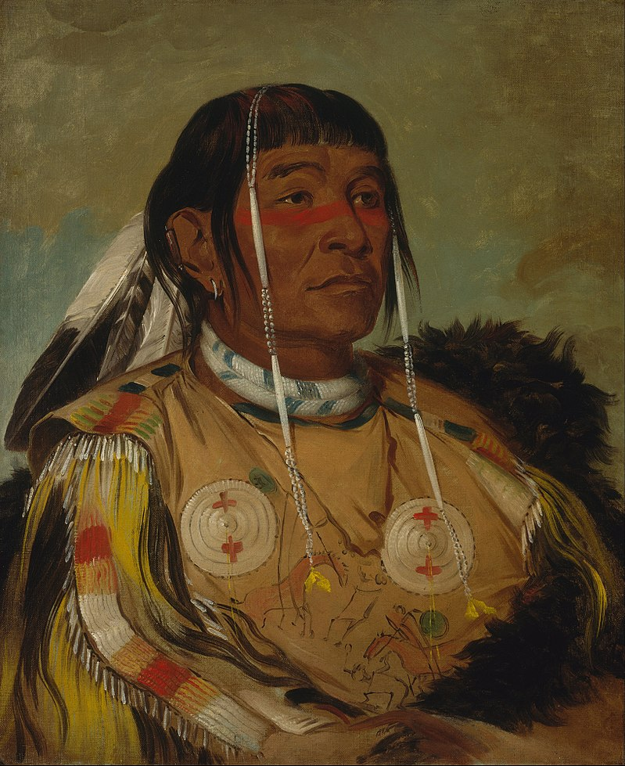

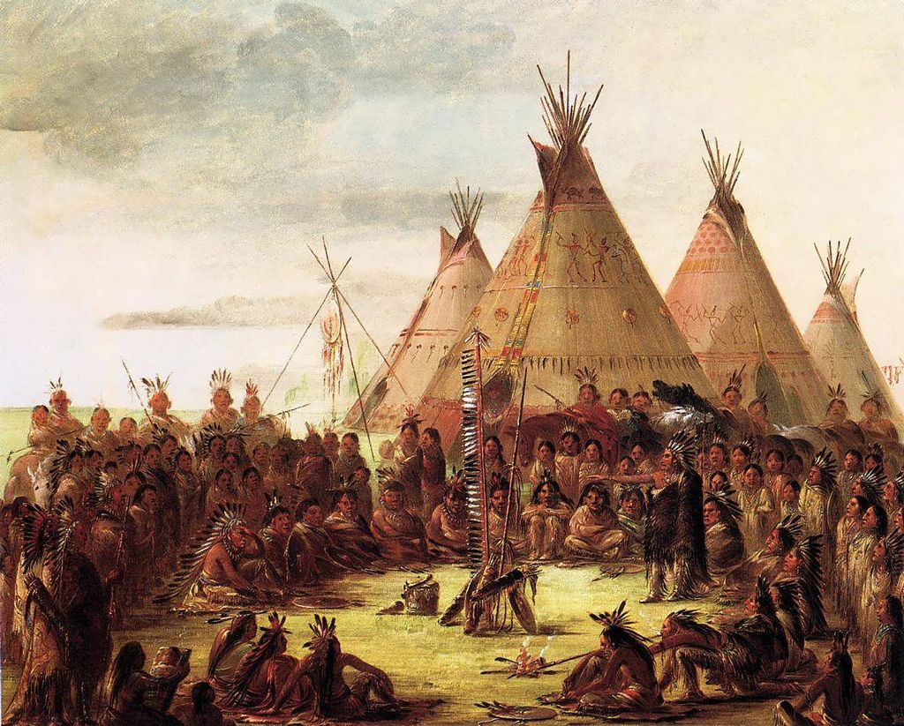

In 1838, when Catlin came back east he put together the painting and numerous artifacts he collected into his Indian Gallery. He also began delivering public lectures that recounted his personal stories and recollections of life among the American Indians. Catlin traveled through major cities like Pittsburgh, Cincinnati, and New York to show off his Indian Gallery. In his gallery Catlin hung his paintings side by side and one above another called a salon style. Viewers identified each of the paintings by the number on the frame. They numbers were listed in a catalogue that Catlin put together. Soon after his shows Catlin began trying to sell his collection to the United States government, which a lifelong effort of his. Even though Catlin was highly interested in the Native Americans not all people felt the same. His touring show did not attract the paying public. Along with that the United States government rejected his initial petition to purchase the works. So, to stay financially sound and stable Catlin took his tour elsewhere.

In 1830, Catlin took his collection across the Atlantic Ocean to tour around the European capitals. In London, Brussels, and Paris Catlin initially attracted crowds to his Indian Gallery shows. Catlin was truly a showman and entrepreneur in his trip. The French critic Charles Baudelaire said, "He has brought back alive the proud and free characters of these chiefs, both their nobility and manliness” about his paintings. More than anything Catlin wanted to sell his Indian Gallery to the United States government, in hopes to have his life’s work preserved and intact. His multiple and continuous attempts to persuade various officials in Washington, D.C. to buy his collection failed. Finally, in 1852 Catlin was forced to sell the original Indian Gallery, which was now at 607 paintings because of his high personal debt. Joseph Harrison, the industrialist, bought the paintings and artifacts and stored in a factory in Philadelphia to keep as security. The last 20 years of Catlin’s life was spent trying to re-create his collection, he managed to recreate more than 400 paintings overall. This second collection of paintings known as the “Cartoon Collection” this was because the works were based on the outlines that Catlin drew of the work he made in the 1830s.

In 1841 Catlin published the book *Manners, Customs, and Condition of the North American Indians*, which came out in two volumes and included about 300 engravings. Three years later he published 25 plates, titled *Catlin’s North American Indian Portfolio*. In 1848 he published *Eight Years' Travels and Residence in Europe.* From 1852 to 1857 Catlin traveled through South and Central American and later went back to further explore in the Far West. His books *Last Rambles amongst the Indians of the Rocky Mountains and the Andes* (1868) and *My Life among the Indians* (ed. by N. G. Humphreys, 1909) show the record of his explorations in the later year. These books also show his paintings of the Spanish American Indians.

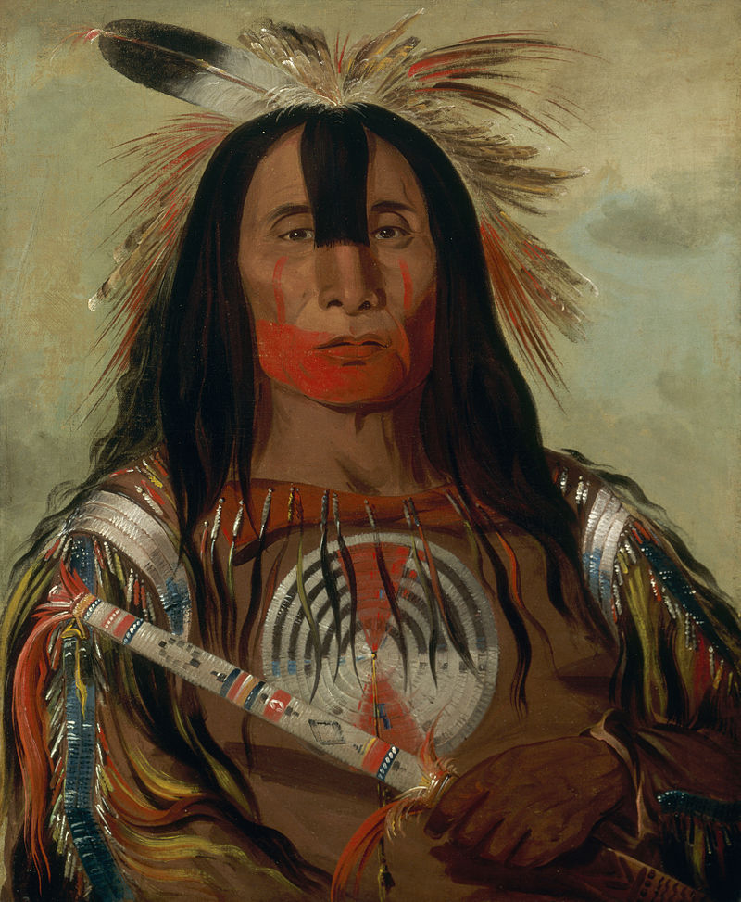

In 1872, at the invitation of [Joseph Henry](https://en.wikipedia.org/wiki/Joseph_Henry), the first secretary of the [Smithsonian](https://en.wikipedia.org/wiki/Smithsonian_Institution), Catlin traveled to Washington, D.C. Catlin worked in a studio in the Smithsonian "Castle" until his death later that year in [Jersey City, New Jersey](https://en.wikipedia.org/wiki/Jersey_City,_New_Jersey). In 1879 Joseph Harrison’s widow donated the original Indian Gallery, which contained more than 500 of Catlin’s works, along with related artifacts, to the Smithsonian.

Today, the virtually complete surviving set of Catlin's first Indian Gallery, which was painted in the 1830s, is now part of the [Smithsonian American Art Museum](https://en.wikipedia.org/wiki/Smithsonian_American_Art_Museum)'s collection. The artifacts associated with Catlin’s collection are contained in the Department of Anthropology , [National Museum of Natural History](https://en.wikipedia.org/wiki/National_Museum_of_Natural_History), [Smithsonian](https://en.wikipedia.org/wiki/Smithsonian_Institution). The [American Museum of Natural History](https://en.wikipedia.org/wiki/American_Museum_of_Natural_History) in New York City holds about 700 sketches. Some of Catlin’s artifacts are in the [University of Pennsylvania Museum of Archaeology and Anthropology](https://en.wikipedia.org/wiki/University_of_Pennsylvania_Museum_of_Archaeology_and_Anthropology) collections. Other illustrative and manuscript material by Catlin are held in the [Huntington Library](https://en.wikipedia.org/wiki/Huntington_Library) in San Marino, California. Which also holds 239 of Catlin's illustrations of both North and South American Indians.

Overtime the accuracy of some of Catlin's observations has been questioned. One of his claims were that he was the first white man to see the [Minnesota pipestone quarries](https://en.wikipedia.org/wiki/Pipestone_National_Monument), and pipestone, which was named [catlinite](https://en.wikipedia.org/wiki/Catlinite). Along with that Catlin exaggerated various features of the site, and his boastful account of his visit aroused his critics, who disputed his claim of being the first white man to investigate the quarry. Previously recorded information says that early visitors included the [Groselliers](https://en.wikipedia.org/wiki/M%C3%A9dard_des_Groseilliers) and [Radisson](https://en.wikipedia.org/wiki/Pierre-Esprit_Radisson), Father [Louis Hennepin](https://en.wikipedia.org/wiki/Louis_Hennepin), Baron LaHonton, and others. [Lewis and Clark](https://en.wikipedia.org/wiki/Lewis_and_Clark_Expedition) also noted the pipestone quarry in their journals in 1805. The fur trader [Philander Prescott](https://en.wikipedia.org/wiki/Philander_Prescott) had written another account of the area in 1831.

Work Cited

“George Catlin.” *Wikipedia*, Wikimedia Foundation, 1 Dec. 2017, en.wikipedia.org/wiki/George_Catlin.

Responsive Website Design by Michael Rose http://www.rosemconsulting.com. “Native American Portraits.” *Native American Portraits and the Artists Famous for Creating Them*, [www.indians.org/articles/native-american-portraits.html](http://www.indians.org/articles/native-american-portraits.html).

“George Catlin.” *George Catlin - The Complete Works*, [www.georgecatlin.org/](http://www.georgecatlin.org/).

*George Catlin: A Biography*, scienceviews.com/historical/georgecatlin.html.