1)
int b[] = {2,4,2,8};

int *p, *q, *r;
p = &b[0];
q = &b[1];
r = &b[2];

2)
a) This input doesn't produce any compile-time or runtime error. The comparison evaluates to true.
b) This input doesn't produce any compile-time or runtime error. The comparison evaluates to true.
c) This input doesn't produce any compile-time or runtime error. The comparison evaluates to false.
d) This input doesn't produce any compile-time or runtime error. The comparison evaluates to true.
e) This input doesn't produce any compile-time or runtime error. The comparison evaluates to true.
f) This input produces a runtime error saying that I have an invalid operand. It still equates to false

3)
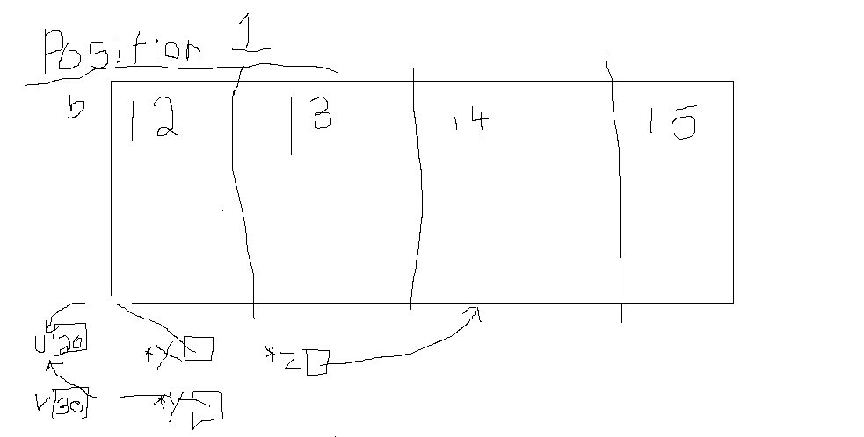
a)

b)
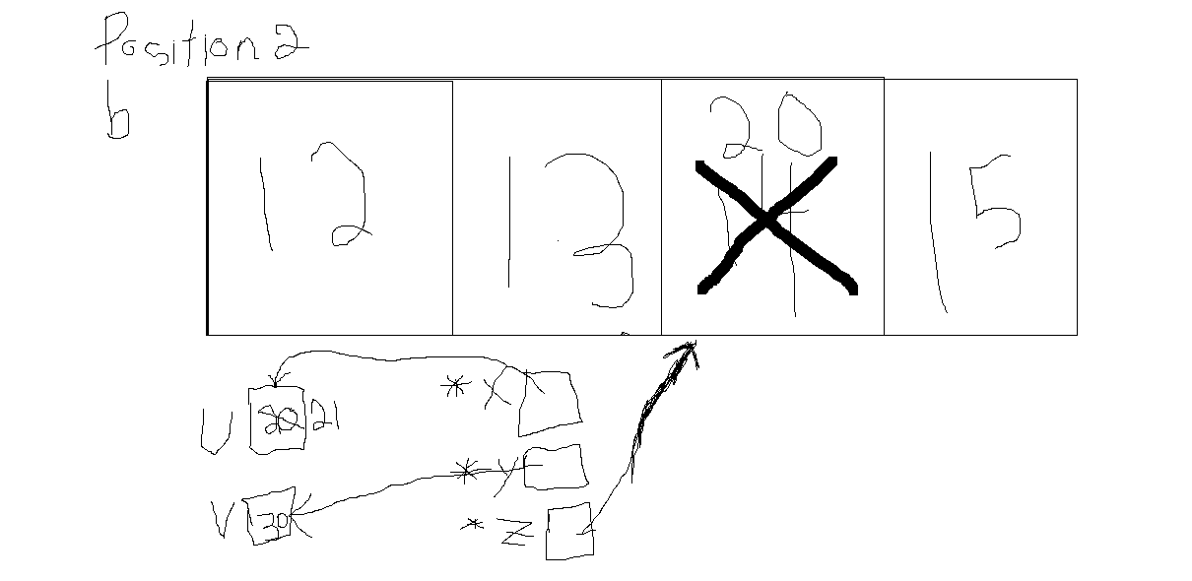

4)
