1.) 3 protocols: HTTP, TCP, TLSv1

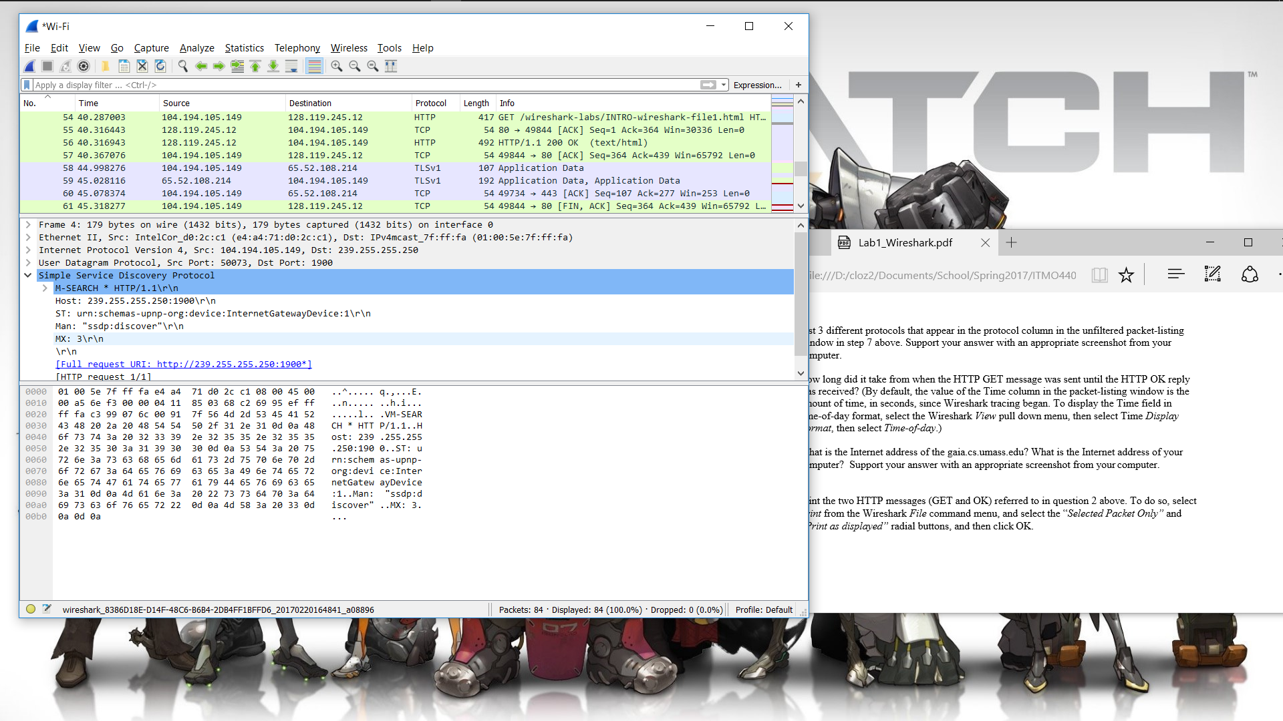

2.) It took about .03 seconds

3.) The address is 128.119.245.12 for gaia.cs.umass.edu. My address is 104.194.105.149

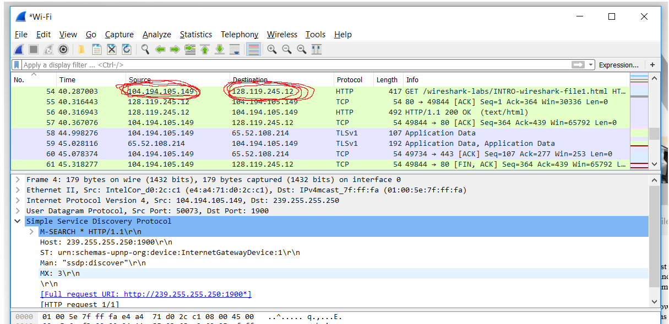

4.) Attached as pdf

5.)