CARLOS G. MARTÍN  COMPUTER & SOFTWARE ENGINEER |  |  | 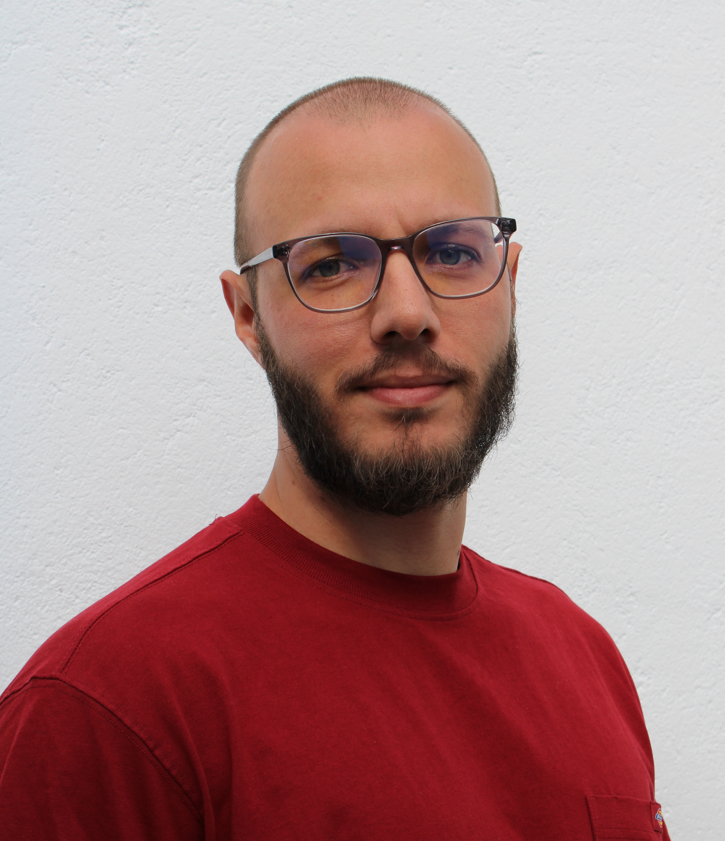
+ PERSONAL INFORMATION |  | + CONTACT
  Location | Remote | Tenerife
  Nationality | Spanish
  Date of birth | February 6, 1993
  Telephone |  | +34 622 13 66 00
  LinkedIn |  | Carlos G. Martín Pérez
  Github |  | Carlosmape
  Email |  | cagrmape@gmail.com

+ PROFESSIONAL SUMMARY
I am a proactive and results-driven software engineer with extensive experience in developing complex systems and leading technical teams. I specialize in Python, C++, and Linux environments, and have a proven track record in designing and implementing solutions for real-time systems, data management, and embedded systems. My expertise spans across software engineering, system analysis, and design, with a particular focus on driving high-performance products. As a natural communicator and leader, I take pride in cultivating collaborative environments, driving projects forward, and mentoring junior developers. I am currently seeking a Tech Lead role where I can continue to leverage my skills in software development and leadership to help teams thrive and deliver exceptional products.

+ EXPERIENCES
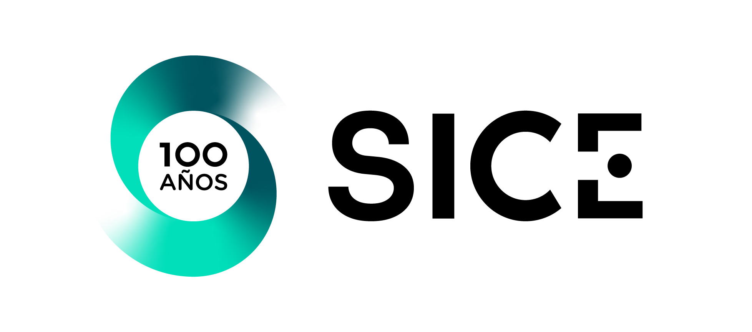 | Software Engineer | Tech Lead  2021 - Present  As a Tech-Lead and Developer, I have been responsible for leading cross-functional teams in designing, developing, and deploying innovative features for our products, including a data warehouse system and energy management algorithms. My leadership skills were further demonstrated as the product owner for a Datawarehouse project. I led the development of key features such as recursive algorithms for catenary energization, and managed the integration of various devices like displays, cameras, and intrusion detection systems.  Key Responsibilities:  + Leading software analysis, design and fevelopment process.  + Mentoring and collaborating with engineers to deliver hihg-quality code.  + Managing the full lifecycle of major features.  + Conducting code reviews and ensuring adherence to conding best practices and SOLID principles.  Languages & Technologies:  Python, NET Framework (C#), C++, SQL, TimescaleDB, Linux, ETL, BigData, Windows services, TLS, Unit Testing
 | Software Engineer  2019 - 2021  I worked on embedded and critical systems for the Madrid Metro's physical and electrical simulators, integrating GPS, PRS, and IMU positioning systems. During this time, I gained a solid understanding of the challenges of working with low-level programming and real-time data streams..  Key Responsibilities:  + Developing embedded systems and integrating them with hardware.  + Ensuring reliability and performance of real-time systems.  + Collaborating in agile environments.  Languages & Technologies:  C++, .NET Framework (C#), Python, Bash, Linux, GitLab, Unit Testing, Oscilloscope.
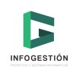 | .NET FULL STACK DEVELOPER  2017 - 2019  Worked on custom development projects for Sage ERP software and Nadilux CMMS, managing databases, performing SW analysis, and designing and implementing solutions. My work focused on database management and web development..  Key Responsibilities:  + SW Analysis, design and development.  + QA & Testing.  + SQL DB Design and management.  Languages & Technologies:  .NET (C#, ASP/NET), SQL, CSS3, Windows services,

+ EDUCATION
 | ENGINEER'S DEGREE, INFORMATICS  2011 - 2016  Universidad de La Laguna  + CSS3 Diploma + CakePHP Diploma
 | ANDROID DEVELOPER DIPLOMA  2018 - 2019  Universitat Politécnica de Valencia
 | LPI ESSENTIALS  2021  Linux Professional Institute
 | NODEJS  2022  Udemy "Node: De cero a experto"

+ REMARKABLE PERSONAL PROJECTS
Developer  Owner | LOREngine  A fully Python-based videogame engine (non-graphical) designed to generate procedural game lore and maps. The engine includes complex features like an NPC dialog system, quest management, TDD, and multiprocess design. (Private repository).
Developer  Owner | ULAUNCHER-CALENDAR  A Python plugin for Ulauncher that integrates Google Calendar and displays upcoming events. https://github.com/Carlosmape/ulauncher-calendar
Developer  Contributor | SLIMBOOK  A Linux tool to manage Slimbook laptop battery status and compatibility across various Linux distributions.https://github.com/slimbook
Developer  Owner | CYLOCK  An IoT solution for bicycle theft protection, utilizing Arduino and Java to alert users via smartphone. (Private repository).
Developer  Researcher | PACA  Developed artificial vision for a mechanical robot designed to help farmers, using OpenCV and RaspberryPi for real-time object tracking. https://github.com/Carlosmape/TRPI

+ LANGUAGES
Mother language | Spanish
Foreign languages | English

+ TECHNICAL SKILLS
Operating systems | Linux, Windows, Android
Programming languages | Python, C, C++, C#, Bash, SQL, Java, NodeJS, Ruby
IDE & Tools | NeoVim, Eclipse, Visual Studio
Version Control System | Git (Github, GitLab), SVN (Tortoise SVN)

+ SOFT SKILLS & PERSONAL TRAITS
Proactive & Self-Driven | I am passionate about taking the initiative and continuously learning new techniques and methodologies to stay at the forefront of technology.
Leadership & Mentoring | I enjoy fostering a collaborative team environment and mentoring junior developers to enhance team performance.
Problem-Solving | I excel in identifying and solving complex problems, delivering reliable and scalable solutions.
Adaptable & Sociable | I easily integrate into new teams, adapting to their needs and contributing to a positive work culture.
Curious & Lifelong Learner | My curiosity drives me to constantly seek new challenges, tools, and methodologies to improve my skills.
Effective Communicator | I am a strong communicator, capable of explaining technical concepts to non-technical stakeholders and ensuring alignment within teams.

+ ADDITIONAL SKILLS & HOBBIES
Cybersecurity & Privacy | Passionate about staying informed on the latest trends and best practices in cybersecurity.
Linux Enthusiast | I use Linux as my primary operating system, with a highly customized BSPWM desktop environment
Sports | Calisthenics, cycling, climbing and nature exploration
FOSS Advocate | Strong supporter of Free and Open Source Software (FOSS) and contributing to the community

