# **4-Floor Elevator Controller Project Report**

## **Abstract**

This project involves the design and implementation of a 4-floor elevator controller system, catering to Ground Floor (GF), Floor 1 (F1), Floor 2 (F2), and Floor 3 (F3). The system includes hardware components such as 7-segment displays, UP/DOWN buttons, LED indicators, and a motor with two-speed and dual-direction capabilities. Additional features include a cabin display for time, date, and temperature readings, implemented using a real-time clock (RTC) and LM35 temperature sensor. The firmware incorporates modular programming and task scheduling to ensure seamless operation. This report details the design, challenges, and future expansion possibilities for the project.

## **Introduction**

Elevators are integral to modern infrastructure, enabling efficient vertical transportation. This project aims to create a microcontroller-based 4-floor elevator controller system that ensures functionality, safety, and user convenience. The system incorporates floor-specific control mechanisms with dedicated buttons and indicators for each level. A comprehensive cabin control interface provides floor selection capabilities while displaying essential information such as time, date, and temperature. The motor control system implements efficient speed and direction adjustment mechanisms to ensure smooth operation. These features are integrated through a modular firmware architecture that manages hardware components and ensures synchronized operation.

## **Firmware Architecture**

The firmware is designed with modularity and scalability in mind, leveraging a cooperative scheduler for task management. The architecture comprises several key components that work in harmony to deliver reliable system operation.

* **Task Scheduler:** The core component, managing periodic and asynchronous tasks while coordinating between various modules such as motor control, display updates, and sensor readings. This ensures precise timing and efficient resource utilization across all system operations.
* **RTC Integration:** Utilizes I2C communication to maintain accurate time and date information. The system processes this data and presents it through the 7-segment display interface, implementing a systematic 10-second interval display cycle.
* **Temperature Monitoring System:** Incorporates the LM35 sensor, utilizing ADC conversion to provide accurate temperature readings. This data is processed and displayed alongside time and date information, offering comprehensive environmental monitoring within the elevator cabin.
* **Motor Control System:** Implements a sophisticated two-speed operation mechanism with dual-direction capabilities. The system integrates closely with strategically positioned limit switches to ensure precise floor positioning and smooth speed transitions during operation.
* **Display Management:** Orchestrates the presentation of information across all system interfaces. The implementation utilizes GPIO operations for floor indicators and implements BCD-based control for the 7-segment displays, ensuring clear and consistent information presentation.

## **Block Diagrams**

System Architecture Diagram:

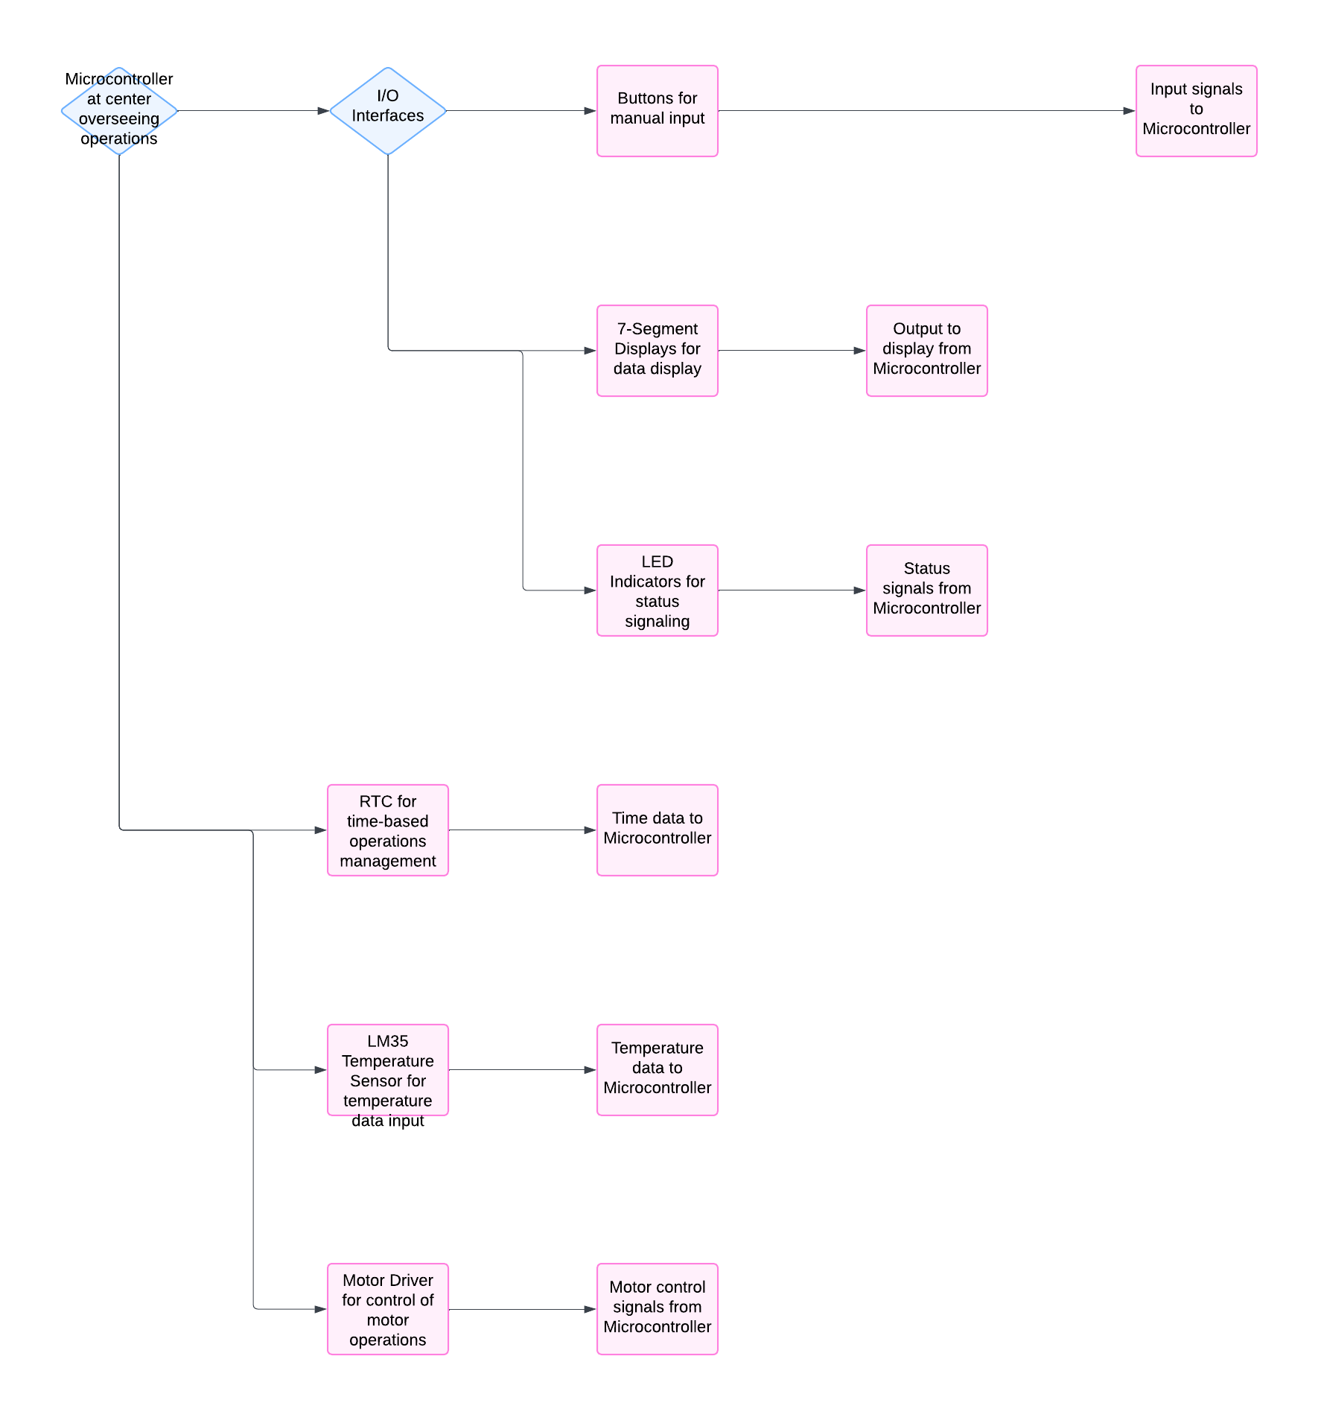

Motor Control System Diagram:

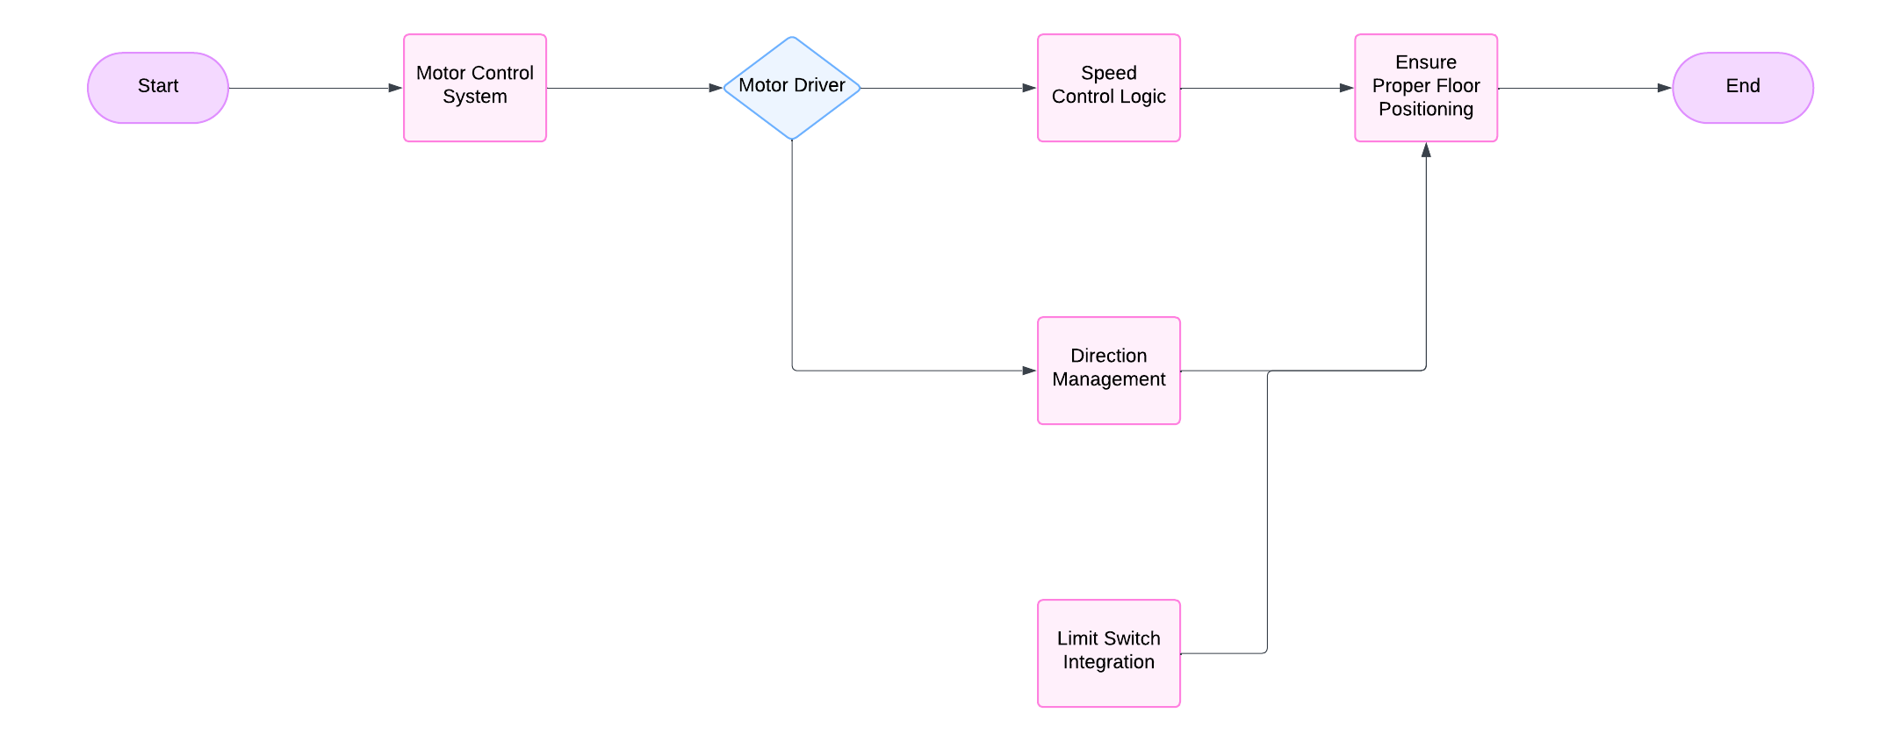

## **Flowcharts**

Floor Request Handling Flowchart:



Display Update Logic Flowchart:

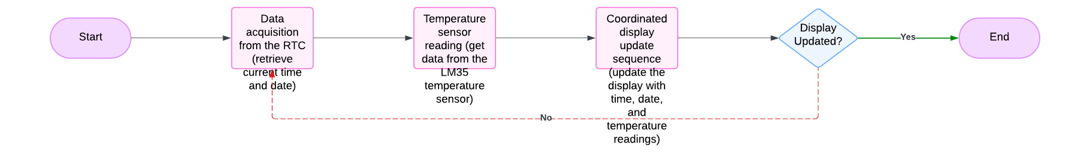

## **Procedures**

* **System Initialization:** Involves configuring hardware components, setting up the scheduler task, and establishing default system states. This process ensures all safety parameters are properly configured before operation commences.
* **Operation Workflow:** Details the handling of floor requests, including button input processing and movement sequence initiation. The speed control mechanism implements a sophisticated approach to movement, beginning with high-speed transit and transitioning to lower speeds as the target floor approaches. This is accomplished through careful monitoring of proximity sensors and precise control of motor parameters.
* **Testing Phase:** Incorporates comprehensive verification of all system components, followed by integrated system testing and performance optimization procedures.

## **Problems Encountered**

Speed Inconsistency

* **Problem**: The elevator may start moving too fast or too slow, leading to inconsistency in the speed at which it reaches the desired floor.
* **Solution**: Fine-tune the motor control logic to ensure consistent speed by adjusting the initial speed setting or the acceleration. You could also add a simple check to confirm that the motor is operating within the expected speed range and make adjustments if needed.

## **Possible Expansions**

* Future system enhancements could include implementation of variable speed control with optimized acceleration profiles. Integration of advanced safety features such as emergency brake systems and door control mechanisms would further enhance operational security.
* System expansion capabilities could accommodate additional floors through modified control logic and enhanced display systems. Implementation of wireless monitoring capabilities would enable remote system oversight and maintenance management.

## **Conclusion**

The 4-floor elevator controller project successfully demonstrates the integration of sophisticated hardware and software components to deliver reliable vertical transportation. The implementation of two-speed motor control with proximity-based adjustment ensures smooth operation and precise positioning. The modular firmware architecture provides a robust foundation for system operation while enabling future expansions and enhancements. Through careful resolution of technical challenges and implementation of comprehensive safety features, the project achieves its objectives of efficient and reliable elevator control.