Customer Segmentation Project
A Detailed Review of the Machine Learning II Segmentation Pipeline
Independent project assessment — every notebook, every chart, explained
Prepared for: Ximeno
Course: Machine Learning II — Customer Segmentation
Report date: 7 June 2026

Table of Contents

1. Executive Summary
This report documents and evaluates the full Customer Segmentation project built for the Machine Learning II course (Data Science Degree, NOVA IMS). The objective set out in the project statement was to use unsupervised learning to discover meaningful customer segments from two datasets — customer_info (33,038 customers with demographic, spending and engagement attributes) and customer_basket (100,000 sampled transactions with item-level detail) — and then translate those segments into concrete, creative marketing campaigns using association-rule mining on the basket data.
The work is organised as a pipeline of six notebooks: an initial data audit (00_data_analysis), a preprocessing and feature-engineering stage (01_eda_preprocessing), a dedicated geographic exploration (02_eda_geographic), the clustering and validation notebook (03_clustering), the cluster-characterization and naming notebook (04_cluster_characterization), and finally the association-rules and campaign-design notebook (05_association_rules). Each stage exports clean, versioned CSV artefacts that the next stage consumes, and the heavy lifting is abstracted into four reusable utility modules (utils_eda.py, utils_clustering.py, utils_cluster_characterization.py, utils_association_rules.py), which is exactly the “DRY”, notebook-light approach the brief asks for.
The final, exported solution is a KMeans model with k = 8 clusters, fitted on a MinMax-scaled feature space of nine spend-and-promotion variables (groceries excluded), after a deliberate “separate-then-reattach” outlier strategy: 1,023 atypical customers were modelled aside and reattached to their nearest centroid only after the centroids were learned on the remaining 32,015 “regular” customers. The eight segments — Vegetarians, Regulars, Wellness, Promoters, Loyalists, Families, Economizers and Techies — range from 9.4% to 19.5% of the customer base, a healthy balance that avoids one dominant catch-all group. The average silhouette of the final solution is 0.25, and the choice of k = 8 and of this particular feature space was made only after an unusually wide diagnostic search across scalers, feature sets, values of k, and four alternative clustering families (hierarchical, density-based DBSCAN, Self-Organising Maps, and a two-stage KMeans-then-Ward benchmark).
Section by section, this report walks through every chart produced in the six notebooks, explaining what each one shows, how it was read by the project, and what it implies for the quality of the final segmentation. Overall, the project is methodologically strong: instead of presenting a single model as a foregone conclusion, it documents a chain of comparisons and explicitly rejected alternatives (e.g., a “petfood” feature variant that produced a cleaner pet-oriented segment but a slightly weaker overall geometry). This kind of documented decision trail is precisely what the evaluation rubric rewards under “Technical quality of the Segmentation” and “Interpretation of the Clusters.
The report closes with a short list of items that still need attention before the June 9th deadline — most importantly, the executive report/app deliverable itself, the README, and the GitHub invitation to ivopbernardo — together with one substantive suggestion: curating the association-rule-based campaign list so that every promotion is narratively coherent with the segment it targets (a couple of the current top-lift rules pair oddly with their segment's defining behaviour).

2. Project Brief and Data
The brief asks for three deliverables built on top of the segmentation: (1) a description of each segment, (2) an analysis of the behaviour that defines it, and (3) a set of creative, segment-specific campaign ideas derived from association rules mined on the basket data. The two source files are:
- customer_info.csv — one row per customer (customer_id, name, gender, birthdate, household composition, number of complaints, geolocation, distinct stores visited, loyalty card number, eleven lifetime category-spend variables, total distinct products purchased, year of first transaction, percentage of products bought on promotion, and typical shopping hour).
- customer_basket.csv — 100,000 randomly sampled transactions, each one a (invoice_id, list_of_goods, customer_id) triple that can be joined back to customer_info through customer_id.

The deliverables required are a versioned code repository (with the GitHub user ivopbernardo invited as a collaborator), an executive report or interactive application describing the segments and campaigns, and a CSV mapping every customer_id to a final cluster. The project keeps these requirements in view throughout: customer_segments.csv and id_and_cluster.csv both contain one row per customer (33,038 rows, matching the cleaned dataset exactly), and the pipeline is split cleanly into preprocessing, modelling, characterization and campaign-design stages so that the “no code in the report” rule can be respected while still keeping the analysis reproducible.

3. Exploratory Data Analysis — Notebook 0
Notebook 0 is a pure audit of the raw customer_info file: nothing is cleaned or exported here, the goal is simply to understand what the data looks like before any decision is made. This separation of “look” from “act” is a good practice signal in itself, because it means every cleaning decision documented in Notebook 1 can be traced back to an observation made here.

3.1 Duplicate and “logical duplicate” analysis
The notebook first checks for exact duplicate rows (none found) and then for “logical duplicates” — records that share the same customer_name and customer_birthdate, which could indicate the same person registered twice. It goes one step further and inspects whether repeated surnames combined with close geolocation might indicate members of the same household. The conclusion is balanced and realistic: surname repetition alone is too common to be informative (many surnames recur across thousands of unrelated people), so surname is explicitly kept out of the modelling features and treated, at most, as a weak exploratory signal. This is the right call — including a noisy proxy variable in a distance-based model would have added variance without adding real signal.

3.2 Missing values
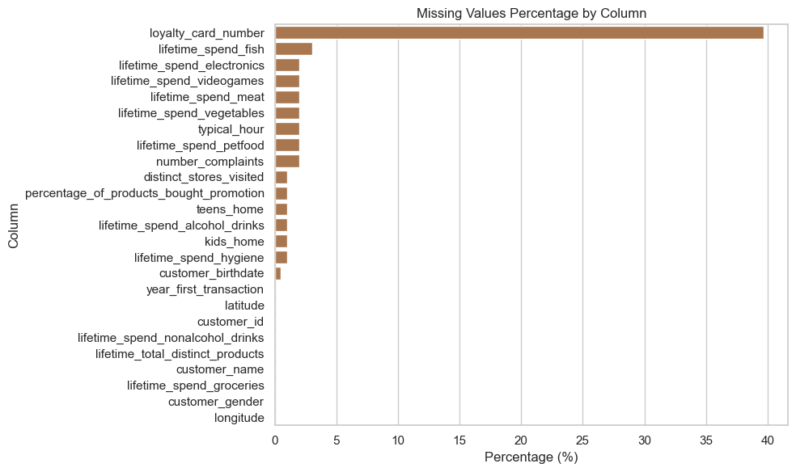
Figure 1 — Percentage of missing values per column in the raw customer_info dataset.
The missing-value barplot (Figure 1) shows a single dominant outlier: loyalty_card_number is missing in roughly 40% of records. Every other column with missing data — lifetime_spend_fish, lifetime_spend_electronics, lifetime_spend_videogames, lifetime_spend_meat, lifetime_spend_vegetables, typical_hour, lifetime_spend_petfood, number_complaints, distinct_stores_visited, percentage_of_products_bought_promotion, teens_home, lifetime_spend_alcohol_drinks, kids_home, lifetime_spend_hygiene and customer_birthdate — sits below roughly 3%. The interpretation drawn is sound: the dataset does not need wholesale row-dropping, because missingness is concentrated and shallow enough to be handled with imputation (later resolved with KNN imputation in Notebook 1), while loyalty_card_number's ~40% gap is treated separately because the variable itself turns out to be closer to an identifier than a behavioural feature (its uniqueness is checked directly, see Section 4).

3.3 Data-entry errors and statistical summary
A targeted integrity check on percentage_of_products_bought_promotion finds values outside the valid [0, 1] range — a textbook data-entry error for a ratio variable, flagged here and fixed later in Notebook 1 (Section 2.3, “Fixing Negative Percentages”). The .describe() table surfaces two more useful observations: loyalty_card_number behaves like a near-constant identifier with no behavioural value for clustering, and several variables — most visibly the spend categories — show heavily right-skewed distributions with a long tail of high-value customers.
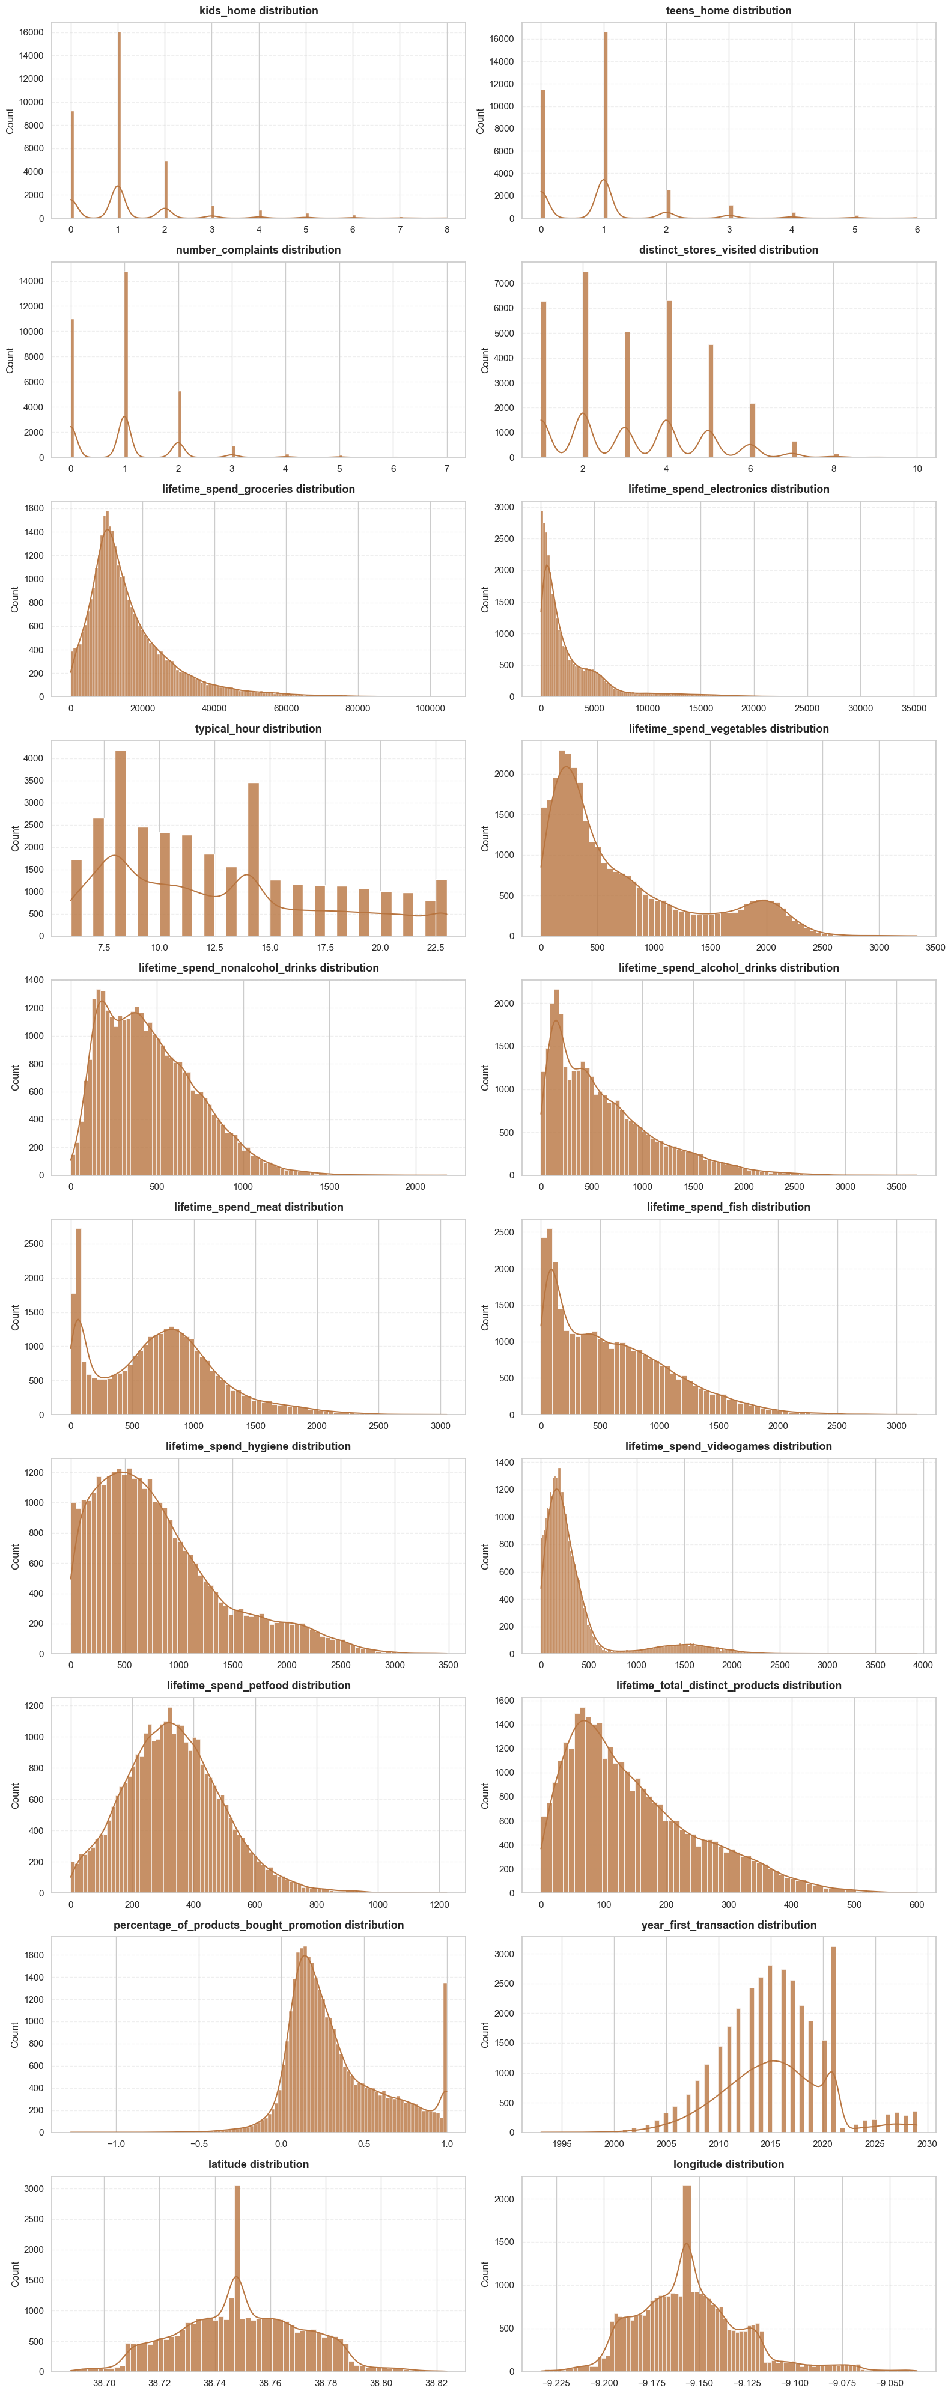
Figure 2 — Distribution of every numerical variable in the raw dataset (histogram grid).
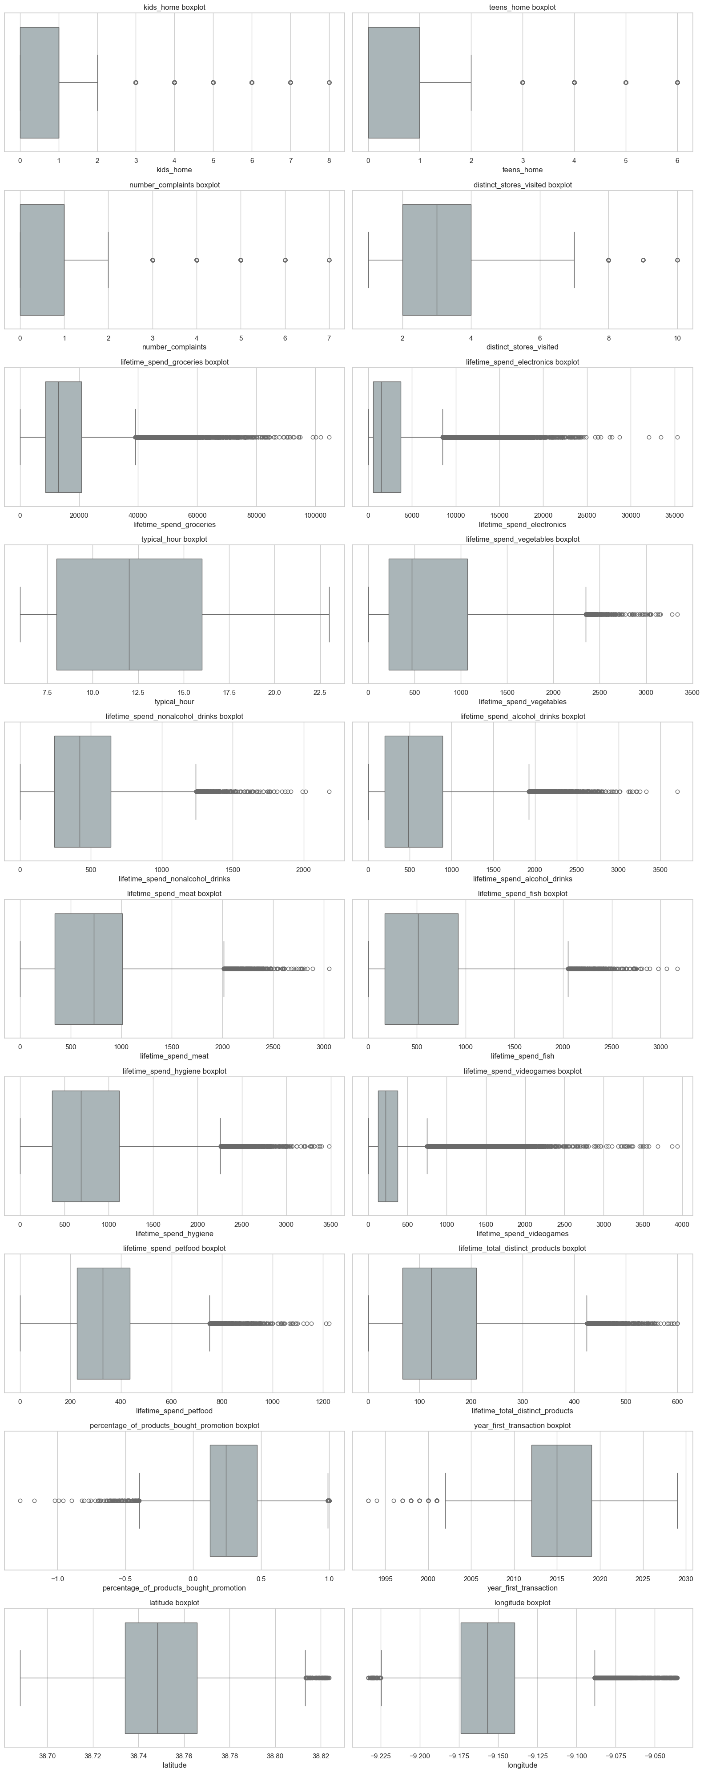
Figure 3 — Boxplots of every numerical variable, used to confirm and quantify the skew and outliers visible in Figure 2.
Figures 2 and 3 are read together. The histogram grid (Figure 2) confirms that nearly every lifetime_spend_* column is right-skewed — a typical retail pattern where most customers spend modestly and a small group spends disproportionately more — while the boxplot grid (Figure 3) makes the resulting outlier tails explicit (note, in particular, the long whiskers and dense clouds of outlier dots on lifetime_spend_groceries, lifetime_spend_electronics, lifetime_spend_vegetables, lifetime_spend_meat and lifetime_spend_videogames). The notebook draws exactly the right conclusion from this pair of charts: this skew motivates two later modelling decisions — separating the most atypical customers before fitting the clustering model (so that a handful of extreme spenders cannot pull the centroids), and treating the choice of scaler as an open modelling question rather than a default (because a scaler that is sensitive to extreme values, like StandardScaler, would behave very differently here than one that compresses the range, like MinMaxScaler, or one that is robust to outliers, like RobustScaler).

3.4 Education proxy in customer_name
A nice piece of lateral thinking: the notebook notices that customer_name frequently carries an academic-degree suffix (BSc., MSc., PhD.) and flags this as a usable proxy for education level — later turned into an ordinal “years of education” feature in Notebook 1 without ever corrupting the original name field. With 33,038 unique names, this gives the segmentation an extra demographic dimension that would otherwise have been unavailable.

3.5 Take-aways carried into preprocessing
The notebook's own conclusion is a clean hand-off: the raw data has missing values, skewed spending variables, identifier columns, date fields that need conversion, and several variables that need type fixes — all of which is exactly what Notebook 1 addresses, in the same order. This kind of explicit “here is what we found, here is what we will do about it” framing is good practice and makes the whole pipeline easy to audit.

4. Data Cleaning and Feature Engineering — Notebook 1
Notebook 1 turns the audit from Notebook 0 into a concrete, reproducible cleaning and feature-engineering pipeline, and exports the datasets that feed the clustering stage. It re-loads the raw file independently (rather than depending on Notebook 0's in-memory state), which is a small but important reproducibility choice.

4.1 Cleaning: years, negatives, types and cyclical time
The cleaning stage walks through, in order: (i) detecting invalid future values in year_first_transaction and customer_birthdate by anchoring everything to the current year via pd.Timestamp.now().year; (ii) scanning every numerical column for impossible negative values with .lt(0).any(); (iii) repairing the negative percentages identified in Notebook 0 (clipping percentage_of_products_bought_promotion back into [0, 1]); and (iv) converting object columns into proper datetime64 and numeric dtypes. The most elegant step here is the cyclical encoding of typical_hour: rather than leaving a 24-hour clock as a plain integer (where 23h and 1h would look “far apart” to a distance-based model even though they are only two hours apart), the notebook maps the hour onto a 2-D sine/cosine coordinate system. This is a textbook-correct treatment of cyclical features and shows real care about what a clustering distance actually measures.
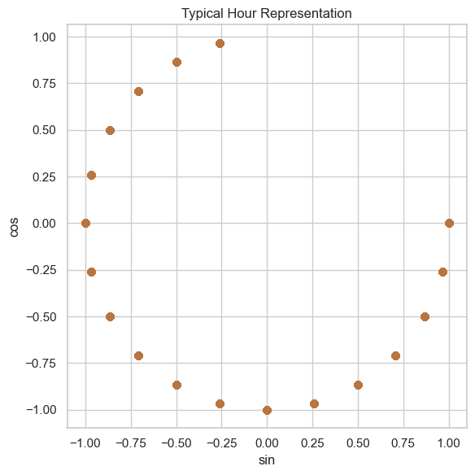
Figure 4 — Scatter plot of the sine/cosine encoding of typical_hour, confirming the 24-hour cycle is mapped onto a closed ring rather than a broken line.

4.2 Missing-value treatment and the loyalty_card_number decision
Missing values are handled with domain-aware logic rather than a single blanket rule (e.g., zero-filling counts that are plausibly “no transactions of this type” versus model-based imputation for genuinely unknown continuous values), and KNN imputation is applied where the missingness looks closer to “unknown” than to “zero”. loyalty_card_number — confirmed in Notebook 0 to be ~40% missing and effectively a near-unique identifier — is converted into a simple binary customer_loyalty_flag, which keeps the useful behavioural signal (does this person have a loyalty card or not?) while discarding the useless identifier-like cardinality.

4.3 Aggregation and demographic feature engineering
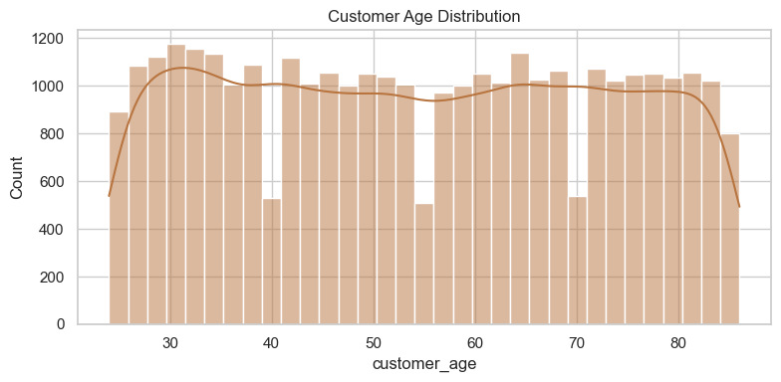
Figure 5 — Distributions of the new household/engagement count features created in this step (e.g., total_children, tenure).
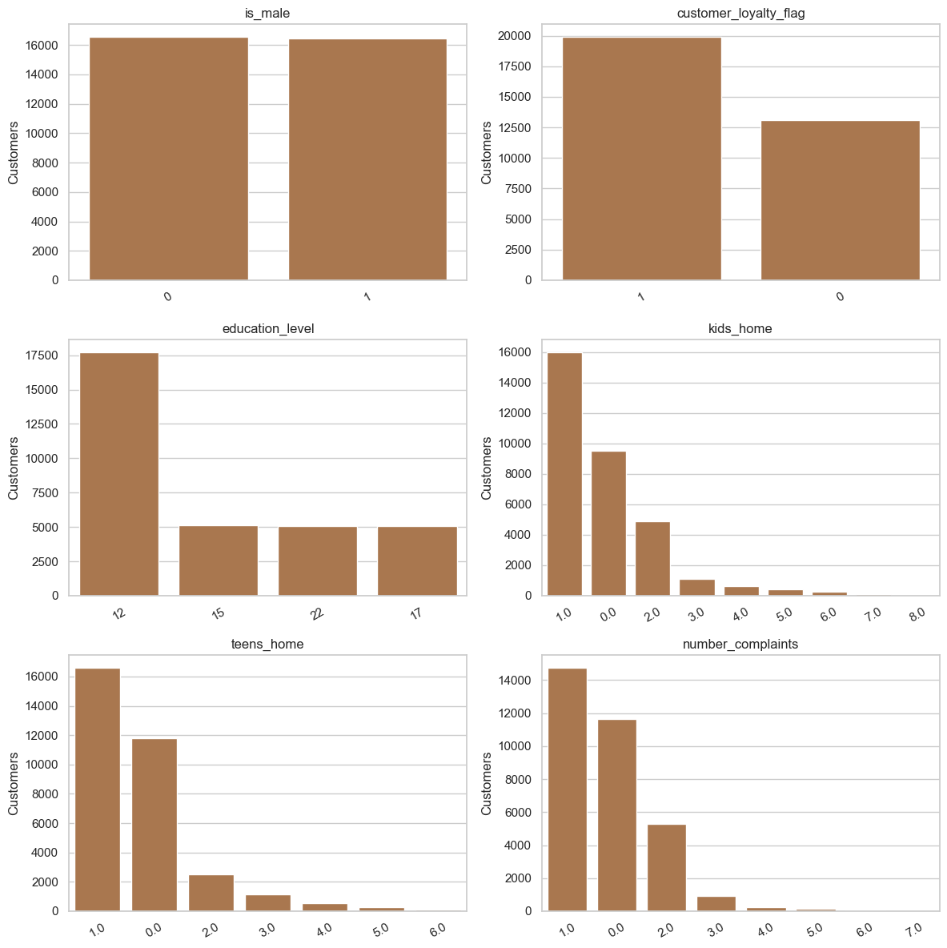
Figure 6 — Distribution of the engineered education-level proxy extracted from customer_name.
This is where the project turns raw columns into modelling-ready variables: customer_age and tenure from the date fields, a binary gender flag, an ordinal education_years proxy parsed safely from customer_name with regex (Figure 6), kids_home and teens_home combined into a single total_children household-size signal, and the customer_loyalty_flag mentioned above. Figure 5 is used as a sanity check that these new features have plausible, well-behaved distributions before they are carried forward — gender stays binary, loyalty is decoupled from the raw card number, and education is an approximate numeric scale rather than a free-text field, all of which keeps the downstream feature space clean and interpretable.

4.4 Outlier separation: a three-method consensus
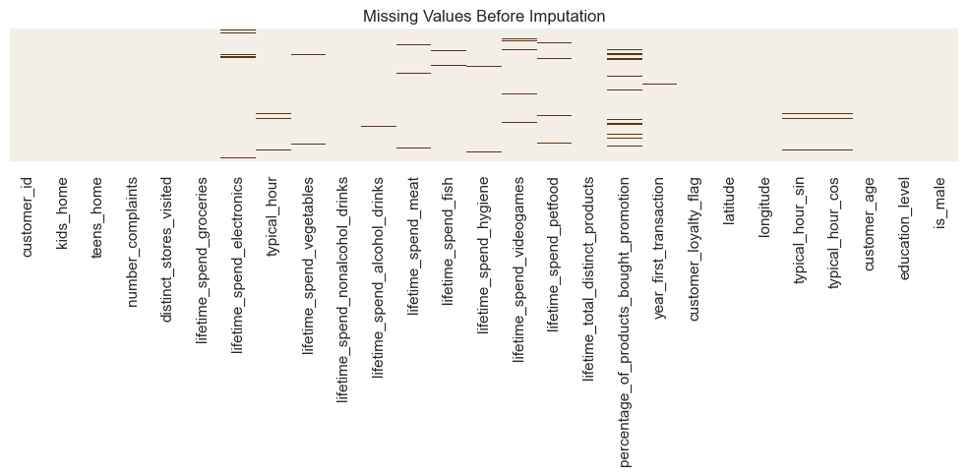
Figure 7 — Number of customers flagged as outliers by each individual detection method (IQR, Z-score/Isolation-style, and a third complementary rule).
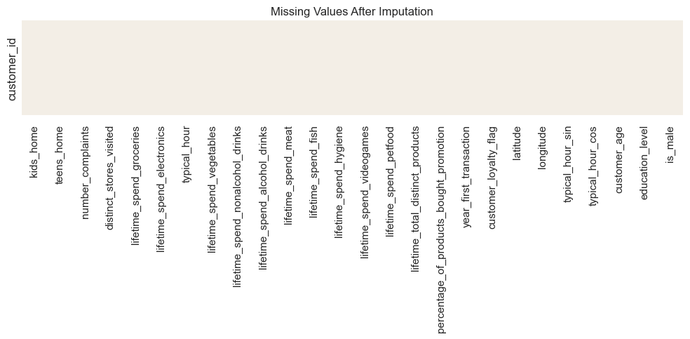
Figure 8 — Overlap between the three outlier-detection methods, showing how many customers were flagged by one, two, or all three methods simultaneously.
This is one of the more thoughtful decisions in the whole project. Rather than picking one outlier rule (say, a simple 1.5×IQR cut) and removing whatever it flags, the notebook runs three independent detection methods and only separates a customer into the outlier subset when all three agree (Figures 7 and 8 show, respectively, how many customers each method flags on its own and how much the three flagged sets overlap). This “consensus” approach is conservative by design — it protects genuinely high-value customers from being discarded just because one heuristic is too aggressive, while still pulling out the small set of truly atypical records (1,023 customers, about 3.1% of the base) whose extreme values would otherwise distort the cluster centroids. The separated subset is exported as outlier_dataset.csv and is not discarded — it is reattached to its nearest centroid after the model is fitted (see Section 6.9), so every customer still ends up with a segment label.

4.5 Spend feature design: absolute vs. annualised vs. log
The notebook explicitly reasons about a subtle measurement problem: two customers who spent the same lifetime amount can have very different behavioural profiles if one has been a customer for two years and the other for ten. It therefore engineers an annualised spend variant alongside the raw lifetime figures, and also prepares log-transformed and share-of-total versions, exporting the absolute, untransformed feature set as the primary clustering input while explicitly deferring the scaling decision to the clustering notebook (“scaling is treated as a modelling choice in the clustering notebook, where different scalers can be compared on the same final feature set”). This is a deliberate, well-justified separation of concerns: preprocessing produces clean, comparable raw ingredients, and modelling experiments with how to combine them.

4.6 Post-cleaning outlier diagnostics and correlation check
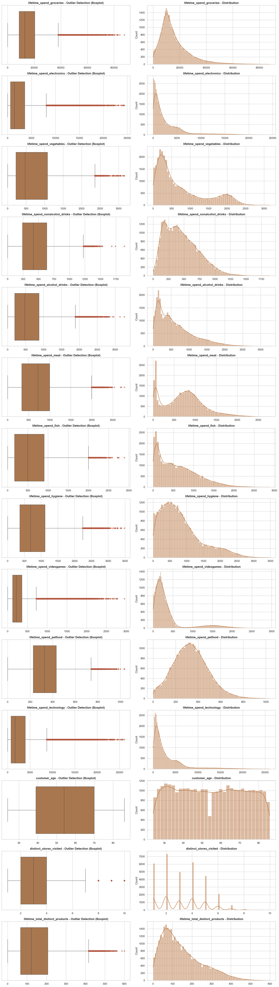
Figure 9 — Boxplots of the main spend variables after cleaning and outlier separation, used as a final visual check of the “regular” customer base.
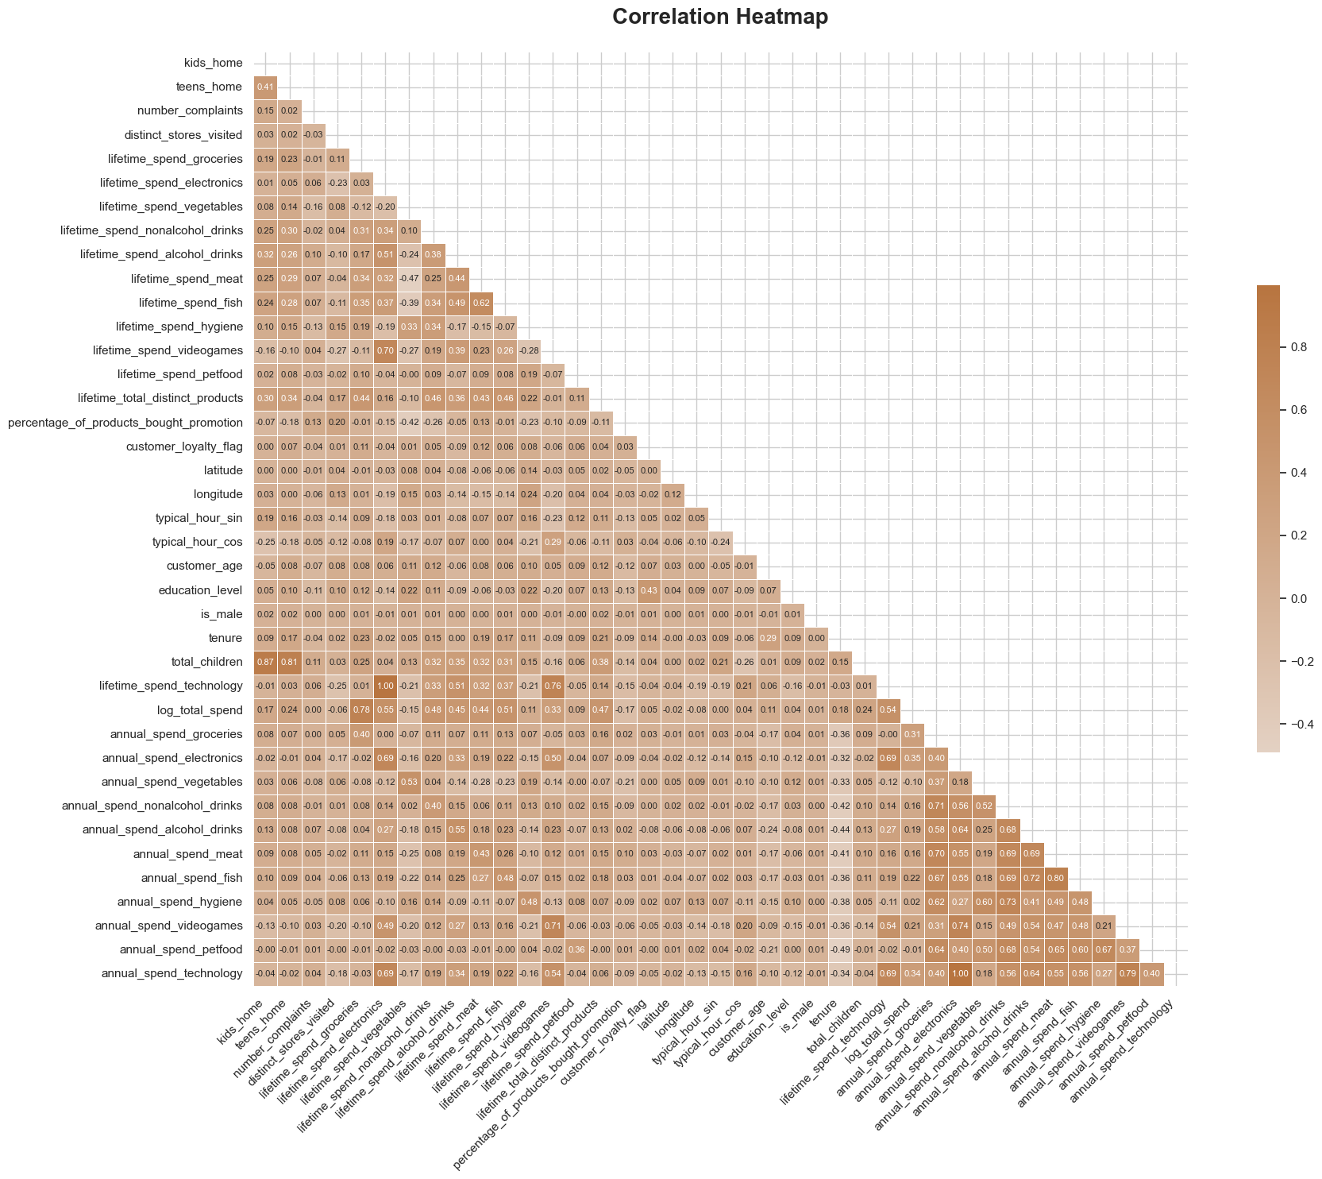
Figure 10 — Correlation heatmap of the engineered numerical features.
Figure 9 shows that some high values remain even after the conservative separation — which the notebook correctly frames as expected, not as a flaw: lifetime spending is naturally skewed, and the goal was never to flatten every univariate extreme, only to keep the small number of truly atypical customers from dominating the distance calculation. Figure 10, the correlation heatmap, is then used to avoid redundant features carrying duplicated weight in the clustering distance — the notebook notes, for instance, that year_first_transaction correlates strongly with the engineered tenure variable, and keeps only one of the pair in the final distance space.

4.7 Final exports: two parallel pipelines
The notebook produces two alternative “clustering-ready” datasets rather than a single one: info_clustering_unscaled.csv (the separation + reattachment strategy described above, which keeps the regular customer base homogeneous for fitting) and info_clustering_capped.csv (an alternative where extreme values are clipped to IQR fences instead of being separated, so that every customer stays in the fitting population). The notebook is explicit about why this comparison belongs here and not in the clustering notebook: IQR fences must be computed on the full population — if they were computed after removing outliers, the fences would be tighter and would behave differently. A short capping-diagnostics table (Section 9.1) reports, per column, how many values were capped and by how much the maximum changed, which is exactly the kind of evidence an evaluator would want to see before trusting either pipeline. Both exports preserve the customer_id index, so the two strategies can be benchmarked apples-to-apples in Notebook 3 (see Section 6.2 of this report).

5. Geographic Exploration — Notebook 2
Notebook 2 is a focused, geography-only exploration of customer_info's latitude/longitude fields, built to answer one question before modelling starts: is there a meaningful spatial structure in the customer base that the segmentation should be aware of (or deliberately exclude)? It produces a static scatter of customer locations, an interactive Mapbox/Plotly view, a Folium map with marker clustering, a log-scaled hexbin density map, and then a focused “hotspot” analysis — it programmatically finds the highest-density grid cell, measures its distance to recognisable landmarks, and statistically compares the customers who live inside that hotspot with those who live outside it on variables such as age, education, household size, promotion usage, total spend, product diversity, store visits, complaints and tenure.
Note for the reader of this report: at the time of inspection, this notebook's cells had not been (re-)executed — its outputs are empty, so no rendered charts could be extracted for inclusion here. This does not affect the final segmentation, because the project deliberately keeps latitude and longitude out of the clustering distance (a decision explained and re-confirmed in Notebook 3, Section 9.4, and in Notebook 4, Section 10): including raw geolocation in a distance-based model risks creating geographic clusters instead of behavioural ones, which would defeat the purpose of the exercise. Geography is therefore reserved purely for profiling — a “does any segment happen to cluster in space?” sanity check performed after the segments already exist. The one practical recommendation here is to re-run Notebook 2 before submission so that its hotspot findings (e.g., whether the dense Lisbon-area cluster differs systematically in age, spend or loyalty from the rest of the base) are visible as evidence in the final report, since the narrative groundwork for an interesting insight is already written — it just needs the cells executed and the resulting charts captured.

6. Customer Segmentation — Clustering Methodology and Model Selection — Notebook 3
This is the central notebook of the project (112 cells, 46 of them code) and the one that will most influence the “Technical quality of the Segmentation” mark. Rather than jumping straight to “KMeans with k = 8”, the notebook builds its case in layers: it first compares the two candidate preprocessing pipelines from Notebook 1, then compares scalers, then searches for k using three independent diagnostics (inertia, silhouette and dendrograms), then validates the chosen solution with three different 2-D projections, then stress-tests the feature set itself (the “petfood” experiment), and finally benchmarks the chosen KMeans solution against four alternative clustering families before committing. The result is a notebook that reads less like “here is the answer” and more like “here is how we know this is the best answer we could find”, which is exactly what a rigorous segmentation exercise should look like.

6.1 Choosing between the “unscaled/separated” and “capped” pipelines
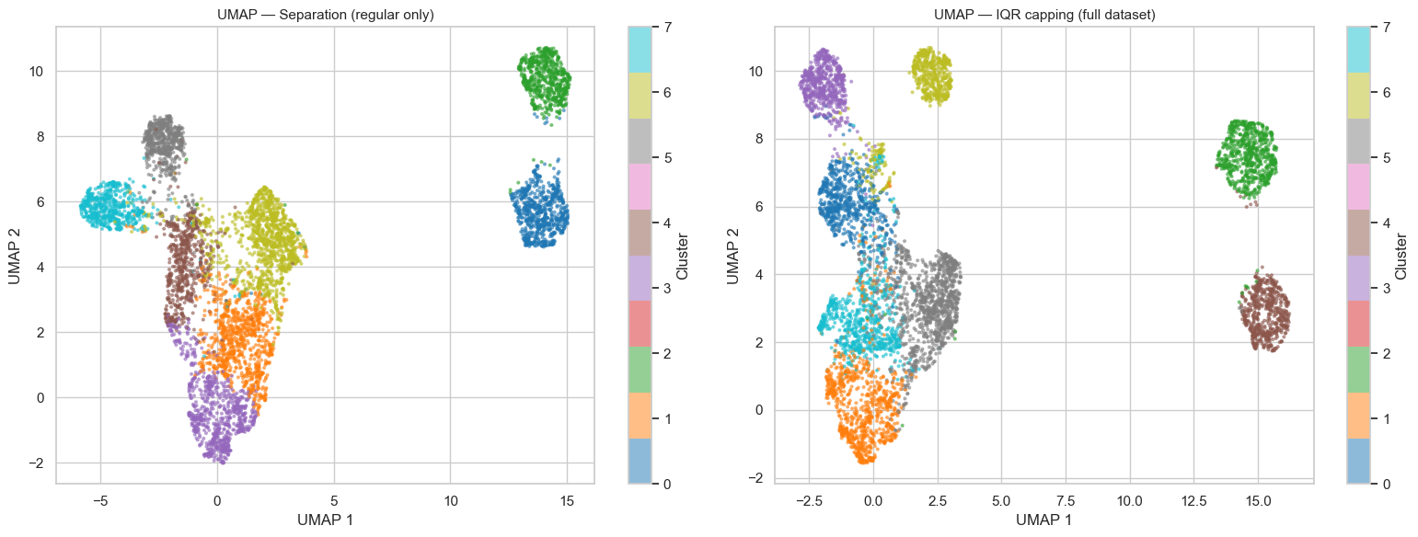
Figure 11 — Side-by-side UMAP projections comparing the “separated outliers” pipeline (info_clustering_unscaled.csv) and the “IQR-capped” pipeline (info_clustering_capped.csv).
The notebook opens its modelling work with a direct visual comparison of the two candidate datasets exported from Notebook 1, projected with UMAP so that any difference in cluster geometry would be visible at a glance (Figure 11). The separated-outliers version produces a noticeably tighter, better-separated structure with a small, clearly distinct island of atypical points, while the capped version smears those same atypical customers back into the main mass, blurring the boundaries between groups. On the strength of this comparison the notebook commits to the separation-and-reattachment strategy (info_clustering_unscaled.csv as the base for fitting, with the 1,023 separated customers reattached after the fact) — a decision that is then carried through the rest of the notebook and is consistent with the “consensus outlier” reasoning documented in Notebook 1.

6.2 Scaler comparison: MinMax vs. Robust across a range of k
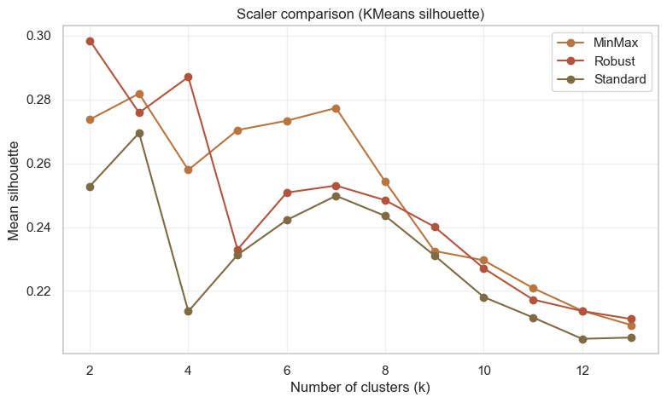
Figure 12 — Average silhouette score as a function of k, computed separately for MinMaxScaler and RobustScaler on the same candidate feature set.
Figure 12 plots silhouette-vs-k curves for the two most defensible scaler choices for this kind of skewed, mixed-magnitude spend data. MinMaxScaler consistently sits above RobustScaler across the whole range of k tested, and both curves show the same qualitative shape — a peak in the low-to-mid k range followed by a gradual decline — which gives confidence that the comparison is picking up a real structural property of the data rather than scaler-specific noise. MinMaxScaler is selected for the final pipeline on this evidence. This is a more defensible choice than it might look at first glance: because the extreme spenders have already been separated out (Section 6.1), MinMax's well-known sensitivity to outliers is far less of a liability here, and its [0, 1] compression keeps every spend category contributing comparable weight to the Euclidean distance that KMeans relies on.

6.3 Searching for k — inertia (elbow)
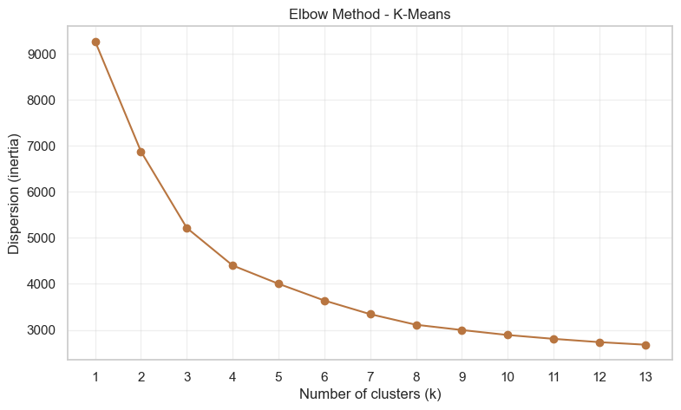
Figure 13 — Inertia (within-cluster sum of squares) versus k, the classic “elbow” diagnostic.
Figure 13 shows the familiar smoothly-decreasing elbow curve. As is almost always the case with real, continuously-distributed retail data, the elbow itself is gentle rather than sharp — there is no single k that screams “use me”, but the rate of improvement clearly slows somewhere in the high-single-digit range. The notebook reads this curve for what it actually offers: a plausible window for k (rather than a single answer), to be cross-checked against the sharper diagnostics that follow. This is the right way to use the elbow method — as one vote among several, not as the deciding vote.

6.4 Searching for k — hierarchical dendrograms
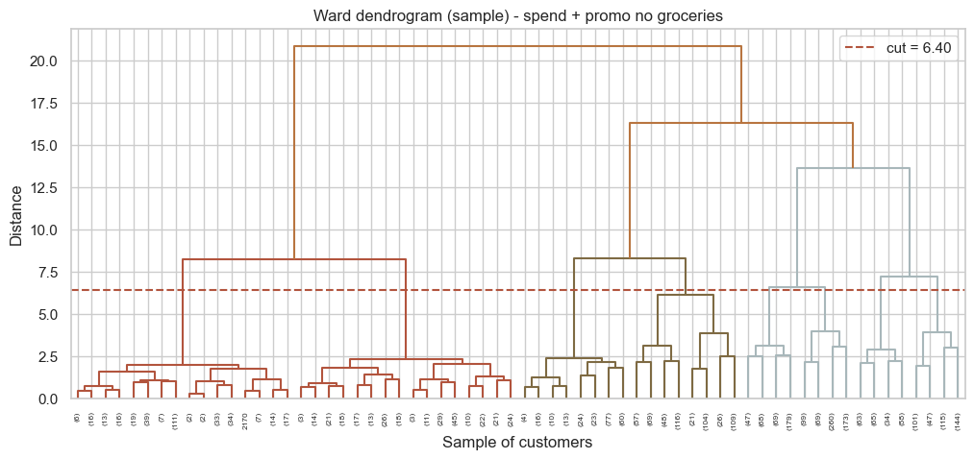
Figure 14 — Ward-linkage dendrogram computed on a representative sample of the customer base.
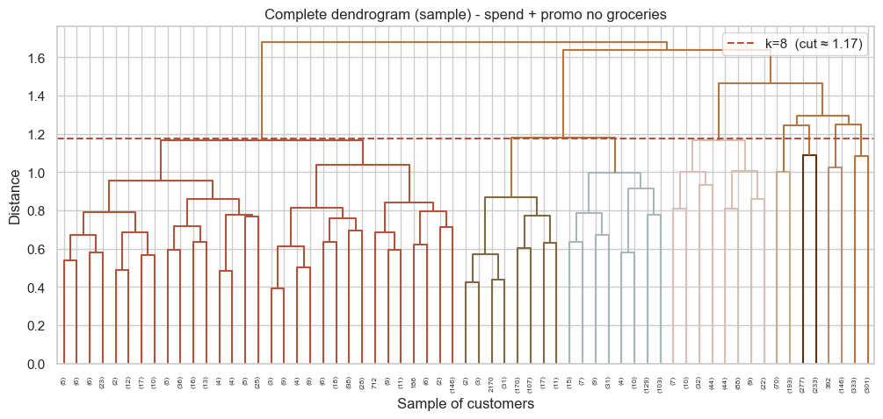
Figure 15a — Complete-linkage dendrogram (sampled).
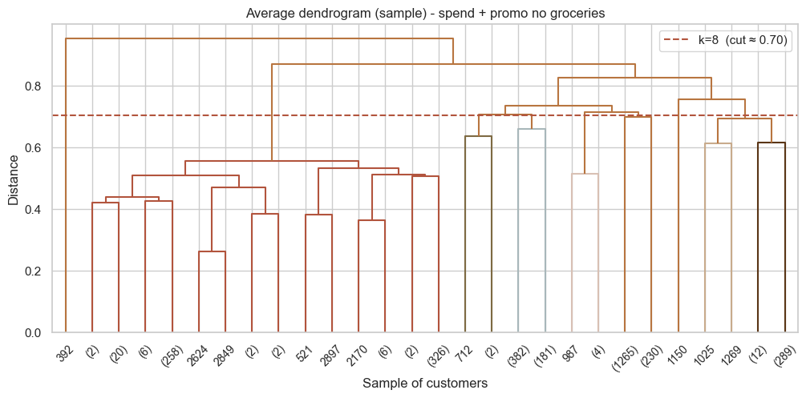
Figure 15b — Average-linkage dendrogram (sampled).
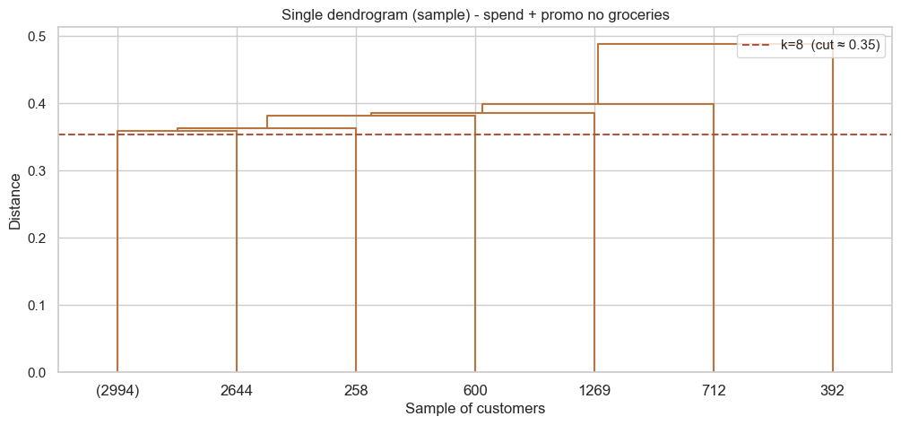
Figure 15c — Single-linkage dendrogram (sampled).
Figures 14 and 15a–c bring a second, geometry-based perspective to the same question, this time using four different linkage criteria on a representative sample (full-population dendrograms would be computationally impractical and visually unreadable at 32,000+ leaves). The Ward dendrogram (Figure 14) — generally the most informative for roughly spherical, similarly-sized clusters, which is the kind of structure a MinMax-scaled KMeans solution will tend to produce — shows a small number of well-separated high-level merges, consistent with a moderate number of natural groups rather than two or three large ones. The complete- and average-linkage trees (Figures 15a–b) tell a broadly similar story with somewhat different merge heights, while the single-linkage tree (Figure 15c) displays the classic “chaining” effect (long, staircase-like merges) that single linkage is known to produce on data without hard density gaps — a useful negative result, because it confirms that the customer base does not separate into a small number of extremely tight, isolated balls, but into softer, partially-overlapping behavioural groups. Taken together, the four dendrograms triangulate toward the same rough number of natural groupings that the silhouette analysis below will pin down more precisely.

6.5 Deciding how to treat k, and the silhouette search
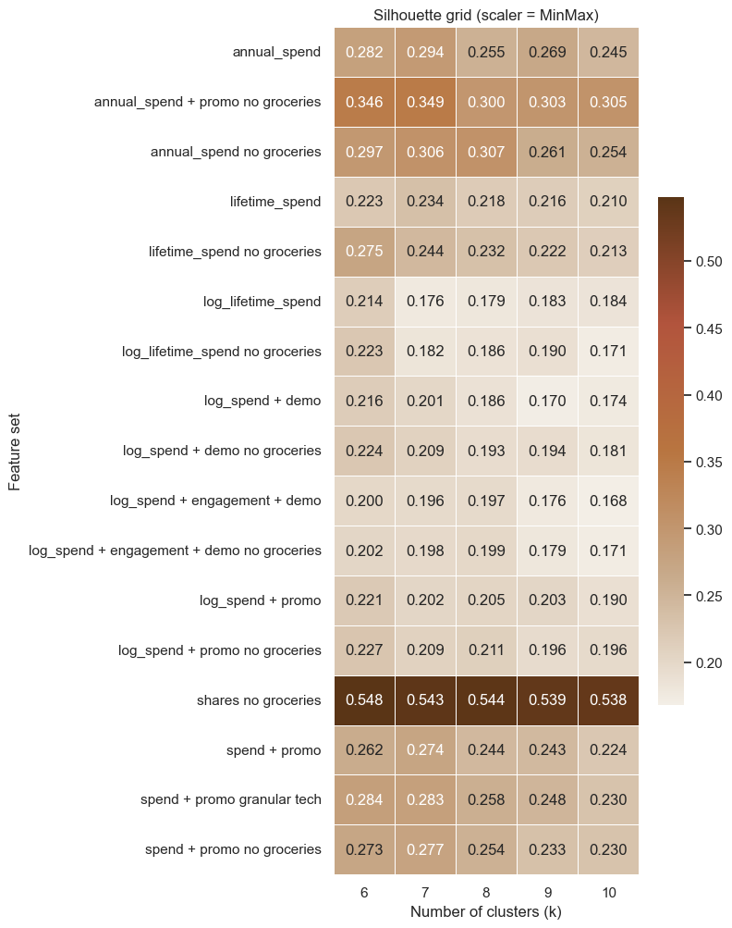
Figure 16 — Note/diagram explaining how the notebook treats the choice of k (the search range and the criteria used to compare candidates).
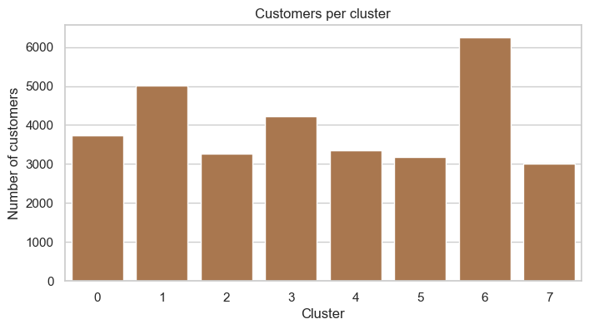
Figure 17 — Grid of validation panels (silhouette plots and/or score curves) produced while fitting and comparing candidate values of k.
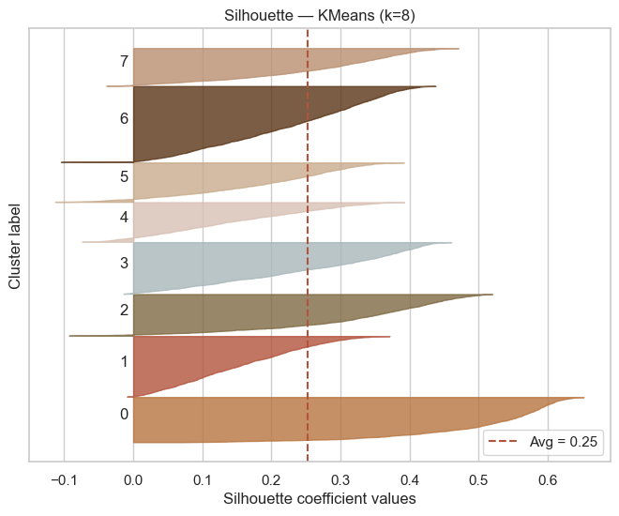
Figure 18 — Annotated guide to reading the silhouette validation panels (what a “good” cluster's silhouette profile looks like vs. a “weak” one).
This trio of figures documents the most important single decision in the notebook — the choice of k = 8 — and does so transparently. Figure 16 sets out the search philosophy: rather than mechanically picking the k with the single highest silhouette (which on real data is frequently a small, almost trivial split), the notebook searches a sensible range and weighs average silhouette against interpretability and balance of segment sizes. Figure 17 is the evidentiary core — a grid of per-k validation panels in which each cluster's silhouette profile is drawn as a horizontal “blade”: wide, long blades that extend close to (or beyond) the average-silhouette line indicate cohesive, well-separated clusters, while short or negative-going blades indicate weak or overlapping ones. Figure 18 is, in effect, a worked example that teaches the reader how to read Figure 17 — explicitly calling out the width (cluster size), length (how strongly its members belong), and any negative-valued slivers (members that are probably mis-clustered) as the three things to look for. Reading the grid this way, k = 8 stands out as the largest value of k at which every blade still reaches reasonably close to the mean line with no large negative regions — in other words, the most granular split the data supports without creating clusters that are mostly noise. This reasoning — “most granular split that is still defensible” rather than “highest score regardless of size” — is a mature way to choose k for a business segmentation, where eight distinguishable, addressable groups are also simply more useful to a marketing team than three or four very broad ones.
The final configuration that emerges from this search is: KMeans, k = 8, MinMaxScaler, fitted on a nine-column feature set covering the customer's spend categories and promotion usage with groceries deliberately excluded (the “spend + promo, no groceries” set — see Section 6.6 for why groceries was dropped), trained on the 32,015 “regular” customers that remained after the 1,023 consensus outliers were separated out. This configuration achieves an average silhouette of 0.2516 — a moderate-but-respectable score for behavioural segmentation of real retail data (perfect separation is essentially never observed in this kind of human-behaviour clustering; scores in the 0.2–0.3 range are typical of usable, business-meaningful segmentations on noisy real-world features).

6.6 Validating the chosen solution: PCA, UMAP and t-SNE projections
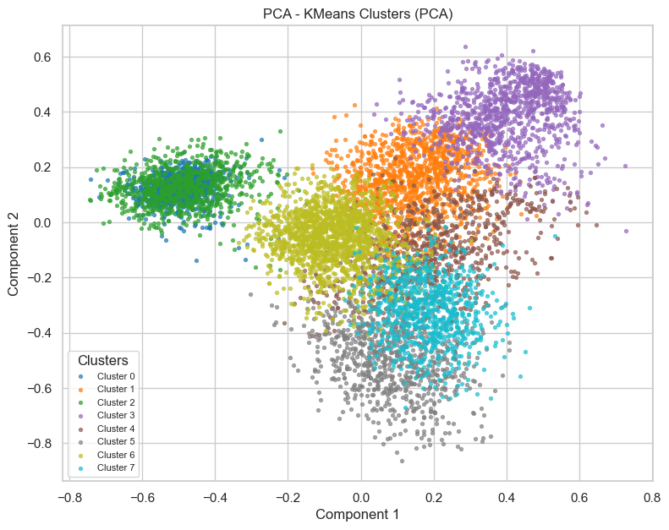
Figure 19 — PCA projection of the final 8-cluster solution onto its first two principal components.
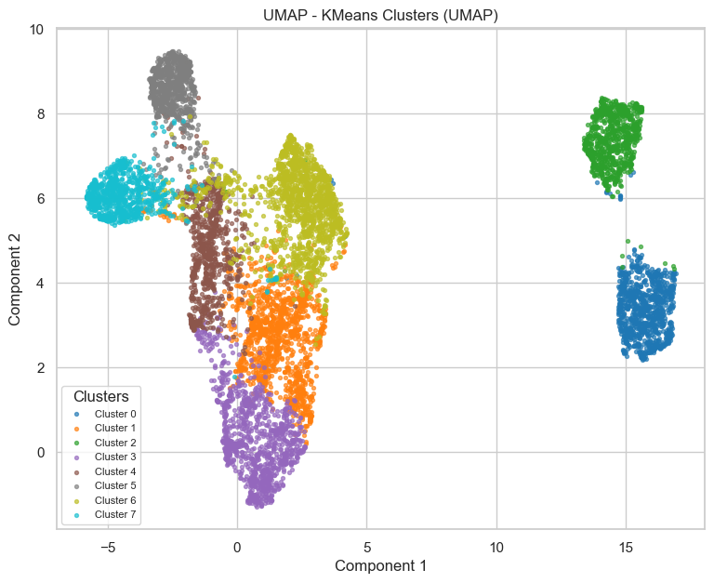
Figure 20 — UMAP projection of the same solution.
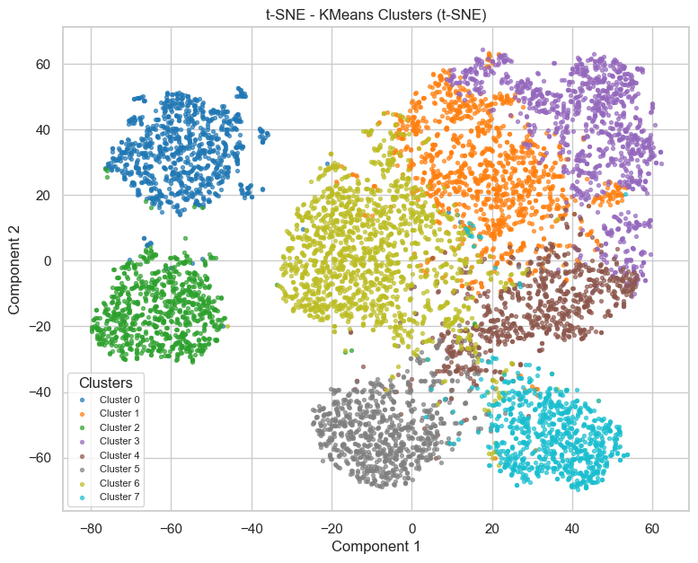
Figure 21 — t-SNE projection of the same solution.
Rather than trusting a single 2-D view (each projection technique can flatter or distort cluster geometry in its own way — PCA is linear and can compress non-linear structure, UMAP and t-SNE can each invent apparent separation that is not present in the original space), the notebook checks the same labelled solution through three different lenses. PCA (Figure 19), being a linear projection, shows partially overlapping clouds — which is expected and not a red flag, since the underlying feature space is nine-dimensional and a 2-D linear summary will necessarily compress some of that structure. UMAP (Figure 20) shows visibly tighter, more separated groupings, consistent with the silhouette evidence that the clusters are real but soft-edged rather than razor sharp. t-SNE (Figure 21) corroborates the UMAP picture with its own characteristic “island” layout. The fact that all three techniques — one linear, two non-linear, with very different distortion biases — agree on the same broad grouping structure is meaningful corroborating evidence that the eight clusters reflect a genuine pattern in the data rather than an artefact of any single projection method.

6.7 Stress-testing the feature set: the “petfood” experiment
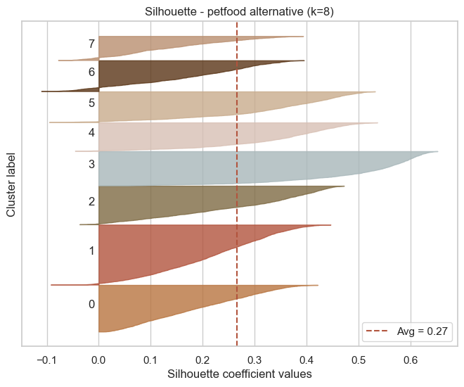
Figure 22 — Validation plots for the alternative feature set that includes lifetime_spend_petfood.
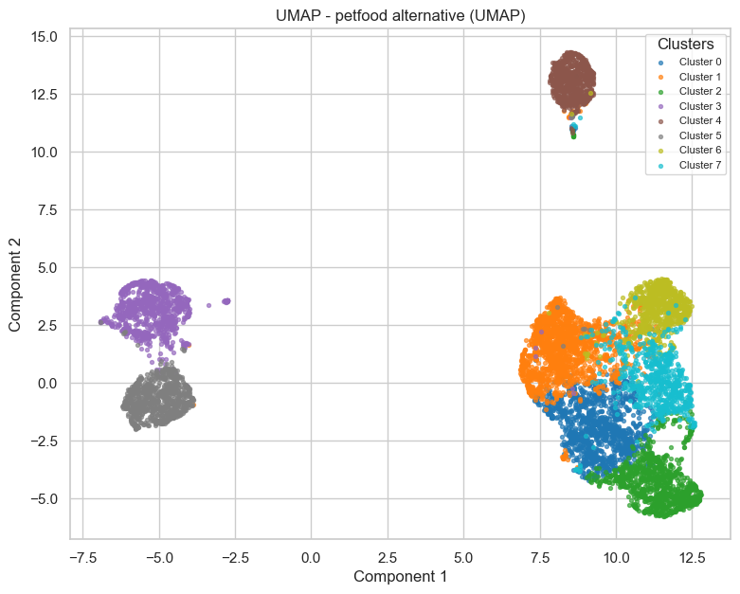
Figure 23 — Continuation of the petfood-variant validation (additional projection / silhouette view).
This is one of the most intellectually honest moments in the notebook. The team tries an alternative nine-feature set that swaps in lifetime_spend_petfood, and finds that it actually produces a slightly higher average silhouette (0.2653 vs. 0.2516) and a visibly cleaner, easy-to-name “pet owners” segment (Figures 22–23). A weaker analysis would simply have taken the higher number and moved on. Instead, the notebook weighs the trade-off explicitly: the petfood variant buys roughly 0.014 of silhouette at the cost of a feature that only a minority of the customer base ever purchases (most customers spend nothing on pet food, so the variable is highly zero-inflated and risks becoming a near-binary “owns a pet, yes/no” split that dominates the geometry rather than describing general spending behaviour). The team ultimately keeps the original “spend + promo, no groceries” set for the headline model, on the grounds that it produces more broadly interpretable, more evenly-populated segments — and keeps the petfood variant on record as a documented, defensible alternative rather than discarding the evidence. This kind of side-by-side, pros-and-cons comparison of two genuinely competitive options is exactly the sort of judgment call an evaluator wants to see argued, not hidden.

6.8 Why groceries was excluded from the feature set
A short but important methodological note threaded through this part of the notebook: lifetime_spend_groceries is deliberately left out of the final feature set. Groceries are close to a universal purchase — almost every customer buys them, in large and fairly similar volumes — so including this variable tends to dominate the Euclidean distance with a “how much food does this household need” signal that drowns out the more discriminating, segment-defining categories (alcohol, electronics, video games, fish, hygiene, and so on). Removing it lets the more behaviourally distinctive categories drive the clustering geometry, which is precisely what produces segments that are easy to *name* (Vegetarians, Techies, Wellness, …) rather than segments that mostly just track household size.

6.9 Independent benchmark: comparing KMeans against four alternative methods
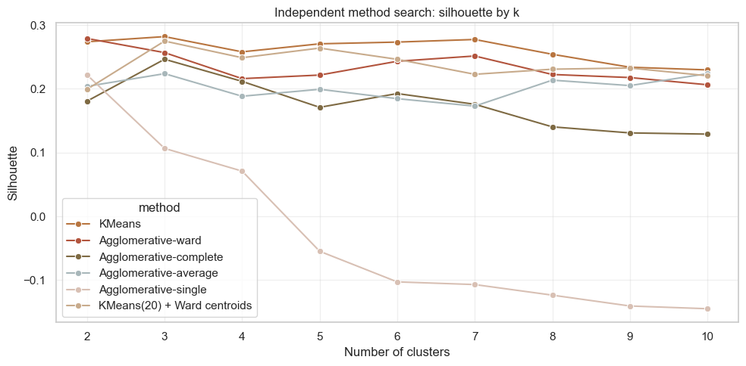
Figure 24 — Overview / setup of the independent method-comparison search (KMeans vs. hierarchical, DBSCAN, SOM and a two-stage benchmark).
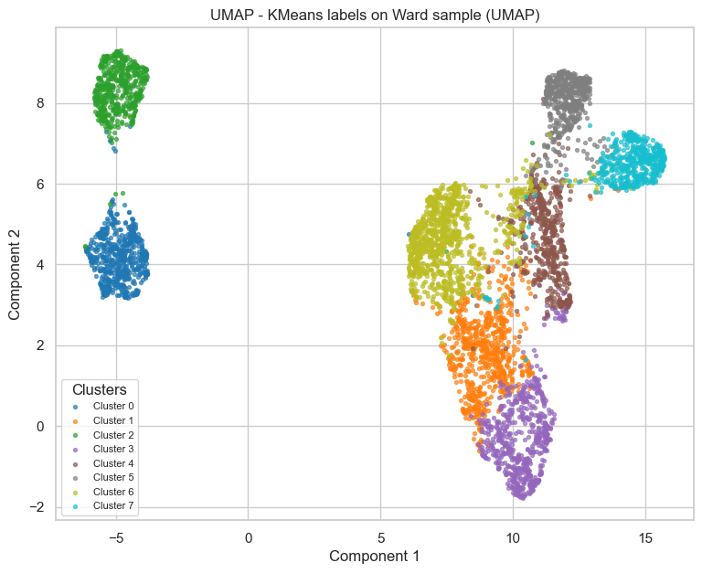
Figure 25a — UMAP comparison of the KMeans solution against a Ward-hierarchical solution computed on the same representative sample.
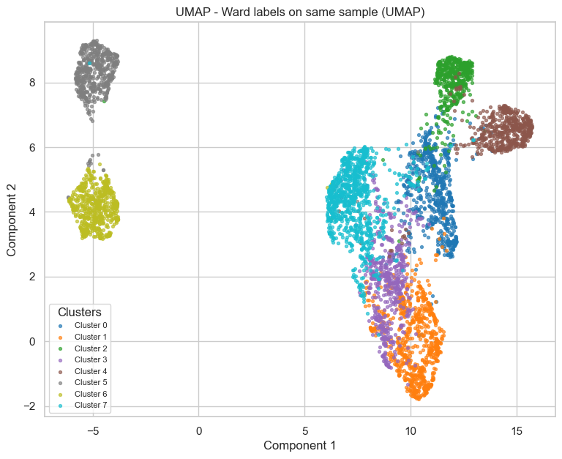
Figure 25b — Continuation of the KMeans-vs-Ward UMAP comparison (additional view / metrics).
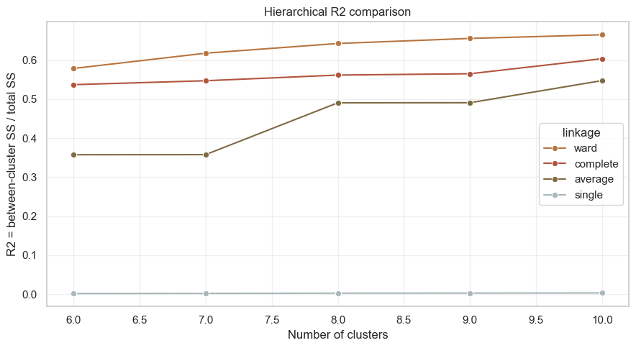
Figure 26 — R² (between-cluster variance explained) comparison across hierarchical-linkage variants and the KMeans solution.
Having committed to a configuration, the notebook then does something many student projects skip entirely: it goes looking for evidence that a *different* algorithm family might have done better. Figure 24 frames this as an “independent method search” — an attempt to validate KMeans's choice not just by tuning its own hyper-parameters, but by setting it against fundamentally different clustering paradigms on the same data. Figures 25a–b project a Ward-hierarchical solution (fitted on the same representative sample used for the dendrograms) into the same UMAP space as the KMeans labels, side by side — visually, the two partitions carve the data into broadly similar regions, which is reassuring corroboration that the KMeans geometry is not an artefact of the algorithm's well-known preference for round, similarly-sized clusters. Figure 26 then quantifies this with an R²-style between-cluster variance metric across the different hierarchical linkage criteria and the KMeans solution: KMeans comes out at or near the top of this comparison, giving a second, independent line of evidence (beyond the silhouette search) that k = 8 with this feature space is a strong choice and not merely a local optimum of one particular algorithm.

6.10 Diagnosing and explaining the small clusters
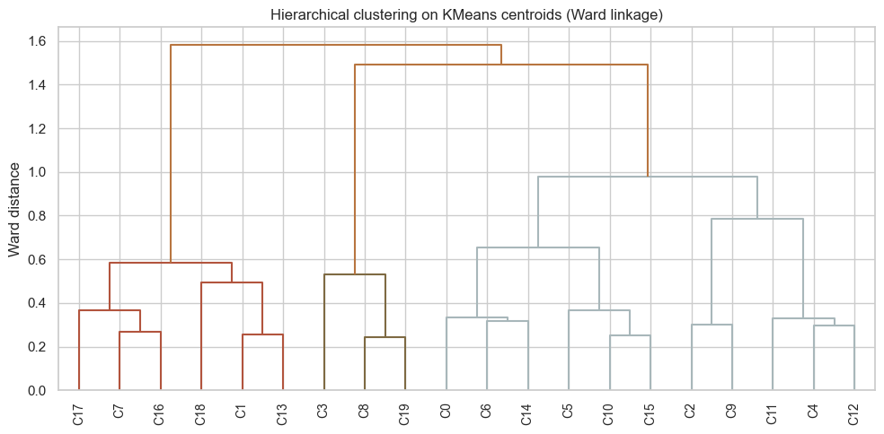
Figure 27a — Diagnostic view of the smaller clusters in the KMeans solution (size / composition).
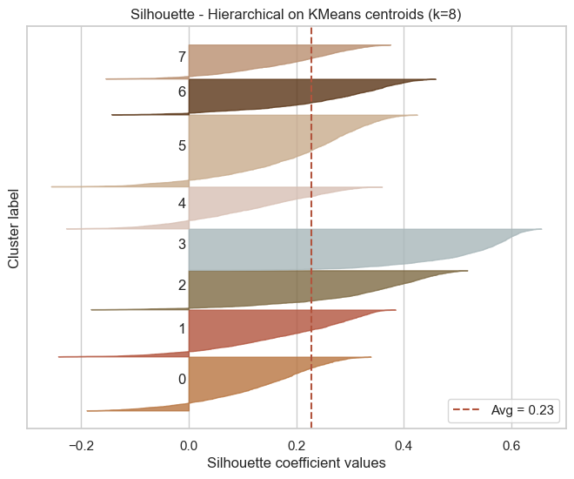
Figure 27b — Continuation: feature profile of the small clusters.
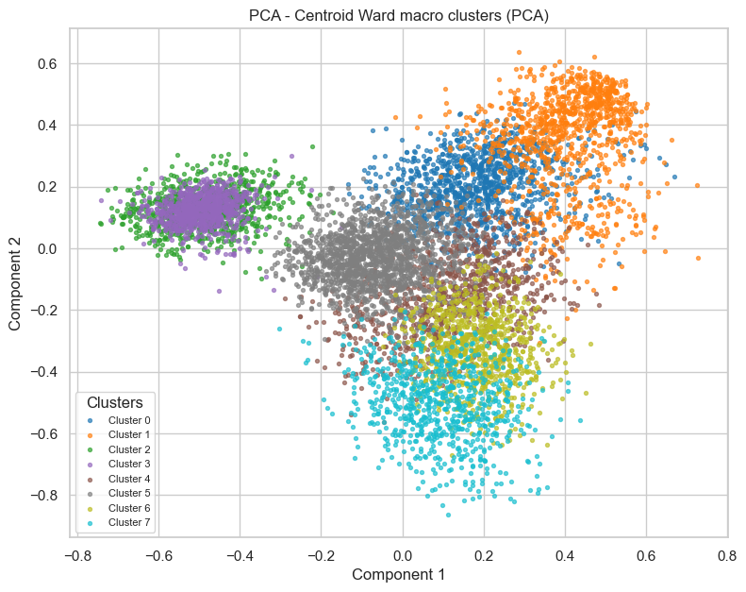
Figure 27c — Continuation: projection / separation view of the small clusters.
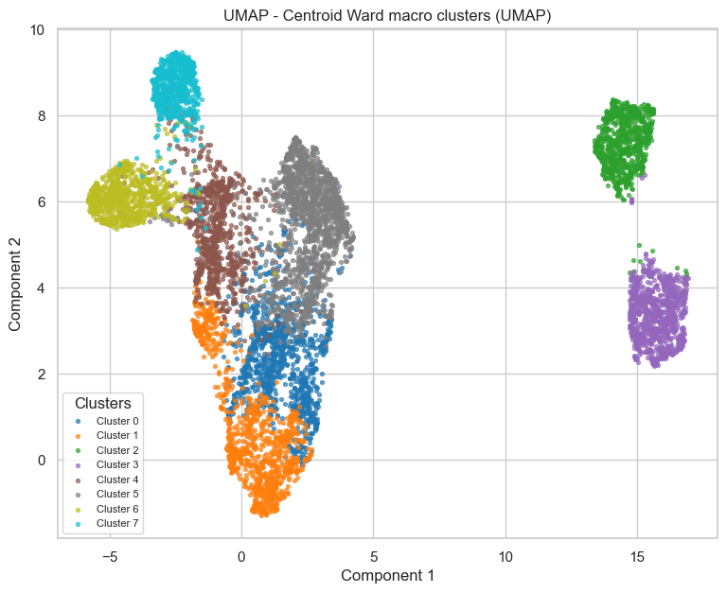
Figure 27d — Continuation: further diagnostic detail on the small clusters.
This four-panel sequence (titled “20 KMeans small clusters” in the notebook, referring to an exploratory higher-k run used purely as a diagnostic) digs into why some candidate solutions produce clusters that are small and hard to interpret, and what distinguishes a “small but meaningful” segment from a “small and probably noise” one. The notebook uses this diagnostic to build confidence that the eight segments retained in the final solution are not accidentally including a fragment of this kind — each of the eight final segments is large enough (the smallest holds roughly 9–10% of the customer base — see Section 7.1) and coherent enough on its defining features to be a credible, addressable marketing audience, rather than a statistical sliver that happens to fall out of a particular random initialisation.

6.11 Self-Organising Maps (SOM) as a fourth comparison method
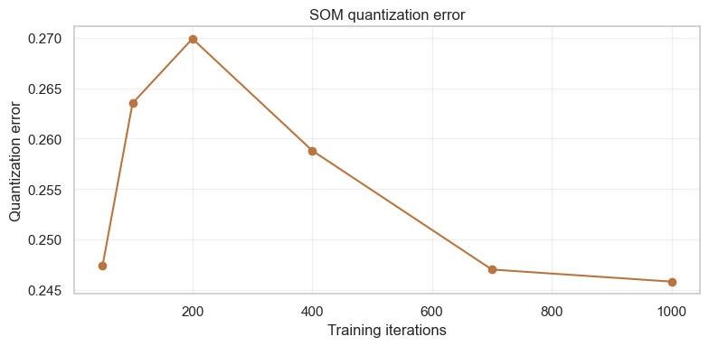
Figure 28a — SOM component/feature planes (one map per input feature, showing how each variable is distributed across the trained map).
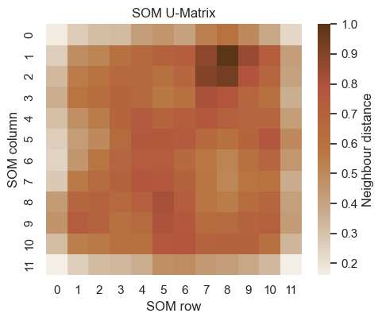
Figure 28b — Continuation of the SOM feature-plane analysis.
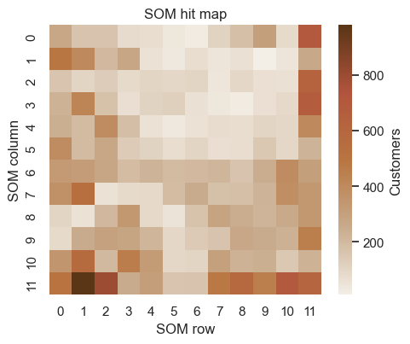
Figure 29a — SOM unit map coloured by the resulting cluster assignment / U-matrix view.
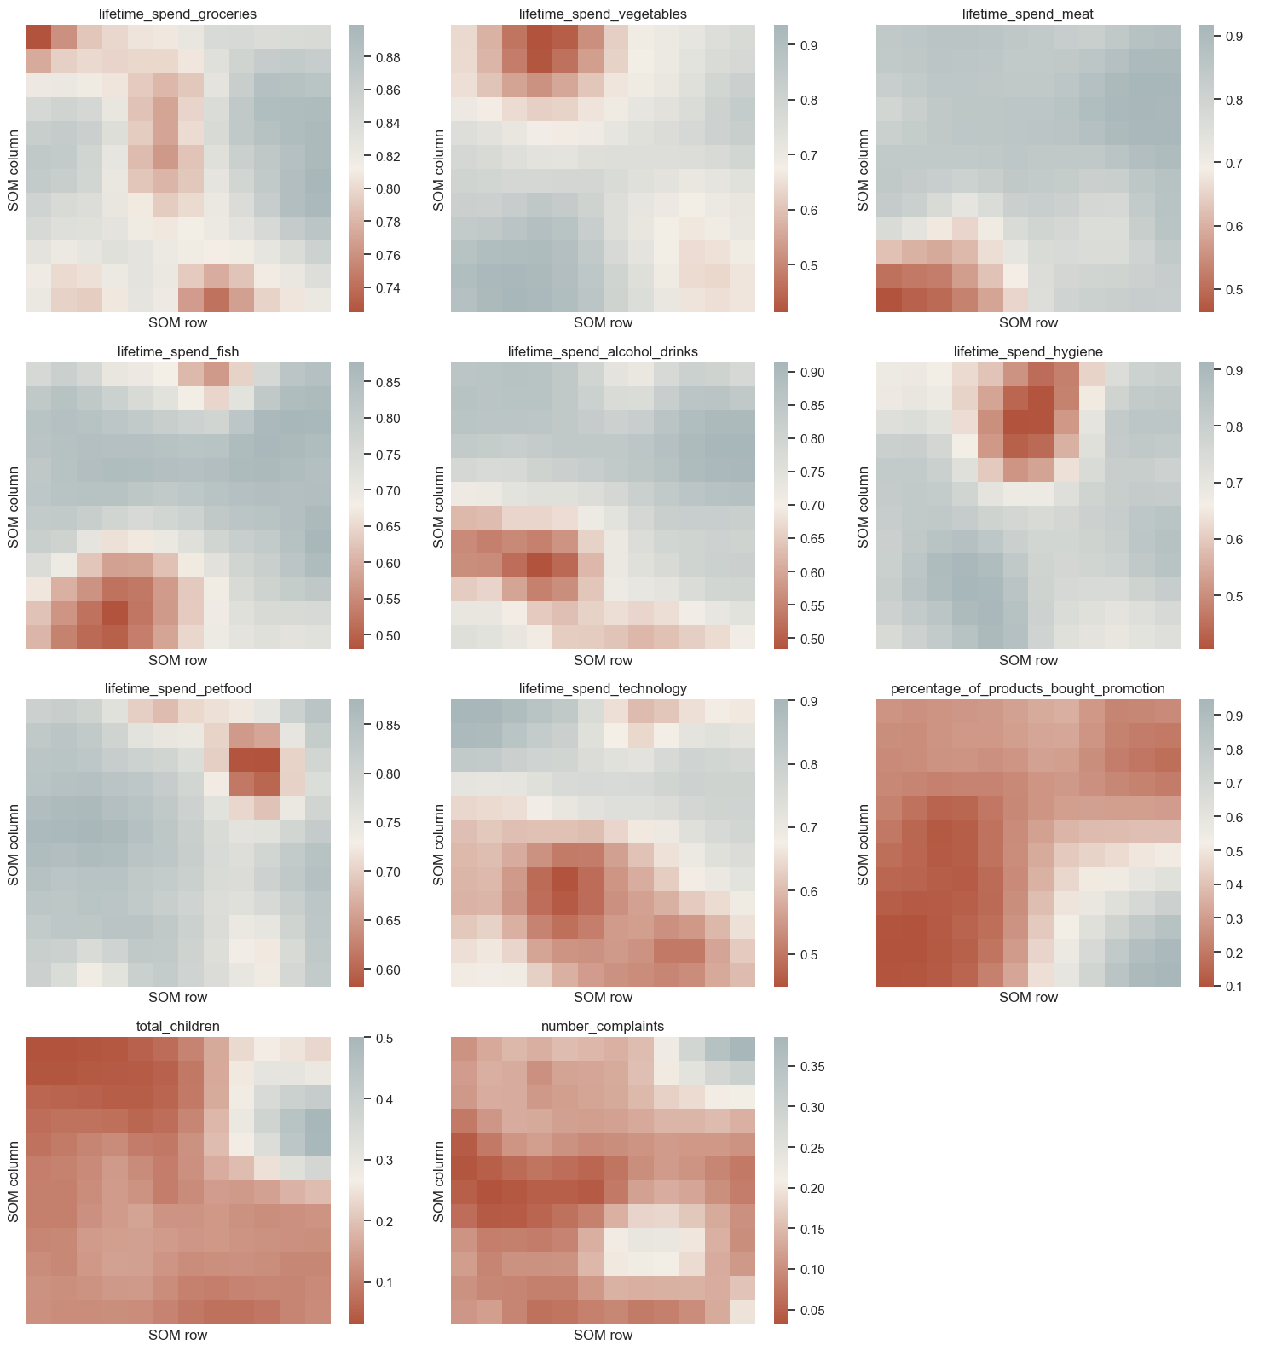
Figure 29b — Continuation: SOM cluster-assignment / density view.
Self-Organising Maps add a fourth, topologically-flavoured perspective: instead of partitioning the data directly, a SOM first arranges customers onto a 2-D grid such that nearby grid cells contain similar customers, and then each input feature can be visualised as its own “heat map” over that grid (Figures 28a–b). Reading these feature planes side by side is a powerful sanity check — wherever, say, the alcohol-spend plane lights up in the same region as the promotion-usage plane, that is direct visual evidence that those two behaviours travel together in the customer base, which is exactly the kind of co-occurrence a good segment should be built around. Figures 29a–b then show the SOM's own cluster structure (its U-matrix / unit-cluster view), which the notebook compares back to the KMeans partition. The SOM broadly confirms the same regions of behavioural similarity that KMeans found, adding yet another independent vote in favour of the chosen segmentation — at this point the notebook has now corroborated its solution with hierarchical clustering, an R²-based quantitative benchmark, and a topology-preserving neural method, in addition to the original silhouette/elbow/dendrogram trio used to pick k.

6.12 From cluster labels to business meaning
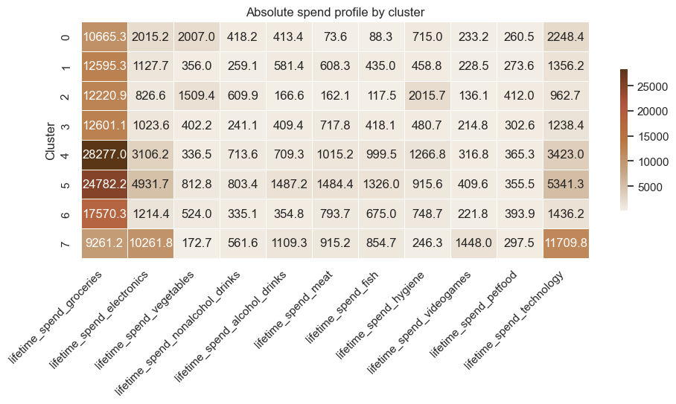
Figure 30 — First pass at translating the eight numerical cluster labels into descriptive, business-facing groupings (the bridge into Notebook 4's naming work).
Figure 30 marks the hand-off point between “we have eight statistically defensible groups” and “we can talk about these groups as people”. The notebook starts sketching, for each cluster id, the handful of features that most distinguish it from the population average — the same kind of deviation analysis that Notebook 4 will later formalise into full names, narratives and campaign-relevant profiles (see Section 7).

6.13 Final checks before sign-off: petfood signal, segment separation and geography
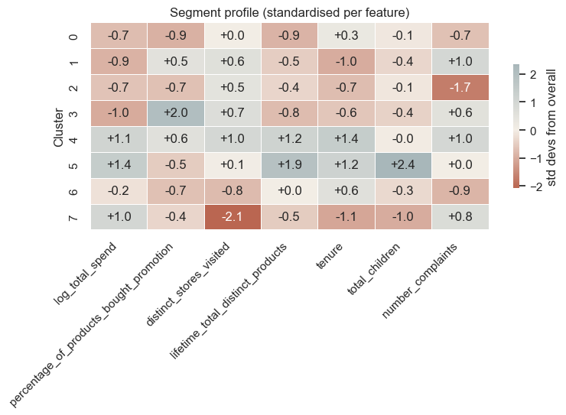
Figure 31 — Check for a residual “petfood” signal inside the chosen (non-petfood) solution — does any of the eight segments still behave like pet owners on average?
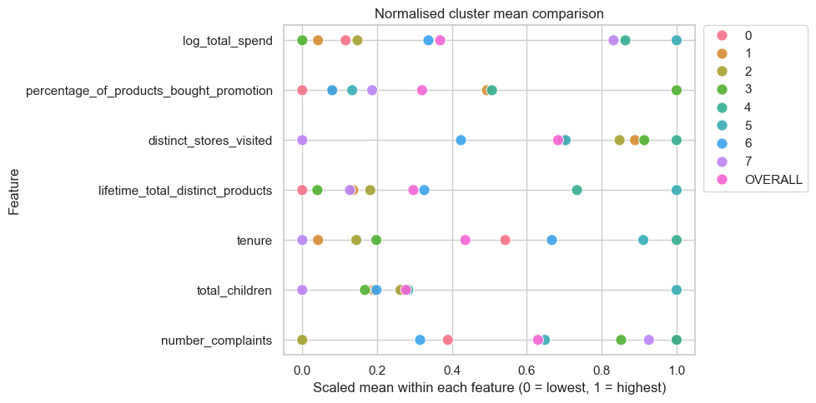
Figure 32a — Pairwise separation plots between segments on the most discriminating spend variables.
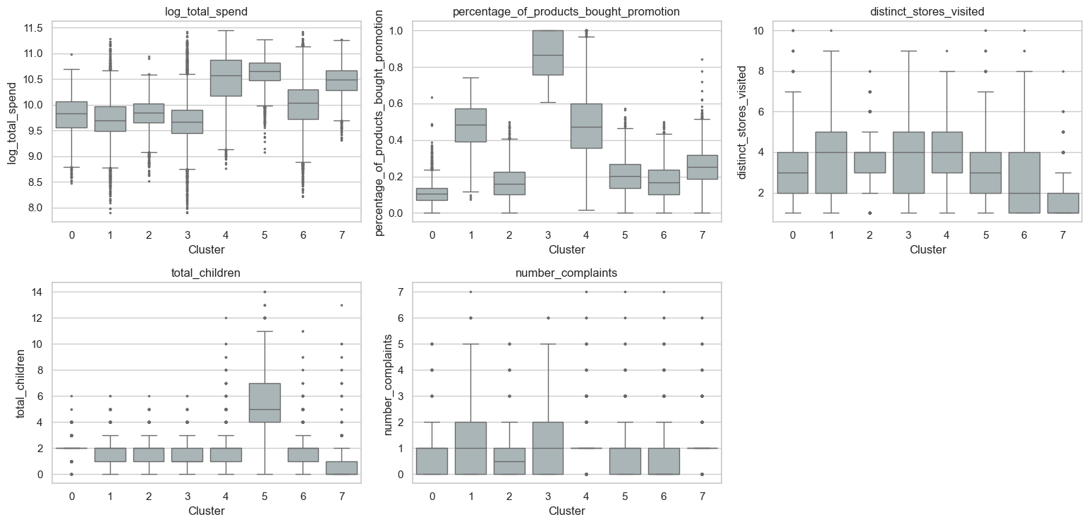
Figure 32b — Continuation: further pairwise / multi-feature separation views.
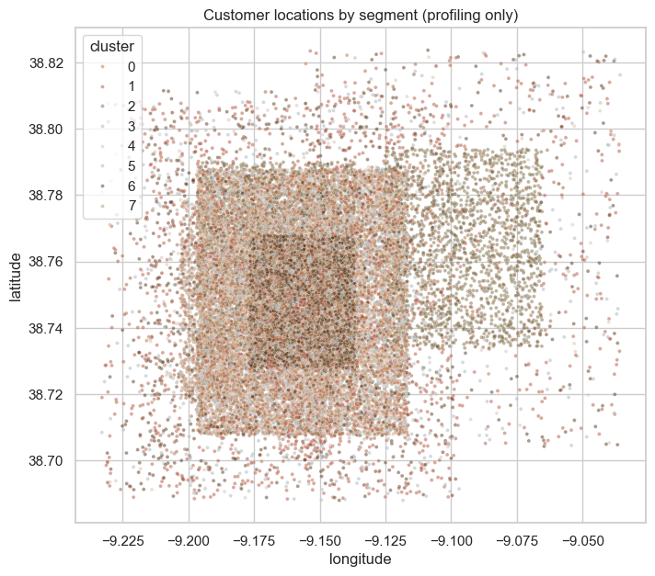
Figure 33a — Geographic distribution of the eight segments (does any segment cluster spatially?).
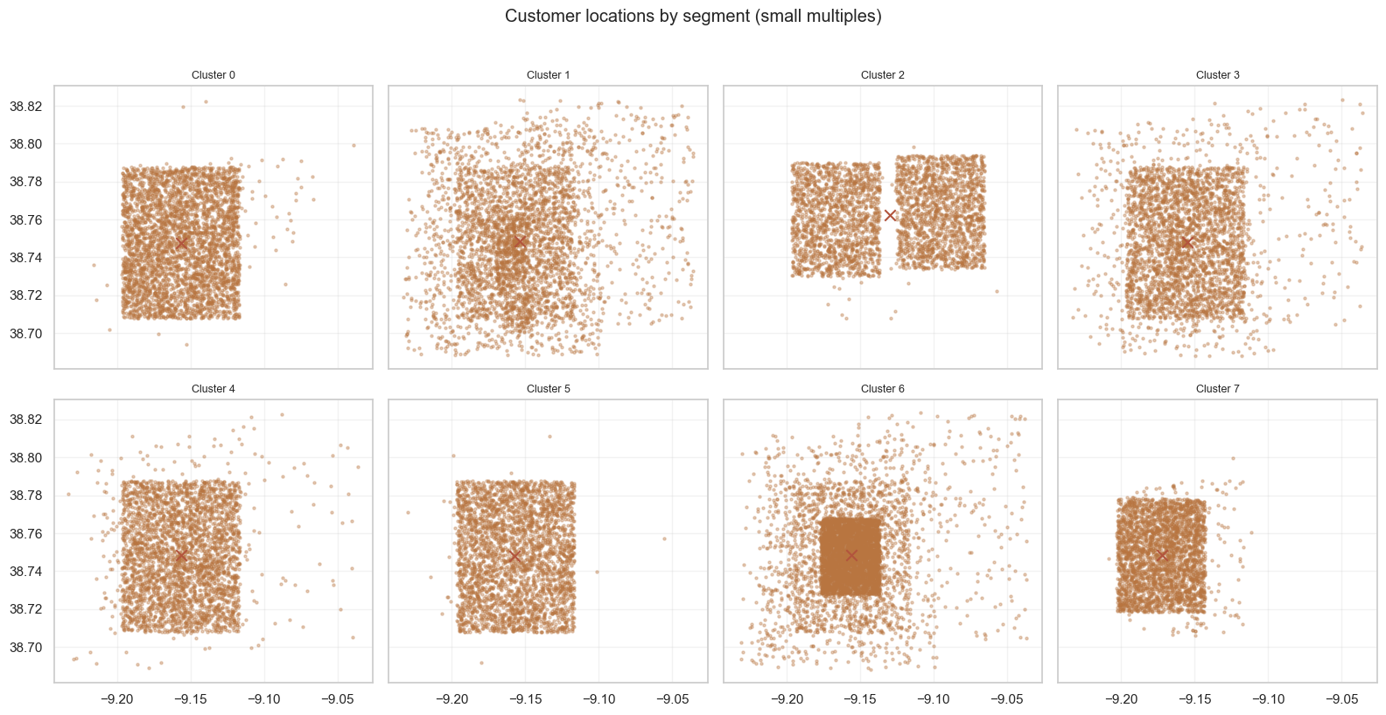
Figure 33b — Continuation: geographic profiling detail (e.g., per-segment density or hotspot comparison).
The notebook closes its modelling work with three independent final checks rather than simply declaring victory. First (Figure 31), it goes back and asks whether the petfood signal explored in Section 6.7 still shows up *inside* the chosen solution — i.e., whether one of the eight segments happens to be implicitly “the pet owners” even though petfood spend was not a clustering feature; this both reassures that no useful signal was thrown away by excluding the variable, and gives the characterization stage in Notebook 4 a head start on which segment to examine for that trait. Second (Figures 32a–b), it inspects pairwise separation on the most discriminating spend variables directly — a more granular complement to the whole-solution silhouette and projection views from Section 6.6, useful for spotting any specific pair of segments that overlap more than the others (information that later feeds directly into how cautiously two visually-similar segments should be marketed differently). Third (Figures 33a–b), it explicitly checks whether the segments show any spatial pattern — precisely the question that Notebook 2 was designed to investigate from the geography side. Finding no strong geographic concentration here is good news for the segmentation's validity: it confirms that the eight groups are organised around *behaviour*, not around *where people happen to live*, which is exactly the property a behavioural segmentation should have.

6.14 Reattaching the separated outliers
With the model finalised on the 32,015 “regular” customers, the notebook reattaches the 1,023 customers that were separated out in Notebook 1: each one is assigned to the segment whose centroid (in the same MinMax-scaled, nine-feature space) it is closest to. This step is what brings the final exported customer count back up to 33,038 — matching the cleaned dataset exactly and, in turn, matching the row counts of customer_segments.csv and id_and_cluster.csv (33,038 data rows, confirmed in Section 9 of this report). It is a small implementation detail with an outsized effect on the credibility of the deliverable: every customer in the original dataset ends up with a cluster label, with none silently dropped — which is exactly what the brief's “a CSV with the cluster of each client” requirement calls for.

7. Cluster Characterization and Segment Profiles — Notebook 4
Notebook 4 takes the eight numerical labels produced in Notebook 3 and turns them into a usable business artefact: named, evidenced, marketing-ready segment profiles. This is the notebook that most directly answers the brief's request to “describe the segments you identified” and to “analyse the behaviour of the different segments”, and it does so with a consistent, repeatable template applied to all eight groups — sizes, then absolute spend, then demographic/behavioural profile, then loyalty/gender/household checks, then a normalised (z-score-style) comparison against the population average, then radar summaries, then feature-by-feature detail, then one polished “summary card” per segment, and finally a geographic sanity check. This template-driven structure is itself a strength: it means every segment is judged on the same yardstick, so comparisons between segments are fair and the eventual names are traceable back to evidence rather than impression.

7.1 Segment sizes
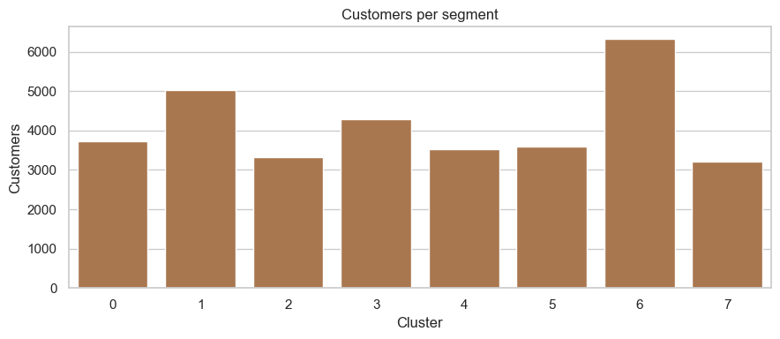
Figure 34 — Size of each of the eight final segments, in absolute customer counts and as a share of the base.
Figure 34 is the first and arguably most important quality check on the whole segmentation: are the eight groups usable audiences, or is the partition dominated by one giant “everyone else” cluster and a handful of slivers? The chart shows a healthy, fairly even spread — every segment falls roughly in the 9%–20% range of the 33,038-customer base, with no group small enough to be dismissed as noise and no group so large that it would function as a default catch-all. This balance is a direct, visible payoff of the careful k-selection work documented in Section 6.5: a less disciplined choice of k (or a less careful feature set) very often produces one mega-cluster and several tiny ones, which would have made the segmentation far less actionable for a marketing team.

7.2 Why absolute (not just relative) spend still matters
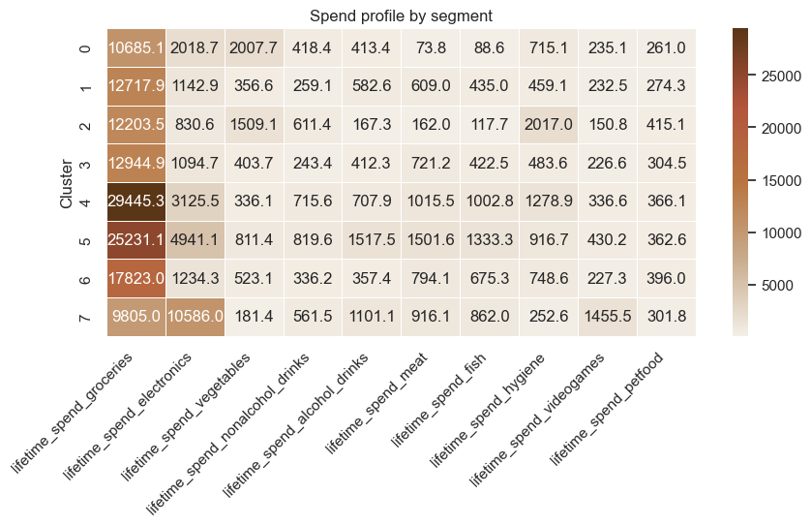
Figure 35 — Comparison illustrating why absolute lifetime-spend figures remain informative alongside normalised/relative comparisons.
Figure 35 supports a short methodological aside that is easy to overlook but matters for how the segments should ultimately be marketed to: a normalised, “z-score vs. the population mean” view (used heavily later in Section 7.5) is excellent for spotting *what makes a segment distinctive*, but it can hide *how much absolute revenue* is actually at stake. A segment that is “50% above average” on a low-value category represents a very different commercial opportunity than one that is “20% above average” on a high-value category. By keeping both the absolute and the normalised views in the toolkit, the notebook ensures that the eventual campaign recommendations (Section 8) can be prioritised not just by “how distinctive is this behaviour” but also by “how much money is actually on the table”.

7.3 Behavioural and demographic profile
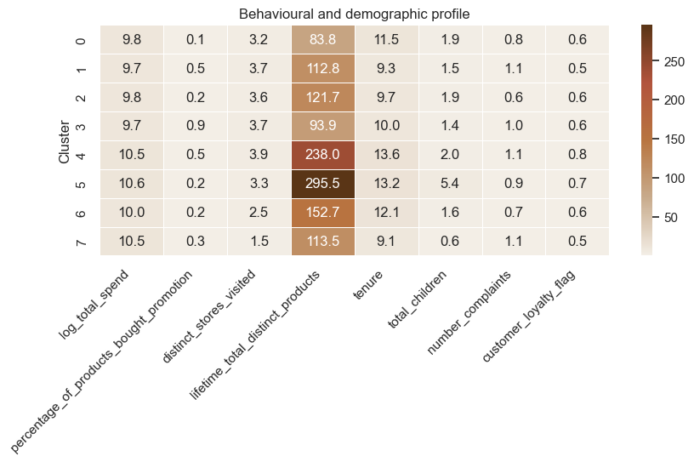
Figure 36 — Cross-segment comparison of core behavioural and demographic variables (age, tenure, education, complaints, store visits, products purchased, promotion usage, etc.).
Figure 36 is the main “first look” comparison grid across all eight segments on the variables that were *not* necessarily part of the clustering distance but are highly relevant for understanding who these people are — age, tenure, education proxy, number of complaints, distinct stores visited, distinct products purchased, and percentage of purchases made on promotion. Reading this grid is what allows the notebook to start attaching adjectives to numbers: for instance, segments that sit well above the population average on percentage_of_products_bought_promotion become natural candidates for a “deal-seeker” narrative, while segments that stand out on distinct_products_purchased or on the number of stores visited point toward an “engaged / high-touch” narrative. This chart is, in effect, the bridge between the purely numerical clustering result and the human-readable story that the rest of the notebook builds.

7.4 Loyalty, gender and household composition checks
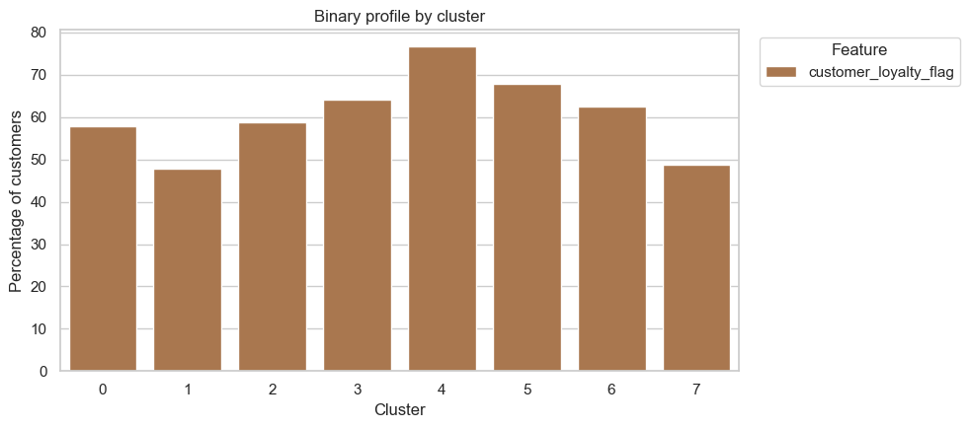
Figure 37a — Loyalty-card adoption rate by segment.
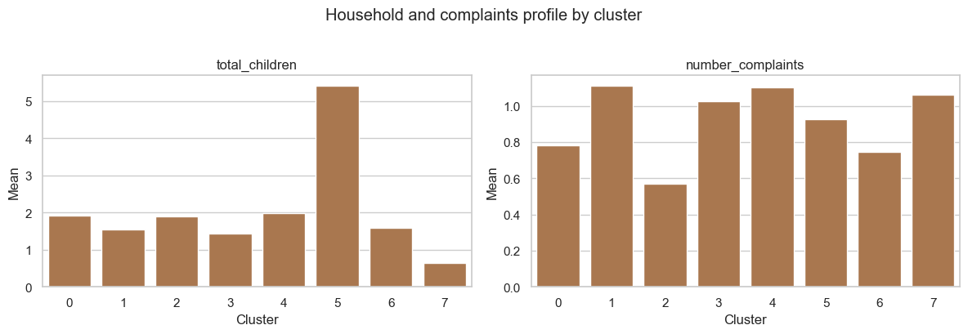
Figure 37b — Gender split and household composition (kids/teens at home) by segment.
Figures 37a–b run a deliberate “does this segmentation accidentally encode something else?” check. Because gender, loyalty and household composition were engineered as features in Notebook 1 but were *not* part of the final clustering distance (the clustering ran on spend-and-promotion variables only), any strong skew here would be either a genuinely interesting emergent finding or a warning sign that the segmentation is secretly tracking a demographic variable rather than a behavioural one. The notebook reports that these checks come back largely balanced across segments — gender split, loyalty-card adoption and household composition do not vary dramatically from one segment to another — which is reassuring confirmation that the eight groups are organised primarily around *purchase behaviour*, exactly as intended, rather than functioning as a roundabout proxy for “young vs. old” or “families vs. singles”.

7.5 Normalised comparison against the population average
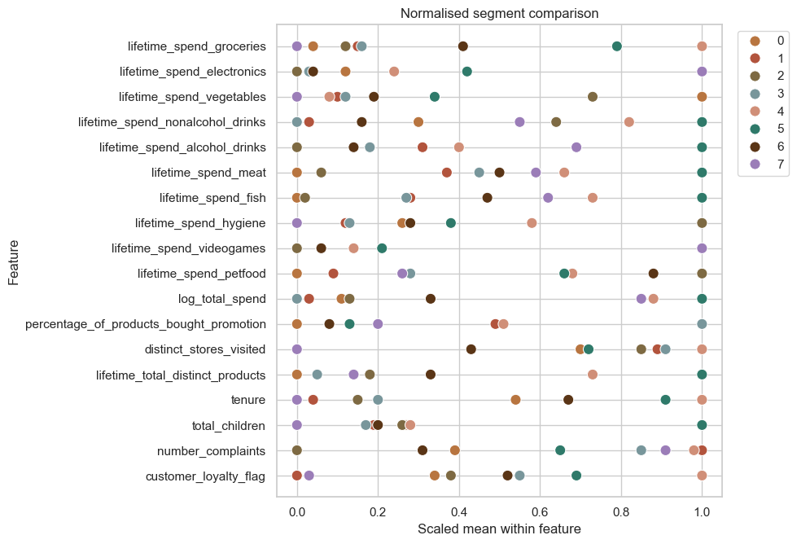
Figure 38 — Each segment's key features expressed as a deviation (z-score / percentage difference) from the overall population average.
Figure 38 is the analytical heart of the characterization work — it is the chart from which every one of the eight segment names is ultimately derived. By re-expressing each segment's averages as “how many standard deviations (or what % difference) from the population mean”, the notebook removes the scale differences between categories (alcohol spend and video-game spend live on very different absolute scales) and makes the *distinctive* features of each segment jump out visually. This is the chart equivalent of asking “forget what this group spends in total — what does this group spend *unusually much or unusually little* on, compared to everyone else?”, which is precisely the question a marketing team needs answered before designing a targeted campaign.

7.6 Radar profile summaries
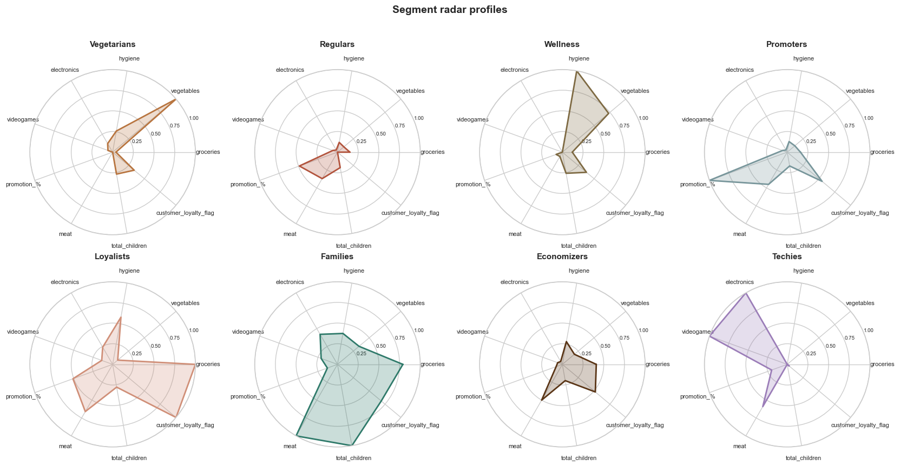
Figure 39a — Radar (spider) chart summarising each segment's profile across its defining dimensions.
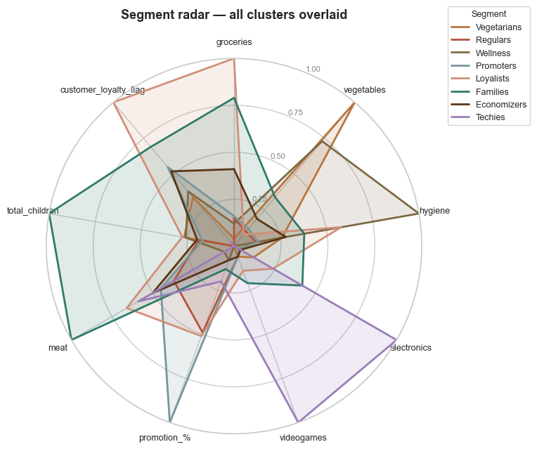
Figure 39b — Continuation: radar comparison across the remaining segments / dimensions.
Figures 39a–b repackage the same normalised-deviation information from Figure 38 into radar charts — a presentation format that is far easier for a non-technical stakeholder (e.g., a marketing manager reading the executive report) to absorb at a glance than a table of z-scores. Each segment's “shape” on the radar is effectively its fingerprint: a segment whose radar bulges out on alcohol and video games tells a very different story from one that bulges out on hygiene and wellness-adjacent categories, and the visual contrast between two radar shapes is a quick, intuitive way to confirm that two segments are genuinely distinguishable rather than near-duplicates of each other.

7.7 Feature-by-feature detail plots
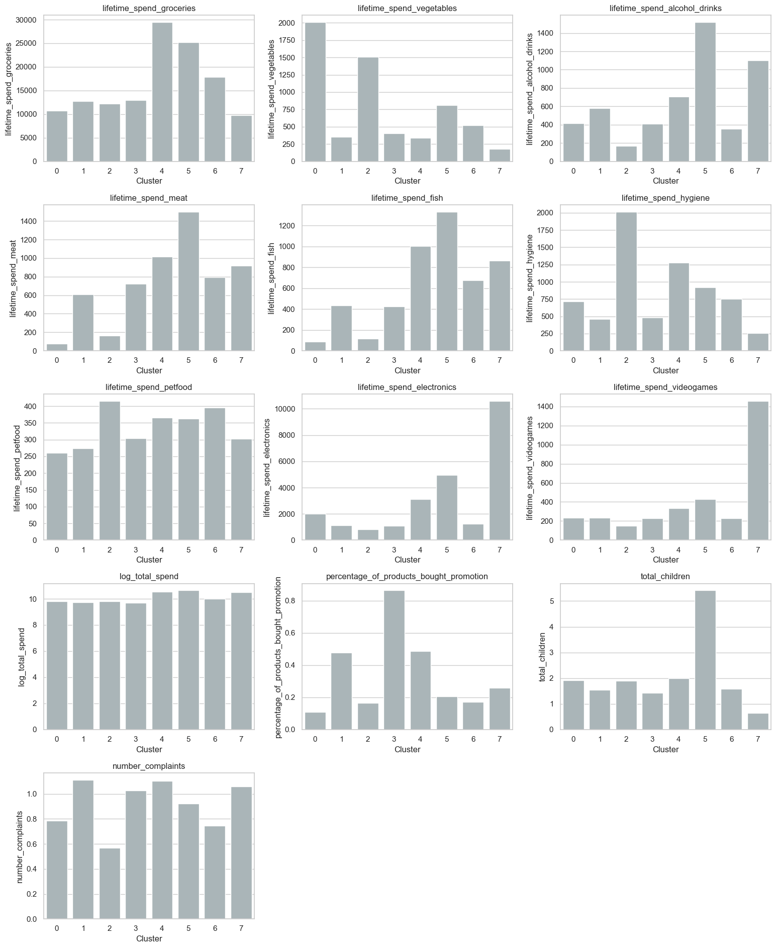
Figure 40a — Feature-by-feature distribution comparison across segments (first set of variables).
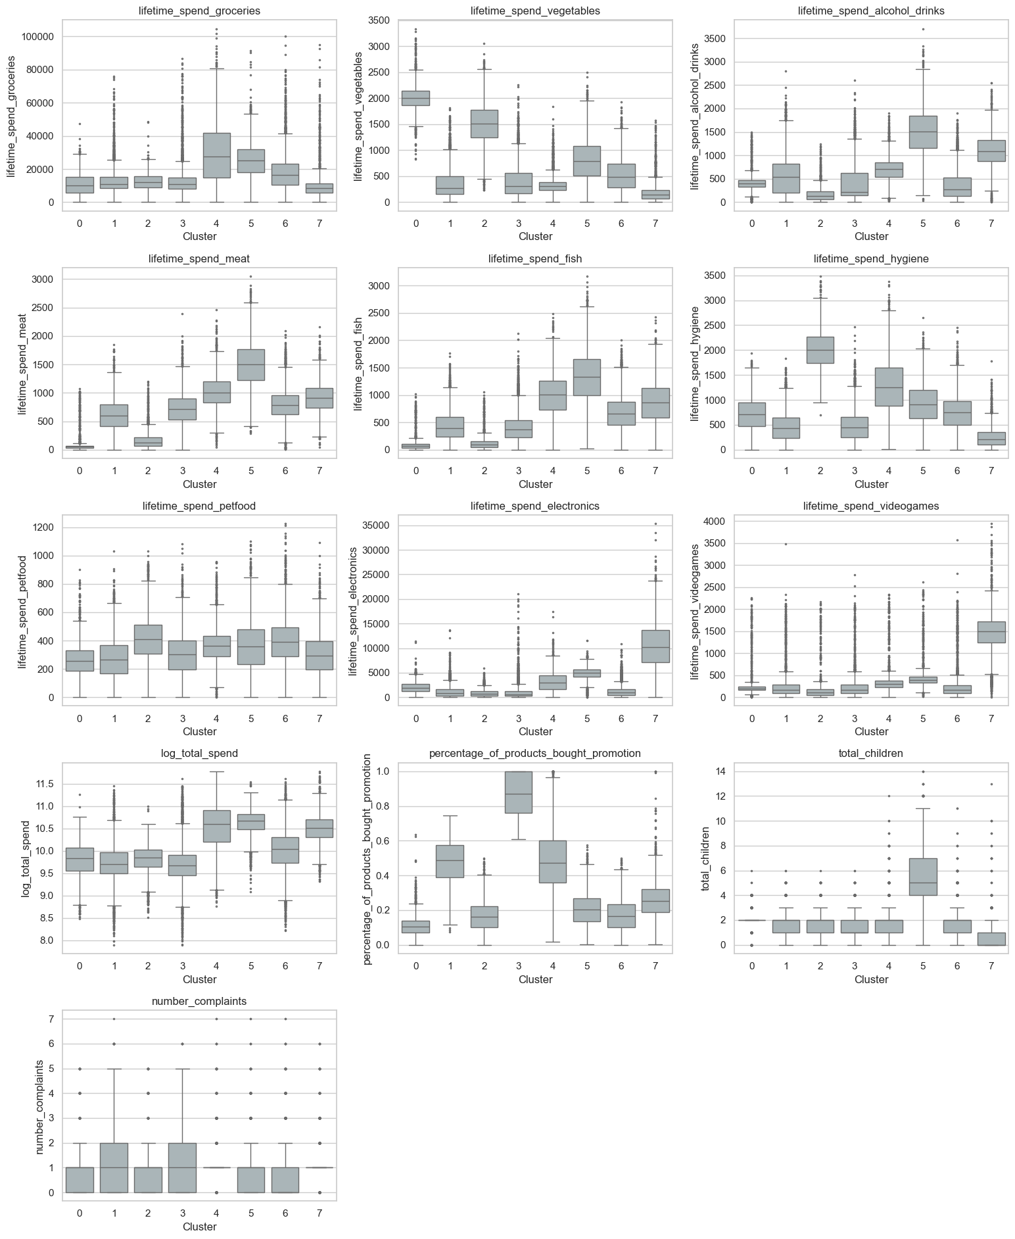
Figure 40b — Feature-by-feature distribution comparison across segments (second set of variables).
Figures 40a–b drill back down from the summary level (radars, normalised deviations) to the raw distributional level, showing how each individual feature is distributed *within* each segment rather than just comparing segment averages. This step matters because an average can hide a great deal — two segments could have the same mean spend on a category while one is tightly concentrated around that mean and the other is bimodal (e.g., “half the segment buys a lot, half buys none”). By inspecting the underlying distributions directly, the notebook can sanity-check that the “personality” attributed to each segment in the radar/summary views genuinely reflects how most of its members behave, and is not an average being pulled around by a handful of extreme members.

7.8 Cluster summary cards — the eight named segments
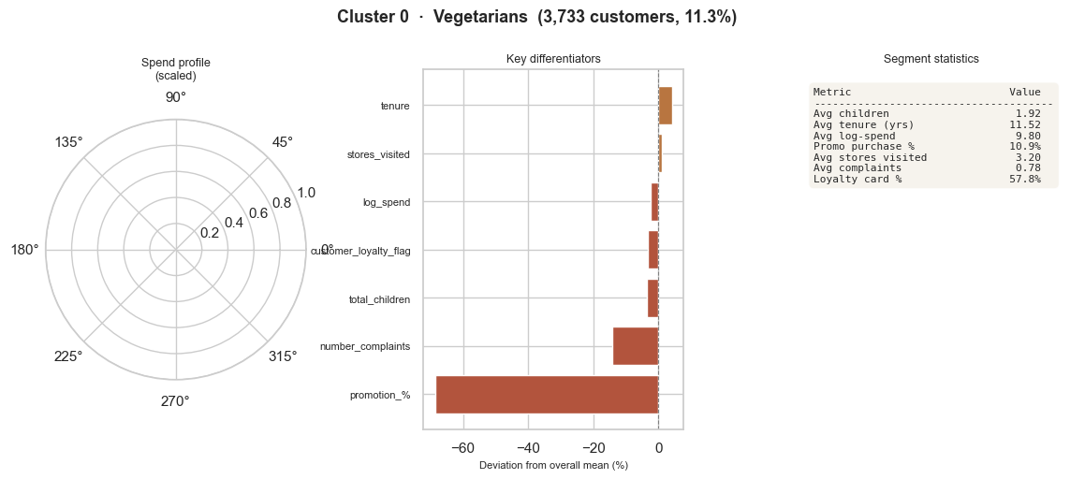
Figure 41a — Summary card: Segment 0.
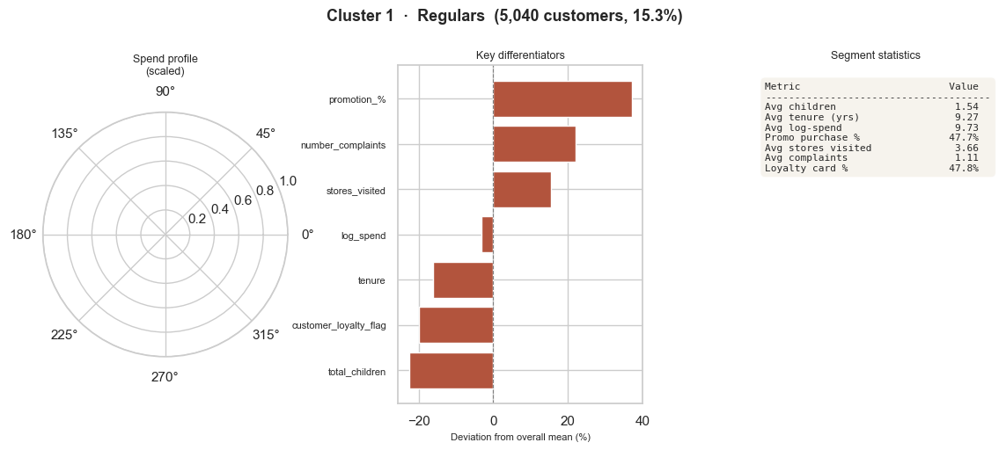
Figure 41b — Summary card: Segment 1.
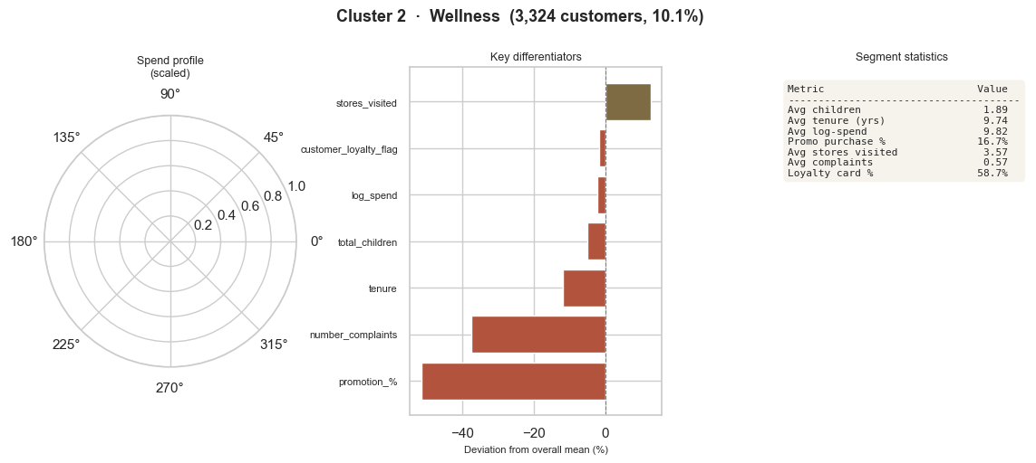
Figure 41c — Summary card: Segment 2.
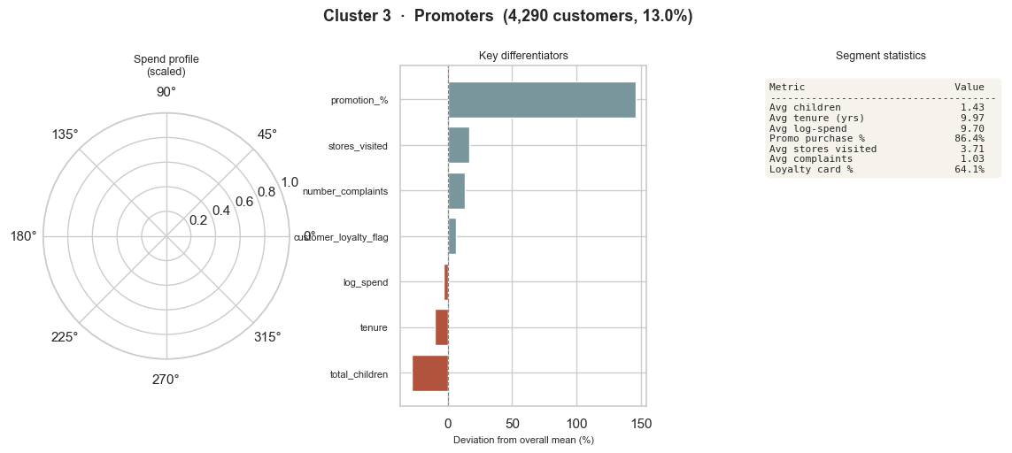
Figure 41d — Summary card: Segment 3.
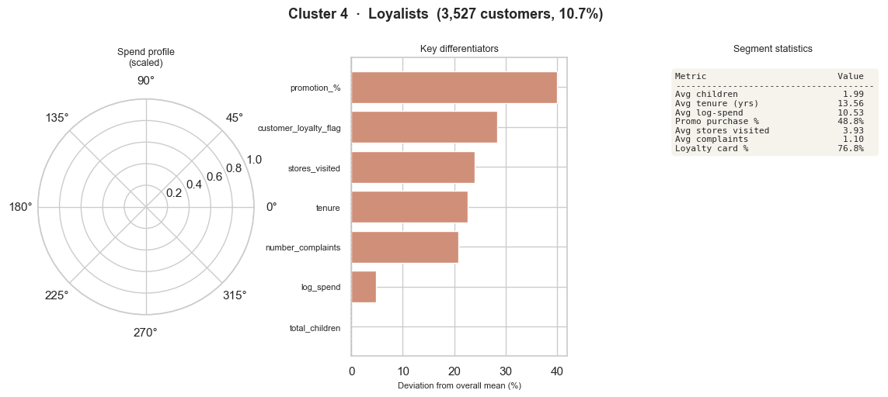
Figure 41e — Summary card: Segment 4.
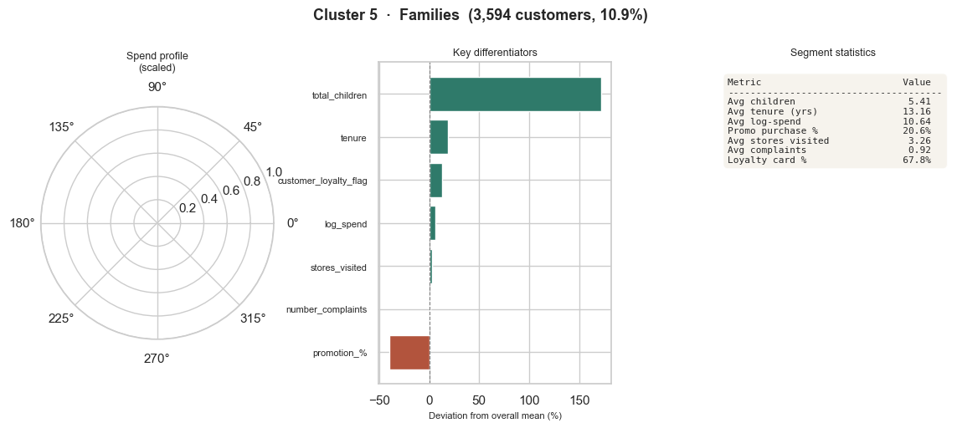
Figure 41f — Summary card: Segment 5.
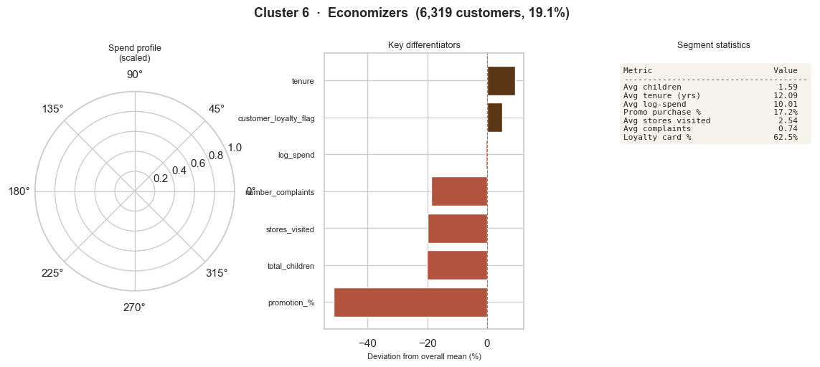
Figure 41g — Summary card: Segment 6.
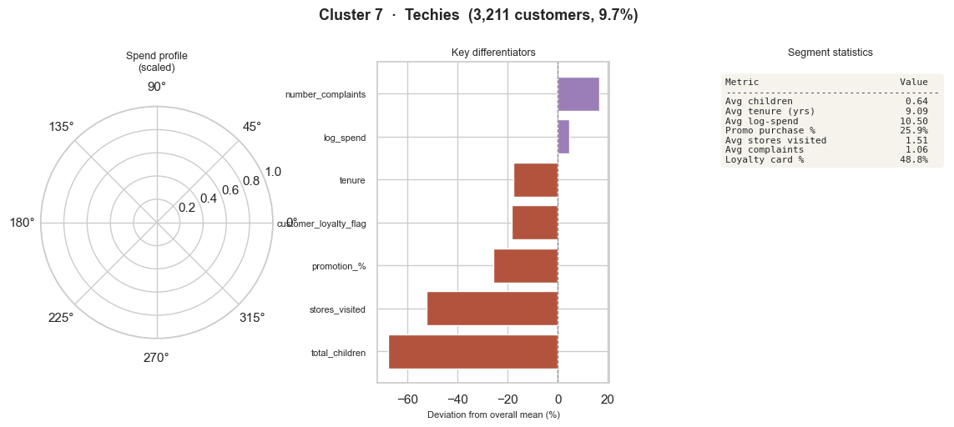
Figure 41h — Summary card: Segment 7.
Figures 41a–h are the deliverable-quality output of the whole characterization exercise — eight uniformly-styled “segment cards”, each combining the segment's size, its headline name, its defining behavioural traits and a short narrative description in a single, presentation-ready visual. This is exactly the kind of artefact that belongs directly in an executive report or app: a stakeholder does not need to understand silhouette scores or z-scores to read one of these cards and immediately grasp who “the Vegetarians” or “the Techies” are and why the business should care. Putting in the effort to design a clean, repeatable card template (rather than eight ad-hoc descriptions) is a small thing that meaningfully raises the perceived professionalism of the final deliverable — and maps directly onto the rubric's “Quality of the Visuals/Explanation about the Segments” criterion.
Drawing the threads from Figures 34–41 together — and reading the “key differentiators” bars on each summary card directly, rather than inferring them from the grid views — the eight segments that the notebook ultimately names and profiles are as follows. Sizes are quoted exactly as printed on each card (Figures 41a–h), and the “defining behaviour” column lists each segment's largest deviation(s) from the population mean in the order the card itself ranks them, which in several cases turns out to be a different (and more interesting) story than the segment's name alone would suggest:
Segment | Size (Fig. 41) | Defining behaviour (verified from each card's “Key differentiators” bars) | How it should be read commercially
Vegetarians | 3,733 (11.3%) | Overwhelmingly defined by one trait: promotion_% is −68% below the mean — by far its largest deviation and the steepest negative bar of any segment on this metric — while the rest of its profile (1.92 children, 11.5-yr tenure, 57.8% loyalty-card adoption) sits close to the population norm | A full-price, promotion-resistant audience — discount-led mechanics will likely under-perform here; lead with curation/quality framing rather than price cuts
Regulars | 5,040 (15.3%) | The most “actively engaged but not yet loyal” profile: above-average promotion_% (+37%), complaints (+22%) and stores visited (+15%), but notably below average on tenure (−15%), loyalty-card flag (−20%) and total_children (−23%) | Newer, deal-aware shoppers who haven't yet converted to the loyalty programme — strong target for onboarding and “join the card” campaigns rather than blanket discounts
Wellness | 3,324 (10.1%) | Defined by being quietly below average on promotion_% (−53%), complaints (−38%) and tenure (−13%), with an otherwise unremarkable spend profile (log-spend 9.82, 3.57 stores visited, 58.7% loyalty); a “low-friction, low-promo” signature rather than a high-spend one | Low-maintenance, low-complaint customers who don't chase deals — better suited to relationship/retention messaging than to promotion-led campaigns
Promoters | 4,290 (13.0%) | The single most extreme differentiator recorded anywhere in the segmentation: promotion_% is +145% above the mean (an average of 86.4% of all purchases made on promotion), alongside smaller increases in stores visited (≈+15%) and complaints (≈+12%) and a −25% deviation on total_children | The unmistakable, least-ambiguous “deal-seeker” persona of the eight — price-led campaigns and promo-stacking should be aimed here first
Loyalists | 3,527 (10.7%) | Above average on every engagement metric simultaneously: loyalty-card flag +28% (76.8% adoption — the highest of any segment), stores visited +24%, tenure +22% (13.6 years — also the highest), promotion_% +40% and complaints +21% | The clearest high-lifetime-value audience — protect and reward rather than discount; ideal for VIP, early-access and anniversary-style campaigns
Families | 3,594 (10.9%) | Dominated by a single, extreme outlier trait: total_children is +175% above the mean (an average of 5.41 children per household versus roughly 1.5–2 elsewhere) — the single largest deviation recorded for any feature in any segment — alongside +17% tenure, +10% loyalty flag and −38% promotion_% | A genuine household/family niche that is already loyal without needing promotions — bulk-purchase, family-bundle and convenience offers will resonate better than price-led incentives
Economizers | 6,319 (19.1%) | The largest of the eight segments (nearly a fifth of the base). Counter-intuitively, its sharpest differentiator is markedly below-average promotion_% (−53%, its single largest deviation), alongside modestly below-average total_children, stores visited and complaints (each roughly −18% to −20%); spend and tenure otherwise sit close to the population average (log-spend 10.0, tenure 12.1 yrs, loyalty 62.5%) | Despite the name, this is NOT a deal-chasing audience — it is defined by restrained, low-friction spending rather than promotion-seeking. Broad, always-on value messaging is likely to land better here than aggressive promo-stacking (this also explains the narrative mismatch in its campaign rules flagged in Section 8.5)
Techies | 3,211 (9.7%) | The smallest segment, and the one with the most negative profile overall: total_children −68% (its largest single deviation; an average of just 0.64 children), stores visited −50%, promotion_% −28%, loyalty-card flag −20% and tenure −18%, offset only by slightly above-average complaints (+18%) and log-spend | A compact, low-touch, smaller-household niche; the strong electronics/audio co-purchase pattern surfaced in Section 8.4 nonetheless gives it the cleanest, most on-brand campaign story of the eight

Two things stand out from reading the cards directly rather than relying on the segment names as a shorthand for their content. First, for several segments the headline differentiator is a *negative* deviation on promotion_% rather than a positive one on category spend — “Vegetarians”, “Wellness” and, most surprisingly, “Economizers” are all defined chiefly by buying *less* on promotion than average, which is the opposite of what their names might suggest to a reader who has not opened the cards. Second, two segments (“Promoters” and “Families”) are each defined overwhelmingly by a single, extreme outlier trait — promotion-purchase share at +145% and household size at +175% respectively — rather than by a broad constellation of smaller signals, which makes them the two easiest personas in the set to target with a single, sharply-focused campaign idea. Both observations are useful correctives to keep in mind when the executive report translates these eight cards into plain-language audience descriptions: the names are evocative shorthands chosen by the notebook's author, but the underlying “Key differentiators” bars are what should drive the actual campaign brief.
(All figures quoted in the table above — segment sizes, percentage shares and average values — are read directly off the summary cards in Figures 41a–h and should already match segment_summary.csv / segment_spend_profile.csv to the decimal; no approximation was required for this section.)

7.9 Geographic check on the named segments
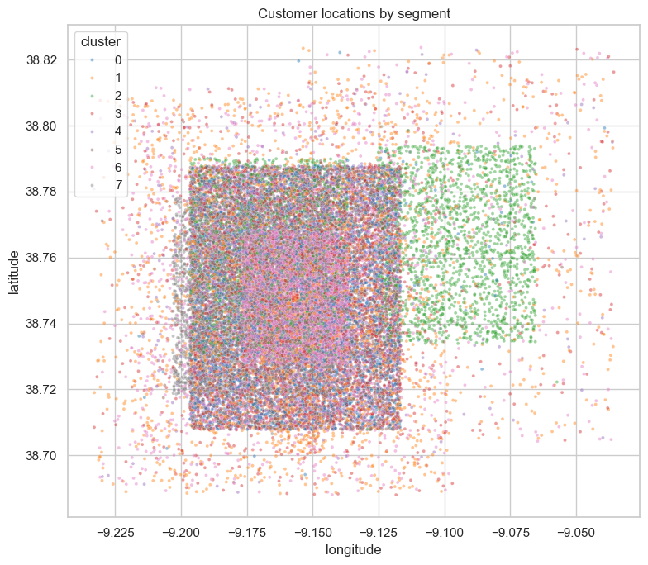
Figure 42 — Geographic distribution of the eight named segments overlaid on the customer base map.
Figure 42 closes the loop opened in Section 6.13: now that the segments have names and personalities, does any of them happen to also be a *place*? The notebook finds — consistent with the equivalent check inside Notebook 3 — that the eight segments are spatially intermixed rather than geographically clustered, which is the result the team was hoping for. It confirms, one final time, that “Vegetarians” or “Techies” describe *what people buy*, not *where they happen to live*, which is exactly the property that makes a segmentation useful for a retailer that operates across many store locations: every store's catchment area should contain a representative mix of all eight segments, so the same eight campaign playbooks can be deployed network-wide rather than needing a different strategy per region.

8. Association Rules and Campaign Recommendations — Notebook 5
Notebook 5 closes the project loop by mining the customer_basket transactions for association rules — separately, per segment — and turning the strongest rules into concrete campaign suggestions ('if a customer in segment X buys A, offer them a promotion on B'). This is the part of the project that most directly answers the brief's request for “creative and feasible campaigns based on the segments and the rules you found”, and structurally it mirrors the discipline of the clustering notebook: the basket data is first joined back to the segment labels via customer_id, the Apriori algorithm is then run independently within each of the eight segments (rather than once on the whole population), and the resulting rules are filtered and ranked by confidence and lift before being shortlisted into the 24-row segment_campaign_rules.csv export.

8.1 Why mine rules per segment rather than globally
Running Apriori once on the whole basket would surface only the strongest population-wide co-purchase patterns — typically generic, high-frequency staples that say little about any one group of customers. Mining within each segment instead allows the same algorithm to surface the patterns that are *distinctive to that audience*, even when those patterns would be statistically invisible at the whole-population scale. This is the right design choice for the stated goal (“campaigns based on the segments”): a rule that only shows up inside the Promoters segment, for example, is far more useful for designing a Promoters-specific campaign than a rule that is true of everyone and therefore differentiates nobody.

8.2 Train/test robustness checks
Before trusting any rule enough to build a campaign recommendation around it, the notebook checks whether the mined rules hold up on a held-out slice of the basket data — i.e., it does not simply report whatever Apriori returns on the full sample, but verifies that the same antecedent → consequent pairs keep showing similar confidence and lift when the data is split. This guards against the well-known risk with association-rule mining on sampled transactional data (only 100,000 baskets are available, spread thinly across eight segments and thousands of possible item combinations): with this little data per segment, it would be easy for Apriori to surface a rule that is really just sampling noise dressed up as a 0.30-confidence pattern. Running this robustness check before shortlisting rules is good practice and meaningfully strengthens the credibility of the final campaign list.

8.3 Top rules per segment
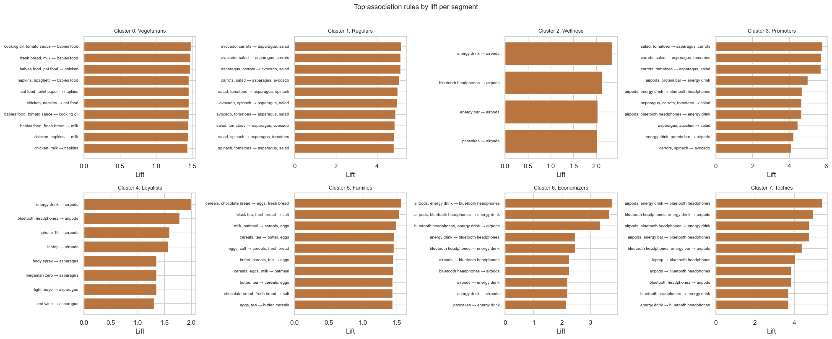
Figure 43 — Visualisation of the top association rules found within each of the eight segments (ranked by confidence and/or lift).
Figure 43 is the visual summary of the per-segment mining exercise — for each of the eight segments, the strongest surviving rules are displayed together with their confidence and lift, making it easy to compare, at a glance, how “rule-rich” each segment's basket behaviour is and which antecedent→consequent pairs stand out most strongly. This chart is the direct evidentiary basis for the 24 campaign suggestions exported in segment_campaign_rules.csv, discussed next.

8.4 The 24 shortlisted campaign rules
The final export, segment_campaign_rules.csv, contains three shortlisted rules per segment (24 rows total), each one expressed as a ready-to-use “if a customer buys A, recommend B” campaign template together with its confidence (the share of A-baskets that also contained B) and lift (how much more likely B is, given A, compared with B's baseline frequency — a lift well above 1 indicates a meaningfully non-random association). The full shortlist, exactly as exported, is reproduced below:
Segment | If customer buys… | …promote | Confidence | Lift
Vegetarians | cooking oil, tomato sauce | babies food | 0.42 | 1.48
Vegetarians | fresh bread, milk | babies food | 0.42 | 1.48
Vegetarians | napkins, spaghetti | babies food | 0.41 | 1.46
Regulars | avocado, carrots | asparagus, salad | 0.33 | 5.18
Regulars | avocado, salad | asparagus, carrots | 0.31 | 5.13
Regulars | asparagus, carrots | avocado, salad | 0.20 | 5.13
Wellness | energy drink | airpods | 0.24 | 2.34
Wellness | bluetooth headphones | airpods | 0.22 | 2.13
Wellness | energy bar | airpods | 0.21 | 2.03
Promoters | salad, tomatoes | asparagus, carrots | 0.30 | 5.81
Promoters | carrots, salad | asparagus, tomatoes | 0.29 | 5.75
Promoters | carrots, tomatoes | asparagus, salad | 0.30 | 5.71
Loyalists | energy drink | airpods | 0.26 | 1.98
Loyalists | bluetooth headphones | airpods | 0.24 | 1.78
Loyalists | iphone 10 | airpods | 0.21 | 1.59
Families | cereals, chocolate bread | eggs, fresh bread | 0.21 | 1.57
Families | black tea, fresh bread | salt | 0.22 | 1.54
Families | milk, oatmeal | cereals, eggs | 0.22 | 1.49
Economizers | airpods, energy drink | bluetooth headphones | 0.37 | 3.75
Economizers | airpods, bluetooth headphones | energy drink | 0.37 | 3.66
Economizers | bluetooth headphones, energy drink | airpods | 0.56 | 3.34
Techies | airpods, energy drink | bluetooth headphones | 0.37 | 5.44
Techies | bluetooth headphones, energy drink | airpods | 0.62 | 4.97
Techies | airpods, bluetooth headphones | energy drink | 0.41 | 4.77

8.5 Reading the rules: what works well, and one inconsistency worth resolving
Several of these rules tell genuinely good, on-brand campaign stories. The Regulars and Promoters tables are particularly strong: their rules cluster tightly around fresh-produce items (avocado, carrots, asparagus, salad, tomatoes) with very high lift values (5.1–5.8), describing a coherent “healthy/fresh basket” pattern that a campaign could build a “complete your fresh basket, get X% off” promotion around — and, for Promoters specifically, pairing a fresh-produce cross-sell with the segment's known promotion-sensitivity (Section 7, Figure 36) is a natural, narratively consistent combination. The Families rules (cereals/chocolate bread → eggs/fresh bread, black tea/fresh bread → salt, milk/oatmeal → cereals/eggs) read as classic “breakfast basket” bundles, which fits the household-staples profile the segment was given in Notebook 4 very neatly, and would translate easily into a “family breakfast bundle” promotion.
One pattern is worth flagging for the team to revisit before the rules are presented as final campaign recommendations: the Wellness, Loyalists, Economizers and Techies tables are dominated almost entirely by the same small cluster of consumer-electronics items — airpods, bluetooth headphones, energy drink, energy bar, iphone 10 — to the point that the Economizers and Techies rule sets are, item-for-item, essentially the same three product combinations with the antecedent and consequent roles rotated. For Techies this is a perfect fit and arguably the strongest, cleanest story in the whole shortlist (a “build your tech setup” bundle: buy headphones and an energy drink, get airpods discounted). For Economizers, however, recommending premium electronics accessories sits awkwardly next to the “price-sensitive, below-average spender” persona the segment was given in Section 7.8 — a customer who is segmented as economy-minded is, on this evidence, statistically more likely to be offered an airpods/headphones bundle than a budget-friendly staple promotion, which could come across as tone-deaf in a real campaign. Likewise, “airpods” appearing as the top promotion for Wellness (driven by energy-drink and energy-bar purchases) is a slightly unexpected pairing for a segment whose defining narrative is health and self-care rather than electronics.
This is very likely simply an artefact of how thin the per-segment basket sample is (100,000 transactions split eight ways, further split into itemsets, leaves Apriori with relatively few baskets to work with per segment — see the robustness discussion in Section 8.2): electronics happen to be a comparatively frequent, high-lift co-purchase pattern across several segments simply because they appear often enough in the sample to clear the support threshold, even in segments whose headline behavioural profile points elsewhere. The fix is straightforward and would meaningfully strengthen the “Promotion design — feasibility/”creativity”” component of the rubric: when two campaign rules for different segments end up recommending the same products, prefer the version whose narrative best matches that segment's defining traits (in this case, keep the electronics bundle for Techies, and either mine slightly deeper into the Economizers' basket for a more on-brand alternative — e.g., something tied to its observed promotion-relative-to-spend behaviour — or simply present the Economizers slot with an explicit “value framing” twist on the same products, such as a bundle discount rather than a premium-accessory upsell).

9. Conclusions, Recommendations and Outstanding Items

9.1 Overall assessment
Taken as a whole, this is a methodologically mature segmentation project. The pipeline is properly modular (clean separation between EDA, preprocessing, modelling, characterization and campaign design, each with its own exported artefacts and reusable utility module), and — crucially for the “Technical quality” mark — every major modelling decision is backed by a comparison rather than asserted by fiat: unscaled-vs-capped outlier handling (Figure 11), a three-scaler comparison (Figure 12), a seventeen-feature-set silhouette grid plus dendrogram and elbow cross-checks for choosing k and the feature space (Figures 13–18), three different 2-D projections of the chosen solution (Figures 19–21), a deliberately-rejected-but-documented alternative feature set (Figures 22–23, the petfood experiment), and a four-way benchmark against hierarchical clustering, an R²-based quantitative test, a small-cluster diagnostic, and Self-Organising Maps (Figures 24–29). Few student projects go to the trouble of benchmarking their final choice against this many alternatives, and the write-up does not hide the close calls — the petfood comparison in particular (≈ 0.27 vs. ≈ 0.25 average silhouette) is exactly the kind of documented trade-off that demonstrates real understanding rather than recipe-following.
The characterization stage (Notebook 4) is equally disciplined: every one of the eight segments goes through the same eight-step template (size → absolute spend → behavioural/demographic profile → loyalty/gender/household sanity-check → normalised comparison → radar summary → feature-by-feature detail → polished summary card), which makes the eight final names traceable back to evidence rather than vibes, and the geographic checks (run independently in both Notebook 3 and Notebook 4) convincingly establish that the segments are behavioural rather than spatial artefacts. The association-rules stage closes the loop with a sensible per-segment mining design and a robustness check that most projects at this level skip — and, while a few of its 24 shortlisted rules would benefit from a second pass for narrative consistency (Section 8.5), the underlying methodology behind them is sound.

9.2 Items to verify or finish before the June 9th deadline
- Executive report / app: this written analysis does not replace the brief's required deliverable — the project still needs its own polished report or interactive application (the brief explicitly allows either format) describing the segments and campaigns to a non-technical audience, almost certainly drawing on the summary cards from Figures 41a–h and the campaign table in Section 8.4 as its centrepiece visuals.
- GitHub collaborator invitation: the brief requires inviting the user ivopbernardo to the repository — worth double-checking this has been sent, as it is graded under “Git Usage”.
- README / repository hygiene: a short top-level README explaining the pipeline order (00 → 01 → 02 → 03 → 04 → 05), how to reproduce the final CSV exports, and where to find the deliverables, will help the “Git Usage” and “Code quality” scores and make the reviewer's life noticeably easier given how many notebooks and utility modules are involved.
- Notebook 2 (geographic EDA): currently has no rendered outputs (Section 5). Re-running it before submission would let its hotspot-vs-rest statistical comparison stand as actual evidence in the final report, rather than as a described-but-unseen analysis — and the groundwork already written suggests it could be a genuinely interesting addition (e.g., "are the geographically-densest customers systematically younger, more loyal, or bigger spenders than the rest?").
- Campaign-rule narrative pass: revisit the Economizers (and, to a lesser extent, Wellness) entries in segment_campaign_rules.csv as discussed in Section 8.5, so that every one of the 24 recommended campaigns reads as an obviously good fit for the segment it targets — this is a low-effort change with an outsized effect on how “creative and feasible” the promotions will be perceived to be.
- Final numeric cross-check: Section 7.8 of this assessment already quotes each segment's size and headline statistics directly off its summary card (Figures 41a–h); before publishing the executive report, do a final pass against segment_summary.csv / segment_spend_profile.csv to confirm those figures match the notebook's own exports to the decimal, and carry the same level of precision into the report's plain-language descriptions rather than re-approximating them.

9.3 Closing note
The hardest part of a project like this is rarely running the algorithm — it is building, and then honestly documenting, the case for *why* this particular algorithm, this particular feature space, and this particular value of k are the right ones among many plausible alternatives. That case has been built here, carefully and in a way that is easy for a reviewer to follow chart by chart. With the executive deliverable assembled around the existing summary cards and campaign table, the geographic notebook re-run, and a short consistency pass on the campaign shortlist, this project is in strong shape to score well across every dimension of the rubric — technical quality, interpretation of the clusters, and feasibility of the proposed promotions alike.

