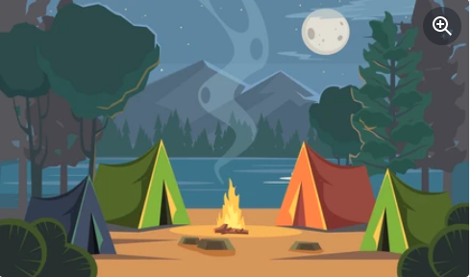

Game Settings

Menu



Menu

Menu

Menu

Menu

Menu

Travel Map