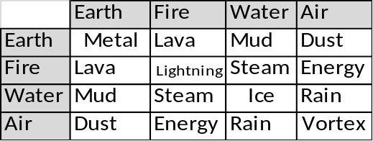
Recepies:
?
Energy + Rain = Storm

Energy + Water = Healing
Energy +
Water + Lava = Stone & Steam
Water + Stone = Sand
Sand + Fire = Glass
Glass + Air + Energy = Slicing Shards

