# Game Document – Game Jam 1

ID737001 Game Development Carlson and Devon

Hues of Memories: The unveiling

## Core Concept

* The player will be placed in a black and white world, where they must find key items, they have lost. The characters have lost their memory, with their primary goal being to explore to get these memories back (key items, skills, people etc.). Exploring the world changes it from a faded memory (black and white) to a restored memory (colour) with the goal of reaching a final area with everything coloured in.
* After 4 level is completed, the game will show the player a brain map, revealing the player is in their brain.

## Design pillars

* Exploration
* Accessible to anyone
* Story
* Platforming / Puzzles

## Level Design

### 4 separate dungeon type

* Frontal Lobe: Puzzle and dodge obstacles
  + **Colour Theme:** Vibrant shades of yellow and orange.
  + **Emotion/Cognitive Function:** Yellow and orange can evoke feelings of energy, enthusiasm, and creativity, which align with the frontal lobe's functions related to problem-solving, decision-making, and creativity.
* Parietal Lobe: Maze like escape
  + **Colour Theme:** Cool tones of blue and green.
  + **Emotion/Cognitive Function:** Blue and green are calming colours often associated with tranquillity and balance. They can represent the spatial awareness and sensory processing functions of the parietal lobe, aiding navigation through complex mazes.
* Temporal Lobe: Gather Memories
  + **Colour Theme:** Warm hues of red and purple.
  + **Emotion/Cognitive Function:** Red and purple can evoke emotions such as passion, nostalgia, and introspection. These colours symbolize the retrieval and processing of memories associated with the temporal lobe's functions, including memory formation and recognition.
* Occipital Lobe: Jump platformer (illusion + memory)
  + **Colour Theme:** Contrasting black and white with occasional flashes of vivid colours.
  + **Emotion/Cognitive Function:** Black and white represent the basic elements of visual perception, while vivid colours symbolize the illusions and memories created by the occipital lobe. This contrast reflects the occipital lobe's role in visual processing, including depth perception and the interpretation of visual stimuli.

## Main Features and Mechanics

* The player’s movement will bring colours to the black and white world, once the world is lit up it will stay lit.
* The player can encounter special events that will give the player a reward, or a clue.
* The special events vary from dungeons; escape room; treasure room.
* Player should gather unique items to progress.
* If the player insists on progressing without key item, player may have reduced abilities, or a message prompt will show, recommending the item first.

*Initial exploration Filled in after exploring*

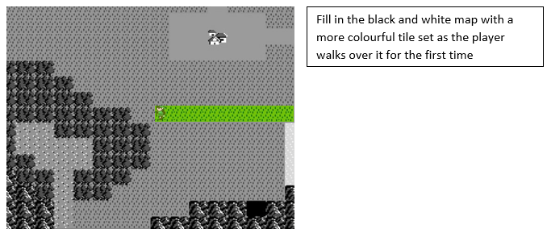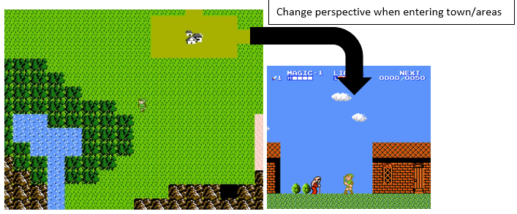

## Target platform and Audience

* Platform: Windows / PC application
* Unity Version: 2022.3.20f1
* Audience: Anyone

## Interface and Control

* Game will be a simple 2D top-down game on the map and 2D side-scrolling in levels
* Top-down will have 8-directional animation for movement
* Keyboard inputs
  + WASD or Arrow Keys for movement
  + Additional key mapping for: interact, jump, *attack, pickup item, use item

*\*(if combat is added)*

## Basic story

* You have lost your memories, each tile you pass lights up memory synapses, leading your way to remembering something your heart is yearning to remember.

## Visual Style

* We will use pixel art tile sets that are free to use.
* Looking to use 32x32 px tile sets for better visuals
* Mini background 1920x1080 resolution

## Audio Style

* Arcade and ambient sounds to match the pixelated graphics

## Narrative:

#### World setting:

* Dyrem is a colourless void, waiting to be discovered. Everything in here has been stripped of their identity.

#### Background story:

* You woke up in an unfamiliar world, not knowing how you ended up here, unaware of who you are, and who you were.

#### Character backstory:

* Luc is an art major student currently in his final year of study.