**Wedding Planning: Your Step by step guide**

**[](https://www.hitched.co.uk/planner/budget-planner/)Step 1: Set a Budget (and stick to it!)**

One of the first things to think about when planning a wedding is your wedding budget and how much you can afford to spend.

Sit down together and have an open discussion about your finances, how much you can both afford and how much you will be able to save over the coming months.

If you think that your parents may help pay for the wedding, then it’s also helpful to talk to them early in your planning stages so you know exactly what they might be able to contribute. Not planning a wedding budget can lead to a lot of financial stress and disappointment later on in the process

**Step 2: Create a Series of Pinterest Boards**

Before you start booking anything, you’ll want to collect lots of wedding inspiration so you can narrow down the style of your big day.

You can’t beat Pinterest – it’s a great way to gather ideas and create boards for each aspect of your wedding. You can collect all of the table décor ideas you like and cakes that take your fancy, and you’ll be able to share your mood boards with your suppliers when the time comes!

[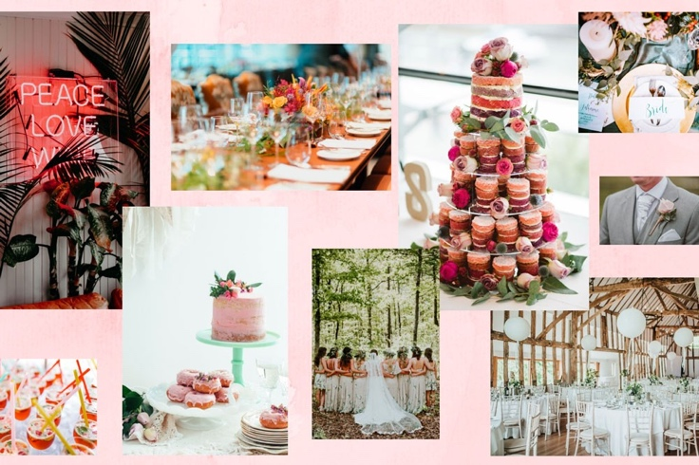](https://www.pinterest.co.uk/hitchedcouk/)

Step 3: Choose Your Theme

[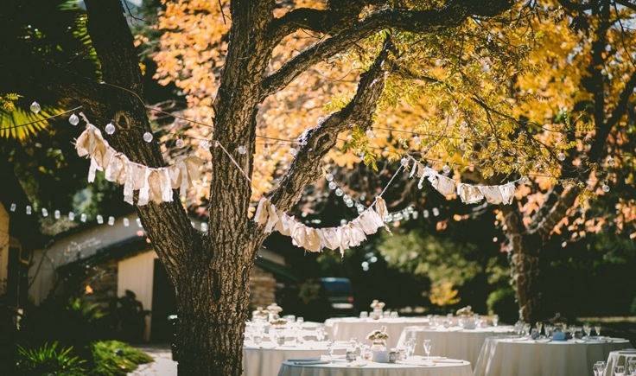](https://www.hitched.co.uk/wedding-planning/organising-and-planning/a-guide-to-wedding-themes_186.htm)

After a little time browsing the likes of Pinterest and our wedding inspiration ideas, it’ll become clear what style of wedding is for you.

Whether you choose a few key colours or an actual wedding theme (like a festival theme or a vintage theme for example), it’s important to choose something to base your wedding around.

Making supplier decisions will be much easier once you know what you’re after, and it will be much easier to ensure everything matches. Our only bit of advice? Once you’ve decided on a theme, *stick to it*, and try and ignore anything which doesn’t fit in.

**Step 4: Find Your Perfect Venue**

Once you’ve set a budget and decided on a theme, you can start to think about choosing a wedding venue which fits in with it all. Your wedding venue will determine your wedding date, location and your maximum guest numbers, so make choosing your venue a priority.

Before you start the hunt for your venue, sit down together and talk about what you both want from your wedding and what type of venue will fit with the theme you’ve chosen. If one of you is picturing a fairy-tale castle venue and the other is dreaming of a rustic barn then you may need to compromise.

Think about other important factors such as whether you want to have a wedding venue with accommodation, whether you want to use your own caterers and what your evening guest number is likely to be. All these factors will play a part in determining which wedding venue you choose.

[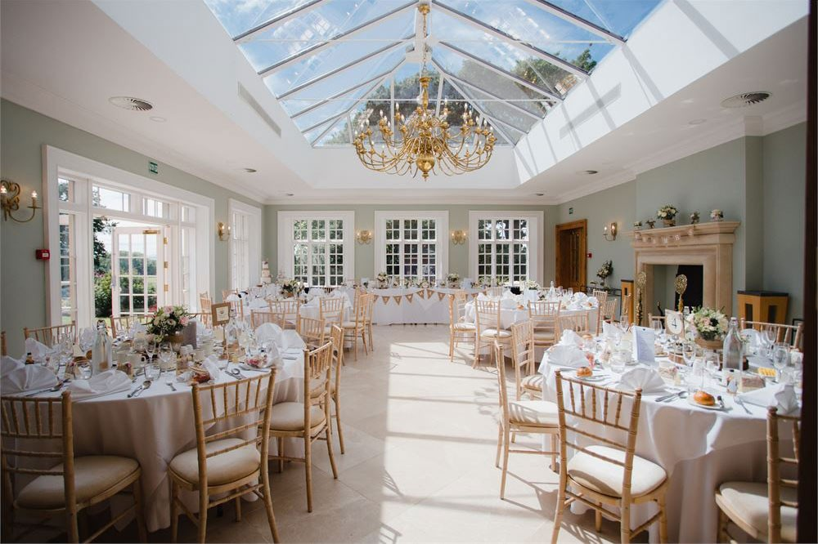](https://www.hitched.co.uk/wedding-venues/willington-hall-hotel_394.htm) *Image:*[*Willington Hall Hotel*](https://www.hitched.co.uk/wedding-venues/willington-hall-hotel_394.htm)

**Step 5: Buy Wedding Insurance**

[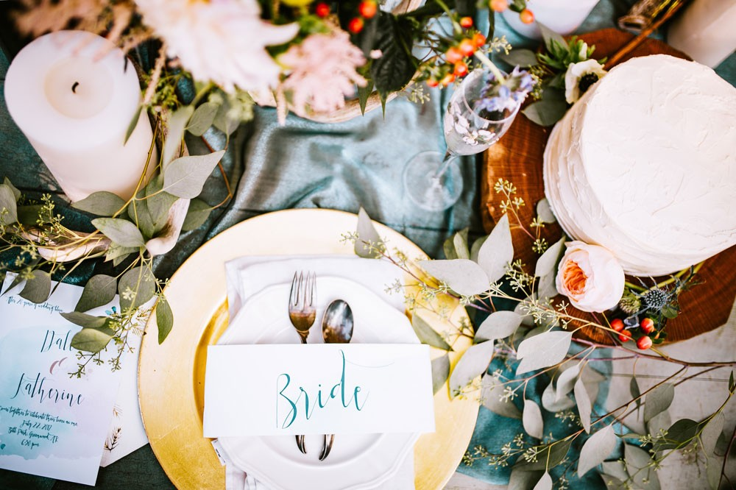](https://www.hitched.co.uk/insurance/)

According to the National Wedding, the average UK wedding costs just under £32,000. A £32,000 wedding budget may seem like a lot but when you consider the cost of your venue, catering, alcohol, the dress and the many other wedding essentials, you’ll soon see how much they add up to.

While it’s not very romantic to think about what might go wrong with your wedding, it’s always best to be prepared. Purchasing wedding insurance from the moment you start spending money on your wedding could really help with peace of mind for both your wedding and honeymoon spend.

**Step 6: Make it Legal**

In the midst of dreaming about colour schemes and wedding playlists, you also need to make time to get your marriage license. This might not be one of the first things you actually need to do, but it should be in the back of your mind from the off-set.

Research what you need and start to gather the necessary marriage documents from early on in your wedding planning process.

Just remember, marriage licenses are typically only valid for a couple of months, so you’ll need to plan accordingly!

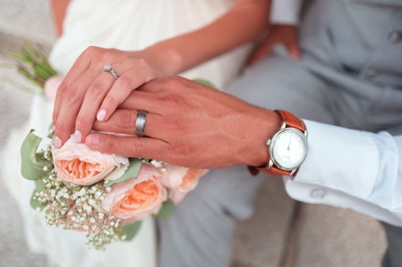

**Step 7: Choose Your Bridal Party**

[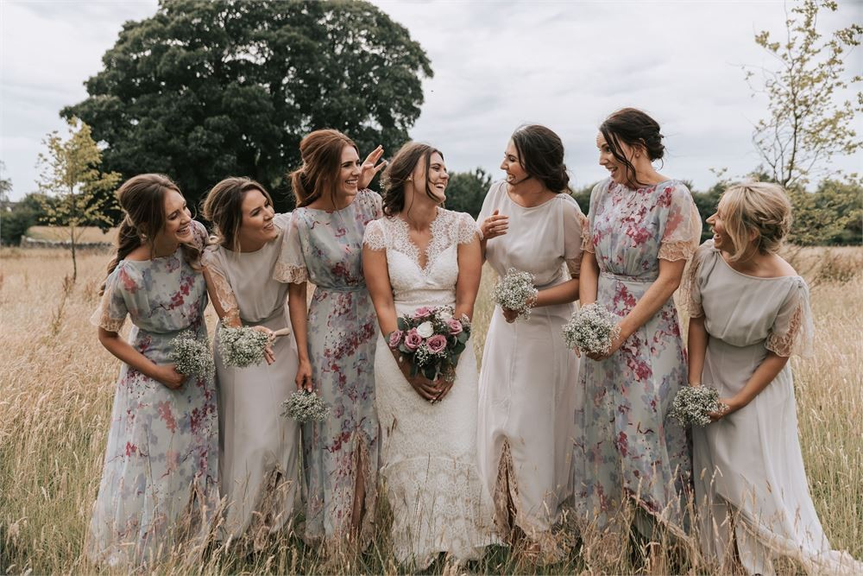](https://www.hitched.co.uk/wedding-photographers/co-down/silent-valley-photography_36467.htm)

*Image Credit –*[*Silent Valley Photography*](https://www.hitched.co.uk/wedding-photographers/co-down/silent-valley-photography_36467.htm)

You may instantly know who your maid of honour, bridesmaids, ushers, best man, flower girls and page boys will be, or you might need a little bit of time to think about it.

If you’re not sure then don’t feel rushed into your decision. Think carefully about who will be the best people to support you and your OH on this special day and in the run up to it.

You may also want to consider the cost as your bridal party will need outfits, bouquets, buttonholes and thank you gifts, so the more people you have, the more this could impact your budget.

**Step 8: Plan Your Wedding Guest List**

Where do you start with planning your guest list? The truth is, you have probably already thought about it and you know the key people you want to invite.

Despite this, you might need a bit of time to decide who to invite to the day versus the evening and what to do about the trickier guest problems such as plus ones and colleagues.

With your wedding venue booked, you will have a rough idea of how many people your venue allows and how much budget you are now able to spend on catering. Your guest list may need to be determined by how much you want to spend per head.

We would suggest adding everyone you would like to invite and then work as a couple to cut this list down if you have gone over your expected numbers.

[](https://www.hitched.co.uk/planner/guest-manager/)

**Step 9: Choose Your Wedding Suppliers**

[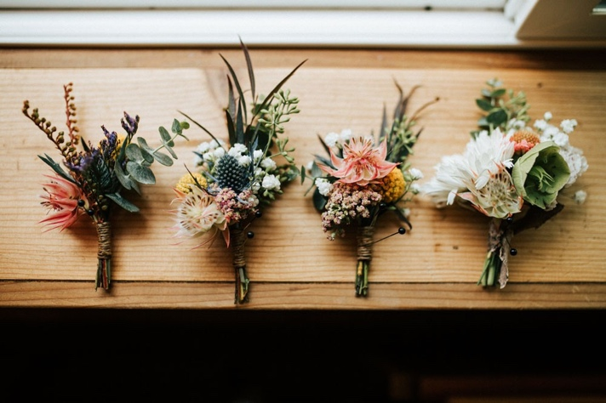](https://www.hitched.co.uk/wedding-suppliers/)

This is probably the biggest step of our wedding planning guide, since it covers everything from photographers to caterers and florists. Start by making a list of all the suppliers you’re going to need to hire. Your wedding venue may already have a list of recommended suppliers which is a great place to start, but make sure you widen your search if you want something a little different *before* you book and pay deposits.

Contact the wedding suppliers you think suit your wedding style and then sit down with your partner and spend some time comparing prices and services to find what suits your style and your budget. Don’t be afraid to shop around!

**Step 10: Buy Your Dress, Bridesmaid Dresses & Grooms wear**

Choosing your wedding dress will be one of the most exciting and emotional parts of your wedding planning.

A lot of designer wedding gowns can take up to six months to make, so give yourself plenty of time to find the dress of your dreams.

Once you have chosen your wedding dress, you can think about bridesmaid dresses that will compliment your wedding gown, and grooms wear that will suit the style of your big day.

[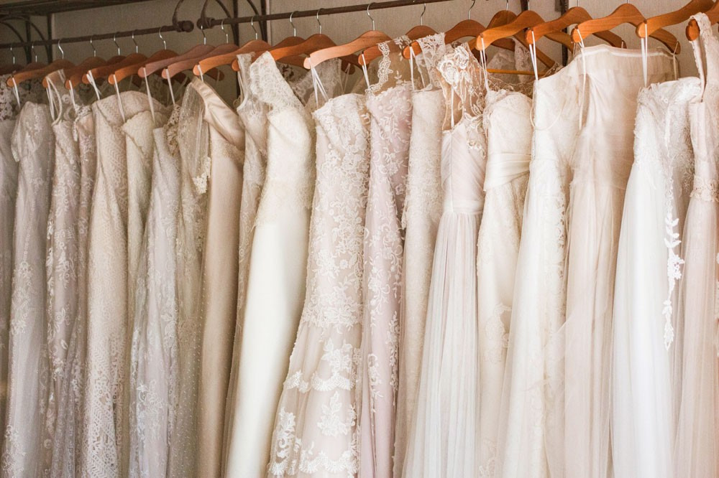](https://www.hitched.co.uk/wedding-dresses/)

**Step 11: Create a Schedule of the Day’s Events**

[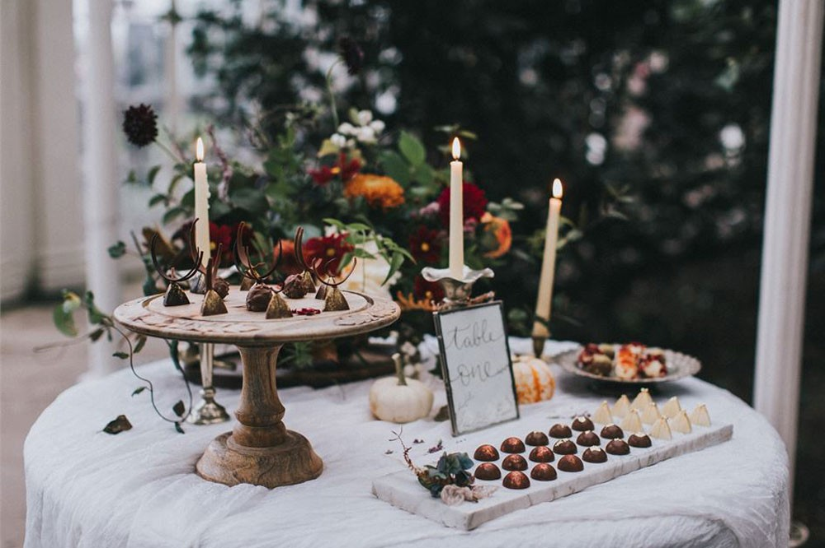](https://www.hitched.co.uk/wedding-venues/wollaton-hall-and-deer-park_6402.htm)

*Image: [Woolaton Hall](https://www.hitched.co.uk/wedding-venues/wollaton-hall-and-deer-park_6402.htm)*

At this point, it’s important to create a schedule for the day’s events. Not only will this give you and your suppliers something to work from, but it’ll remind you if there’s anything you’ve forgotten.

What’s more, writing everything down will help you create your ‘Order of the Day’ cards which you might want to match with your wedding invitations.

On your schedule, include things like when your vendors will arrive, what time the ceremony will take place, what time you’ll take photos and what time you’ll sit down to eat. You can also include what time the first dance will happen and what time you’ll cut the cake.

Be sure to give a copy of your run of events to your photographer, venue, maid of honour, DJ, ushers and anyone else who should be in the know!

**Step 12: Create a Wedding Gift List**

It’s almost time to send your wedding invitations, but before you do, you might want to think about starting a wedding gift list, because you can send details of this with your invites.

Although it may feel strange telling guests what you want as a gift, it will actually make the whole process easier for them. Your guests are going to want to buy you a wedding gift, so save them the stress of trying to decide what to buy and create a wedding gift list, whether it be a honeymoon fund, an online gift list or a traditional department store list.

[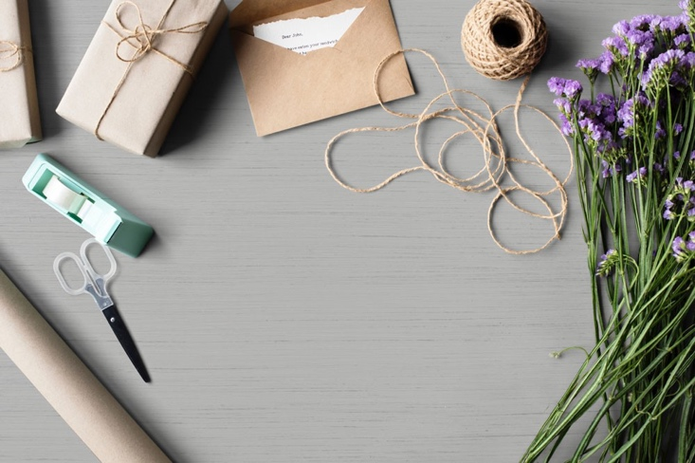](https://www.hitched.co.uk/giftlist/)

**Step 13: Send Your Save the Dates and Invitations**

[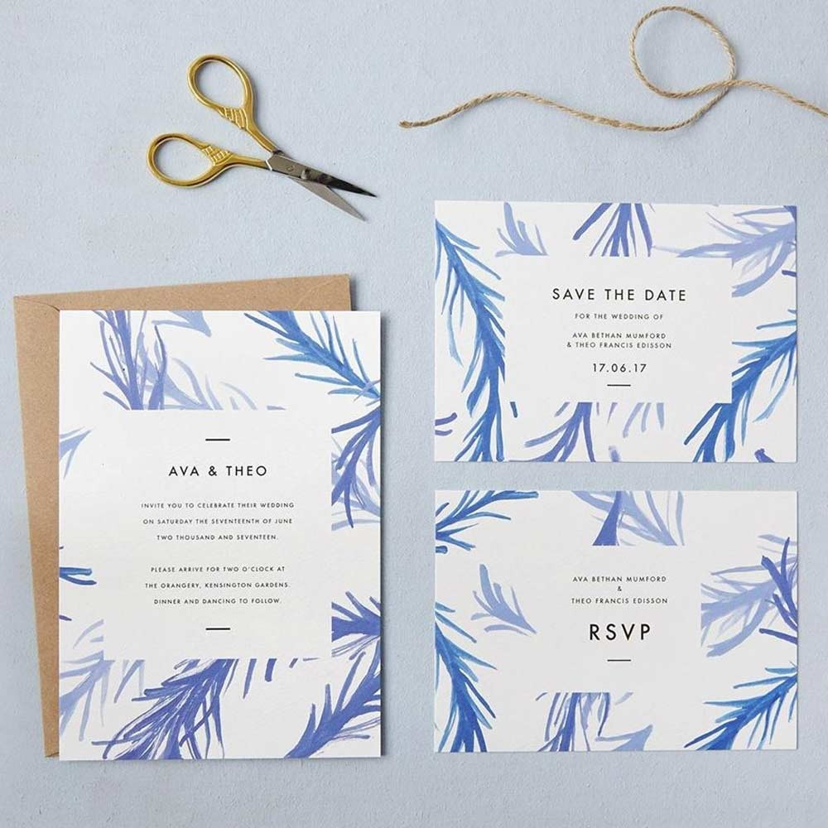](https://www.hitched.co.uk/wedding-stationery/london/studio-sophie_36836.htm)

*Image Credit –*[*Studio Sophie*](https://www.hitched.co.uk/wedding-stationery/london/studio-sophie_36836.htm)

Whilst you’ve probably already told everyone you know about your upcoming marriage, now is the time to make it official.

Your wedding invitations should be sent out approximately 3-6 months in advance of your big day, but it’s never too early to choose a design, style or stationery supplier that you love.

In order to give your guests as much notice as possible, why not send out ‘save the date’ cards as soon as the venue is booked to announce your wedding and ensure your guests keep that date free, with an ‘official invitation to follow’ note?

**Step 14: Book Your Honeymoon**

Booking your honeymoon will be one of the most fun parts of your wedding planning – you are basically planning your dream holiday!

If you have planned your honeymoon costs and budgeted for them then you can book something straight away, or you may have chosen to use your gift list to subsidise some of your honeymoon. If this is the case, you might want to wait until after the wedding to book.

If you are still feeling budget conscious then you could always plan a minimoon for straight after the wedding – giving you a few days to escape, relax and enjoy your newlywed status.

You can then spend some time after the wedding saving towards a bigger trip later in the year that will be your official honeymoon.

[](https://www.hitched.co.uk/honeymoons/)

**Step 15: Collect RSVPs and Create a Table Plan**

[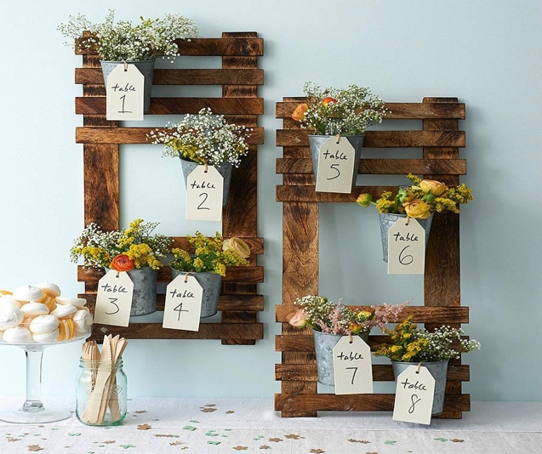](https://www.hitched.co.uk/wedding-planning/organising-and-planning/wedding-table-plans_480.htm)

*Image Credit –*[*Wedding in a Teacup*](https://weddinginateacup.co.uk/)

Be prepared that there may be a few guests that you need to chase up! Once you have your final numbers, you will be able to start working on your table plan.

Put your wedding guests into family and friend groups and then play around with your tables to see who will fit where. It may also be worth considering whether you have any guests that will need easier access in and out of the room, such as those with young children or the elderly, as you might want to seat those guests nearer the doors.

Once your table plan is complete then it’s time for the fun bit… you can get creative and think about what table names you are going to use and how you are going to display your table plan.

**Step 16: Arrange Stag & Hen Nights**

Hopefully your awesome bridesmaids and amazing best man will have this covered, but make sure you know if there’s anything you need to prepare for, pack or pay for so you can factor this into your planning and your budget.

You also want to ensure that the timings suit both you and your partner – gone are the days where stag and hen parties take place the night before the wedding (eek!) so make sure the dates and arrangements are appropriate.

[](https://www.hitched.co.uk/wedding-planning/stag-and-hen/)

**Step 17: The Finishing Touches**

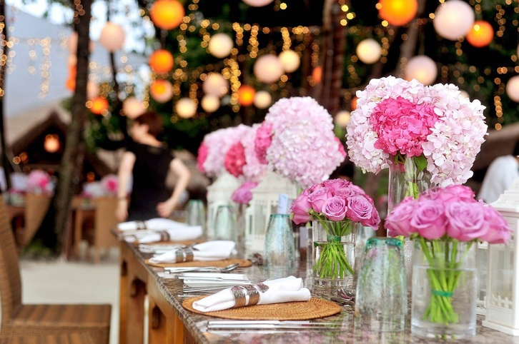

Now you have all the main things covered, it’s time to think about those little details.

Decide on your wedding songs and readings for the ceremony, think about who is going to do speeches at the wedding breakfast, and order any thank you gifts that you want to give to those who have really helped during the planning process.

If you have additional budget leftover then you might also want to buy some last minute additional decor items.

The joy really is in these little details, so enjoy piecing together all the finishing touches!