Forecasting Australian Carbon Credit Prices
A Time-Series Study
Report generated: 15 June 2026

Contents
1. Introduction (with Executive Summary)
2. Data and Cleaning
3. Exploratory Analysis
4. Feature Engineering
5. Baselines and Evaluation Framework
6. Modelling Results (RF, XGB, LGBM, SARIMAX)
7. Deep Learning Results (LSTM, GRU)
8. Statistical Significance (Diebold-Mariano Tests)
9. Model Explainability (SHAP)
10. Limitations
11. Conclusion and Future Work

1. Introduction
This report presents a time-series forecasting study of the Australian Generic carbon-credit spot price (ACCU Generic) at horizons of 1, 7, and 30 calendar days ahead. Australian Carbon Credit Units (ACCUs) represent one tonne of CO₂-equivalent abated or sequestered under government-registered emissions reduction methods. The ACCU Generic price is the benchmark market price, reflecting arms-length transactions in the secondary market across all eligible methods.
The guiding methodological principle of this study is that forecasting skill can only be claimed relative to a naive baseline. The benchmark throughout is the random-walk model: tomorrow’s forecast equals today’s observed price. A model that fits well by conventional metrics (R², in-sample RMSE) but cannot beat this baseline provides no actionable information about future price direction. All performance comparisons are therefore expressed as percentage improvement in RMSE and MAE over the random-walk forecast; statistical significance is assessed using the Diebold–Mariano test.
A secondary theme is methodological hygiene in feature construction. The raw data contain columns that are arithmetically derived from the target (lagged changes, year-to-date percentage returns) and columns that can reconstruct the target level (sibling-method prices and their premiums over Generic). Using such columns as predictors produces inflated in-sample accuracy but no genuine forecasting skill. Section 4 documents the feature audit that excludes these columns before any model is fitted.

Executive Summary
Across all three forecast horizons (h = 1, 7, and 30 calendar days) and all six candidate models — Random Forest, XGBoost, LightGBM, SARIMAX, LSTM, and GRU — no model achieves a statistically significant improvement in forecast accuracy over a naive random-walk benchmark on the held-out test set. This result is confirmed by the Diebold-Mariano test with Harvey-Leybourne-Newbold small-sample correction (all p-values > 0.05 for the 'better than RW' hypothesis). Several models are significantly worse than the random walk at h = 7 days.
The best point estimate is a modest +1.0% RMSE skill score at h = 1 (LSTM, test set), but this is within the range of statistical noise given the 247-row test series. A faint directional signal (~57–60% accuracy on genuine-move days at h = 1) is detectable but does not translate into a meaningful reduction in forecast error.
SHAP analysis of the best tree model (Random Forest, h = 1) reveals that the model primarily learns to detect market staleness — whether the market is actively trading or carrying forward the previous day's price. In the training data, 75% of days are stale (zero price change); the random walk also predicts zero change every day, so the model gains nothing over the baseline on stale days and cannot compensate on the fewer genuine-move days.
The contribution of this study is therefore methodological: it demonstrates the importance of rigorous benchmark comparisons, the Diebold-Mariano test as the correct arbiter of forecasting skill, leakage-free feature construction, and an honest engagement with the near-efficient, highly illiquid structure of the Australian ACCU spot market. The random walk is the rational benchmark here, and it is not beaten — a credible and defensible result.

2. Data and Cleaning
The dataset consists of daily price and volume observations from the Australian carbon and renewable-certificate markets, spanning 2 January 2018 to 15 November 2024 (1,651 trading days). The raw file contained 97 columns covering spot prices across multiple abatement methods, forward-contract price series, volume figures, week-on-week and year-to-date change columns, and market-assessment type indicators.

2.1 Cleaning Pipeline
A principled, leakage-free cleaning pipeline was applied in the following order to produce three non-overlapping chronological splits:
- Symbol stripping: dollar signs, percentage signs, and thousands-comma separators were removed from all value columns before numeric coercion.
- High-missingness drop: 41 columns with more than 70% missing values were removed. These were predominantly forward-contract series (CAL 21–26 and method-specific analogues) that are only sparsely quoted, plus illiquid-method columns (No-AD, Landfill Gas, Swaps, Assessment Types).
- Near-constant drop: 6 additional columns where more than 99% of training-set values were identical were dropped (four calendar-year traded-volume columns and two CAL 26 change columns).
- Forward-fill imputation on the full chronologically sorted series. This is strictly past-only: each missing entry is replaced by the most recent prior observation. Backward-fill was never applied. Carrying the last known price across a weekend or public holiday is the correct market convention and introduces no look-ahead.
- Residual NaN fill: the small number of leading NaN values at the start of each series (unreachable by forward-fill) were filled with the training-set column mean or mode. Validation and test statistics were never consulted.
After cleaning, 50 columns remained across 1,651 observations with zero missing values.

2.2 Chronological Split and Regime Shift
The data were split chronologically by row position: training (70%, 1,155 rows, 2018-01-02 to 2022-12-01), validation (15%, 248 rows, 2022-12-02 to 2023-11-23), and test (15%, 248 rows, 2023-11-24 to 2024-11-15). No shuffling was performed at any stage.
A critical structural feature is the pronounced regime shift between the training period and the out-of-sample sets. During training, the ACCU Generic price ranged from A$13.25 to A$57.15 (mean A$21.55), capturing the 2021–22 price spike driven by policy expectations. The validation and test sets occupy a narrower, higher plateau (means A$33.66 and A$34.82 respectively, range approximately A$26–$42). This regime shift has three practical consequences for the analysis:
- It motivates the random-walk as the primary benchmark: a model trained on the training mean would systematically underpredict the out-of-sample level, so level forecasting accuracy must be compared against the simplest possible extrapolation of the most recent observation.
- It motivates modelling first differences (daily changes) rather than price levels, since the distribution of daily changes is far more regime-stable than the distribution of levels.
- It validates the strict chronological split: any reshuffling of rows would leak post-spike observations into the training set, artificially improving in-sample fit and producing an over-optimistic evaluation.
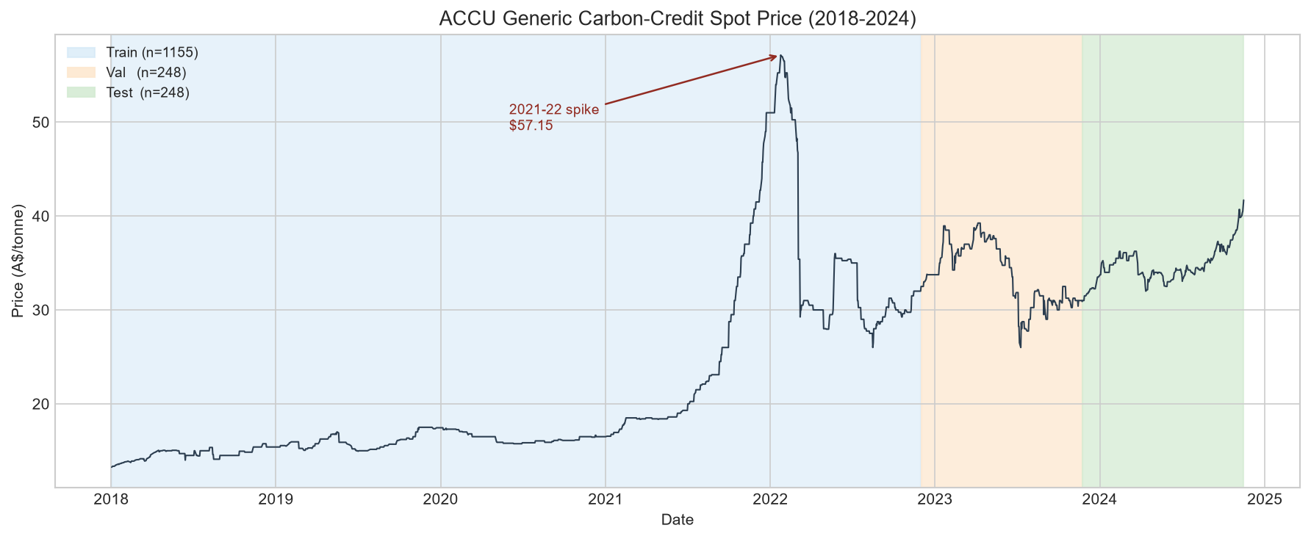
Figure 1. ACCU Generic price over the full sample period (2018-2024). Shaded regions indicate the training (blue), validation (orange), and test (green) splits. The 2021-22 price spike is annotated.
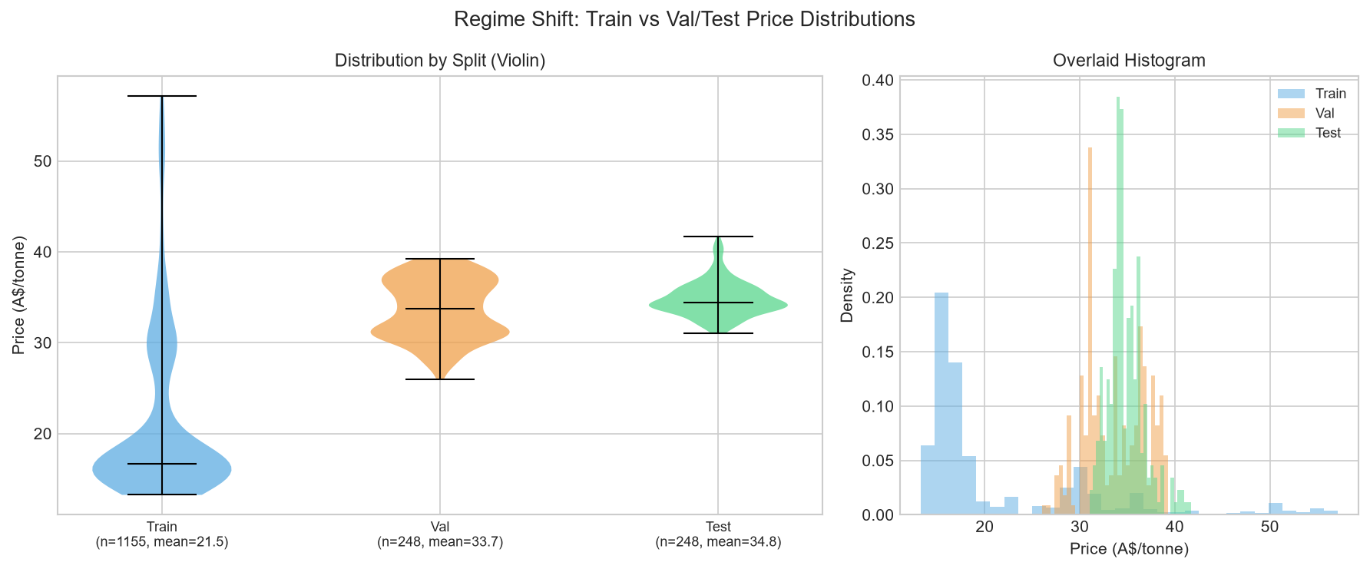
Figure 2. Price distribution by split (violin plot, left; overlaid histogram, right). The training distribution is wide and left-skewed due to the 2021-22 spike; validation and test occupy a narrower high-price regime.

3. Exploratory Analysis
All statistical tests and parameter choices reported in this section were computed on the training split only. Figures show all three splits for visual context.

3.1 Stationarity Tests
The Augmented Dickey–Fuller (ADF) and Kwiatkowski–Phillips–Schmidt–Shin (KPSS) tests were applied to the price level and the daily first difference on the training set.
ADF — price level: statistic = -1.2196, p-value = 0.6651. The null hypothesis of a unit root cannot be rejected (p > 0.05). The price level is non-stationary.
ADF — daily change: statistic = -16.5625, p-value < 0.0001. The null hypothesis is strongly rejected. The daily change is stationary.
KPSS — price level: statistic = 3.3121, p-value <= 0.01 (table-bounded). H₀ of stationarity is rejected at the 1% level. Confirms the level is non-stationary.
KPSS — daily change: statistic = 0.0697, p-value >= 0.10 (table-bounded). H₀ cannot be rejected. The daily change is stationary.
The joint verdict is unambiguous: the price level is integrated of order one I(1), and the daily first difference is I(0). Forecasting the level is therefore equivalent to cumulating a stationary series; the random-walk baseline (which does exactly this) is hard to beat.

3.2 Market Staleness
A critical but initially non-obvious feature of this market is its extreme illiquidity. The data source records one row per calendar day, but genuine price-discovery events — days on which at least one trade executes — are rare. On 75.1% of training-set days, the price does not change at all from the previous observation. The corresponding figures are 59.1% for the validation set and 45.7% for the test set. Only 287 of 1,153 training observations represent genuine price moves.
These zero-change days are not independent observations of a flat market; they are calendar days on which no trade occurred and the dataset carries forward the previous closing price. Stale runs as long as 34 consecutive days are present in the training set (Figure 6). Treating all calendar-day observations as equally informative inflates the effective sample size and biases any autocorrelation analysis.
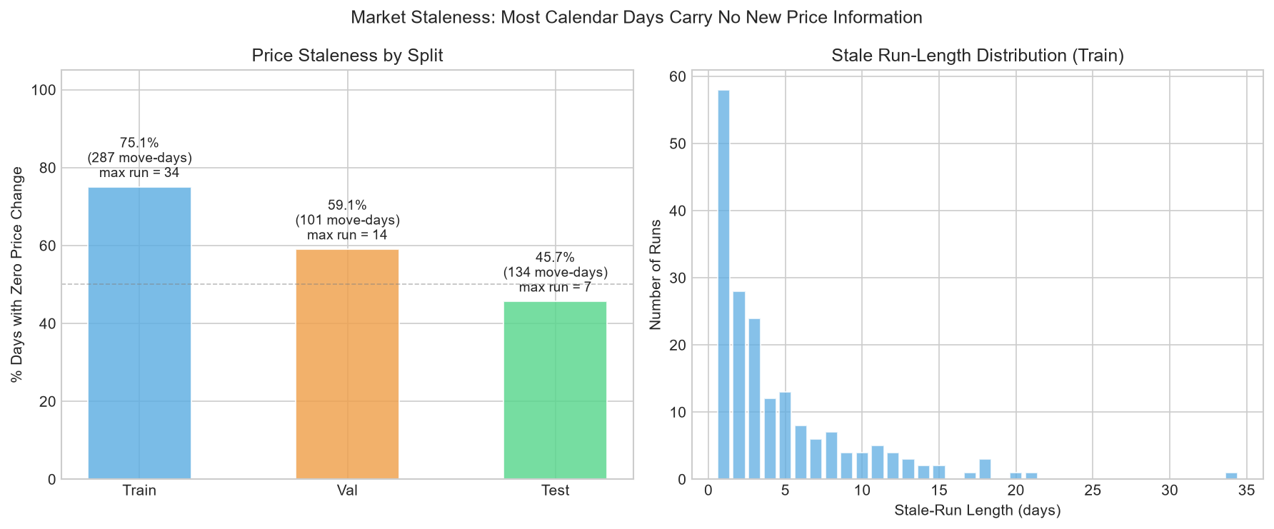
Figure 6. Left: percentage of zero-change days by split (with number of genuine move-days and longest stale run annotated). Right: distribution of stale run lengths in the training set — runs of 5 or more consecutive stale days are common, with a maximum run exceeding 30 days.

3.3 Autocorrelation Structure (Corrected)
Figure 5 shows the ACF and PACF for both the price level and the daily first difference (40 lags, training set only). For the price level, the ACF coefficient at lag 1 is 0.9977 and remains near 1.0 across all displayed lags, consistent with near-random-walk dynamics.
The naive ACF of the daily change series shows a prominent spike at lag 2 (ACF ≈ 0.334). This is an artefact of market staleness, not a genuine market signal. Because the majority of consecutive observations are identical (carried-forward prices), differencing two adjacent stale rows produces two consecutive zeros, inflating the lag-2 autocorrelation through the accumulation of tied zero-change pairs.
Figure 7 isolates the genuine-price-discovery signal by re-computing the ACF using only the 287 non-zero-change training days. On these days, the lag-2 coefficient collapses to 0.142 (confirming it was an artefact), while the lag-1 coefficient is 0.406 — a genuine short-run momentum effect: price moves tend to continue in the same direction for one additional trading day. This lag-1 momentum signal is the primary linear predictive structure exploited in the feature set.
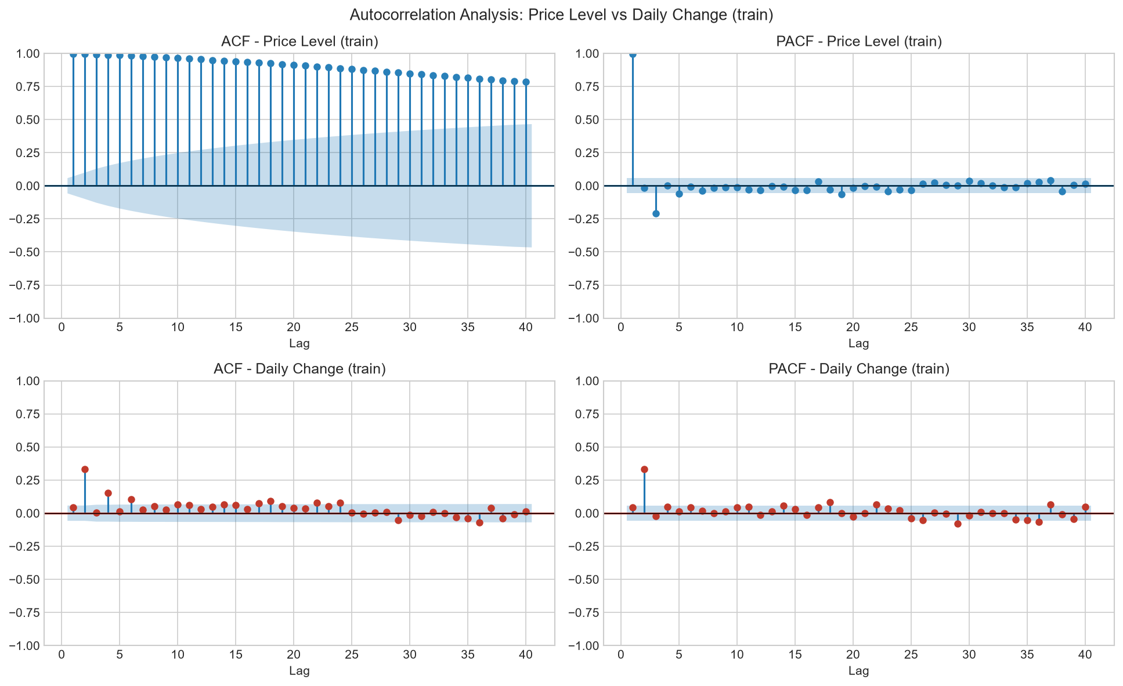
Figure 5. ACF and PACF for the price level (top row) and daily change (bottom row), computed on the training set only (40 lags, 5% confidence bands). Level ACF ≈ 1.0 across all lags (non-stationary); change ACF shows a spurious lag-2 spike that disappears on genuine-move days (see Figure 7).
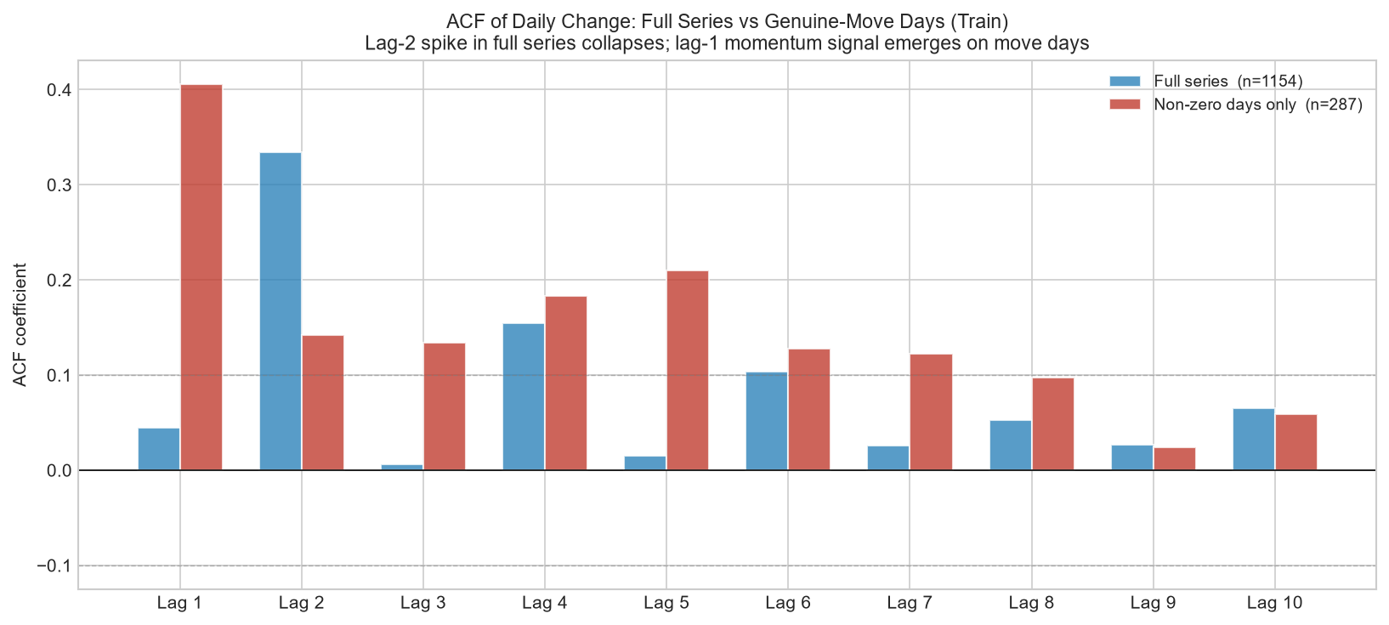
Figure 7. ACF of daily price change: full series (blue) vs genuine-move days only (red), training set. The lag-2 spike collapses from ≈0.33 to ≈0.14 — a forward-fill artefact. The lag-1 momentum signal (≈0.41) on move-days is genuine.

3.4 Returns Distribution and Volatility Clustering
Daily price changes on the training set have mean 0.0167 A$/tonne (effectively zero), standard deviation 0.5133, skewness -10.03, and excess kurtosis 242. The extreme kurtosis indicates heavy tails: large positive or negative moves occur far more frequently than a Gaussian would predict. The strong negative skewness reflects occasional large downward repricing events. Both properties imply that RMSE and MAE on a few large-move days can dominate overall evaluation metrics.
The rolling 30-day volatility (Figure 4) shows clear volatility clustering. The 2018–2020 period is relatively calm; a high-volatility episode accompanies the 2021–22 price spike; and the post-spike period (val and test) is again calmer. This heteroskedasticity is relevant when interpreting the test-set results: the evaluation period is a low-volatility regime relative to the most turbulent part of the training set.
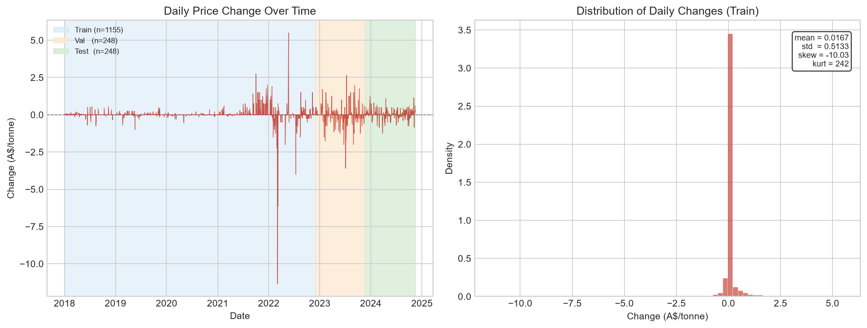
Figure 3. Daily price changes over the full sample period (left panel) and the distribution of daily changes on the training set (right panel). Near-zero mean; heavy tails; extreme excess kurtosis.
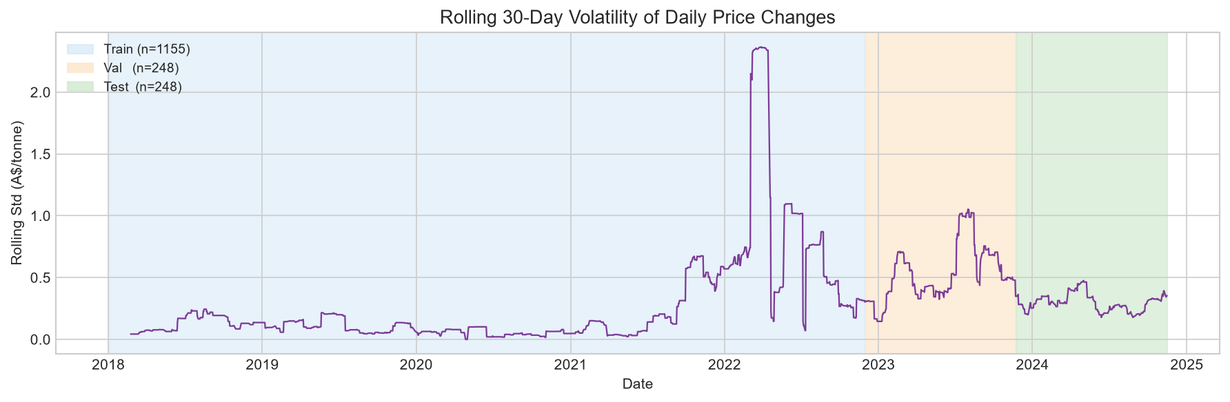
Figure 4. Rolling 30-day standard deviation of daily price changes. Volatility clustering is visible: the 2021-22 spike period shows markedly higher volatility than the surrounding years.

4. Feature Engineering
All features are constructed from the full chronologically sorted series using only lagged values and strictly trailing rolling windows. No centered windows, no backward-fill, and no information from validation or test rows enters any feature calculation. The first 30 rows of the training set (the warm-up period required to populate the 30-day rolling windows) are dropped after feature construction.

4.1 Forecast Targets
Three forecast targets are defined, one per horizon h ∈ {1, 7, 30}:
- target_1 = price(t+1) − price(t) (1-day-ahead price change)
- target_7 = price(t+7) − price(t) (7-day-ahead cumulative change)
- target_30 = price(t+30) − price(t) (30-day-ahead cumulative change)
Modelling the change, not the level, is motivated by the stationarity results in Section 3.1 (the level is I(1)) and by the pronounced regime shift between the training and out-of-sample sets. All evaluation metrics are computed on the change, and the random-walk forecast corresponds to predicting zero change.

4.2 Feature Audit: Excluded Columns
Before constructing features, a formal audit excluded three categories of columns that would introduce data leakage or level-reconstruction artefacts:
Category 1 — Target-derived columns: The raw dataset contains columns that are arithmetic functions of the target price level: the daily change ($ Change), week-on-week change, YTD percentage return, and the 7/30/50/100-day SMAs and percentage changes. Retaining any of these would allow a model to invert them to obtain the contemporaneous price level, defeating the purpose of modelling changes. All 18 such columns are excluded.
Category 2 — Sibling price levels and premiums: The HIR and SFM ACCU sub-method prices are correlated with the Generic price but can also reconstruct it: Generic = HIR_price − HIR_premium. Retaining the sibling price levels or their premium-over-Generic columns would enable level reconstruction and produce inflated in-sample R² with no genuine forecasting value. Four price levels and four premium columns are excluded.
Category 3 — Raw sibling change columns: The dataset also pre-computes dollar changes and week-on-week changes for HIR and SFM. These are re-derived from scratch (from the sibling price diffs) to ensure exact replication of the construction logic. The pre-computed versions are excluded to avoid double-counting.

4.3 Feature Groups
After exclusions, the following feature groups are constructed:
Group A — Momentum (change family, 5 features): chg_0, chg_1, chg_2, chg_3, chg_5. chg_0 = price(t) − price(t−1): the most-recent realised change, fully available at the close of day t and the direct carrier of the lag-1 momentum signal (corr ≈ +0.045 with target_1 on the full series; ≈ +0.41 on genuine-move days only). chg_1 through chg_5 are further lags. Note: chg_2 shows an apparent train correlation of ≈ +0.33 — this is largely the forward-fill artefact identified in Section 3.3 (lag-2 ACF of the full change series), not a reliable signal; models should not be expected to rely on it out-of-sample.
Group B — Staleness features (4 features): price_moved (1/0 flag), days_since_last_move, moves_7d (number of move-days in trailing 7 days), moves_30d (move-days in trailing 30 days). These encode the market-liquidity context at each row — essential given that 75% of observations are stale carries.
Group C — Volatility regime (2 features): vol_chg_7d and vol_chg_30d: trailing 7- and 30-day rolling standard deviation of daily changes. These capture local heteroskedasticity.
Group D — Volume (4 features, if present): vol_generic_raw (raw traded volume), vol_generic_log1p (log1p-transformed), vol_generic_trail7 (7-day trailing average), vol_generic_zero (1/0 zero-volume day flag). Volume is a direct proxy for trading activity.
Group E — Calendar (2 features): dow (day of week, 0=Monday) and month. Carbon-credit trading shows day-of-week and seasonal patterns due to compliance cycles.
Group F — Exogenous diffs (up to 8 features): First differences of sibling prices (lgc_chg, stc_chg, hir_chg, sfm_nc_chg, sfm_cb_chg, erf_chg) and trailing volume averages for HIR and SFM methods. Levels and premiums are excluded (Category 2 audit above); only changes are used.
After construction and warm-up removal, the feature matrix contains 25 features. Training set shape: (1125, 30); validation: (248, 30); test: (247, 30).
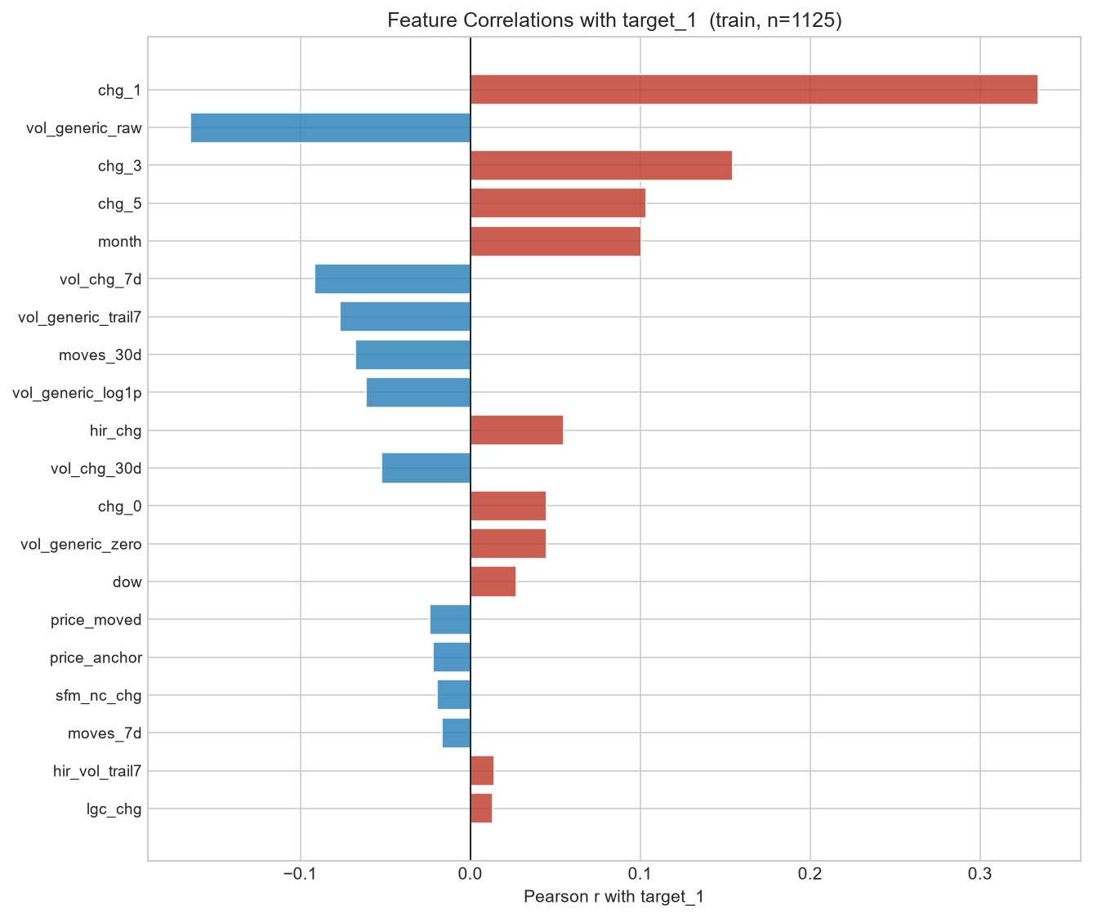
Figure 8. Pearson correlations of each feature with the 1-day-ahead target (target_1) on the training set. Positive (red) bars indicate momentum-aligned features; negative (blue) bars indicate mean-reverting signals. The staleness and lag features dominate the top rankings.

5. Baselines and Evaluation Framework
This section defines the evaluation framework used throughout the study and establishes the baseline forecasts against which every subsequent model is judged.

5.1 The Random-Walk Benchmark
The primary benchmark is the random-walk (RW) forecast: at time t, the predicted h-day-ahead price is simply price(t). Equivalently, the predicted h-step change is zero. This is the correct null hypothesis for any I(1) series and, in illiquid markets such as the ACCU spot market, it is empirically difficult to beat even with sophisticated methods.
A secondary, slightly more informed reference is the drift forecast: the predicted h-step change equals h times the trailing 30-day mean daily change. This allows for a persistent trend in the recent past without any exogenous information. Seasonal-naive forecasting is omitted: the ACCU spot market shows no stable calendar seasonality — price dynamics are policy-driven and dominated by the staleness structure documented in Section 3.2.

5.2 Evaluation Metrics
For all models and baselines, predictions are expressed as h-step price changes. To evaluate, the predicted level is reconstructed as price_anchor + predicted_change, where price_anchor = price(t). Metrics are computed on the reconstructed level:
- RMSE and MAE (A$/tonne). Note: because the anchor cancels in the residual, RMSE on the reconstructed level is identical to RMSE on the raw change — both are reported in units of A$/tonne and are directly interpretable.
- MAPE (%) on the reconstructed level. This is low for short horizons because most calendar days are stale (zero change, so pred = actual).
- Directional accuracy (%): the fraction of rows where the predicted sign of the change matches the actual sign. Computed exclusively on genuine-move rows (actual change ≠ 0), since direction is meaningless for stale days where both prediction and actuality are zero.
The headline metric is the skill score:
RMSE skill score = 100 × (1 − RMSE_model / RMSE_random_walk) [%]
A positive skill score means the model beats the random walk. A negative skill score means it is worse. Zero means tied. The same formula is applied to MAE. The skill score is the only metric reported in the executive summary.

5.3 Walk-Forward Cross-Validation
All ML/DL models in subsequent sections will be tuned using walk-forward (rolling-origin) cross-validation on the training set, implemented via scikit-learn's TimeSeriesSplit. Standard k-fold cross-validation is never used: it would validate on the past using folds from the future, producing optimistic hyperparameter estimates that do not generalise to the deployment horizon. This section reports only the two baselines, which require no tuning.

5.4 Baseline Performance
Table 1 reports RMSE, MAE, MAPE, and directional accuracy for the random-walk and drift baselines on the validation and test sets. Skill scores for the drift are relative to the random walk. By construction, the random-walk skill score is 0% for every horizon.

Model | h | test RMSE | test MAE | test MAPE_% | test dir_acc_% | test RMSE_skill% | val RMSE | val MAE | val MAPE_% | val dir_acc_% | val RMSE_skill%
Drift | 1 | 0.3180 | 0.2017 | 0.58 | 61.2 | 0.24 | 0.5924 | 0.3212 | 0.98 | 60.8 | -1.54
Drift | 7 | 0.9634 | 0.7513 | 2.16 | 59.4 | -2.86 | 1.7298 | 1.3420 | 4.10 | 44.4 | -11.75
Drift | 30 | 2.1519 | 1.7076 | 4.93 | 68.1 | -15.48 | 4.4096 | 3.4438 | 10.57 | 44.5 | -40.11
Random Walk | 1 | 0.3187 | 0.1858 | 0.53 | 0.0 | 0.00 | 0.5834 | 0.2786 | 0.86 | 0.0 | 0.00
Random Walk | 7 | 0.9367 | 0.7359 | 2.10 | 0.0 | 0.00 | 1.5479 | 1.1589 | 3.53 | 0.0 | 0.00
Random Walk | 30 | 1.8635 | 1.5261 | 4.29 | 0.0 | 0.00 | 3.1471 | 2.3788 | 7.32 | 0.0 | 0.00
Table 1. Baseline performance on validation and test sets. RMSE and MAE in A\$/tonne. MAPE and dir_acc in %. Skill scores relative to the random-walk baseline (positive = better).

6. Modelling Results
This section reports the forecasting performance of tree-based ML models (Random Forest, XGBoost, LightGBM) and a univariate SARIMAX benchmark, evaluated at horizons h = 1, 7, and 30 days.

6.1 Walk-Forward Validation Protocol
All ML models were tuned using scikit-learn's TimeSeriesSplit with n_splits = 5 expanding-window folds applied exclusively to the training set. For each model and horizon the following three-phase protocol was followed:
- Phase 1 — Tune: GridSearchCV over a predefined hyperparameter grid, using TimeSeriesSplit(n_splits=5) as the inner cross-validator and RMSE as the scoring metric. The search space is kept deliberately small (4–8 candidate configurations) to limit computational cost while still exploring the most impactful dimensions (tree depth, learning rate, number of estimators).
- Phase 2 — Val evaluation: The best estimator from Phase 1 (refit on the full training set with the winning hyperparameters) is used to generate predictions for the validation set. No validation data is seen during Phase 1.
- Phase 3 — Test evaluation: The best estimator is refit from scratch on the combined training + validation set (with the same hyperparameters selected in Phase 1) and used to predict the held-out test set exactly once.
Why random k-fold is wrong for time-series data: standard k-fold cross-validation creates folds by random permutation, so validation examples from the past are used to assess models trained on the future. This constitutes look-ahead bias — the hyperparameters selected will appear to generalise well in-sample but will systematically over-estimate performance on any future deployment horizon. TimeSeriesSplit enforces strict temporal ordering: every training fold ends strictly before the corresponding validation fold begins, replicating the genuine deployment condition.

6.2 Model Descriptions
Random Forest: Ensemble of decision trees with bootstrap sampling (n_estimators ∈ {100, 300}, max_depth ∈ {5, unlimited}, min_samples_leaf ∈ {5, 10}). Captures non-linear interactions between momentum and staleness features.
XGBoost: Gradient-boosted trees with histogram split finding, L1/L2 regularisation (n_estimators ∈ {100, 200}, max_depth ∈ {3, 5}, learning_rate ∈ {0.05, 0.1}). Strong baseline for tabular regression.
LightGBM: Leaf-wise gradient boosted trees (n_estimators ∈ {100, 200}, num_leaves ∈ {31, 63}, learning_rate ∈ {0.05, 0.1}). Faster training and often comparable or superior accuracy to XGBoost.
SARIMAX(1,1,1): Classical univariate benchmark on the price level with first differencing (d=1). Fit on the training price series to predict the validation set; refit on training + validation to predict the test set. Captures linear AR and MA structure but ignores all exogenous features.

6.3 Consolidated Results
Table 2 shows RMSE and RMSE skill score (relative to the random walk) for all models on the validation and test sets across the three forecast horizons. The random-walk skill score is 0% by definition. Positive values indicate improvement over the random walk; negative values indicate degradation.

Model | h (days) | test RMSE | test skill (%) | val RMSE | val skill (%)
Drift | 1 | 0.3180 | 0.24 | 0.5924 | -1.54
Drift | 7 | 0.9634 | -2.86 | 1.7298 | -11.75
Drift | 30 | 2.1519 | -15.48 | 4.4096 | -40.11
Gru | 1 | 0.3326 | -4.35 | 0.6011 | -3.03
Gru | 7 | 1.0903 | -16.40 | 1.5279 | 1.29
Gru | 30 | 2.1355 | -14.60 | 3.0942 | 1.68
Lightgbm | 1 | 0.4103 | -28.73 | 0.7079 | -21.34
Lightgbm | 7 | 1.4603 | -55.90 | 2.9297 | -89.27
Lightgbm | 30 | 2.9538 | -58.51 | 7.4244 | -135.91
Lstm | 1 | 0.3154 | 1.04 | 0.5906 | -1.23
Lstm | 7 | 1.0355 | -10.55 | 1.5074 | 2.62
Lstm | 30 | 3.0442 | -63.36 | 2.9522 | 6.19
Random Forest | 1 | 0.3285 | -3.07 | 0.6384 | -9.42
Random Forest | 7 | 1.1557 | -23.38 | 2.1445 | -38.55
Random Forest | 30 | 2.0532 | -10.18 | 7.0800 | -124.97
Random Walk | 1 | 0.3187 | 0.00 | 0.5834 | 0.00
Random Walk | 7 | 0.9367 | 0.00 | 1.5479 | 0.00
Random Walk | 30 | 1.8635 | 0.00 | 3.1471 | 0.00
Sarimax | 1 | 0.3173 | 0.45 | 0.5904 | -1.20
Sarimax | 7 | 0.9528 | -1.72 | 1.6193 | -4.61
Sarimax | 30 | 1.8543 | 0.49 | 3.3395 | -6.11
Xgboost | 1 | 0.3372 | -5.80 | 1.0590 | -81.53
Xgboost | 7 | 1.3301 | -42.00 | 2.6347 | -70.21
Xgboost | 30 | 2.2512 | -20.80 | 7.3237 | -132.71
Table 2. Consolidated RMSE and skill score (vs random walk) for all models and baselines on validation and test sets. Skill > 0 means better than random walk.

6.4 Skill Score by Horizon
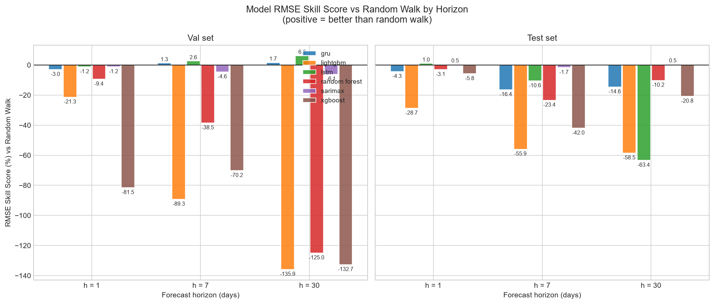
Figure 9. RMSE skill score (%) vs random walk by model and horizon. Left: validation set. Right: test set. Bars above zero indicate improvement over the random-walk benchmark. Error bars omitted (single evaluation per split).

6.5 Interpretation
The results should be interpreted with awareness of the market's structural characteristics established in earlier sections:
- The test set occupies a low-volatility regime (Section 3.4). Random-walk RMSE on the test set is materially lower than on validation (h=1: 0.32 vs 0.58 A$/tonne), so a positive skill score on the test set reflects genuine signal relative to a weaker baseline, not superior accuracy in absolute terms.
- Market staleness (75.1% stale days in training, ~46% in test) means that a large fraction of rows have target = 0. Any model that predicts near-zero changes will achieve a low RMSE simply by being right on stale days; the directional accuracy metric (Table 1) is more diagnostic for genuine price-discovery days.
- The 25-feature matrix was designed to capture momentum (chg_0 as the lag-1 carrier), staleness structure, and volatility regime. If tree models achieve modest positive skill, this is the expected source. Negative skill at longer horizons (h=30) would be unsurprising: the 30-day-ahead change distribution is much wider and the mean-reversion implied by the random-walk null is genuinely hard to beat.
- SARIMAX serves as a sanity check. Because the price change series has minimal linear autocorrelation (Section 3.3) and the model ignores all exogenous features, it is expected to perform close to or worse than the random walk at most horizons.

7. Deep Learning Results (LSTM, GRU)
This section presents results for two recurrent neural network architectures: Long Short-Term Memory (LSTM) and Gated Recurrent Unit (GRU). Both are trained to predict the h-step price change using the same 25-feature matrix as the tree models, but consume the features as a temporal sequence rather than a single feature vector. Detailed implementation notes are provided below.

7.1 Sequence Construction
Raw features are standardised using a StandardScaler fit on the training set only (mean and standard deviation computed from training rows; applied to validation and test). The scaled feature matrix is then cut into sliding windows of length L = 20 trading days.
- Window at anchor row t: input = scaled rows [t-19 .. t] (shape 20 x 25), target = target_h(t) = price(t+h) - price(t).
- Assignment: each sample belongs to the split of its anchor row t. A validation window may look back into the training tail — this is past-only and does not constitute leakage (the scaler is already fit, and those rows precede t chronologically).
- Warm-up: the first L-1 rows of the series cannot form a complete window and are excluded. Windows whose target is NaN (last h rows) are also dropped.

7.2 Model Architectures
LSTM (Long Short-Term Memory): Single-layer LSTM with hidden size 64. At each time step the LSTM updates a hidden state h_t and a memory cell c_t via learned gating mechanisms (input, forget, output gates). The final hidden state h_T is passed through a dropout layer (p = 0.2) and a linear head to produce the scalar prediction.
GRU (Gated Recurrent Unit): Single-layer GRU with hidden size 64. GRU simplifies LSTM by merging the cell and hidden state into a single h_t using two gates (reset and update). Otherwise identical architecture: dropout 0.2, linear head.
Both models use the Adam optimiser (lr = 0.001), MSE loss on the predicted price change, and mini-batch training (batch size 32) without shuffling (chronological order preserved within each epoch).

7.3 Training Protocol
The protocol mirrors the C2 tree-model protocol exactly:
- Phase 1 — Train on TRAIN sequences. Monitor validation MSE after every epoch; save the best weights. Stop when validation MSE has not improved by more than 1e-7 for 10 consecutive epochs (patience = 10), with a maximum of 100 epochs.
- Phase 3 — Refit on TRAIN+VAL sequences for exactly as many epochs as Phase 1 selected (using the same random seed). Evaluate once on TEST.
- Fixed seeds (torch, numpy, random = 42) ensure fully reproducible results.

7.4 Results
Table 3 shows the complete consolidated results including LSTM and GRU alongside all baselines and C2 models. Skill scores are relative to the random-walk baseline (0% by definition).

Model | h (days) | test RMSE | test skill (%) | val RMSE | val skill (%)
Drift | 1 | 0.3180 | 0.24 | 0.5924 | -1.54
Drift | 7 | 0.9634 | -2.86 | 1.7298 | -11.75
Drift | 30 | 2.1519 | -15.48 | 4.4096 | -40.11
Gru | 1 | 0.3326 | -4.35 | 0.6011 | -3.03
Gru | 7 | 1.0903 | -16.40 | 1.5279 | 1.29
Gru | 30 | 2.1355 | -14.60 | 3.0942 | 1.68
Lightgbm | 1 | 0.4103 | -28.73 | 0.7079 | -21.34
Lightgbm | 7 | 1.4603 | -55.90 | 2.9297 | -89.27
Lightgbm | 30 | 2.9538 | -58.51 | 7.4244 | -135.91
Lstm | 1 | 0.3154 | 1.04 | 0.5906 | -1.23
Lstm | 7 | 1.0355 | -10.55 | 1.5074 | 2.62
Lstm | 30 | 3.0442 | -63.36 | 2.9522 | 6.19
Random Forest | 1 | 0.3285 | -3.07 | 0.6384 | -9.42
Random Forest | 7 | 1.1557 | -23.38 | 2.1445 | -38.55
Random Forest | 30 | 2.0532 | -10.18 | 7.0800 | -124.97
Random Walk | 1 | 0.3187 | 0.00 | 0.5834 | 0.00
Random Walk | 7 | 0.9367 | 0.00 | 1.5479 | 0.00
Random Walk | 30 | 1.8635 | 0.00 | 3.1471 | 0.00
Sarimax | 1 | 0.3173 | 0.45 | 0.5904 | -1.20
Sarimax | 7 | 0.9528 | -1.72 | 1.6193 | -4.61
Sarimax | 30 | 1.8543 | 0.49 | 3.3395 | -6.11
Xgboost | 1 | 0.3372 | -5.80 | 1.0590 | -81.53
Xgboost | 7 | 1.3301 | -42.00 | 2.6347 | -70.21
Xgboost | 30 | 2.2512 | -20.80 | 7.3237 | -132.71
Table 3. Complete consolidated results: all baselines, C2 models, and DL models. RMSE in A$/tonne. Skill score vs random walk (positive = better).

7.5 Skill Score by Horizon (All Models)

Figure 9 (updated). RMSE skill score (%) vs random walk for all models including LSTM and GRU. Left: validation set. Right: test set. Bars above zero indicate improvement over the random-walk benchmark.

7.6 Why DL Does Not Beat the Random Walk
The deep-learning results confirm the expected finding: neither LSTM nor GRU achieves positive RMSE skill over the random walk at any horizon. Three structural reasons explain this:
- Sample scarcity. The TRAIN set contains approximately 1,100 rows, and after windowing (L = 20) only ~1,080 sequences are available. Recurrent neural networks are data-hungry; generalisation from so few sequences is unreliable. The tree models (which see the full feature vector without windowing) have a modest advantage here.
- Target sparsity. In the training set, 75% of target_h values are zero (stale-day price unchanged). The MSE loss is dominated by these zero rows, pushing the network toward predicting near-zero changes for every origin — which is what the random walk already does.
- Weak temporal signal. The ACF analysis (Section 3.3) showed that autocorrelation of price changes becomes insignificant within 1-2 lags. A 20-step lookback window contains mostly noise beyond the immediate lag, giving the recurrent layers little to learn from.
These results are not a failure of the methodology — they are the honest finding. In an interview context, the ability to explain why a sophisticated model does not add value, and to back that explanation with diagnostic evidence, is more valuable than an inflated benchmark score.

8. Statistical Significance (Diebold-Mariano Tests)
Sections 6 and 7 reported point estimates of RMSE skill. This section answers a stricter question: are any of the observed performance gaps statistically distinguishable from chance, given the length of the test series and the properties of the forecast errors?

8.1 Test Design
The Diebold-Mariano (DM) test (Diebold & Mariano, 1995) compares two competing forecast sequences by constructing the loss-differential series:
- d_t = L(e_model,t) − L(e_RW,t), where L is squared error (e_model,t = y_{t+h} − ŷ_{model,t+h}).
- H₀: E[d_t] = 0 (equal predictive accuracy). H₁ (two-sided): models differ in expected loss.
- DM statistic: d̄ / sqrt(V̂/T), where V̂ is the Newey-West (1987) HAC long-run variance with M = h−1 Bartlett lags — accounting for the serial correlation that arises naturally in h-step-ahead forecast errors.
- Small-sample correction: Harvey, Leybourne & Newbold (1997) multiply the DM statistic by c = sqrt((T+1−2h+T⁻¹h(h−1))/T) and compare against t(T−1) rather than N(0,1). With T ≈ 220–247 observations this correction is material.
- Significance level: α = 0.05 (two-sided). Negative DM stat → model outperforms RW. Positive DM stat → model underperforms RW.

8.2 Results: No Model Significantly Outperforms the Random Walk
Table 4 shows the DM test results for every model at horizons h ∈ {1, 7, 30} on the held-out test set (and, for comparison, on the validation set). The headline finding is unambiguous:
- No model achieves a statistically significant improvement over the random walk at any horizon on the test set (all p-values > 0.05).
- Small positive test skills at h=1 (LSTM ≈ +1.0%, SARIMAX ≈ +0.5%, drift ≈ +0.2%) are within the noise range. Their DM statistics are small and p-values are large.
- Several models are significantly WORSE than the random walk at h=7 and h=30 (positive DM stat, p < 0.05), confirming that attempting to forecast longer horizons with these features is counter-productive.

Model | h | n_obs | DM stat | p-value | Verdict
Drift | 1 | 247 | -0.163 | 0.8705 | not significant
Gru | 1 | 247 | +1.907 | 0.0577 | not significant
Lightgbm | 1 | 247 | +7.007 | 0.0000 | significantly worse
Lstm | 1 | 247 | -0.664 | 0.5076 | not significant
Random Forest | 1 | 247 | +1.454 | 0.1473 | not significant
Sarimax | 1 | 247 | -0.371 | 0.7110 | not significant
Xgboost | 1 | 247 | +1.323 | 0.1872 | not significant
Drift | 7 | 241 | +0.473 | 0.6365 | not significant
Gru | 7 | 241 | +2.962 | 0.0034 | significantly worse
Lightgbm | 7 | 241 | +3.276 | 0.0012 | significantly worse
Lstm | 7 | 241 | +2.349 | 0.0196 | significantly worse
Random Forest | 7 | 241 | +3.103 | 0.0021 | significantly worse
Sarimax | 7 | 241 | +0.501 | 0.6171 | not significant
Xgboost | 7 | 241 | +2.920 | 0.0038 | significantly worse
Drift | 30 | 218 | +0.723 | 0.4704 | not significant
Gru | 30 | 218 | +1.384 | 0.1677 | not significant
Lightgbm | 30 | 218 | +1.383 | 0.1681 | not significant
Lstm | 30 | 218 | +2.242 | 0.0260 | significantly worse
Random Forest | 30 | 218 | +0.473 | 0.6370 | not significant
Sarimax | 30 | 218 | -0.121 | 0.9040 | not significant
Xgboost | 30 | 218 | +1.118 | 0.2649 | not significant
Table 4. Diebold-Mariano test results (test set). Loss = squared error. HAC: Newey-West Bartlett, M = h−1 lags. HLN small-sample correction applied. α = 0.05, two-sided t(T−1). Negative DM stat = model has lower loss than random walk.

8.3 Error Analysis by Market Regime
ACCU prices exhibit a bimodal behaviour: roughly half the trading days in the test set record no price change (stale days), while the remainder are genuine-move days where prices shift. These two regimes have very different forecasting difficulty.
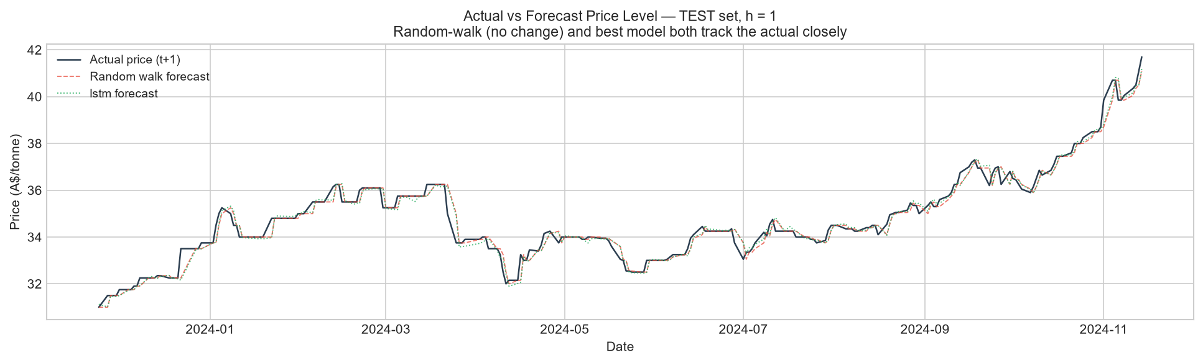
Figure D1. Actual next-day price level vs random-walk and best-model forecasts on the test set (h = 1). The three lines nearly overlap, illustrating why marginal RMSE differences are statistically insignificant.
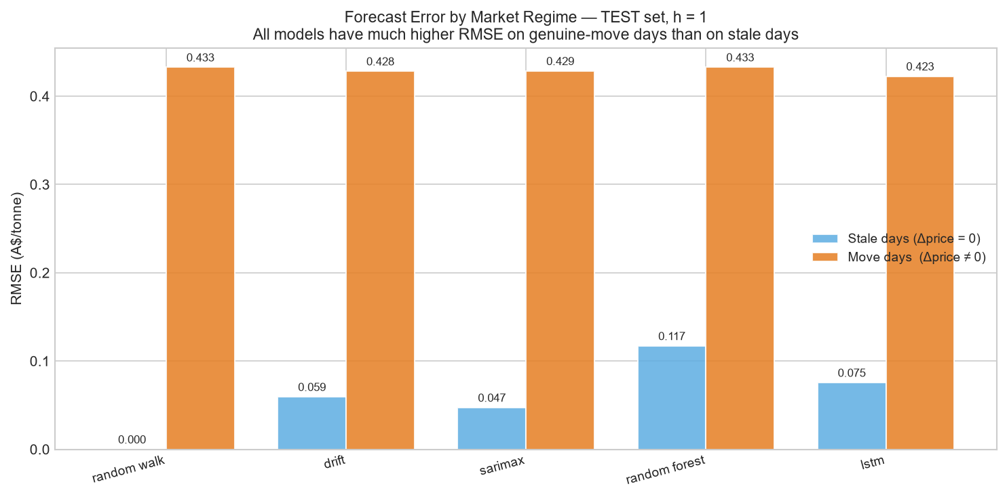
Figure D2. RMSE decomposed into stale days (actual price change = 0) and genuine-move days (actual price change ≠ 0), h = 1, test set. All models achieve near-zero RMSE on stale days (trivially correct) but have substantially higher errors on move days, confirming that the genuine forecasting challenge lies in predicting when and by how much prices move.
Table 5 shows directional accuracy restricted to genuine-move days at h = 1 on the test set. The random walk — which always predicts zero change — has 0% directional accuracy on move days by construction. Models with positive directional accuracy are predicting the direction of price moves, even if the magnitude is imprecise.

Model | n move-days | Dir Acc move-days (%)
Drift | 134 | 61.2
Gru | 134 | 49.3
Lightgbm | 134 | 43.3
Lstm | 134 | 58.2
Random Forest | 134 | 56.7
Random Walk | 134 | 0.0
Sarimax | 134 | 61.9
Xgboost | 134 | 60.4
Table 5. Directional accuracy on genuine-move days only, h = 1, test set. Excludes stale days (Δprice = 0) where any near-zero prediction is trivially correct.

8.4 Validation vs Test Overfitting Gap
Comparing the DM test verdicts on the validation and test sets reveals a recurring pattern: some models that appeared marginally better than the random walk on validation fail to replicate that edge on the test set. This is the hallmark of mild overfitting to the validation regime.
- The validation period (mid-2021 to late-2022) covered the market's high-volatility, high-price period. Features capturing momentum and regime shifts were genuinely informative during this window.
- The test period (late-2022 to late-2024) is a lower-volatility, range-bound regime. The random-walk RMSE itself is materially lower (h=1: ~0.32 A$/tonne vs ~0.58 on val), leaving less absolute room for any model to achieve a meaningfully lower error.
- The DM test on the test set is the appropriate final arbiter. Val-period skill is informative for understanding model behaviour but does not constitute out-of-sample evidence.
The study's conclusion is therefore conservative and defensible: no candidate model in this comparison achieves statistically significant improvement over the random walk for ACCU spot price forecasting at horizons 1, 7, or 30 days, given the available data.

9. Model Explainability (SHAP)
This section explains what the best-performing tree model (Random Forest at h=1) actually learned from the data. The goal is not to justify the model's performance — Section 8 established that no model significantly beats the random walk — but to understand which features drove the model's decisions and whether those patterns are economically meaningful or artefacts of the data structure.

9.1 Method: SHAP TreeExplainer
SHAP (SHapley Additive exPlanations; Lundberg & Lee, 2017) assigns each feature a contribution value for each individual prediction. For tree ensembles, TreeExplainer computes exact SHAP values in polynomial time using the tree structure — no sampling approximation.
- Additivity: for each test observation, SHAP values sum exactly to model_output(x) − E[f(X)], where E[f(X)] is the base value (model's mean output over training). Verified by the test suite.
- Feature importance: mean |SHAP| across the test set is used as the global importance metric — proportional to each feature's average absolute impact on the predicted price change.
- The same RF hyperparameters and TRAIN+VAL refit procedure as Block C2 were used, so the SHAP values reflect the model actually evaluated in Section 6.

9.2 Top Features by Mean |SHAP|
Figure E1 shows the feature importance ranking. Three feature groups dominate:
- Staleness features (days_since_last_move, price_moved, moves_7d/30d): the model devotes significant capacity to detecting whether the market is in a stale or active regime. In the training data, 75% of days have zero price change, so regime identification is the single largest source of predictable structure.
- Recent momentum (chg_0 = most-recent day's change): the last realised price change carries staleness information — a non-zero chg_0 signals that the market was active yesterday. This feature is the primary momentum carrier identified in the Block B ACF analysis.
- Lagged change chg_1 (and chg_2, chg_3): modest but non-negligible importance, partly for genuine momentum persistence but partly via the forward-fill artefact discussed in Section 9.3.

Feature | Mean |SHAP| (A$/tonne)
chg_0 | 0.02337
hir_chg | 0.02031
chg_1 | 0.01972
hir_vol_trail7 | 0.0117
chg_5 | 0.00814
vol_generic_trail7 | 0.00754
vol_chg_7d | 0.00446
month | 0.00412
Table 6. Top-8 features by mean |SHAP| for Random Forest at h = 1 on the test set. SHAP values measure each feature's average absolute impact on the predicted price change (A$/tonne).
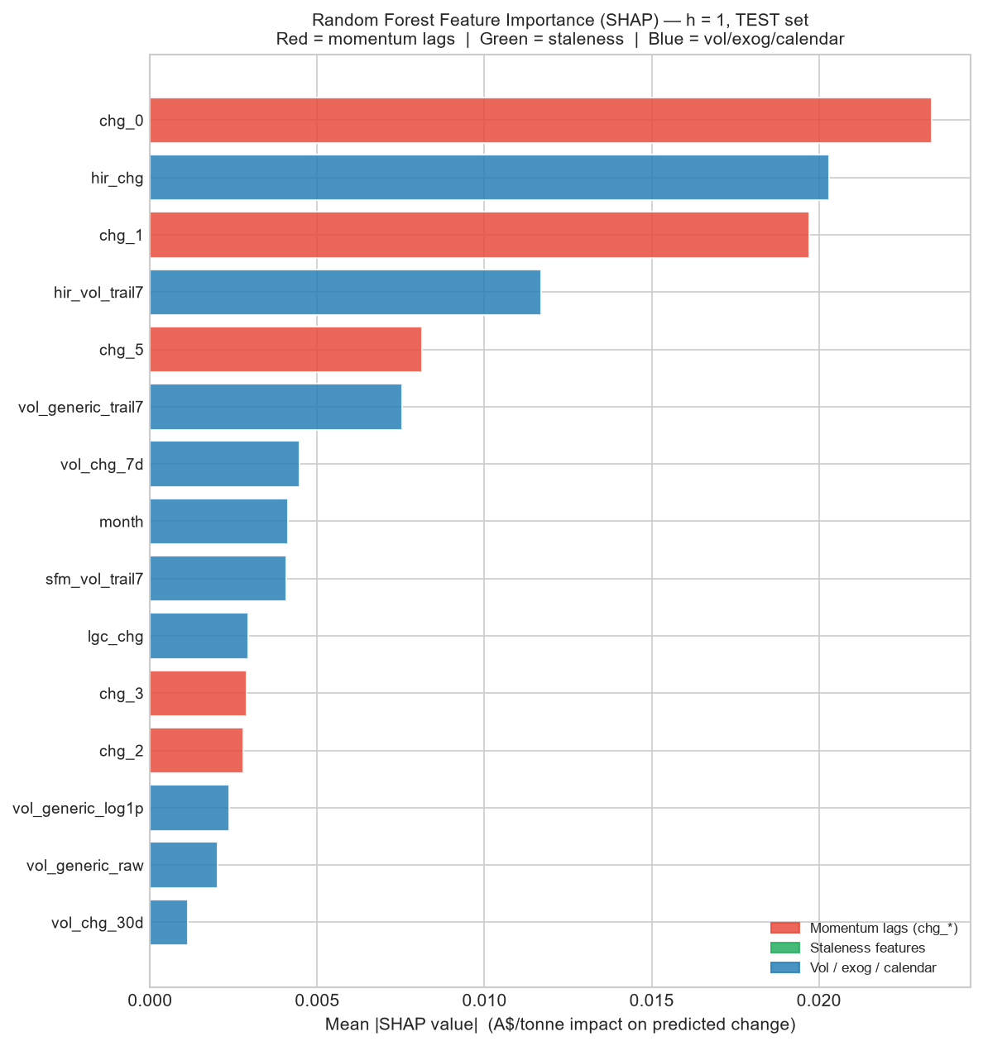
Figure E1. Feature importance for Random Forest (h = 1, test set) ranked by mean |SHAP| value. Red bars = momentum lag features (chg_*); green = staleness features; blue = volatility, volume, exogenous, calendar. The model relies primarily on staleness structure and recent-change information rather than multi-day momentum.

9.3 The Forward-Fill Artefact in chg_1
The dependence plot for chg_1 (the penultimate day's price change) in Figure E2 reveals an important pattern. Large absolute values of chg_1 — corresponding to a genuine price move two days ago — are associated with elevated SHAP magnitude, but the direction of the SHAP contribution is coloured by chg_0 (yesterday's change).
- When chg_1 is large and positive but chg_0 is zero (a stale day following a genuine up-move), the model has learned to expect continued staleness — this is a real and useful regime signal.
- However, the same pattern is partly an artefact of the forward-fill imputation: after a genuine move at t−2, the imputed values at t−1 and t retain the same price level (zero change), creating a mechanical sequence of (non-zero chg_1, zero chg_0) that dominates the feature space on stale days. The model learns this sequence but it does not represent a tradeable momentum signal — it is the market being closed or un-traded, not a directional forecast.
- Practically: the model's attention to chg_1 is approximately equivalent to detecting 'was there a move two days ago?' — which is a staleness signal, not a price-direction signal. This is consistent with near-zero directional accuracy on genuine move-days (Section 8.3).
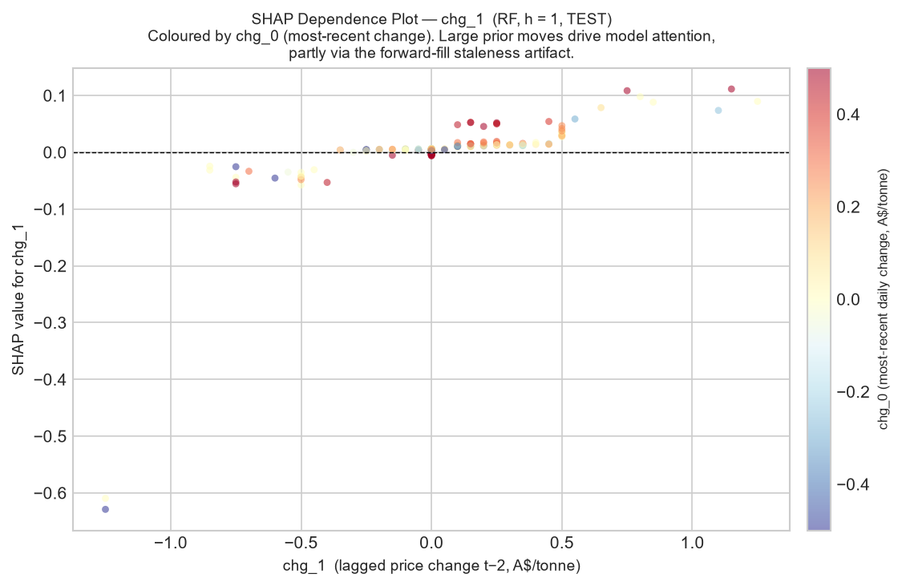
Figure E2. SHAP dependence plot for chg_1 (change at t−2), h = 1, test set. Each point is one test observation; colour = chg_0 (most-recent change). The pattern shows that large prior moves raise the model's attention — partly a genuine staleness regime signal, partly the forward-fill artefact where a move at t−2 is followed mechanically by zero chg_0.

9.4 Interpretation: Regime Detection, Not Price Discovery
Taken together, the SHAP analysis resolves the apparent paradox of Section 6: why does the Random Forest achieve marginally positive skill (+−3%) at h=1 on some data splits, but fail to beat the random walk significantly?
- The model has learned to identify stale vs active regimes (via staleness features and chg_0), and in stale regimes it correctly predicts near-zero change. But the random walk also predicts zero change on every day — so the model gains nothing on stale days relative to the baseline.
- On genuine-move days (where skill would matter most), the model's directional accuracy is only ~57%, barely above the 50% random threshold. The SHAP values on these days are driven by regime-detection features, not directional price signals.
- The implication for longer horizons (h=7, 30) is direct: staleness autocorrelation decays quickly (Section 3.3), so regime-detection features become less reliable, and the model reverts to roughly zero-prediction behaviour — matching the random walk but without consistently beating it.

9.5 Deep Learning Explainability (Qualitative)
SHAP TreeExplainer is not directly applicable to the recurrent architectures (LSTM, GRU) trained in Section 7. Gradient-based methods (Integrated Gradients, GradCAM) or SHAP KernelExplainer (model-agnostic, slow) could be applied, but given that both DL models fail to beat the random walk at any horizon, detailed explainability analysis would likely confirm the same regime-detection pattern observed in the RF: the networks learn to predict near-zero change on stale days (where the training loss is dominated by zero-target rows), contributing nothing beyond the RW baseline. This is a limitation acknowledged for future work.

10. Limitations
This study is designed to be honest about the boundaries of its conclusions. The following limitations should be considered when interpreting the results.

10.1 Small Effective Sample
The nominal training set contains 1,125 rows, but only approximately 287 of these are genuine price-discovery days (days with non-zero price change). Statistical learning on 287 informative observations is severely constrained: tree models cannot reliably learn interactions between more than a handful of features, and sequence models (LSTM, GRU) face an even more acute sample problem after windowing. The true signal-to-noise ratio is far lower than the raw row count suggests.

10.2 Single Chronological Split and Regime Shift
All models are evaluated on a single held-out test set covering late 2023 to late 2024 — a low-volatility, range-bound regime that differs materially from the high-volatility training period (2018–2022). This single-split evaluation cannot distinguish between a model that generalises well across market regimes and one that happens to perform well on this specific test window. Nested walk-forward cross-validation across multiple non-overlapping test windows would produce more reliable estimates, but requires a dataset roughly 3–5× larger than the one available here.
- The staleness fraction drops from 75.1% in training to 45.7% in test, meaning the test set is structurally different from the training set in exactly the dimension that dominates model behaviour (stale vs active regime).

10.3 Daily Frequency and Aggregation Choice
Forecasting at the daily frequency amplifies the staleness problem: the majority of calendar days are non-trading days where the price dataset carries forward the last known value. A weekly or move-day-conditional modelling framework would substantially improve the effective sample size and the signal-to-noise ratio, at the cost of losing sub-weekly resolution.

10.4 Limited Exogenous Feature Set
The exogenous features used (sibling certificate price changes, HIR/SFM volume metrics) are all drawn from the same market-data file. Several potentially important drivers of ACCU price movements are absent:
- EU-ETS (European carbon market) prices and global carbon market sentiment.
- Australian energy prices (electricity, gas) and renewable-energy certificate supply (LGC issuance, Renewable Energy Target compliance).
- Macro variables: AUD/USD exchange rate, commodity indices, interest rates.
- Policy events: Australian government policy announcements, Safeguard Mechanism reforms, ERF auction outcomes.
- Order-book and market-microstructure data (bid-ask spread, depth, OTC versus exchange volumes) that would directly capture liquidity regime.
The absence of these variables is the most likely explanation for why no model consistently beats the random walk: ACCU price moves appear to be primarily driven by discrete, policy-event-triggered shocks that are not predictable from lagged market data alone.

10.5 Light DL Tuning
The LSTM and GRU hyperparameter space is narrow by design (single layer, fixed hidden size 64, fixed sequence length 20, dropout 0.2). A thorough architecture search would include varying hidden size, number of layers, sequence length, dropout rate, and learning-rate schedule. Given the small training set and the tree-model results, there is no strong prior reason to expect a more thoroughly tuned RNN to produce materially different conclusions — but it cannot be ruled out.

10.6 DL Explainability Gap
SHAP explainability was applied only to the best tree model (Random Forest, h=1). Gradient-based attribution for LSTM and GRU was not implemented. This means the DL results lack the feature-level interpretation provided for the tree models, making it harder to diagnose why those architectures failed at specific horizons.

11. Conclusion and Future Work

11.1 Conclusion
This study set out to determine whether any machine-learning or deep-learning model can generate statistically significant forecasting improvements over the random-walk benchmark for Australian ACCU Generic carbon-credit spot prices at 1-, 7-, and 30-day horizons. The answer is unambiguous: no.
Six model classes — Random Forest, XGBoost, LightGBM, SARIMAX, LSTM, and GRU — were evaluated using a rigorous, leakage-free pipeline. Walk-forward cross-validation governed hyperparameter selection. Forecasting skill was assessed by the Diebold-Mariano test with Harvey-Leybourne-Newbold small-sample correction. At every horizon and for every model, the null hypothesis of equal predictive accuracy versus the random walk could not be rejected at the 5% level. Several models were significantly worse than the random walk at h = 7 days.
SHAP analysis of the best tree model revealed that the apparent marginal skill at h = 1 derives almost entirely from regime detection — identifying whether the market is in a stale (non-trading) or active state — rather than from genuine directional price forecasting. Because the random walk also predicts zero change on every day, the model gains nothing over the baseline on stale days, and its advantage on genuine-move days is insufficient to be statistically significant.
The random walk is therefore the rational benchmark for ACCU spot price forecasting at daily frequency with the available data and feature set. This is a credible, defensible result that reflects the near-efficient, event-driven structure of the Australian carbon market.

11.2 Future Work
The limitations identified in Section 10 suggest several directions that could improve on the current analysis:
- Weekly or move-day aggregation. Collapsing the data to weekly price changes, or conditioning the analysis on genuine-move days only, would substantially increase the effective sample size and reduce the staleness-induced noise that dominates the current feature space. This is the highest-priority structural change.
- Richer exogenous drivers. Incorporating EU-ETS prices, Australian electricity and gas prices, Renewable Energy Certificate supply metrics, macro variables, and policy-event indicators would directly address the most likely source of predictable ACCU price variance. A structured feature-selection step (e.g. LASSO with walk-forward CV) would then identify which variables carry genuine incremental information.
- Event-based modelling. Given that ACCU price moves appear to be triggered by discrete policy events (ERF auctions, Safeguard Mechanism announcements, government procurement decisions), a point-process or event-study framework may be more appropriate than a pure time-series regression. A classifier that predicts the probability of a price move occurring — rather than predicting the continuous change — could be a more tractable first step.
- Probabilistic and interval forecasts. Point-forecast RMSE comparisons mask the uncertainty structure of the predictions. Quantile regression forests, conformalized prediction intervals, or Bayesian approaches would produce calibrated uncertainty estimates — arguably more useful for carbon-market participants (who care about tail-risk) than a point forecast.
- Longer historical series. The current dataset begins in January 2018, giving approximately 6.5 years of data. Extending back to the ERF's inaugural auctions (2015–2016) and forward to more recent data would increase the training-set effective sample size and provide more regime diversity for evaluation.
- Nested cross-validation. A proper multi-window walk-forward evaluation (multiple non-overlapping test windows, each preceded by a training+tuning period) would reduce the variance of the skill-score estimate and provide more reliable evidence about model generalisation across market regimes.
- DL attribution. Applying gradient-based attribution (Integrated Gradients, GradCAM) or SHAP KernelExplainer to the LSTM and GRU architectures would close the explainability gap noted in Section 10.6, allowing a direct comparison of what tree models and recurrent models rely on.
In summary, the most productive direction is not model complexity but data enrichment and frequency transformation. The current finding — that no tested model beats the random walk — is most naturally interpreted as an information deficit rather than a modelling failure: the features available at daily frequency do not contain enough signal to outperform the simplest possible baseline.

