Shopify Sales & Weather Analysis

Descriptive Sales Analysis and Weather-Driven Revenue Modelling
for a Danish Artisan Food Chain

June 2026
Confidential — not for distribution

1 Data & Methodology

1.1 Data Source
Transaction data were extracted from the client's Shopify platform via the Shopify Admin API. The export covers the period from January 2024 to March 2025 (15 calendar months) and comprises seven tables: orders, line_items, products, locations, customers, discounts, and refunds. After cleaning and joining, the analytical dataset contains 454,821 transaction lines across 282,380 unique orders placed across seven physical stores.
The central fact table is line_items, which records one row per product line within each order. It was joined to: orders (timestamps, financial totals, fulfilment status, and store location); products (product title, vendor, and tags, joined on product_id); locations (store name and city, joined on location_id); and refunds (summed per order and filled with zero where no refund was recorded). Customers and discounts were loaded but are not used in the analyses presented here.

1.2 Cleaning Rules
The following rules were applied to the merged dataset in sequence, yielding the 454,821-row analytical base:
- Columns with more than 95% missing values were dropped (sku, customer_id, email, product_type).
- Missing categoricals were filled: store_name → 'Unknown Store'; title → 'Unknown Product'; vendor → 'Unknown Vendor'; tags → 'Unknown Tag'.
- Rows tagged 'Indpakning' (packaging-only lines) were removed.
- Only completed sales were retained: financial_status = 'paid' AND fulfillment_status = 'fulfilled' AND cancelled_at is null.
- Rows from a designated test store were excluded.
- A transaction-level revenue column was derived as price × quantity.
The product name field (name) from line_items is used as the primary product identifier throughout, rather than the title field from the products catalogue. The name field is populated by the point-of-sale (POS) terminal for every transaction, whereas title depends on a successful product_id join to the Shopify catalogue — a join that fails for approximately 1% of lines (see Section 3).

1.3 Product Categorisation
Products were assigned to one of eight client-defined families based on the POS name field, using an exact-name lookup against a curated mapping table (src/product_categories.csv). The eight families are: Ice Cream, Hot Beverages, Buns & Bakery, Chocolate, Gifts & Cards, Snacks & Nuts, Christmas, and Others. The mapping incorporates client feedback that moved flødeboller and bar-type products from Buns & Bakery to Chocolate, which changed the category ranking (Chocolate overtook Buns & Bakery to become the second-largest category by revenue).

1.4 Anonymisation Note
Store identities are anonymised throughout this report. The seven stores are referred to as Store A through Store G, ranked by total revenue (Store A = highest revenue). Revenue figures and unit counts are expressed as a percentage of the dataset total, or as an index scaled so that the maximum value equals 100, rather than as absolute monetary amounts. This protects client confidentiality while preserving all relative comparisons and analytical conclusions.

2 Sales Analysis

2.1 Product Concentration
Revenue is highly concentrated in a small number of products. The single top product — a two-scoop ice cream — accounts for approximately 19.6% of total revenue, more than any other product by a substantial margin. The next largest, a one-scoop ice cream, contributes around 10.8%. Together the top five products account for roughly half of all revenue.
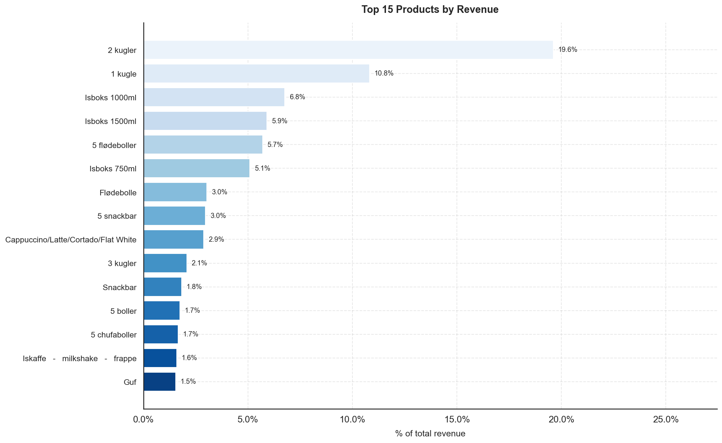
Figure 1: Top 15 products by revenue share (% of total). The two- and one-scoop ice creams dominate; the remaining products in the top 15 each contribute 1–7%.
A Pareto analysis confirms the classic 80/20 pattern: 21 products collectively account for 80% of total revenue, out of 320 distinct product names in the catalogue. The cumulative revenue curve rises steeply through the first 20 products and then flattens sharply, indicating that the long tail of niche products contributes comparatively little to overall sales.
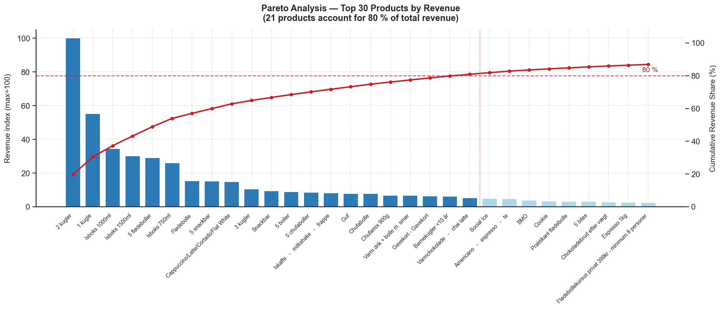
Figure 2: Pareto chart: product revenue index (bars, left axis) and cumulative revenue share (red line, right axis) for the top 30 products. The dashed red line marks the 80% threshold; the vertical dotted line falls at product 21.

2.2 Revenue by Category
Ice Cream is by far the dominant revenue category, contributing 57.0% of total revenue. Chocolate is the second-largest at 17.0%, followed by Buns & Bakery at 12.4%. Together these three categories account for more than 86% of all revenue. Hot Beverages (6.0%), Gifts & Cards (3.6%), and Others (2.4%) make up most of the remainder, while Snacks & Nuts (0.9%) and Christmas (0.8%) are small in absolute terms but may serve important margin and basket-building roles.
The dominance of Ice Cream is consistent with the client's positioning as a premium artisan ice cream chain. The relative size of Chocolate — driven largely by flødeboller (cream puffs) and chocolate-coated bars — reflects a secondary product identity that is strongest in the colder months when ice cream demand falls.
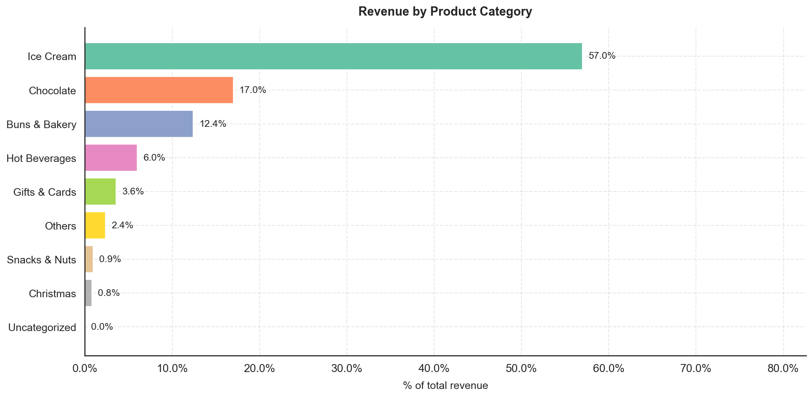
Figure 3: Revenue share by product category (% of total). Ice Cream (57%) and Chocolate (17%) together account for nearly three-quarters of all revenue.

2.3 Seasonality
Monthly revenue follows a clear seasonal arc driven by ice cream demand. May 2024 was the peak month, with June 2024 also significantly above the annual average. Revenue then softens through July and August before recovering partially in August — consistent with summer holiday patterns in Denmark — before declining through the autumn. Winter months (October through February) are substantially quieter, running at roughly one-quarter to one-third of peak-month levels.
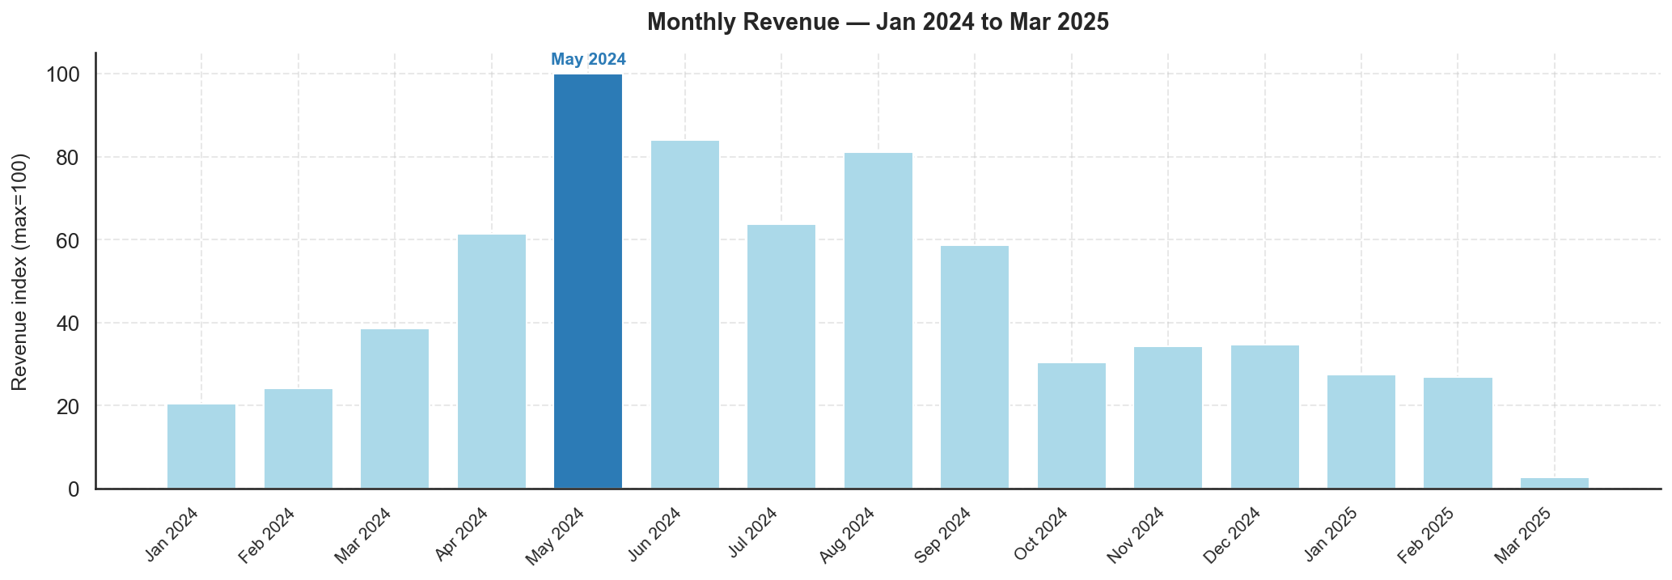
Figure 4: Monthly revenue index (max = 100, May 2024). The seasonal arc peaks in May–June, falls through autumn, and recovers modestly in December.
Day-of-week patterns show that Saturday and Friday are the two busiest trading days by revenue, generating roughly 60–70% more revenue than the quietest days (Monday and Tuesday). This pattern is consistent across all stores and reflects the discretionary, leisure-oriented nature of the product range — customers visit artisan food stores more frequently on weekends and towards the end of the working week.
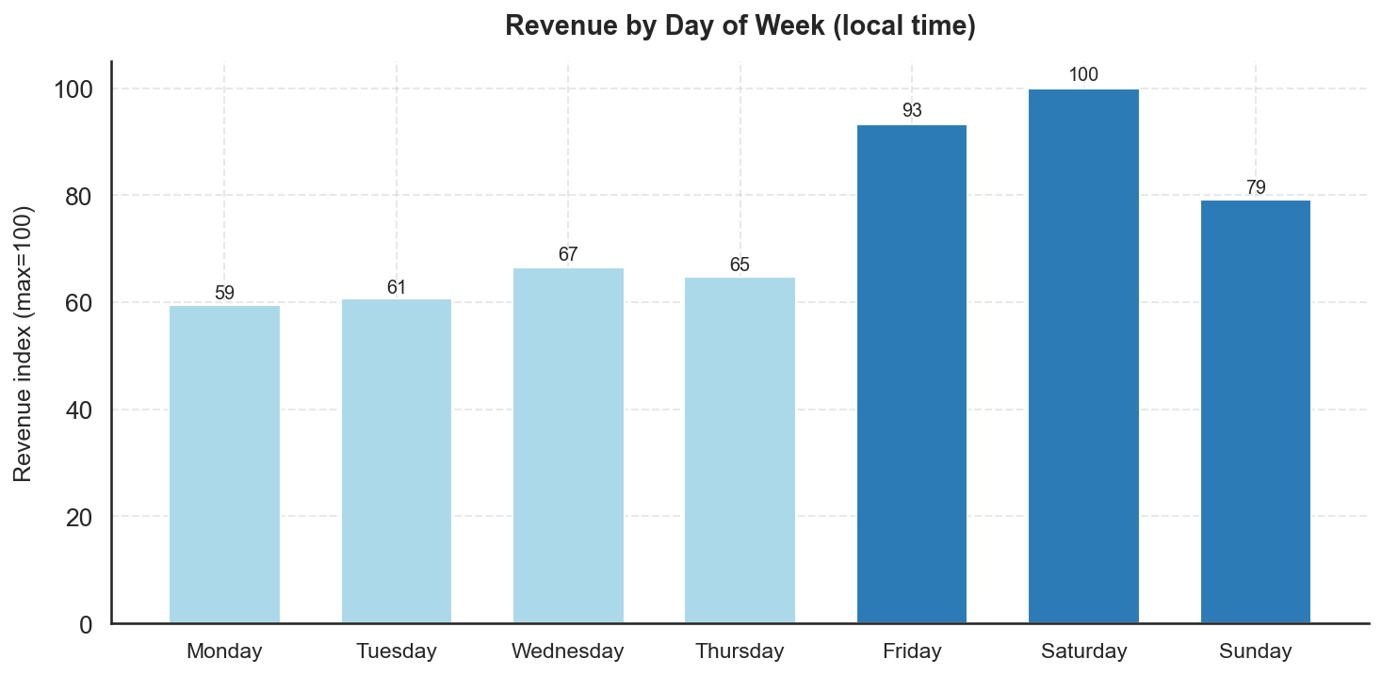
Figure 5: Revenue by day of week (index, max = 100 = Saturday). Friday and Saturday are the two peak days; Monday and Tuesday are the quietest.
Within the trading day, revenue is concentrated in the early-to-mid afternoon. The peak revenue window is 14:00–16:00 (local Copenhagen time), with 15:00 and 16:00 being the top two hours by revenue index. Activity rises from store opening around 10:00 and is substantially lower in the morning and evening. Staffing and preparation schedules should be calibrated to this window.
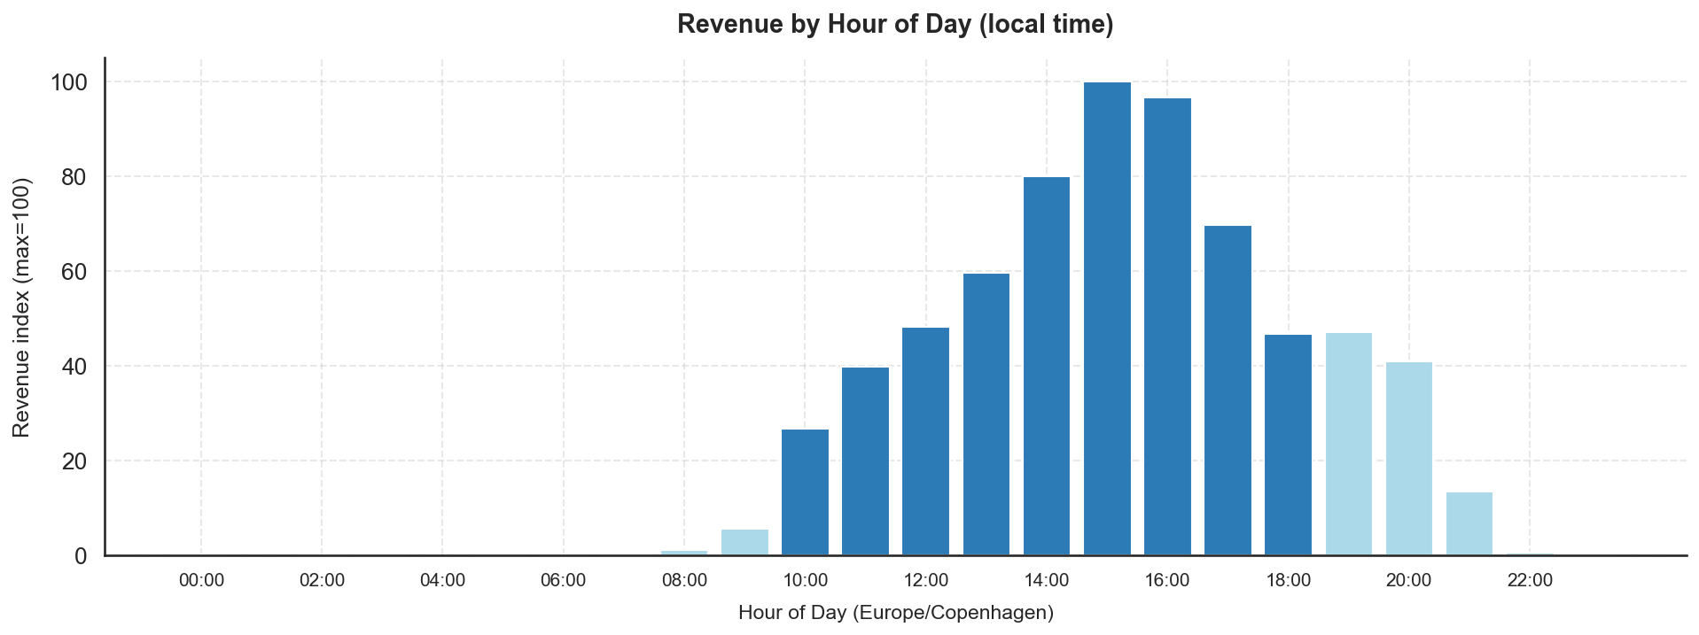
Figure 6: Revenue by hour of day, Copenhagen local time (index, max = 100). The 14:00–16:00 window drives the largest share of daily revenue.
Category seasonality reveals the structural logic behind the aggregate curve. Ice Cream peaks sharply in May and June, contributing over 75% of revenue in those months, and falls back substantially from October onwards. Hot Beverages and Christmas items follow an inverse seasonal profile, peaking in November and December when ice cream demand is lowest. This counter-seasonality is commercially important: it moderates the winter revenue trough and keeps cross-trained staff productively employed year-round. Buns & Bakery is more evenly distributed, serving as a year-round complement to both ice cream and hot drinks.
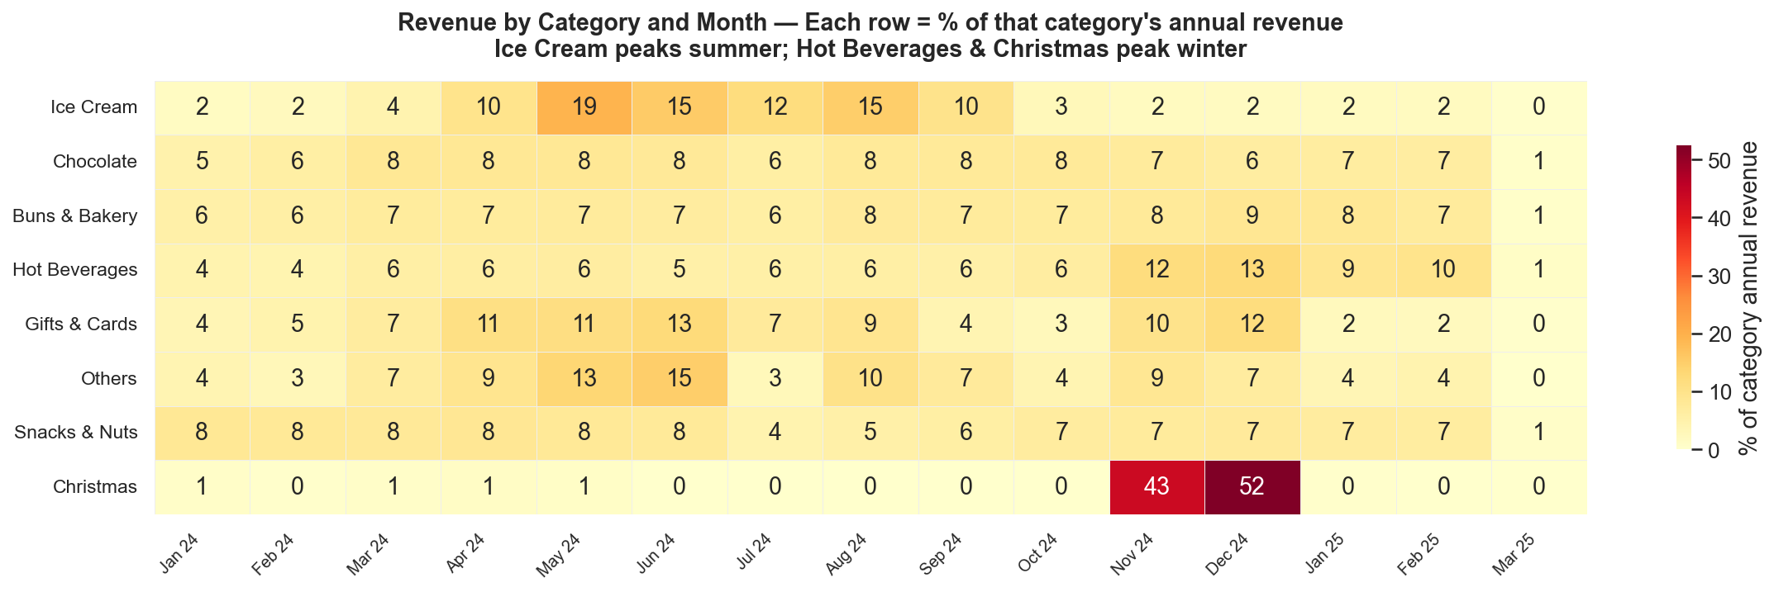
Figure 7: Category revenue heatmap: each cell shows that category's revenue as a percentage of its own annual total. Ice Cream peaks May–June; Hot Beverages and Christmas peak November–December.

2.4 Store Comparison
Store A is the highest-revenue store, accounting for approximately 21.7% of total revenue, with Store B (17.4%) and Store C (17.1%) close behind. Store G is the smallest by both revenue (6.0%) and order count (7.3%). Average order value (AOV) varies meaningfully across stores: Store B records the highest AOV (indexed at 100), suggesting either higher unit prices, larger basket sizes, or a stronger mix of premium products. Store G records the lowest AOV, which may reflect a different customer profile or product mix.
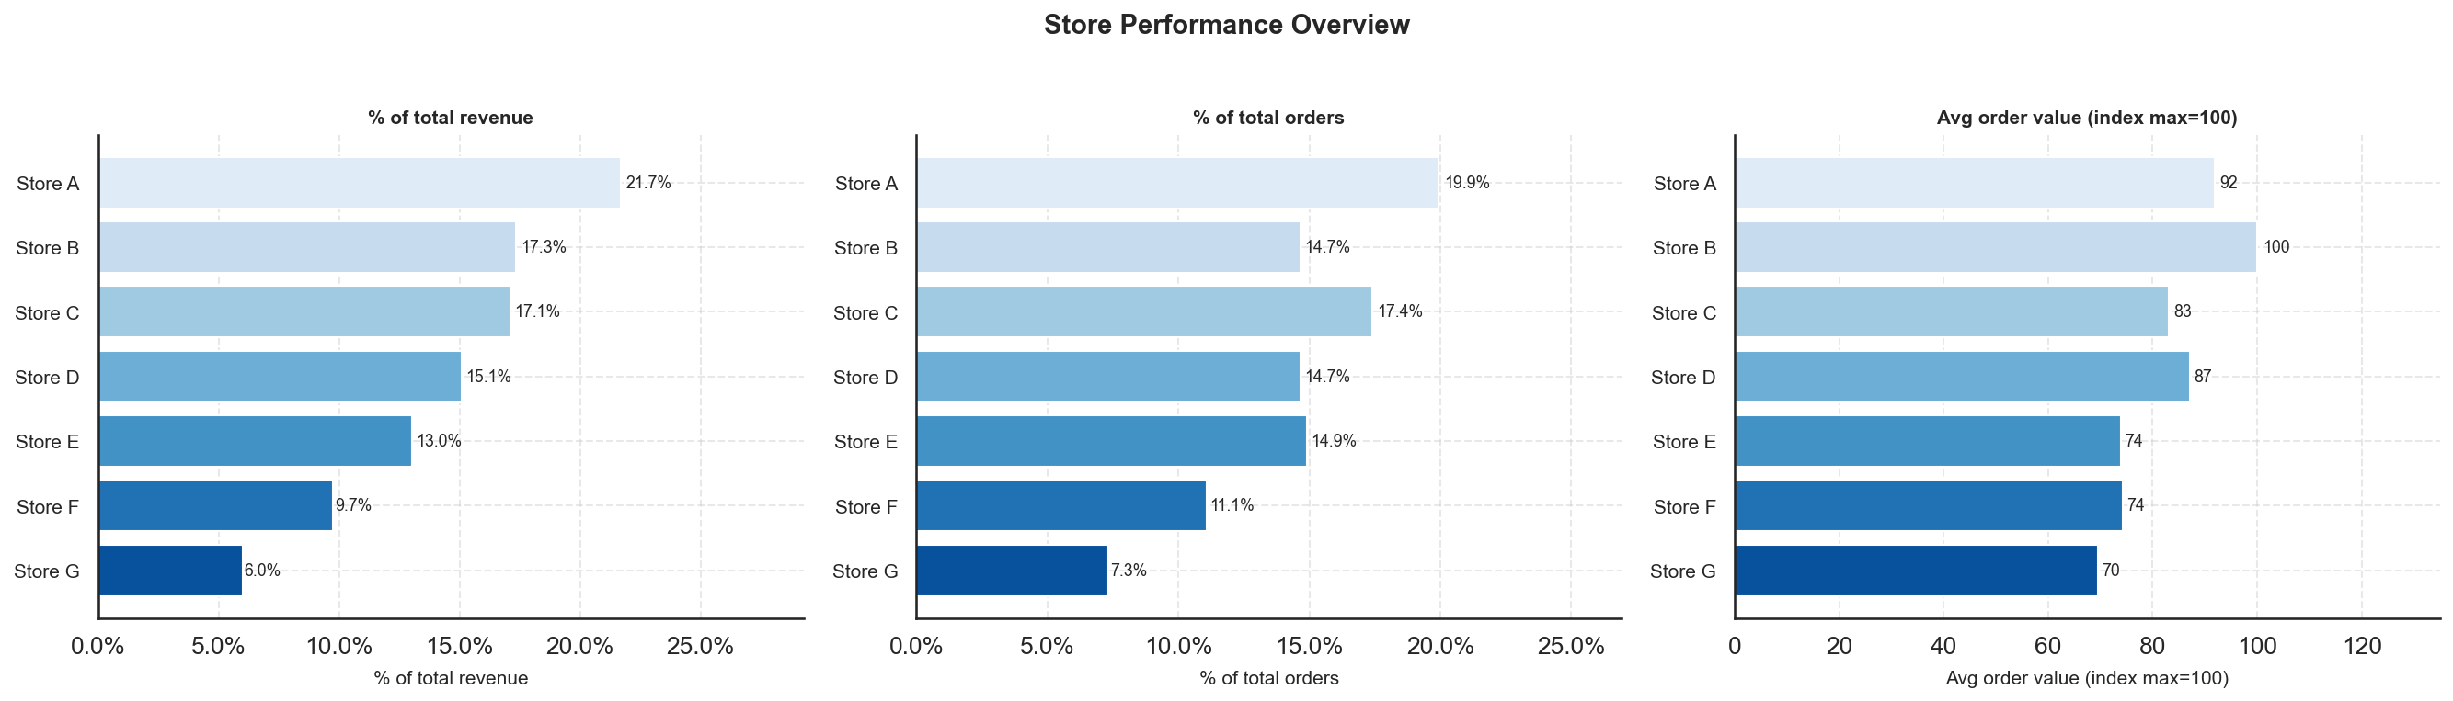
Figure 8: Store performance overview: revenue share (%), order share (%), and average order value index (max = 100 = Store B). Store A leads on revenue; Store B on transaction value.
The category mix charts reveal that Ice Cream is the dominant category at every store, but the degree of dominance varies. Store A has the highest Ice Cream share (consistent with it being in a high-footfall area), while stores with lower Ice Cream dependence show proportionally stronger Chocolate and Buns & Bakery contributions. Niche categories such as Snacks & Nuts and Christmas show variation across locations, suggesting locally tailored assortments or different customer demographics.
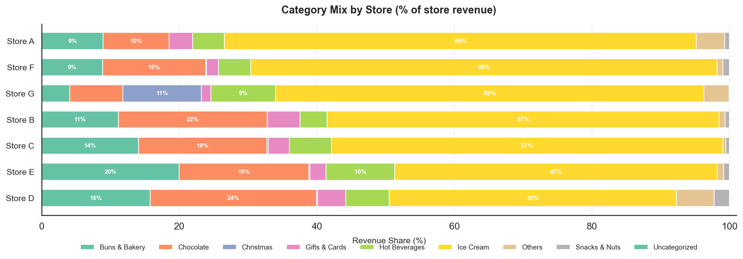
Figure 9: Category revenue mix by store (100% stacked bar, % of each store's revenue). Ice Cream dominates everywhere; relative Chocolate and Buns & Bakery shares vary materially by location.

3 Data Quality — Unknown Products

3.1 Definition of the Issue
Each row in the analytical dataset carries two product identity fields: name, populated directly by the POS terminal at the point of sale, and title, sourced from the Shopify product catalogue via a join on product_id. When a POS terminal records a transaction without a valid product_id — for example, when a product is sold under a temporary or unregistered SKU — the catalogue join fails, and title is filled with the placeholder value 'Unknown Product'. The name field is always present and is used for all categorisation and analysis in this report; the Unknown Product flag therefore does not compromise revenue or category findings. It does, however, signal a POS configuration gap that is worth investigating and correcting.

3.2 Scale and Row-vs-Unit Divergence
At the row level, Unknown Product is a minor issue: 4,484 lines out of 454,821 carry the flag, a rate of 0.99%. At the unit (quantity-weighted) level, however, the rate is 11.77% — approximately twelve times larger. The reason is that Unknown Product lines are not typical single-item transactions: they average approximately 28 units per line, compared with roughly 2 units per line for known-product lines. These are bulk or box-format sales — ice cream tubs, multi-pack confectionery, or similar high-quantity items — that were entered at the POS without a catalogue-linked SKU. The unit rate is therefore the more meaningful indicator of the operational footprint of this issue.
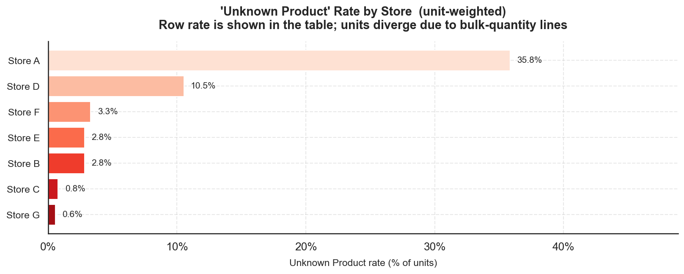
Figure 10: Unknown Product unit rate by store. Store A carries 35.8% of units as Unknown Product — far above any other location.

3.3 Store Concentration
The issue is heavily concentrated in one store. Store A accounts for 92,393 of the 125,717 unknown units — approximately 73% — despite contributing 21.7% of total revenue. Its unknown unit rate is 35.8%, compared with 10.5% for the second-most-affected store (Store D) and under 4% for all others. This pattern strongly suggests a store-specific POS configuration problem: a terminal at Store A was accepting high-quantity transactions for products not registered in the Shopify catalogue, rather than a system-wide data collection issue.

3.4 Trend Over Time
The time series of the unknown unit rate does not show a single, clean cutover. Instead, it is highly irregular: the overall rate peaks at 29.5% in June 2024 and at 24.3% in May 2024, falls sharply in July 2024, rises again in August 2024 (11.4%), and then declines erratically before settling near zero from late 2024 onwards. The row rate — less sensitive to the bulk-quantity effect — shows a more gradual improvement from about 2.6% in January 2024 to under 0.3% by February 2025.
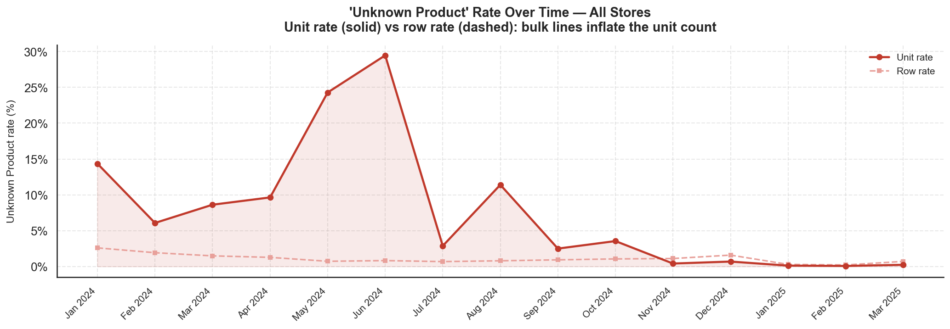
Figure 11: Unknown Product rate over time for all stores combined: unit rate (solid red) and row rate (dashed). The unit rate is highly variable with large summer peaks; both rates converge near zero by early 2025.
At Store A specifically, the unit rate reaches 67.5% in June 2024 and 54.1% in May 2024, implying that more than half of all units sold at that store in those months were not linked to any Shopify catalogue entry. The rate drops below 1% from July 2024 in most months, though individual months see small spikes through to December 2024. From January 2025 onwards the rate is consistently below 0.5% at this store.
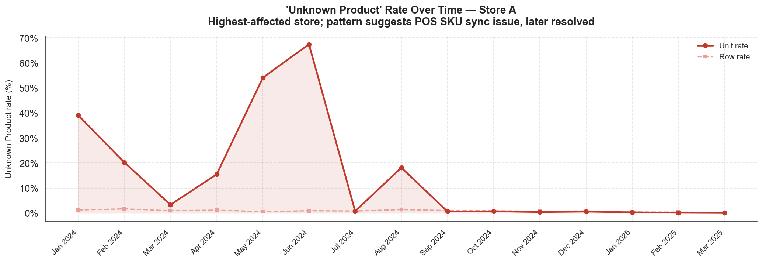
Figure 12: Unknown Product rate over time for Store A (most-affected): unit rate (solid) and row rate (dashed). Peak unit rates of 54–68% in May–June 2024 point to intermittent high-volume POS entries without catalogue linkage.
The pattern is consistent with a POS terminal that intermittently accepted bulk product entries — possibly from a secondary interface or offline mode — without resolving the SKU against the Shopify catalogue. The resolution appears to have been implemented progressively rather than as a single configuration change, with the most severe episodes concentrated in the summer peak period when transaction volumes are highest. A full investigation should verify whether any revenues were misattributed to incorrect product categories during the affected period.

