Shopify Sales & Weather Analysis

Descriptive Sales Analysis and Weather-Driven Revenue Modelling
for a Danish Artisan Food Chain

June 2026
Confidential — not for distribution

Executive Summary

This report analyses 14 months of point-of-sale transaction data from a Danish artisan food chain operating seven physical stores, all running on Shopify. The dataset covers approximately 454,000 transaction lines across around 280,000 completed orders. The analysis pursues two business goals: understanding what drives revenue across products, categories, stores, and seasons; and building a weather-driven forecast to support staffing, ice-cream preparation, and inventory decisions.
Revenue is highly concentrated: roughly 20 products account for 80% of total revenue, with Ice Cream the dominant category at approximately 57%. Sales follow a strong seasonal pattern, peaking in May and June, with Friday and Saturday the highest-revenue days and the 14:00–16:00 window the busiest part of the trading day. Weather effects on daily Ice Cream revenue are large and statistically significant: each additional degree Celsius is associated with approximately 5.7% higher revenue (95% CI: +4.4% to +7.1%) and each additional hour of daylight with approximately 11.2% more (+4.6% to +18.2%), after controlling for day-of-week, month, and store fixed effects. A data-quality investigation identified that one store’s POS terminal was not synced to Shopify product codes, causing a concentrated pattern of unattributed transactions; the issue declined sharply following a POS reconfiguration.
An XGBoost forecaster, validated with five-fold time-series cross-validation, achieves a weighted absolute percentage error (WAPE) of 39.5% against a seasonal-naive baseline of 47.2% — a 7.7-percentage-point improvement. The model is primarily autoregressive, with weather variables providing a further material contribution. Calibrated 90% prediction intervals reach approximately 81% empirical coverage after conformal calibration, with the remaining gap attributable to distributional shifts across time.
The three most actionable recommendations are: (1) concentrate staffing and ice-cream preparation on Friday, Saturday, and the 14:00–16:00 window, where revenue is disproportionately high; (2) use the weather-driven forecast to scale ice-cream prep and staffing ahead of warm, long-daylight days — a forecast of warmer, longer days is a direct signal to increase preparation; and (3) fix the POS configuration at the affected store to restore full per-category revenue attribution.

SECTION 1 - Data & Methodology

1.1. Data Source
Transaction data were extracted from the client's Shopify platform via the Shopify Admin API. The export covers a 14-month period (January 2024–March 2025) and comprises seven tables: orders, line_items, products, locations, customers, discounts, and refunds. After cleaning and joining, the analytical dataset contains 454,821 transaction lines across 282,380 unique orders placed across seven physical stores.
The central fact table is line_items, which records one row per product line within each order. It was joined to: orders (timestamps, financial totals, fulfilment status, and store location); products (product title, vendor, and tags, joined on product_id); locations (store name and city, joined on location_id); and refunds (summed per order and filled with zero where no refund was recorded). Customers and discounts were loaded but are not used in the analyses presented here.

1.2 Cleaning Rules
The following rules were applied to the merged dataset in sequence, yielding the 454,821-row analytical base:
- Columns with more than 95% missing values were dropped (sku, customer_id, email, product_type).
- Missing categoricals were filled: store_name → 'Unknown Store'; title → 'Unknown Product'; vendor → 'Unknown Vendor'; tags → 'Unknown Tag'.
- Rows tagged 'Indpakning' (packaging-only lines) were removed.
- Only completed sales were retained: financial_status = 'paid' AND fulfillment_status = 'fulfilled' AND cancelled_at is null.
- Rows from a designated test store were excluded.
- A transaction-level revenue column was derived as price × quantity.
The product name field (name) from line_items is used as the primary product identifier throughout, rather than the title field from the products catalogue. The name field is populated by the point-of-sale (POS) terminal for every transaction, whereas title depends on a successful product_id join to the Shopify catalogue — a join that fails for approximately 1% of lines (see Section 3).

1.3 Product Categorisation
Products were assigned to one of eight client-defined families based on the POS name field, using an exact-name lookup against a curated mapping table (src/product_categories.csv). The eight families are: Ice Cream, Hot Beverages, Buns & Bakery, Chocolate, Gifts & Cards, Snacks & Nuts, Christmas, and Others. The mapping incorporates client feedback that moved flødeboller and bar-type products from Buns & Bakery to Chocolate, which changed the category ranking (Chocolate overtook Buns & Bakery to become the second-largest category by revenue).

1.4 Anonymization Note
Store identities are anonymised throughout this report. The seven stores are referred to as Store A through Store G, ranked by total revenue (Store A = highest revenue). Revenue figures and unit counts are expressed as a percentage of the dataset total, or as an index scaled so that the maximum value equals 100, rather than as absolute monetary amounts. This protects client confidentiality while preserving all relative comparisons and analytical conclusions.
SECTION 2 - Sales Analysis

2.1 Product Concentration
Revenue is highly concentrated in a small number of products. The single top product — a two-scoop ice cream — accounts for approximately 19.6% of total revenue, more than any other product by a substantial margin. The next largest, a one-scoop ice cream, contributes around 10.8%. Together the top five products account for roughly half of all revenue.
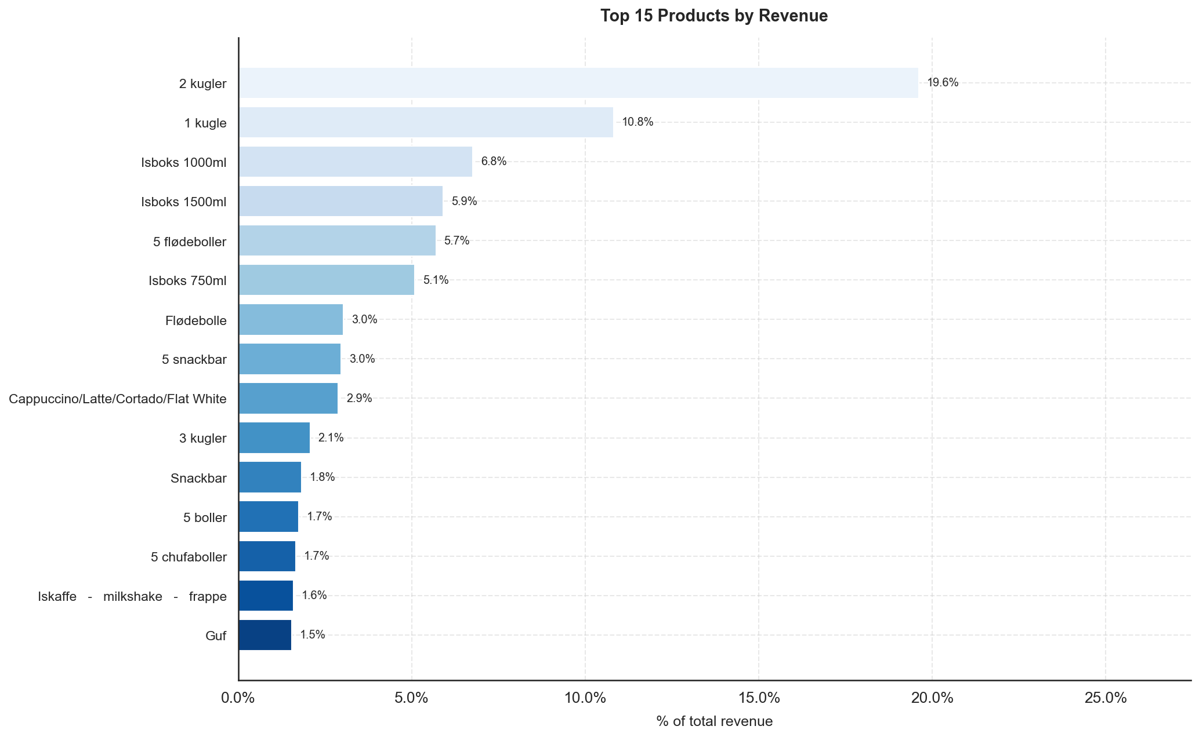
Figure 1: Top 15 products by revenue share (% of total). The two- and one-scoop ice creams dominate; the remaining products in the top 15 each contribute 1–7%.
A Pareto analysis confirms the classic 80/20 pattern: 21 products collectively account for 80% of total revenue, out of 320 distinct product names in the catalogue. The cumulative revenue curve rises steeply through the first 20 products and then flattens sharply, indicating that the long tail of niche products contributes comparatively little to overall sales.
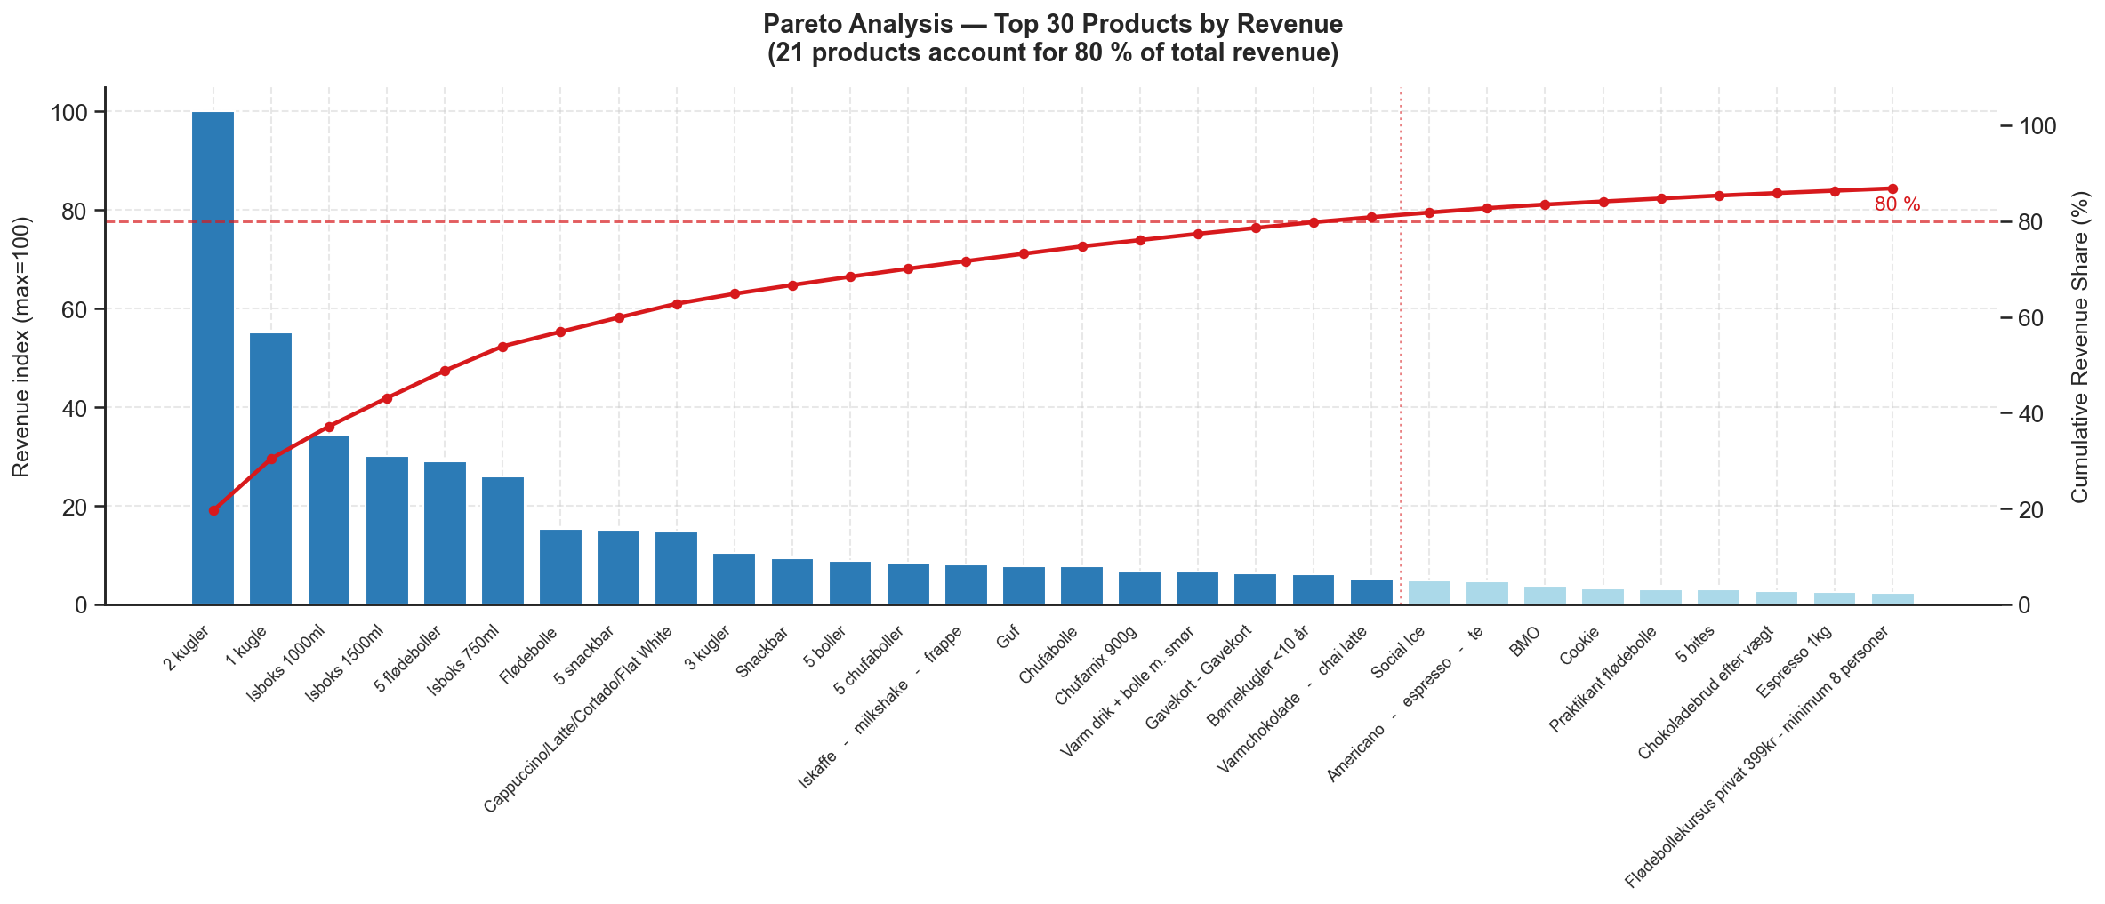
Figure 2: Pareto chart: product revenue index (bars, left axis) and cumulative revenue share (red line, right axis) for the top 30 products. The dashed red line marks the 80% threshold; the vertical dotted line falls at product 21.

2.2 Revenue by Category
Ice Cream is by far the dominant revenue category, contributing 57.0% of total revenue. Chocolate is the second-largest at 17.0%, followed by Buns & Bakery at 12.4%. Together these three categories account for more than 86% of all revenue. Hot Beverages (6.0%), Gifts & Cards (3.6%), and Others (2.4%) make up most of the remainder, while Snacks & Nuts (0.9%) and Christmas (0.8%) are small in absolute terms but may serve important margin and basket-building roles.
The dominance of Ice Cream is consistent with the client's positioning as a premium artisan ice cream chain. The relative size of Chocolate — driven largely by flødeboller (cream puffs) and chocolate-coated bars — reflects a secondary product identity that is strongest in the colder months when ice cream demand falls.
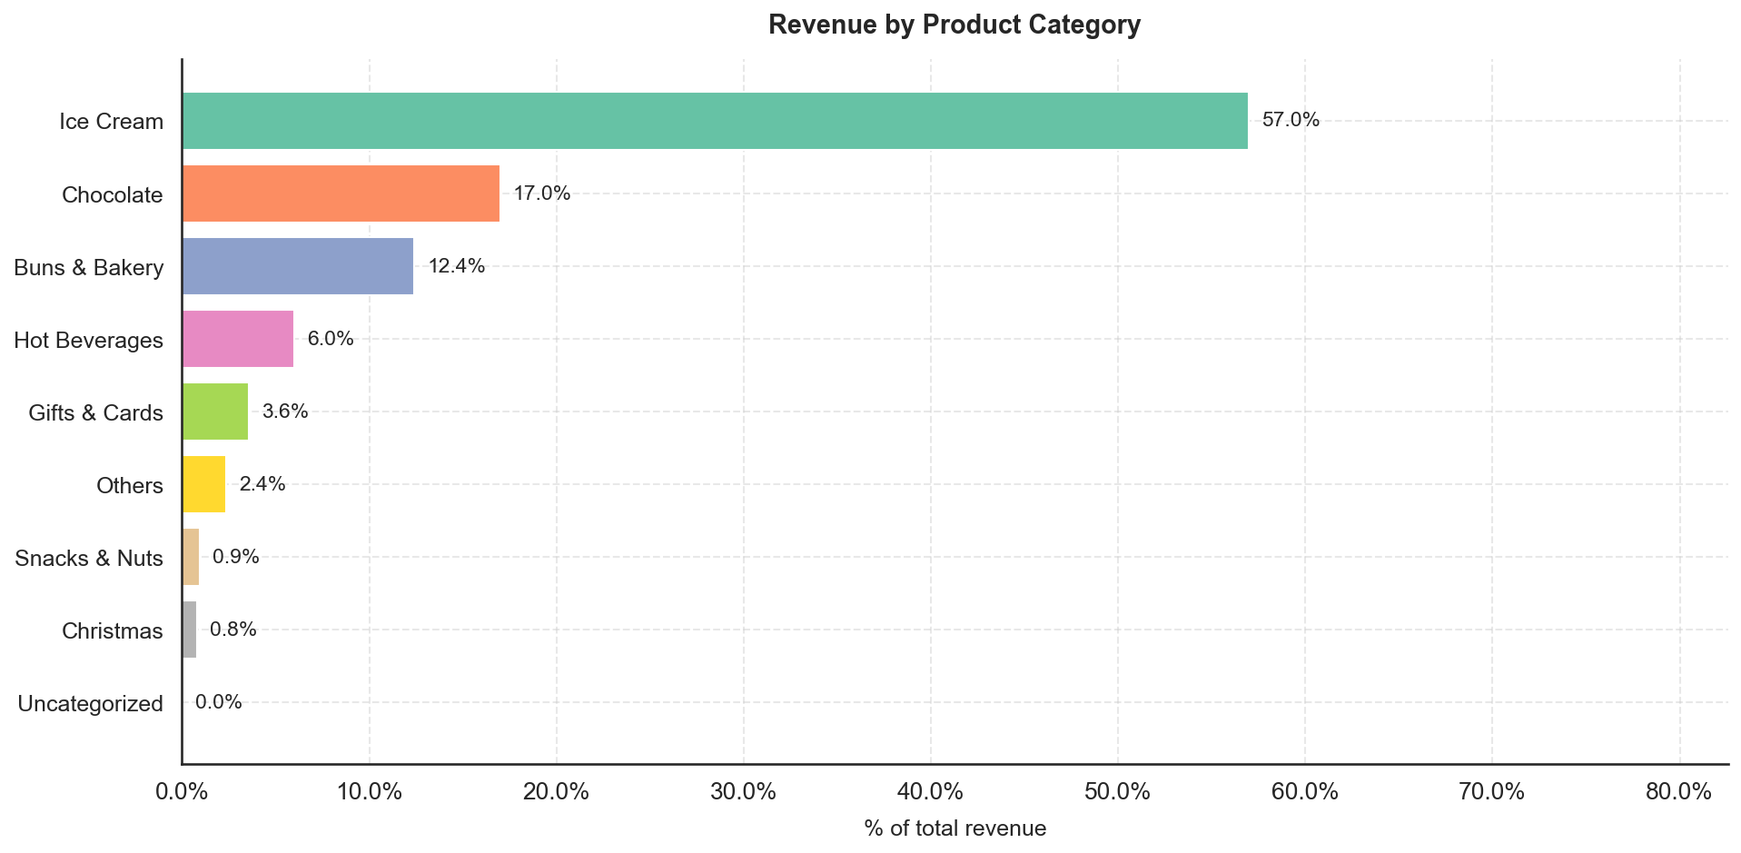
Figure 3: Revenue share by product category (% of total). Ice Cream (57%) and Chocolate (17%) together account for nearly three-quarters of all revenue.

2.3 Seasonality
Monthly revenue follows a clear seasonal arc driven by ice cream demand. May 2024 was the peak month, with June 2024 also significantly above the annual average. Revenue then softens through July and August before recovering partially in August — consistent with summer holiday patterns in Denmark — before declining through the autumn. Winter months (October through February) are substantially quieter, running at roughly one-quarter to one-third of peak-month levels.
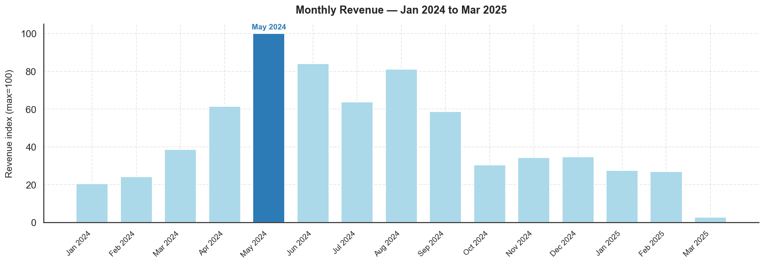
Figure 4: Monthly revenue index (max = 100, May 2024). The seasonal arc peaks in May–June, falls through autumn, and recovers modestly in December.
Day-of-week patterns show that Saturday and Friday are the two busiest trading days by revenue, generating roughly 60–70% more revenue than the quietest days (Monday and Tuesday). This pattern is consistent across all stores and reflects the discretionary, leisure-oriented nature of the product range — customers visit artisan food stores more frequently on weekends and towards the end of the working week.
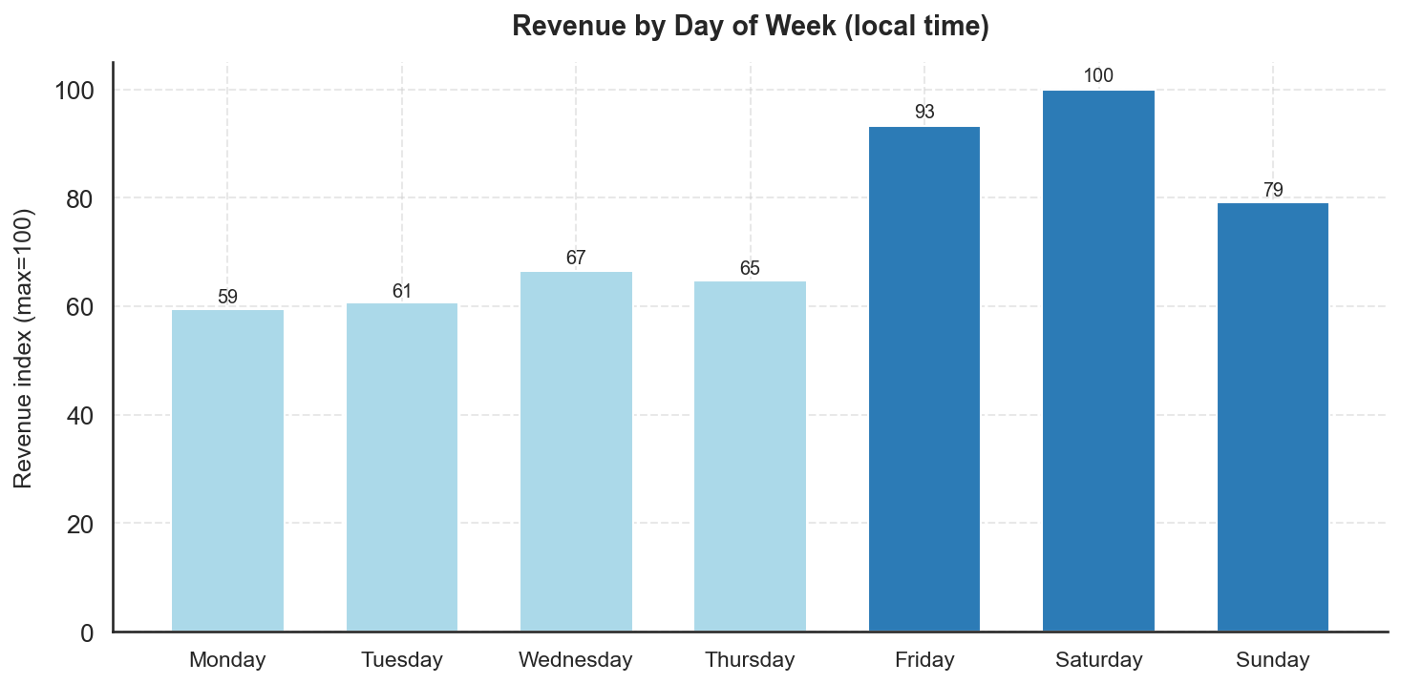
Figure 5: Revenue by day of week (index, max = 100 = Saturday). Friday and Saturday are the two peak days; Monday and Tuesday are the quietest.
Within the trading day, revenue is concentrated in the early-to-mid afternoon. The peak revenue window is 14:00–16:00 (local Copenhagen time), with 15:00 and 16:00 being the top two hours by revenue index. Activity rises from store opening around 10:00 and is substantially lower in the morning and evening. Staffing and preparation schedules should be calibrated to this window.
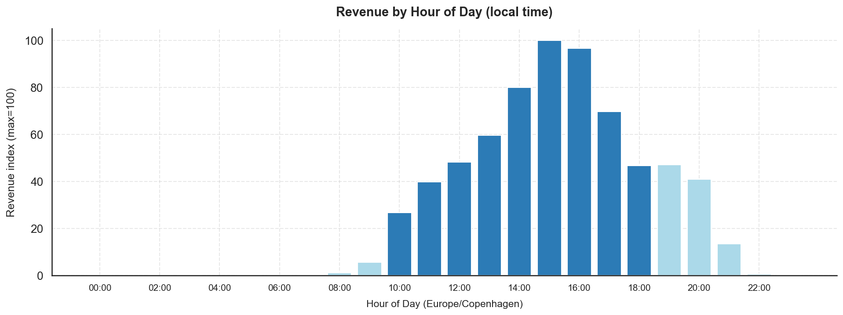
Figure 6: Revenue by hour of day, Copenhagen local time (index, max = 100). The 14:00–16:00 window drives the largest share of daily revenue.
Category seasonality reveals the structural logic behind the aggregate curve. Ice Cream peaks sharply in May and June, contributing over 75% of revenue in those months, and falls back substantially from October onwards. Hot Beverages and Christmas items follow an inverse seasonal profile, peaking in November and December when ice cream demand is lowest. This counter-seasonality is commercially important: it moderates the winter revenue trough and keeps cross-trained staff productively employed year-round. Buns & Bakery is more evenly distributed, serving as a year-round complement to both ice cream and hot drinks.
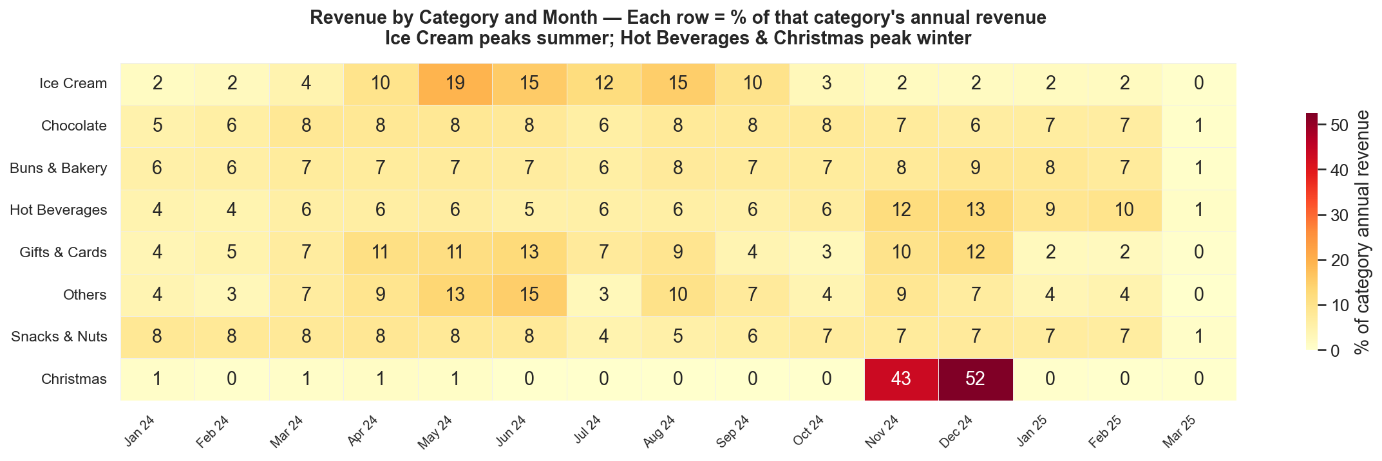
Figure 7: Category revenue heatmap: each cell shows that category's revenue as a percentage of its own annual total. Ice Cream peaks May–June; Hot Beverages and Christmas peak November–December.

2.4 Store Comparison
Store A is the highest-revenue store, accounting for approximately 21.7% of total revenue, with Store B (17.4%) and Store C (17.1%) close behind. Store G is the smallest by both revenue (6.0%) and order count (7.3%). Average order value (AOV) varies meaningfully across stores: Store B records the highest AOV (indexed at 100), suggesting either higher unit prices, larger basket sizes, or a stronger mix of premium products. Store G records the lowest AOV, which may reflect a different customer profile or product mix.
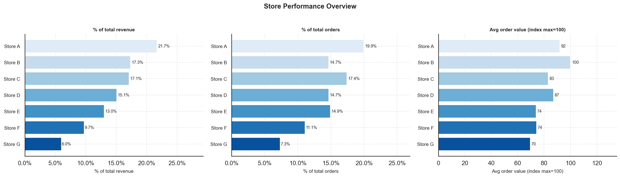
Figure 8: Store performance overview: revenue share (%), order share (%), and average order value index (max = 100 = Store B). Store A leads on revenue; Store B on transaction value.
The category mix charts reveal that Ice Cream is the dominant category at every store, but the degree of dominance varies. Store A has the highest Ice Cream share (consistent with it being in a high-footfall area), while stores with lower Ice Cream dependence show proportionally stronger Chocolate and Buns & Bakery contributions. Niche categories such as Snacks & Nuts and Christmas show variation across locations, suggesting locally tailored assortments or different customer demographics.
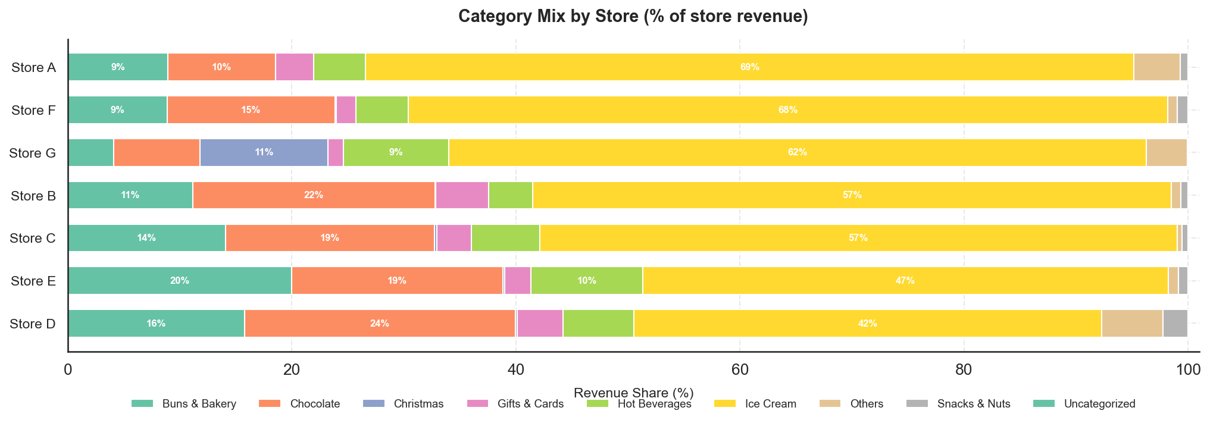
Figure 9: Category revenue mix by store (100% stacked bar, % of each store's revenue). Ice Cream dominates everywhere; relative Chocolate and Buns & Bakery shares vary materially by location.

SECTION 3 - Data Quality — Unknown Products

3.1 Definition of the Issue
Each row in the analytical dataset carries two product identity fields: name, populated directly by the POS terminal at the point of sale, and title, sourced from the Shopify product catalogue via a join on product_id. When a POS terminal records a transaction without a valid product_id — for example, when a product is sold under a temporary or unregistered SKU — the catalogue join fails, and title is filled with the placeholder value 'Unknown Product'. The name field is always present and is used for all categorisation and analysis in this report; the Unknown Product flag therefore does not compromise revenue or category findings. It does, however, signal a POS configuration gap that is worth investigating and correcting.

3.2 Scale and Row-vs-Unit Divergence
At the row level, Unknown Product is a minor issue: 4,484 lines out of 454,821 carry the flag, a rate of 0.99%. At the unit (quantity-weighted) level, however, the rate is 11.77% — approximately twelve times larger. The reason is that Unknown Product lines are not typical single-item transactions: they average approximately 28 units per line, compared with roughly 2 units per line for known-product lines. These are bulk or box-format sales — ice cream tubs, multi-pack confectionery, or similar high-quantity items — that were entered at the POS without a catalogue-linked SKU. The unit rate is therefore the more meaningful indicator of the operational footprint of this issue.
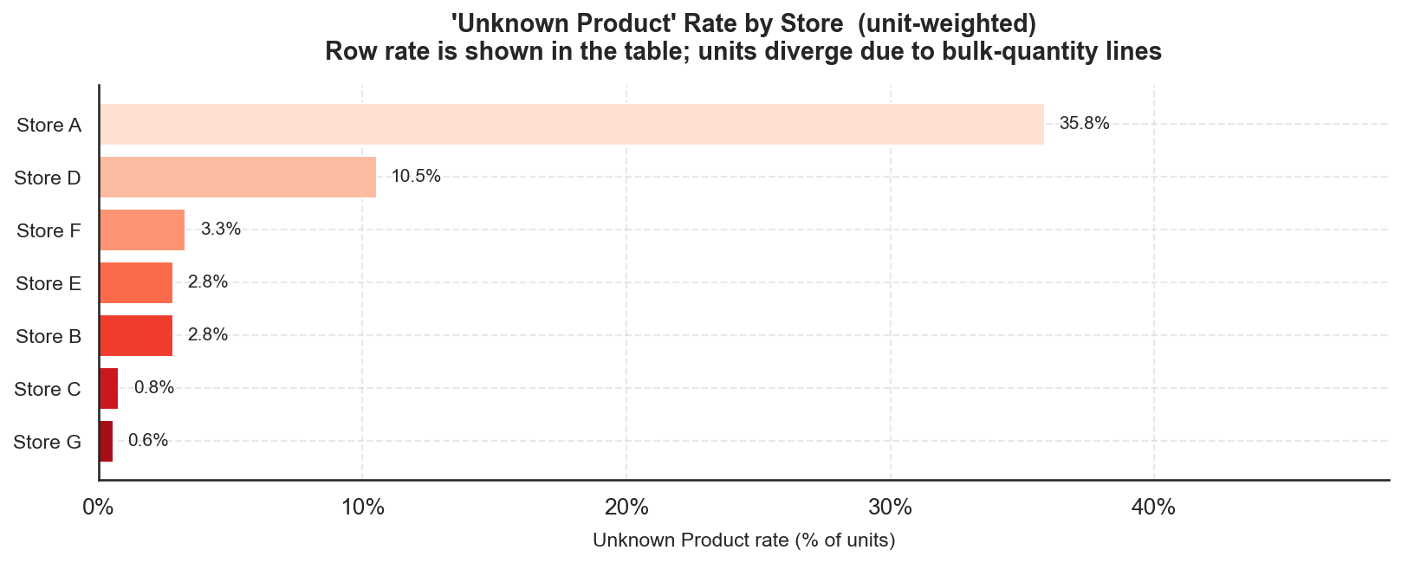
Figure 10: Unknown Product unit rate by store. Store A carries 35.8% of units as Unknown Product — far above any other location.

3.3 Store Concentration
The issue is heavily concentrated in one store. Store A accounts for 92,393 of the 125,717 unknown units — approximately 73% — despite contributing 21.7% of total revenue. Its unknown unit rate is 35.8%, compared with 10.5% for the second-most-affected store (Store D) and under 4% for all others. This pattern strongly suggests a store-specific POS configuration problem: a terminal at Store A was accepting high-quantity transactions for products not registered in the Shopify catalogue, rather than a system-wide data collection issue.

3.4 Trend Over Time
The time series of the unknown unit rate does not show a single, clean cutover. Instead, it is highly irregular: the overall rate peaks at 29.5% in June 2024 and at 24.3% in May 2024, falls sharply in July 2024, rises again in August 2024 (11.4%), and then declines erratically before settling near zero from late 2024 onwards. The row rate — less sensitive to the bulk-quantity effect — shows a more gradual improvement from about 2.6% in January 2024 to under 0.3% by February 2025.
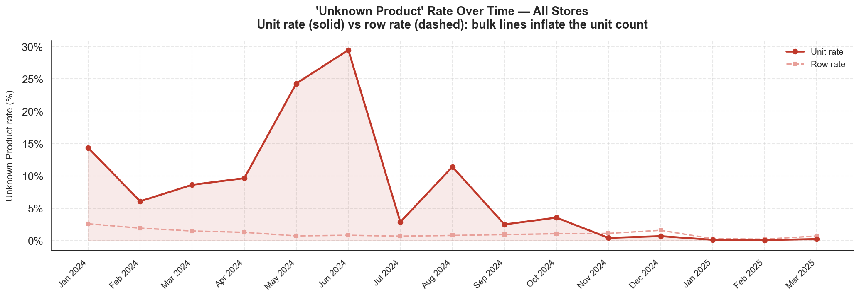
Figure 11: Unknown Product rate over time for all stores combined: unit rate (solid red) and row rate (dashed). The unit rate is highly variable with large summer peaks; both rates converge near zero by early 2025.
At Store A specifically, the unit rate reaches 67.5% in June 2024 and 54.1% in May 2024, implying that more than half of all units sold at that store in those months were not linked to any Shopify catalogue entry. The rate drops below 1% from July 2024 in most months, though individual months see small spikes through to December 2024. From January 2025 onwards the rate is consistently below 0.5% at this store.
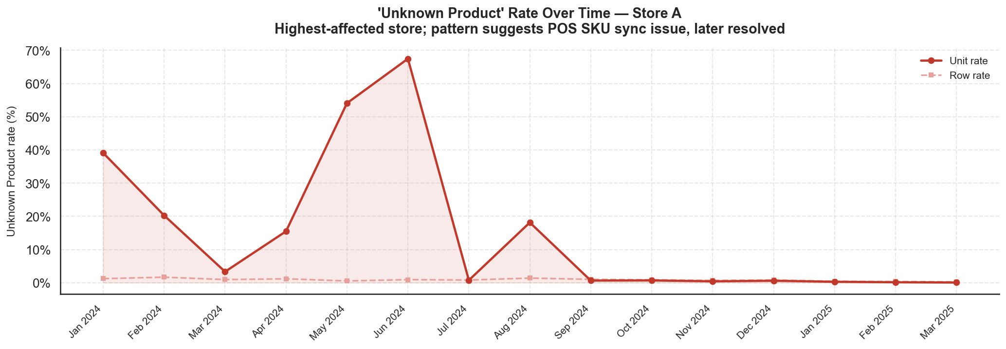
Figure 12: Unknown Product rate over time for Store A (most-affected): unit rate (solid) and row rate (dashed). Peak unit rates of 54–68% in May–June 2024 point to intermittent high-volume POS entries without catalogue linkage.
The pattern is consistent with a POS terminal that intermittently accepted bulk product entries — possibly from a secondary interface or offline mode — without resolving the SKU against the Shopify catalogue. The resolution appears to have been implemented progressively rather than as a single configuration change, with the most severe episodes concentrated in the summer peak period when transaction volumes are highest. A full investigation should verify whether any revenues were misattributed to incorrect product categories during the affected period.

SECTION 4 - Weather Analysis

This section examines the statistical association between daily weather conditions and daily revenue at the aggregate and category level. Weather data were fetched from the Open-Meteo archive API at daily resolution for each store city and area-averaged to produce a single daily weather panel. Seven predictors were examined: maximum temperature, apparent maximum temperature, daylight duration, total precipitation, rain, snowfall, and maximum wind speed. All revenue figures are expressed as daily percentage shares of total revenue.

4.1 Weather-Revenue Correlations
Daily total revenue is strongly positively associated with temperature and daylight. Spearman correlations with total daily revenue share are r = 0.70 for maximum temperature (block-bootstrap 95% CI [0.60, 0.77]) and r = 0.70 for daylight duration (CI [0.58, 0.75]). The association is considerably stronger for Ice Cream, the dominant revenue category: Spearman r = 0.82 with daylight duration (CI [0.75, 0.84]) and r = 0.77 with maximum temperature (CI [0.67, 0.82]). Hot Beverages run in the opposite direction -- r = -0.34 with daylight (CI [-0.52, -0.13]) and r = -0.22 with maximum temperature (CI [-0.41, -0.03]) -- consistent with customers substituting warm drinks for cold ones in cooler months.
All temperature and daylight associations survive Benjamini-Hochberg false discovery rate (FDR) correction across the full family of 42 tests (adjusted p < 0.001). Snowfall shows a modest negative association with total revenue (Spearman r = -0.29, CI [-0.37, -0.16], adjusted p < 0.001). Rain's association is weak (Spearman r = -0.07) and does not survive FDR correction (adjusted p = 0.19); the direction is therefore not reliable. Pearson and Spearman coefficients agree closely throughout, suggesting the relationships are not artefacts of non-linearity.
Block-bootstrap confidence intervals use 7-day consecutive blocks to preserve the autocorrelation structure of the daily revenue series; standard p-values are approximate under temporal autocorrelation and should be read alongside the bootstrap intervals.

Table 1: Weather-Revenue Correlations -- Pearson r, Spearman r, block-bootstrap 95% CI (7-day blocks), and BH FDR-adjusted p-value for each outcome x predictor pair. Sig. = Y where adjusted p < 0.05.

Outcome | Predictor | Pearson r | Spearman r | 95% CI (Spearman) | FDR-adj. p | Sig.
Total | Temp max | +0.70 | +0.70 | [+0.60, +0.77] | <0.001 | Y
 | App. temp max | +0.70 | +0.70 | [+0.59, +0.76] | <0.001 | Y
 | Daylight | +0.71 | +0.70 | [+0.58, +0.75] | <0.001 | Y
 | Precipitation | -0.16 | -0.14 | [-0.27, +0.01] | 0.006 | Y
 | Rain | -0.13 | -0.07 | [-0.22, +0.08] | 0.188
 | Snowfall | -0.17 | -0.29 | [-0.37, -0.16] | <0.001 | Y
 | Wind speed | -0.16 | -0.15 | [-0.28, +0.01] | 0.003 | Y
Ice Cream | Temp max | +0.76 | +0.77 | [+0.67, +0.82] | <0.001 | Y
 | App. temp max | +0.76 | +0.76 | [+0.67, +0.81] | <0.001 | Y
 | Daylight | +0.77 | +0.82 | [+0.75, +0.84] | <0.001 | Y
 | Precipitation | -0.14 | -0.12 | [-0.25, +0.03] | 0.017 | Y
 | Rain | -0.11 | -0.05 | [-0.20, +0.09] | 0.310
 | Snowfall | -0.15 | -0.29 | [-0.38, -0.17] | <0.001 | Y
 | Wind speed | -0.17 | -0.15 | [-0.29, -0.00] | 0.002 | Y
Hot Beverages | Temp max | -0.29 | -0.22 | [-0.41, -0.03] | <0.001 | Y
 | App. temp max | -0.27 | -0.20 | [-0.39, -0.00] | <0.001 | Y
 | Daylight | -0.39 | -0.34 | [-0.52, -0.13] | <0.001 | Y
 | Precipitation | -0.23 | -0.21 | [-0.32, -0.08] | <0.001 | Y
 | Rain | -0.21 | -0.19 | [-0.31, -0.06] | <0.001 | Y
 | Snowfall | -0.10 | -0.06 | [-0.20, +0.12] | 0.249
 | Wind speed | -0.12 | -0.14 | [-0.24, +0.00] | 0.005 | Y

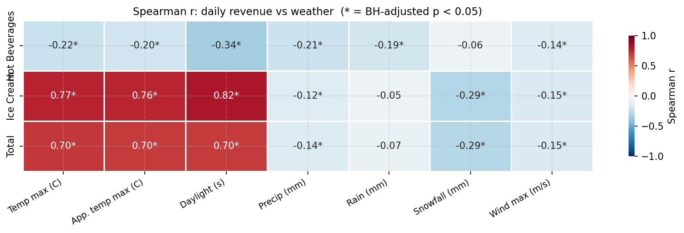
Figure 13: Spearman correlation heatmap -- daily revenue share (Total, Ice Cream, Hot Beverages) vs seven weather predictors. Cell values show Spearman r to two decimal places; asterisks (*) mark associations surviving BH FDR correction (adjusted p < 0.05). Temperature and daylight are strongly positive for Total and Ice Cream revenue, and negative for Hot Beverages.
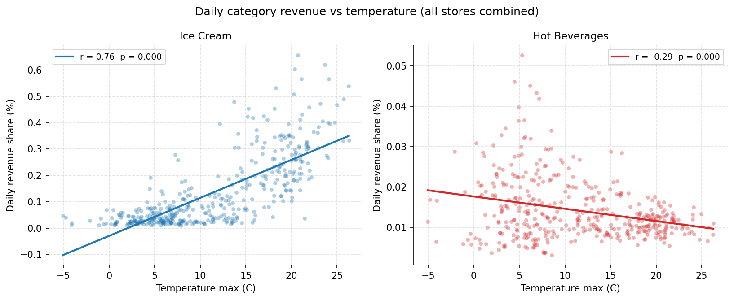
Figure 14: Daily revenue share vs maximum temperature for Ice Cream (left, blue) and Hot Beverages (right, red), with OLS fit lines. The opposing slopes illustrate seasonal substitution between the two categories. Pearson r and p-value are shown in each panel legend.

4.2 Multicollinearity Among Weather Predictors
The Pearson correlation between maximum temperature and apparent maximum temperature is r = 0.988; their variance inflation factors (VIF) are 93.6 and 94.1 respectively. In practice only one of these variables can be included in a regression specification; maximum temperature is the preferred choice as the more physically interpretable measure. Daylight duration is also strongly correlated with temperature (r = 0.80) but has a comparatively modest VIF of 2.78, so it can enter a model alongside temperature provided apparent temperature is excluded.
The precipitation cluster presents a more severe problem: total precipitation equals rain plus snowfall by construction, producing VIFs of 1,341,169 (precipitation), 1,238,813 (rain), and 57,888 (snowfall). These three variables cannot be interpreted independently in any multivariate model and must be collapsed to a single measure or replaced with mutually exclusive flags. Wind speed (VIF 2.60) is independent of the remaining predictors and can be included without inflation. These collinearity findings motivate pruning the predictor set before fitting the regression model.
Table 2: Variance Inflation Factors for the seven weather predictors. Temperature and apparent temperature (VIF ~94) and the precipitation cluster (VIF >57,000) are highly collinear and cannot enter a regression together.

Weather Predictor | VIF
Temp max | 93.58
App. temp max | 94.09
Daylight | 2.78
Precipitation | 1,341,169
Rain | 1,238,813
Snowfall | 57,888
Wind speed | 2.60

4.3 Group Comparisons
Four binary splits were tested using Mann-Whitney U tests with rank-biserial correlation as the effect-size measure and 1,000-iteration bootstrap 95% confidence intervals on the difference in group medians, expressed in daily revenue-share percentage points (pp). All four adjusted p-values passed the BH FDR threshold.
Revenue is substantially higher on warm, long-daylight days and in summer. Three of the four splits produce large, highly significant effects:
- Summer (Apr-Sep) vs Winter (Oct-Mar): rank-biserial r = 0.86, median difference +0.21 pp, 95% CI [0.187, 0.227], adjusted p < 0.001.
- Long daylight (>= 11.2 h) vs Short daylight (< 11.2 h): rank-biserial r = 0.82, median difference +0.19 pp, 95% CI [0.168, 0.218], adjusted p < 0.001.
- Warm (>= 10.8 C) vs Cold (< 10.8 C): rank-biserial r = 0.71, median difference +0.17 pp, 95% CI [0.156, 0.205], adjusted p < 0.001.
- Rainy (> 1 mm) vs Dry: rank-biserial r = -0.12, median difference -0.026 pp, 95% CI [-0.065, +0.017], adjusted p = 0.034. The bootstrap CI crosses zero, so the direction of the precipitation effect is uncertain despite the test reaching nominal significance.

Table 3: Group Comparisons -- Mann-Whitney U test results. Sorted by effect size (rank-biserial r). Median diff is in daily revenue-share percentage points (pp). Rainy vs Dry 95% CI crosses zero.

Split | Rank-biserial r | Median diff (pp) | 95% CI | FDR-adj. p
Summer vs Winter | +0.86 | +0.208 | [+0.187, +0.227] | <0.001
Long vs Short Daylight | +0.82 | +0.191 | [+0.168, +0.218] | <0.001
Warm vs Cold | +0.71 | +0.174 | [+0.156, +0.205] | <0.001
Rainy vs Dry | -0.12 | -0.026 | [-0.065, +0.017] | 0.034

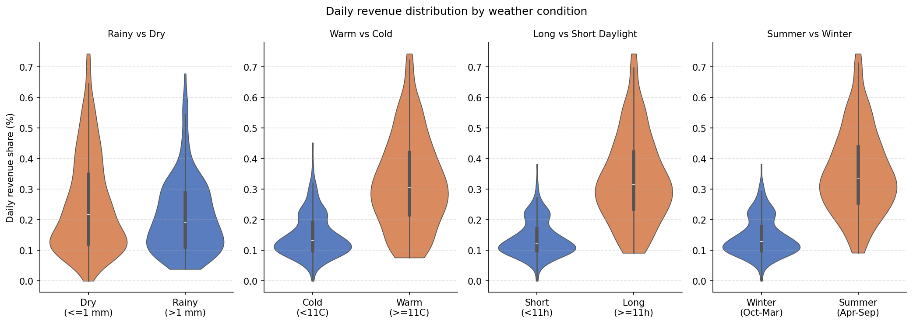
Figure 15: Violin plots of daily revenue share by group for the four binary splits. The inner box-and-whisker marks the median and interquartile range. The warm/cold, long/short-daylight, and summer/winter splits all show large revenue shifts; the rainy/dry split shows minimal separation with overlapping distributions.

4.4 Per-Store Temperature Sensitivity
All seven stores show positive Spearman correlations between daily revenue share and maximum temperature, with all FDR-adjusted p-values below 0.001. Store A is the most weather-sensitive (r = 0.75), followed by Store F (r = 0.69), Store C (r = 0.67), Store E (r = 0.63), Store B (r = 0.59), Store D (r = 0.43), and Store G (r = 0.31). The variation likely reflects differences in store size, footfall mix, and category composition: stores with a higher ice cream revenue share are expected to show stronger positive temperature correlations, consistent with the category-level findings in Section 4.1.
Table 4: Per-Store Temperature Sensitivity -- Spearman correlation with daily maximum temperature (sorted most to least sensitive; all FDR-adjusted p < 0.001).

Store | Spearman r | 95% CI | FDR-adj. p
Store A | +0.75 | [+0.65, +0.80] | <0.001
Store F | +0.69 | [+0.59, +0.76] | <0.001
Store C | +0.67 | [+0.56, +0.73] | <0.001
Store E | +0.63 | [+0.54, +0.70] | <0.001
Store B | +0.59 | [+0.49, +0.66] | <0.001
Store D | +0.43 | [+0.29, +0.53] | <0.001
Store G | +0.31 | [+0.12, +0.46] | <0.001

4.5 Caveats
Three limitations should be noted. First, all findings are observational: temporal autocorrelation inflates the effective sample size implied by standard p-values, so the block-bootstrap confidence intervals (7-day blocks) are the more reliable uncertainty indicators. Second, the extreme collinearity among temperature and apparent temperature, and among the three precipitation variables, means that the marginal associations reported here cannot be translated into independent coefficient estimates in a multivariate regression without first pruning predictors to a near-orthogonal set. Third, omitted variables such as public holidays, promotional events, and local footfall patterns may confound the weather-revenue relationship; the correlations documented here motivate including weather as a predictor in a revenue model but do not constitute causal evidence.

SECTION 5 - Predictive Modelling
This section describes two complementary models built to quantify and forecast daily Ice Cream revenue at the store-day level. The first model is an interpretable log-linear regression (the 'why') that translates each predictor into an explicit percentage effect on revenue. The second is an XGBoost gradient-boosting forecaster (the 'how much') that captures non-linear interactions and autoregressive dynamics. Both models use the VIF-pruned feature set established in Section 4.2, plus store fixed effects and calendar controls; all metrics are scale-free (R², WAPE, percentage effects) -- no absolute revenue figures are reported.

5.1 Interpretable Regression (OLS)
An OLS model is fitted to log(Ice Cream revenue + 1) with heteroscedasticity-consistent HC3 standard errors. The log-linear specification was preferred over a Gamma GLM with log link for three reasons: (1) the +1 offset is negligible relative to typical revenue magnitudes, making log(revenue + 1) approximately equal to log(revenue) for all practical values; (2) only 1.7% of store-days carry zero Ice Cream revenue, so zero-inflation treatment is unnecessary; and (3) OLS on the log scale yields closed-form HC3 confidence intervals and coefficients that exponentiate directly into multiplicative percentage effects.
The model is fitted on N = 2,714 store-days across seven stores and achieves R² = 0.667 (adjusted R² = 0.664) on the log-transformed target. In-sample WAPE on the original scale is 39.5%. The 28-parameter specification covers four weather predictors, eleven month dummies, six day-of-week dummies, and six store fixed effects.
Weather effects. Table 5 reports the four weather coefficient estimates expressed as percentage changes in daily Ice Cream revenue per unit increase in each predictor. Temperature is the dominant weather driver: each additional degree Celsius is associated with a 5.7% increase in Ice Cream revenue (95% CI: +4.4% to +7.1%), and each additional hour of daylight with an 11.2% increase (+4.6% to +18.2%). Both effects survive BH FDR correction across the full coefficient family. Each additional millimetre of precipitation reduces revenue by 4.7% (-5.4% to -3.9%). This significant conditional effect contrasts with the weaker bivariate rain–revenue association reported in Section 4.1: by controlling for temperature and seasonality, the regression isolates precipitation’s independent contribution to revenue, separating it from the seasonal co-movement shared with colder, wetter periods. Wind speed shows a small negative point estimate (-0.4%) but is not significant (p = 0.108) after controlling for temperature and seasonality.
Table 5: OLS weather effects on daily Ice Cream revenue. Coefficients exponentiated to % change per unit increase. HC3 robust 95% CIs. FDR-adjusted p-values (BH) across all 27 non-intercept coefficients.

Weather predictor | Unit change | % Effect | 95% CI | FDR-adj. p | Sig.
Temp max | +1 C | +5.7% | [+4.4%, +7.1%] | <0.001 | Y
Daylight | +1 h | +11.2% | [+4.6%, +18.2%] | <0.001 | Y
Precipitation | +1 mm | -4.7% | [-5.4%, -3.9%] | <0.001 | Y
Wind speed | +1 m/s | -0.4% | [-0.9%, +0.1%] | 0.108

Calendar and store effects. Day-of-week effects are large and highly significant: Saturday carries a +122% premium over Monday (95% CI: +95% to +152%), Friday +109% (+83% to +139%), and Sunday +61% (+41% to +83%). These patterns are consistent with the footfall seasonality described in Section 2.3. Store fixed effects show substantial variation relative to Store A: Stores D, E, and F are 44-50% lower, and Store G 89% lower, reflecting differences in size, location, and trading format.
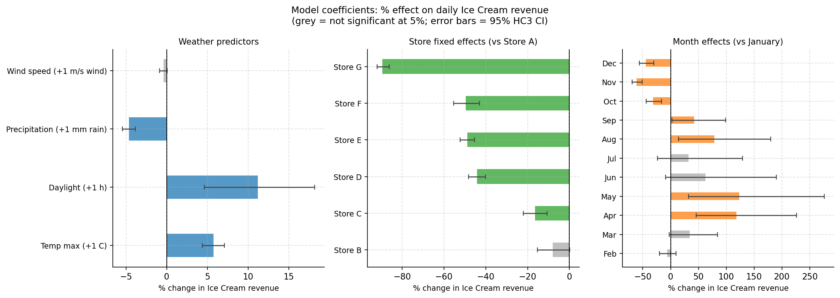
Figure 16: OLS coefficient forest plot. Left panel: weather % effects per unit change (95% HC3 CI; grey = not significant at 5%). Centre: store fixed effects relative to Store A. Right: month effects relative to January. Error bars are 95% confidence intervals.

5.2 XGBoost Forecaster
An XGBoost gradient-boosting regressor is trained on a richer feature set that extends the OLS specification with autoregressive lag features: the previous day's revenue (lag-1), the same weekday from the prior week (lag-7), and a 7-day rolling mean (all computed within each store in strict date order to prevent leakage). Additional calendar features include a weekend flag and cyclical day-of-year encodings (sine and cosine of the day number, preserving the circular calendar structure). The model is validated using TimeSeriesSplit cross-validation (5 folds) keyed on unique dates so all stores' observations for a given date are always assigned to the same fold.
Table 6 reports per-fold WAPE for the seasonal-naive baseline (lag-7 forecast) and XGBoost, together with the fold-level R². Overall, XGBoost achieves WAPE = 39.5% against a naive baseline of 47.2%, beating the baseline on four of five folds. Fold 1 is the exception: with fewer than three months of training data the model cannot capture full seasonal variation, and the lag features degrade as the forecast horizon extends beyond seven days. XGBoost out-of-sample WAPE is essentially identical to the OLS in-sample WAPE (39.5% vs 39.5%), which is an honest result: both methods explain roughly the same variation. XGBoost's incremental value lies in its non-linear lag-weather interactions and, as described in Section 5.3, its capacity to produce calibrated prediction intervals.
Table 6: XGBoost 5-fold time-series cross-validation metrics. Naive baseline = lag-7 (seasonal-naive forecast). Overall row aggregates all test folds. Fold 1 note: training window covers fewer than three months.
Fold | Naive WAPE | XGB WAPE | XGB R² | n test
1 | 43.9% | 52.8% | -0.02 | 480
2 | 50.5% | 32.6% | 0.59 | 483
3 | 47.8% | 33.1% | 0.69 | 473
4 | 41.8% | 40.3% | 0.65 | 463
5 | 48.7% | 37.2% | 0.47 | 405
Overall | 47.2% | 39.5% | 0.55 | 2,304

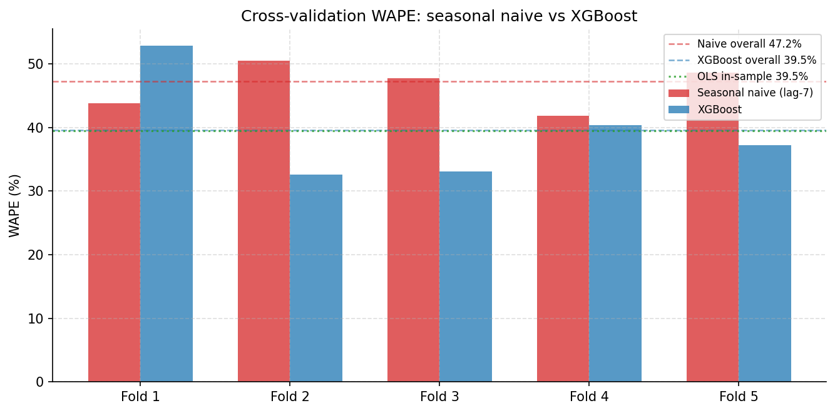
Figure 17: Cross-validation WAPE by fold. Grouped bars show seasonal-naive (red) vs XGBoost (blue); dashed lines show overall WAPE; dotted green line shows OLS in-sample WAPE for reference. XGBoost beats the naive baseline on 4/5 folds; Fold 1 underperforms due to a short early training window.
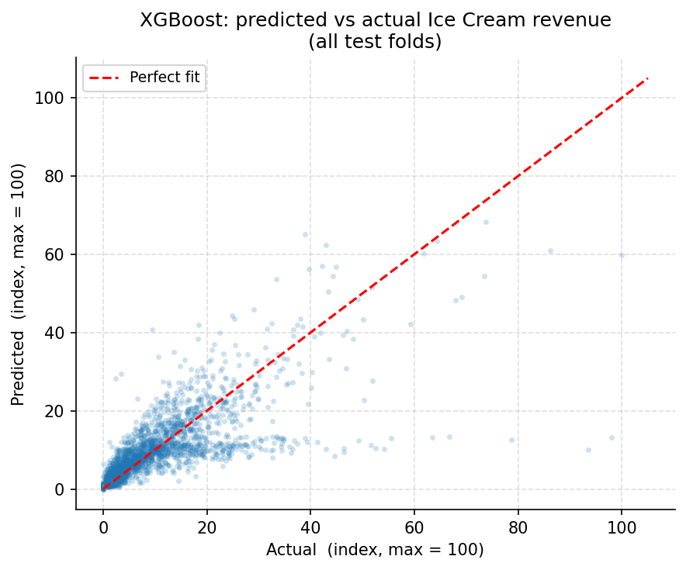
Figure 18: XGBoost predicted vs actual Ice Cream revenue across all test folds (revenue indexed, max = 100). Observations cluster near the diagonal for mid-range values; variance is higher at the extremes, consistent with the heteroscedastic residual pattern.

5.3 Prediction Intervals (Conformal Calibration)
Point forecasts alone are insufficient for operational planning; prediction intervals are needed to quantify uncertainty. The XGBoost model produces raw 90% prediction intervals using separate quantile regressors trained on the lower and upper quantiles. Without calibration, the raw intervals achieve only 64.5% empirical coverage across the test folds -- well below the 90% target -- because quantile regression in gradient-boosted trees systematically underestimates uncertainty.
Conformalized Quantile Regression (CQR) is applied to correct this. Within each training fold, the last 20% of dates form a held-out calibration window. Conformity scores are computed on that window as the amount by which the raw interval must be symmetrically expanded to just cover each observation. The finite-sample adjusted 90th percentile of those scores -- the CQR adjustment q_hat -- is then added to both bounds of the test-set intervals. CQR is theoretically guaranteed to achieve at least 90% marginal coverage for exchangeable data.
After CQR calibration, empirical coverage rises from 64.5% to 81.2%, a gain of 16.7 percentage points. The remaining 8.8-point shortfall from the 90% target reflects temporal non-stationarity: the test period can exhibit different distributional properties from the calibration window, violating the exchangeability assumption. The per-fold CQR adjustments varied substantially, with one fold requiring a notably larger expansion than the others -- evidence that the data contains regime shifts that a stationary conformal procedure cannot fully absorb. Adaptive conformal prediction (which recalibrates the adjustment at each time step) would be the natural next step to close the remaining gap.
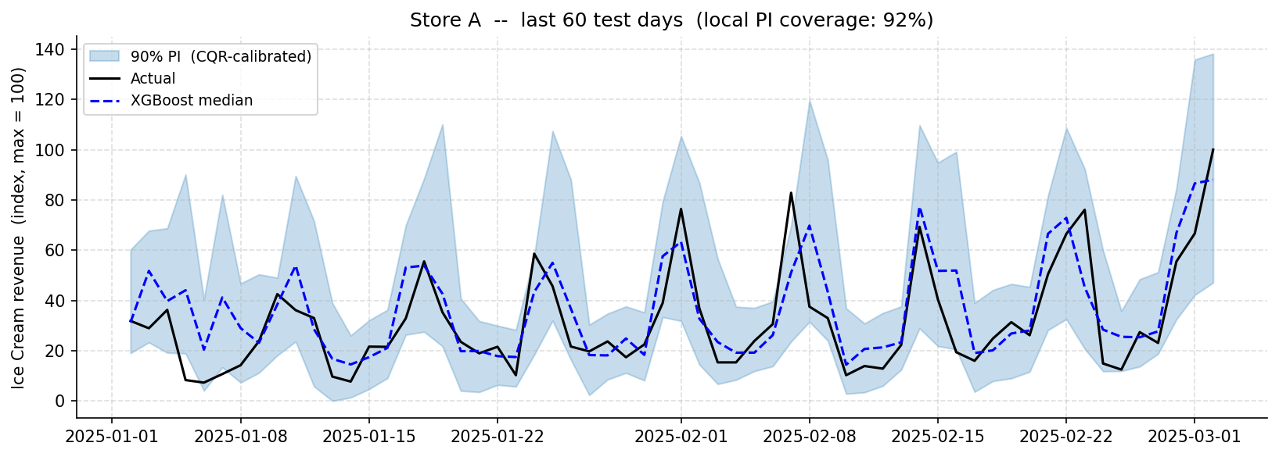
Figure 19: Example forecast with CQR-calibrated 90% prediction interval for Store A, last 60 test days. Revenue is indexed (max = 100). The shaded band shows the calibrated interval; the black line is actual revenue; the dashed blue line is the XGBoost median forecast. Local coverage is shown in the panel title.

5.4 Feature Importance (SHAP)
SHAP (SHapley Additive exPlanations) values are computed on the full dataset using a tree explainer. Figure 20 shows mean absolute SHAP values, which measure each feature's average contribution to the model's output across all observations.
The model is predominantly autoregressive. The previous day's revenue (lag-1) is by far the most important single feature, followed by the 7-day rolling mean. Together these two lag features dominate the attribution, which reflects the strong day-to-day persistence and weekly rhythm in ice cream demand. Note that lag-1, rolling-7-day mean, and lag-7 are mutually collinear; their individual SHAP values are ambiguous (collinear features share attribution depending on which was observed first in the tree splits), but their combined contribution is correctly measured.
Among non-lag features, temperature and daylight are the strongest drivers, consistent with the OLS regression findings in Section 5.1. Precipitation and day-of-week rank next. The cyclical day-of-year features (sine and cosine encodings) capture smooth within-year seasonality that the monthly dummies in the OLS model approximate discretely. Month, weekend flag, and wind speed have modest but non-zero importance. The overall picture is that weather is a real but secondary driver: the autoregressive lag structure explains the majority of variance, while weather variables account for a further material share.
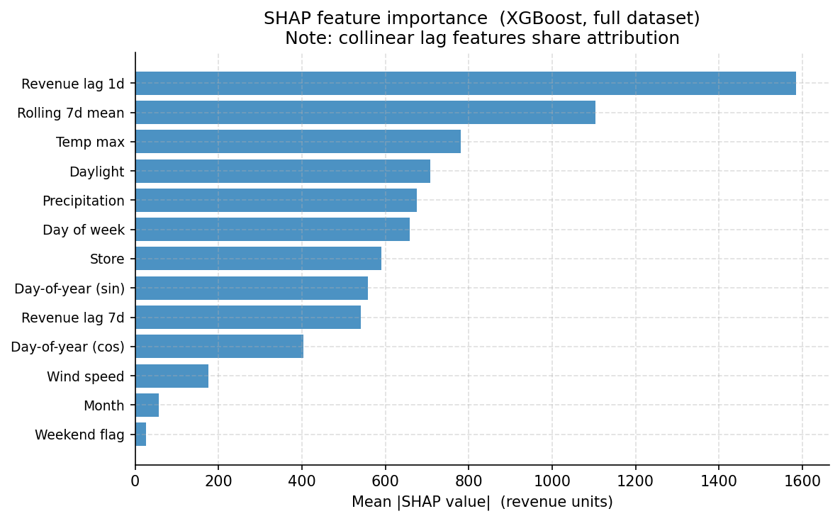
Figure 20: SHAP feature importance (mean |SHAP value|, XGBoost trained on full dataset). Lag-1 revenue and rolling 7-day mean dominate; temperature and daylight are the leading weather predictors. Collinear lag features share attribution; their individual values should be interpreted jointly.

5.5 Caveats
Four limitations apply to both models. First, both are trained and validated on the available historical period; if the business expands to new locations or product ranges, retraining will be required. Second, the autoregressive lag features in the XGBoost model mean that forecast accuracy degrades as the horizon extends beyond one week (lags become unavailable and must themselves be forecast). Third, the conformal calibration assumes approximate stationarity between the calibration and test windows; the observed shortfall from 90% coverage indicates some non-stationarity is present. Fourth, neither model accounts for causal drivers such as marketing campaigns, price changes, or public holidays, all of which may confound the weather-revenue relationship and reduce out-of-sample accuracy if these factors change.

SECTION 6 - Recommendations
Five concrete recommendations follow directly from the analysis. Each is grounded in a specific quantitative finding.
- Concentrate staffing and preparation on peak periods. Friday and Saturday carry revenue premiums of approximately +109% and +122% over Monday respectively. Within the trading day the 14:00–16:00 window is the revenue peak. Scheduling staff and ice-cream preparation to align with these peaks will reduce both under-service on busy days and over-staffing on quiet ones.
- Use the weather-driven forecast to scale ice-cream demand. Each additional degree Celsius above the baseline is associated with approximately 5.7% higher daily Ice Cream revenue; each additional hour of daylight with approximately 11.2%. The XGBoost forecaster operationalises these effects: a warm, long-daylight forecast is a direct signal to increase ice-cream stock, preparation capacity, and staffing. Summer and warm/long-daylight days drive the largest upswings and carry the highest risk of under-preparation.
- Build a counter-seasonal product mix. Ice Cream revenue drops sharply in winter. Hot Beverages and Chocolate/Christmas products show the inverse seasonal profile and can partially offset the off-season trough. Cross-training staff across seasonal product lines will reduce scheduling friction as the product mix shifts between summer and winter.
- Fix the POS configuration at the affected store. One store’s POS terminal was not synced to Shopify product codes, generating a concentrated block of transactions with no product attribution. This understates that store’s per-category revenue and distorts any category-level comparisons involving it. Completing the POS reconfiguration (already partially enacted) and back-filling historical data where possible will restore accurate attribution.
- Focus inventory and promotion on the core product set. Approximately 20 products drive 80% of total revenue — a clean Pareto distribution. Inventory depth, promotional spend, and operational attention should be weighted towards these lines; long-tail products with negligible revenue contribution are candidates for rationalisation.

SECTION 7 - Limitations & Next Steps

Five limitations apply to the analysis and models presented in this report.
- Observational data — no causal claims. The dataset is an observational transaction record; no controlled experiment was run. All stated effects (weather on revenue, day-of-week premiums) are associations, not causal estimates. Unmeasured confounders — marketing campaigns, pricing changes, local events — may drive part of the observed variation. Causal conclusions would require experimental or quasi-experimental designs.
- Temporal autocorrelation. Daily revenue observations from the same store are serially correlated. The bootstrap confidence intervals reported for group comparisons and store-level temperature sensitivities are more reliable than the conventional asymptotic standard errors, because they do not assume independence across observations. Raw p-values from parametric tests should be treated as indicative rather than definitive.
- Severe collinearity among weather predictors. Temperature, feels-like temperature, daylight duration, and calendar season are highly intercorrelated. The regression uses VIF-pruned predictors (feels-like excluded) to reduce this, but the retained coefficients still carry shared attribution with the excluded variables. Individual predictor effects should be interpreted jointly, not in isolation.
- The forecaster is predominantly autoregressive. The XGBoost model’s SHAP analysis shows that recent lag revenue (previous day, 7-day rolling mean) dominates feature importance; weather variables are a secondary but material contributor. Forecast accuracy therefore degrades as the horizon extends beyond one week, because lag features must themselves be forecast. The model is best suited to short-horizon (1–7 day) operational planning rather than long-range demand projection.
- Conformal prediction interval coverage is capped near 81%. The CQR-calibrated 90% prediction intervals achieve approximately 81% empirical coverage — 9 percentage points below the nominal target. The shortfall reflects temporal non-stationarity between the calibration and test windows: the exchangeability assumption required for exact conformal coverage guarantees is violated when the data distribution shifts over time. The q-hat adjustment varies substantially across folds, confirming the presence of regime shifts that a stationary conformal procedure cannot fully absorb.

Next Steps
- Adaptive conformal prediction. Replacing the static CQR calibration with an adaptive conformal procedure — which recalibrates the interval adjustment at each time step using a rolling window — would close the remaining coverage gap by tracking distributional shifts in real time.
- Incorporate external events. Neither model accounts for marketing campaigns, price changes, or public holidays. Adding a public-holiday indicator and, where available, campaign flags would reduce residual variance and improve both the regression coefficient estimates and the forecaster’s out-of-sample accuracy.
- Expand the store coverage. Both models were trained and validated on the current seven-store network. If the business expands to new locations, the models should be retrained on data that includes the new stores; extrapolating store fixed effects to novel locations is unreliable.

