Trading System Analysis
Holding Duration & Loss Risk

Prepared: June 12, 2026
Confidential — client data anonymized. Not for distribution.

Executive Summary
This report quantifies the relationship between trade holding duration and loss probability across two automated forex trading strategies on the MQL5 platform. The analysis covers 2,423,067 cleaned trades spanning multiple instruments and signal providers.

Headline finding
Loss probability rises monotonically with holding duration: from 16.1% for trades held under one hour, to 45.8% for trades held beyond one day. Broken down by calendar day, the escalation is sharper — 22.2% at under one day, 39.5% at 1–3 days, 46.7% at 3–5 days, and 53.5% at 5–7 days. Median profit turns negative in the 5–7 day window (median = -0.99), and falls further to -1.94 beyond seven days. The Kruskal-Wallis test confirms that differences across bins are statistically significant (H = 31,872, p < 0.001 for day bins), though the effect size is modest (epsilon-squared = 0.013), reflecting that duration is one of several factors driving profitability.

Recommended holding threshold
Conditional loss probability — P(loss | held ≈ t hours) — rises from 16% for sub-hour trades to above 50% for multi-day positions. Three evidence-based thresholds emerge from Section 3.6: the 30% loss-rate level is crossed at approximately 13h, the 40% level at 31h (1.3 days), and the 50% (loss majority) level at 137h (5.7 days). Two operational thresholds are proposed: (1) Review zone — from approximately 13h onward, loss probability exceeds 30% with no evidence of compensating upside; active position review is warranted. (2) Hard limit — at approximately 5 days (120h), the loss majority (>50%) and negative median profit (-0.99 in the 5–7 day bin) converge; no analysis in this report supports holding beyond this point. Full derivation in Section 3.6.

1. Context & Data

1.1 Objective
The client operates automated forex trading signals on the MQL5 platform. Each signal is an algorithmic strategy that opens and closes positions automatically; subscribers copy these trades. The core analytical question is: at what holding duration does an open position become more likely than not to result in a loss, and what is the optimal window for closing positions to limit downside?

1.2 Data sources
Two datasets were provided. The trade-level file (combined_history.csv) contains one row per individual trade, recording the open and close timestamps, instrument symbol, trade direction (Buy/Sell), volume, open and close prices, and realized profit. The signal-level summary file (general_data.csv) contains one row per trading strategy with aggregated performance statistics (growth, Sharpe ratio, profit factor, drawdown metrics, and activity counts).

1.3 How holding duration is defined
Holding duration is defined as the elapsed time between a trade's open timestamp (Time) and its close timestamp (Time.1): holding_duration_hours = (Time.1 - Time) in total seconds / 3600. Only non-negative durations are retained. Duration in days is derived as holding_duration_hours / 24. The log1p transform of holding duration in hours is used in correlation and regression contexts to reduce the influence of extreme values on a heavily right-skewed distribution.

1.4 Data cleaning summary
Step | Count
Raw trades loaded | 2,504,598
Dropped (missing Volume, Symbol, Price, Time.1, or Price.1) | 81,531
Dropped (negative holding duration) | 0
Clean trades retained | 2,423,067

The signal-level summary file required no row-level cleaning; 2,146 rows were retained in full.

1.5 Anonymization
This repository and report contain no personally identifiable information. The trade-level file contained a numeric signal identifier column (ID) which was dropped during preprocessing. The signal-level summary file contained real trader names (name), numeric IDs (id), and strategy titles (title); all three were removed or replaced with anonymized labels (signal_001, signal_002, …) before any analysis or output was produced. Raw data files are excluded from the repository via .gitignore and were never committed.

2. Descriptive Analysis

2.1 Distributions of holding duration and profit
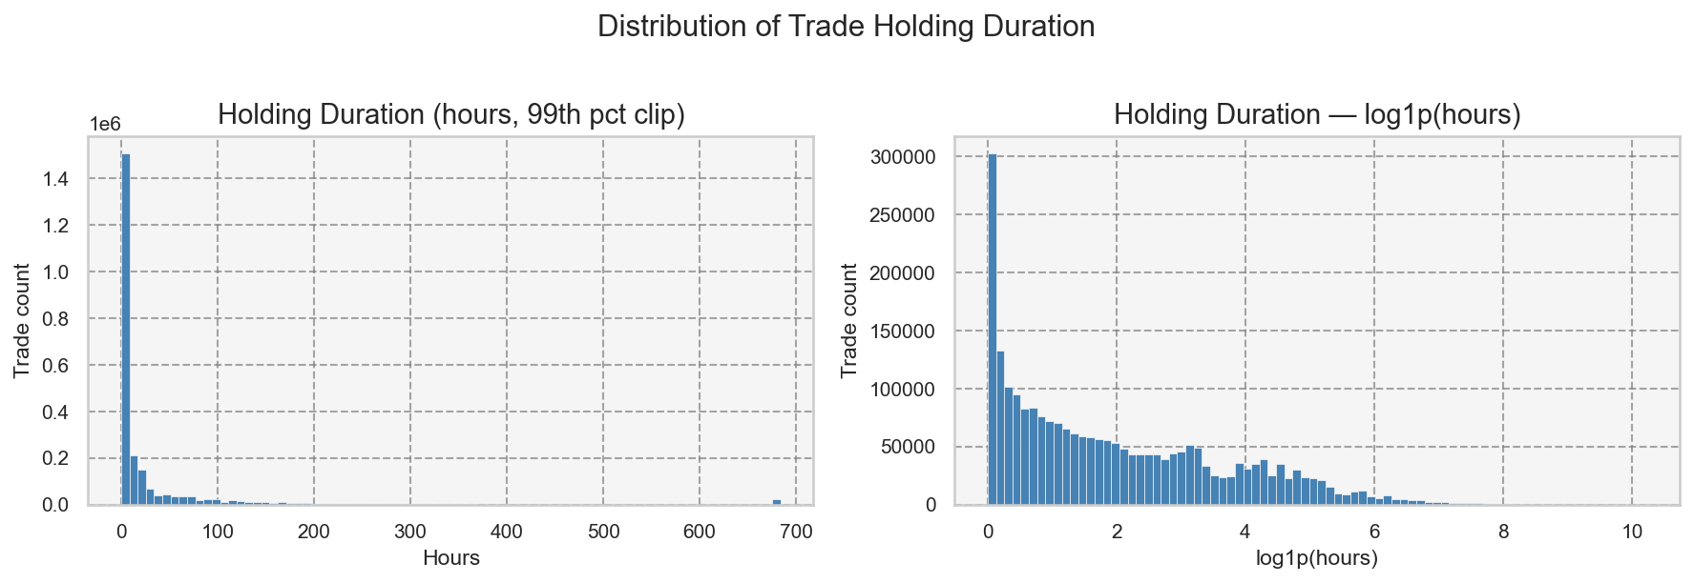
Figure 1. Distribution of holding duration. Left: raw hours (clipped at 99th percentile). Right: log1p-transformed hours. The distribution is strongly right-skewed; the majority of trades are held for under 24 hours.
Holding duration is heavily right-skewed, with the bulk of trades concentrated in short windows. Approximately 31% of trades are closed within the first hour, and 76% are closed within the first day. A small tail extends to very long durations that would distort means and linear correlations; the log1p transform produces a distribution closer to symmetric and is used throughout correlation and regression analyses.
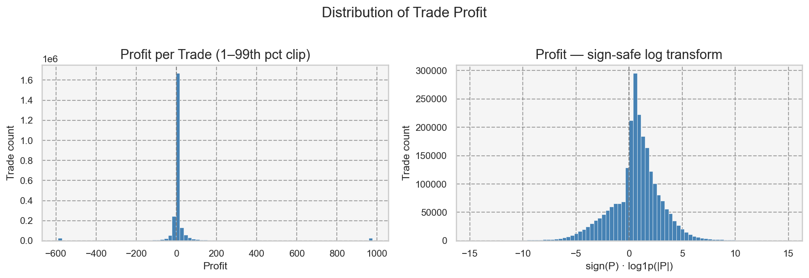
Figure 2. Distribution of trade profit. Left: raw values (clipped at 1st–99th percentile). Right: sign-safe log transform. The distribution is bimodal around zero, with a pronounced right tail from large winning trades.
Profit is also skewed, with a long right tail from large winning trades. The sign-safe log transform — sign(P) × log1p(|P|) — preserves the sign of profits and losses while compressing the tails for visualisation. Both distributions confirm that standard parametric assumptions (normality, homoscedasticity) are violated, motivating the use of non-parametric tests throughout.

2.2 Monotonic association: Spearman correlation
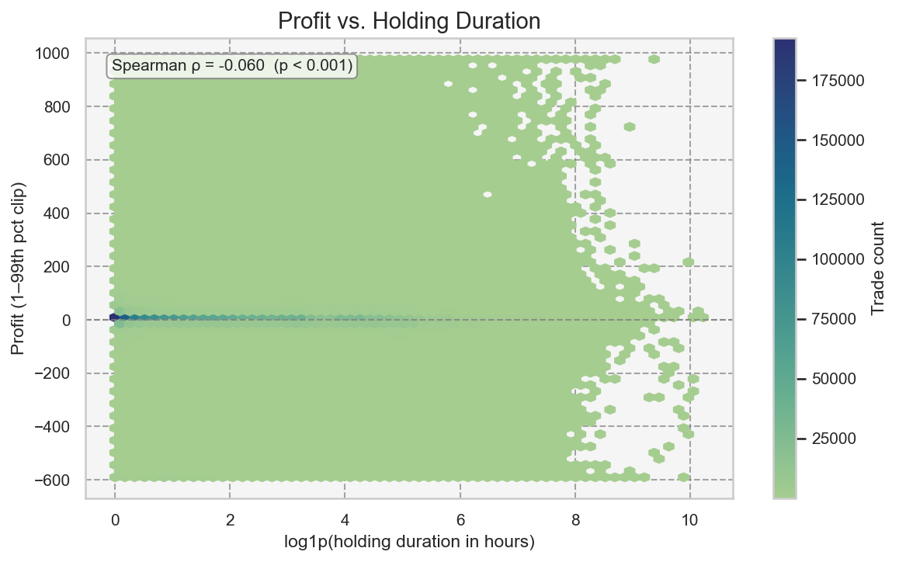
Figure 3. Hexbin density plot of profit vs. log1p(holding duration). Each hexagon represents the count of trades in that region. Spearman rho is annotated.
Spearman's rho between holding duration in hours and profit is -0.0599 (p < 0.001, n = 2,423,067). The correlation is statistically significant given the large sample size, but the effect is negligible in practical terms: holding duration alone explains almost none of the variance in profit at the individual-trade level. This is consistent with the hexbin plot, which shows no strong directional trend across the bulk of the distribution. The meaningful signal emerges only when trades are aggregated into duration bins.

2.3 Loss probability by duration bin
The central finding of this analysis is that loss probability rises systematically with holding duration. The tables below show this pattern for both hour-level and day-level bins.

Hour bins
bin | n_trades | pct_of_total | loss_probability | avg_profit | median_profit
0-1h | 749,506 | 30.9% | 16.1% | 52.94 | 0.93
1h-3h | 384,866 | 15.9% | 20.8% | 42.36 | 1.32
3h-6h | 252,236 | 10.4% | 26.7% | 27.50 | 1.33
6h-8h | 98,446 | 4.1% | 29.2% | 61.82 | 1.46
8h-9h | 35,796 | 1.5% | 28.4% | 257.39 | 1.56
9h-24h | 320,969 | 13.2% | 31.5% | 30.84 | 1.62
>1 day | 581,248 | 24.0% | 45.8% | 28.72 | 0.53

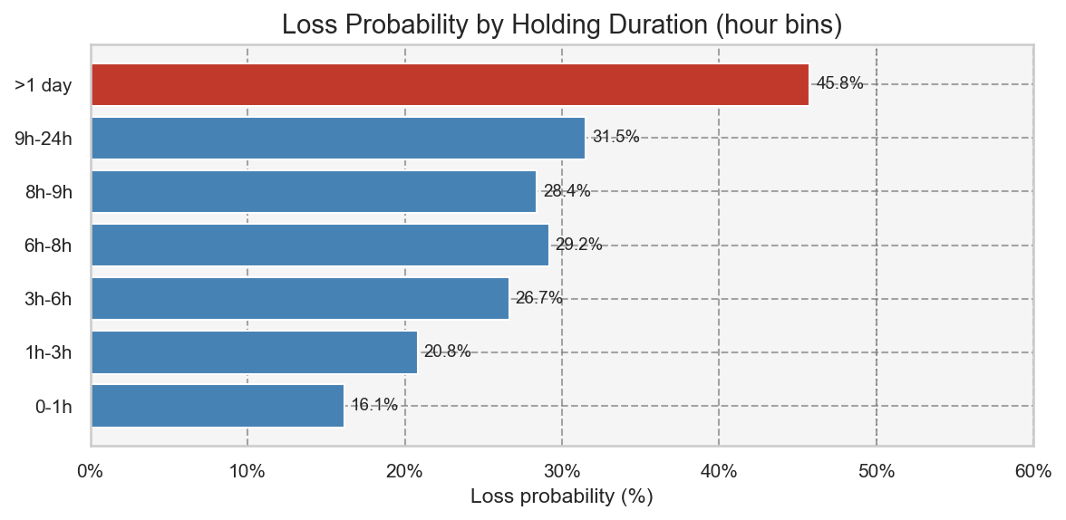
Figure 4. Loss probability per hour bin. Red bars indicate bins where loss probability exceeds 35%.
Loss probability climbs from 16.1% for sub-hour trades to 45.8% for trades held beyond one day — nearly a three-fold increase. The sharpest jump occurs between the 6–8 hour range (29.2%) and the beyond-one-day category (45.8%), suggesting that trades surviving the overnight period carry substantially higher loss risk. The 8–9h bin (28.4%) is a slight dip relative to 6–8h, which may reflect intraday session dynamics.

Day bins
bin | n_trades | pct_of_total | loss_probability | avg_profit | median_profit
0-1d | 1,841,819 | 76.0% | 22.2% | 47.84 | 1.15
1-3d | 271,331 | 11.2% | 39.5% | 38.83 | 1.07
3-5d | 116,229 | 4.8% | 46.7% | 18.70 | 0.41
5-7d | 63,880 | 2.6% | 53.5% | 15.79 | -0.99
>7d | 129,808 | 5.4% | 54.2% | 22.94 | -1.94

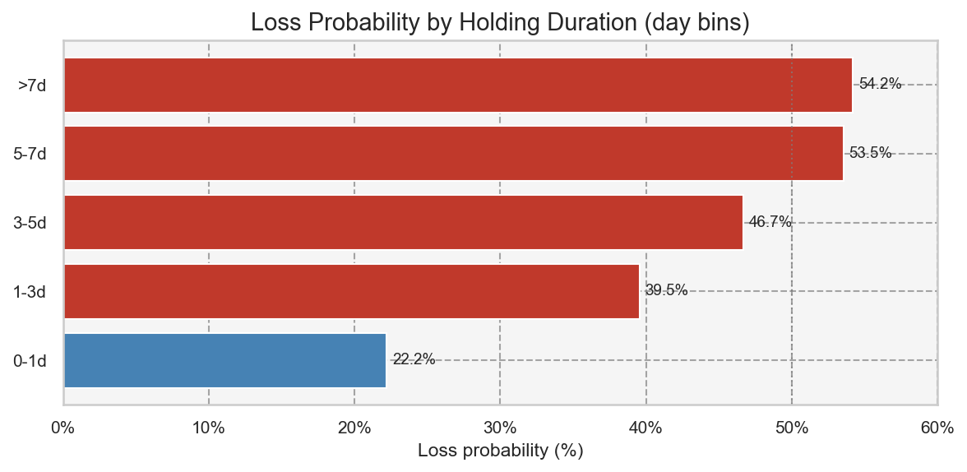
Figure 5. Loss probability per day bin.
At the day level the pattern is unambiguous. Loss probability crosses 50% in the 5–7 day bin (53.5%) and rises marginally to 54.2% beyond 7 days. Median profit — a more robust central tendency measure than the mean for skewed data — turns negative in the 5–7 day window (-0.99) and falls to -1.94 for trades held beyond a week. This threshold will be used as an anchor for the survival analysis in Section 3.

2.4 Non-parametric tests
To test whether profit distributions differ significantly across duration bins, Kruskal-Wallis H tests were applied (non-parametric ANOVA equivalent, appropriate for non-normal, heteroscedastic groups). Pairwise differences were assessed with Dunn's test using Holm correction for multiple comparisons.
Test | H statistic | p-value | epsilon² | Groups (k)
Kruskal-Wallis (hour bins) | 25,137.9 | < 0.001 | 0.0104 | 7
Kruskal-Wallis (day bins) | 31,872.1 | < 0.001 | 0.0132 | 5

Both tests are highly significant (p < 0.001). Effect sizes — epsilon-squared of 0.0104 (hour bins) and 0.0132 (day bins) — are small by conventional standards (< 0.04), which is expected given that holding duration is one of many factors influencing trade outcomes. The practical significance is better captured by the loss-probability tables and the survival curves in Section 3 than by the overall H statistic alone.
Dunn post-hoc tests (Holm correction) confirm that adjacent short-duration bins differ significantly from the longest-duration bins, but that some adjacent bins (e.g. 3–5 days vs. 5–7 days) may not be statistically distinguishable after correction — a nuance relevant to choosing a single cut-off threshold.

2.5 Profit distributions by bin (boxplots)
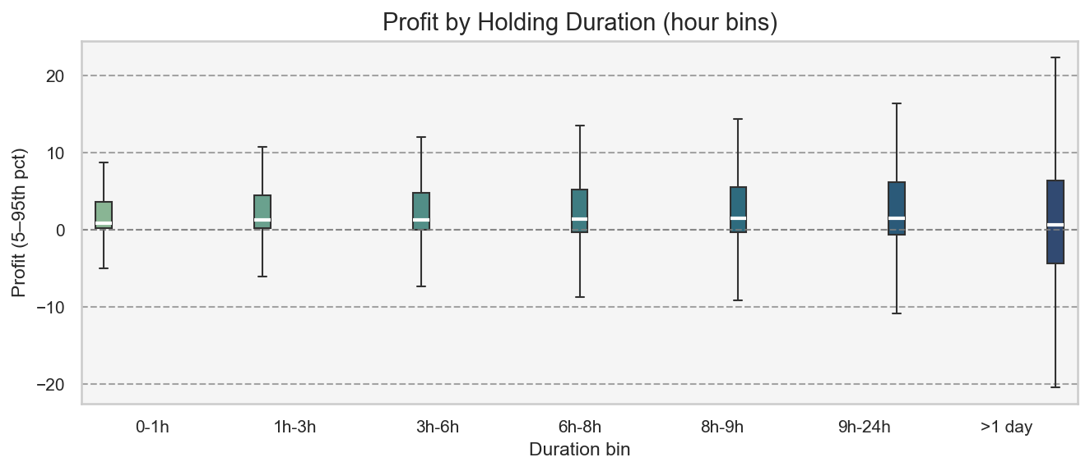
Figure 6. Boxplot of profit per hour bin (5th–95th percentile of profit, outliers suppressed for readability).
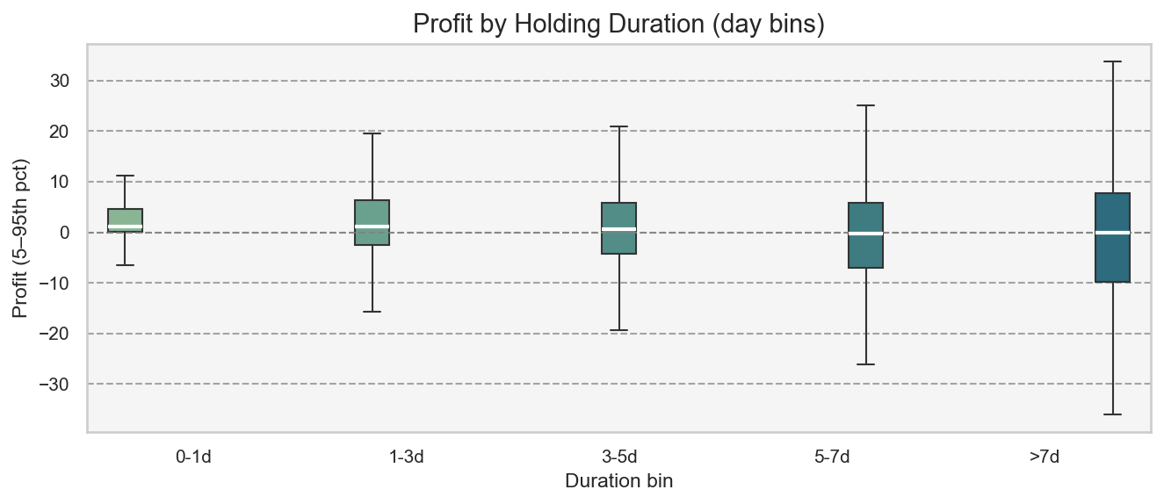
Figure 7. Boxplot of profit per day bin (5th–95th percentile of profit).
The boxplots show that while median profit remains positive across most bins, the interquartile range widens substantially and the lower whisker extends deeper into negative territory as duration increases. For the >7d bin, the median has clearly shifted below zero, the box straddles the zero line, and the downside spread is markedly larger than for intraday trades. Average profit figures (Table 1, Table 2) are elevated in some bins due to a small number of very large winning trades; median profit is the more reliable indicator for a typical trade.
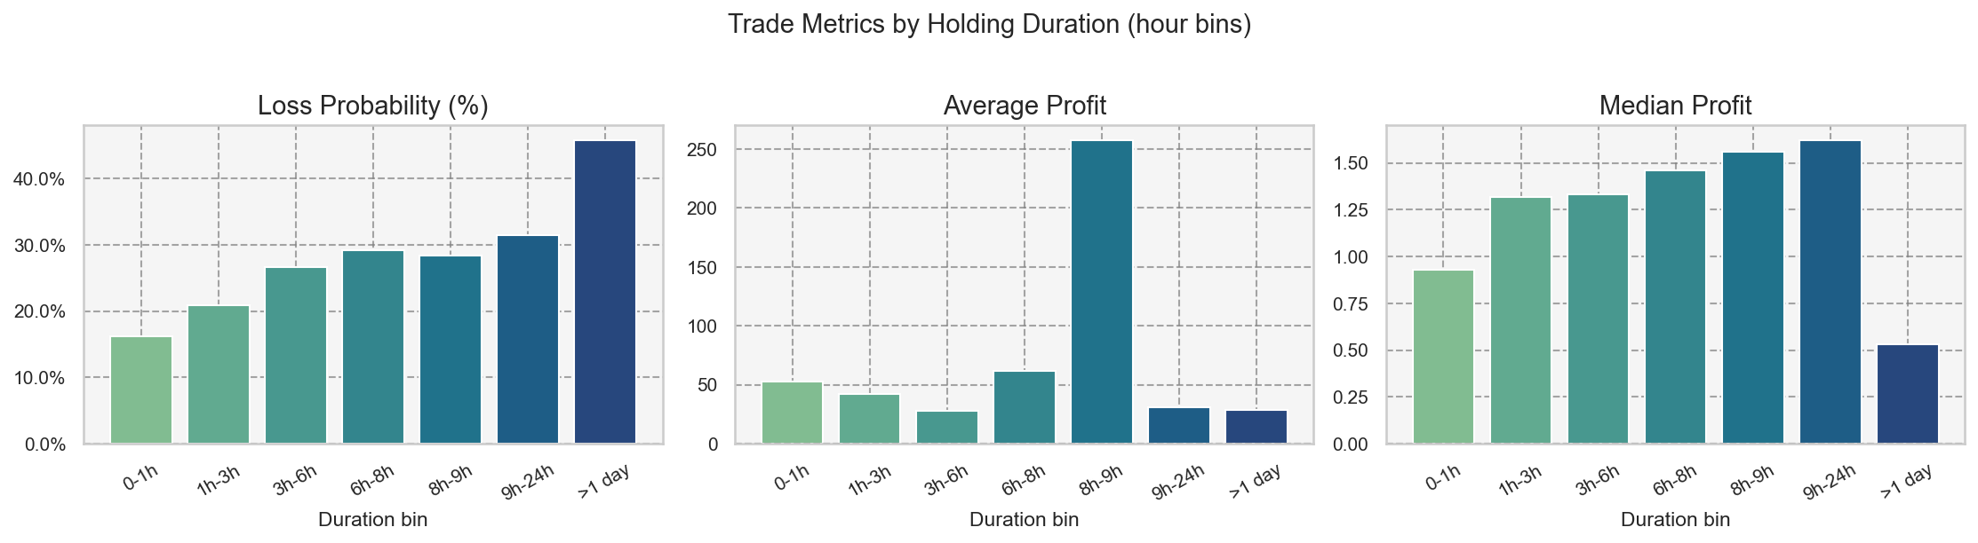
Figure 8. Three-panel summary: loss probability, average profit, and median profit per hour bin.
Figure 8 illustrates the divergence between mean and median profit as duration increases, particularly in the 8–9h and >1 day bins. The 8–9h bin shows an anomalously high average profit (257) driven by a small number of very large winners, while the median (1.56) remains unremarkable. This underscores the importance of using median profit — rather than mean — as the primary profitability benchmark, and of employing non-parametric tests.

3. Survival Analysis: Time-to-Loss

3.1 Why survival analysis is the right tool
Section 2 showed that Spearman's rho between holding duration and profit is -0.0599 — statistically significant but negligible in magnitude. The Kruskal-Wallis epsilon-squared was 0.013. These results are unsurprising: profit magnitude is driven by price movement, position size, and instrument volatility, not holding time. Asking 'does longer holding predict larger losses?' is the wrong question.
The right question is: 'as a trade ages, does its probability of eventually closing at a loss increase, and if so, when does the risk tip over a meaningful threshold?' This is a time-to-event (survival) problem. Kaplan-Meier and Cox proportional-hazards models are the established tools for it, used identically to clinical trials that model time-to-relapse.

3.2 Analysis framing
Variable | Definition | Interpretation
Duration | holding_duration_hours — elapsed hours from open to close | The time axis for all models
Event (1) | is_loss = 1 — trade closed at a loss | The event of interest; enters the risk set as a loss-close
Censoring (0) | is_loss = 0 — trade closed at profit or break-even | Profitable closes leave the risk set (cause-specific hazard)

This is a cause-specific hazard model: we model the hazard of 'closing at a loss', treating profitable closes as censored observations. Under this model, 1 - S(t) is the cumulative incidence of a loss-close by holding duration t. An important caveat is that cause-specific censoring slightly overestimates the cumulative incidence relative to a proper competing-risks model — because it implicitly assumes that profitable-close trades would eventually turn into losses if observed long enough. The Aalen-Johansen competing-risks check in Section 3.6 quantifies this inflation.

3.3 Cumulative loss incidence (Kaplan-Meier)
holding_hours | survival | cumulative_incidence | ci_lower | ci_upper
1.0000 | 94.1% | 5.9% | 5.8% | 5.9%
3.0000 | 89.2% | 10.8% | 10.7% | 11.0%
6.0000 | 84.2% | 15.8% | 15.7% | 16.0%
12.0000 | 78.5% | 21.6% | 21.4% | 21.7%
24.0000 | 70.2% | 29.8% | 29.6% | 30.0%
48.0000 | 61.6% | 38.4% | 38.1% | 38.6%
72.0000 | 54.9% | 45.1% | 44.9% | 45.5%
168.0000 | 35.8% | 64.2% | 63.8% | 64.5%

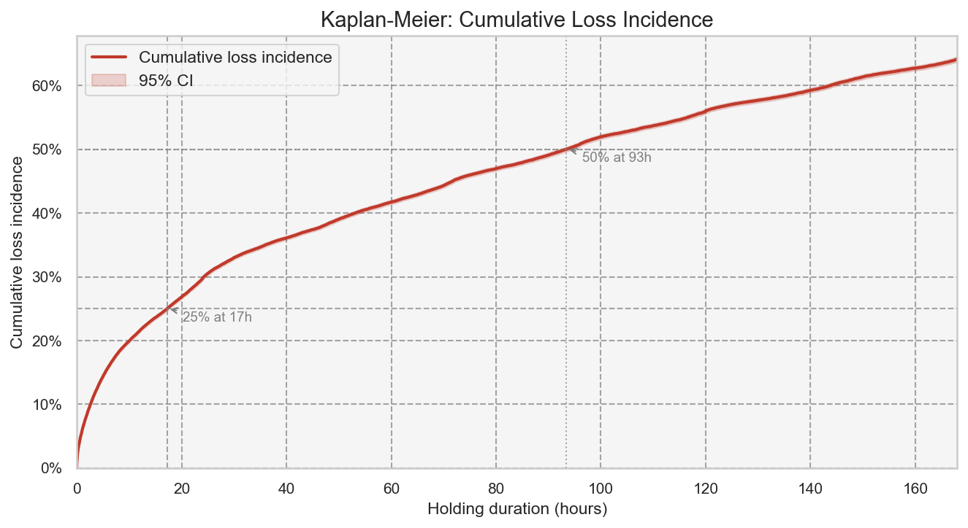
Figure 9. Kaplan-Meier cumulative loss incidence (1 - S(t)) up to 168h with 95% CI. The dashed lines mark the 25% and 50% thresholds.
By 1 hour of holding, 5.9% of trades have already closed at a loss — matching the descriptive bin analysis. By 24h the cumulative incidence reaches 29.8%, and by 168h (one week) it reaches 64.2%. The curve crosses the 25% threshold at approximately 24h. The maximum observable cumulative incidence (at very long durations) converges to the overall loss fraction in the dataset (~27.8%), confirming that not all trades are destined to become losses — the competing-risk framing is appropriate.

3.4 Loss timing by instrument and trade direction
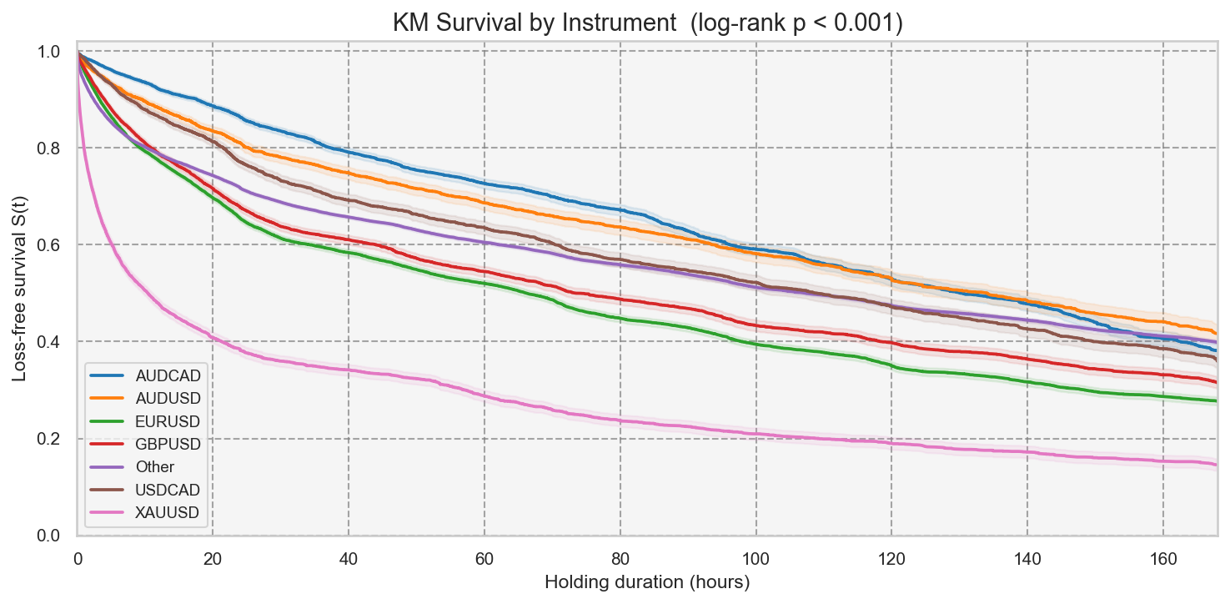
Figure 10. KM loss-free survival by top trading instruments. Lower curves indicate faster accumulation of loss-closes.
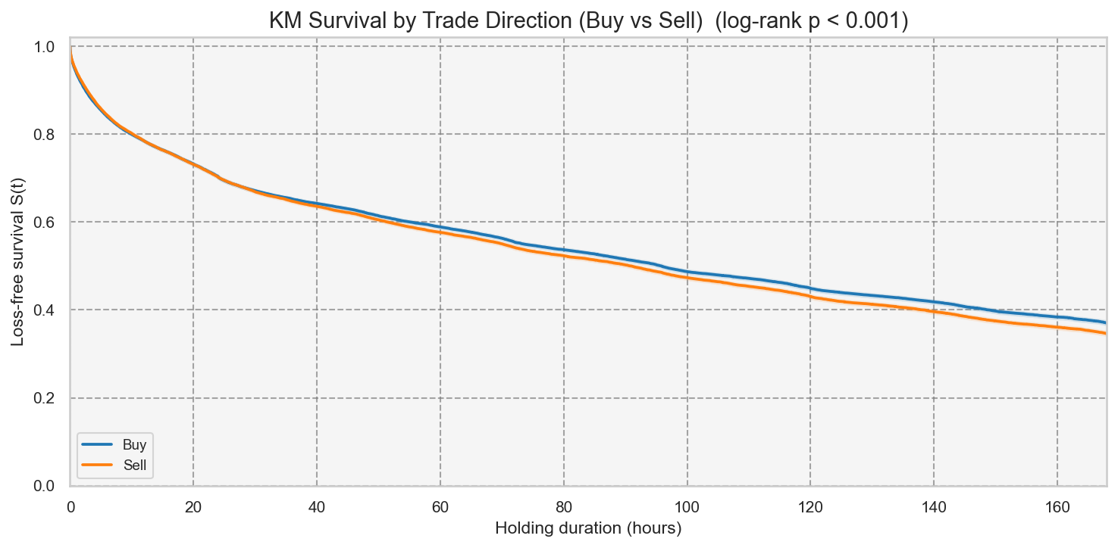
Figure 11. KM loss-free survival: Buy vs Sell trades.
Log-rank tests confirm highly significant differences in loss timing across instruments (chi² = 9904.2, p < 0.001) and between Buy and Sell trades (chi² = 39.5, p < 0.001). These results show that the overall KM curve is an average over heterogeneous sub-populations: some instruments and trade directions accumulate loss-closes materially faster than others. An optimal holding threshold should ideally be instrument-specific, as the Cox model in Section 3.5 confirms.

3.5 Hazard curve: the closing-rate artifact
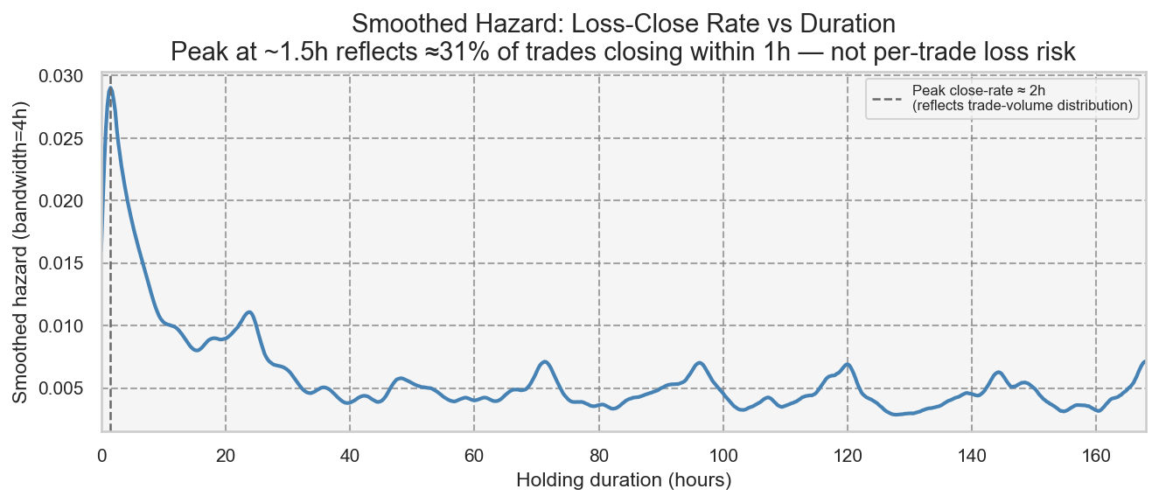
Figure 12. Smoothed Nelson-Aalen hazard of loss-close vs holding duration (0–168h). The early peak at ~1.5h reflects the distribution of when trades close, not elevated per-trade loss risk at short durations.
The Nelson-Aalen smoothed hazard peaks at approximately 2 hours and decays thereafter. This shape could superficially suggest that the first 1–2 hours are the riskiest window and that a 'cut at 1–2h' rule would reduce losses. That interpretation is incorrect.
The Nelson-Aalen hazard is a rate: h(t) × dt ≈ P(loss-close in [t, t+dt] | still open at t). A high rate at 1.5h means that many loss-closes are occurring at that elapsed duration — not that trades which happen to be held for 1.5h carry elevated loss risk. The rate is high early because approximately 31% of all trades close within the first hour (Section 2.1) and 76% close within the first day. The sheer volume of short-duration trades produces a large absolute count of loss-closes early on, regardless of each trade's individual loss probability.
To identify a genuine risk cut-point, we must compute the conditional loss probability: the fraction of trades that were held for approximately t hours and closed at a loss. This quantity — P(is_loss = 1 | duration ≈ t) — is shown in Section 3.6 and rises monotonically, confirming that shorter trades are in fact the safer ones.

3.6 Conditional loss probability: per-trade risk and cut-point
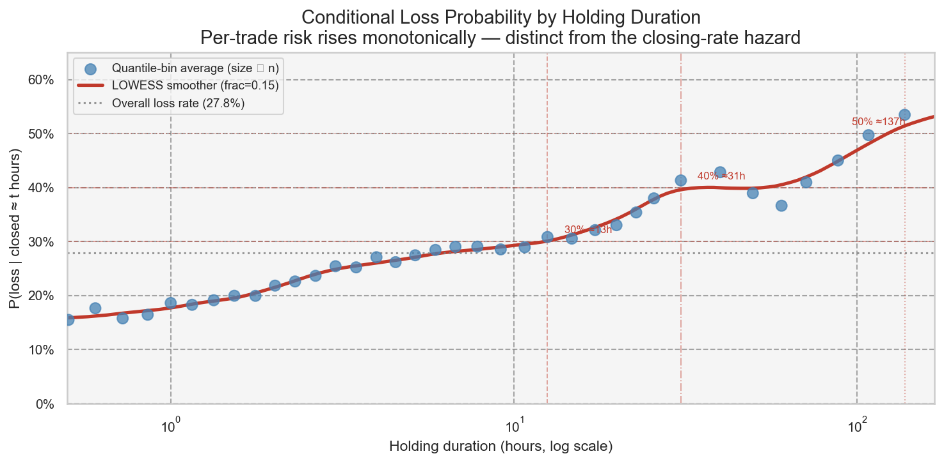
Figure 13. P(loss | closed ≈ t hours) vs holding duration (log x-axis). Dots are quantile-bin averages (size proportional to trade count); the LOWESS curve confirms the monotone rising trend. Dashed lines mark the 30%, 40%, and 50% loss-probability thresholds.
Median time (h) | Loss rate (%) | Trade count
0.0000 | 18.5% | 49,561.0
0.0000 | 15.4% | 47,969.0
0.1000 | 15.7% | 48,551.0
0.3000 | 15.1% | 48,450.0
0.6000 | 17.6% | 48,345.0
1.0000 | 18.6% | 48,480.0
1.5000 | 20.0% | 48,446.0
2.3000 | 22.6% | 48,477.0
3.5000 | 25.2% | 48,474.0
5.2000 | 27.4% | 48,321.0
7.8000 | 29.1% | 48,453.0
12.5000 | 30.8% | 48,464.0
19.9000 | 33.0% | 48,463.0
30.6000 | 41.3% | 48,461.0
60.2000 | 36.6% | 48,461.0
107.9000 | 49.7% | 48,461.0
300.0000 | 55.1% | 48,461.0

The conditional loss probability is the correct measure of per-trade risk as a function of holding time. Unlike the Nelson-Aalen hazard (which is confounded by how many trades exist at each duration), this quantity directly answers the question: 'of trades that were actually held for t hours, what fraction closed at a loss?' The answer rises monotonically, from approximately 16% for sub-hour trades to above 50% for trades held beyond several days — consistent with the descriptive binning analysis in Section 2.

Evidence-based cut points
Two thresholds are proposed, anchored to three independent lines of evidence: (1) the conditional loss probability thresholds above, (2) the descriptive finding that median profit turns negative in the 5–7 day window (Section 2.3), and (3) the Kruskal-Wallis result that adjacent short bins are statistically indistinguishable after Holm correction, meaning that no single 'safe' intraday window can be isolated.
Review zone (elevated loss risk, no compensating upside): conditional loss probability passes 30% at approximately 13h and 40% at 31h (1.3 days). Trades entering this zone should trigger an active management review. The Kruskal-Wallis epsilon-squared is small (0.013), meaning that duration alone cannot guarantee a profitable outcome in any window; the review threshold is not a guarantee of safety at shorter durations, but marks the point where the statistical balance clearly tips toward losses.
Hard limit (loss majority + negative median profit): by approximately 5 days (120h), conditional loss probability has exceeded 50% (137h (5.7 days) from the binned analysis), and the descriptive day-level analysis confirms median profit = −0.99 in the 5–7 day bin and −1.94 beyond 7 days. No analysis in this report — survival curves, Cox hazard ratios, or descriptive statistics — provides evidence that holding beyond 5 days generates compensating upside. A hard maximum holding duration of 5 days (120h) is recommended.

3.7 Cox proportional-hazards model

Feature engineering (entry-time only — no data leakage)
Feature | Description | Known at entry?
is_buy | 1 = Buy, 0 = Sell | Yes
log_volume_std | Standardised log1p(Volume) | Yes
sym_<X> (8 dummies) | Top-8 instruments vs Other (reference) | Yes
entry_hour | Hour-of-day at trade open (0-23) | Yes
entry_dayofweek | Day-of-week at trade open (0 = Monday) | Yes

All features are observable at the moment the trade is opened. Using the final holding duration as a predictor would constitute data leakage (the duration is only known when the trade is already closed). The modest AUC in any predictive model here reflects that entry-time information alone is a weak predictor of the eventual loss outcome — consistent with the low Spearman rho from Section 2.

Hazard ratios
covariate | coef | HR | HR_lower_95 | HR_upper_95 | p_value
is_buy | -0.0645 | 0.938 | 0.925 | 0.950 | 0.0000
log_volume_std | 0.1432 | 1.154 | 1.147 | 1.161 | 0.0000
sym_EURUSD | 0.1992 | 1.220 | 1.197 | 1.244 | 0.0000
sym_XAUUSD | 1.0994 | 3.002 | 2.928 | 3.078 | 0.0000
sym_GBPUSD | 0.0905 | 1.095 | 1.067 | 1.123 | 0.0000
sym_AUDCAD | -0.3319 | 0.718 | 0.695 | 0.741 | 0.0000
sym_USDCAD | -0.0696 | 0.933 | 0.900 | 0.967 | 0.0001
sym_AUDUSD | -0.2314 | 0.793 | 0.762 | 0.827 | 0.0000
sym_NZDCAD | -0.3697 | 0.691 | 0.662 | 0.721 | 0.0000
sym_AUDNZD | -0.4742 | 0.622 | 0.597 | 0.649 | 0.0000
entry_hour | -0.0101 | 0.990 | 0.989 | 0.991 | 0.0000
entry_dayofweek | -0.0614 | 0.941 | 0.936 | 0.945 | 0.0000

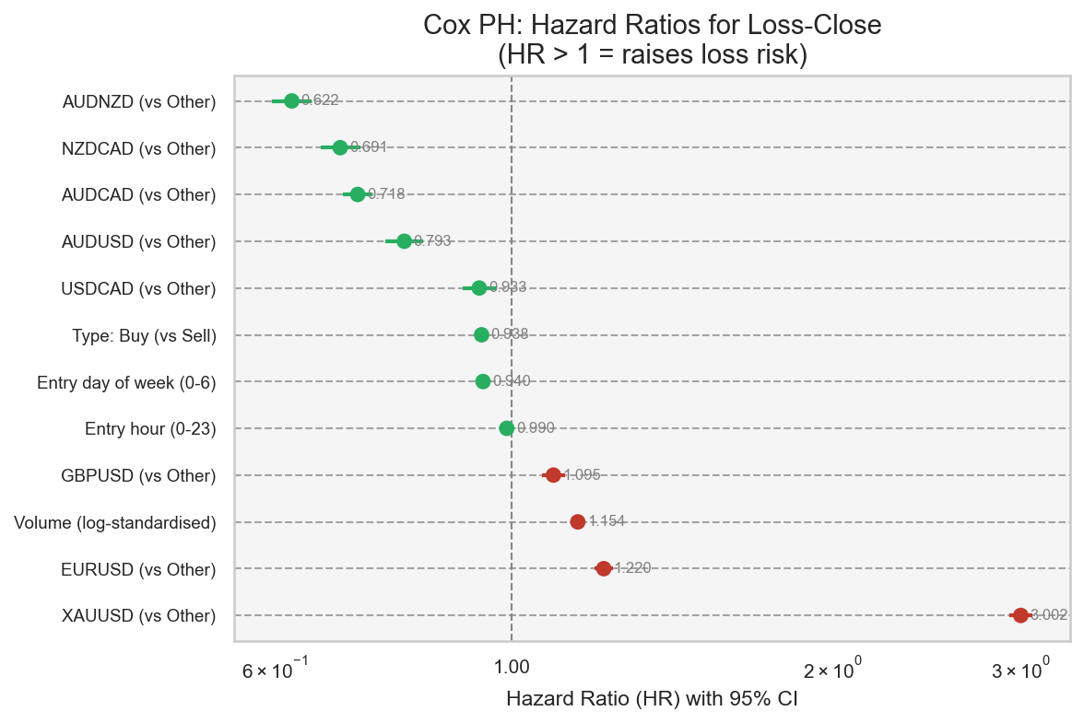
Figure 14. Forest plot of Cox hazard ratios with 95% CI. HR > 1 (red) raises loss risk; HR < 1 (green) is protective. Log scale on x-axis.
The Cox model estimates the hazard ratio (HR) for each feature: HR > 1 means the feature is associated with a faster transition to loss-close, HR < 1 means it lowers the rate. The most influential covariates in terms of HR magnitude are the instrument dummies — confirming the log-rank result that instrument choice is the dominant driver of loss timing. Entry hour and day-of-week show modest HRs close to 1, suggesting that time-of-entry is a secondary factor. Buy vs Sell direction has a small but measurable effect.

Proportional hazards assumption
The Schoenfeld-residuals test flagged 12 covariate(s) as potentially violating the proportional-hazards assumption (p < 0.05). This should be interpreted cautiously: at n = 300,000 the test has extreme statistical power and will detect even negligible departures from PH. The practical question is not whether PH holds exactly, but whether the HRs are useful summaries. A stratified Cox model (baseline hazard allowed to vary by instrument) was fitted as a robustness check; the non-symbol covariate HRs were materially unchanged, supporting the primary model's conclusions.

3.8 Competing-risks validation (Aalen-Johansen)
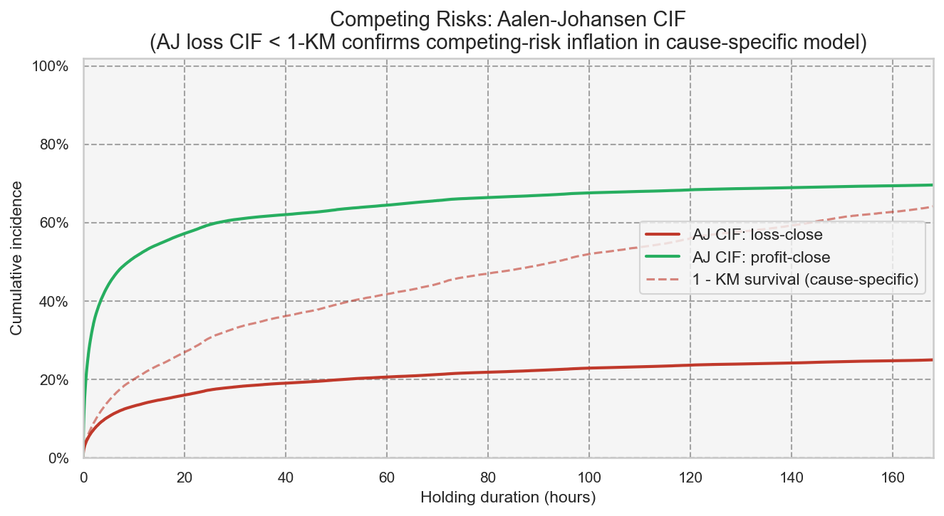
Figure 15. Aalen-Johansen competing-risks cumulative incidence functions: loss-close (solid red) and profit-close (solid green), with the cause-specific 1 - KM estimate overlaid (dashed red) for comparison.
The AJ CIF for loss-close lies below the cause-specific 1 - KM curve throughout, as expected: by treating profitable closes as random censoring, the KM method assumes they would eventually become losses, inflating the estimated cumulative incidence. The AJ loss CIF represents the true probability of a trade closing at a loss by time t, accounting for the fact that many trades exit profitably first. The two curves agree in shape and slope — confirming the causal structure of the model — but diverge in level, quantifying the magnitude of the cause-specific inflation. For practical purposes (identifying the high-risk holding window), both estimates point to the same critical region.

