Choose report type as `Yearly Airline Performance Report` and year as 2019.

Choose report type as `Yearly Airline Performance Report` and year as 2015

Choose report type as `Yearly Airline Delay Report` and year as 2019

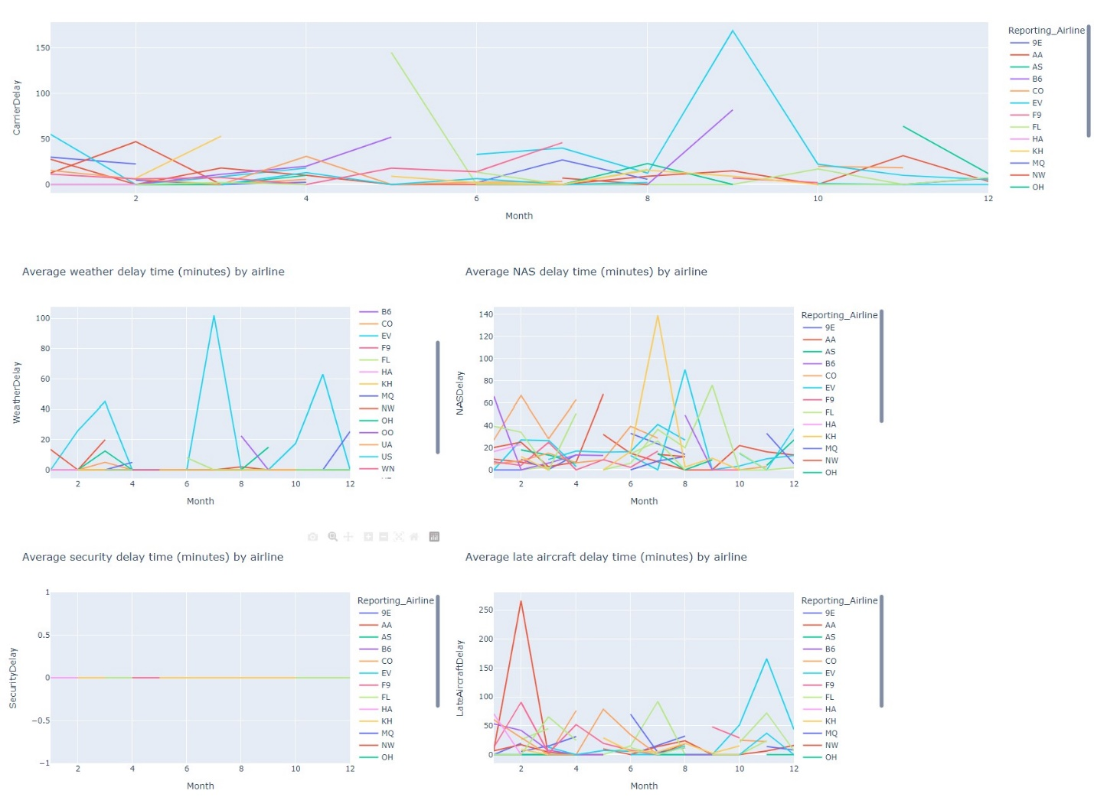

Choose report type as `Yearly Airline Delay Report` and year as 2008