**Task 1: Define Classes**

**Done**

**Task 2: Implement Constructors**

**Done**

**Task 3: Implement Methods**

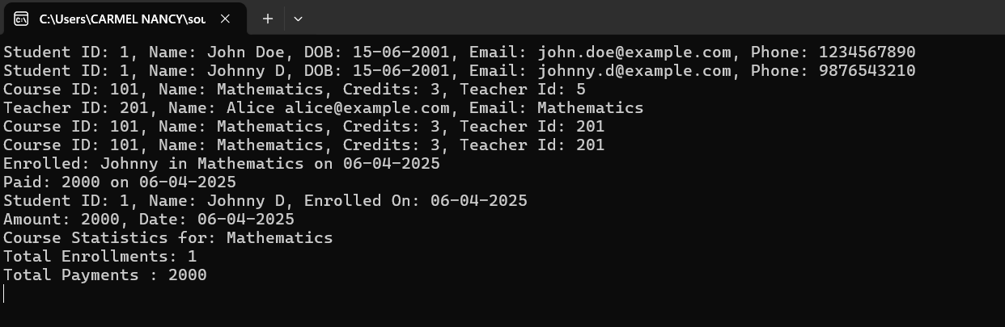

**Task 4: Exceptions handling and Custom Exceptions**

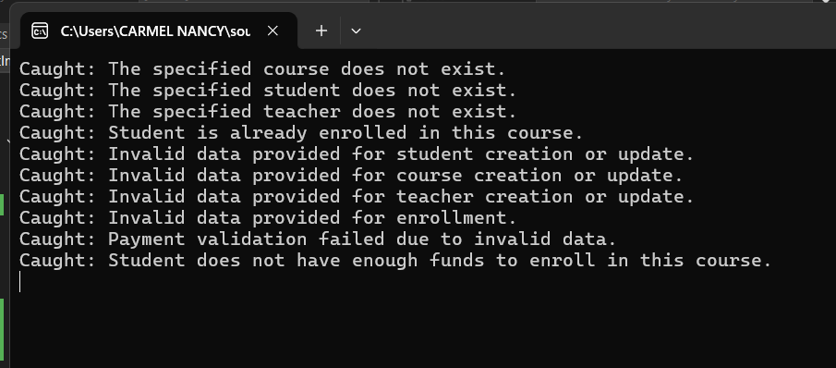

**Task 5: Collections**

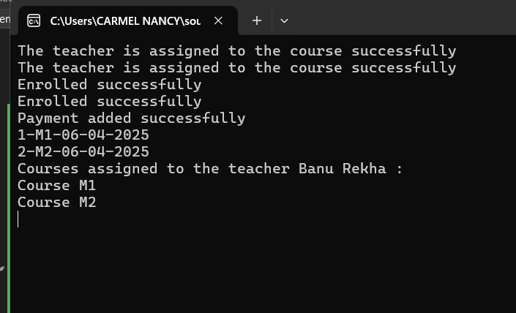

**Task 7: Database Connectivity**

**Data Retrieval +Data Insertion and Updating +Transaction Management +Dynamic Query Builder**

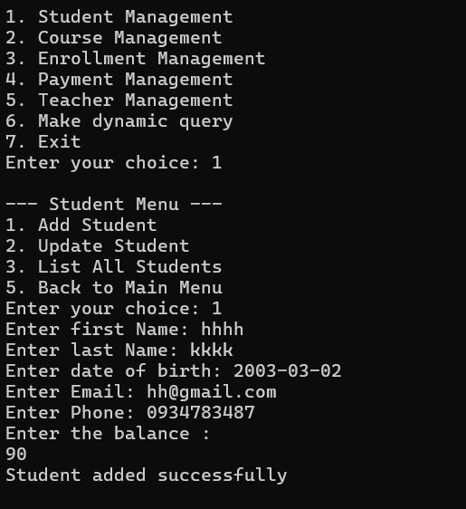

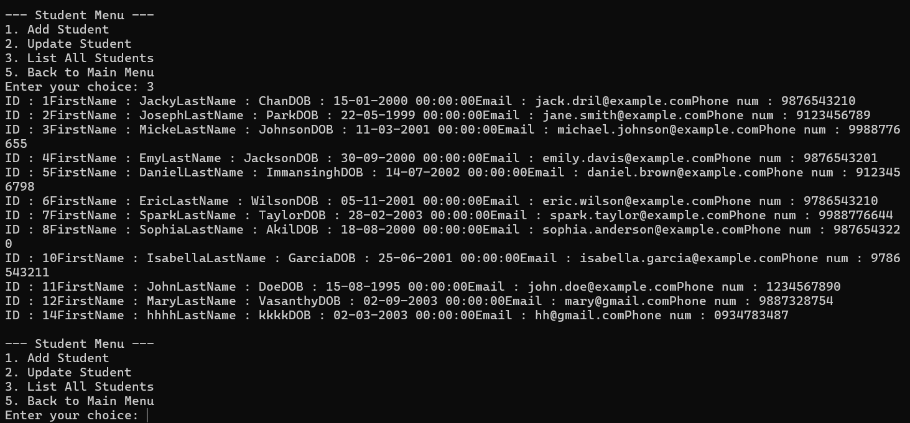

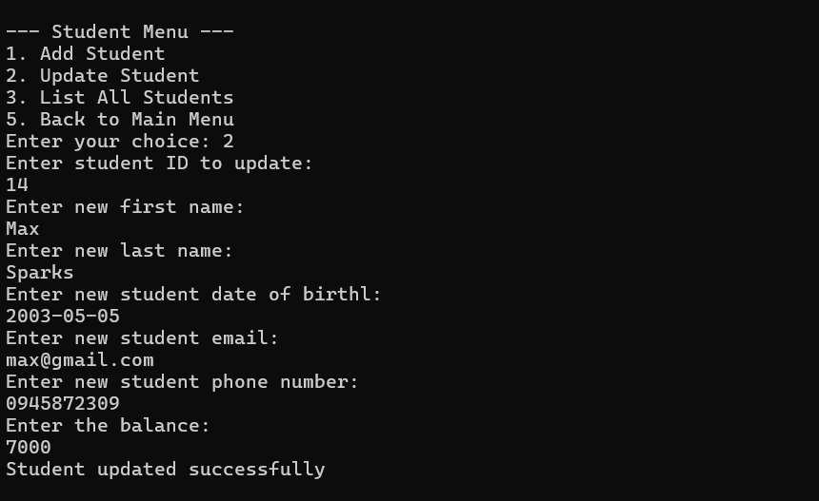

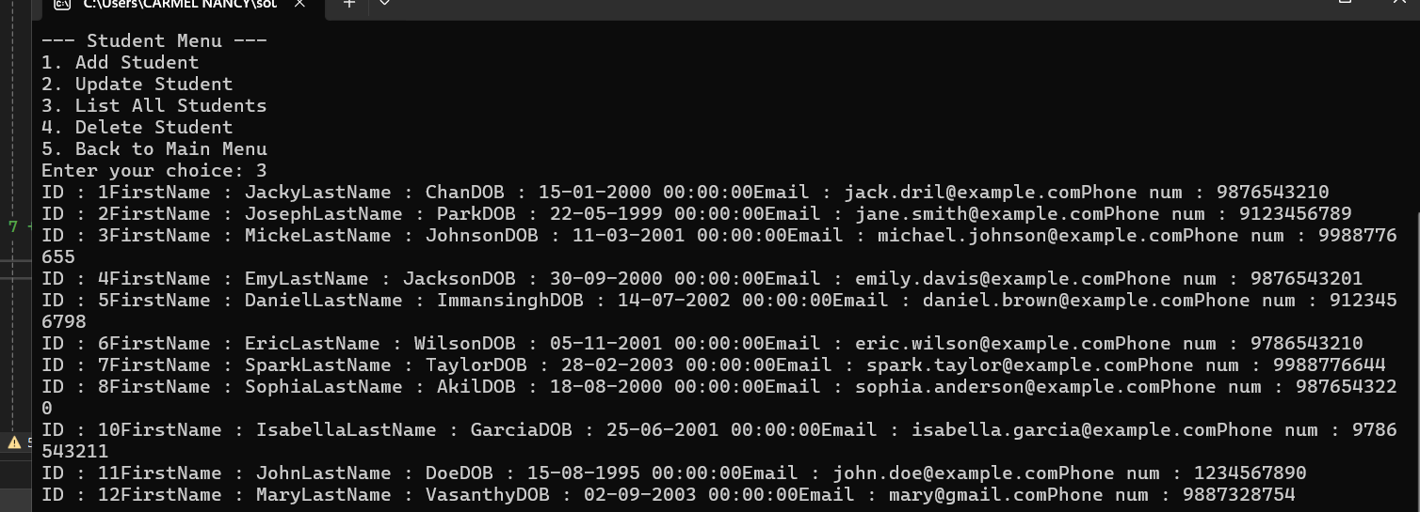

**Task 8: Student Enrollment**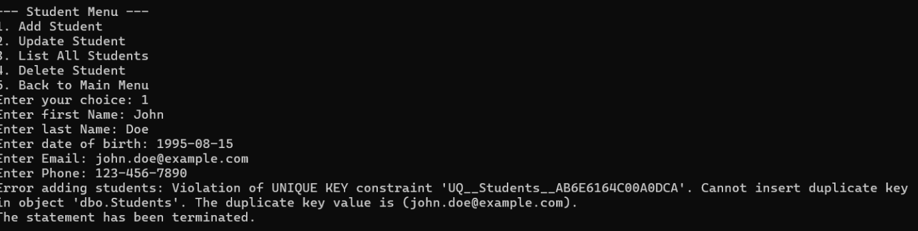

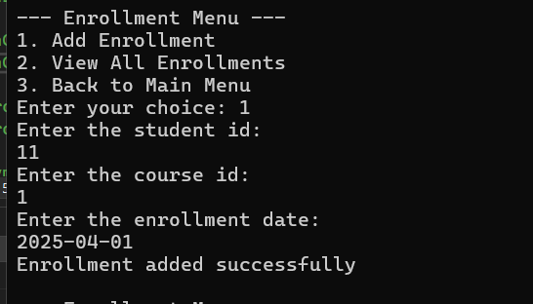

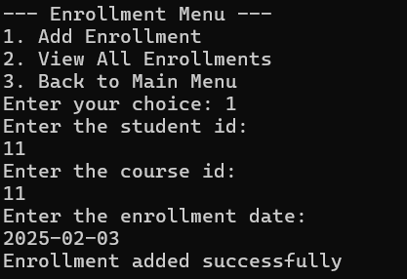

**Task 9: Teacher Assignment**

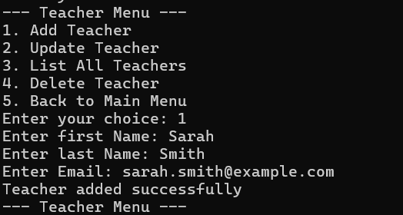

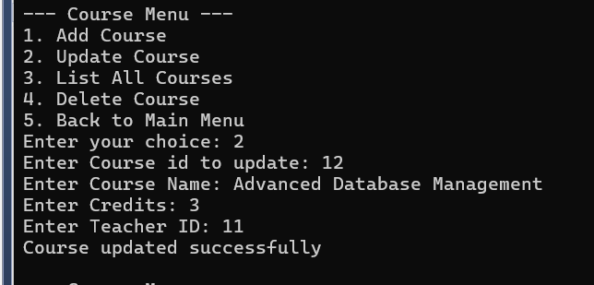

**Task 10: Payment Record**

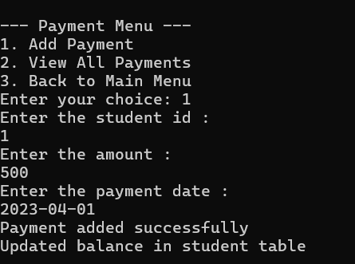

**Task 11: Enrollment Report Generation**

