**Case Study on Ecommerce Application**

9. Create the exceptions in package **myexceptions** and create the following custom exceptions and throw them in methods whenever needed. Handle all the exceptions in main method,

CustomerNotFoundException

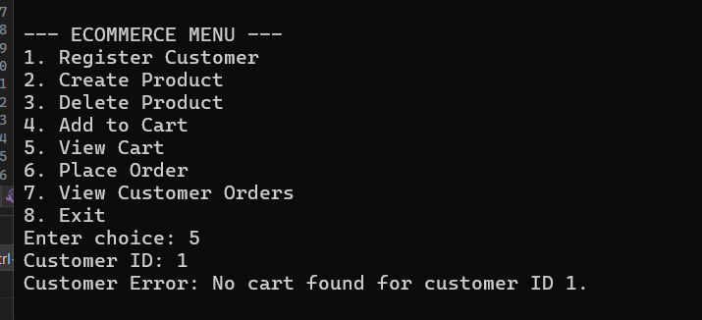

ProductNotFoundException

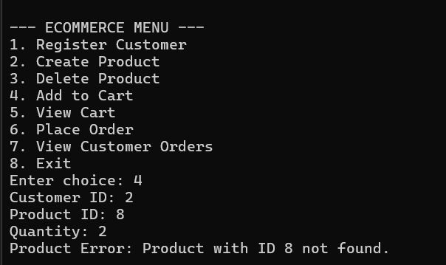

OrderNotFoundException

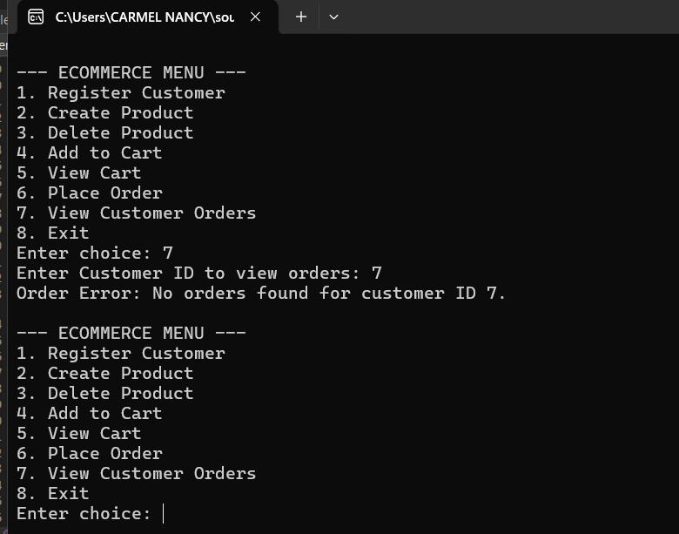

10. Create class named **EcomApp** with main method in app Trigger all the methods in service implementation class by user choose operation from the following menu.

1. Register Customer

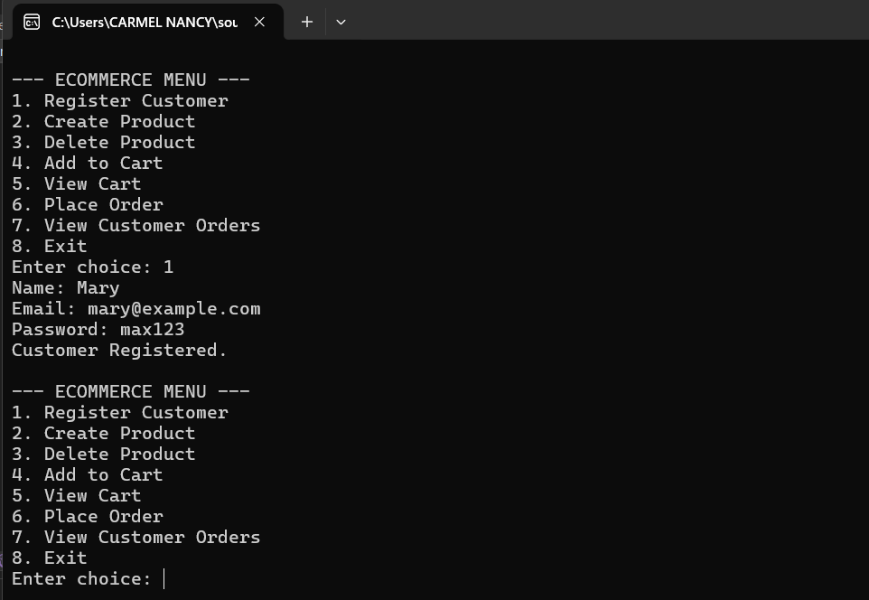

2. Create Product.

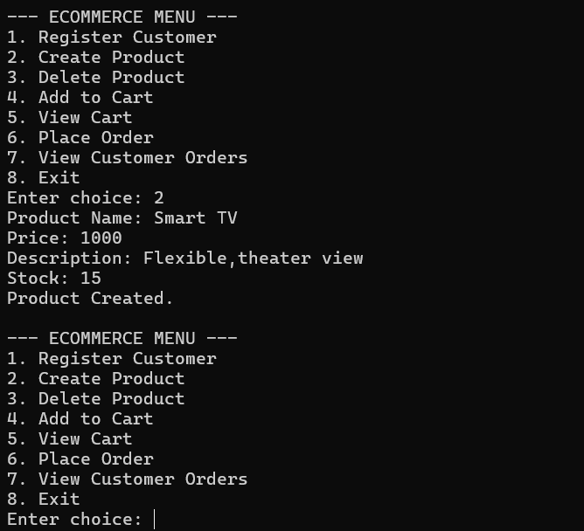

3. Delete Product.

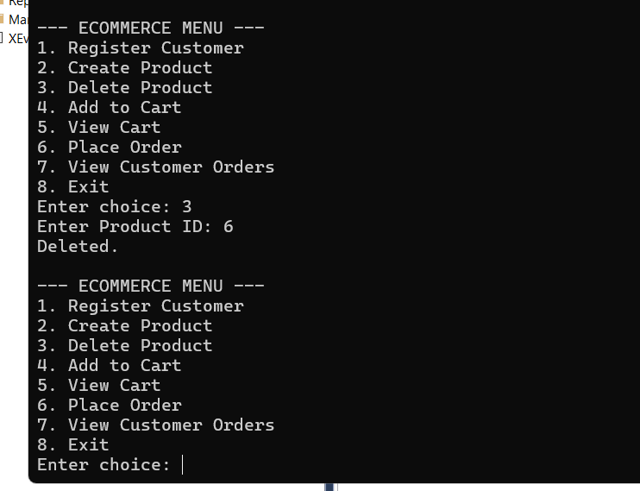

4. Add to cart.

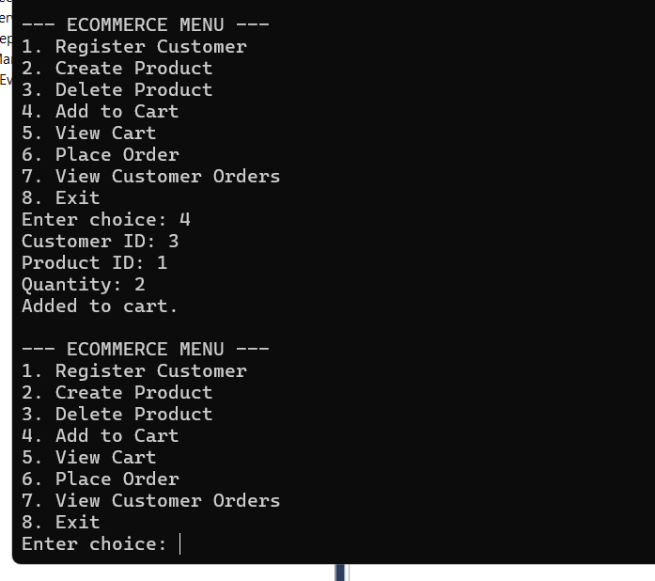

5. View cart.

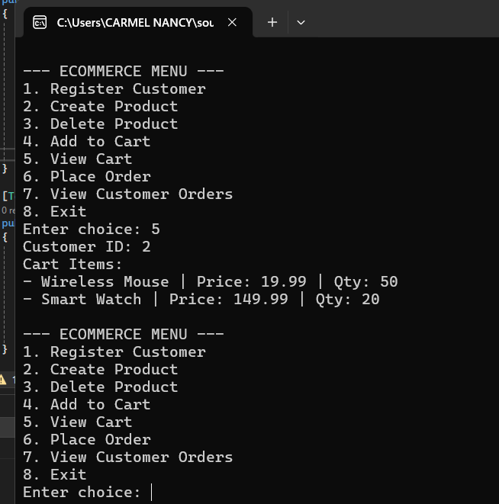

6. Place order

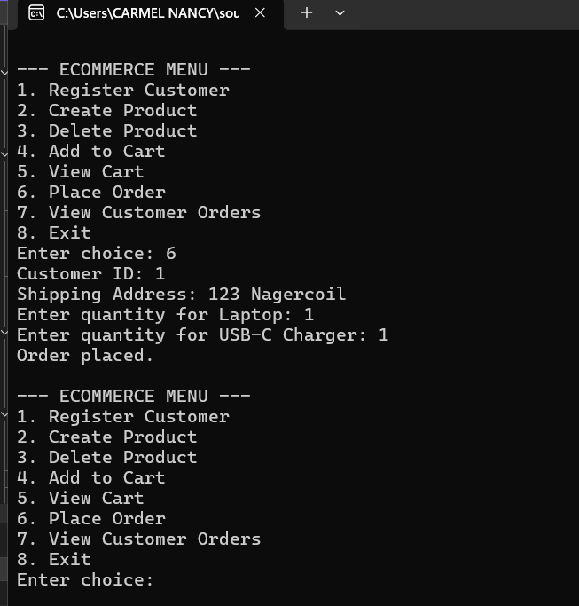

7. View Customer Order

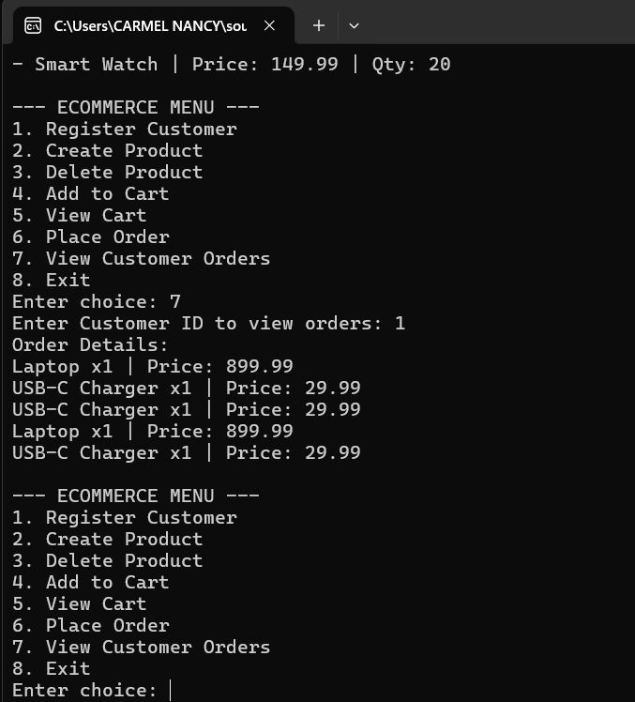

**Unit Testing**

11. Create Unit test cases for **Ecommerce System** are essential to ensure the correctness and reliability of your system.

