Steps to Create SharePoint App

# SharePoint

*Make sure you are the site owner – app registration is limited to site owners*

1. Navigate to the site url:

https://company.sharepoint.com/sites/<site_name>/

1. Add the app registration form to the site url:

https://company.sharepoint.com/sites/<site_name>/_layouts/15/AppRegNew.aspx

1. The following form will appear in your browser:

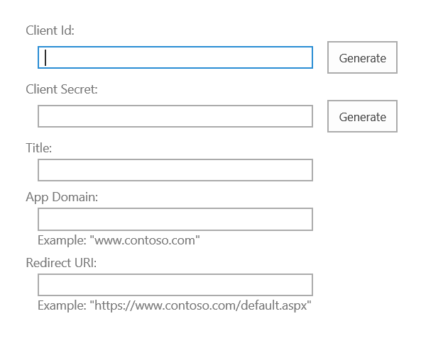

1. Fill in the following details:

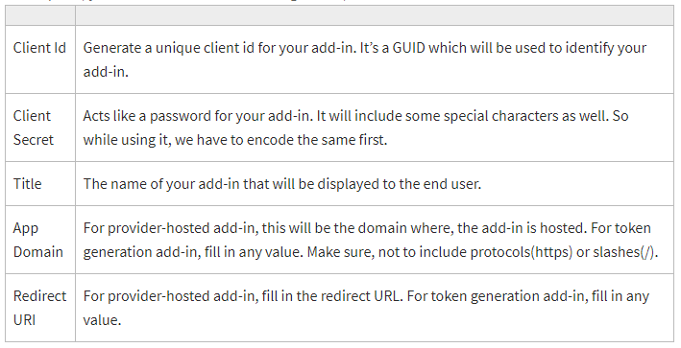

App Domain and Redirect URI can also be set to the following:

* App Domain: [www.google.com](http://www.google.com)
* Redirect URI: <https://www.google.com>

1. After finishing the registration form, a page will appear with the app detials (save this for reference):

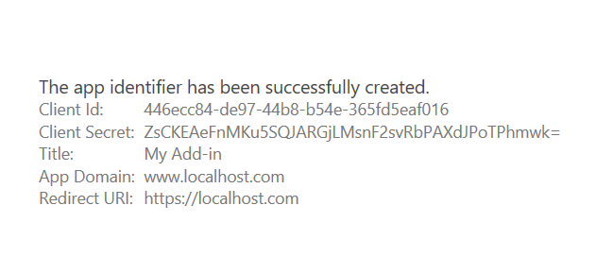

1. Grant permission by adding the following to the site url:

https://company.sharepoint.com/sites/<site_name>/ _layouts/15/AppInv.aspx

1. The following form will appear in your browser:

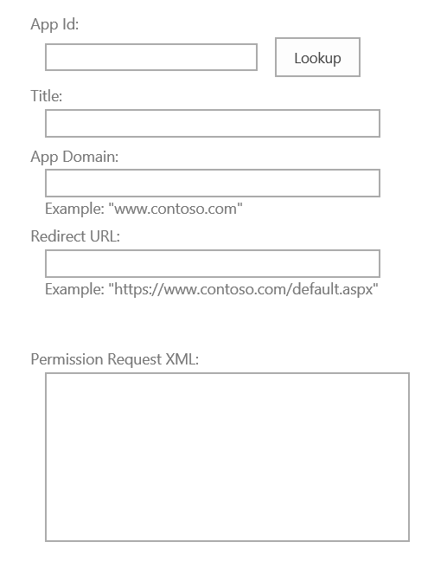

1. Enter the Client Id in App Id and click Lookup
2. Paste the following to Permission Request XML:

<AppPermissionRequests AllowAppOnlyPolicy="true">

<AppPermissionRequest Scope="http://sharepoint/content/sitecollection" Right="FullControl"/>

<AppPermissionRequest Scope="http://sharepoint/content/sitecollection/web" Right="FullControl"/>

</AppPermissionRequests>

1. Click Create and Trust the add-in:

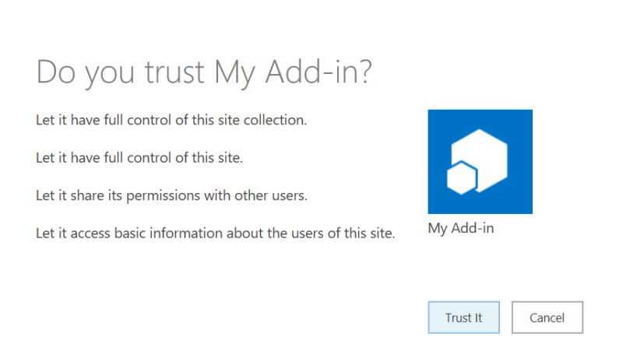

References

1. Register App in Sharepoint: <https://piyushksingh.com/2018/12/26/register-app-in-sharepoint/>
2. Add-in Permissions in SharePoint: <https://docs.microsoft.com/en-us/sharepoint/dev/sp-add-ins/add-in-permissions-in-sharepoint#available-scopes-and-permissions-and-restrictions-on-office-store-apps-permissions>
3. Register SharePoint Add-ins: <https://docs.microsoft.com/en-us/sharepoint/dev/sp-add-ins/register-sharepoint-add-ins>