Calibration method for the L1 Analog Trigger System for CTA LST camera.

Abstract

This is a description of the algorithm used for the calibration of L1 Analog Trigger System for CTA LST camera.
The calibration method consists in a rate scan procedure to find the threshold needed to obtain a trigger rate of 50% of the events for different input pulses reaching the L1.
The different pulses are generated progressively adding the different channels (corresponding to the seven pixels in one cluster) in where a pulse of constant amplitude is generated through a test pulser.
The program that performs the rate scan uses an algorithm to find the threshold that gives a target trigger rate (in our case, the 50% rate). This is done for 6 input pulses of increasing amplitudes, corresponding to the sum of 6 pixels one by one. It is necessary for running the program, to select the Adder (A, B or C) that is being used for the sums, and to specify the rate that has to be reached.

Introduction

To perform the calibration of the L1 ASIC we use a Rate Scan method. It consists in measuring the threshold voltage that is needed to get a trigger rate of the 50% of the events for a given input voltage.

In the module of 7 pixels, there is a test pulser that generates a pulse of a certain voltage. It is possible to enable and disable each pixel separately, so the resulting input voltage for the L1 is the sum of all the activated pixels. The amplitude of the pulses can be equalized.

The rate scan program runs a loop over the six pixels, activating one more pixel in every step. In each of those steps the algorithm described below is used to find the 50% trigger rate.
The final result are six measures of threshold corresponding to the 50% trigger rate for 6 input pulses of increasing amplitudes.

Regarding the L0 trigger, settings are considered fixed during the test and the delay lines are equalized.

Rate Scan Algorithm

In the L1 ASIC, the Threshold voltage is configured through a DAC with 8 bits to generate up to 255 different voltages, from 0,0 V to 1,2 V. Each step increases in 4,8 mV.

The algorithm finds which DAC combination is necessary to obtain a threshold that provides the desired rate. It goes bit to bit and needs only 8 steps to find the final DAC configuration. In each step the threshold is modified so the algorithm can test the trigger rate and compares it with the target rate. Once the final step is reached, the resulting 50% rate Threshold is calculated.

The 50% rate value depends on the frequency and window configured for the test pulser.

Detailed description of the algorithm

The process starts configuring the threshold registers at their maximun value, meaning that the Current Threshold is set at “11111111” (the 255th DAC combination). A loop runs over the 8 bits, starting from the most significant bit (#7).

Bit numbering #7 #6 #5 #4 #3 #2 #1 #0
Bit content 1 1 1 1 1 1 1 1

First, the 7th bit is checked and its value is set to 0. This gives a new DAC combination that represents a so called New Threshold (which would be 0111111 or the 127th combination of DAC). The rate is checked at this New Threshold:

- If rate at new threshold is less than the target rate, New Threshold is stored as the Current Threshold that will be used in the next step.

- If rate at new threshold is higher than the target rate, the Current Threshold is not modified.

Afterwards, the loop continues to the next bit of the Current Threshold and the same procedure is applied. Once bit 0 is reached, the loop ends and the threshold for the 50% rate is calculated through the next formula:

((Target rate – Baseline) )/(Baseline – (Rate[Curent Threshold – 1]) + Current Threshold

Where Baseline is the rate at Current Threshold (the last threshold stored in the loop).

In figure 1 there is a flux diagram explaining the loop applied in the algorithm:
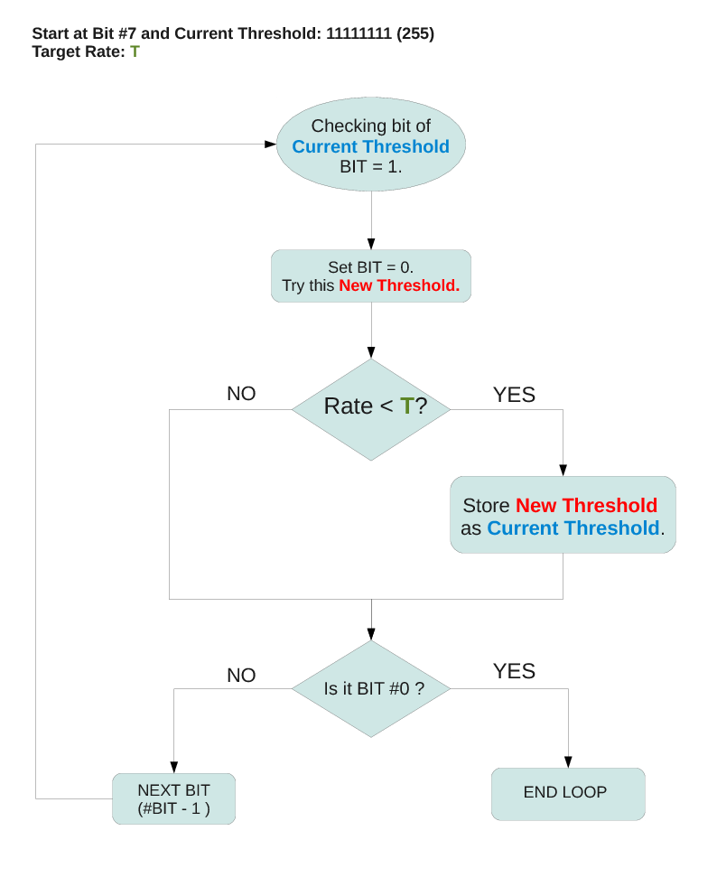
Figure 1: Flux diagram for the rate scan loop.

The output of the algorithm at each step has the following structure:

“CHECKING BIT {#Bit} RATE {Trigger rate} {New Threshold DAC combination in binary (0's to the left missing)} {DAC Combination in decimal}”.

This is an example for a case where the target rate representing the 50% trigger would be “1250”:

CHEKING BIT 7 RATE 0 1111111 127
CHEKING BIT 6 RATE 0 111111 63
CHEKING BIT 5 RATE 0 11111 31
CHEKING BIT 4 RATE 2485 1111 15
CHEKING BIT 3 RATE 0 10111 23
CHEKING BIT 2 RATE 2454 10011 19
CHEKING BIT 1 RATE 577 10101 21
CHEKING BIT 0 RATE 1956 10100 20
###########################2051 1111

The last line gives the final result for the Threshold in DAC units multiplied by 100. In this case that means that the Threshold obtained would be 20,51 * 4,8 mV.

For this example:
Current Threshold = 21
Target rate = 1250
Baseline = 577
Rate[Current Threshold – 1] = Rate[20] = 1956

Th*100 = ((1250-577) * 100)/(577-1956) + 21*100 = 2051.

Final Result

Once the rate scan is applied to the 6 signals corresponding to the sums of the pixels, (one pixel added each time), the result is 6 different thresholds that gives the 50% trigger rate for different amplitudes of imput pulses.
A plot of the threshold versus the number of pixels is presented in figure 2:

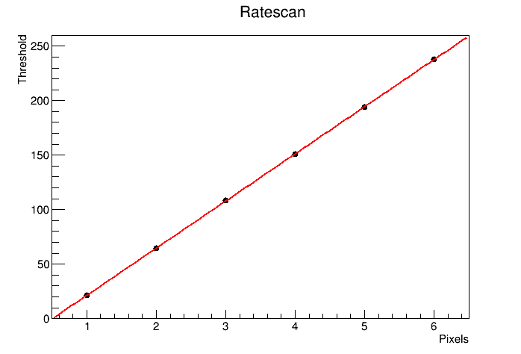
Figure 2: Result of the rate scan for Adder A of one module.

If the pulse applied in the pixels is known, it is possible to retrieve the gain and the offset of the L1 ASIC from the linear fit to the points.

Method verification

It is necessary to fully understand the behaviour of the test pulser to know if the pulses from the test pulser are representative enough to be used in the calibration.
Besides this method can't provide absolute values for the gain and offset without knowing the precise voltage in the pixels, it is possible to check the validity of the method through the correlation between the three different adders. The gain for each adder was measured in que characterization of the L1 ASIC. If we compare the slope obtained with the calibration algorithm, to the gain of the characterization and correlate this relation adder to adder, it is possible to find a correlation as can be seen in figure 3. This correlation implies that the relation between the slope and the real gain is maintained through the three adders.

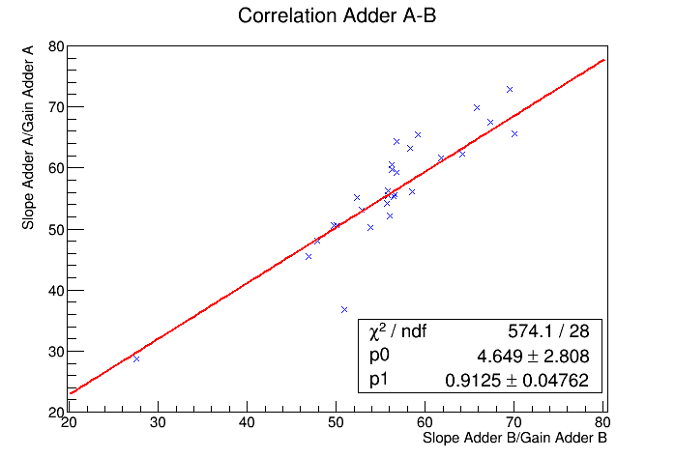
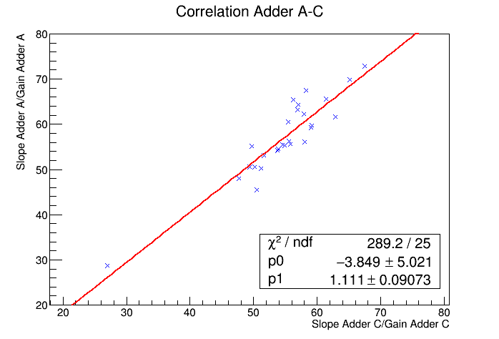
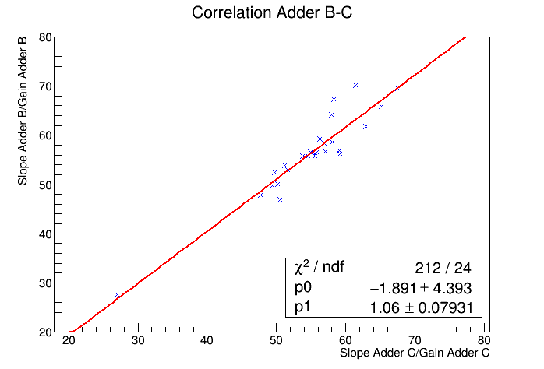
Figure 3: Correlations between adders of the relation between the slope measured in the rate scan with the algorithm and the gain obtained from the characterization of L1 ASIC.

