Simulation and Calibration of CTA LST Camera trigger system.

Part 1: Simulation

I developed a simulator for the trigger system of LST camera in order to emulate the response signal of the trigger and establish the calibration methodology.

The trigger system performs at two levels, Level 0, where the siganls received from the seven pixels of one cluster is summed; and Level 1, where signals from seven clusters are compared.
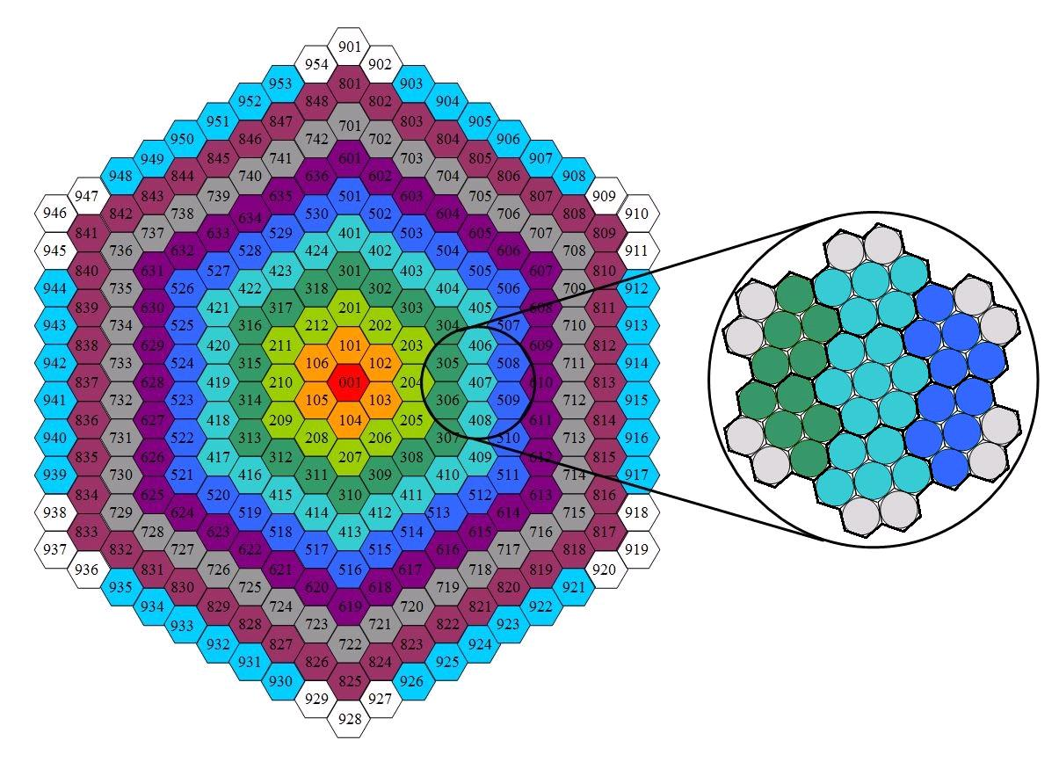
The simulation generates an input signal for each of the seven pixels of one cluster, then L0 actuates and send the resulting signal to the L1. L1 takes signals from up to seven clusters and generates the final trigger signal. The simulation performs one run of L1 trigger and as many runs of L0 as clusters are recalled to participate in the simulated event, up to 7 clusters.

Figure 1: Clusters distribution for the LST camera, from CTA. This simulation covers the zoomed group of seven clusters.

The L0 trigger simulation is divided in four different parts. First of all, a gaussian pulse is generated, emulating the signal produced by photoelectrons. The FWHM is 3,5 ns and the amplitude depend on the input voltage given in mV. To the signal, a gaussian noise with sigma 30*srwt(12) is added. Also a random time delay (+- 1ns) and gain variation is applied to each pixel (+-10 mV). The input signal then goes through the attenuation phase, where it is multiplied by an attenuation factor whcih can go from 0,6 to 1,3. Afterwards, the signal is driven to one of the two possible trigger approaches of L0: Sum trigger, where a clipping of a certain voltage is applied (normally 60 mV); and majority trigger, where the signal is compared to a threshold.
In the case of this document, only the sum trigger has been taken into account, and the majority trigger is not fully implemented yet. Finally, the signals from seven pixels are added to compose the L0 ouput signal which is sent to the L1 trigger. At this phase, the bandwidth is applied, making a convolution of the summed signal with a sinc function to obtain a 500 mHz bandwidth. Since the convolution would have a certain effect on the amplitude of the signal, specially for low voltages, it is necessary to include a correction factor, to properly simulate the required gain of the ASIC. This factor has been calculated for the range from 0 to 60 mV and its value is 1,324. Therefore, the gain introduced in the simulation has to be multiplied by this factor, to properly simulate the real signal amplitude. This factor has a strong dependence on the range of the input voltages, so this value calculated works only for a clipping of 60 mV.

Each run of L0 simulation produces a signal from one cluster. L1 trigger takes as input such signals, depending on the number of clusters (up to seven) that is being taken into account. Therefore, for one L1 run, is necessary to run L0 as many times as the number of clusters wanted to participate.

The Level 1 trigger has also four different phases. First of all, the input signals coming from L0 runs are modified with a time delay(+- 1 ns) and a gain variation for each cluster(+- 10mV). Then the signals are triplicated and pass through a combination of switches where it is decided which clusters are participating in the simulation (channels). Afterwards, for each group of replics, the signals from the seven channels are added and the result are three signals coming out from each adder. Finally, this three signals are compared to a certain threshold voltage in the discriminator phase. If one of the three signals is over the threshold voltage, the simulation gives the result “triggered” and produces an output signal where 0 value is given to all the points under the threshold and 3 V value is given to all points over the threshold. In this phase, to avoid possible peak like ouputs due to the noise, only output signals which are over the threshold for a minimum time (normally 1 ns) are considered as a triggered response.
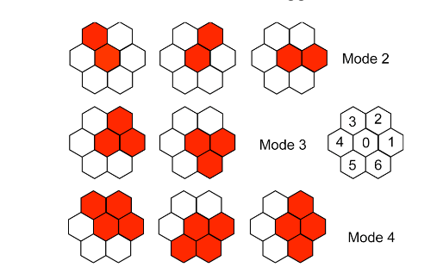
Figure 2: Possible combinations for L1 trigger system. Within the simulation it is possible to choose one of the three modes and any of the possible cluster cobinations in it.

Before running the simulation, it is necessary to run the configuration program wich permits to select the pixels that are participating in each L0 run, the modes for L1 and the 21 switches configuration for L1. The simulator has been designed to reproduce events in detail, producing the data (amplitude versus time) of the singals in each phase of the simulation. This mode is useful to plot the signals in every phase and understand the behaviour of the trigger system (see figures 3 and 4). On the other hand, it is possible to run a big number of events where only the final trigger result is stored, saving a lot of running time. This mode is useful to perform the rate scan needed for the calibration.
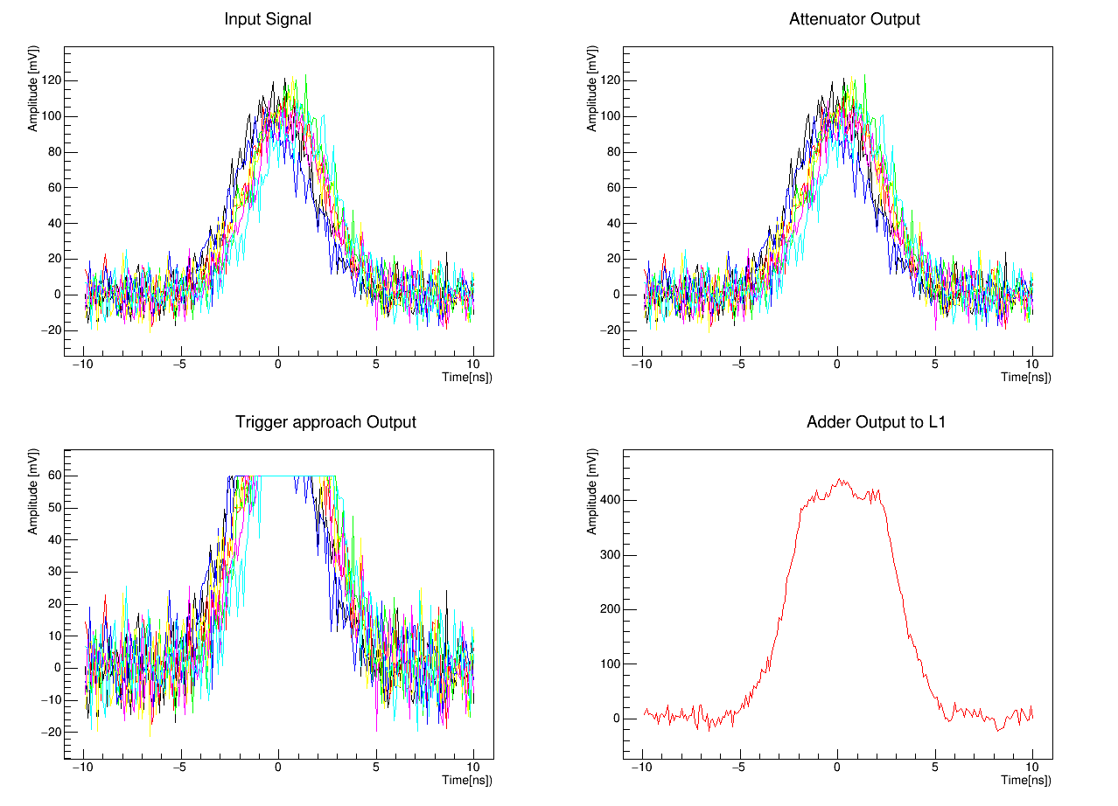
Figure 3: Example of L0 trigger simulation for one cluster. There are seven input signals of 100mV corresponding to the seven pixels of one cluster. Attenuation factor is 1 in this case, and the trigger approach is sum trigger, with clipping at 60 mV. The final output of L0 (bottom-right) goes to one of the channels of L1.

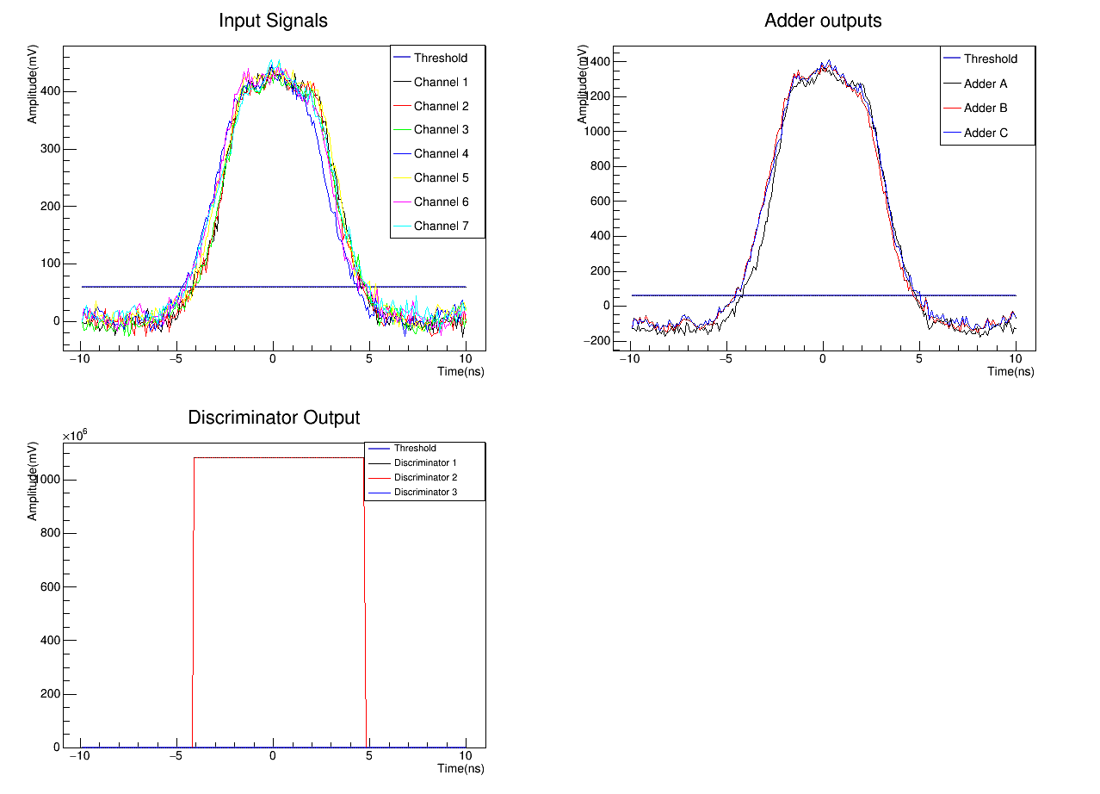
Figure 4: L1 simulation. The seven channels correspond to seven signals coming from 7 runs of L0, similar to that of figure 1 (input voltage for all pixels 100 mV). The combination for the switches is: Adder A: ch 1, 2, 3. Adder B: ch 4, 5, 6. Adder C: ch 5, 6, 7. Threshold is 60 mV.

Part 2: Simulation for calibration

To calibrate the trigger system, is necessary to make a rate scan of the trigger response for each ASIC , which means that a priori, a lot of data points are needed and so, a lot of time is required to calibrate all the ASICs. With the simulation, we try to optimize the time required for the calibration, stablishing a time saving methodology where the minimum number of data points are necessary to be measured.

The rate scan consist on fiding the Threshold voltage for which the trigger probability is 50%, for a certain input voltage. After having several of this points for different input voltages, plotting the threshold versus the input voltage would give a linear relation where the slope is the gain, and the origin ordinate corresponds to the offset.

The calibration is going to be made with signals from one pixel and one cluster at a time.

To find the trigger probability is necessary to perfom at least 100 events for each threshold voltage tested, so the number of events that trigger, is the trigger probability. It is necessary to decide how many and which threshold voltages are going to be tested to find the range where the probability passes from 100 % trigger to 0 % trigger. The number of points that has to be taken in this pahse is variable and it depends on the precission wanted. The simulation will help to test what is the minimun number of points that has to be taken to have a good result, so it is not necessary to take a lot of data. Finally, the rate scan has to be repeated for different voltages in order to calculate the gain and the offset.

In the case that at least 10 input voltages are tested, the number of data points needed would be 10 * 100 * N, where N is the number of threshold points tested.

In the next example of the simulation, input voltages from 10 mV to 300mV were used, taking 10 intervals of 10 mV from 0 to 100, and three intervals of 100 mV from 100 to 300. The configuration parameters were the following:

1 pixel per cluster, 1 cluster per simulation, 1 adder active.
Gain: 0,87
Offset: 0
Attenuation: 1
L0 approach: Sum trigger.
Clipping: 60 mV
Threshold binning: 0,5 mV.

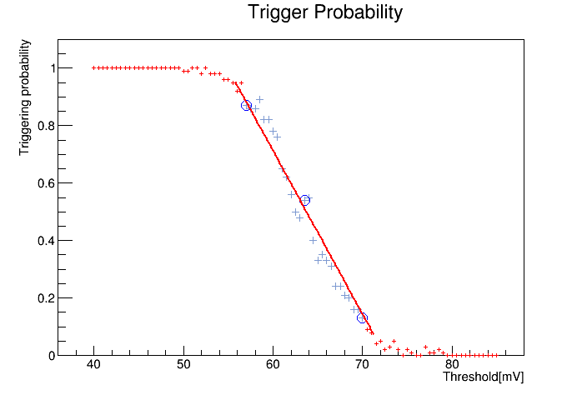
Figure 5: Rate scan procedure. The trigger probability is calculated running 100 events and counting how many events trigger for every threshold probed. In this case, for an input voltage of 50 mV, thresholds from 40 mV to 85 mV were probed to obtain this plot. The aim is findig the threshold for what the probability is 50%. Blue crosses shows the range where the linear fit is performed. Blue circles show the three points used to do another linear fit but with much less points, to test what is the error commited for not taking so many points in that range.

Figure 5 shows an example of rate scan procedure for one input voltage, in this case 50 mV. For each input voltage, the threshold for what the trigger probability is 50 % needs to be calculated. As can be observed, the range when the probability falls from 100 % to 0 % can be approximated by a linear fit and from the fit parameters, the probability can be easily calculated.
Since the aim of this work is to check how many points from the range from 100 to 0 probability are needed to have a good linear fit, the probability has been calculated taking one point every 0,5 mV of threshold, and taking only 3 points (the first, the middle one and the last points of the range fitted). In table 1 the results are showed:

__________________________________________
Input V (mV) Th. (50%)(mV) Th(50%)(mV)
all points 3 points
__________________________________________
10 28.0934 28.298
20 35.0465 35.1612
30 43.5574 43.6139
40 53.2274 53.1937
50 63.5512 63.5965
60 70.5641 70.7297
70 74.8774 75.3811
80 77.1196 77.0213
90 78.6759 79.7089
100 79.6172 79.0947
200 82.8117 82.5644
300 83.6864 83.6711
__________________________________________
Table 1: Thresholds for 50% trigger probability obtained for different input voltages, doing the linear fit to all the points generated (one per 0,5 mV of threshold) and to only 3 points in the linear range.

As can be seen in the table, the difference between the two values of threshold is minimal, being in most cases << 1 mV.

In figure 2, the points of table 1, conforming the rate scan result, are shown:

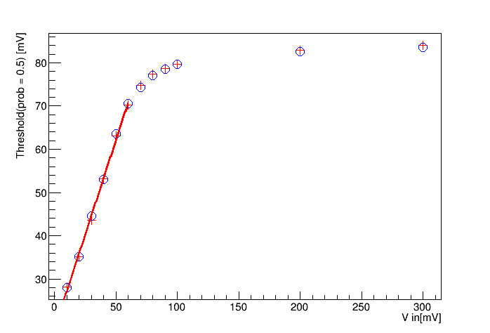

Figure 2: Rate scan result, threshold for 50% trigger probability versus input voltage. Red crosses represent the thresholds calculated fitting all points and blue circles represent thresholds calculated fitting only 3 points. The limitation observed is caused by the clipping.

To calculate the gain it must be done a fit to the linear part of the graph, in this case from 0 to 60 mV. The fit parameters obtained are:

Obtained fitting all points of the rate scan:
p0: 18.4822 p1: 0.869327
Only 3 points:
p0: 18.4919 p1:0.875615

Gain corresponds to parameter p1, and parameter p0 must correspond to the offset. The input gain provided for the simulation was 0,870. Taking all points for the fit, the gain obtained is pretty close, 0,869, but taking only three points, the gain differs with an error ~0,006, having 0,876. We can consider this error acceptable, since from the ASICs caharcterization, the calculation of the gain from the typical ASIC had an error of +- 0,038 >> 0,006.

In the case of the offset, some kind of correction is needed, since clearly the result doesn't correspond to the offset given in the simulation (which was 0). The correction factor still needs to be calculated. In any case, the offset value won't affect the calculation of the gain, the slope of the fit will be the same regardless of the origin ordinate.

We can conclude that, to make a good calibration of the ASICs by the rate scan methodology, it is enough to take only 3 points in the range of thresholds where the trigger probability falls from 100 to 0. The number of points needed for calibration, then are: 100 * Ninputs * 3, being Ninputs the number of input voltages used for the rate scan. Typically 10 points, but if we assume that the clipping is at 60 mV and we only take input voltages every 10 mV, it would be enough with only 5 points, 100 * 5 * 3 = 1500 points.

Part 3: Calibration Procedure.

