Financial news and stock direction
  - Data collection and exploratory analysis
DATA1030 | 19 October 2026

Introduction
We want to test whether financial headlines improve prediction of a stock's next trading day direction beyond historical market data. We plan to compare a model using market data with the same model plus headline features, using the same labels and dates.
This report builds on Carmen's Alpaca collection and saved summaries. Joyce added the Yahoo and EODHD samples, plots and further data checks. The price checks passed, while the news needs more work on coverage and timing. We have not trained the models yet.

Data collected
Source | Coverage | Records | Evidence available
Alpaca | AAPL and JNJ news  2020 to October 2026 | 27,893 | Saved notebook summaries
Yahoo chart | AAPL AMZN JNJ SPY prices  2020 to October 2026 | 6,824 | Raw price rows inspected
EODHD demo | AAPL and AMZN news  Calendar year 2024 | 10,817 | Raw news rows inspected
The original Alpaca files are not in this checkout, so the Alpaca findings use the saved notebook summaries [1]. Yahoo prices were collected through its undocumented public chart interface, with October 16, 2026 as the exclusive end date [3]. EODHD demo news was requested in 24 monthly ticker requests [2]. AMZN is an additional case for review; the team still needs to choose its final stocks and data source.
Price fields include the session date, OHLC, volume and adjusted close. News fields include ticker, publication time, headline, URL and linked symbols. The collectors save request settings, retrieval times and response hashes. Provider sentiment scores are saved for reference until we can establish when they became available.

Exploratory data analysis

News coverage
AAPL has far more news records than JNJ in the saved Alpaca summaries. The added 2024 sample also has a sharp drop in records late in the year. We need to understand these coverage differences before combining the data for modeling.
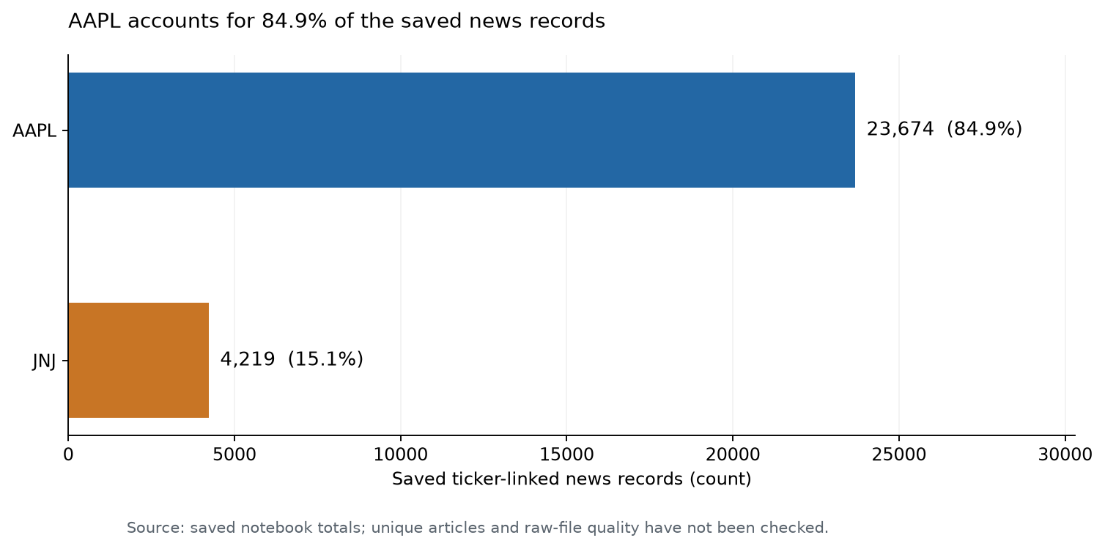
Figure 1. Carmen's saved Alpaca totals: AAPL has 23,674 records and JNJ has 4,219. AAPL makes up 84.9% of the total. Checking unique stories and duplicates will require the original files.
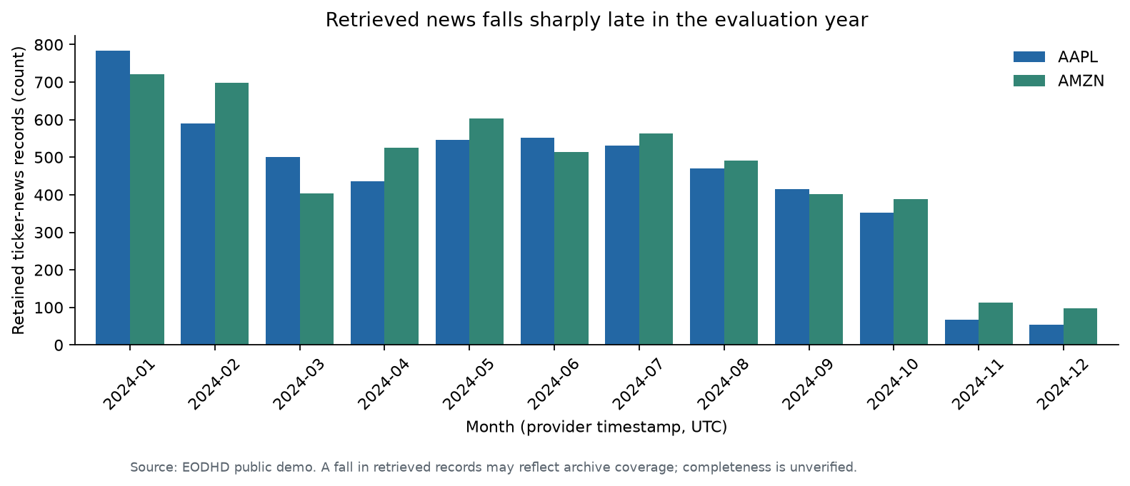
Figure 2. EODHD news in 2024: combined counts fall from 1,505 in January to 179 in November and 151 in December. We need to check archive and source coverage before interpreting this as a change in actual news activity.

Price behavior and headline structure
All four Yahoo series have 1,706 valid rows, matching the expected NYSE sessions from January 2, 2020 through October 15, 2026. No duplicate dates, missing sessions or failed OHLC checks were found. Returns use adjusted close after matching dates to the trading calendar; missing sessions would be left empty [4].
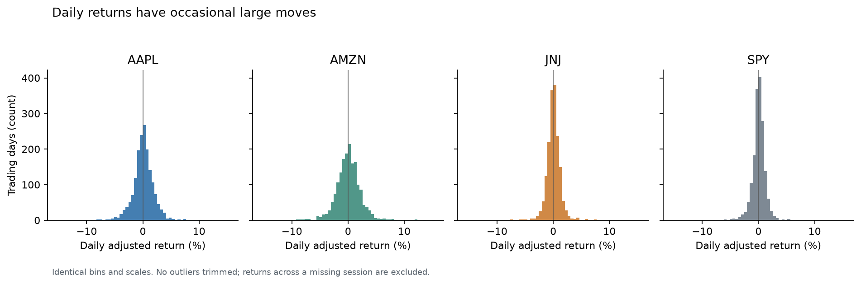
Figure 3. Daily returns from Yahoo prices, 2020 to 2026. Standard deviations are 1.97% for AAPL, 2.24% for AMZN, 1.25% for JNJ and 1.26% for SPY. The plots use the same bins and scales, with extreme observations retained.
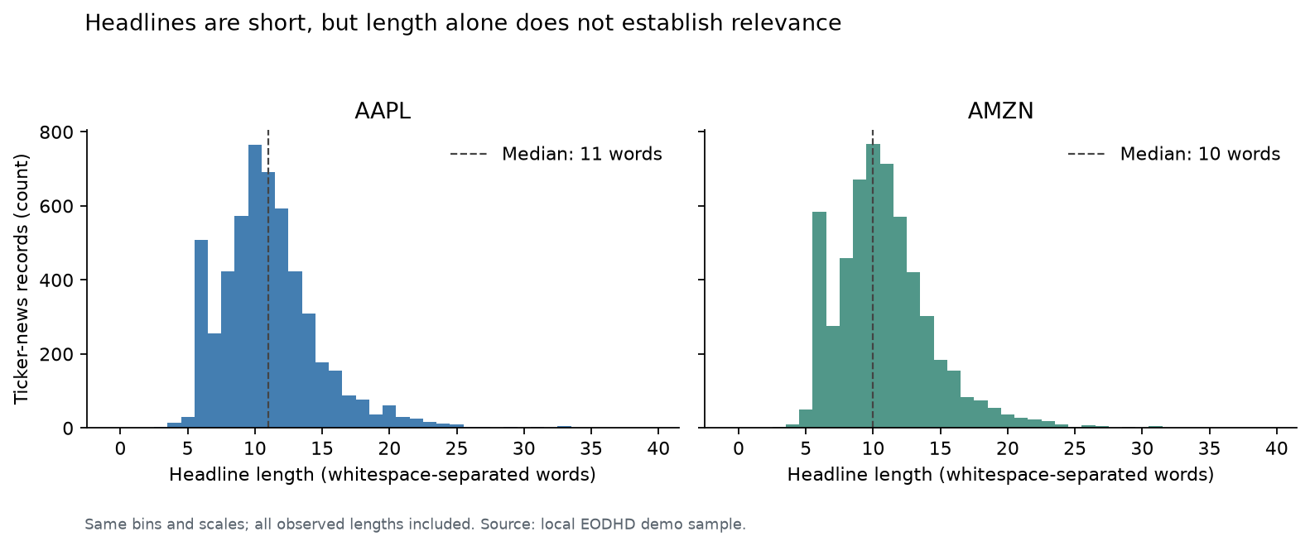
Figure 4. EODHD headline lengths in 2024. The median is 11 words for AAPL and 10 for AMZN; about 95% have no more than 18 and 17 words respectively. This describes the amount of text available for later analysis.
The 10,817 news records contain 10,038 distinct URLs, with no blank headlines or exact record duplicates after collection. Another 95 rows share a normalized title and timestamp across different URLs and may be syndicated. Company names or aliases appear in 42.7% of AAPL and 32.6% of AMZN headlines. We should review unmatched articles before deciding which to keep.

Problem description and potential impact
We plan to predict whether a stock rises over the next trading session. Let P be adjusted close for stock i, and let t + 1 mean the next trading session. Both models will use the same binary target:
$$y_{i,t} = 1 if P_{i,t+1} > P_{i,t}$$
$$y_{i,t} = 0 if P_{i,t+1} ≤ P_{i,t}$$
At today's actual NYSE close, we use news published after the previous close and through today's close to predict the next session's direction. Later news moves to the next cutoff. The exchange calendar accounts for holidays, daylight saving time and early closes.
A total of 2,380 news rows (22.0%) have timestamps exactly at midnight UTC. These may only have date precision, so we keep them in monthly totals and leave them out of close-based pairing until checked. Publication time also cannot establish when a revised headline or sentiment score became available. Excluding uncertain times and edge windows leaves 250 stock-days per ticker in 2024, or 500 in total; archive completeness remains unverified.
We plan to compare a majority-class reference, a regularized logistic regression using historical market features, and the same model with headline word-frequency features. Both models will use identical stock-days and chronological splits, with dates aligned across stocks. Vocabulary, scaling and tuning will use only the training portion, leaving the final test period untouched. We will report class balance, balanced accuracy and ROC AUC, and assess uncertainty across dates because headlines from the same day are not independent prediction observations.
The full price sample has 1,705 labels per stock. The shorter 2024 news-paired sample has 142 up and 108 other labels for AAPL (56.8% up), and 133 and 117 for AMZN (53.2% up). These proportions differ from the full-period chart. With only 500 paired rows, a longer news history with reliable timing would strengthen the comparison.
Xu and Cohen studied tweets alongside historical prices [6], and Araci studied financial sentiment classification [5]. These studies motivate trying text features, but we still need to test their value for our headlines. The next steps are to obtain the original files, investigate changes in news coverage, review headline relevance and timestamps, and confirm the provider's academic access and sharing terms [7]. A small or zero improvement would also answer our research question.

References
[1] CarmenYan. finmedia-stock-pred. Original collection notebook. https://github.com/CarmenYan/finmedia-stock-pred/blob/main/src/collect_data.ipynb
[2] EODHD. Financial News Feed and Stock News Sentiment data API. https://eodhd.com/financial-apis/stock-market-financial-news-api
[3] Yahoo Finance. Public chart interface used for price retrieval; undocumented endpoint. https://query1.finance.yahoo.com/v8/finance/chart/AAPL
[4] pandas_market_calendars. Calendar usage and schedules. https://pandas-market-calendars.readthedocs.io/en/latest/usage.html
[5] Araci, D. (2019). FinBERT Financial Sentiment Analysis with Pretrained Language Models. https://arxiv.org/abs/1908.10063
[6] Xu, Y., and Cohen, S. B. (2018). Stock Movement Prediction from Tweets and Historical Prices. ACL, 1970-1979. https://aclanthology.org/P18-1183/
[7] EODHD. Terms and Conditions. https://eodhd.com/financial-apis/terms-conditions

Appendix figures
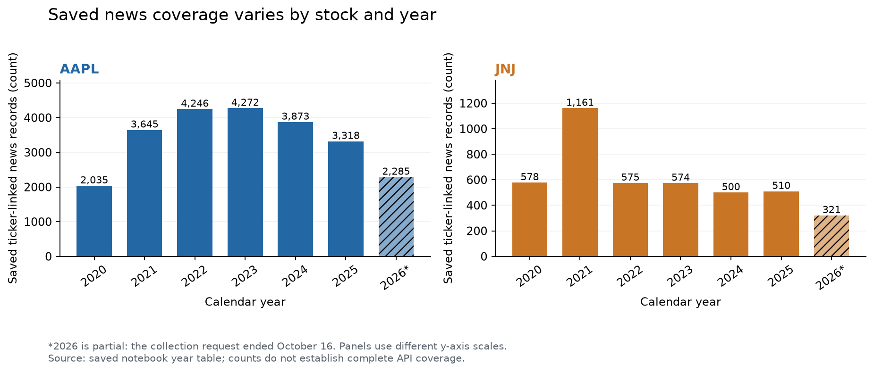
Figure A1. Annual Alpaca news counts from Carmen's saved tables. Each panel has its own vertical scale. The 2026 request ends in October, so its count covers less time than the complete years.

Additional price checks
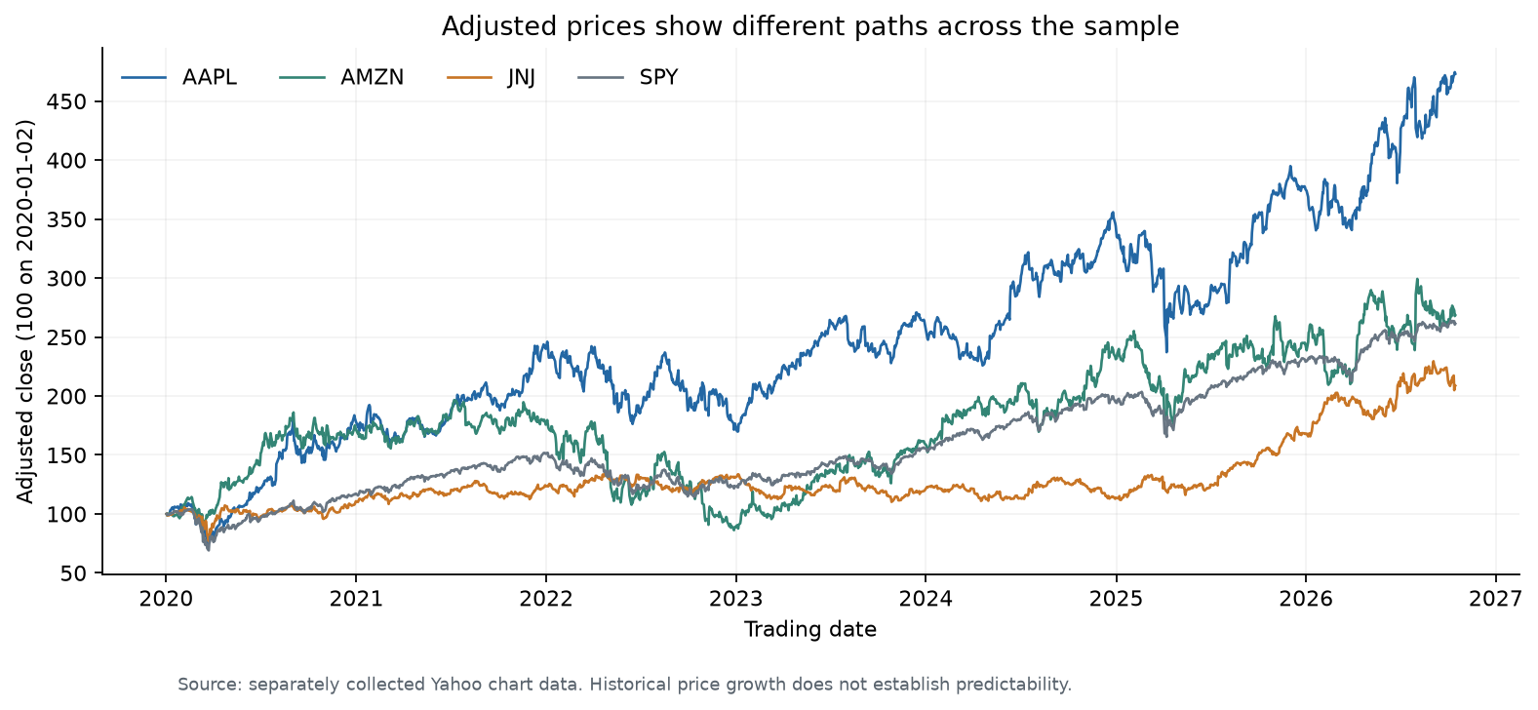
Figure A2. Yahoo adjusted prices start at 100 on the same date. A value of 150 means the adjusted price is 50% above its starting value. The lines show relative price changes over the sample.
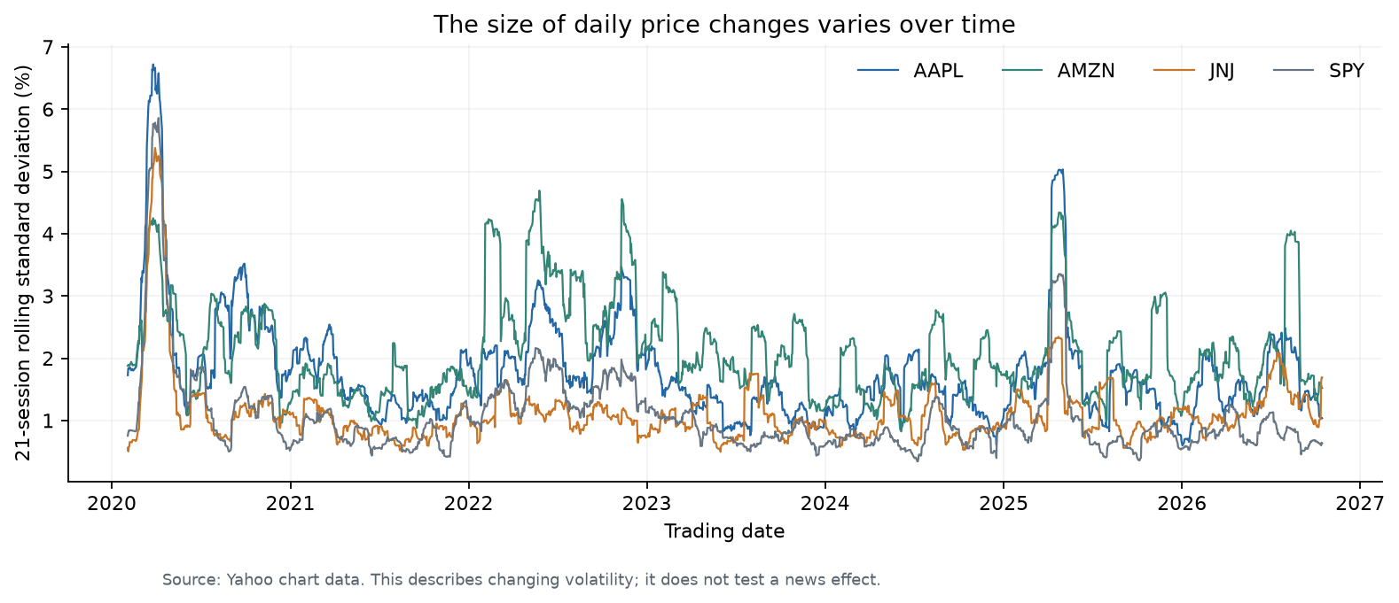
Figure A3. Standard deviation of daily returns over the latest 21 trading sessions. Volatility changes over time, which makes evaluation on later dates useful. The plot does not identify the causes of these changes.

Target balance and news pairing
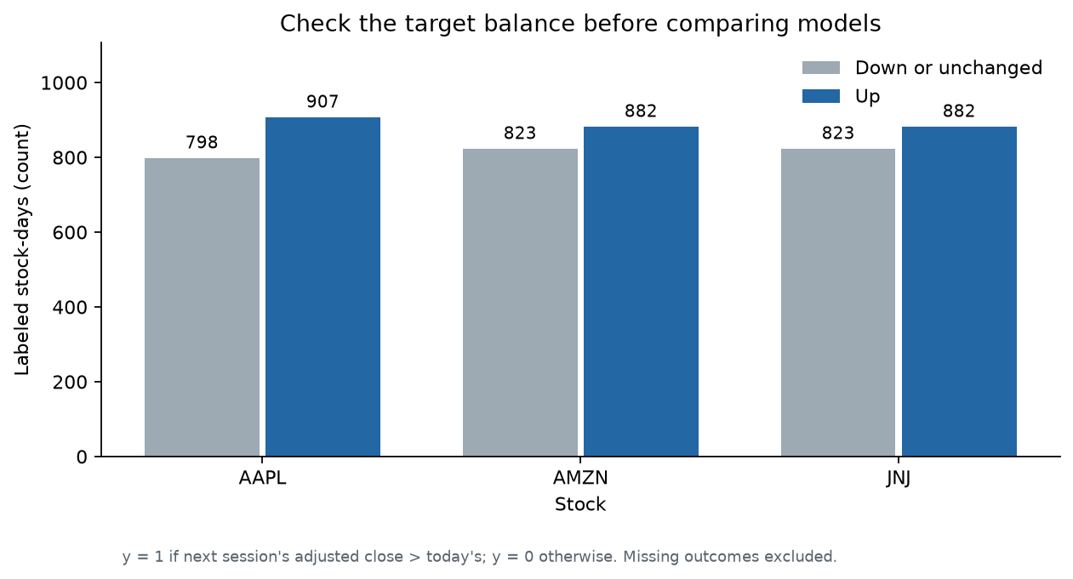
Figure A4. Labels over the full 2020 to 2026 price period. AAPL has 907 up labels out of 1,705 (53.2%); AMZN and JNJ each have 882 (51.7%). The 2024 news-paired sample has a different class balance.
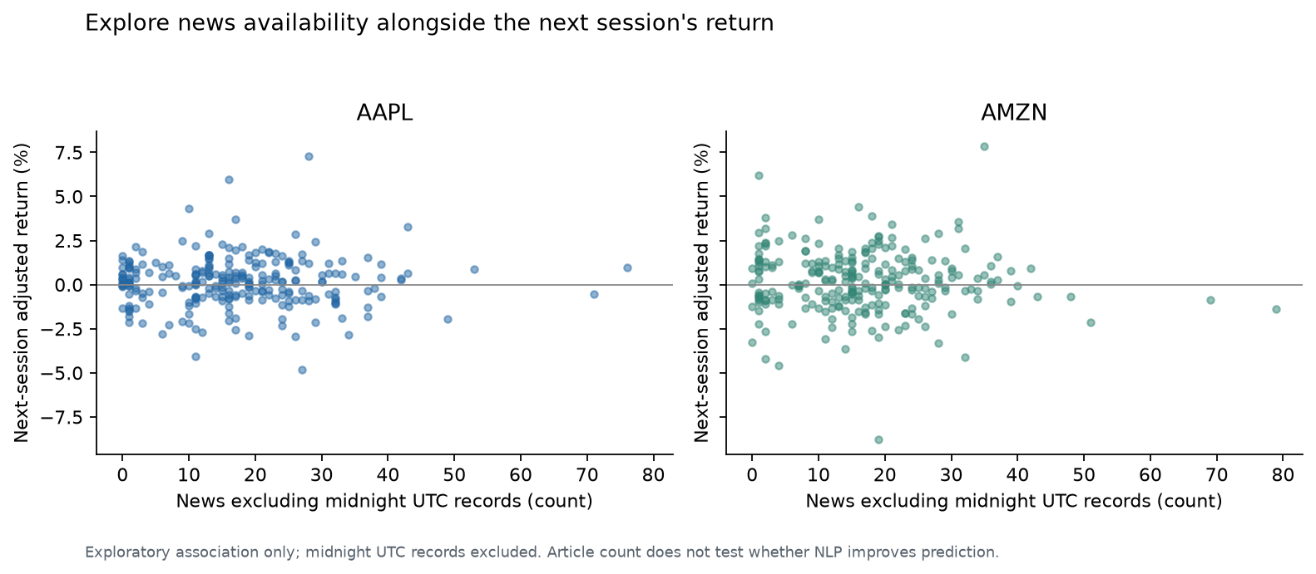
Figure A5. News counts and next-session returns in 2024, using 250 stock-days per ticker. Midnight UTC records are left out. Count/return correlations are 0.0079 for AAPL and -0.0403 for AMZN. Testing headline wording will require the planned model comparison.

