ShoePPING

1. **Software Requirement Specification**
2. **Introduction**
3. Aim of the document.

The purpose of the document is to describe the functionality of the application ShoePPING.

1. Overview of the defined system.

The application allows the owner of a shoe shop to manage the online sale of their products and to maintain their catalog of shoes.

The application allows users to sell shoes and buy new and used shoes.

1. HW e SW requirements.

Minimum hardware requirements:

Processor: Intel(R) Core(TM) i5-8265U CPU @ 1.60GHz 1.80 GHz

RAM: 16,0 GB

Hard disk: 80 GB

Minimum software requirements:

OS: Windows 10

1. Related systems (at least 2), Pros and Cons.

Nike Sportswear

Compared to our app, Nike Sportswear offers more support options (favorites list, shopping cart, chat support). Unlike our app, it doesn't allow users to sell their shoes online

Vinted

Vinted allows users to communicate via chat, simplifying the sales agreement. When a user puts an object up for sale, he can insert one or more photos of the product. The application only manages the sale between private individuals, as there is no shop as manager.

1. **User Stories**

Daniele Ausili:

1. As a customer,

I want to know the prices of the shoes,

so that I can choose according to my budget.

1. As a shopkeeper,

I want to check customers' orders,

so that I can accept or reject them.

1. As a seller,

I want to know the buyer's address,

so that I can ship the shoes to him.

Carmine Aprile:

1. As a seller,

I want to sell my shoes online,

so that I can earn money by selling shoes that I don't use.

1. As a shopkeeper,

I want to update the shoes' prices,

so that I can give discounts.

1. As a customer,

I want to check my orders,

so that I can see what I have bought.

1. **Functional Requirements**

Daniele Ausili:

1. The system shall display a message when the customer registers correctly.
2. The system shall store information about the order in a database when a customer buys a pair of shoes.

2.1. The system shall memorize the date, the item, the price, the condition, the address, and the status of the order.

1. The system shall display a list of shoes when the customer clicks on the catalog of used shoe menu.

Carmine Aprile:

1. The system shall display an error message when the customer inserts invalid data on the login page.
2. The system shall edit the customer's profile data when he changes his data on the profile menu.
3. The system shall display the login page right after the shopkeeper clicks the exit button in the top right corner.
4. **Use Cases: Overview Diagram**

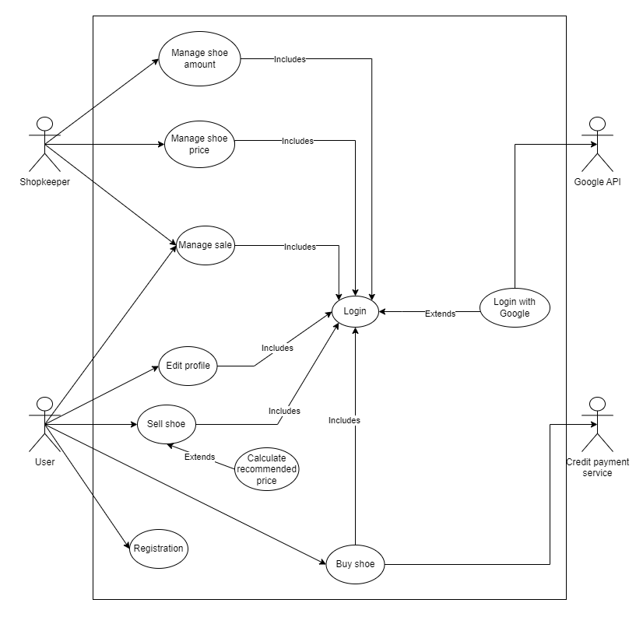

1. **Storyboards**

Link file HTML:

<ShoePPING-Storyboards.html>

1. **Design**

* **Activity diagram**

[ActivityDiagram-DanieleAusili.pdf](Activity%20Diagram%20ShoePPING/ActivityDiagram-DanieleAusili.pdf)

The timer and notification handling has not been implemented in the code.

[ActivityDiagram-CarmineAprile.pdf](Activity%20Diagram%20ShoePPING/ActivityDiagram-CarmineAprile.pdf)