Document Title

A plain paragraph having some **bold** and some *italic.*

# Heading, level 1

Intense quote

* first item in unordered list

1. first item in ordered list

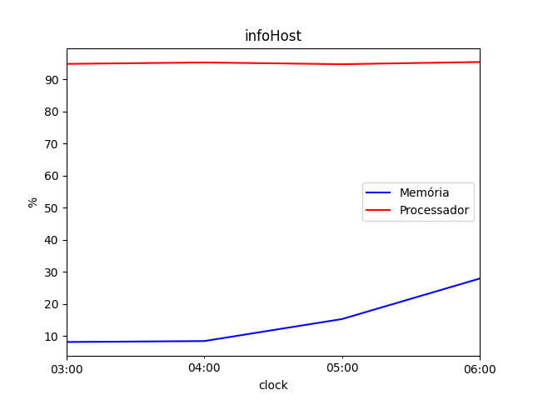

|  |  |
| --- | --- |
| Item | Valor |
| Servername | BARRETOS\BARRETOS |
| Hostname | BARRETOS |
| SQLVersion | Microsoft SQL Server 2017 (RT |
| OSVersion | Windows Server 2012 R2 Datacenter 6.3 <X64> (Build 9600: ) (Hypervisor) |
| ServerIp | 190.1.1.10 |
| InstancePort | 62209 |
| Instance | BARRETOS |
| ProductVersion | 14.0.3421.10 |
| Edition | Standard Edition (64-bit) |
| ProductLevel | RTM |
| ProductUpdateLevel | CU27 |
| Collation | SQL_Latin1_General_CP1_CI_AI |
| ServerMemory | 65535 |
| TargetServerMemory | 57344 |
| MaxDop | 8 |
| RemoteDAC | 1 |
| CTFP | 30 |
| IsVirtualMachine | True |
| SystemModel | System Manufacturer: 'VMware, Inc.', System Model: 'VMware Virtual Platform'. |
| CPUModel | Intel(R) Xeon(R) Gold 5220R CPU @ 2.20GHz |
| CPUCount | 24 |
| NUMANodesCount | 4 |
| LogicalCPUsCount | 24 |
| OfflineCPUsCount | 0 |
| SQLServerStartTime | Apr 15 2022 1:17PM |
| Uptime | 53d 0h 33m |
| DatabasesCount | 38 |
| ServiceName | BARRETOS |
| ServiceAccount | MINERVA\SVC_SQLSERVICES |
| InstantFileInitialization | True |
| SQLDiskCount | 2 |
| SQLDiskDetails | D:\ com tamanho total de 2201GB e 823GB livres.,C:\ com tamanho total de 159GB e 35GB livres. |
| SQLTotalSizeGB | 1229.56 |
| IsClustered | 0 |
| IsAlwaysOnAGEnabled | 0 |
| LogShippingDatabases | 0 |
| MirroringDatabases | 0 |
| ReplicationDatabases | 11 |
| TraceFlags | [1117,1118,2371,3226,9481] |
| Servername | BARRETOS\BARRETOS |
| Hostname | BARRETOS |
| SQLVersion | Microsoft SQL Server 2017 (RT |
| OSVersion | Windows Server 2012 R2 Datacenter 6.3 <X64> (Build 9600: ) (Hypervisor) |
| ServerIp | 190.1.1.10 |
| InstancePort | 62209 |
| Instance | BARRETOS |
| ProductVersion | 14.0.3421.10 |
| Edition | Standard Edition (64-bit) |
| ProductLevel | RTM |
| ProductUpdateLevel | CU27 |
| Collation | SQL_Latin1_General_CP1_CI_AI |
| ServerMemory | 65535 |
| TargetServerMemory | 57344 |
| MaxDop | 8 |
| RemoteDAC | 1 |
| CTFP | 30 |
| IsVirtualMachine | True |
| SystemModel | System Manufacturer: 'VMware, Inc.', System Model: 'VMware Virtual Platform'. |
| CPUModel | Intel(R) Xeon(R) Gold 5220R CPU @ 2.20GHz |
| CPUCount | 24 |
| NUMANodesCount | 4 |
| LogicalCPUsCount | 24 |
| OfflineCPUsCount | 0 |
| SQLServerStartTime | Apr 15 2022 1:17PM |
| Uptime | 54d 0h 33m |
| DatabasesCount | 38 |
| ServiceName | BARRETOS |
| ServiceAccount | MINERVA\SVC_SQLSERVICES |
| InstantFileInitialization | True |
| SQLDiskCount | 2 |
| SQLDiskDetails | D:\ com tamanho total de 2201GB e 822GB livres.,C:\ com tamanho total de 159GB e 35GB livres. |
| SQLTotalSizeGB | 1230.07 |
| IsClustered | 0 |
| IsAlwaysOnAGEnabled | 0 |
| LogShippingDatabases | 0 |
| MirroringDatabases | 0 |
| ReplicationDatabases | 11 |
| TraceFlags | [1117,1118,2371,3226,9481] |
| Servername | BARRETOS\BARRETOS |
| Hostname | BARRETOS |
| SQLVersion | Microsoft SQL Server 2017 (RT |
| OSVersion | Windows Server 2012 R2 Datacenter 6.3 <X64> (Build 9600: ) (Hypervisor) |
| ServerIp | 190.1.1.10 |
| InstancePort | 62209 |
| Instance | BARRETOS |
| ProductVersion | 14.0.3421.10 |
| Edition | Standard Edition (64-bit) |
| ProductLevel | RTM |
| ProductUpdateLevel | CU27 |
| Collation | SQL_Latin1_General_CP1_CI_AI |
| ServerMemory | 65535 |
| TargetServerMemory | 57344 |
| MaxDop | 8 |
| RemoteDAC | 1 |
| CTFP | 30 |
| IsVirtualMachine | True |
| SystemModel | System Manufacturer: 'VMware, Inc.', System Model: 'VMware Virtual Platform'. |
| CPUModel | Intel(R) Xeon(R) Gold 5220R CPU @ 2.20GHz |
| CPUCount | 24 |
| NUMANodesCount | 4 |
| LogicalCPUsCount | 24 |
| OfflineCPUsCount | 0 |
| SQLServerStartTime | Apr 15 2022 1:17PM |
| Uptime | 55d 0h 33m |
| DatabasesCount | 38 |
| ServiceName | BARRETOS |
| ServiceAccount | MINERVA\SVC_SQLSERVICES |
| InstantFileInitialization | True |
| SQLDiskCount | 2 |
| SQLDiskDetails | C:\ com tamanho total de 159GB e 35GB livres.,D:\ com tamanho total de 2201GB e 821GB livres. |
| SQLTotalSizeGB | 1231.08 |
| IsClustered | 0 |
| IsAlwaysOnAGEnabled | 0 |
| LogShippingDatabases | 0 |
| MirroringDatabases | 0 |
| ReplicationDatabases | 11 |
| TraceFlags | [1117,1118,2371,3226,9481] |
| Servername | BARRETOS\BARRETOS |
| Hostname | BARRETOS |
| SQLVersion | Microsoft SQL Server 2017 (RT |
| OSVersion | Windows Server 2012 R2 Datacenter 6.3 <X64> (Build 9600: ) (Hypervisor) |
| ServerIp | 190.1.1.10 |
| InstancePort | 62209 |
| Instance | BARRETOS |
| ProductVersion | 14.0.3421.10 |
| Edition | Standard Edition (64-bit) |
| ProductLevel | RTM |
| ProductUpdateLevel | CU27 |
| Collation | SQL_Latin1_General_CP1_CI_AI |
| ServerMemory | 65535 |
| TargetServerMemory | 57344 |
| MaxDop | 8 |
| RemoteDAC | 1 |
| CTFP | 30 |
| IsVirtualMachine | True |
| SystemModel | System Manufacturer: 'VMware, Inc.', System Model: 'VMware Virtual Platform'. |
| CPUModel | Intel(R) Xeon(R) Gold 5220R CPU @ 2.20GHz |
| CPUCount | 24 |
| NUMANodesCount | 4 |
| LogicalCPUsCount | 24 |
| OfflineCPUsCount | 0 |
| SQLServerStartTime | Apr 15 2022 1:17PM |
| Uptime | 56d 0h 33m |
| DatabasesCount | 38 |
| ServiceName | BARRETOS |
| ServiceAccount | MINERVA\SVC_SQLSERVICES |
| InstantFileInitialization | True |
| SQLDiskCount | 2 |
| SQLDiskDetails | C:\ com tamanho total de 159GB e 35GB livres.,D:\ com tamanho total de 2201GB e 821GB livres. |
| SQLTotalSizeGB | 1231.59 |
| IsClustered | 0 |
| IsAlwaysOnAGEnabled | 0 |
| LogShippingDatabases | 0 |
| MirroringDatabases | 0 |
| ReplicationDatabases | 11 |
| TraceFlags | [1117,1118,2371,3226,9481] |