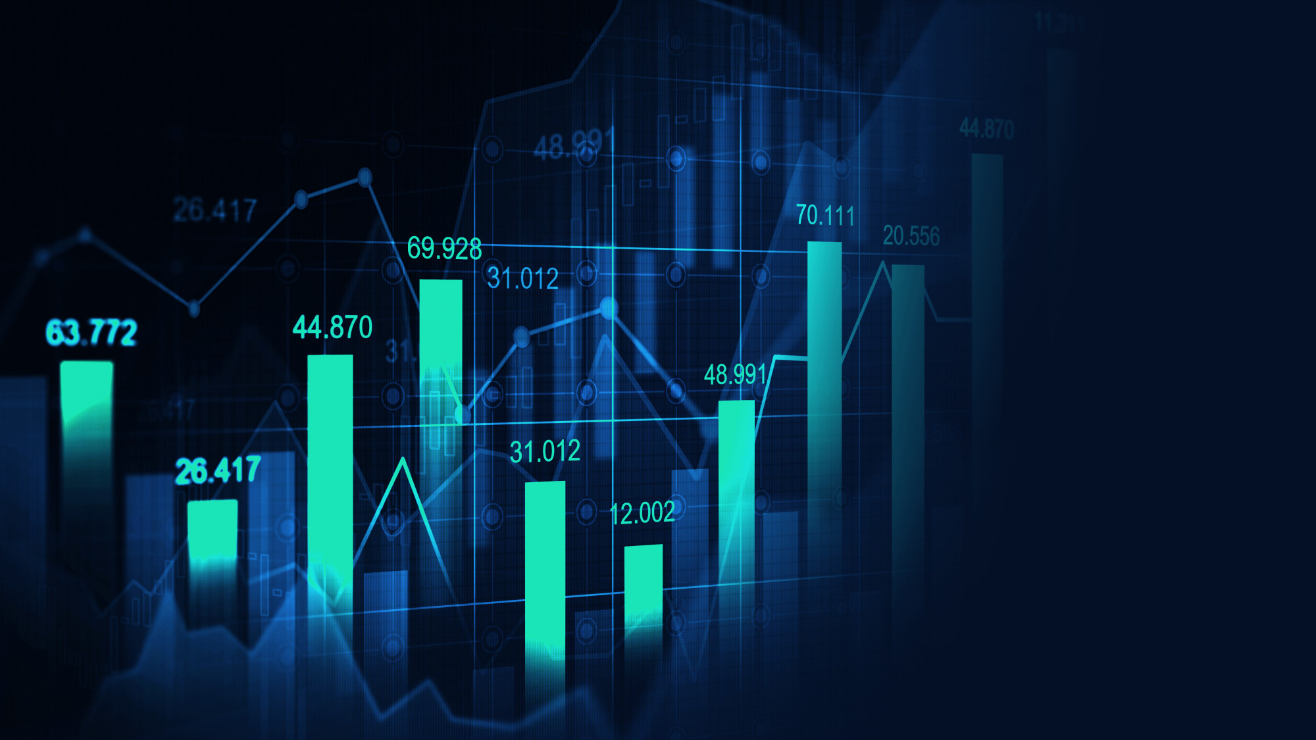

Stock Analysis

Analysis between 2 different stock markets

Kevin Carmody | Certificate in Data Analytics for Finance | July/August 2022

Contents

GitHub URL 1

Abstract 1

Introduction 1

Dataset 2

Implementation Process 2

Results 2

Insights 2

References 2

# GitHub URL

GitHub URL Link:

<https://github.com/Carmomeister/UCDPA_KevinCarmody>

# Abstract

Test

# Introduction – (125 Words)

I chose this as a project because I've always been fascinated by the stock market and how it operates. With my interest in data analytics, it was a no-brainer for me to participate in a project that utilized stock market data.

Data analysis is critical in the financial sector for acquiring a deeper knowledge of the stock market's rhythms. You can use data science to create an evaluation that allows traders to make educated decisions on whether to purchase, sell, or hold a particular commodity, or to determine the best composition of a trading portfolio to achieve specified financial goals or objectives over such a set period.

With this, I strive to uncover some important information using the data that has been presented to me.

# Dataset - (91 Words)

The dataset I've chosen to use for my UCDPA Project is made up of 20+ years of data made accessible to the public by Yahoo Finance.

The content includes daily price data for indexes tracking stock exchanges throughout the world, including that of the United States, China, Canada, Germany, Japan, and other countries.

There aren't that many websites available on the internet where you can get several decades of accurate figures, thus I felt that it was appropriate to use this data for my project based on its validity or accuracy.

# Implementation Process

You could explore the stock market in several different ways to evaluate certain stocks. In order to conduct this study, I decided to search out statistics which could be useful if someone were to evaluate why people buy or sell shares.

First, I began with my package installation, which included Plotly, seaborn, and cufflinks. I was not at all sure whether or not I was going to use Plotly or Seaborn at this point. Plotly supports several languages and allows for a high degree of customization and interaction, whereas Seaborn is a completely open Python Visual Library built on top of Matplotlib. Following some exploration, I elected to choose Plotly as my graphing package of choice.

Following that, we installed NumPy for any Mathematical Functions we may require, Pandas for constructing our data frames, Cufflinks to utilize Plotly locally, and, of course, our Plotly installation, which contained many packages.

We would then combine our datasets after reading and obtaining them. We subsequently produce some dataset information to verify that our merger was successful, and then run different tests, such as using Pandas to convert dates from a string to a date.

I now utilize numerous methods to choose two nations from our dataset that had comparable index counts. I chose Hong Kong and Germany since they both had near identical index counts. This would be a much fairer comparison to use.

We used Plotly to create numerous graphs after deciding on our two nations. We began with some basic graphs that show Adjusted Close Stock Price & Opening Stock Price for both countries and then produced two supplementary graphs of the same idea but with German & Hong Kong stocks independently to have a detailed look at them.

Following that, after we gain a better understanding of the information, we will investigate the volume of shares traded on both exchanges where try to understand where people buy and sell on the market. Doing this we can find out if an exchange is more stable over the other exchange. Some other tests we can ran within our implementation of the code where we would for stock validity.

# Results

# Insights

Throughout the implementation you can start to see various trends happening such as massive dips in stock price between March 2000 to March 2003 within the German Stock Exchange or in Hong Kong in 2008 where the market seemed to have crashed by under 300% from a value of 31k to 11k. This seemed to be due to the Global Recession in 2008.

# References