**Peak Current and Wire Gauge Calculations**

Peak current for one motor = 160mA

For 6 motors = 160mA x 6 = 960mA

**Peak current = 960mA**

Assumption wire gauge calculations:

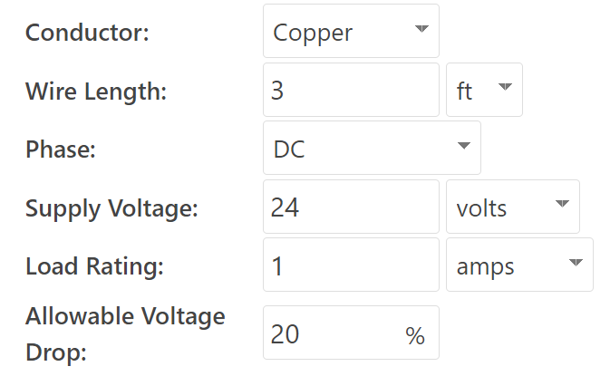

**Wire gauge = 38 AWG**

**Expected voltage drop = 16.5%**

**Torque Calculations**

Approximate weight of rover (ansys) = 6.5kg

Normal force on each wheel = (6.5 x 9.8)/6 = 10.62N

Assuming frictional coefficient to be 0.8

Frictional force is then = 0.8 x 10.62 = 8.5N

Assuming wheel radius to be 5cm.

**Required Torque = 8.5 x 5 = 42.5N-cm**