Based in the analysis of the scores of Mathematics and Reading from 15 schools provided from the same district, we can note:

* The Best Passing rates are in Charter Schools, and worst in Discrict Schools.
* There is not necessary to have the best budget per student to have the best passing rate.
* The best scores are from school that have medium size

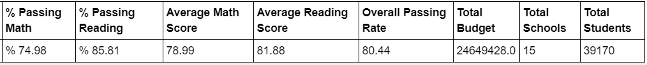

Best Schools passing rate:

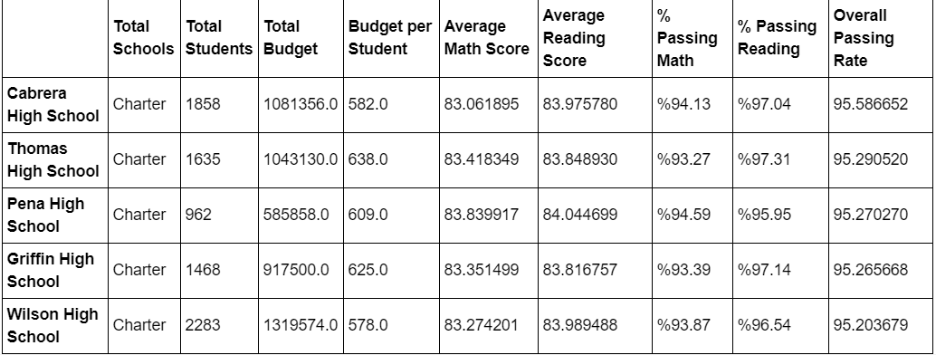

Worst Schools passing rate:

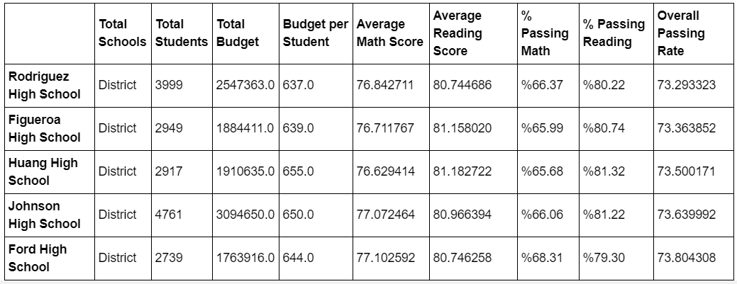

Overall Passing rate of Type of School.

