Based in the analysis of the every active driver and historic ride, have been created the following Bubble Chart that shows:

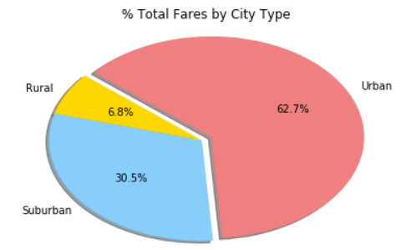

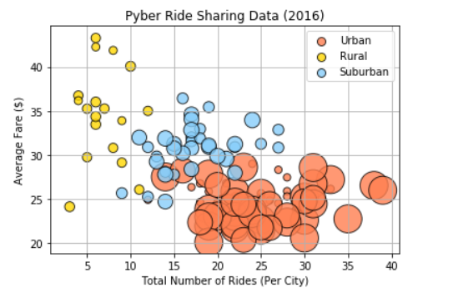

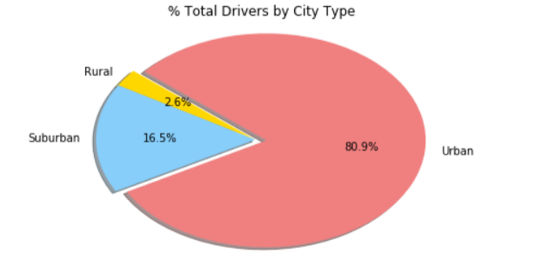

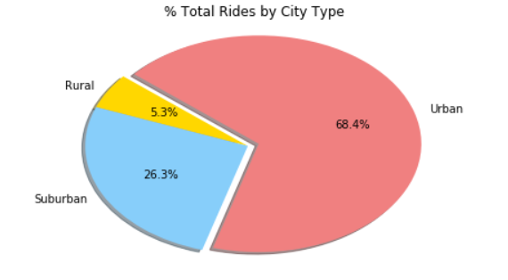

* The Urban Cities have more rides than Rural and Suburban Cities.
* The more quantities of Drivers are in Urban Cities.
* For Urban Cities there are more riders than rides.