**What’s the Weather like as we approach the equator?**

The Temperature is higher when we approach to the equator. And in the Northern of the earth is colder than south.

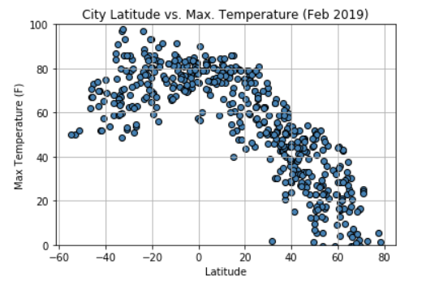

The Latitude and humidity don’t have a representative relation, but also we can notice that between lat [-40,-20] and [20,40] can be some cities with less humidity, than the rest.

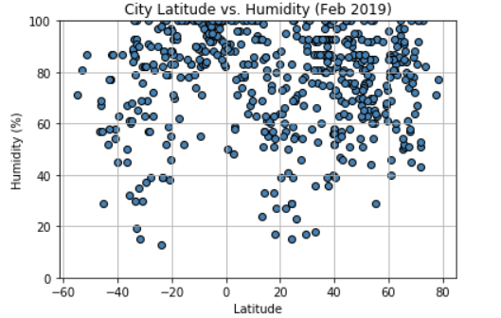

The Latitude and Cloudiness don’t have a representative relation.

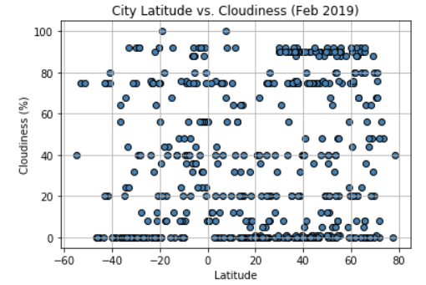

The Latitude and wind speed plot shows to us than the Wind Speed used to be higher in the Northern.

