Inaction We Trust

Adrien Fillon

27/01/2021

Table of Contents

# Study 1a

Summary study 1a

| rowname | vars | n | mean | sd | median | trimmed | mad | min | max | range | skew | kurtosis | se | Q0.25 | Q0.75 |
| --- | --- | --- | --- | --- | --- | --- | --- | --- | --- | --- | --- | --- | --- | --- | --- |
| preference | 1 | 256 | -0.98 | 2.04 | 0 | -0.99 | 1.48 | -5 | 5 | 10 | 0.10 | 0.38 | 0.13 | -2 | 0 |
| competence | 2 | 274 | -0.49 | 1.81 | 0 | -0.43 | 0.00 | -5 | 5 | 10 | -0.33 | 1.66 | 0.11 | -1 | 0 |
| normative | 3 | 271 | -0.65 | 2.51 | 0 | -0.73 | 2.97 | -5 | 5 | 10 | 0.24 | -0.48 | 0.15 | -3 | 1 |
| regret | 4 | 264 | 2.11 | 2.70 | 3 | 2.48 | 2.97 | -5 | 5 | 10 | -0.93 | 0.25 | 0.17 | 0 | 4 |
| sex* | 5 | 330 | 1.74 | 0.49 | 2 | 1.77 | 0.00 | 1 | 3 | 2 | -0.52 | -0.46 | 0.03 | 1 | 2 |
| age | 6 | 332 | 37.54 | 12.01 | 35 | 36.57 | 11.86 | 16 | 73 | 57 | 0.67 | -0.26 | 0.66 | 28 | 46 |

Summary gender

| Var1 | Freq |
| --- | --- |
| 1 | 93 |
| 2 | 230 |
| 3 | 7 |

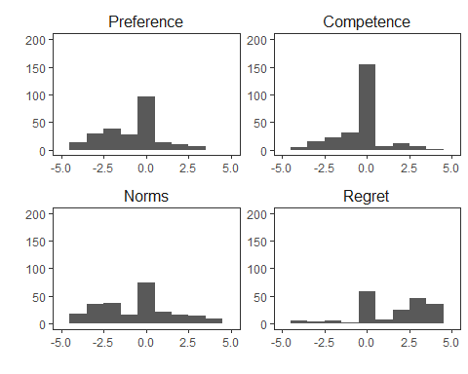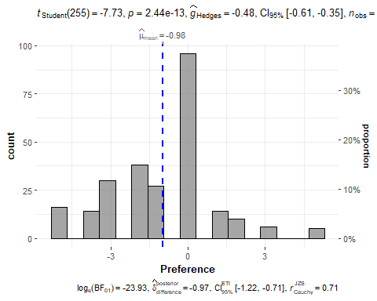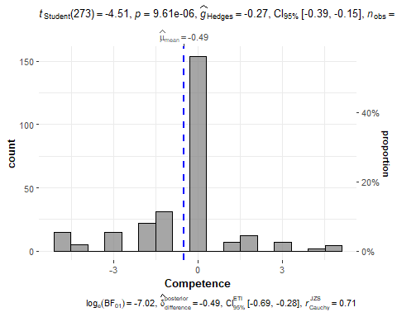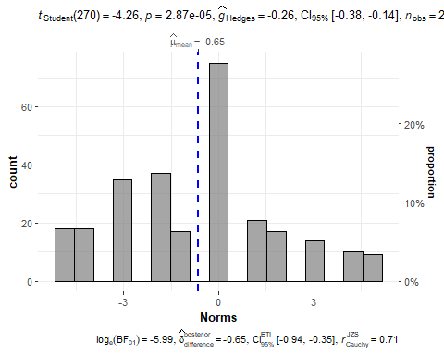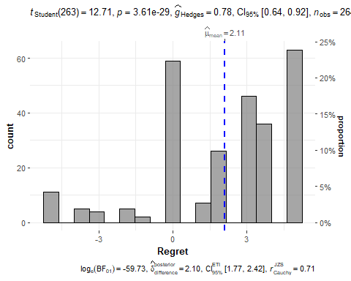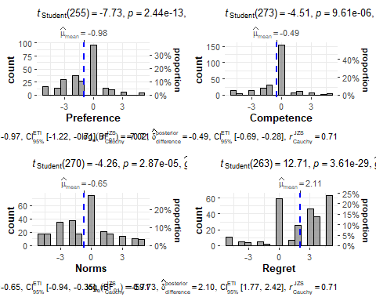

## Effect sizes were labelled following Cohen's (1988) recommendations.  
##   
## The One Sample t-test testing the difference between data1$competence (mean =  
## -0.49) and mu = 0 suggests that the effect is negative, statistically  
## significant, and small (difference = -0.49, 95% CI [-0.71, -0.28], t(273) =  
## -4.51, p < .001; Cohen's d = -0.27, 95% CI [-0.39, -0.15])

## Effect sizes were labelled following Cohen's (1988) recommendations.  
##   
## The One Sample t-test testing the difference between data1$normative (mean =  
## -0.65) and mu = 0 suggests that the effect is negative, statistically  
## significant, and small (difference = -0.65, 95% CI [-0.95, -0.35], t(270) =  
## -4.26, p < .001; Cohen's d = -0.26, 95% CI [-0.38, -0.14])

## Effect sizes were labelled following Cohen's (1988) recommendations.  
##   
## The One Sample t-test testing the difference between data1$regret (mean = 2.11)  
## and mu = 0 suggests that the effect is positive, statistically significant, and  
## medium (difference = 2.11, 95% CI [1.78, 2.44], t(263) = 12.71, p < .001;  
## Cohen's d = 0.78, 95% CI [0.64, 0.92])

# Study 1b

Summary descriptives

| rowname | vars | n | mean | sd | median | trimmed | mad | min | max | range | skew | kurtosis | se | Q0.25 | Q0.75 |
| --- | --- | --- | --- | --- | --- | --- | --- | --- | --- | --- | --- | --- | --- | --- | --- |
| preference | 1 | 339 | -0.74 | 2.16 | 0 | -0.79 | 1.48 | -5 | 5 | 10 | 0.23 | 0.38 | 0.12 | -2 | 0 |
| competence | 2 | 339 | -0.40 | 1.83 | 0 | -0.41 | 0.00 | -5 | 5 | 10 | 0.05 | 1.48 | 0.10 | -1 | 0 |
| normative | 3 | 339 | -0.69 | 2.47 | 0 | -0.77 | 2.97 | -5 | 5 | 10 | 0.26 | -0.43 | 0.13 | -3 | 1 |
| regret | 4 | 339 | 2.09 | 2.74 | 3 | 2.44 | 2.97 | -5 | 5 | 10 | -0.84 | -0.03 | 0.15 | 0 | 5 |
| gender* | 5 | 339 | 2.63 | 0.53 | 3 | 2.66 | 0.00 | 1 | 4 | 3 | -0.46 | -0.73 | 0.03 | 2 | 3 |
| age | 6 | 335 | 37.62 | 13.30 | 34 | 36.54 | 11.86 | 12 | 81 | 69 | 0.72 | -0.07 | 0.73 | 28 | 47 |

Summary gender

| Var1 | Freq |
| --- | --- |
|  | 3 |
| 1 | 124 |
| 2 | 208 |
| 3 | 4 |

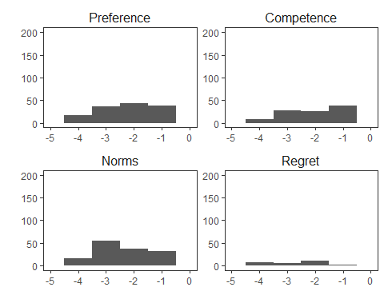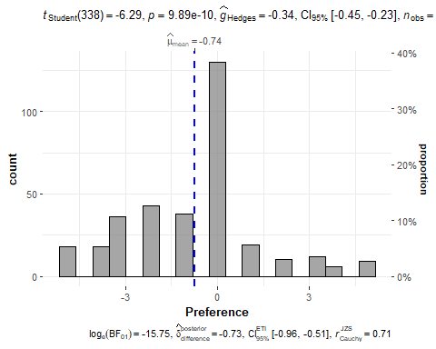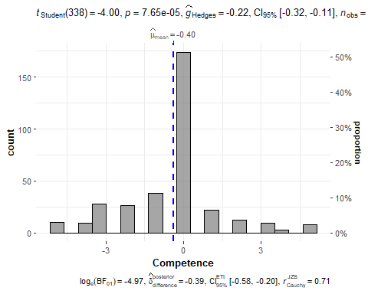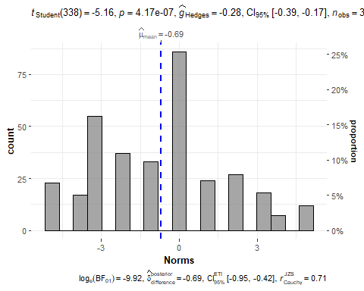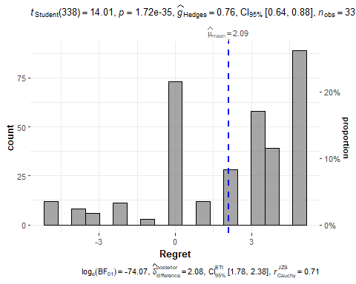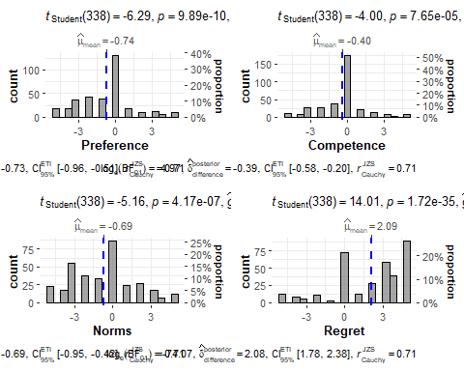

## Effect sizes were labelled following Cohen's (1988) recommendations.  
##   
## The One Sample t-test testing the difference between data1b$preference (mean =  
## -0.74) and mu = 0 suggests that the effect is negative, statistically  
## significant, and small (difference = -0.74, 95% CI [-0.97, -0.51], t(338) =  
## -6.29, p < .001; Cohen's d = -0.34, 95% CI [-0.45, -0.23])

## Effect sizes were labelled following Cohen's (1988) recommendations.  
##   
## The One Sample t-test testing the difference between data1b$competence (mean =  
## -0.40) and mu = 0 suggests that the effect is negative, statistically  
## significant, and small (difference = -0.40, 95% CI [-0.59, -0.20], t(338) =  
## -4.00, p < .001; Cohen's d = -0.22, 95% CI [-0.33, -0.11])

## Effect sizes were labelled following Cohen's (1988) recommendations.  
##   
## The One Sample t-test testing the difference between data1b$normative (mean =  
## -0.69) and mu = 0 suggests that the effect is negative, statistically  
## significant, and small (difference = -0.69, 95% CI [-0.96, -0.43], t(338) =  
## -5.16, p < .001; Cohen's d = -0.28, 95% CI [-0.39, -0.17])

## Effect sizes were labelled following Cohen's (1988) recommendations.  
##   
## The One Sample t-test testing the difference between data1b$regret (mean =  
## 2.09) and mu = 0 suggests that the effect is positive, statistically  
## significant, and medium (difference = 2.09, 95% CI [1.80, 2.38], t(338) =  
## 14.01, p < .001; Cohen's d = 0.76, 95% CI [0.64, 0.88])

# Study 2

##   
## Welch Two Sample t-test  
##   
## data: datasetexpect12$expect by datasetexpect12$condition  
## t = 9, df = 304, p-value <0.0000000000000002  
## alternative hypothesis: true difference in means between group 1 and group 2 is not equal to 0  
## 95 percent confidence interval:  
## 1.57 2.43  
## sample estimates:  
## mean in group 1 mean in group 2   
## 0.229 -1.773

##   
## Welch Two Sample t-test  
##   
## data: datasetexpect13$expect by datasetexpect13$condition  
## t = -10, df = 271, p-value <0.0000000000000002  
## alternative hypothesis: true difference in means between group 1 and group 3 is not equal to 0  
## 95 percent confidence interval:  
## -2.83 -1.88  
## sample estimates:  
## mean in group 1 mean in group 3   
## 0.229 2.584

As expected, positive prior outcome was found with lower change to advisors behavior than absent prior outcome, m1=-1.773, m2= 0.229, t(304.021)=9.181, p = 0. Likewise, absent prior outcome was found with lower change to advisors behavior than negative prior outcome, m = 2.584, t(271.08)=-9.705, p = 0. The check is successful.

S2Control <- data2 %>% filter (condition == 1)  
  
summary2 <- S2Control %>%  
 select(preference, competence, descriptive.norms, Injunctive, regret, joy, age, gender) %>%   
 psych::describe(quant=c(.25,.75)) %>% as_tibble(rownames="rowname")  
knitr::kable(summary2, digits=2, caption = "Summary descriptives", align = "c")

Summary descriptives

| rowname | vars | n | mean | sd | median | trimmed | mad | min | max | range | skew | kurtosis | se | Q0.25 | Q0.75 |
| --- | --- | --- | --- | --- | --- | --- | --- | --- | --- | --- | --- | --- | --- | --- | --- |
| preference | 1 | 141 | -0.45 | 2.26 | 0.0 | -0.50 | 1.48 | -5 | 5 | 10 | 0.20 | 0.34 | 0.19 | -2 | 0 |
| competence | 2 | 140 | -0.59 | 1.51 | 0.0 | -0.47 | 0.00 | -5 | 5 | 10 | -0.51 | 2.07 | 0.13 | -1 | 0 |
| descriptive.norms | 3 | 141 | 0.32 | 2.35 | 0.0 | 0.38 | 2.97 | -5 | 5 | 10 | -0.19 | -0.23 | 0.20 | -1 | 2 |
| Injunctive | 4 | 141 | 0.95 | 2.68 | 1.0 | 1.12 | 2.97 | -5 | 5 | 10 | -0.50 | -0.34 | 0.23 | 0 | 3 |
| regret | 5 | 142 | 2.03 | 2.57 | 2.5 | 2.33 | 3.71 | -5 | 5 | 10 | -0.90 | 0.48 | 0.22 | 0 | 4 |
| joy | 6 | 140 | 0.45 | 3.24 | 0.0 | 0.55 | 4.45 | -5 | 5 | 10 | -0.19 | -1.15 | 0.27 | -2 | 3 |
| age | 7 | 140 | 36.59 | 12.03 | 34.0 | 35.71 | 13.34 | 18 | 74 | 56 | 0.64 | -0.19 | 1.02 | 27 | 46 |
| gender | 8 | 140 | 1.81 | 0.44 | 2.0 | 1.87 | 0.00 | 1 | 3 | 2 | -0.82 | 0.52 | 0.04 | 2 | 2 |

tablegender2<-table(S2Control$gender)  
knitr::kable(tablegender2, digits=2, caption = "Summary gender", align = "c")

Summary gender

| Var1 | Freq |
| --- | --- |
| 1 | 29 |
| 2 | 108 |
| 3 | 3 |

dplot2 <- S2Control %>%   
 select(preference, competence, descriptive.norms, Injunctive, regret, joy) %>%  
 rename(Preference = preference, Competence = competence,  
 "Descriptive norms" = descriptive.norms,  
 "Injunctive norms" = Injunctive, Regret = regret, Joy = joy)%>%  
 gather()  
dplot2$key<-factor(dplot2$key, levels = c("Preference","Competence",  
 "Descriptive norms", "Injunctive norms",  
 "Regret", "Joy"))  
  
dplot2 %>% ggplot(aes(value)) +   
 facet_wrap(~ key, scales = "free")+ geom_histogram(binwidth = 1)+theme_apa()+  
 labs(x = "", y = "")+ scale_x_continuous(limits = c(-5,0,5))+ ylim(0, 250)

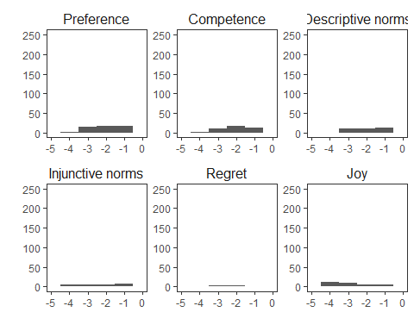

S2preferenceplot <- ggstatsplot::gghistostats(  
 data = S2Control, # data from which variable is to be taken  
 x = preference, # numeric variable  
 xlab = "Preference", # x-axis label  
 # title = "Preference", # title for the plot  
 #ggtheme = ggthemes::theme_tufte(), # changing default theme  
 test.value = 0, # test value  
 #caption = "Data courtesy of: SAPA project (https://sapa-project.org)"  
)  
S2preferenceplot

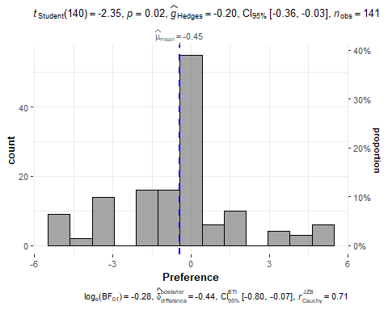

ggsave("Study2-preference.png", dpi = 600, scale = 1.7)  
  
S2competenceplot <- ggstatsplot::gghistostats(  
 data = S2Control, # data from which variable is to be taken  
 x = competence, # numeric variable  
 xlab = "Competence", # x-axis label  
 # title = "Competence", # title for the plot  
 #ggtheme = ggthemes::theme_tufte(), # changing default theme  
 test.value = 0, # test value  
 #caption = "Data courtesy of: SAPA project (https://sapa-project.org)"  
)  
S2competenceplot

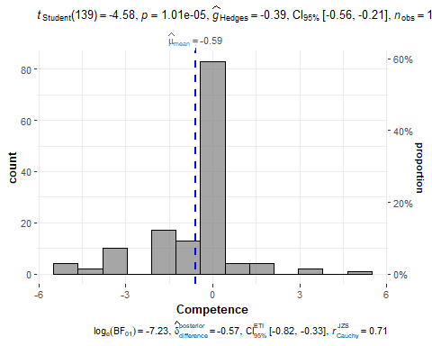

ggsave("Study2-competence.png", dpi = 600, scale = 1.7)  
  
  
S2desnormativeplot <- ggstatsplot::gghistostats(  
 data = S2Control, # data from which variable is to be taken  
 x = descriptive.norms, # numeric variable  
 xlab = "Descriptive norms", # x-axis label  
 # title = "Norms", # title for the plot  
 #ggtheme = ggthemes::theme_tufte(), # changing default theme  
 test.value = 0, # test value  
 #caption = "Data courtesy of: SAPA project (https://sapa-project.org)"  
)  
S2desnormativeplot

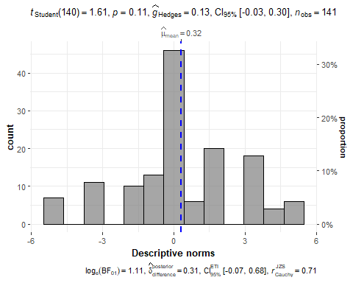

ggsave("Study2-descriptive-norms.png", dpi = 600, scale = 1.7)  
  
S2injnormativeplot <- ggstatsplot::gghistostats(  
 data = S2Control, # data from which variable is to be taken  
 x = Injunctive, # numeric variable  
 xlab = "Injunctive norms", # x-axis label  
 # title = "Norms", # title for the plot  
 #ggtheme = ggthemes::theme_tufte(), # changing default theme  
 test.value = 0, # test value  
 #caption = "Data courtesy of: SAPA project (https://sapa-project.org)"  
)  
S2injnormativeplot

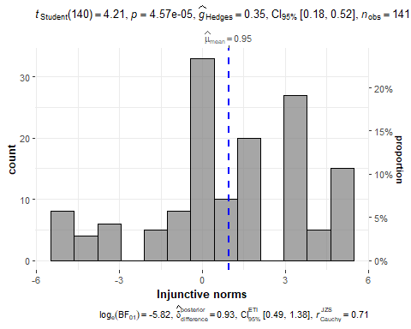

ggsave("Study2-injunctive-norms.png", dpi = 600, scale = 1.7)  
  
S2regretplot <- ggstatsplot::gghistostats(  
 data = S2Control, # data from which variable is to be taken  
 x = regret, # numeric variable  
 xlab = "Regret", # x-axis label  
 # title = "Preference", # title for the plot  
 #ggtheme = ggthemes::theme_tufte(), # changing default theme  
 test.value = 0, # test value  
 #caption = "Data courtesy of: SAPA project (https://sapa-project.org)"  
)  
S2regretplot

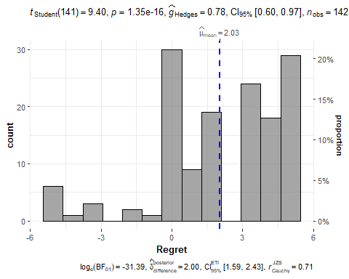

ggsave("Study2-regret.png", dpi = 600, scale = 1.7)  
  
S2joyplot <- ggstatsplot::gghistostats(  
 data = S2Control, # data from which variable is to be taken  
 x = joy, # numeric variable  
 xlab = "Joy", # x-axis label  
 # title = "Preference", # title for the plot  
 #ggtheme = ggthemes::theme_tufte(), # changing default theme  
 test.value = 0, # test value  
 #caption = "Data courtesy of: SAPA project (https://sapa-project.org)"  
)  
S2joyplot

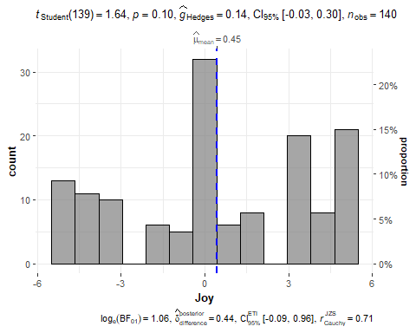

ggsave("Study2-joy.png", dpi = 600, scale = 1.7)  
  
  
# six in one  
library(ggpubr)  
ggarrange(S2preferenceplot, S2competenceplot, S2desnormativeplot, S2injnormativeplot, S2regretplot, S2joyplot, ncol = 2, nrow = 3, common.legend = TRUE)

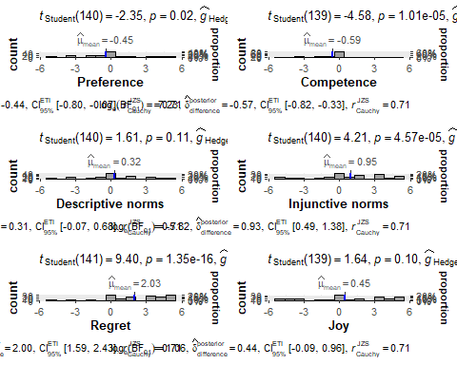

ggsave("Study2-control-6 in one.png", width = 12, height = 18, dpi = 600, scale = 1)  
  
  
preference2<-t.test(S2Control$preference, mu = 0)  
report(preference2)

## Effect sizes were labelled following Cohen's (1988) recommendations.  
##   
## The One Sample t-test testing the difference between S2Control$preference (mean  
## = -0.45) and mu = 0 suggests that the effect is negative, statistically  
## significant, and very small (difference = -0.45, 95% CI [-0.82, -0.07], t(140)  
## = -2.35, p = 0.020; Cohen's d = -0.20, 95% CI [-0.36, -0.03])

competence2 <- t.test(S2Control$competence, mu = 0)  
report(competence2)

## Effect sizes were labelled following Cohen's (1988) recommendations.  
##   
## The One Sample t-test testing the difference between S2Control$competence (mean  
## = -0.59) and mu = 0 suggests that the effect is negative, statistically  
## significant, and small (difference = -0.59, 95% CI [-0.84, -0.33], t(139) =  
## -4.58, p < .001; Cohen's d = -0.39, 95% CI [-0.56, -0.21])

descriptive.norms2<-t.test(S2Control$descriptive.norms, mu = 0)  
report(descriptive.norms2)

## Effect sizes were labelled following Cohen's (1988) recommendations.  
##   
## The One Sample t-test testing the difference between  
## S2Control$descriptive.norms (mean = 0.32) and mu = 0 suggests that the effect  
## is positive, statistically not significant, and very small (difference = 0.32,  
## 95% CI [-0.07, 0.71], t(140) = 1.61, p = 0.109; Cohen's d = 0.14, 95% CI  
## [-0.03, 0.30])

Injunctive2<-t.test(S2Control$Injunctive, mu = 0)  
report(Injunctive2)

## Effect sizes were labelled following Cohen's (1988) recommendations.  
##   
## The One Sample t-test testing the difference between S2Control$Injunctive (mean  
## = 0.95) and mu = 0 suggests that the effect is positive, statistically  
## significant, and small (difference = 0.95, 95% CI [0.50, 1.40], t(140) = 4.21,  
## p < .001; Cohen's d = 0.35, 95% CI [0.18, 0.52])

regret2<-t.test(S2Control$regret, mu = 0)  
report(regret2)

## Effect sizes were labelled following Cohen's (1988) recommendations.  
##   
## The One Sample t-test testing the difference between S2Control$regret (mean =  
## 2.03) and mu = 0 suggests that the effect is positive, statistically  
## significant, and medium (difference = 2.03, 95% CI [1.60, 2.45], t(141) = 9.40,  
## p < .001; Cohen's d = 0.79, 95% CI [0.60, 0.98])

joy2<-t.test(S2Control$joy, mu = 0)  
report(joy2)

## Effect sizes were labelled following Cohen's (1988) recommendations.  
##   
## The One Sample t-test testing the difference between S2Control$joy (mean =  
## 0.45) and mu = 0 suggests that the effect is positive, statistically not  
## significant, and very small (difference = 0.45, 95% CI [-0.09, 0.99], t(139) =  
## 1.64, p = 0.103; Cohen's d = 0.14, 95% CI [-0.03, 0.30])

### differences between conditions

#1. In case of no prior outcomes or positive prior outcomes, the advisor that did not act will be preferred over the one who did act, assuming both action and inaction led to negative outcomes. Additionally, we predict that the advisor who did not act will be seen as more competent, and that his decision will be seen as more in line with social norms (injunctive and descriptive). less than 0 : Paul = inaction more than 0 : George = action we want the t-test being significantly lower than 0

Test for no prior outcomes or positive prior outcomes:

data2$conditionrecode <- recode(data2$condition, '1' = "Control", '2' = "Positive", '3' = "Negative", .default = NA_character_)  
  
S2anovapreference <- ggstatsplot::ggbetweenstats(  
 data = data2,  
 x = conditionrecode,  
 y = preference,  
 xlab = "Condition",  
 ylab = "Preference",  
 point.path = FALSE,  
 point.args = list(size = 4, alpha = 0.2,   
 position = ggplot2::position_jitterdodge(jitter.width = 0.4, jitter.height = 0.4)),  
 # centrality.point.args = list(size = 7, alpha = 0.7, color="#b30000"),  
 # ggtheme = ggstatsplot::theme_ggstatsplot(),  
 # violin.args = list(width = 1, alpha = 0.2),  
 bf.message = TRUE,  
 plot.type = "violin",  
 results.subtitle = TRUE  
 # effsize.type = "d"  
)  
S2anovapreference

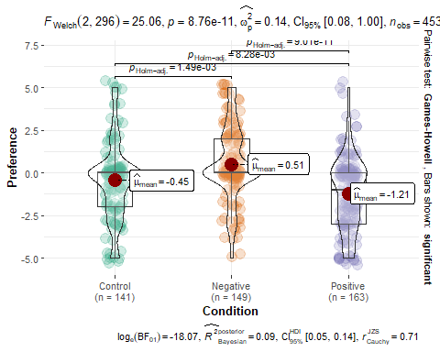

ggsave("Study2-anova-preference.png", dpi = 600, scale = 1)  
  
S2anovacompetence <- ggstatsplot::ggbetweenstats(  
 data = data2,  
 x = conditionrecode,  
 y = competence,  
 xlab = "Condition",  
 ylab = "Competence",  
 point.path = FALSE,  
 point.args = list(size = 4, alpha = 0.2,   
 position = ggplot2::position_jitterdodge(jitter.width = 0.4, jitter.height = 0.4)),  
 # centrality.point.args = list(size = 7, alpha = 0.7, color="#b30000"),  
 # ggtheme = ggstatsplot::theme_ggstatsplot(),  
 # violin.args = list(width = 1, alpha = 0.2),  
 bf.message = TRUE,  
 plot.type = "violin",  
 results.subtitle = TRUE  
 # effsize.type = "d"  
)  
S2anovacompetence

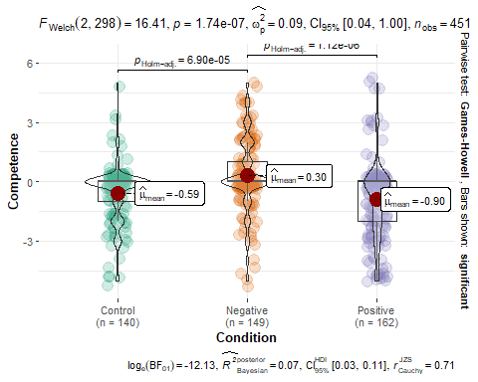

ggsave("Study2-anova-competence.png", dpi = 600, scale = 1)  
  
S2anovadescnorms <- ggstatsplot::ggbetweenstats(  
 data = data2,  
 x = conditionrecode,  
 y = descriptive.norms,  
 xlab = "Condition",  
 ylab = "Descriptive norms",  
 point.path = FALSE,  
 point.args = list(size = 4, alpha = 0.2,   
 position = ggplot2::position_jitterdodge(jitter.width = 0.4, jitter.height = 0.4)),  
 # centrality.point.args = list(size = 7, alpha = 0.7, color="#b30000"),  
 # ggtheme = ggstatsplot::theme_ggstatsplot(),  
 # violin.args = list(width = 1, alpha = 0.2),  
 bf.message = TRUE,  
 plot.type = "violin",  
 results.subtitle = TRUE  
 # effsize.type = "d"  
)  
S2anovadescnorms

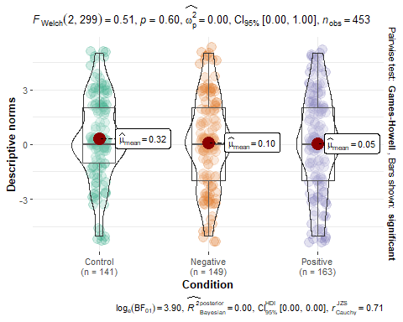

ggsave("Study2-anova-descnorms.png", dpi = 600, scale = 1)  
  
  
S2anovainjnorms <- ggstatsplot::ggbetweenstats(  
 data = data2,  
 x = conditionrecode,  
 y = Injunctive,  
 xlab = "Condition",  
 ylab = "Injunctive norms",  
 point.path = FALSE,  
 point.args = list(size = 4, alpha = 0.2,   
 position = ggplot2::position_jitterdodge(jitter.width = 0.4, jitter.height = 0.4)),  
 # centrality.point.args = list(size = 7, alpha = 0.7, color="#b30000"),  
 # ggtheme = ggstatsplot::theme_ggstatsplot(),  
 # violin.args = list(width = 1, alpha = 0.2),  
 bf.message = TRUE,  
 plot.type = "violin",  
 results.subtitle = TRUE  
 # effsize.type = "d"  
)  
S2anovainjnorms

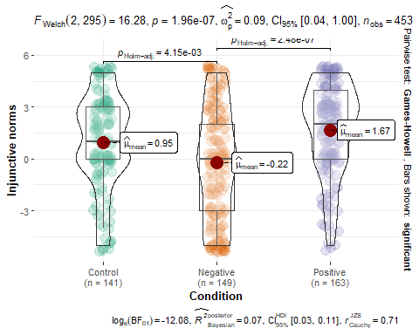

ggsave("Study2-anova-injnorms.png", dpi = 600, scale = 1)  
  
S2anovaregret <- ggstatsplot::ggbetweenstats(  
 data = data2,  
 x = conditionrecode,  
 y = regret,  
 xlab = "Condition",  
 ylab = "Regret",  
 point.path = FALSE,  
 point.args = list(size = 4, alpha = 0.2,   
 position = ggplot2::position_jitterdodge(jitter.width = 0.4, jitter.height = 0.4)),  
 # centrality.point.args = list(size = 7, alpha = 0.7, color="#b30000"),  
 # ggtheme = ggstatsplot::theme_ggstatsplot(),  
 # violin.args = list(width = 1, alpha = 0.2),  
 bf.message = TRUE,  
 plot.type = "violin",  
 results.subtitle = TRUE  
 # effsize.type = "d"  
)  
S2anovaregret

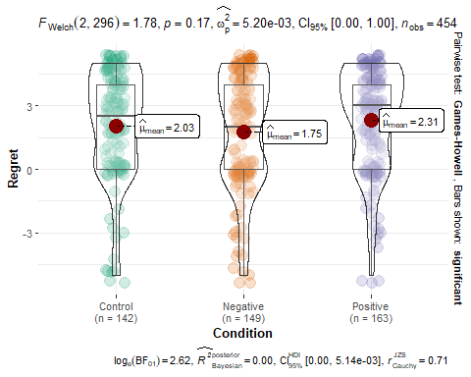

ggsave("Study2-anova-regret.png", dpi = 600, scale = 1)  
  
S2anovajoy <- ggstatsplot::ggbetweenstats(  
 data = data2,  
 x = conditionrecode,  
 y = joy,  
 xlab = "Condition",  
 ylab = "Joy",  
 point.path = FALSE,  
 point.args = list(size = 4, alpha = 0.2,   
 position = ggplot2::position_jitterdodge(jitter.width = 0.4, jitter.height = 0.4)),  
 # centrality.point.args = list(size = 7, alpha = 0.7, color="#b30000"),  
 # ggtheme = ggstatsplot::theme_ggstatsplot(),  
 # violin.args = list(width = 1, alpha = 0.2),  
 bf.message = TRUE,  
 plot.type = "violin",  
 results.subtitle = TRUE  
 # effsize.type = "d"  
)  
S2anovajoy

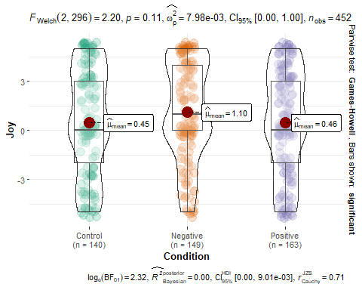

ggsave("Study2-anova-joy.png", dpi = 600, scale = 1)  
  
# six in one  
library(ggpubr)  
ggarrange(S2anovapreference, S2anovacompetence, S2anovadescnorms, S2anovainjnorms, S2anovaregret, S2anovajoy)

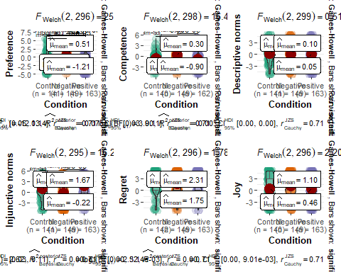

ggsave("Study2-anova-6 in one.png", width = 15, height = 10, dpi = 600, scale = 1)  
  
  
datasetexpect12 <-data2 %>% select (condition, preference, competence, Injunctive, descriptive.norms) %>% filter (condition <3)  
  
  
  
preference12<-t.test(datasetexpect12$preference, mu = 0)  
report(preference12)

## Effect sizes were labelled following Cohen's (1988) recommendations.  
##   
## The One Sample t-test testing the difference between datasetexpect12$preference  
## (mean = -0.86) and mu = 0 suggests that the effect is negative, statistically  
## significant, and small (difference = -0.86, 95% CI [-1.11, -0.60], t(303) =  
## -6.69, p < .001; Cohen's d = -0.38, 95% CI [-0.50, -0.27])

competence12<-t.test(datasetexpect12$competence, mu = 0)  
report(competence12)

## Effect sizes were labelled following Cohen's (1988) recommendations.  
##   
## The One Sample t-test testing the difference between datasetexpect12$competence  
## (mean = -0.75) and mu = 0 suggests that the effect is negative, statistically  
## significant, and small (difference = -0.75, 95% CI [-0.96, -0.55], t(301) =  
## -7.18, p < .001; Cohen's d = -0.41, 95% CI [-0.53, -0.30])

Injunctive12<-t.test(datasetexpect12$Injunctive, mu = 0)  
report(Injunctive12)

## Effect sizes were labelled following Cohen's (1988) recommendations.  
##   
## The One Sample t-test testing the difference between datasetexpect12$Injunctive  
## (mean = 1.34) and mu = 0 suggests that the effect is positive, statistically  
## significant, and small (difference = 1.34, 95% CI [1.03, 1.64], t(303) = 8.68,  
## p < .001; Cohen's d = 0.50, 95% CI [0.38, 0.62])

descriptive.norms12<-t.test(datasetexpect12$descriptive.norms, mu = 0)  
report(descriptive.norms12)

## Effect sizes were labelled following Cohen's (1988) recommendations.  
##   
## The One Sample t-test testing the difference between  
## datasetexpect12$descriptive.norms (mean = 0.17) and mu = 0 suggests that the  
## effect is positive, statistically not significant, and very small (difference =  
## 0.17, 95% CI [-0.11, 0.46], t(303) = 1.21, p = 0.228; Cohen's d = 0.07, 95% CI  
## [-0.04, 0.18])

1. In case of negative prior outcomes, the advisor who did act will be preferred over the one who did not act, assuming both action and inaction led to negative outcomes. Finally, we predict that the advisor who did act will be seen as more competent, and that his decision will be seen as more in line with social norms (injunctive and descriptive).

we want the t-test being significantly higher than 0

Test for Negative prior outcomes:

datasetexpect3 <-data2 %>% select (condition, preference, competence, Injunctive, descriptive.norms) %>% filter (condition ==3)  
  
preference3<-t.test(datasetexpect3$preference, mu = 0)  
report(preference3)

## Effect sizes were labelled following Cohen's (1988) recommendations.  
##   
## The One Sample t-test testing the difference between datasetexpect3$preference  
## (mean = 0.51) and mu = 0 suggests that the effect is positive, statistically  
## significant, and small (difference = 0.51, 95% CI [0.16, 0.86], t(148) = 2.92,  
## p = 0.004; Cohen's d = 0.24, 95% CI [0.08, 0.40])

competence3<-t.test(datasetexpect3$competence, mu = 0)  
report(competence3)

## Effect sizes were labelled following Cohen's (1988) recommendations.  
##   
## The One Sample t-test testing the difference between datasetexpect3$competence  
## (mean = 0.30) and mu = 0 suggests that the effect is positive, statistically  
## significant, and very small (difference = 0.30, 95% CI [1.08e-03, 0.60], t(148)  
## = 1.98, p = 0.049; Cohen's d = 0.16, 95% CI [5.71e-04, 0.32])

Injunctive3<-t.test(datasetexpect3$Injunctive, mu = 0)  
report(Injunctive3)

## Effect sizes were labelled following Cohen's (1988) recommendations.  
##   
## The One Sample t-test testing the difference between datasetexpect3$Injunctive  
## (mean = -0.22) and mu = 0 suggests that the effect is negative, statistically  
## not significant, and very small (difference = -0.22, 95% CI [-0.73, 0.29],  
## t(148) = -0.86, p = 0.392; Cohen's d = -0.07, 95% CI [-0.23, 0.09])

descriptive.norms3<-t.test(datasetexpect3$descriptive.norms, mu = 0)  
report(descriptive.norms3)

## Effect sizes were labelled following Cohen's (1988) recommendations.  
##   
## The One Sample t-test testing the difference between  
## datasetexpect3$descriptive.norms (mean = 0.10) and mu = 0 suggests that the  
## effect is positive, statistically not significant, and very small (difference =  
## 0.10, 95% CI [-0.31, 0.51], t(148) = 0.49, p = 0.628; Cohen's d = 0.04, 95% CI  
## [-0.12, 0.20])

We will also look at the correlations between regret, joy, competence, normativeness, and hiring preferences and expect them to be related positively with each other generally.

For study 1

corrdf1<-data1%>%select (competence, preference, normative, regret)%>%na.omit(corrdf1)  
correlate1<-cor(corrdf1, method = "pearson")  
p<-rcorr(as.matrix(corrdf1), type="pearson")  
corrplot(correlate1)

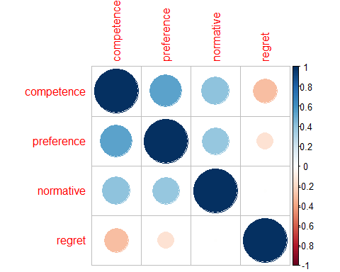

chart.Correlation(corrdf1, histogram=TRUE, pch=19)

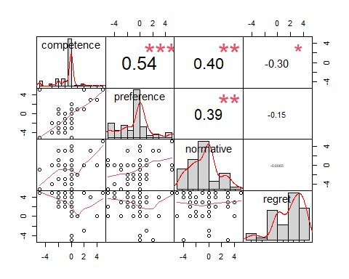

corr_ci(data1)

## # A tibble: 10 × 7  
## V1 V2 Corr n CI LL UL  
## <chr> <chr> <dbl> <int> <dbl> <dbl> <dbl>  
## 1 preference competence 0.537 62 0.186 0.351 0.723   
## 2 preference regret -0.150 62 0.253 -0.403 0.103   
## 3 preference normative 0.388 62 0.210 0.178 0.597   
## 4 preference age -0.0423 62 0.276 -0.318 0.233   
## 5 competence regret -0.304 62 0.224 -0.528 -0.0795  
## 6 competence normative 0.403 62 0.207 0.196 0.610   
## 7 competence age -0.0608 62 0.272 -0.332 0.211   
## 8 regret normative -0.00653 62 0.283 -0.290 0.277   
## 9 regret age -0.0525 62 0.273 -0.326 0.221   
## 10 normative age 0.113 62 0.261 -0.148 0.373

## # A tibble: 10 × 7  
## V1 V2 Corr n CI LL UL  
## <chr> <chr> <dbl> <int> <dbl> <dbl> <dbl>  
## 1 preference competence 0.537 62 0.186 0.351 0.723   
## 2 preference regret -0.150 62 0.253 -0.403 0.103   
## 3 preference normative 0.388 62 0.210 0.178 0.597   
## 4 preference age -0.0423 62 0.276 -0.318 0.233   
## 5 competence regret -0.304 62 0.224 -0.528 -0.0795  
## 6 competence normative 0.403 62 0.207 0.196 0.610   
## 7 competence age -0.0608 62 0.272 -0.332 0.211   
## 8 regret normative -0.00653 62 0.283 -0.290 0.277   
## 9 regret age -0.0525 62 0.273 -0.326 0.221   
## 10 normative age 0.113 62 0.261 -0.148 0.373

For study 1b

corrdf1b<-data1b%>%select (competence, preference, normative, regret)%>%na.omit(corrdf1b)  
correlate1b<-cor(corrdf1b, method = "pearson")  
rcorr(as.matrix(corrdf1b), type="pearson")

## competence preference normative regret  
## competence 1.00 0.48 0.27 -0.27  
## preference 0.48 1.00 0.35 -0.39  
## normative 0.27 0.35 1.00 -0.16  
## regret -0.27 -0.39 -0.16 1.00  
##   
## n= 339   
##   
##   
## P  
## competence preference normative regret  
## competence 0.0000 0.0000 0.0000  
## preference 0.0000 0.0000 0.0000  
## normative 0.0000 0.0000 0.0026  
## regret 0.0000 0.0000 0.0026

corrplot(correlate1b)

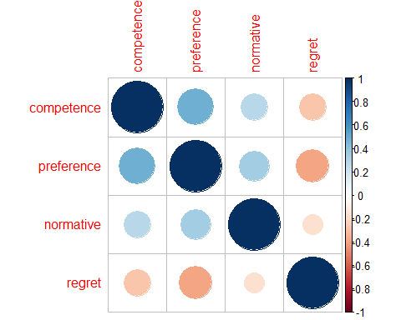

chart.Correlation(corrdf1b, histogram=TRUE, pch=19)

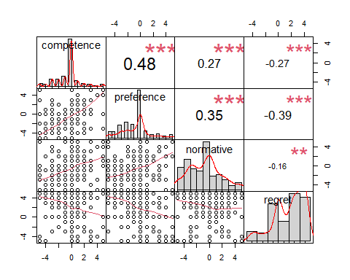

cor.test(data1$competence, data1$preference)

##   
## Pearson's product-moment correlation  
##   
## data: data1$competence and data1$preference  
## t = 7, df = 193, p-value = 0.00000000004  
## alternative hypothesis: true correlation is not equal to 0  
## 95 percent confidence interval:  
## 0.331 0.556  
## sample estimates:  
## cor   
## 0.451

corr_ci(data1b)

## # A tibble: 10 × 7  
## V1 V2 Corr n CI LL UL  
## <chr> <chr> <dbl> <int> <dbl> <dbl> <dbl>  
## 1 preference competence 0.490 335 0.0830 0.407 0.573   
## 2 preference normative 0.357 335 0.0922 0.265 0.449   
## 3 preference regret -0.395 335 0.0895 -0.484 -0.305   
## 4 preference age 0.0263 335 0.120 -0.0935 0.146   
## 5 competence normative 0.260 335 0.0996 0.161 0.360   
## 6 competence regret -0.266 335 0.0991 -0.365 -0.167   
## 7 competence age 0.0153 335 0.121 -0.106 0.136   
## 8 normative regret -0.156 335 0.108 -0.265 -0.0483  
## 9 normative age 0.0896 335 0.114 -0.0244 0.204   
## 10 regret age -0.0366 335 0.119 -0.155 0.0823

## # A tibble: 10 × 7  
## V1 V2 Corr n CI LL UL  
## <chr> <chr> <dbl> <int> <dbl> <dbl> <dbl>  
## 1 preference competence 0.490 335 0.0830 0.407 0.573   
## 2 preference normative 0.357 335 0.0922 0.265 0.449   
## 3 preference regret -0.395 335 0.0895 -0.484 -0.305   
## 4 preference age 0.0263 335 0.120 -0.0935 0.146   
## 5 competence normative 0.260 335 0.0996 0.161 0.360   
## 6 competence regret -0.266 335 0.0991 -0.365 -0.167   
## 7 competence age 0.0153 335 0.121 -0.106 0.136   
## 8 normative regret -0.156 335 0.108 -0.265 -0.0483  
## 9 normative age 0.0896 335 0.114 -0.0244 0.204   
## 10 regret age -0.0366 335 0.119 -0.155 0.0823

For study 2

nopriorcorrdf<-data2%>%select (regret, joy, competence, Injunctive, descriptive.norms, preference, condition)%>%filter (condition == 1) %>% na.omit(nopriorcorrdf)%>%select(-condition)  
positivepriorcorrdf<-data2%>%select (regret, joy, competence, Injunctive, descriptive.norms, preference, condition)%>%filter (condition == 2) %>% na.omit(corrdf)%>%select(-condition)  
negativepriorcorrdf<-data2%>%select (regret, joy, competence, Injunctive, descriptive.norms, preference, condition)%>%filter (condition == 3) %>% na.omit(negativepriorcorrdf)%>%select(-condition)  
  
# these correlations are made using correlation package, who provide more details on the correlations  
#nopriorcorrelate<-correlation::correlation(nopriorcorrdf, method = "pearson")  
#positivepriorcorrelate<-correlation::correlation(positivepriorcorrdf, method = "pearson")  
#negativepriorcorrelate<-correlation::correlation(negativepriorcorrdf, method = "pearson")  
  
  
apa.cor.table(nopriorcorrdf, filename="nopriorcorrelation.doc",show.conf.interval = TRUE, show.sig.stars = FALSE, landscape = TRUE)

##   
##   
## Means, standard deviations, and correlations with confidence intervals  
##   
##   
## Variable M SD 1 2 3   
## 1. regret 2.04 2.59   
##   
## 2. joy 0.45 3.24 .12   
## [-.04, .28]   
##   
## 3. competence -0.59 1.51 -.35 .01   
## [-.49, -.20] [-.16, .17]   
##   
## 4. Injunctive 0.96 2.69 .29 -.08 -.22   
## [.13, .43] [-.24, .09] [-.37, -.05]  
##   
## 5. descriptive.norms 0.32 2.36 -.08 .03 .06   
## [-.24, .09] [-.13, .20] [-.11, .22]   
##   
## 6. preference -0.44 2.27 -.38 .18 .44   
## [-.52, -.23] [.02, .34] [.30, .56]   
##   
## 4 5   
##   
##   
##   
##   
##   
##   
##   
##   
##   
##   
##   
## -.30   
## [-.44, -.14]   
##   
## -.23 .04   
## [-.38, -.07] [-.13, .20]  
##   
##   
## Note. M and SD are used to represent mean and standard deviation, respectively.  
## Values in square brackets indicate the 95% confidence interval.  
## The confidence interval is a plausible range of population correlations   
## that could have caused the sample correlation (Cumming, 2014).  
##

apa.cor.table(positivepriorcorrdf, filename="positivepriorcorrelation.doc",show.conf.interval = TRUE, show.sig.stars = FALSE, landscape = TRUE)

##   
##   
## Means, standard deviations, and correlations with confidence intervals  
##   
##   
## Variable M SD 1 2 3   
## 1. regret 2.32 2.45   
##   
## 2. joy 0.46 3.17 -.02   
## [-.17, .13]   
##   
## 3. competence -0.90 2.04 -.15 .01   
## [-.30, .00] [-.14, .17]   
##   
## 4. Injunctive 1.68 2.65 .30 -.10 -.32   
## [.15, .43] [-.25, .06] [-.45, -.17]  
##   
## 5. descriptive.norms 0.04 2.65 -.06 .04 .11   
## [-.21, .10] [-.12, .19] [-.04, .26]   
##   
## 6. preference -1.23 2.14 -.24 -.05 .37   
## [-.38, -.09] [-.20, .11] [.22, .49]   
##   
## 4 5   
##   
##   
##   
##   
##   
##   
##   
##   
##   
##   
##   
## -.24   
## [-.38, -.09]   
##   
## -.25 -.06   
## [-.39, -.10] [-.21, .10]  
##   
##   
## Note. M and SD are used to represent mean and standard deviation, respectively.  
## Values in square brackets indicate the 95% confidence interval.  
## The confidence interval is a plausible range of population correlations   
## that could have caused the sample correlation (Cumming, 2014).  
##

apa.cor.table(negativepriorcorrdf, filename="negativepriorcorrelation.doc",show.conf.interval = TRUE, show.sig.stars = FALSE, landscape = TRUE)

##   
##   
## Means, standard deviations, and correlations with confidence intervals  
##   
##   
## Variable M SD 1 2 3   
## 1. regret 1.75 2.73   
##   
## 2. joy 1.10 3.00 -.07   
## [-.23, .09]   
##   
## 3. competence 0.30 1.86 -.04 -.02   
## [-.20, .12] [-.18, .14]   
##   
## 4. Injunctive -0.22 3.15 .13 -.17 -.17   
## [-.03, .29] [-.32, -.01] [-.32, -.01]  
##   
## 5. descriptive.norms 0.10 2.53 -.18 .07 .30   
## [-.33, -.02] [-.09, .23] [.14, .44]   
##   
## 6. preference 0.51 2.13 -.17 .02 .44   
## [-.32, -.01] [-.14, .18] [.30, .56]   
##   
## 4 5   
##   
##   
##   
##   
##   
##   
##   
##   
##   
##   
##   
## -.24   
## [-.39, -.08]   
##   
## -.32 .13   
## [-.45, -.16] [-.03, .29]  
##   
##   
## Note. M and SD are used to represent mean and standard deviation, respectively.  
## Values in square brackets indicate the 95% confidence interval.  
## The confidence interval is a plausible range of population correlations   
## that could have caused the sample correlation (Cumming, 2014).  
##