1 实验内容

把车次表添加到PC机上 实现从MySQL简单读取（不用解析）和新增

查询和删除功能的实现可以参看安卓大群里我发的sample压缩包里androidsample中MainActivity量力完成

2 实验效果

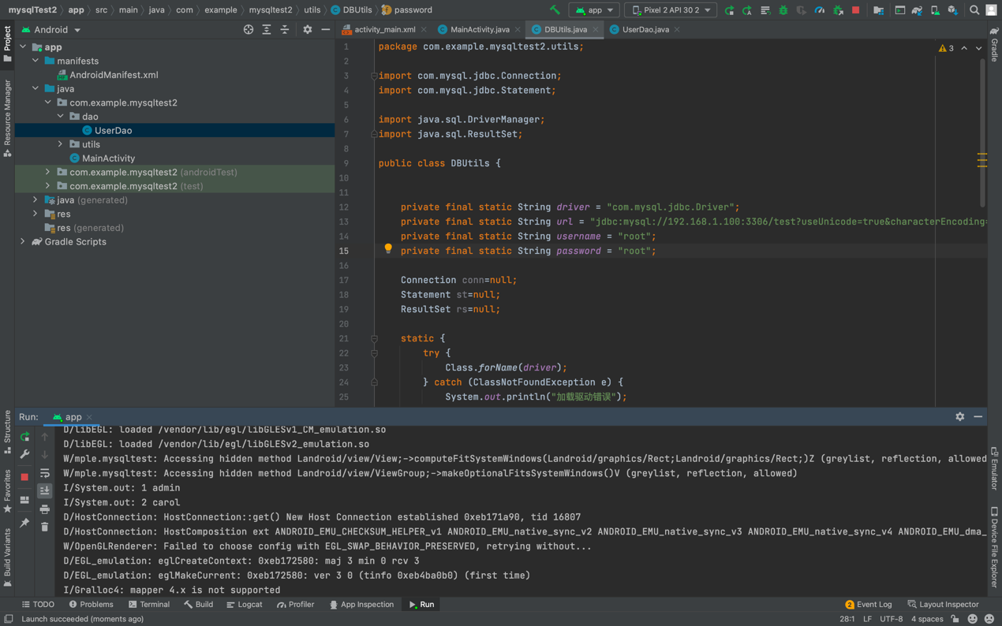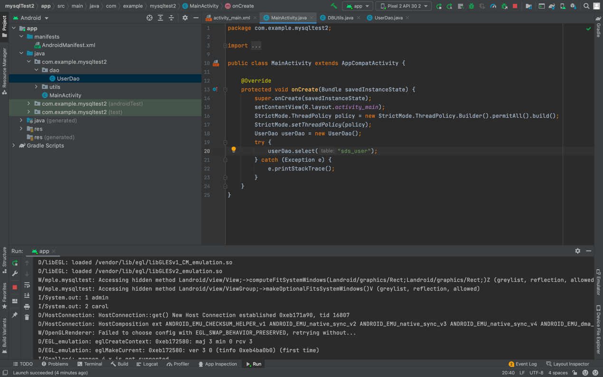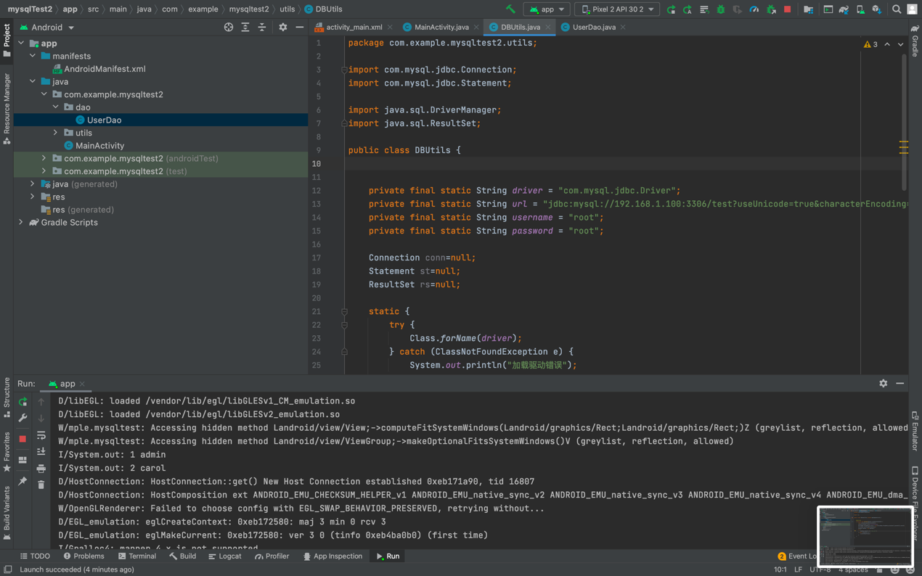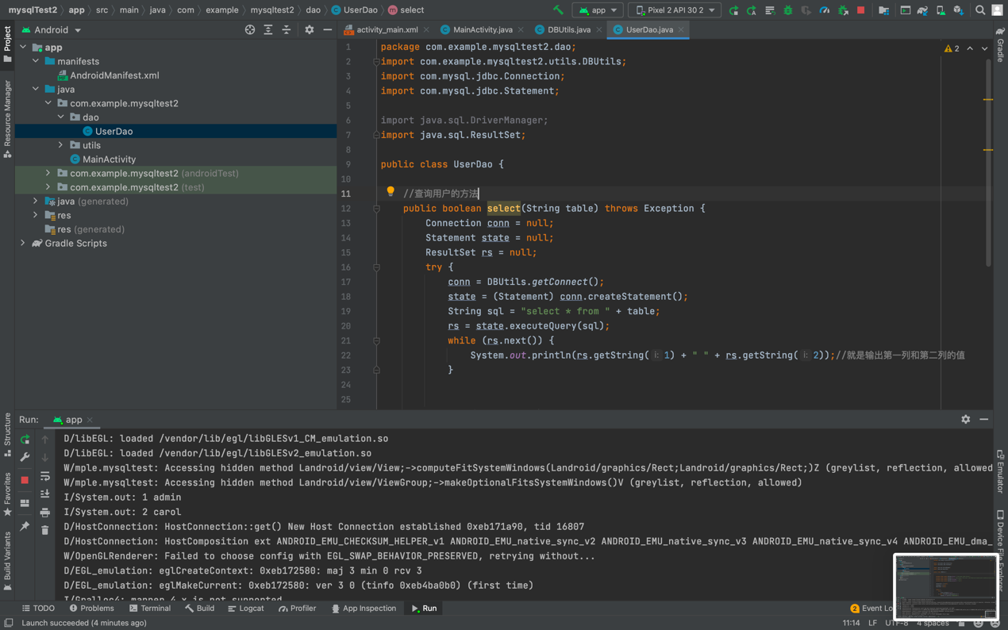

3 实验实现过程

先创建utils实现mysql连接，再用dao实现数据库操作，同时main里要创建新的线程。

package com.example.mysqltest2.utils;

import com.mysql.jdbc.Connection;

import com.mysql.jdbc.Statement;

import java.sql.DriverManager;

import java.sql.ResultSet;

public class DBUtils {

private final static String driver = "com.mysql.jdbc.Driver";

private final static String url = "jdbc:mysql://192.168.1.100:3306/test?useUnicode=true&characterEncoding=UTF-8&useSSL=false";

private final static String username = "root";

private final static String password = "root";

Connection conn=null;

Statement st=null;

ResultSet rs=null;

static {

try {

Class.forName(driver);

} catch (ClassNotFoundException e) {

System.out.println("加载驱动错误");

}

}

//2. 获取连接

public static Connection getConnect() throws Exception {

return (Connection) DriverManager.getConnection(url, username, password);

}

//3. 释放连接资源

public static void release(Connection conn, Statement st, ResultSet rs) throws Exception {

if (rs != null) {

rs.close();

}

if (st != null) {

st.close();

}

if (conn != null) {

conn.close();

}

}

}

package com.example.mysqltest2.dao;

import com.example.mysqltest2.utils.DBUtils;

import com.mysql.jdbc.Connection;

import com.mysql.jdbc.Statement;

import java.sql.DriverManager;

import java.sql.ResultSet;

public class UserDao {

//查询用户的方法

public boolean select(String table) throws Exception {

Connection conn = null;

Statement state = null;

ResultSet rs = null;

try {

conn = DBUtils.getConnect();

state = (Statement) conn.createStatement();

String sql = "select * from " + table;

rs = state.executeQuery(sql);

while (rs.next()) {

System.out.println(rs.getString(1) + " " + rs.getString(2));//就是输出第一列和第二列的值

}

} catch (Exception e) {

e.printStackTrace();

} finally {

DBUtils.release(conn, state, rs);

}

return true;

}

}

package com.example.mysqltest2;

import androidx.appcompat.app.AppCompatActivity;

import android.os.Bundle;

import android.os.StrictMode;

import com.example.mysqltest2.dao.UserDao;

public class MainActivity extends AppCompatActivity {

@Override

protected void onCreate(Bundle savedInstanceState) {

super.onCreate(savedInstanceState);

setContentView(R.layout.activity_main);

StrictMode.ThreadPolicy policy = new StrictMode.ThreadPolicy.Builder().permitAll().build();

StrictMode.setThreadPolicy(policy);

UserDao userDao = new UserDao();

try {

userDao.select("sds_user");

} catch (Exception e) {

e.printStackTrace();

}

}

}