1 实验内容

把表添加到PC机上 完成新增、修改、删除

2 实验效果

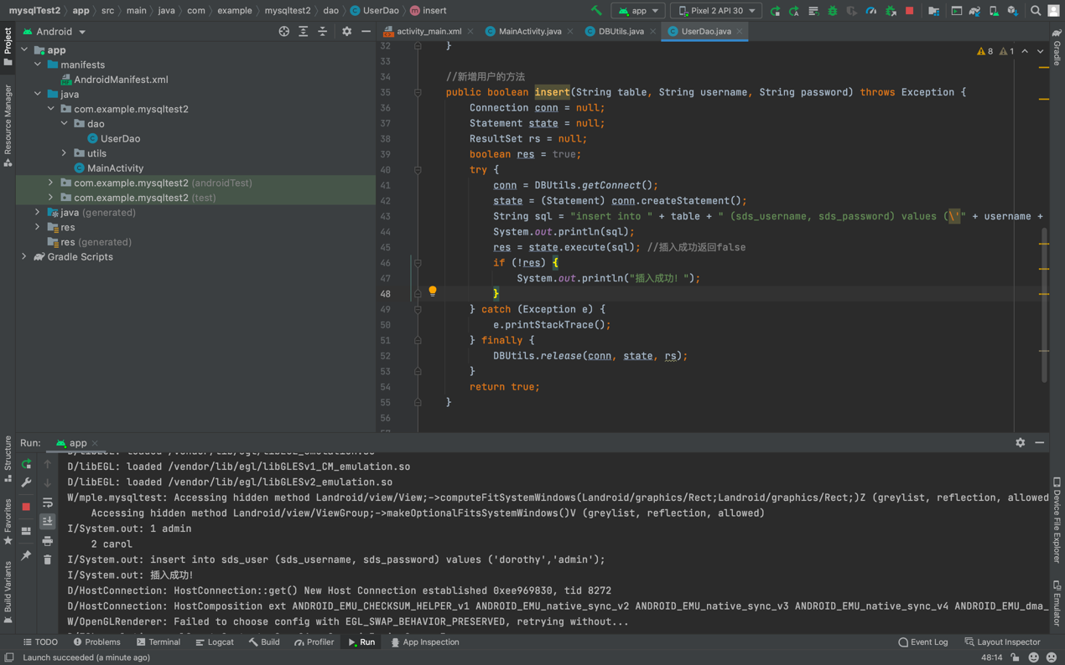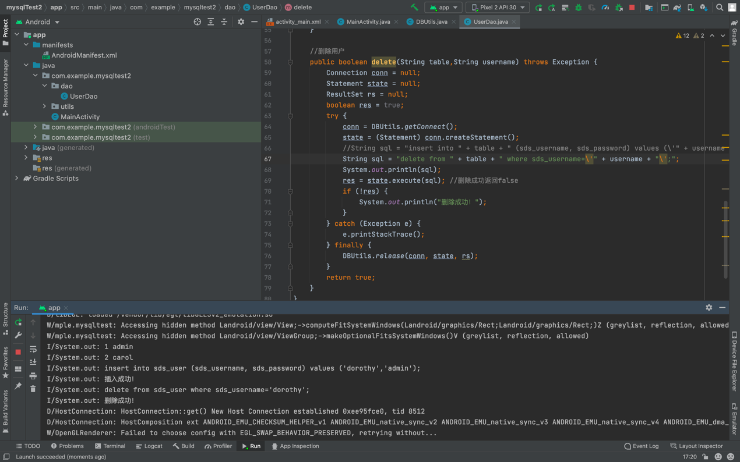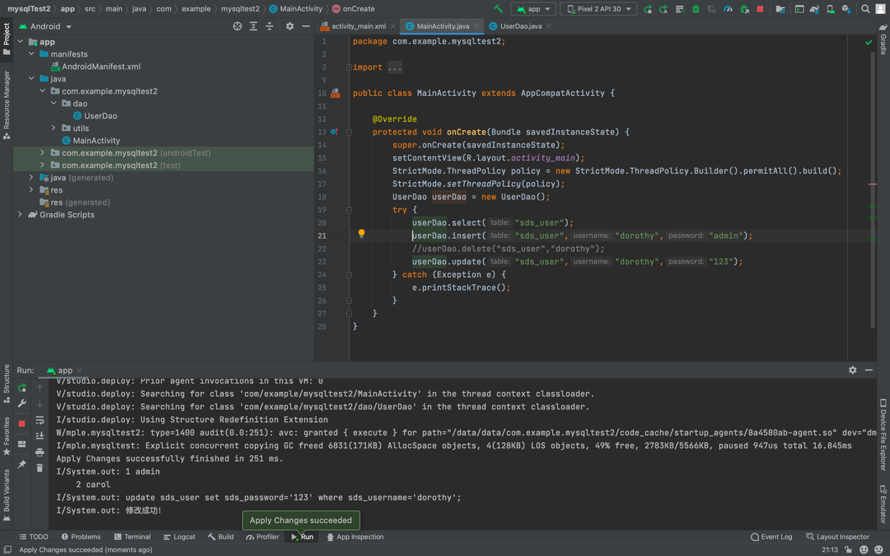

3 实验实现过程

先创建utils实现mysql连接，再用dao实现数据库操作，同时main里要创建新的线程。

package com.example.mysqltest2.dao;

import android.widget.Toast;

import com.example.mysqltest2.utils.DBUtils;

import com.mysql.jdbc.Connection;

import com.mysql.jdbc.Statement;

import java.sql.DriverManager;

import java.sql.ResultSet;

public class UserDao {

//查询用户的方法

public boolean select(String table) throws Exception {

Connection conn = null;

Statement state = null;

ResultSet rs = null;

try {

conn = DBUtils.getConnect();

state = (Statement) conn.createStatement();

String sql = "select * from " + table;

rs = state.executeQuery(sql);

while (rs.next()) {

System.out.println(rs.getString(1) + " " + rs.getString(2));//就是输出第一列和第二列的值

}

} catch (Exception e) {

e.printStackTrace();

} finally {

DBUtils.release(conn, state, rs);

}

return true;

}

//新增用户的方法

public boolean insert(String table, String username, String password) throws Exception {

Connection conn = null;

Statement state = null;

ResultSet rs = null;

boolean res = true;

try {

conn = DBUtils.getConnect();

state = (Statement) conn.createStatement();

String sql = "insert into " + table + " (sds_username, sds_password) values (\'" + username + "\',\'"+ password + "\');";

System.out.println(sql);

res = state.execute(sql); //插入成功返回false

if (!res) {

System.out.println("插入成功！");

}

} catch (Exception e) {

e.printStackTrace();

} finally {

DBUtils.release(conn, state, rs);

}

return true;

}

//删除用户

public boolean delete(String table,String username) throws Exception {

Connection conn = null;

Statement state = null;

ResultSet rs = null;

boolean res = true;

try {

conn = DBUtils.getConnect();

state = (Statement) conn.createStatement();

//String sql = "insert into " + table + " (sds_username, sds_password) values (\'" + username + "\',\'"+ password + "\');";

String sql = "delete from " + table + " where sds_username=\'" + username + "\';";

System.out.println(sql);

res = state.execute(sql); //删除成功返回false

if (!res) {

System.out.println("删除成功！");

}

} catch (Exception e) {

e.printStackTrace();

} finally {

DBUtils.release(conn, state, rs);

}

return true;

}

//修改密码

public boolean update(String table,String username,String password) throws Exception {

Connection conn = null;

Statement state = null;

ResultSet rs = null;

boolean res = true;

try {

conn = DBUtils.getConnect();

state = (Statement) conn.createStatement();

String sql = "update "+table+" set sds_password="+"\'"+password+"\' where sds_username="+"\'"+username+"\';";

System.out.println(sql);

res = state.execute(sql); //删除成功返回false

if (!res) {

System.out.println("修改成功！");

}

} catch (Exception e) {

e.printStackTrace();

} finally {

DBUtils.release(conn, state, rs);

}

return true;

}

}