1 实验内容

在上周的基础上完成读取的解析

2 实验效果

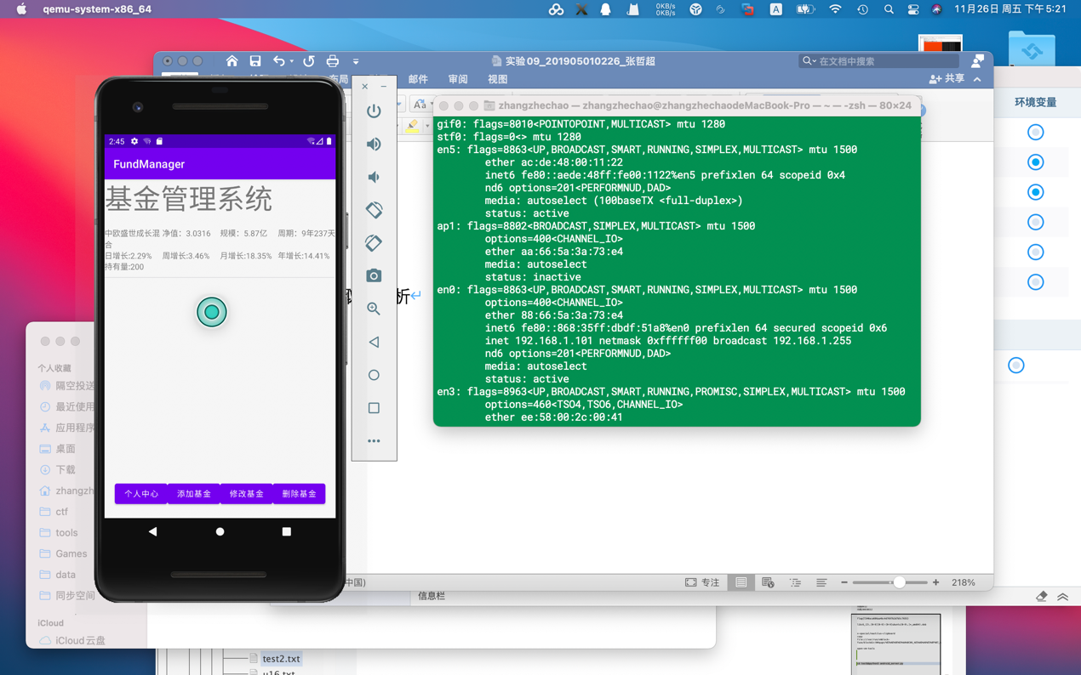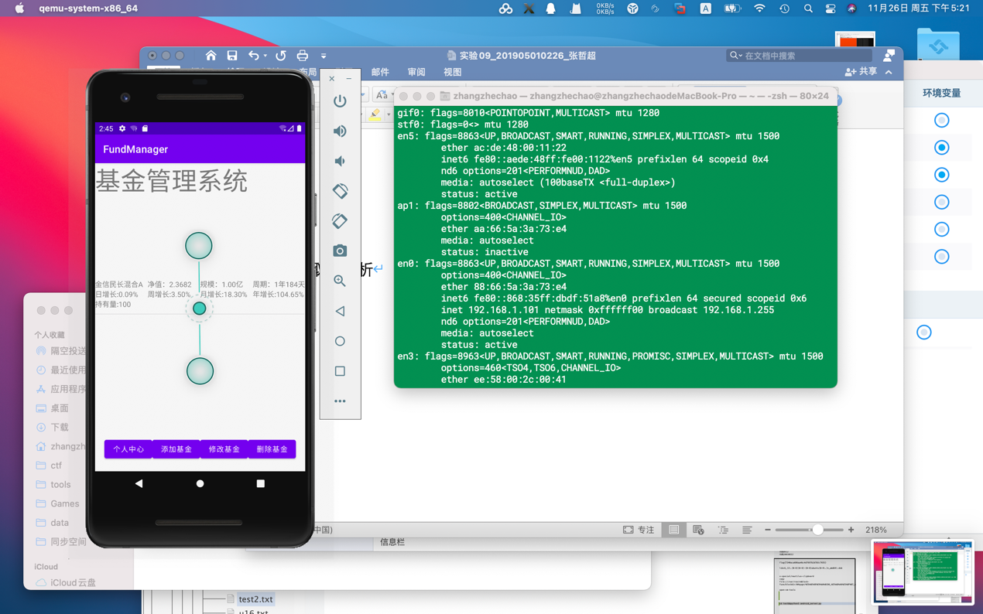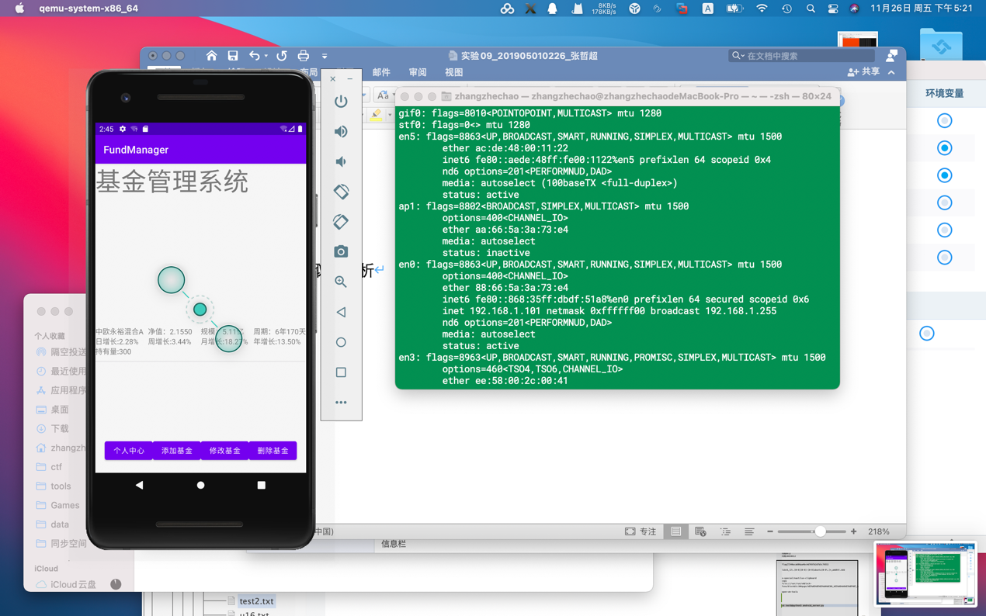

3 实验实现过程

package com.example.fundmanager

import android.app.Activity

import android.content.Intent

import androidx.appcompat.app.AppCompatActivity

import android.os.Bundle

import android.text.Editable

import android.text.TextWatcher

import com.example.fundmanager.databinding.ActivityFundInnerBinding

import com.example.fundmanager.databinding.ActivityFundManagerBinding

class FundInnerActivity : AppCompatActivity() {

override fun onCreate(savedInstanceState: Bundle?) {

super.onCreate(savedInstanceState)

setContentView(R.layout.activity_fund_inner)

val binding = ActivityFundInnerBinding.inflate(layoutInflater)

setContentView(binding.root)

val holdNum = intent.getIntExtra("holdNum", 0)

binding.tvTest.text = "持有数："

binding.tvHoldNum.text = "${holdNum}"

binding.tvHoldNumE.addTextChangedListener(object : TextWatcher {

override fun beforeTextChanged(p0: CharSequence?, p1: Int, p2: Int, p3: Int) {

// TODO("Not yet implemented")

val str = binding.tvHoldNumE.text.toString()

binding.tvHoldNum.setText(str)

}

override fun onTextChanged(p0: CharSequence?, p1: Int, p2: Int, p3: Int) {

// TODO("Not yet implemented")

val str = binding.tvHoldNumE.text.toString()

binding.tvHoldNum.setText(str)

}

override fun afterTextChanged(p0: Editable?) {

// TODO("Not yet implemented")

val str = binding.tvHoldNumE.text.toString()

binding.tvHoldNum.setText(str)

}

})

binding.btnReturnPara.setOnClickListener(){

val intent = Intent()

intent.putExtra("holdNum", binding.tvHoldNum.text.toString().toInt())

setResult(Activity.RESULT_OK,intent)

finish()

}

}

}