实验-------GDI与Windows绘图

学生姓名：张哲超 专业班级：计算机192
课程名称：Windows程序设计 实验类型：综合

一 实验目的
熟悉Windows编程的基本结构和框架，实现一个基本的Windows窗口程序。在此基础上，练习GDI（图形设备接口）编程。重点掌握Windows操作系统中的GDI环境获取、句柄、画笔、画刷、RGB颜色、常用的绘图函数等编程技术和应用。

二 实验环境
PC机 + Windows 操作系统 + Visual C++

三 实验内容
实验题目1 编写程序，要求不断变换窗口屏幕中的颜色（以红橙黄绿青蓝紫的顺序依次变换，变换间隔为0.5秒）。

实验过程1（思路（文字描述）、关键代码（WndProc 函数））
LRESULT CALLBACK WndProc(HWND hWnd, UINT message, WPARAM wParam, LPARAM lParam){
PAINTSTRUCT ps;
HDC hdc;
HPEN hP;
HBRUSH hBr;
LPPOINT lpPoint;
POINT pt;
RECT rect;
static long i = 1;
switch(message){
case WM_DESTROY:
PostQuitMessage(0); //调用PostQuiteMessage发出WM_QUIT消息
return 0;
case WM_PAINT:
GetClientRect(hWnd, &rect);
hdc = BeginPaint(hWnd, &ps);
if (i == 1)
{
hBr = CreateSolidBrush(RGB(255, 0, 0));
SelectObject(hdc, hBr);
hP = CreatePen(PS_SOLID, 1, RGB(255, 0, 0));
SelectObject(hdc, hP);
Rectangle(hdc, 0, 0, rect.right, rect.bottom);

DeleteObject(hP);
DeleteObject(hBr);
}
if (i == 2)
{
hBr = CreateSolidBrush(RGB(255, 125, 0));
SelectObject(hdc, hBr);
hP = CreatePen(PS_SOLID, 1, RGB(255, 125, 0));
SelectObject(hdc, hP);
Rectangle(hdc, 0, 0, rect.right, rect.bottom);

DeleteObject(hP);
DeleteObject(hBr);
}
if (i == 3)
{
hBr = CreateSolidBrush(RGB(255, 225, 0));
SelectObject(hdc, hBr);
hP = CreatePen(PS_SOLID, 1, RGB(255, 225, 0));
SelectObject(hdc, hP);
Rectangle(hdc, 0, 0, rect.right, rect.bottom);

DeleteObject(hP);
DeleteObject(hBr);
}
if (i == 4)
{
hBr = CreateSolidBrush(RGB(0, 225, 0));
SelectObject(hdc, hBr);
hP = CreatePen(PS_SOLID, 1, RGB(0, 225, 0));
SelectObject(hdc, hP);
Rectangle(hdc, 0, 0, rect.right, rect.bottom);

DeleteObject(hP);
DeleteObject(hBr);
}
if (i == 5)
{
hBr = CreateSolidBrush(RGB(0, 0, 225));
SelectObject(hdc, hBr);
hP = CreatePen(PS_SOLID, 1, RGB(0, 0, 255));
SelectObject(hdc, hP);
Rectangle(hdc, 0, 0, rect.right, rect.bottom);

DeleteObject(hP);
DeleteObject(hBr);
}
if (i == 6)
{
hBr = CreateSolidBrush(RGB(0, 225, 255));
SelectObject(hdc, hBr);
hP = CreatePen(PS_SOLID, 1, RGB(0, 225, 255));
SelectObject(hdc, hP);
Rectangle(hdc, 0, 0, rect.right, rect.bottom);

DeleteObject(hP);
DeleteObject(hBr);
}
if (i == 7)
{
hBr = CreateSolidBrush(RGB(255, 0, 255));
SelectObject(hdc, hBr);
hP = CreatePen(PS_SOLID, 1, RGB(255, 0, 255));
SelectObject(hdc, hP);
Rectangle(hdc, 0, 0, rect.right, rect.bottom);

DeleteObject(hP);
DeleteObject(hBr);
}
i++;

DeleteObject(hP);
EndPaint(hWnd, &ps);
Sleep(500);
if (i < 8)
InvalidateRect(hWnd, NULL, 1);
else{
i=1;
InvalidateRect(hWnd, NULL, 1);
}
return 0;
default: //默认时采用系统消息默认处理函数
return DefWindowProc(hWnd, message, wParam, lParam);
}
}
实验结果1
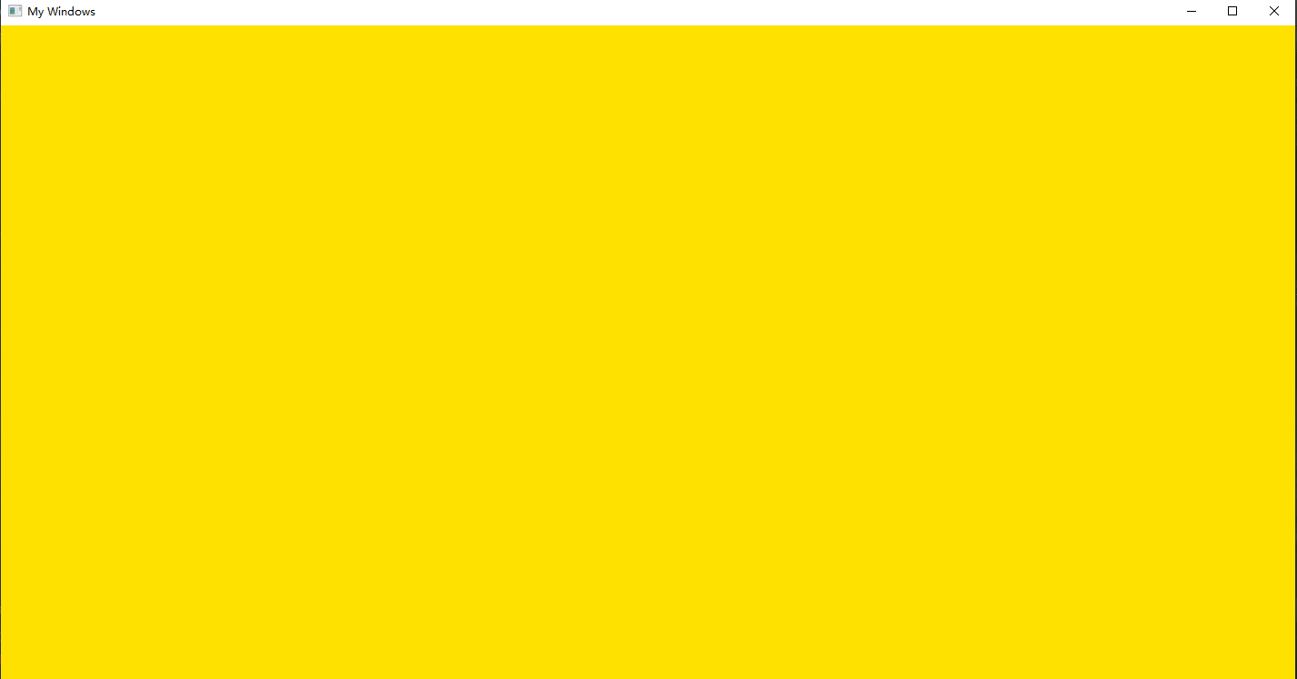

实验题目2 请先实现一个电子钟 （只显示分钟和秒即可）

实验过程2（思路（文字描述）、关键代码（WndProc 函数））
LRESULT CALLBACK WndProc(HWND hWnd, UINT message, WPARAM wParam, LPARAM lParam){
PAINTSTRUCT ps;
HDC hdc;
HPEN hP;
HBRUSH hBr;
LPPOINT lpPoint;
POINT pt;
RECT rect;
static long i = 0;
static long j = 0;
static long k = 0;
static long l = 0;
switch(message){
case WM_DESTROY:
PostQuitMessage(0); //调用PostQuiteMessage发出WM_QUIT消息
return 0;
case WM_PAINT:
GetClientRect(hWnd, &rect);
hdc = BeginPaint(hWnd, &ps);
hP = (HPEN)CreatePen(PS_SOLID, 3, RGB(0, 255, 0));
SelectObject(hdc, hP);
Rectangle(hdc, (rect.left+rect.right)/8, (rect.top+rect.bottom)/8,
(rect.right+rect.left)/1.2, (rect.bottom+rect.top)/1.7);
MoveToEx(hdc, (rect.right+rect.left)/2.1, (rect.bottom+rect.top)/8, lpPoint);
LineTo(hdc, (rect.right+rect.left)/2.1, (rect.bottom+rect.top)/1.7);
//0
// Rectangle(hdc, (rect.left+rect.right)/7, (rect.top+rect.bottom)/6,
// (rect.right+rect.left)/4, (rect.bottom+rect.top)/1.8);
// Rectangle(hdc, (rect.left+rect.right)/3.1, (rect.top+rect.bottom)/6,
// (rect.right+rect.left)/2.3, (rect.bottom+rect.top)/1.8);
// Rectangle(hdc, (rect.left+rect.right)/2, (rect.top+rect.bottom)/6,
// (rect.right+rect.left)/1.6, (rect.bottom+rect.top)/1.8);
// Rectangle(hdc, (rect.left+rect.right)/1.5, (rect.top+rect.bottom)/6,
// (rect.right+rect.left)/1.25, (rect.bottom+rect.top)/1.8);
//1
// MoveToEx(hdc, (rect.left+rect.right)/5, (rect.top+rect.bottom)/6, lpPoint);
// LineTo(hdc, (rect.left+rect.right)/5, (rect.top+rect.bottom)/1.8);

// MoveToEx(hdc, (rect.left+rect.right)/2.5, (rect.top+rect.bottom)/6, lpPoint);
// LineTo(hdc, (rect.left+rect.right)/2.5, (rect.top+rect.bottom)/1.8);

// MoveToEx(hdc, (rect.left+rect.right)/1.8, (rect.top+rect.bottom)/6, lpPoint);
// LineTo(hdc, (rect.left+rect.right)/1.8, (rect.top+rect.bottom)/1.8);

// MoveToEx(hdc, (rect.left+rect.right)/1.3, (rect.top+rect.bottom)/6, lpPoint);
// LineTo(hdc, (rect.left+rect.right)/1.3, (rect.top+rect.bottom)/1.8);
// //2
// MoveToEx(hdc, (rect.left+rect.right)/6, (rect.top+rect.bottom)/6, lpPoint);
// LineTo(hdc, (rect.left+rect.right)/4, (rect.top+rect.bottom)/6);
// LineTo(hdc, (rect.left+rect.right)/4, (rect.top+rect.bottom)/3);
// LineTo(hdc, (rect.left+rect.right)/6, (rect.top+rect.bottom)/3);
// LineTo(hdc, (rect.left+rect.right)/6, (rect.top+rect.bottom)/2);
// LineTo(hdc, (rect.left+rect.right)/4, (rect.top+rect.bottom)/2);

// MoveToEx(hdc, (rect.left+rect.right)/3, (rect.top+rect.bottom)/6, lpPoint);
// LineTo(hdc, (rect.left+rect.right)/2.3, (rect.top+rect.bottom)/6);
// LineTo(hdc, (rect.left+rect.right)/2.3, (rect.top+rect.bottom)/3);
// LineTo(hdc, (rect.left+rect.right)/3, (rect.top+rect.bottom)/3);
// LineTo(hdc, (rect.left+rect.right)/3, (rect.top+rect.bottom)/2);
// LineTo(hdc, (rect.left+rect.right)/2.3, (rect.top+rect.bottom)/2);

// MoveToEx(hdc, (rect.left+rect.right)/1.9, (rect.top+rect.bottom)/6, lpPoint);
// LineTo(hdc, (rect.left+rect.right)/1.6, (rect.top+rect.bottom)/6);
// LineTo(hdc, (rect.left+rect.right)/1.6, (rect.top+rect.bottom)/3);
// LineTo(hdc, (rect.left+rect.right)/1.9, (rect.top+rect.bottom)/3);
// LineTo(hdc, (rect.left+rect.right)/1.9, (rect.top+rect.bottom)/2);
// LineTo(hdc, (rect.left+rect.right)/1.6, (rect.top+rect.bottom)/2);
//
// MoveToEx(hdc, (rect.left+rect.right)/1.5, (rect.top+rect.bottom)/6, lpPoint);
// LineTo(hdc, (rect.left+rect.right)/1.3, (rect.top+rect.bottom)/6);
// LineTo(hdc, (rect.left+rect.right)/1.3, (rect.top+rect.bottom)/3);
// LineTo(hdc, (rect.left+rect.right)/1.5, (rect.top+rect.bottom)/3);
// LineTo(hdc, (rect.left+rect.right)/1.5, (rect.top+rect.bottom)/2);
// LineTo(hdc, (rect.left+rect.right)/1.3, (rect.top+rect.bottom)/2);
//3
// MoveToEx(hdc, (rect.left+rect.right)/6, (rect.top+rect.bottom)/6, lpPoint);
// LineTo(hdc, (rect.left+rect.right)/4, (rect.top+rect.bottom)/6);
// LineTo(hdc, (rect.left+rect.right)/4, (rect.top+rect.bottom)/3);
// LineTo(hdc, (rect.left+rect.right)/6, (rect.top+rect.bottom)/3);
// MoveToEx(hdc, (rect.left+rect.right)/4, (rect.top+rect.bottom)/3, lpPoint);
// LineTo(hdc, (rect.left+rect.right)/4, (rect.top+rect.bottom)/2);
// LineTo(hdc, (rect.left+rect.right)/6, (rect.top+rect.bottom)/2);
//
// MoveToEx(hdc, (rect.left+rect.right)/3, (rect.top+rect.bottom)/6, lpPoint);
// LineTo(hdc, (rect.left+rect.right)/2.3, (rect.top+rect.bottom)/6);
// LineTo(hdc, (rect.left+rect.right)/2.3, (rect.top+rect.bottom)/3);
// LineTo(hdc, (rect.left+rect.right)/3, (rect.top+rect.bottom)/3);
// MoveToEx(hdc, (rect.left+rect.right)/2.3, (rect.top+rect.bottom)/3, lpPoint);
// LineTo(hdc, (rect.left+rect.right)/2.3, (rect.top+rect.bottom)/2);
// LineTo(hdc, (rect.left+rect.right)/3, (rect.top+rect.bottom)/2);
//
// MoveToEx(hdc, (rect.left+rect.right)/1.9, (rect.top+rect.bottom)/6, lpPoint);
// LineTo(hdc, (rect.left+rect.right)/1.6, (rect.top+rect.bottom)/6);
// LineTo(hdc, (rect.left+rect.right)/1.6, (rect.top+rect.bottom)/3);
// LineTo(hdc, (rect.left+rect.right)/1.9, (rect.top+rect.bottom)/3);
// MoveToEx(hdc, (rect.left+rect.right)/1.6, (rect.top+rect.bottom)/3, lpPoint);
// LineTo(hdc, (rect.left+rect.right)/1.6, (rect.top+rect.bottom)/2);
// LineTo(hdc, (rect.left+rect.right)/1.9, (rect.top+rect.bottom)/2);
//
// MoveToEx(hdc, (rect.left+rect.right)/1.5, (rect.top+rect.bottom)/6, lpPoint);
// LineTo(hdc, (rect.left+rect.right)/1.3, (rect.top+rect.bottom)/6);
// LineTo(hdc, (rect.left+rect.right)/1.3, (rect.top+rect.bottom)/3);
// LineTo(hdc, (rect.left+rect.right)/1.5, (rect.top+rect.bottom)/3);
// MoveToEx(hdc, (rect.left+rect.right)/1.3, (rect.top+rect.bottom)/3, lpPoint);
// LineTo(hdc, (rect.left+rect.right)/1.3, (rect.top+rect.bottom)/2);
// LineTo(hdc, (rect.left+rect.right)/1.5, (rect.top+rect.bottom)/2);
// //4
// MoveToEx(hdc, (rect.left+rect.right)/6, (rect.top+rect.bottom)/6, lpPoint);
// LineTo(hdc, (rect.left+rect.right)/6, (rect.top+rect.bottom)/3);
// LineTo(hdc, (rect.left+rect.right)/4, (rect.top+rect.bottom)/3);
// MoveToEx(hdc, (rect.left+rect.right)/4.5, (rect.top+rect.bottom)/6, lpPoint);
// LineTo(hdc, (rect.left+rect.right)/4.5, (rect.top+rect.bottom)/2);
//
// MoveToEx(hdc, (rect.left+rect.right)/3, (rect.top+rect.bottom)/6, lpPoint);
// LineTo(hdc, (rect.left+rect.right)/3, (rect.top+rect.bottom)/3);
// LineTo(hdc, (rect.left+rect.right)/2.3, (rect.top+rect.bottom)/3);
// MoveToEx(hdc, (rect.left+rect.right)/2.5, (rect.top+rect.bottom)/6, lpPoint);
// LineTo(hdc, (rect.left+rect.right)/2.5, (rect.top+rect.bottom)/2);
//
// MoveToEx(hdc, (rect.left+rect.right)/1.9, (rect.top+rect.bottom)/6, lpPoint);
// LineTo(hdc, (rect.left+rect.right)/1.9, (rect.top+rect.bottom)/3);
// LineTo(hdc, (rect.left+rect.right)/1.6, (rect.top+rect.bottom)/3);
// MoveToEx(hdc, (rect.left+rect.right)/1.7, (rect.top+rect.bottom)/6, lpPoint);
// LineTo(hdc, (rect.left+rect.right)/1.7, (rect.top+rect.bottom)/2);
//
// MoveToEx(hdc, (rect.left+rect.right)/1.5, (rect.top+rect.bottom)/6, lpPoint);
// LineTo(hdc, (rect.left+rect.right)/1.5, (rect.top+rect.bottom)/3);
// LineTo(hdc, (rect.left+rect.right)/1.3, (rect.top+rect.bottom)/3);
// MoveToEx(hdc, (rect.left+rect.right)/1.4, (rect.top+rect.bottom)/6, lpPoint);
// LineTo(hdc, (rect.left+rect.right)/1.4, (rect.top+rect.bottom)/2);
// 5
// MoveToEx(hdc, (rect.left+rect.right)/6, (rect.top+rect.bottom)/6, lpPoint);
// LineTo(hdc, (rect.left+rect.right)/4, (rect.top+rect.bottom)/6);
// MoveToEx(hdc, (rect.left+rect.right)/6, (rect.top+rect.bottom)/6, lpPoint);
// LineTo(hdc, (rect.left+rect.right)/6, (rect.top+rect.bottom)/3);
// LineTo(hdc, (rect.left+rect.right)/4, (rect.top+rect.bottom)/3);
// LineTo(hdc, (rect.left+rect.right)/4, (rect.top+rect.bottom)/2);
// LineTo(hdc, (rect.left+rect.right)/6, (rect.top+rect.bottom)/2);

// MoveToEx(hdc, (rect.left+rect.right)/3, (rect.top+rect.bottom)/6, lpPoint);
// LineTo(hdc, (rect.left+rect.right)/2.3, (rect.top+rect.bottom)/6);
// MoveToEx(hdc, (rect.left+rect.right)/3, (rect.top+rect.bottom)/6, lpPoint);
// LineTo(hdc, (rect.left+rect.right)/3, (rect.top+rect.bottom)/3);
// LineTo(hdc, (rect.left+rect.right)/2.3, (rect.top+rect.bottom)/3);
// LineTo(hdc, (rect.left+rect.right)/2.3, (rect.top+rect.bottom)/2);
// LineTo(hdc, (rect.left+rect.right)/3, (rect.top+rect.bottom)/2);
//
// MoveToEx(hdc, (rect.left+rect.right)/1.9, (rect.top+rect.bottom)/6, lpPoint);
// LineTo(hdc, (rect.left+rect.right)/1.6, (rect.top+rect.bottom)/6);
// MoveToEx(hdc, (rect.left+rect.right)/1.9, (rect.top+rect.bottom)/6, lpPoint);
// LineTo(hdc, (rect.left+rect.right)/1.9, (rect.top+rect.bottom)/3);
// LineTo(hdc, (rect.left+rect.right)/1.6, (rect.top+rect.bottom)/3);
// LineTo(hdc, (rect.left+rect.right)/1.6, (rect.top+rect.bottom)/2);
// LineTo(hdc, (rect.left+rect.right)/1.9, (rect.top+rect.bottom)/2);
//
// MoveToEx(hdc, (rect.left+rect.right)/1.5, (rect.top+rect.bottom)/6, lpPoint);
// LineTo(hdc, (rect.left+rect.right)/1.3, (rect.top+rect.bottom)/6);
// MoveToEx(hdc, (rect.left+rect.right)/1.5, (rect.top+rect.bottom)/6, lpPoint);
// LineTo(hdc, (rect.left+rect.right)/1.5, (rect.top+rect.bottom)/3);
// LineTo(hdc, (rect.left+rect.right)/1.3, (rect.top+rect.bottom)/3);
// LineTo(hdc, (rect.left+rect.right)/1.3, (rect.top+rect.bottom)/2);
// LineTo(hdc, (rect.left+rect.right)/1.5, (rect.top+rect.bottom)/2);
// 6
// MoveToEx(hdc, (rect.left+rect.right)/6, (rect.top+rect.bottom)/6, lpPoint);
// LineTo(hdc, (rect.left+rect.right)/6, (rect.top+rect.bottom)/2);
// LineTo(hdc, (rect.left+rect.right)/4, (rect.top+rect.bottom)/2);
// LineTo(hdc, (rect.left+rect.right)/4, (rect.top+rect.bottom)/3);
// LineTo(hdc, (rect.left+rect.right)/6, (rect.top+rect.bottom)/3);
//
// MoveToEx(hdc, (rect.left+rect.right)/3, (rect.top+rect.bottom)/6, lpPoint);
// LineTo(hdc, (rect.left+rect.right)/3, (rect.top+rect.bottom)/2);
// LineTo(hdc, (rect.left+rect.right)/2.3, (rect.top+rect.bottom)/2);
// LineTo(hdc, (rect.left+rect.right)/2.3, (rect.top+rect.bottom)/3);
// LineTo(hdc, (rect.left+rect.right)/3, (rect.top+rect.bottom)/3);
//
// MoveToEx(hdc, (rect.left+rect.right)/1.9, (rect.top+rect.bottom)/6, lpPoint);
// LineTo(hdc, (rect.left+rect.right)/1.9, (rect.top+rect.bottom)/2);
// LineTo(hdc, (rect.left+rect.right)/1.6, (rect.top+rect.bottom)/2);
// LineTo(hdc, (rect.left+rect.right)/1.6, (rect.top+rect.bottom)/3);
// LineTo(hdc, (rect.left+rect.right)/1.9, (rect.top+rect.bottom)/3);

// MoveToEx(hdc, (rect.left+rect.right)/1.5, (rect.top+rect.bottom)/6, lpPoint);
// LineTo(hdc, (rect.left+rect.right)/1.5, (rect.top+rect.bottom)/2);
// LineTo(hdc, (rect.left+rect.right)/1.3, (rect.top+rect.bottom)/2);
// LineTo(hdc, (rect.left+rect.right)/1.3, (rect.top+rect.bottom)/3);
// LineTo(hdc, (rect.left+rect.right)/1.5, (rect.top+rect.bottom)/3);
//7
// MoveToEx(hdc, (rect.left+rect.right)/3, (rect.top+rect.bottom)/6, lpPoint);
// LineTo(hdc, (rect.left+rect.right)/2.3, (rect.top+rect.bottom)/6);
// LineTo(hdc, (rect.left+rect.right)/2.3, (rect.top+rect.bottom)/2);
//
// MoveToEx(hdc, (rect.left+rect.right)/1.5, (rect.top+rect.bottom)/6, lpPoint);
// LineTo(hdc, (rect.left+rect.right)/1.3, (rect.top+rect.bottom)/6);
// LineTo(hdc, (rect.left+rect.right)/1.3, (rect.top+rect.bottom)/2);
//8
// Rectangle(hdc, (rect.left+rect.right)/3, (rect.top+rect.bottom)/6,
// (rect.left+rect.right)/2.3, (rect.top+rect.bottom)/2);
// MoveToEx(hdc, (rect.left+rect.right)/3, (rect.top+rect.bottom)/3, lpPoint);
// LineTo(hdc, (rect.left+rect.right)/2.3, (rect.top+rect.bottom)/3);
//
// Rectangle(hdc, (rect.left+rect.right)/1.5, (rect.top+rect.bottom)/6,
// (rect.left+rect.right)/1.3, (rect.top+rect.bottom)/2);
// MoveToEx(hdc, (rect.left+rect.right)/1.5, (rect.top+rect.bottom)/3, lpPoint);
// LineTo(hdc, (rect.left+rect.right)/1.3, (rect.top+rect.bottom)/3);
// //9
// MoveToEx(hdc, (rect.left+rect.right)/3, (rect.top+rect.bottom)/6, lpPoint);
// LineTo(hdc, (rect.left+rect.right)/2.3, (rect.top+rect.bottom)/6);
// LineTo(hdc, (rect.left+rect.right)/2.3, (rect.top+rect.bottom)/3);
// LineTo(hdc, (rect.left+rect.right)/3, (rect.top+rect.bottom)/3);
// LineTo(hdc, (rect.left+rect.right)/3, (rect.top+rect.bottom)/6);
// MoveToEx(hdc, (rect.left+rect.right)/2.3, (rect.top+rect.bottom)/3, lpPoint);
// LineTo(hdc, (rect.left+rect.right)/2.3, (rect.top+rect.bottom)/2);
// LineTo(hdc, (rect.left+rect.right)/3, (rect.top+rect.bottom)/2);
//
// MoveToEx(hdc, (rect.left+rect.right)/1.5, (rect.top+rect.bottom)/6, lpPoint);
// LineTo(hdc, (rect.left+rect.right)/1.3, (rect.top+rect.bottom)/6);
// LineTo(hdc, (rect.left+rect.right)/1.3, (rect.top+rect.bottom)/3);
// LineTo(hdc, (rect.left+rect.right)/1.5, (rect.top+rect.bottom)/3);
// LineTo(hdc, (rect.left+rect.right)/1.5, (rect.top+rect.bottom)/6);
// MoveToEx(hdc, (rect.left+rect.right)/1.3, (rect.top+rect.bottom)/3, lpPoint);
// LineTo(hdc, (rect.left+rect.right)/1.3, (rect.top+rect.bottom)/2);
// LineTo(hdc, (rect.left+rect.right)/1.5, (rect.top+rect.bottom)/2);
if(l==0){
Rectangle(hdc, (rect.left+rect.right)/1.5, (rect.top+rect.bottom)/6,
(rect.right+rect.left)/1.25, (rect.bottom+rect.top)/1.8);
}else if(l==1){
MoveToEx(hdc, (rect.left+rect.right)/1.3, (rect.top+rect.bottom)/6, lpPoint);
LineTo(hdc, (rect.left+rect.right)/1.3, (rect.top+rect.bottom)/1.8);
}else if(l==2){
MoveToEx(hdc, (rect.left+rect.right)/1.5, (rect.top+rect.bottom)/6, lpPoint);
LineTo(hdc, (rect.left+rect.right)/1.3, (rect.top+rect.bottom)/6);
LineTo(hdc, (rect.left+rect.right)/1.3, (rect.top+rect.bottom)/3);
LineTo(hdc, (rect.left+rect.right)/1.5, (rect.top+rect.bottom)/3);
LineTo(hdc, (rect.left+rect.right)/1.5, (rect.top+rect.bottom)/2);
LineTo(hdc, (rect.left+rect.right)/1.3, (rect.top+rect.bottom)/2);
}else if(l==3){
MoveToEx(hdc, (rect.left+rect.right)/1.5, (rect.top+rect.bottom)/6, lpPoint);
LineTo(hdc, (rect.left+rect.right)/1.3, (rect.top+rect.bottom)/6);
LineTo(hdc, (rect.left+rect.right)/1.3, (rect.top+rect.bottom)/3);
LineTo(hdc, (rect.left+rect.right)/1.5, (rect.top+rect.bottom)/3);
MoveToEx(hdc, (rect.left+rect.right)/1.3, (rect.top+rect.bottom)/3, lpPoint);
LineTo(hdc, (rect.left+rect.right)/1.3, (rect.top+rect.bottom)/2);
LineTo(hdc, (rect.left+rect.right)/1.5, (rect.top+rect.bottom)/2);
}else if(l==4){
MoveToEx(hdc, (rect.left+rect.right)/1.5, (rect.top+rect.bottom)/6, lpPoint);
LineTo(hdc, (rect.left+rect.right)/1.5, (rect.top+rect.bottom)/3);
LineTo(hdc, (rect.left+rect.right)/1.3, (rect.top+rect.bottom)/3);
MoveToEx(hdc, (rect.left+rect.right)/1.4, (rect.top+rect.bottom)/6, lpPoint);
LineTo(hdc, (rect.left+rect.right)/1.4, (rect.top+rect.bottom)/2);
}else if(l==5){
MoveToEx(hdc, (rect.left+rect.right)/1.5, (rect.top+rect.bottom)/6, lpPoint);
LineTo(hdc, (rect.left+rect.right)/1.3, (rect.top+rect.bottom)/6);
MoveToEx(hdc, (rect.left+rect.right)/1.5, (rect.top+rect.bottom)/6, lpPoint);
LineTo(hdc, (rect.left+rect.right)/1.5, (rect.top+rect.bottom)/3);
LineTo(hdc, (rect.left+rect.right)/1.3, (rect.top+rect.bottom)/3);
LineTo(hdc, (rect.left+rect.right)/1.3, (rect.top+rect.bottom)/2);
LineTo(hdc, (rect.left+rect.right)/1.5, (rect.top+rect.bottom)/2);
}else if(l==6){
MoveToEx(hdc, (rect.left+rect.right)/1.5, (rect.top+rect.bottom)/6, lpPoint);
LineTo(hdc, (rect.left+rect.right)/1.5, (rect.top+rect.bottom)/2);
LineTo(hdc, (rect.left+rect.right)/1.3, (rect.top+rect.bottom)/2);
LineTo(hdc, (rect.left+rect.right)/1.3, (rect.top+rect.bottom)/3);
LineTo(hdc, (rect.left+rect.right)/1.5, (rect.top+rect.bottom)/3);
}else if(l==7){
MoveToEx(hdc, (rect.left+rect.right)/1.5, (rect.top+rect.bottom)/6, lpPoint);
LineTo(hdc, (rect.left+rect.right)/1.3, (rect.top+rect.bottom)/6);
LineTo(hdc, (rect.left+rect.right)/1.3, (rect.top+rect.bottom)/2);
}else if(l==8){
Rectangle(hdc, (rect.left+rect.right)/1.5, (rect.top+rect.bottom)/6,
(rect.left+rect.right)/1.3, (rect.top+rect.bottom)/2);
MoveToEx(hdc, (rect.left+rect.right)/1.5, (rect.top+rect.bottom)/3, lpPoint);
LineTo(hdc, (rect.left+rect.right)/1.3, (rect.top+rect.bottom)/3);
}else if(l==9){
MoveToEx(hdc, (rect.left+rect.right)/1.5, (rect.top+rect.bottom)/6, lpPoint);
LineTo(hdc, (rect.left+rect.right)/1.3, (rect.top+rect.bottom)/6);
LineTo(hdc, (rect.left+rect.right)/1.3, (rect.top+rect.bottom)/3);
LineTo(hdc, (rect.left+rect.right)/1.5, (rect.top+rect.bottom)/3);
LineTo(hdc, (rect.left+rect.right)/1.5, (rect.top+rect.bottom)/6);
MoveToEx(hdc, (rect.left+rect.right)/1.3, (rect.top+rect.bottom)/3, lpPoint);
LineTo(hdc, (rect.left+rect.right)/1.3, (rect.top+rect.bottom)/2);
LineTo(hdc, (rect.left+rect.right)/1.5, (rect.top+rect.bottom)/2);
}else{}

//十位
if(k==0){
Rectangle(hdc, (rect.left+rect.right)/2, (rect.top+rect.bottom)/6,
(rect.right+rect.left)/1.6, (rect.bottom+rect.top)/1.8);
}else if(k==1){
MoveToEx(hdc, (rect.left+rect.right)/1.8, (rect.top+rect.bottom)/6, lpPoint);
LineTo(hdc, (rect.left+rect.right)/1.8, (rect.top+rect.bottom)/1.8);
}else if(k==2){
MoveToEx(hdc, (rect.left+rect.right)/1.9, (rect.top+rect.bottom)/6, lpPoint);
LineTo(hdc, (rect.left+rect.right)/1.6, (rect.top+rect.bottom)/6);
LineTo(hdc, (rect.left+rect.right)/1.6, (rect.top+rect.bottom)/3);
LineTo(hdc, (rect.left+rect.right)/1.9, (rect.top+rect.bottom)/3);
LineTo(hdc, (rect.left+rect.right)/1.9, (rect.top+rect.bottom)/2);
LineTo(hdc, (rect.left+rect.right)/1.6, (rect.top+rect.bottom)/2);
}else if(k==3){
MoveToEx(hdc, (rect.left+rect.right)/1.9, (rect.top+rect.bottom)/6, lpPoint);
LineTo(hdc, (rect.left+rect.right)/1.6, (rect.top+rect.bottom)/6);
LineTo(hdc, (rect.left+rect.right)/1.6, (rect.top+rect.bottom)/3);
LineTo(hdc, (rect.left+rect.right)/1.9, (rect.top+rect.bottom)/3);
MoveToEx(hdc, (rect.left+rect.right)/1.6, (rect.top+rect.bottom)/3, lpPoint);
LineTo(hdc, (rect.left+rect.right)/1.6, (rect.top+rect.bottom)/2);
LineTo(hdc, (rect.left+rect.right)/1.9, (rect.top+rect.bottom)/2);
}else if(k==4){
MoveToEx(hdc, (rect.left+rect.right)/1.9, (rect.top+rect.bottom)/6, lpPoint);
LineTo(hdc, (rect.left+rect.right)/1.9, (rect.top+rect.bottom)/3);
LineTo(hdc, (rect.left+rect.right)/1.6, (rect.top+rect.bottom)/3);
MoveToEx(hdc, (rect.left+rect.right)/1.7, (rect.top+rect.bottom)/6, lpPoint);
LineTo(hdc, (rect.left+rect.right)/1.7, (rect.top+rect.bottom)/2);
}else if(k==5){
MoveToEx(hdc, (rect.left+rect.right)/1.9, (rect.top+rect.bottom)/6, lpPoint);
LineTo(hdc, (rect.left+rect.right)/1.6, (rect.top+rect.bottom)/6);
MoveToEx(hdc, (rect.left+rect.right)/1.9, (rect.top+rect.bottom)/6, lpPoint);
LineTo(hdc, (rect.left+rect.right)/1.9, (rect.top+rect.bottom)/3);
LineTo(hdc, (rect.left+rect.right)/1.6, (rect.top+rect.bottom)/3);
LineTo(hdc, (rect.left+rect.right)/1.6, (rect.top+rect.bottom)/2);
LineTo(hdc, (rect.left+rect.right)/1.9, (rect.top+rect.bottom)/2);
}else if(k==6){
MoveToEx(hdc, (rect.left+rect.right)/1.9, (rect.top+rect.bottom)/6, lpPoint);
LineTo(hdc, (rect.left+rect.right)/1.9, (rect.top+rect.bottom)/2);
LineTo(hdc, (rect.left+rect.right)/1.6, (rect.top+rect.bottom)/2);
LineTo(hdc, (rect.left+rect.right)/1.6, (rect.top+rect.bottom)/3);
LineTo(hdc, (rect.left+rect.right)/1.9, (rect.top+rect.bottom)/3);
}else {}

//百位
if(j==0){
Rectangle(hdc, (rect.left+rect.right)/3.1, (rect.top+rect.bottom)/6,
(rect.right+rect.left)/2.3, (rect.bottom+rect.top)/1.8);
}else if(j==1){
MoveToEx(hdc, (rect.left+rect.right)/2.5, (rect.top+rect.bottom)/6, lpPoint);
LineTo(hdc, (rect.left+rect.right)/2.5, (rect.top+rect.bottom)/1.8);
}else if(j==2){
MoveToEx(hdc, (rect.left+rect.right)/3, (rect.top+rect.bottom)/6, lpPoint);
LineTo(hdc, (rect.left+rect.right)/2.3, (rect.top+rect.bottom)/6);
LineTo(hdc, (rect.left+rect.right)/2.3, (rect.top+rect.bottom)/3);
LineTo(hdc, (rect.left+rect.right)/3, (rect.top+rect.bottom)/3);
LineTo(hdc, (rect.left+rect.right)/3, (rect.top+rect.bottom)/2);
LineTo(hdc, (rect.left+rect.right)/2.3, (rect.top+rect.bottom)/2);
}else if(j==3){
MoveToEx(hdc, (rect.left+rect.right)/3, (rect.top+rect.bottom)/6, lpPoint);
LineTo(hdc, (rect.left+rect.right)/2.3, (rect.top+rect.bottom)/6);
LineTo(hdc, (rect.left+rect.right)/2.3, (rect.top+rect.bottom)/3);
LineTo(hdc, (rect.left+rect.right)/3, (rect.top+rect.bottom)/3);
MoveToEx(hdc, (rect.left+rect.right)/2.3, (rect.top+rect.bottom)/3, lpPoint);
LineTo(hdc, (rect.left+rect.right)/2.3, (rect.top+rect.bottom)/2);
LineTo(hdc, (rect.left+rect.right)/3, (rect.top+rect.bottom)/2);
}else if(j==4){
MoveToEx(hdc, (rect.left+rect.right)/3, (rect.top+rect.bottom)/6, lpPoint);
LineTo(hdc, (rect.left+rect.right)/3, (rect.top+rect.bottom)/3);
LineTo(hdc, (rect.left+rect.right)/2.3, (rect.top+rect.bottom)/3);
MoveToEx(hdc, (rect.left+rect.right)/2.5, (rect.top+rect.bottom)/6, lpPoint);
LineTo(hdc, (rect.left+rect.right)/2.5, (rect.top+rect.bottom)/2);
}else if(j==5){
MoveToEx(hdc, (rect.left+rect.right)/3, (rect.top+rect.bottom)/6, lpPoint);
LineTo(hdc, (rect.left+rect.right)/2.3, (rect.top+rect.bottom)/6);
MoveToEx(hdc, (rect.left+rect.right)/3, (rect.top+rect.bottom)/6, lpPoint);
LineTo(hdc, (rect.left+rect.right)/3, (rect.top+rect.bottom)/3);
LineTo(hdc, (rect.left+rect.right)/2.3, (rect.top+rect.bottom)/3);
LineTo(hdc, (rect.left+rect.right)/2.3, (rect.top+rect.bottom)/2);
LineTo(hdc, (rect.left+rect.right)/3, (rect.top+rect.bottom)/2);
}else if(j==6){
MoveToEx(hdc, (rect.left+rect.right)/3, (rect.top+rect.bottom)/6, lpPoint);
LineTo(hdc, (rect.left+rect.right)/3, (rect.top+rect.bottom)/2);
LineTo(hdc, (rect.left+rect.right)/2.3, (rect.top+rect.bottom)/2);
LineTo(hdc, (rect.left+rect.right)/2.3, (rect.top+rect.bottom)/3);
LineTo(hdc, (rect.left+rect.right)/3, (rect.top+rect.bottom)/3);
}else if(j==7){
MoveToEx(hdc, (rect.left+rect.right)/3, (rect.top+rect.bottom)/6, lpPoint);
LineTo(hdc, (rect.left+rect.right)/2.3, (rect.top+rect.bottom)/6);
LineTo(hdc, (rect.left+rect.right)/2.3, (rect.top+rect.bottom)/2);
}else if(j==8){
Rectangle(hdc, (rect.left+rect.right)/3, (rect.top+rect.bottom)/6,
(rect.left+rect.right)/2.3, (rect.top+rect.bottom)/2);
MoveToEx(hdc, (rect.left+rect.right)/3, (rect.top+rect.bottom)/3, lpPoint);
LineTo(hdc, (rect.left+rect.right)/2.3, (rect.top+rect.bottom)/3);
}else if(j==9){
MoveToEx(hdc, (rect.left+rect.right)/3, (rect.top+rect.bottom)/6, lpPoint);
LineTo(hdc, (rect.left+rect.right)/2.3, (rect.top+rect.bottom)/6);
LineTo(hdc, (rect.left+rect.right)/2.3, (rect.top+rect.bottom)/3);
LineTo(hdc, (rect.left+rect.right)/3, (rect.top+rect.bottom)/3);
LineTo(hdc, (rect.left+rect.right)/3, (rect.top+rect.bottom)/6);
MoveToEx(hdc, (rect.left+rect.right)/2.3, (rect.top+rect.bottom)/3, lpPoint);
LineTo(hdc, (rect.left+rect.right)/2.3, (rect.top+rect.bottom)/2);
LineTo(hdc, (rect.left+rect.right)/3, (rect.top+rect.bottom)/2);
}else{}

//千位
if(i==0){
Rectangle(hdc, (rect.left+rect.right)/7, (rect.top+rect.bottom)/6,
(rect.right+rect.left)/4, (rect.bottom+rect.top)/1.8);
}else if(i==1){
MoveToEx(hdc, (rect.left+rect.right)/5, (rect.top+rect.bottom)/6, lpPoint);
LineTo(hdc, (rect.left+rect.right)/5, (rect.top+rect.bottom)/1.8);
}else if(i==2){
MoveToEx(hdc, (rect.left+rect.right)/6, (rect.top+rect.bottom)/6, lpPoint);
LineTo(hdc, (rect.left+rect.right)/4, (rect.top+rect.bottom)/6);
LineTo(hdc, (rect.left+rect.right)/4, (rect.top+rect.bottom)/3);
LineTo(hdc, (rect.left+rect.right)/6, (rect.top+rect.bottom)/3);
LineTo(hdc, (rect.left+rect.right)/6, (rect.top+rect.bottom)/2);
LineTo(hdc, (rect.left+rect.right)/4, (rect.top+rect.bottom)/2);
}else if(i==3){
MoveToEx(hdc, (rect.left+rect.right)/6, (rect.top+rect.bottom)/6, lpPoint);
LineTo(hdc, (rect.left+rect.right)/4, (rect.top+rect.bottom)/6);
LineTo(hdc, (rect.left+rect.right)/4, (rect.top+rect.bottom)/3);
LineTo(hdc, (rect.left+rect.right)/6, (rect.top+rect.bottom)/3);
MoveToEx(hdc, (rect.left+rect.right)/4, (rect.top+rect.bottom)/3, lpPoint);
LineTo(hdc, (rect.left+rect.right)/4, (rect.top+rect.bottom)/2);
LineTo(hdc, (rect.left+rect.right)/6, (rect.top+rect.bottom)/2);
}else if(i==4){
MoveToEx(hdc, (rect.left+rect.right)/6, (rect.top+rect.bottom)/6, lpPoint);
LineTo(hdc, (rect.left+rect.right)/6, (rect.top+rect.bottom)/3);
LineTo(hdc, (rect.left+rect.right)/4, (rect.top+rect.bottom)/3);
MoveToEx(hdc, (rect.left+rect.right)/4.5, (rect.top+rect.bottom)/6, lpPoint);
LineTo(hdc, (rect.left+rect.right)/4.5, (rect.top+rect.bottom)/2);
}else if(i==5){
MoveToEx(hdc, (rect.left+rect.right)/6, (rect.top+rect.bottom)/6, lpPoint);
LineTo(hdc, (rect.left+rect.right)/4, (rect.top+rect.bottom)/6);
MoveToEx(hdc, (rect.left+rect.right)/6, (rect.top+rect.bottom)/6, lpPoint);
LineTo(hdc, (rect.left+rect.right)/6, (rect.top+rect.bottom)/3);
LineTo(hdc, (rect.left+rect.right)/4, (rect.top+rect.bottom)/3);
LineTo(hdc, (rect.left+rect.right)/4, (rect.top+rect.bottom)/2);
LineTo(hdc, (rect.left+rect.right)/6, (rect.top+rect.bottom)/2);
}else if(i==6){
MoveToEx(hdc, (rect.left+rect.right)/6, (rect.top+rect.bottom)/6, lpPoint);
LineTo(hdc, (rect.left+rect.right)/6, (rect.top+rect.bottom)/2);
LineTo(hdc, (rect.left+rect.right)/4, (rect.top+rect.bottom)/2);
LineTo(hdc, (rect.left+rect.right)/4, (rect.top+rect.bottom)/3);
LineTo(hdc, (rect.left+rect.right)/6, (rect.top+rect.bottom)/3);
}else {}

++l;
if(l==9){
l=0;
k++;
if(k==6){
k=0;
j++;
if(j==9){
j=0;
i++;
}
}
}
DeleteObject(hP);
EndPaint(hWnd, &ps);
Sleep(100);
if (i < 7)
InvalidateRect(hWnd, NULL, 1);
return 0;
default: //默认时采用系统消息默认处理函数
return DefWindowProc(hWnd, message, wParam, lParam);
}
}
实验结果2:
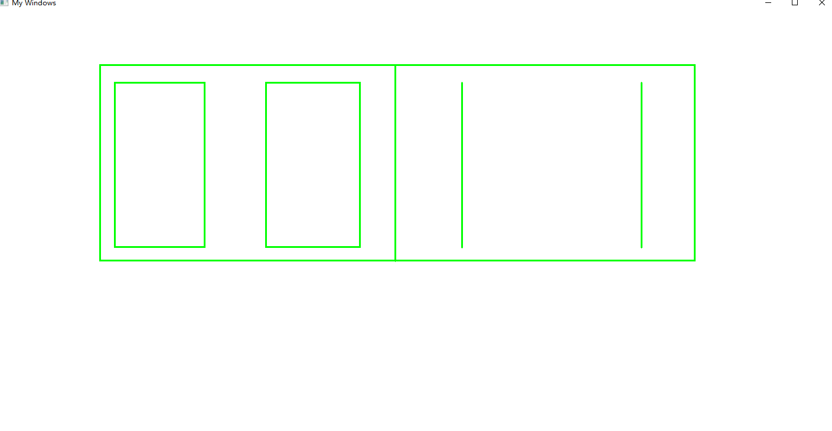

实验题目3 编写一个程序，在屏幕中出现一个圆心沿正弦曲线轨迹移动的小圆，要求每隔四分之一周期，圆的填充色和圆的周边颜色都发生变化（颜色自己选取），同时，圆的半径在四分之一周期之内由正弦曲线幅值的0.2倍至0.6倍线性增长。小圆能从左向右再从右向左不间断移动。

实验过程3（思路（文字描述）、关键代码（WndProc 函数））
LRESULT CALLBACK WndProc(HWND hWnd, UINT message, WPARAM wParam, LPARAM lParam){
PAINTSTRUCT ps;
HDC hDC; //定义设备环境句柄.
HBRUSH hBrush; //定义画刷句柄
HPEN hP; //定义画笔句柄
PAINTSTRUCT PtStr; //定义包含绘图信息的结构体变量
static double dfRange=100.0;
static long i=0, j=0;
static long lCentreX=0,lCentreY=0,lRadious=(long)(0.2*dfRange);//定义圆心坐标和圆坐标.
static POINT lpSin[100]; //定义正弦曲线的点坐标.
static bool flag=1;

for(int j=0;j<100;j++) //生成正弦曲线的点坐标.
{
lpSin[j].x=(long)(j*2*Pi/100*60);
lpSin[j].y=(long)(dfRange*sin(j*2*Pi/100));
}

switch(message)
{
case WM_PAINT: //处理绘图消息.
hDC=BeginPaint(hWnd,&PtStr); //获得设备环境指针.
SetWindowOrgEx(hDC,-200,-200,NULL); //设置原点坐标为(-200,-200).

hP=CreatePen(PS_SOLID,1,RGB(255,0,0)); //创新画笔.
SelectObject(hDC,hP); //选入画笔.
Polyline(hDC,lpSin,100); //绘制正弦曲线.
DeleteObject(hP); //删除画笔.

if(i<=25) //第一个1/4周期.
{
hP=CreatePen(PS_DASH,1,RGB(255,0,0));//创新红笔.
hBrush=CreateHatchBrush(HS_BDIAGONAL,RGB(255,0,0));//创新红画刷.
lRadious=(long)(dfRange*0.2+i%25*dfRange*0.4/25);//计算半径.
}
else if(i<=50)//第二个1/4周期.
{
hP=CreatePen(PS_DASH,1,RGB(0,255,0));//创新绿笔.
hBrush=CreateHatchBrush(HS_DIAGCROSS,RGB(0,255,0));//创新绿刷.
lRadious=(long)(dfRange*0.2+i%25*dfRange*0.4/25);//计算半径.
}
else if(i<=75)//第三个周期.
{
hP=CreatePen(PS_DASH,1,RGB(0,0,255));//创新蓝笔
hBrush=CreateHatchBrush(HS_CROSS,RGB(0,0,255));//创新蓝刷.
lRadious=(long)(dfRange*0.2+i%25*dfRange*0.4/25);//计算半径.
}
else//第四个周期.
{
hP=CreatePen(PS_DASH,1,RGB(255,255,0));//创新黄笔
hBrush=CreateHatchBrush(HS_VERTICAL,RGB(255,255,0));//创新黄刷.
lRadious=(long)(dfRange*0.2+i%25*dfRange*0.4/25);//计算半径.
}
SelectObject(hDC,hBrush); //选入画刷.
SelectObject(hDC,hP); //选入画笔.
lCentreX=lpSin[i].x; //圆心x坐标.
lCentreY=lpSin[i].y; //圆心y坐标.
Ellipse(hDC,lCentreX-lRadious,lCentreY-lRadious,
lCentreX+lRadious,lCentreY+lRadious); //画圆.
if(i<99){
if(flag==1)
i++;
else
i--;
}
else if(i==99){
flag=0;
i--;
}
DeleteObject(hP);
EndPaint(hWnd, &ps);
Sleep(100);
if (0<i && i<100)
InvalidateRect(hWnd, NULL, 1);

return 0;
default: //默认时采用系统消息默认处理函数
return DefWindowProc(hWnd, message, wParam, lParam);
}
}
实验结果3
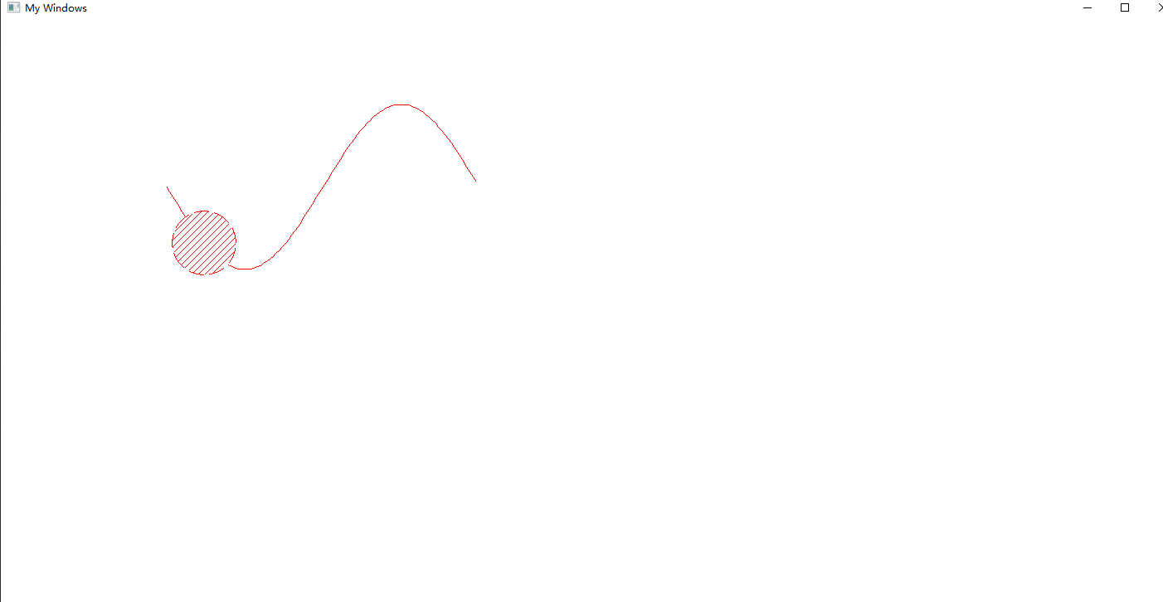

实验题目4编程实现1个红色小球在屏幕中不停地斜向匀速运动，且碰到边界时能合理变向。
实验过程4（思路（文字描述）、关键代码（WndProc 函数））
LRESULT CALLBACK WndProc(HWND hwnd,UINT message,WPARAM wParam,LPARAM lParam)
{
static int x , y ;
static int vx = 3 , vy = 4 ;
static int r = 5 ;
static int uddis = 1 ;
static int lrdis = 1 ;
static int t ;

HPEN hp;
HBRUSH hbr;
HDC hdc;
PAINTSTRUCT ps;
RECT rect;
int nextx , nexty ;
GetClientRect(hwnd , &rect) ;

switch(message)
{
case WM_CREATE:
srand(time(NULL)) ;
x = rand() % 1000 +10 ;
y = rand() % 1000 +10 ;
vx = rand() % 50 ;
vy = rand() % 50 ;
r = rand() % 50 ;
t = rand() ;
if(t%2){
vx = -vx ;
}
t = rand() ;
if(t%2){
vy = -vy ;
}
return 0;

case WM_DESTROY:
PostQuitMessage(0);
return 0;
case WM_PAINT:
hdc = BeginPaint(hwnd,&ps) ;
hp = (HPEN)CreatePen(PS_SOLID, 1, RGB(255,0,0));
hbr = (HBRUSH)CreateHatchBrush(HS_BDIAGONAL, RGB(255, 0, 0));
SelectObject(hdc,hp) ;
SelectObject(hdc,hbr) ;

Ellipse(hdc,x-r,y-r,x+r,y+r) ;

nextx = x + lrdis * vx ;
nexty = y + uddis * vy ;
if(nextx < rect.left+r){
nextx = rect.left + r ;
lrdis = -lrdis ;
}
if(nexty < rect.top+r){
nexty = rect.top + r ;
uddis = -uddis ;
}
if(nextx > rect.right - r){
nextx = rect.right - r ;
lrdis = -lrdis ;
}
if(nexty > rect.bottom - r){
nexty = rect.bottom - r ;
uddis = -uddis ;
}
x = nextx ;
y = nexty ;

Sleep(100) ;
InvalidateRect(hwnd,NULL,1) ;
EndPaint(hwnd,&ps) ;
return 0;

default:
return DefWindowProc(hwnd,message,wParam,lParam);
}
return 0;
}
实验结果4
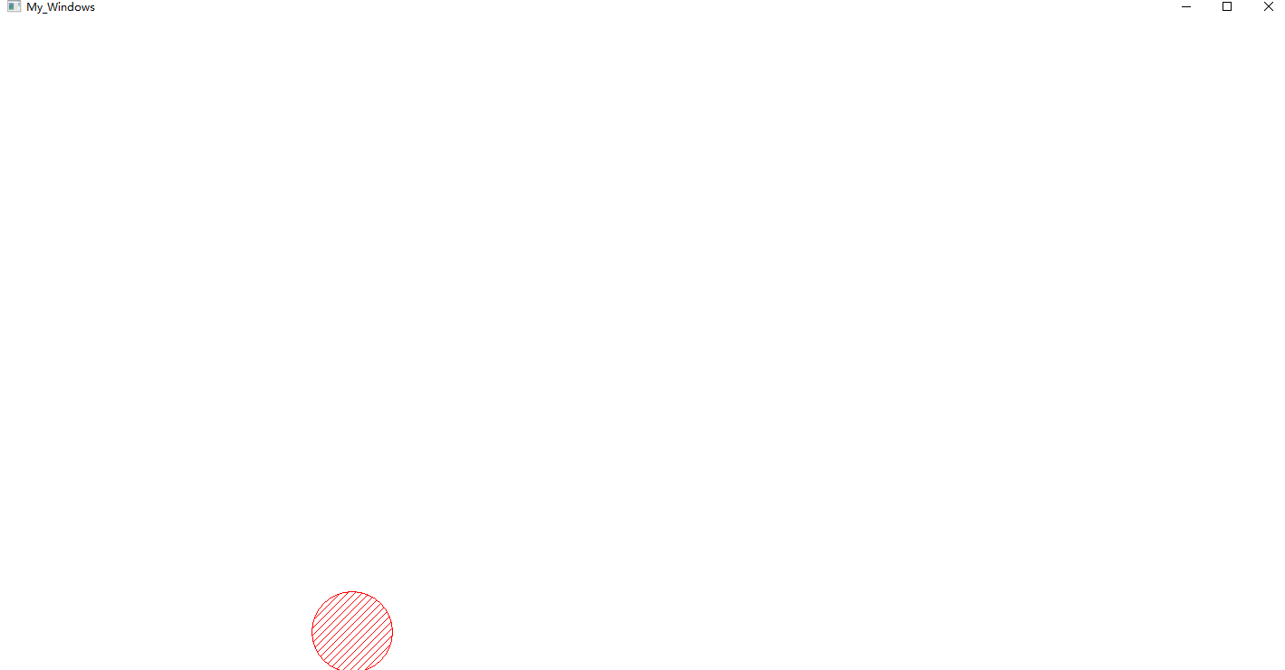

四 实验小结
电子钟应该有更短的方法实现，这次写的挺长的。

