[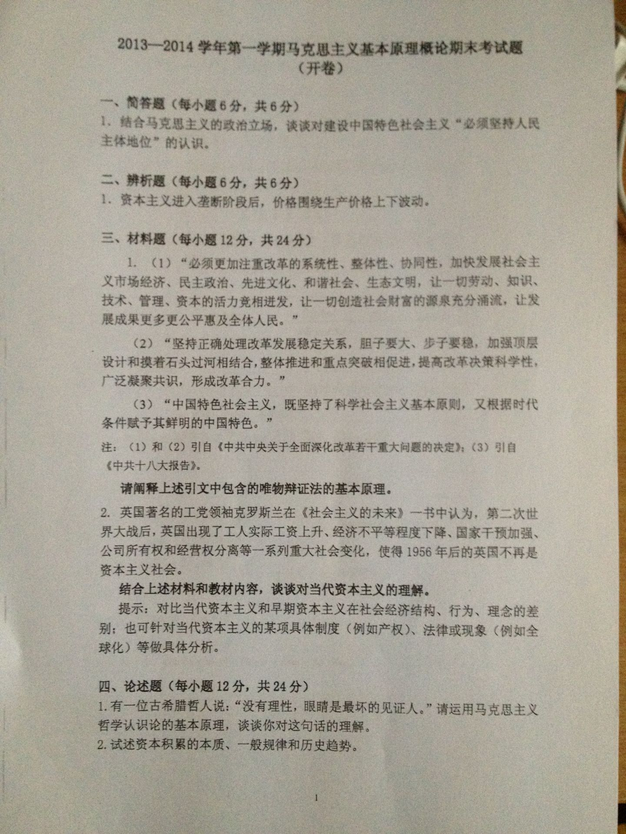](http://attach3.bdwm.net/attach/boards/Courses/M.1388737362.A/%e7%85%a7%e7%89%87.jpg)