Evaluating an Aggregate Method for Estimating Intra-Limb Proportions for Commingled Remains

Carol Doudou Cao

2023-06-08

# Install and load necessary packages

install.packages("tidyverse", repos = "https://cran.r-project.org/")

## Installing package into 'C:/Users/carol/Documents/R/win-library/4.1'  
## (as 'lib' is unspecified)

## package 'tidyverse' successfully unpacked and MD5 sums checked  
##   
## The downloaded binary packages are in  
## C:\Users\carol\AppData\Local\Temp\RtmpUXyJjV\downloaded_packages

install.packages("viridis", repos = "https://cran.r-project.org/")

## Installing package into 'C:/Users/carol/Documents/R/win-library/4.1'  
## (as 'lib' is unspecified)

##   
## There is a binary version available but the source version is later:  
## binary source needs_compilation  
## viridis 0.6.2 0.6.3 FALSE

## installing the source package 'viridis'

install.packages("terra", repos = "https://cran.r-project.org/")

## Installing package into 'C:/Users/carol/Documents/R/win-library/4.1'  
## (as 'lib' is unspecified)

##   
## There is a binary version available but the source version is later:  
## binary source needs_compilation  
## terra 1.7-23 1.7-29 TRUE  
##   
## Binaries will be installed  
## package 'terra' successfully unpacked and MD5 sums checked

## Warning: cannot remove prior installation of package 'terra'

## Warning in file.copy(savedcopy, lib, recursive = TRUE): problem copying  
## C:\Users\carol\Documents\R\win-library\4.1\00LOCK\terra\libs\x64\terra.dll to  
## C:\Users\carol\Documents\R\win-library\4.1\terra\libs\x64\terra.dll: Permission  
## denied

## Warning: restored 'terra'

##   
## The downloaded binary packages are in  
## C:\Users\carol\AppData\Local\Temp\RtmpUXyJjV\downloaded_packages

install.packages("gridExtra", repos = "https://cran.r-project.org/")

## Installing package into 'C:/Users/carol/Documents/R/win-library/4.1'  
## (as 'lib' is unspecified)

## package 'gridExtra' successfully unpacked and MD5 sums checked  
##   
## The downloaded binary packages are in  
## C:\Users\carol\AppData\Local\Temp\RtmpUXyJjV\downloaded_packages

library(viridis)

## Loading required package: viridisLite

library(tidyverse)

## -- Attaching core tidyverse packages ------------------------ tidyverse 2.0.0 --  
## v dplyr 1.1.2 v readr 2.1.4  
## v forcats 1.0.0 v stringr 1.5.0  
## v ggplot2 3.4.1 v tibble 3.2.1  
## v lubridate 1.9.2 v tidyr 1.3.0  
## v purrr 1.0.1

## -- Conflicts ------------------------------------------ tidyverse_conflicts() --  
## x dplyr::filter() masks stats::filter()  
## x dplyr::lag() masks stats::lag()  
## i Use the ]8;;http://conflicted.r-lib.org/conflicted package]8;; to force all conflicts to become errors

library(terra)

## terra 1.7.23  
##   
## Attaching package: 'terra'  
##   
## The following object is masked from 'package:tidyr':  
##   
## extract

library(gridExtra)

##   
## Attaching package: 'gridExtra'  
##   
## The following object is masked from 'package:dplyr':  
##   
## combine

library(scales)

##   
## Attaching package: 'scales'  
##   
## The following object is masked from 'package:terra':  
##   
## rescale  
##   
## The following object is masked from 'package:purrr':  
##   
## discard  
##   
## The following object is masked from 'package:readr':  
##   
## col_factor  
##   
## The following object is masked from 'package:viridis':  
##   
## viridis_pal

# 1. Prepare the data

## 1.1. Read the Goldman and EU datasets

# Goldman dataset  
Goldman <- read.csv("D:/DATA SET/Data processing/AggregatedCI&BI/simulation_dataset/Goldman.csv")  
  
# EU_Ruff  
EU <- read.csv("D:/DATA SET/Data processing/AggregatedCI&BI/simulation_dataset/Ruff-European.csv")

## 1.2. Select the columns of interest (Assuming datasets have been loaded)

# Select limb lengths in Goldman dataset  
Goldman_selected_columns <- Goldman[, c("ID", "Sex", "NOTE", "LHML", "RHML", "LRML", "RRML", "LFBL", "RFBL", "LTML", "RTML")]  
  
# Select limb lengths in EU_Ruff dataset  
EU_selected_columns <- EU[, c("SITE", "SPECIMEN_No", "SEX", "DATE.RANGE", "YEARS.BP", "FBICLN", "TMAXLN", "HRMAXLN", "HLMAXLN", "RRMAXLN", "RLMAXLN")]

## 1.3. Calculate final length of the humerus (HML), radius (RML),femur (FBL) and tibia (TML)

—Because in some limbs, the lengths of both left and right sides are reported, the final length of a limb is the averge of two sides-

# --- Arm ---  
## Goldman  
### Average the maximum length of the left and right humerus   
Goldman_selected_columns$finalHML <- rowMeans(Goldman_selected_columns[, c("LHML", "RHML")], na.rm = TRUE)  
  
### Average the maximum length of the left and right radius   
Goldman_selected_columns$finalRML <- rowMeans(Goldman_selected_columns[, c("LRML", "RRML")], na.rm = TRUE)  
  
## EU_Ruff  
### Average the maximum length of the left and right humerus   
EU_selected_columns$finalHML <- rowMeans(EU_selected_columns[, c("HRMAXLN", "HLMAXLN")], na.rm = TRUE)  
  
### Average the maximum length of the left and right radius   
EU_selected_columns$finalRML <- rowMeans(EU_selected_columns[, c("RRMAXLN", "RLMAXLN")], na.rm = TRUE)  
  
# --- Leg ---  
  
## Goldman  
### Average the bicondylar length of the left and right femur  
Goldman_selected_columns$finalFBL <- rowMeans(Goldman_selected_columns[, c("LFBL", "RFBL")], na.rm = TRUE)  
  
### Average the maximum length of the left and right tibia   
Goldman_selected_columns$finalTML <- rowMeans(Goldman_selected_columns[, c("LTML", "RTML")], na.rm = TRUE)

## 1.4. Drop rows with missing values

# --- Arm ---  
Goldman_filtered_arm <- Goldman_selected_columns[complete.cases(Goldman_selected_columns$finalHML, Goldman_selected_columns$finalRML), ]  
  
## EU_Ruff  
EU_filtered_arm <- EU_selected_columns[complete.cases(EU_selected_columns$finalHML, EU_selected_columns$finalRML), ]  
  
# --- Leg ---  
## Goldman   
Goldman_filtered_leg <- Goldman_selected_columns[complete.cases(Goldman_selected_columns$finalFBL, Goldman_selected_columns$finalTML), ]  
## EU_Ruff  
EU_filtered_leg <- EU_selected_columns[complete.cases(EU_selected_columns$TMAXLN, EU_selected_columns$FBICLN), ]

## 1.5. Filter out small-size groups (no.individuals < 5)

# Count number of individuals per NOTE (in Goldman dataset) and SITE group (in EU_Ruff set)  
# Arm  
no_group_GM_arm <- table(Goldman_filtered_arm$NOTE)  
no_group_EU_arm <- table(EU_filtered_arm$SITE)  
  
# Leg  
no_group_GM_leg <- table(Goldman_filtered_leg$NOTE)  
no_group_EU_leg <- table(EU_filtered_leg$SITE)  
  
# Filter out small-size groups (no.individuals < 5)  
## Arm  
### Goldman  
Goldman_filtered_final_arm <- Goldman_filtered_arm[Goldman_filtered_arm$NOTE %in% names(no_group_GM_arm[no_group_GM_arm >= 5]), ]  
  
### EU_Ruff  
EU_filtered_final_arm <- EU_filtered_arm[EU_filtered_arm$SITE %in% names(no_group_EU_arm[no_group_EU_arm >= 5]), ]  
  
## Leg  
### Goldman  
Goldman_filtered_final_leg <- Goldman_filtered_leg[Goldman_filtered_leg$NOTE %in% names(no_group_GM_leg[no_group_GM_leg >= 5]), ]  
  
EU_filtered_final_leg <- EU_filtered_leg[EU_filtered_leg$SITE %in% names(no_group_EU_leg[no_group_EU_leg >= 5]), ]

## 1.6. Calculate the Conventional Brachial and Crural indices

# Brachial index  
## Goldman  
Goldman_filtered_final_arm$ConventionalBI <- Goldman_filtered_final_arm$finalRML/   
Goldman_filtered_final_arm$finalHML  
  
## EU_Ruff  
EU_filtered_final_arm$ConventionalBI <- EU_filtered_final_arm$finalRML/   
EU_filtered_final_arm$finalHML  
  
# Crural index  
## Goldman  
Goldman_filtered_final_leg$ConventionalCI <- Goldman_filtered_final_leg$finalTML /   
Goldman_filtered_final_leg$finalFBL  
  
# Rename columns  
names(EU_filtered_final_leg)[names(EU_filtered_final_leg) == "FBICLN"] <- "finalFBL"  
names(EU_filtered_final_leg)[names(EU_filtered_final_leg) == "TMAXLN"] <- "finalTML"  
  
# Calculate TrueCI  
EU_filtered_final_leg$ConventionalCI <- EU_filtered_final_leg$finalTML / EU_filtered_final_leg$finalFBL

# 2. Create the subset of the arm and leg

## 2.1. Data cleaning and transformation operations on the Sex column of two datasets

# Convert missing data or uncertain sex values to NA in arm dataset  
Goldman_filtered_final_arm$Sex <- ifelse(Goldman_filtered_final_arm$Sex %in% c("0?", "1?"), NA, Goldman_filtered_final_arm$Sex)  
  
# Convert 0 and 1 values to 1 and 2, respectively, in arm dataset  
Goldman_filtered_final_arm$Sex <- ifelse(Goldman_filtered_final_arm$Sex == 1, 2, Goldman_filtered_final_arm$Sex)  
Goldman_filtered_final_arm$Sex <- ifelse(Goldman_filtered_final_arm$Sex == 0, 1, Goldman_filtered_final_arm$Sex)  
  
# Convert missing data or uncertain sex values to NA in leg dataset  
Goldman_filtered_final_leg$Sex <- ifelse(Goldman_filtered_final_leg$Sex %in% c("0?", "1?"), NA, Goldman_filtered_final_leg$Sex)  
  
# Convert 0 and 1 values to 1 and 2, respectively, in leg dataset  
Goldman_filtered_final_leg$Sex <- ifelse(Goldman_filtered_final_leg$Sex == 1, 2, Goldman_filtered_final_leg$Sex)  
Goldman_filtered_final_leg$Sex <- ifelse(Goldman_filtered_final_leg$Sex == 0, 1, Goldman_filtered_final_leg$Sex)

## 2.2. Create the subset of the arm and leg

Armset <- rbind(transform(  
 EU_filtered_final_arm[, c("SITE", "SEX", "SPECIMEN_No", "finalHML", "finalRML", "ConventionalBI")],  
 ID = SPECIMEN_No,  
 Sex = SEX,  
 source = "EU"  
 )[, c("SITE", "ID", "Sex", "finalHML", "finalRML", "ConventionalBI")]  
,  
transform(  
 Goldman_filtered_final_arm[, c("NOTE", "ID", "Sex", "finalHML", "finalRML", "ConventionalBI")],  
 SITE = NOTE,  
 source = "Goldman"  
 )[, c("SITE", "ID", "Sex", "finalHML", "finalRML", "ConventionalBI")]  
   
)  
  
# Legset  
Legset <- rbind(  
 transform(  
 EU_filtered_final_leg[, c("SITE", "SEX", "SPECIMEN_No", "finalFBL", "finalTML", "ConventionalCI")],  
 ID = SPECIMEN_No,  
 Sex = SEX,  
 source = "EU"  
 )[, c("SITE", "Sex", "ID", "finalFBL", "finalTML", "ConventionalCI")],  
 transform(  
 Goldman_filtered_final_leg[, c("NOTE", "ID", "Sex", "finalTML", "finalFBL", "ConventionalCI")],  
 SITE = NOTE,  
 source = "Goldman",  
 Sex = as.numeric(Sex)  
 )[, c("SITE", "Sex", "ID", "finalFBL", "finalTML", "ConventionalCI")]  
)

# 3. Visualise the limb lengths and indices between males and females

## 3.1. Counting males and females

# Counting males and females in Armset dataset  
Armset_count_male <- sum(Armset$Sex == 1, na.rm = TRUE)  
Armset_count_female <- sum(Armset$Sex == 2, na.rm = TRUE)  
  
# Counting males and females in Legset dataset  
Legset_count_male <- sum(Legset$Sex == 1, na.rm = TRUE)  
Legset_count_female <- sum(Legset$Sex == 2, na.rm = TRUE)  
  
# Print the counts  
cat("Count of males in Armset:", Armset_count_male, "\n")

## Count of males in Armset: 1513

cat("Count of females in Armset:", Armset_count_female, "\n")

## Count of females in Armset: 1019

cat("Count of males in Legset:", Legset_count_male, "\n")

## Count of males in Legset: 1667

cat("Count of females in Legset:", Legset_count_female, "\n")

## Count of females in Legset: 1143

## 3.2. Plot the lengths and indices of males and females

### 3.2.1 Combine the data

# Combine the data of limb lengths  
HML_male <- Armset$finalHML[Armset$Sex == 1]  
HML_female <- Armset$finalHML[Armset$Sex == 2]  
HML_both <- Armset$finalHML  
RML_male <- Armset$finalRML[Armset$Sex == 1]  
RML_female <- Armset$finalRML[Armset$Sex == 2]  
RML_both <- Armset$finalRML  
FBL_male <- Legset$finalFBL[Legset$Sex == 1]  
FBL_female <- Legset$finalFBL[Legset$Sex == 2]  
FBL_both <- Legset$finalFBL  
TML_male <- Legset$finalTML[Legset$Sex == 1]  
TML_female <- Legset$finalTML[Legset$Sex == 2]  
TML_both <- Legset$finalTML  
  
# Combine the data of index  
BI_male <- Armset$ConventionalBI[Armset$Sex == 1]  
BI_female <- Armset$ConventionalBI[Armset$Sex == 2]  
BI_both <- Armset$ConventionalBI  
CI_male <- Legset$ConventionalCI[Legset$Sex == 1]  
CI_female <- Legset$ConventionalCI[Legset$Sex == 2]  
CI_both <- Legset$ConventionalCI

# Create a data frame for HML  
df_HML <- data.frame(values = c(HML_male, HML_female),  
 group = rep(c("HML - Male", "HML - Female"), c(length(HML_male), length(HML_female))))  
  
# Create the histogram for HML   
p1 <- ggplot(df_HML, aes(x = values, fill = group)) +   
 geom_histogram(binwidth = 10, alpha = 0.6, position = "identity") +  
 scale_fill_manual(values = c("#d45087","skyblue" )) +  
 labs(title = "", x = "HML", y = "Frequency", fill = "Sex") +  
 theme_classic()+  
 theme(legend.title = element_text(face = "bold", size = 12),  
 legend.text = element_text(face = "bold", size = 12),  
 axis.title = element_text(face = "bold", size = 14),  
 axis.text = element_text(face = "bold", size = 12))  
  
  
# Create a data frame for RML  
df_RML <- data.frame(values = c(RML_male, RML_female),  
 group = rep(c("RML - Male", "RML - Female"), c(length(RML_male), length(RML_female))))  
  
# Create the histogram for RML  
p2 <- ggplot(df_RML, aes(x = values, fill = group)) +   
 geom_histogram(binwidth = 10, alpha = 0.6, position = "identity") +  
 scale_fill_manual(values = c( "#d45087","skyblue" )) +  
 labs(title = "", x = "RML", y = "Frequency", fill = "Sex") +  
 theme_classic()+  
 theme(legend.title = element_text(face = "bold", size = 12),  
 legend.text = element_text(face = "bold", size = 12),  
 axis.title = element_text(face = "bold", size = 14),  
 axis.text = element_text(face = "bold", size = 12))  
  
  
# Create a data frame for FBL  
df_FBL <- data.frame(values = c(FBL_male, FBL_female),  
 group = rep(c("FBL - Male", "FBL - Female"), c(length(FBL_male), length(FBL_female))))  
  
# Create the histogram for FBL  
p3 <- ggplot(df_FBL, aes(x = values, fill = group)) +   
 geom_histogram(binwidth = 10, alpha = 0.6, position = "identity") +  
 scale_fill_manual(values = c("#a05195", "blue")) +  
 labs(title = "", x = "FBL", y = "Frequency", fill = "Sex") +  
 theme_classic()+  
 theme(legend.title = element_text(face = "bold", size = 12),  
 legend.text = element_text(face = "bold", size = 12),  
 axis.title = element_text(face = "bold", size = 14),  
 axis.text = element_text(face = "bold", size = 12))  
  
# Create a data frame for TML  
df_TML <- data.frame(values = c(TML_male, TML_female),  
 group = rep(c("TML - Male", "TML - Female"), c(length(TML_male), length(TML_female))))  
  
# Create a data frame for TML  
df_TML <- data.frame(values = c(TML_male, TML_female),  
 group = rep(c("TML - Male", "TML - Female"), c(length(TML_male), length(TML_female))))  
  
# Create the histogram for RML  
p4 <- ggplot(df_TML, aes(x = values, fill = group)) +   
 geom_histogram(binwidth = 10, alpha = 0.6, position = "identity") +  
 scale_fill_manual(values = c( "#a05195", "blue")) +  
 labs(title = "", x = "TML", y = "Frequency", fill = "Sex") +  
 theme_classic()+  
 theme(legend.title = element_text(face = "bold", size = 12),  
 legend.text = element_text(face = "bold", size = 12),  
 axis.title = element_text(face = "bold", size = 14),  
 axis.text = element_text(face = "bold", size = 12))  
  
# Create a data frame for BI  
df_BI <- subset(data.frame(values = c(BI_male, BI_female),  
 group = rep(c("BIt - Male", "BIt - Female"), c(length(BI_male), length(BI_female)))),  
 values > 0.6 & values < 0.99)  
  
# Create the histogram for BIt   
  
p5 <- ggplot(df_BI, aes(x = values, fill = group)) +   
 geom_histogram(binwidth = 0.01, alpha = 0.6, position = "identity") +  
 scale_fill_manual(values = c("#d45087", "skyblue")) +  
 labs(title = "", x = "BIc", y = "Frequency", fill = "Sex") +  
 theme_classic() +  
 theme(  
 legend.title = element_text(face = "bold", size = 14),  
 legend.text = element_text(face = "bold", size = 14),  
 axis.title = element_text(face = "bold", size = 18),  
 axis.text = element_text(face = "bold", size = 14)) +  
 scale_x_continuous(breaks = seq(0, 1, by = 0.05))  
  
# Create a data frame for CI  
df_CI <- subset(data.frame(values = c(CI_male, CI_female),  
 group = rep(c("CIt - Male", "CIt - Female"), c(length(CI_male), length(CI_female)))), values < 1)  
  
# Create the histogram for CIt  
p6 <- ggplot(df_CI, aes(x = values, fill = group)) +   
 geom_histogram(binwidth = 0.01, alpha = 0.6, position = "identity") +  
 scale_fill_manual(values = c( "#a05195", "blue")) +  
 labs(title = "", x = "CIc", y = "Frequency", fill = "Sex") +  
 theme_classic()+  
 theme(legend.title = element_text(face = "bold", size = 14),  
 legend.text = element_text(face = "bold", size = 14),  
 axis.title = element_text(face = "bold", size = 18),  
 axis.text = element_text(face = "bold", size = 14))  
  
# Create the combined plot  
combined_histogram_limblength <- grid.arrange(p1, p2, p3, p4, ncol = 2,nrow = 2)

## Warning: Removed 18 rows containing non-finite values (`stat_bin()`).  
## Removed 18 rows containing non-finite values (`stat_bin()`).

## Warning: Removed 20 rows containing non-finite values (`stat_bin()`).  
## Removed 20 rows containing non-finite values (`stat_bin()`).

combined_histogram_indices <- grid.arrange(p5, p6, ncol = 2)

# 4. Summarise the limb lengths and indices

## 4.1. Summarise the limb lengths

### 4.1.1. Summarise the limb lengths (combined)

# Humerus  
Mean_HML <- aggregate(Armset$finalHML, by = list(Armset$SITE), FUN = mean)  
colnames(Mean_HML) <- c("SITE", "mean_finalHML")  
  
summary_HML <- data.frame(  
 mean_mean_finalHML = mean(Mean_HML$mean_finalHML),  
 max_mean_finalHML = max(Mean_HML$mean_finalHML),  
 min_mean_finalHML = min(Mean_HML$mean_finalHML),  
 sd_mean_finalHML = sd(Mean_HML$mean_finalHML)  
)  
  
# Radius  
Mean_RML <- aggregate(Armset$finalRML, by = list(Armset$SITE), FUN = mean)  
colnames(Mean_RML) <- c("SITE", "mean_finalRML")  
  
summary_RML <- data.frame(  
 mean_mean_finalRML = mean(Mean_RML$mean_finalRML),  
 max_mean_finalRML = max(Mean_RML$mean_finalRML),  
 min_mean_finalRML = min(Mean_RML$mean_finalRML),  
 sd_mean_finalRML = sd(Mean_RML$mean_finalRML)  
)  
  
# Femur  
Mean_FBL <- aggregate(Legset$finalFBL, by = list(Legset$SITE), FUN = mean)  
colnames(Mean_FBL) <- c("SITE", "mean_finalFBL")  
  
summary_FBL <- data.frame(  
 mean_mean_finalFBL = mean(Mean_FBL$mean_finalFBL),  
 max_mean_finalFBL = max(Mean_FBL$mean_finalFBL),  
 min_mean_finalFBL = min(Mean_FBL$mean_finalFBL),  
 sd_mean_finalFBL = sd(Mean_FBL$mean_finalFBL)  
)  
  
# Tibia  
Mean_TML <- aggregate(Legset$finalTML, by = list(Legset$SITE), FUN = mean)  
colnames(Mean_TML) <- c("SITE", "mean_finalTML")  
  
summary_TML <- data.frame(  
 mean_mean_finalTML = mean(Mean_TML$mean_finalTML),  
 max_mean_finalTML = max(Mean_TML$mean_finalTML),  
 min_mean_finalTML = min(Mean_TML$mean_finalTML),  
 sd_mean_finalTML = sd(Mean_TML$mean_finalTML)  
)  
  
# Print summary statistics  
print(summary_HML)

## mean_mean_finalHML max_mean_finalHML min_mean_finalHML sd_mean_finalHML  
## 1 308.7287 344.6 271.2679 13.23827

print(summary_RML)

## mean_mean_finalRML max_mean_finalRML min_mean_finalRML sd_mean_finalRML  
## 1 234.4692 259.9 209.2976 10.10622

print(summary_FBL)

## mean_mean_finalFBL max_mean_finalFBL min_mean_finalFBL sd_mean_finalFBL  
## 1 426.6817 467.7273 383.7941 16.51014

print(summary_TML)

## mean_mean_finalTML max_mean_finalTML min_mean_finalTML sd_mean_finalTML  
## 1 356.1171 399.7273 314.1429 14.91811

### 4.1.2. Summarise the limb lengths (by sex)

# Humerus  
## Male  
Mean_HML_male <- aggregate(finalHML ~ SITE, data = Armset[Armset$Sex == 1, ], FUN = mean)  
colnames(Mean_HML_male) <- c("SITE", "mean_finalHML_male")  
  
summary_HML_male <- data.frame(  
 mean_mean_finalHML_male = mean(Mean_HML_male$mean_finalHML_male),  
 max_mean_finalHML_male = max(Mean_HML_male$mean_finalHML_male),  
 min_mean_finalHML_male = min(Mean_HML_male$mean_finalHML_male),  
 sd_mean_finalHML_male = sd(Mean_HML_male$mean_finalHML_male)  
)  
  
## Female  
Mean_HML_female <- aggregate(finalHML ~ SITE, data = Armset[Armset$Sex == 2, ], FUN = mean)  
colnames(Mean_HML_female) <- c("SITE", "mean_finalHML_female")  
  
summary_HML_female <- data.frame(  
 mean_mean_finalHML_female = mean(Mean_HML_female$mean_finalHML_female),  
 max_mean_finalHML_female = max(Mean_HML_female$mean_finalHML_female),  
 min_mean_finalHML_female = min(Mean_HML_female$mean_finalHML_female),  
 sd_mean_finalHML_female = sd(Mean_HML_female$mean_finalHML_female)  
)  
  
# Radius  
## Male  
Mean_RML_male <- aggregate(finalRML ~ SITE, data = Armset[Armset$Sex == 1, ], FUN = mean)  
colnames(Mean_RML_male) <- c("SITE", "mean_finalRML_male")  
  
summary_RML_male <- data.frame(  
 mean_mean_finalRML_male = mean(Mean_RML_male$mean_finalRML_male),  
 max_mean_finalRML_male = max(Mean_RML_male$mean_finalRML_male),  
 min_mean_finalRML_male = min(Mean_RML_male$mean_finalRML_male),  
 sd_mean_finalRML_male = sd(Mean_RML_male$mean_finalRML_male)  
)  
  
## Female  
Mean_RML_female <- aggregate(finalRML ~ SITE, data = Armset[Armset$Sex == 2, ], FUN = mean)  
colnames(Mean_RML_female) <- c("SITE", "mean_finalRML_female")  
  
summary_RML_female <- data.frame(  
 mean_mean_finalRML_female = mean(Mean_RML_female$mean_finalRML_female),  
 max_mean_finalRML_female = max(Mean_RML_female$mean_finalRML_female),  
 min_mean_finalRML_female = min(Mean_RML_female$mean_finalRML_female),  
 sd_mean_finalRML_female = sd(Mean_RML_female$mean_finalRML_female)  
)  
  
# Femur  
## Male  
Mean_FBL_male <- aggregate(finalFBL ~ SITE, data = Legset[Legset$Sex == 1, ], FUN = mean)  
colnames(Mean_FBL_male) <- c("SITE", "mean_finalFBL_male")  
  
summary_FBL_male <- data.frame(  
 mean_mean_finalFBL_male = mean(Mean_FBL_male$mean_finalFBL_male),  
 max_mean_finalFBL_male = max(Mean_FBL_male$mean_finalFBL_male),  
 min_mean_finalFBL_male = min(Mean_FBL_male$mean_finalFBL_male),  
 sd_mean_finalFBL_male = sd(Mean_FBL_male$mean_finalFBL_male)  
)  
  
## Female  
Mean_FBL_female <- aggregate(finalFBL ~ SITE, data = Legset[Legset$Sex == 2, ], FUN = mean)  
colnames(Mean_FBL_female) <- c("SITE", "mean_finalFBL_female")  
  
summary_FBL_female <- data.frame(  
 mean_mean_finalFBL_female = mean(Mean_FBL_female$mean_finalFBL_female),  
 max_mean_finalFBL_female = max(Mean_FBL_female$mean_finalFBL_female),  
 min_mean_finalFBL_female = min(Mean_FBL_female$mean_finalFBL_female),  
 sd_mean_finalFBL_female = sd(Mean_FBL_female$mean_finalFBL_female)  
)  
  
# Tibia  
## Male  
Mean_TML_male <- aggregate(finalTML ~ SITE, data = Legset[Legset$Sex == 1, ], FUN = mean)  
colnames(Mean_TML_male) <- c("SITE", "mean_finalTML_male")  
  
summary_TML_male <- data.frame(  
 mean_mean_finalTML_male = mean(Mean_TML_male$mean_finalTML_male),  
 max_mean_finalTML_male = max(Mean_TML_male$mean_finalTML_male),  
 min_mean_finalTML_male = min(Mean_TML_male$mean_finalTML_male),  
 sd_mean_finalTML_male = sd(Mean_TML_male$mean_finalTML_male)  
)  
  
## Female  
Mean_TML_female <- aggregate(finalTML ~ SITE, data = Legset[Legset$Sex == 2, ], FUN = mean)  
colnames(Mean_TML_female) <- c("SITE", "mean_finalTML_female")  
  
summary_TML_female <- data.frame(  
 mean_mean_finalTML_female = mean(Mean_TML_female$mean_finalTML_female),  
 max_mean_finalTML_female = max(Mean_TML_female$mean_finalTML_female),  
 min_mean_finalTML_female = min(Mean_TML_female$mean_finalTML_female),  
 sd_mean_finalTML_female = sd(Mean_TML_female$mean_finalTML_female)  
)  
  
# Print summary statistics  
summary_HML_male

## mean_mean_finalHML_male max_mean_finalHML_male min_mean_finalHML_male  
## 1 317.5135 351.1562 277.3571  
## sd_mean_finalHML_male  
## 1 13.47029

summary_HML_female

## mean_mean_finalHML_female max_mean_finalHML_female min_mean_finalHML_female  
## 1 294.4087 319.3333 259.5  
## sd_mean_finalHML_female  
## 1 11.94954

summary_RML_male

## mean_mean_finalRML_male max_mean_finalRML_male min_mean_finalRML_male  
## 1 242.8363 270.0909 216.1818  
## sd_mean_finalRML_male  
## 1 9.812945

summary_RML_female

## mean_mean_finalRML_female max_mean_finalRML_female min_mean_finalRML_female  
## 1 220.3566 248.75 195.25  
## sd_mean_finalRML_female  
## 1 9.689279

summary_FBL_male

## mean_mean_finalFBL_male max_mean_finalFBL_male min_mean_finalFBL_male  
## 1 439.514 487 387.6786  
## sd_mean_finalFBL_male  
## 1 17.99187

summary_FBL_female

## mean_mean_finalFBL_female max_mean_finalFBL_female min_mean_finalFBL_female  
## 1 406.637 439.1667 352.5833  
## sd_mean_finalFBL_female  
## 1 15.8518

summary_TML_male

## mean_mean_finalTML_male max_mean_finalTML_male min_mean_finalTML_male  
## 1 367.0466 412.75 327.4643  
## sd_mean_finalTML_male  
## 1 15.84586

summary_TML_female

## mean_mean_finalTML_female max_mean_finalTML_female min_mean_finalTML_female  
## 1 338.9564 371 299.5  
## sd_mean_finalTML_female  
## 1 15.21897

## 4.2 Summarise the indices

### 4.2.1. Summarise the indices (combined)

# Brachial index  
## Mean_BIc  
Mean_BIc <- aggregate(Armset$ConventionalBI, by = list(Armset$SITE), FUN = mean)  
colnames(Mean_BIc) <- c("SITE", "mean_BIc")  
  
summary_mean_BIc <- data.frame(  
 mean_mean_BIc = mean(Mean_BIc$mean_BIc),  
 max_mean_BIc = max(Mean_BIc$mean_BIc),  
 min_mean_BIc = min(Mean_BIc$mean_BIc),  
 sd_mean_BIc = sd(Mean_BIc$mean_BIc)  
)  
  
## SD_BIc  
SD_BIc <- aggregate(Armset$ConventionalBI, by = list(Armset$SITE), FUN = sd)  
colnames(SD_BIc) <- c("SITE", "sd_BIc")  
  
summary_sd_BIc <- data.frame(  
 mean_sd_BIc = mean(SD_BIc$sd_BIc),  
 max_sd_BIc = max(SD_BIc$sd_BIc),  
 min_sd_BIc = min(SD_BIc$sd_BIc),  
 sd_sd_BIc = sd(SD_BIc$sd_BIc)  
)  
  
  
# Crural index  
## Mean_CIt  
Mean_CIc <- aggregate(Legset$ConventionalCI, by = list(Legset$SITE), FUN = mean)  
colnames(Mean_CIc) <- c("SITE", "mean_CIc")  
  
summary_mean_CIc <- data.frame(  
 mean_mean_CIc = mean(Mean_CIc$mean_CIc),  
 max_mean_CIc = max(Mean_CIc$mean_CIc),  
 min_mean_CIc = min(Mean_CIc$mean_CIc),  
 sd_mean_CIc = sd(Mean_CIc$mean_CIc)  
)  
  
## SD_CIt  
SD_CIc <- aggregate(Legset$ConventionalCI, by = list(Legset$SITE), FUN = sd)  
colnames(SD_CIc) <- c("SITE", "sd_CIc")  
  
summary_sd_CIc <- data.frame(  
 mean_sd_CIc = mean(SD_CIc$sd_CIc),  
 max_sd_CIc = max(SD_CIc$sd_CIc),  
 min_sd_CIc = min(SD_CIc$sd_CIc),  
 sd_sd_CIc = sd(SD_CIc$sd_CIc)  
)  
  
# Print summary statistics  
summary_mean_BIc

## mean_mean_BIc max_mean_BIc min_mean_BIc sd_mean_BIc  
## 1 0.7597169 0.8083747 0.7189173 0.01946723

summary_mean_CIc

## mean_mean_CIc max_mean_CIc min_mean_CIc sd_mean_CIc  
## 1 0.8347534 0.8693167 0.7930667 0.01539735

summary_sd_BIc

## mean_sd_BIc max_sd_BIc min_sd_BIc sd_sd_BIc  
## 1 0.02433381 0.07224909 0.002343426 0.008424029

summary_sd_CIc

## mean_sd_CIc max_sd_CIc min_sd_CIc sd_sd_CIc  
## 1 0.02297197 0.04407612 0.008654487 0.005982578

### 4.2.2. Summarise the indices (by sex)

# Brachial index  
## Mean_BIc   
### Male  
Mean_BIc_male <- aggregate(ConventionalBI ~ SITE, data = Armset[Armset$Sex == 1, ], FUN = mean)  
colnames(Mean_BIc_male) <- c("SITE", "mean_BIc_male")  
  
summary_mean_BIc_male <- data.frame(  
 mean_mean_BIc_male = mean(Mean_BIc_male$mean_BIc_male),  
 max_mean_BIc_male = max(Mean_BIc_male$mean_BIc_male),  
 min_mean_BIc_male = min(Mean_BIc_male$mean_BIc_male),  
 sd_mean_BIc_male = sd(Mean_BIc_male$mean_BIc_male)  
)  
  
## SD_BIc   
### Male  
SD_BIc_male <- aggregate(ConventionalBI ~ SITE, data = Armset[Armset$Sex == 1, ], FUN = sd)  
colnames(SD_BIc_male) <- c("SITE", "sd_BIc_male")  
  
summary_sd_BIc_male <- data.frame(  
 mean_sd_BIc_male = mean(SD_BIc_male$sd_BIc_male, na.rm = TRUE),  
 max_sd_BIc_male = max(SD_BIc_male$sd_BIc_male, na.rm = TRUE),  
 min_sd_BIc_male = min(SD_BIc_male$sd_BIc_male, na.rm = TRUE),  
 sd_sd_BIc_male = sd(SD_BIc_male$sd_BIc_male, na.rm = TRUE)  
)  
  
#### Female  
Mean_BIc_female <- aggregate(ConventionalBI ~ SITE, data = Armset[Armset$Sex == 2, ], FUN = mean)  
colnames(Mean_BIc_female) <- c("SITE", "mean_BIc_female")  
  
summary_mean_BIc_female <- data.frame(  
 mean_mean_BIc_female = mean(Mean_BIc_female$mean_BIc_female),  
 max_mean_BIc_female = max(Mean_BIc_female$mean_BIc_female),  
 min_mean_BIc_female = min(Mean_BIc_female$mean_BIc_female),  
 sd_mean_BIc_female = sd(Mean_BIc_female$mean_BIc_female)  
)  
  
### SD_BIt   
SD_BIc_female <- aggregate(ConventionalBI ~ SITE, data = Armset[Armset$Sex == 2, ], FUN = sd)  
colnames(SD_BIc_female) <- c("SITE", "sd_BIc_female")  
  
summary_sd_BIc_female <- data.frame(  
 mean_sd_BIc_female = mean(SD_BIc_female$sd_BIc_female, na.rm = TRUE),  
 max_sd_BIc_female = max(SD_BIc_female$sd_BIc_female, na.rm = TRUE),  
 min_sd_BIc_female = min(SD_BIc_female$sd_BIc_female, na.rm = TRUE),  
 sd_sd_BIc_female = sd(SD_BIc_female$sd_BIc_female, na.rm = TRUE)  
)  
  
## Crural index  
  
### Male  
#### Mean_CIc  
Mean_CIc_male <- aggregate(Legset$ConventionalCI[Legset$Sex == 1], by = list(Legset$SITE[Legset$Sex == 1]), FUN = mean)  
colnames(Mean_CIc_male) <- c("SITE", "mean_CIc_male")  
  
summary_mean_CIc_male <- data.frame(  
 mean_mean_CIc_male = mean(Mean_CIc_male$mean_CIc_male),  
 max_mean_CIc_male = max(Mean_CIc_male$mean_CIc_male),  
 min_mean_CIc_male = min(Mean_CIc_male$mean_CIc_male),  
 sd_mean_CIc_male = sd(Mean_CIc_male$mean_CIc_male)  
)  
  
#### SD_CIc   
SD_CIc_male <- aggregate(Legset$ConventionalCI[Legset$Sex == 1], by = list(Legset$SITE[Legset$Sex == 1]), FUN = sd)  
colnames(SD_CIc_male) <- c("SITE", "sd_CIc_male")  
  
summary_sd_CIc_male <- data.frame(  
 mean_sd_CIc_male = mean(SD_CIc_male$sd_CIc_male, na.rm = TRUE),  
 max_sd_CIc_male = max(SD_CIc_male$sd_CIc_male, na.rm = TRUE),  
 min_sd_CIc_male = min(SD_CIc_male$sd_CIc_male, na.rm = TRUE),  
 sd_sd_CIc_male = sd(SD_CIc_male$sd_CIc_male, na.rm = TRUE)  
)  
  
### Female  
#### Mean_CIc  
Mean_CIc_female <- aggregate(Legset$ConventionalCI[Legset$Sex == 2], by = list(Legset$SITE[Legset$Sex == 2]), FUN = mean)  
colnames(Mean_CIc_female) <- c("SITE", "mean_CIc_female")  
  
summary_mean_CIc_female <- data.frame(  
 mean_mean_CIc_female = mean(Mean_CIc_female$mean_CIc_female),  
 max_mean_CIc_female = max(Mean_CIc_female$mean_CIc_female),  
 min_mean_CIc_female = min(Mean_CIc_female$mean_CIc_female),  
 sd_mean_CIc_female = sd(Mean_CIc_female$mean_CIc_female)  
)  
  
#### SD_CIc   
SD_CIc_female <- aggregate(Legset$ConventionalCI[Legset$Sex == 2], by = list(Legset$SITE[Legset$Sex == 2]), FUN = sd)  
colnames(SD_CIc_female) <- c("SITE", "sd_CIc_female")  
  
summary_sd_CIc_female <- data.frame(  
 mean_sd_CIc_female = mean(SD_CIc_female$sd_CIc_female, na.rm = TRUE),  
 max_sd_CIc_female = max(SD_CIc_female$sd_CIc_female, na.rm = TRUE),  
 min_sd_CIc_female = min(SD_CIc_female$sd_CIc_female, na.rm = TRUE),  
 sd_sd_CIc_female = sd(SD_CIc_female$sd_CIc_female, na.rm = TRUE)  
)  
  
  
# Print summary statistics  
summary_mean_BIc_male

## mean_mean_BIc_male max_mean_BIc_male min_mean_BIc_male sd_mean_BIc_male  
## 1 0.765382 0.8177492 0.7202265 0.02026929

summary_mean_CIc_male

## mean_mean_CIc_male max_mean_CIc_male min_mean_CIc_male sd_mean_CIc_male  
## 1 0.8353172 0.8707922 0.774247 0.01662843

summary_sd_BIc_male

## mean_sd_BIc_male max_sd_BIc_male min_sd_BIc_male sd_sd_BIc_male  
## 1 0.02231857 0.08363879 0.002185631 0.01040683

summary_sd_CIc_male

## mean_sd_CIc_male max_sd_CIc_male min_sd_CIc_male sd_sd_CIc_male  
## 1 0.02309152 0.07623647 0.002767523 0.008869297

summary_mean_BIc_female

## mean_mean_BIc_female max_mean_BIc_female min_mean_BIc_female  
## 1 0.7489142 0.803763 0.6893204  
## sd_mean_BIc_female  
## 1 0.02204575

summary_mean_CIc_female

## mean_mean_CIc_female max_mean_CIc_female min_mean_CIc_female  
## 1 0.833674 0.8829517 0.7516861  
## sd_mean_CIc_female  
## 1 0.01885759

summary_sd_BIc_female

## mean_sd_BIc_female max_sd_BIc_female min_sd_BIc_female sd_sd_BIc_female  
## 1 0.02219891 0.08592764 0.0003745373 0.01269634

summary_sd_CIc_female

## mean_sd_CIc_female max_sd_CIc_female min_sd_CIc_female sd_sd_CIc_female  
## 1 0.02064353 0.05740544 0.0001869027 0.008734694

# 5. Compare the limb lengths and indices between males and females

## 5.1. Conduct t-tests on the limb lengths

results_ttest_limblength <- data.frame()  
  
# Conduct t-tests for limb lengths between males and females at each site  
for (site in unique(Armset$SITE)) {  
 male_hml <- subset(Armset, Sex == 1 & SITE == site)$finalHML  
 female_hml <- subset(Armset, Sex == 2 & SITE == site)$finalHML  
 male_rml <- subset(Armset, Sex == 1 & SITE == site)$finalRML  
 female_rml <- subset(Armset, Sex == 2 & SITE == site)$finalRML  
  
 male_fbl <- subset(Legset, Sex == 1 & SITE == site)$finalFBL  
 female_fbl <- subset(Legset, Sex == 2 & SITE == site)$finalFBL  
 male_tml <- subset(Legset, Sex == 1 & SITE == site)$finalTML  
 female_tml <- subset(Legset, Sex == 2 & SITE == site)$finalTML  
  
 if (length(male_hml) >= 3 & length(female_hml) >= 3 & length(male_rml) >= 3 & length(female_rml) >= 3 & length(male_fbl) >= 3 & length(female_fbl) >= 3 & length(male_tml) >= 3 & length(female_tml) >= 3) {  
 ttest_hml <- t.test(male_hml, female_hml)  
 ttest_rml <- t.test(male_rml, female_rml)  
 ttest_fbl <- t.test(male_fbl, female_fbl)  
 ttest_tml <- t.test(male_tml, female_tml)  
  
 results_ttest_limblength <- rbind(results_ttest_limblength,  
 data.frame(Site = site,  
 Variable = c("HML", "RML", "FBL", "TML"),  
 Group = rep("Male vs. Female", 4),  
 t_statistic = c(ttest_hml$statistic, ttest_rml$statistic, ttest_fbl$statistic, ttest_tml$statistic),  
 p_value = c(ttest_hml$p.value, ttest_rml$p.value, ttest_fbl$p.value, ttest_tml$p.value))  
 )  
 }  
}  
  
# HML  
num_sig_ttests_HML <- sum(results_ttest_limblength$Variable == 'HML' & results_ttest_limblength$p_value < 0.05)  
cat("Number of significant T-tests for HML:", num_sig_ttests_HML, "\n")

## Number of significant T-tests for HML: 78

num_nonsig_ttests_HML <- sum(results_ttest_limblength$Variable == 'HML' & results_ttest_limblength$p_value >= 0.05)  
cat("Number of non-significant T-tests for HML:", num_nonsig_ttests_HML, "\n")

## Number of non-significant T-tests for HML: 21

# RML  
num_sig_ttests_RML <- sum(results_ttest_limblength$Variable == 'RML' & results_ttest_limblength$p_value < 0.05)  
cat("Number of significant T-tests for RML:", num_sig_ttests_RML, "\n")

## Number of significant T-tests for RML: 81

num_nonsig_ttests_RML <- sum(results_ttest_limblength$Variable == 'RML' & results_ttest_limblength$p_value >= 0.05)  
cat("Number of non-significant T-tests for RML:", num_nonsig_ttests_RML, "\n")

## Number of non-significant T-tests for RML: 18

# FBL  
num_sig_ttests_FBL <- sum(results_ttest_limblength$Variable == 'FBL' & results_ttest_limblength$p_value < 0.05)  
cat("Number of significant T-tests for FBL:", num_sig_ttests_FBL, "\n")

## Number of significant T-tests for FBL: 81

num_nonsig_ttests_FBL <- sum(results_ttest_limblength$Variable == 'FBL' & results_ttest_limblength$p_value >= 0.05)  
cat("Number of non-significant T-tests for FBL:", num_nonsig_ttests_FBL, "\n")

## Number of non-significant T-tests for FBL: 18

# TML  
num_sig_ttests_TML <- sum(results_ttest_limblength$Variable == 'TML' & results_ttest_limblength$p_value < 0.05)  
cat("Number of significant T-tests for TML:", num_sig_ttests_TML, "\n")

## Number of significant T-tests for TML: 73

num_nonsig_ttests_TML <- sum(results_ttest_limblength$Variable == 'TML' & results_ttest_limblength$p_value >= 0.05)  
cat("Number of non-significant T-tests for TML:", num_nonsig_ttests_TML, "\n")

## Number of non-significant T-tests for TML: 26

## 5.2. Conduct t-tests on the indices

results_ttest_BC <- data.frame()  
  
# Conduct t-tests for BI and CI between males and females at each site  
for (site in unique(Armset$SITE)) {  
 male_bic <- subset(Armset, Sex == 1 & SITE == site)$ConventionalBI  
 female_bic <- subset(Armset, Sex == 2 & SITE == site)$ConventionalBI  
 male_cic <- subset(Legset, Sex == 1 & SITE == site)$ConventionalCI  
 female_cic <- subset(Legset, Sex == 2 & SITE == site)$ConventionalCI  
  
 if (length(male_bic) >= 3 & length(female_bic) >= 3 & length(male_cic) >= 3 & length(female_cic) >= 3) {  
 ttest_bic <- t.test(male_bic, female_bic)  
 ttest_cic <- t.test(male_cic, female_cic)  
  
 results_ttest_BC <- rbind(results_ttest_BC,  
 data.frame(Site = site,  
 Variable = c("BIc", "CIc"),  
 Group = rep("Male vs. Female", 2),  
 t_statistic = c(ttest_bic$statistic, ttest_cic$statistic),  
 p_value = c(ttest_bic$p.value, ttest_cic$p.value))  
 )  
 }  
}  
  
# Count the number of significant and non-significant t-tests  
num_sig_ttests_BIc <- sum(results_ttest_BC$Variable == 'BIc' & results_ttest_BC$p_value < 0.05)  
cat("Number of significant T-tests for BIc:", num_sig_ttests_BIc, "\n")

## Number of significant T-tests for BIc: 26

num_nonsig_ttests_BIc <- sum(results_ttest_BC$Variable == 'BIc' & results_ttest_BC$p_value >= 0.05)  
cat("Number of non-significant T-tests for BIc:", num_nonsig_ttests_BIc, "\n")

## Number of non-significant T-tests for BIc: 73

num_sig_ttests_CIc <- sum(results_ttest_BC$Variable == 'CIc' & results_ttest_BC$p_value < 0.05)  
cat("Number of significant T-tests for CIc:", num_sig_ttests_CIc, "\n")

## Number of significant T-tests for CIc: 4

num_nonsig_ttests_CIc <- sum(results_ttest_BC$Variable == 'CIc' & results_ttest_BC$p_value >= 0.05)  
cat("Number of non-significant T-tests for CIc:", num_nonsig_ttests_CIc, "\n")

## Number of non-significant T-tests for CIc: 95

# 6. Compare the conventional and aggregated indices without the simulation

## 6.1. Compute averages of conventinal values and mean limb lengths for each site

res_arm <- aggregate(cbind(finalHML,finalRML,ConventionalBI)~SITE,data=Armset,mean)  
res_leg <- aggregate(cbind(finalFBL,finalTML,ConventionalCI)~SITE,data=Legset,mean)

## 6.2. compute conventional indices obtained from the mean limb lengths

res_arm$BIa <- res_arm$finalRML/res_arm$finalHML  
res_leg$CIa <- res_leg$finalTML/res_leg$finalFBL

## 6.3. Linear regression

# Fit the linear regression model  
lm_model_bi <- lm(BIa ~ ConventionalBI, data = res_arm)  
lm_model_ci <- lm(CIa ~ ConventionalCI, data = res_leg)  
  
# Print the model summary  
summary(lm_model_bi)

##   
## Call:  
## lm(formula = BIa ~ ConventionalBI, data = res_arm)  
##   
## Residuals:  
## Min 1Q Median 3Q Max   
## -0.0037638 -0.0002091 0.0000340 0.0002725 0.0017243   
##   
## Coefficients:  
## Estimate Std. Error t value Pr(>|t|)   
## (Intercept) 0.003114 0.001952 1.595 0.113   
## ConventionalBI 0.995895 0.002569 387.678 <2e-16 ***  
## ---  
## Signif. codes: 0 '***' 0.001 '**' 0.01 '*' 0.05 '.' 0.1 ' ' 1  
##   
## Residual standard error: 0.0005658 on 127 degrees of freedom  
## Multiple R-squared: 0.9992, Adjusted R-squared: 0.9991   
## F-statistic: 1.503e+05 on 1 and 127 DF, p-value: < 2.2e-16

summary(lm_model_ci)

##   
## Call:  
## lm(formula = CIa ~ ConventionalCI, data = res_leg)  
##   
## Residuals:  
## Min 1Q Median 3Q Max   
## -1.375e-03 -1.768e-04 2.800e-07 1.887e-04 1.184e-03   
##   
## Coefficients:  
## Estimate Std. Error t value Pr(>|t|)   
## (Intercept) 0.002570 0.001923 1.337 0.184   
## ConventionalCI 0.996803 0.002303 432.781 <2e-16 ***  
## ---  
## Signif. codes: 0 '***' 0.001 '**' 0.01 '*' 0.05 '.' 0.1 ' ' 1  
##   
## Residual standard error: 0.0004121 on 134 degrees of freedom  
## Multiple R-squared: 0.9993, Adjusted R-squared: 0.9993   
## F-statistic: 1.873e+05 on 1 and 134 DF, p-value: < 2.2e-16

## 6.4. Plot

# Scatter plot with linear regression line for BIa vs. BIc  
plot_bi <- ggplot(data = res_arm, aes(x = ConventionalBI, y = BIa)) +  
 geom_point() +  
 geom_smooth(method = "lm", se = FALSE, color = "#d45087") +  
 labs(title = "BIc vs. BIa", x = "BIc", y = "BIa")+  
 theme(axis.text = element_text(size = 12),  
 axis.title = element_text(size = 14))  
  
# Scatter plot with linear regression line for CIa vs. CIc  
plot_ci <- ggplot(data = res_leg, aes(x = ConventionalCI, y = CIa)) +  
 geom_point() +  
 geom_smooth(method = "lm", se = FALSE, color = "steelblue") +  
 labs(title = "CIc vs. CIa", x = "CIc", y = "CIa")+  
 theme(axis.text = element_text(size = 12),  
 axis.title = element_text(size = 14))  
  
# Combine the plots  
combined_indices <- grid.arrange(plot_bi, plot_ci, ncol = 2,nrow = 1)

## `geom_smooth()` using formula = 'y ~ x'  
## `geom_smooth()` using formula = 'y ~ x'

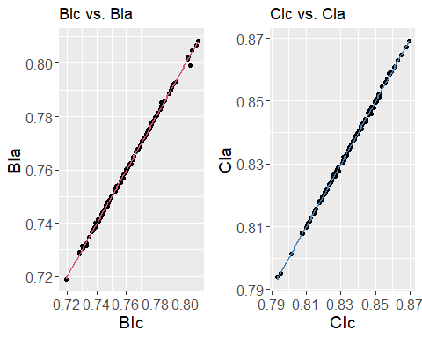

# 7. Simulating Three Commingling Conditions

## Description of Arguments in the Simulation

### Input Arguments

# - **N**: The total number of sample limbs, which can be the combination of the humerus and radius for the upper limb, or the combination of the femur and tibiae for the lower limb  
# - **n1**: The number of matched bones, i.e., humeri and radius (or the femur and tibia) from the same individual  
# - **n2**: The number of matched bones, i.e., the humerus and radius (or the femur and tibia) from different individuals  
# - **c**: The commingling degree of sample limbs, which quantifies the proportion of unmatched bones within the assemblage. For example, the n2 can be calculated as N * c, while n1 can be calculated as N * (1 - c)  
# - **mean.hml**: The mean of the maximum humeral length  
# - **mean.fbl**: The mean of the bicondylar femoral length  
# - **mean.bic**: The mean of the conventional Brachial Index  
# - **mean.cic**: The mean of the conventional Crural Index  
# - **sd.hml**: The standard deviation of the maximum humeral length  
# - **sd.fbl**: The standard deviation of the bicondylar femoral length  
# - **sd.bic**: The standard deviation of the conventionalBrachial Index, which also represents the within-group variation in the intra-upper-limb proportion.  
# - **sd.cic**: The standard deviation of the conventional Crural Index, which also represents the within-group variation in the intra-lower-limb proportion.  
# - **nsim**: The number of iterations to be performed in the simulation loop

### Output Arguments

# - **est.bi**: Estimated Brachial Index using the aggregate method  
# - **est.ci**: Estimated Crural Index using the aggregate method  
# - **error.bi**: The difference between the estimated Brachial Index and the input Brachial Index, i.e., error.bi = est.bi – mean.bi  
# - **error.ci**: The difference between the estimated Crural Index and the input Crural Index, i.e., error.ci = est.ci – mean.ci

## 7.1. Function for calculating and comparing the aggregated and conventional indices

### 7.1.1 BIc vs. BIa

simFun_bi <- function(n1,n2,mean.hml,sd.hml,sd.bi,mean.bi,nsim)  
{  
 est.bi <- numeric(length=nsim) #just a placeholder vector for storing estimates  
 for (i in 1:nsim) #main simulation loop  
 {  
 #Simulate paired individuals  
 hml.paired <- rnorm(n1/2,mean=mean.hml,sd=sd.hml)  
 bi.paired <- rnorm(n1/2,mean=mean.bi,sd=sd.bi)  
 rml.paired <- hml.paired * bi.paired  
 #Simulate unpaired individuals  
 hml.unpaired <- rnorm(n2/2,mean=mean.hml,sd=sd.hml)   
 #Simulate half the femur as normal  
 rml.unpaired <- rnorm(n2/2,mean=mean.hml,sd=sd.hml) * rnorm(n2/2,mean=mean.bi,sd=sd.bi) #Simulate another set of femurs but store only their corresponding Tibia after drawing other crural index values  
 #Combine  
 hml <- c(hml.paired,hml.unpaired)  
 rml <- c(rml.paired,rml.unpaired)  
 #Estimate  
 est.bi[i] <- mean(rml)/mean(hml)  
 }  
 return(list(true.bi=mean.bi,est.bi=est.bi,error=est.bi-mean.bi))  
}

### 7.1.2 CIc vs. CIa

simFun_ci <- function(n1,n2,mean.fbl,sd.fbl,sd.ci,mean.ci,nsim)  
{  
 est.ci <- numeric(length=nsim) #just a placeholder vector for storing estimates  
 for (i in 1:nsim) #main simulaion loop  
 {  
 #Simulate paired individuals  
 fbl.paired <- rnorm(n1/2,mean=mean.fbl,sd=sd.fbl)  
 ci.paired <- rnorm(n1/2,mean=mean.ci,sd=sd.ci)  
 tml.paired <- fbl.paired * ci.paired  
 #Simulate unpaired individuals  
 fbl.unpaired <- rnorm(n2/2,mean=mean.fbl,sd=sd.fbl)   
 #Simulate half the femur as normal  
 tml.unpaired <- rnorm(n2/2,mean=mean.fbl,sd=sd.fbl) * rnorm(n2/2,mean=mean.ci,sd=sd.ci) #Simulate another set of femurs but store only their corresponding Tibia after drawing other crural index values  
 #Combine  
 fbl <- c(fbl.paired,fbl.unpaired)  
 tml <- c(tml.paired,tml.unpaired)  
 #Estimate  
 est.ci[i] <- mean(tml)/mean(fbl)  
 }  
 return(list(true.ci=mean.ci,est.ci=est.ci,error=est.ci-mean.ci)) #   
}

## 7.2. Function for simulating the sample size (n), commingling (c) and variation (v)

### 7.2.1. Simulate the BI

# Create grid of parameter combinations to simulate  
n <- seq(10, 300, length.out = 30) # Sample size  
c <- seq(0, 1, length.out = 30) # Commingling Degree  
v <- c(0.01, 0.02, 0.08) # Within-group Variation in the Brachial index  
parm <- expand.grid(n, c, v)  
  
# Modify simulate function to run simulation 10000 times  
simulate <- function(parms, n_sims = 10000) {  
 # Extract parameters from parms  
 n <- parms[1]  
 c <- parms[2]  
 v <- parms[3]  
   
 # Round n to the nearest even number  
 n <- round(n/2) * 2  
   
 # Initialize variables to store results  
 error_set <- numeric(n_sims)  
   
 # Run simulations  
 for (i in 1:n_sims) {  
 # Call the simFun_ci function with the specified parameters  
 sim_result <- simFun_bi(n1 = round(n*(1-c)), n2 = round(n*c), mean.hml=308.73,sd.hml=13.24, sd.bi = v, mean.bi = 0.7597, nsim = 1)  
   
 # Compute error  
 error <- abs(sim_result$error)  
   
 # Store results  
 error_set[i] <- sim_result$error  
 }  
   
 # Compute summary statistics of the errors  
 mean_abs_error <- abs(mean(error_set)) # the absolute value of the mean  
 median_abs_error <- abs(median(error_set)) # absolute value of the median_error  
 percentile_75 <- abs(quantile(error_set, probs = 0.75, na.rm = TRUE))# Compute the 75th percentile of the errors  
   
 # Compute values that are greater than 0.02  
 abs_error_count <- sum(abs(error_set) > 0.02, na.rm = TRUE) # the number of errors in the error_set that have an absolute value greater than 0.02, excluding any NA values.  
 # the proportion of simulations where the absolute value of the median_error is greater than 0.02  
 prop_large_error <- abs_error_count / sum(!is.na(error_set))  
  
 # Create data frame with results and parameters  
 results_df_bi <- data.frame(n = n, c = c, v = v,   
 mean_abs_error = mean_abs_error,median_abs_error = median_abs_error, percentile_75=percentile_75,   
 abs_error_count = abs_error_count, prop_large_error = prop_large_error)  
  
 return(results_df_bi)  
}  
  
# Run simulation and store results in a data frame  
set.seed(123) # set seed for reproducibility  
results_bi <- replicate(1, apply(parm, 1, simulate), simplify = FALSE)  
results_df_bi <- bind_rows(results_bi)

### 7.2.1. Simulate the CI

# Create grid of parameter combinations to simulate  
n <- seq(10, 300, length.out = 30) # Sample size  
c <- seq(0, 1, length.out = 30) # Commingling Degree  
v <- c(0.01, 0.02, 0.05) # Within-group Variation in the Crural index  
parm <- expand.grid(n, c, v)  
  
# Modify simulate function to run simulation 10000 times  
simulate <- function(parms, n_sims = 10000) {  
 # Extract parameters from parms  
 n <- parms[1]  
 c <- parms[2]  
 v <- parms[3]  
   
 # Round n to the nearest even number  
 n <- round(n/2) * 2  
   
 # Initialize variables to store results  
 error_set <- numeric(n_sims)  
   
 # Run simulations  
 for (i in 1:n_sims) {  
 # Call the simFun_ci function with the specified parameters  
 sim_result <- simFun_ci(n1 = round(n*(1-c)), n2 = round(n*c), mean.fbl=426.64,sd.fbl=26.07, sd.ci = v, mean.ci = 0.8348, nsim = 1)  
   
 # Compute error  
 error <- abs(sim_result$error)  
   
 # Store results  
 error_set[i] <- sim_result$error  
 }  
   
 # Compute summary statistics of the errors  
 mean_abs_error <- abs(mean(error_set)) # the absolute value of the mean  
 median_abs_error <- abs(median(error_set)) # absolute value of the median_error  
 percentile_75 <- abs(quantile(error_set, probs = 0.75, na.rm = TRUE))# Compute the 75th percentile of the errors  
   
 # Compute values that are greater than 0.02  
 abs_error_count <- sum(abs(error_set) > 0.02, na.rm = TRUE) # the number of errors in the error_set that have an absolute value greater than 0.02, excluding any NA values.  
 # the proportion of simulations where the absolute value of the median_error is greater than 0.02  
 prop_large_error <- abs_error_count / sum(!is.na(error_set))  
   
  
 # Create data frame with results and parameters  
 results_df_ci <- data.frame(n = n, c = c, v = v,   
 mean_abs_error = mean_abs_error,median_abs_error = median_abs_error, percentile_75=percentile_75,   
 abs_error_count = abs_error_count, prop_large_error = prop_large_error)  
  
 return(results_df_ci)  
}  
  
# Run simulation and store results in a data frame  
set.seed(123) # set seed for reproducibility  
results_ci <- replicate(1, apply(parm, 1, simulate), simplify = FALSE)  
results_df_ci <- bind_rows(results_ci)

# 8. Plot

## 8.1. Set the parameter for indicative lines and common colour scale for each graph

# parameter for indicative lines  
simulated_n <- c (30, 50, 100)  
simulated_c <- c (0.25, 0.5, 0.75)  
  
# Find the common color scale limits for different sets of plots (mean, median, 75 percentile, and the number as well as proportion of large errors)  
## BI  
color_scale_mean_bi <- scale_fill_distiller(palette = "RdYlBu", limits = c(min(results_df_bi$mean_abs_error), max(results_df_bi$mean_abs_error)))  
color_scale_median_bi <- scale_fill_distiller(palette = "RdYlBu", limits = c(min(results_df_bi$median_abs_error), max(results_df_bi$median_abs_error)))  
color_scale_percentile_75_bi <- scale_fill_distiller(palette = "RdYlBu", limits = c(min(results_df_bi$percentile_75), max(results_df_bi$percentile_75)))  
color_scale_no_large_error_bi <- scale_fill_distiller(palette = "RdYlBu", limits = c(min(results_df_bi$abs_error_count), max(results_df_bi$abs_error_count)))  
color_scale_prop_large_error_bi <- scale_fill_distiller(palette = "RdYlBu", limits = c(min(results_df_bi$prop_large_error), max(results_df_bi$prop_large_error)))  
  
## CI  
color_scale_mean_ci <- scale_fill_distiller(palette = "RdYlBu", limits = c(min(results_df_ci$mean_abs_error), max(results_df_ci$mean_abs_error)))  
color_scale_median_ci <- scale_fill_distiller(palette = "RdYlBu", limits = c(min(results_df_ci$median_abs_error), max(results_df_ci$median_abs_error)))  
color_scale_percentile_75_ci <- scale_fill_distiller(palette = "RdYlBu", limits = c(min(results_df_ci$percentile_75), max(results_df_ci$percentile_75)))  
color_scale_no_large_error_ci <- scale_fill_distiller(palette = "RdYlBu", limits = c(min(results_df_ci$abs_error_count), max(results_df_ci$abs_error_count)))  
color_scale_prop_large_error_ci <- scale_fill_distiller(palette = "RdYlBu", limits = c(min(results_df_ci$prop_large_error), max(results_df_ci$prop_large_error)))

## 8.2. Plot-BI

### 8.2.1.Variation = 0.01

#### 8.2.1.1. Mean error ~ sample size + commingling

plot01 <- ggplot(results_df_bi[results_df_bi$v == 0.01, ], aes(x = n, y = c, fill = mean_abs_error)) +  
 geom_raster() +  
 geom_vline(xintercept = simulated_n, color = 'black', linewidth = 0.5, linetype = 'dashed') +  
 geom_hline(yintercept = simulated_c, color = 'black', linewidth = 0.5, linetype = 'dashed') +  
 color_scale_mean_bi +  
 xlab('Sample Size') +  
 ylab('Commingling degree') +  
 labs(fill = "Mean Errors\  
(sd.bi = 0.01)") +  
 coord_cartesian(expand = FALSE) +  
 theme_bw() +  
 theme(panel.grid = element_blank(), panel.border = element_blank(),  
 axis.text = element_text(size = 8, face = 'bold'), # Adjust axis text size  
 axis.title = element_text(size = 8, face = 'bold'), # Adjust axis title size  
 legend.title = element_text(size = 8, face = 'bold'),  
 legend.text = element_text(size = 8, face = 'bold'))  
  
# Print  
plot01

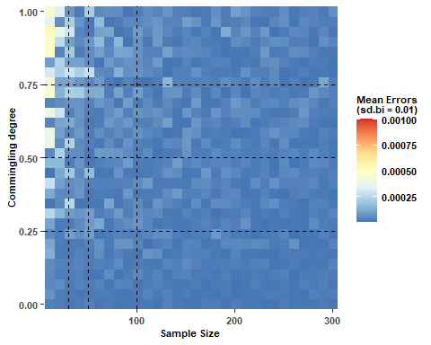

#### 8.2.1.2. Median absolute error ~ sample size + commingling

plot02 <- ggplot(results_df_bi[results_df_bi$v == 0.01, ], aes(x = n, y = c, fill = median_abs_error)) +  
 geom_raster() +  
 geom_vline(xintercept = simulated_n, color = 'black', size = 0.5, linetype = 'dashed') +  
 geom_hline(yintercept = simulated_c, color = 'black', size = 0.5, linetype = 'dashed') +  
 color_scale_median_bi +  
 xlab('Sample Size') +  
 ylab('Commingling') +  
 labs(fill = "Median Errors\  
(sd.bi = 0.01)") +  
 coord_cartesian(expand = FALSE) +  
 theme_bw() +  
 theme(panel.grid = element_blank(), panel.border = element_blank(),  
 axis.text = element_text(size = 8, face = 'bold'), # Adjust axis text size  
 axis.title = element_text(size = 8, face = 'bold'), # Adjust axis title size  
 legend.title = element_text(size = 8, face = 'bold'),  
 legend.text = element_text(size = 8, face = 'bold'))

## Warning: Using `size` aesthetic for lines was deprecated in ggplot2 3.4.0.  
## i Please use `linewidth` instead.  
## This warning is displayed once every 8 hours.  
## Call `lifecycle::last_lifecycle_warnings()` to see where this warning was  
## generated.

# Print  
plot02

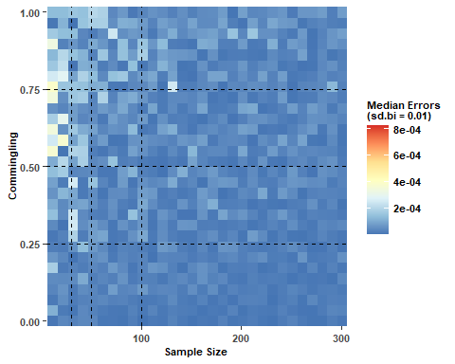

#### 8.2.1.3. Error 75% ~ sample size + commingling

plot03 <- ggplot(results_df_bi[results_df_bi$v == 0.01, ], aes(x = n, y = c, fill = percentile_75)) +  
 geom_raster() +  
 geom_vline(xintercept = simulated_n, color = 'black', size = 0.5, linetype = 'dashed') +  
 geom_hline(yintercept = simulated_c, color = 'black', size = 0.5, linetype = 'dashed') +  
 color_scale_percentile_75_bi +  
 xlab('Sample Size') +  
 ylab('Commingling') +  
 labs(fill = "75th Percentile\  
(sd.bi = 0.01)") +  
 coord_cartesian(expand = FALSE) +  
 theme_bw() +  
 theme(panel.grid = element_blank(), panel.border = element_blank(),  
 axis.text = element_text(size = 8, face = 'bold'), # Adjust axis text size  
 axis.title = element_text(size = 8, face = 'bold'), # Adjust axis title size  
 legend.title = element_text(size = 8, face = 'bold'),  
 legend.text = element_text(size = 8, face = 'bold'))  
  
# Print  
plot03

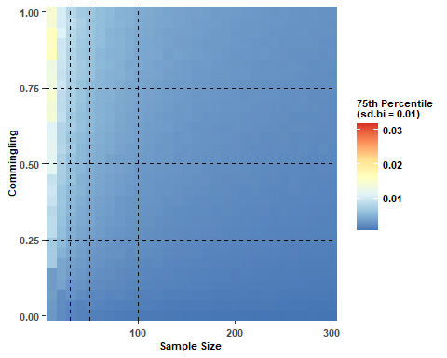

#### 8.2.1.4. Large error count ~ sample size + commingling

plot04 <- ggplot(results_df_bi[results_df_bi$v == 0.01, ], aes(x = n, y = c, fill = abs_error_count)) +  
 geom_raster() +  
 geom_vline(xintercept = simulated_n, color = 'black', size = 0.5, linetype = 'dashed') +  
 geom_hline(yintercept = simulated_c, color = 'black', size = 0.5, linetype = 'dashed') +  
 color_scale_no_large_error_bi +  
 xlab('Sample Size') +  
 ylab('Commingling') +  
 labs(fill = "The Number of\  
Large Errors(> 0.02,\  
sd.bi = 0.02)") +  
 coord_cartesian(expand = FALSE) +  
 theme_bw() +  
 theme(panel.grid = element_blank(), panel.border = element_blank(),  
 axis.text = element_text(size = 8, face = 'bold'), # Adjust axis text size  
 axis.title = element_text(size = 8, face = 'bold'), # Adjust axis title size  
 legend.title = element_text(size = 8, face = 'bold'),  
 legend.text = element_text(size = 8, face = 'bold'))  
  
# Print  
plot04

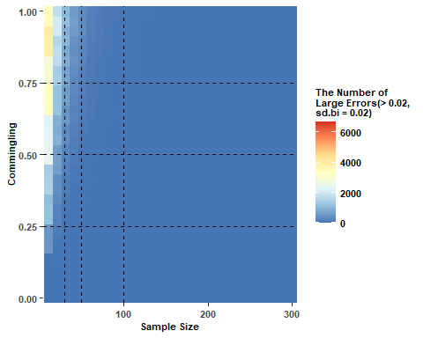

#### 8.2.1.5. Proportion of large error ~ sample size + commingling

plot05 <- ggplot(results_df_bi[results_df_bi$v == 0.01, ], aes(x = n, y = c, fill = prop_large_error)) +  
 geom_raster() +  
 geom_vline(xintercept = simulated_n, color = 'black', size = 0.5, linetype = 'dashed') +  
 geom_hline(yintercept = simulated_c, color = 'black', size = 0.5, linetype = 'dashed') +  
 color_scale_prop_large_error_bi +  
 xlab('Sample Size') +  
 ylab('Commingling') +  
 labs(fill = "Proportion of\  
Large Errors\  
(sd.bi = 0.01)") +  
 coord_cartesian(expand = FALSE) +  
 theme_bw() +  
 theme(panel.grid = element_blank(), panel.border = element_blank(),  
 axis.text = element_text(size = 8, face = 'bold'), # Adjust axis text size  
 axis.title = element_text(size = 8, face = 'bold'), # Adjust axis title size  
 legend.title = element_text(size = 8, face = 'bold'),  
 legend.text = element_text(size = 8, face = 'bold'))  
# Print  
plot05

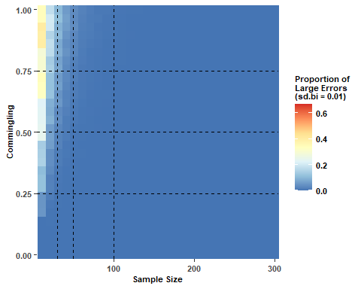

### 8.2.2. Variation = 0.02

#### 8.2.2.1. Mean error ~ sample size + commingling

plot06 <- ggplot(results_df_bi[results_df_bi$v == 0.02, ], aes(x = n, y = c, fill = mean_abs_error)) +  
 geom_raster() +  
 geom_vline(xintercept = simulated_n, color = 'black', linewidth = 0.5, linetype = 'dashed') +  
 geom_hline(yintercept = simulated_c, color = 'black', linewidth = 0.5, linetype = 'dashed') +  
 color_scale_mean_bi +  
 xlab('Sample Size') +  
 ylab('Commingling') +  
 labs(fill = "Mean Errors\  
(sd.bi = 0.02)") +  
 coord_cartesian(expand = FALSE) +  
 theme_bw() +  
 theme(panel.grid = element_blank(), panel.border = element_blank(),  
 axis.text = element_text(size = 8, face = 'bold'), # Adjust axis text size  
 axis.title = element_text(size = 8, face = 'bold'), # Adjust axis title size  
 legend.title = element_text(size = 8, face = 'bold'),  
 legend.text = element_text(size = 8, face = 'bold'))  
  
# Print  
plot06

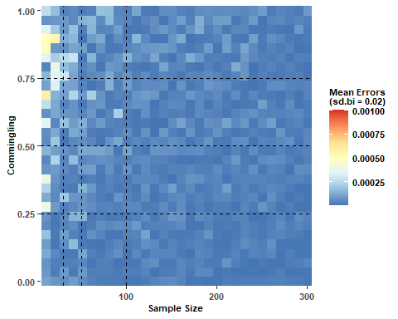

#### 8.2.2.2. Median absolute error ~ sample size + commingling

plot07 <- ggplot(results_df_bi[results_df_bi$v == 0.02, ], aes(x = n, y = c, fill = median_abs_error)) +  
 geom_raster() +  
 geom_vline(xintercept = simulated_n, color = 'black', size = 0.5, linetype = 'dashed') +  
 geom_hline(yintercept = simulated_c, color = 'black', size = 0.5, linetype = 'dashed') +  
 color_scale_median_bi +  
 xlab('Sample Size') +  
 ylab('Commingling') +  
 labs(fill = "Median Errors\  
(sd.bi = 0.02)") +  
 coord_cartesian(expand = FALSE) +  
 theme_bw() +  
 theme(panel.grid = element_blank(), panel.border = element_blank(),  
 axis.text = element_text(size = 8, face = 'bold'), # Adjust axis text size  
 axis.title = element_text(size = 8, face = 'bold'), # Adjust axis title size  
 legend.title = element_text(size = 8, face = 'bold'),  
 legend.text = element_text(size = 8, face = 'bold'))  
  
# Print  
plot07

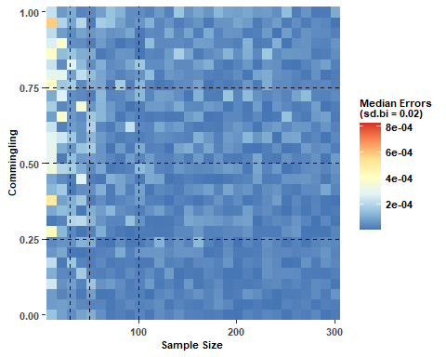

#### 8.2.2.3. Error 75% ~ sample size + commingling

plot08 <- ggplot(results_df_bi[results_df_bi$v == 0.02, ], aes(x = n, y = c, fill = percentile_75)) +  
 geom_raster() +  
 geom_vline(xintercept = simulated_n, color = 'black', size = 0.5, linetype = 'dashed') +  
 geom_hline(yintercept = simulated_c, color = 'black', size = 0.5, linetype = 'dashed') +  
 color_scale_percentile_75_bi +  
 xlab('Sample Size') +  
 ylab('Commingling') +  
 labs(fill = "75th Percentile\  
(sd.bi = 0.02)") +  
 coord_cartesian(expand = FALSE) +  
 theme_bw() +  
 theme(panel.grid = element_blank(), panel.border = element_blank(),  
 axis.text = element_text(size = 8, face = 'bold'), # Adjust axis text size  
 axis.title = element_text(size = 8, face = 'bold'), # Adjust axis title size  
 legend.title = element_text(size = 8, face = 'bold'),  
 legend.text = element_text(size = 8, face = 'bold'))  
  
# Print  
plot08

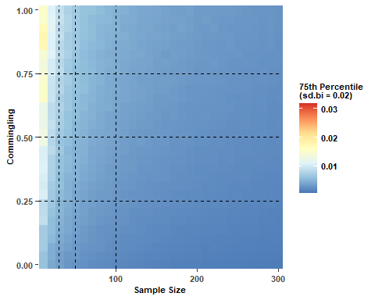

#### 8.2.2.4. Large error count ~ sample size + commingling

plot09 <- ggplot(results_df_bi[results_df_bi$v == 0.02, ], aes(x = n, y = c, fill = abs_error_count)) +  
 geom_raster() +  
 geom_vline(xintercept = simulated_n, color = 'black', size = 0.5, linetype = 'dashed') +  
 geom_hline(yintercept = simulated_c, color = 'black', size = 0.5, linetype = 'dashed') +  
 color_scale_no_large_error_bi +  
 xlab('Sample Size') +  
 ylab('Commingling') +  
 labs(fill = "The Number of\  
Large Error (> 0.02,\  
sd.bi = 0.02)") +  
 coord_cartesian(expand = FALSE) +  
 theme_bw() +  
 theme(panel.grid = element_blank(), panel.border = element_blank(),  
 axis.text = element_text(size = 8, face = 'bold'), # Adjust axis text size  
 axis.title = element_text(size = 8, face = 'bold'), # Adjust axis title size  
 legend.title = element_text(size = 8, face = 'bold'),  
 legend.text = element_text(size = 8, face = 'bold'))  
  
# Print  
plot09

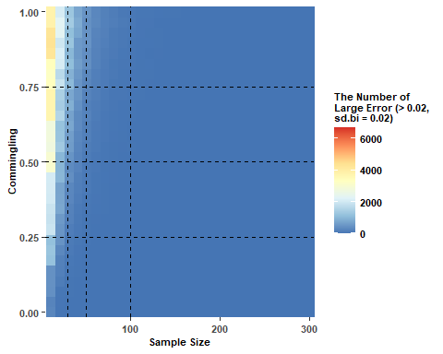

#### 8.2.2.5. Proportion of large error ~ sample size + commingling

plot010 <- ggplot(results_df_bi[results_df_bi$v == 0.02, ], aes(x = n, y = c, fill = prop_large_error)) +  
 geom_raster() +  
 geom_vline(xintercept = simulated_n, color = 'black', size = 0.5, linetype = 'dashed') +  
 geom_hline(yintercept = simulated_c, color = 'black', size = 0.5, linetype = 'dashed') +  
 color_scale_prop_large_error_bi +  
 xlab('Sample Size') +  
 ylab('Commingling') +  
 labs(fill = "Proportion of\  
Large Errors\  
(sd.bi = 0.02)") +  
 coord_cartesian(expand = FALSE) +  
 theme_bw() +  
 theme(panel.grid = element_blank(), panel.border = element_blank(),  
 axis.text = element_text(size = 8, face = 'bold'), # Adjust axis text size  
 axis.title = element_text(size = 8, face = 'bold'), # Adjust axis title size  
 legend.title = element_text(size = 8, face = 'bold'),  
 legend.text = element_text(size = 8, face = 'bold'))  
  
# Print  
plot010

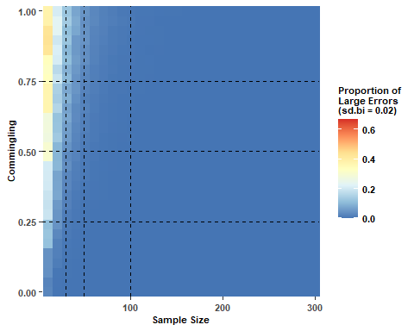

### 8.2.1. Variation = 0.08

#### 8.2.3.1. Mean error ~ sample size + commingling

plot011 <- ggplot(results_df_bi[results_df_bi$v == 0.08, ], aes(x = n, y = c, fill = mean_abs_error)) +  
 geom_raster() +  
 geom_vline(xintercept = simulated_n, color = 'black', linewidth = 0.5, linetype = 'dashed') +  
 geom_hline(yintercept = simulated_c, color = 'black', linewidth = 0.5, linetype = 'dashed') +  
 color_scale_mean_bi +  
 xlab('Sample Size') +  
 ylab('Commingling') +  
 labs(fill = "Mean Errors\  
(sd.bi = 0.08)") +  
 coord_cartesian(expand = FALSE) +  
 theme_bw() +  
 theme(panel.grid = element_blank(), panel.border = element_blank(),  
 axis.text = element_text(size = 8, face = 'bold'), # Adjust axis text size  
 axis.title = element_text(size = 8, face = 'bold'), # Adjust axis title size  
 legend.title = element_text(size = 8, face = 'bold'),  
 legend.text = element_text(size = 8, face = 'bold'))  
  
# Print  
plot011

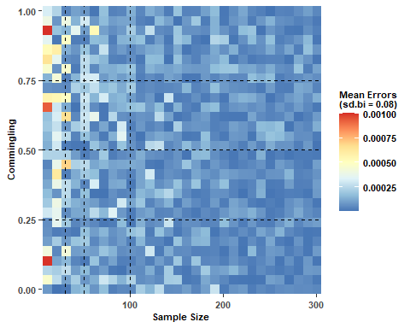

#### 8.2.3.2. Median absolute error ~ sample size + commingling

plot012 <- ggplot(results_df_bi[results_df_bi$v == 0.08, ], aes(x = n, y = c, fill = median_abs_error)) +  
 geom_raster() +  
 geom_vline(xintercept = simulated_n, color = 'black', size = 0.5, linetype = 'dashed') +  
 geom_hline(yintercept = simulated_c, color = 'black', size = 0.5, linetype = 'dashed') +  
 color_scale_median_bi +  
 xlab('Sample Size') +  
 ylab('Commingling') +  
 labs(fill = "Median Errors\  
(sd.bi = 0.08)") +  
 coord_cartesian(expand = FALSE) +  
 theme_bw() +  
 theme(panel.grid = element_blank(), panel.border = element_blank(),  
 axis.text = element_text(size = 8, face = 'bold'), # Adjust axis text size  
 axis.title = element_text(size = 8, face = 'bold'), # Adjust axis title size  
 legend.title = element_text(size = 8, face = 'bold'),  
 legend.text = element_text(size = 8, face = 'bold'))  
  
# Print  
plot012

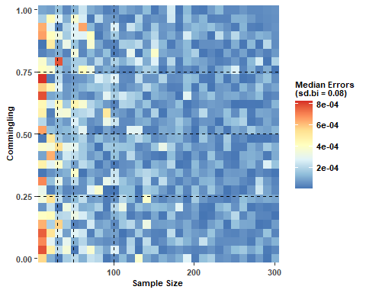

#### 8.2.3.3. Error 75% ~ sample size + commingling

plot013 <- ggplot(results_df_bi[results_df_bi$v == 0.08, ], aes(x = n, y = c, fill = percentile_75)) +  
 geom_raster() +  
 geom_vline(xintercept = simulated_n, color = 'black', size = 0.5, linetype = 'dashed') +  
 geom_hline(yintercept = simulated_c, color = 'black', size = 0.5, linetype = 'dashed') +  
 color_scale_percentile_75_bi +  
 xlab('Sample Size') +  
 ylab('Commingling') +  
 labs(fill = "75th Percentile\  
(sd.bi = 0.08)") +  
 coord_cartesian(expand = FALSE) +  
 theme_bw() +  
 theme(panel.grid = element_blank(), panel.border = element_blank(),  
 axis.text = element_text(size = 8, face = 'bold'), # Adjust axis text size  
 axis.title = element_text(size = 8, face = 'bold'), # Adjust axis title size  
 legend.title = element_text(size = 8, face = 'bold'),  
 legend.text = element_text(size = 8, face = 'bold'))  
  
# Print  
plot013

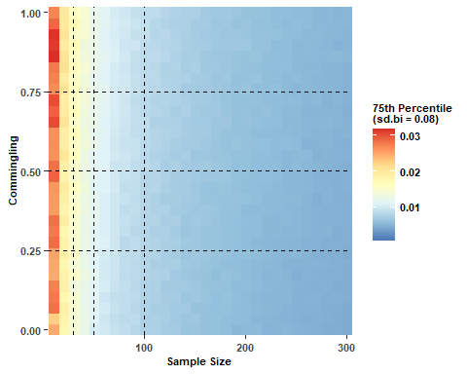

#### 8.2.3.4. Large error count ~ sample size + commingling

plot014 <- ggplot(results_df_bi[results_df_bi$v == 0.08, ], aes(x = n, y = c, fill = abs_error_count)) +  
 geom_raster() +  
 geom_vline(xintercept = simulated_n, color = 'black', size = 0.5, linetype = 'dashed') +  
 geom_hline(yintercept = simulated_c, color = 'black', size = 0.5, linetype = 'dashed') +  
 color_scale_no_large_error_bi +  
 xlab('Sample Size') +  
 ylab('Commingling') +  
 labs(fill = "The Number of\  
Large Error (> 0.02,\  
sd.bi = 0.08)") +  
 coord_cartesian(expand = FALSE) +  
 theme_bw() +  
 theme(panel.grid = element_blank(), panel.border = element_blank(),  
 axis.text = element_text(size = 8, face = 'bold'), # Adjust axis text size  
 axis.title = element_text(size = 8, face = 'bold'), # Adjust axis title size  
 legend.title = element_text(size = 8, face = 'bold'),  
 legend.text = element_text(size = 8, face = 'bold'))  
  
# Print  
plot014

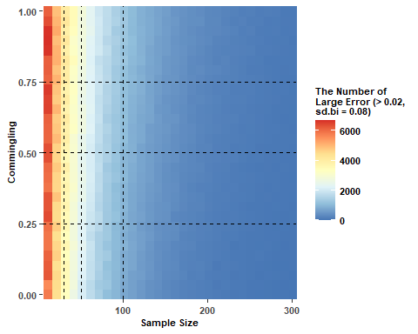

#### 8.2.3.5. Proportion of large error ~ sample size + commingling

plot015 <- ggplot(results_df_bi[results_df_bi$v == 0.08, ], aes(x = n, y = c, fill = prop_large_error)) +  
 geom_raster() +  
 geom_vline(xintercept = simulated_n, color = 'black', size = 0.5, linetype = 'dashed') +  
 geom_hline(yintercept = simulated_c, color = 'black', size = 0.5, linetype = 'dashed') +  
 color_scale_prop_large_error_bi +  
 xlab('Sample Size') +  
 ylab('Commingling') +  
 labs(fill = "Proportion of\  
Large Errors\  
(sd.bi = 0.08)") +  
 coord_cartesian(expand = FALSE) +  
 theme_bw() +  
 theme(panel.grid = element_blank(), panel.border = element_blank(),  
 axis.text = element_text(size = 8, face = 'bold'), # Adjust axis text size  
 axis.title = element_text(size = 8, face = 'bold'), # Adjust axis title size  
 legend.title = element_text(size = 8, face = 'bold'),  
 legend.text = element_text(size = 8, face = 'bold'))  
  
# Print  
plot015

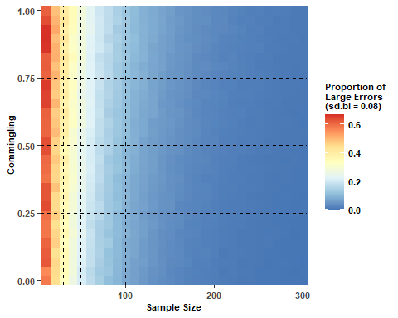

## 8.3. Plot CI

### 8.3.1. Variation = 0.01

#### 8.3.1.1. Mean error ~ sample size + commingling

plot1 <- ggplot(results_df_ci[results_df_ci$v == 0.01, ], aes(x = n, y = c, fill = mean_abs_error)) +  
 geom_raster() +  
 geom_vline(xintercept = simulated_n, color = 'black', linewidth = 0.5, linetype = 'dashed') +  
 geom_hline(yintercept = simulated_c, color = 'black', linewidth = 0.5, linetype = 'dashed') +  
 color_scale_mean_ci +  
 xlab('Sample Size') +  
 ylab('Commingling degree') +  
 labs(fill = "Mean Errors\  
(sd.ci = 0.01)") +  
 coord_cartesian(expand = FALSE) +  
 theme_bw() +  
 theme(panel.grid = element_blank(), panel.border = element_blank(),  
 axis.text = element_text(size = 8, face = 'bold'), # Adjust axis text size  
 axis.title = element_text(size = 8, face = 'bold'), # Adjust axis title size  
 legend.title = element_text(size = 8, face = 'bold'),  
 legend.text = element_text(size = 8, face = 'bold'))  
  
# Print  
plot1

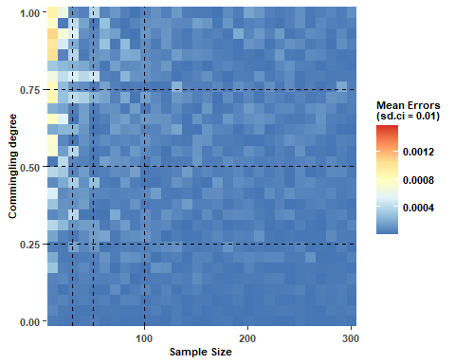

#### 8.3.1.2. Median absolute error ~ sample size + commingling

plot2 <- ggplot(results_df_ci[results_df_ci$v == 0.01, ], aes(x = n, y = c, fill = median_abs_error)) +  
 geom_raster() +  
 geom_vline(xintercept = simulated_n, color = 'black', size = 0.5, linetype = 'dashed') +  
 geom_hline(yintercept = simulated_c, color = 'black', size = 0.5, linetype = 'dashed') +  
 color_scale_median_ci +  
 xlab('Sample Size') +  
 ylab('Commingling') +  
 labs(fill = "Median Errors\  
(sd.ci = 0.01)") +  
 coord_cartesian(expand = FALSE) +  
 theme_bw() +  
 theme(panel.grid = element_blank(), panel.border = element_blank(),  
 axis.text = element_text(size = 8, face = 'bold'), # Adjust axis text size  
 axis.title = element_text(size = 8, face = 'bold'), # Adjust axis title size  
 legend.title = element_text(size = 8, face = 'bold'),  
 legend.text = element_text(size = 8, face = 'bold'))  
  
# Print  
plot2

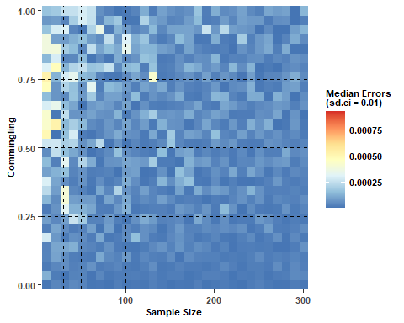

#### 8.3.1.3. Error 75% ~ sample size + commingling

plot3 <- ggplot(results_df_ci[results_df_ci$v == 0.01, ], aes(x = n, y = c, fill = percentile_75)) +  
 geom_raster() +  
 geom_vline(xintercept = simulated_n, color = 'black', size = 0.5, linetype = 'dashed') +  
 geom_hline(yintercept = simulated_c, color = 'black', size = 0.5, linetype = 'dashed') +  
 color_scale_percentile_75_ci +  
 xlab('Sample Size') +  
 ylab('Commingling') +  
 labs(fill = "75th Percentile   
(sd.ci = 0.01)") +  
 coord_cartesian(expand = FALSE) +  
 theme_bw() +  
 theme(panel.grid = element_blank(), panel.border = element_blank(),  
 axis.text = element_text(size = 8, face = 'bold'), # Adjust axis text size  
 axis.title = element_text(size = 8, face = 'bold'), # Adjust axis title size  
 legend.title = element_text(size = 8, face = 'bold'),  
 legend.text = element_text(size = 8, face = 'bold'))  
  
# Print  
plot3

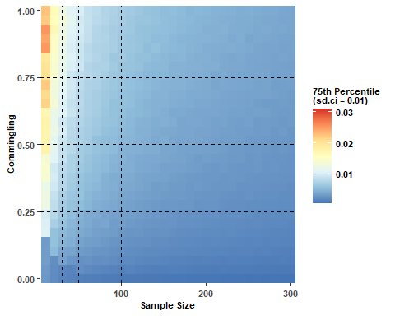

#### 8.3.1.4. Large error count ~ sample size + commingling

plot4 <- ggplot(results_df_ci[results_df_ci$v == 0.01, ], aes(x = n, y = c, fill = abs_error_count)) +  
 geom_raster() +  
 geom_vline(xintercept = simulated_n, color = 'black', size = 0.5, linetype = 'dashed') +  
 geom_hline(yintercept = simulated_c, color = 'black', size = 0.5, linetype = 'dashed') +  
 color_scale_no_large_error_ci +  
 xlab('Sample Size') +  
 ylab('Commingling') +  
 labs(fill = "The Number of\  
Large Errors(> 0.02,\  
sd.ci = 0.01)") +  
 coord_cartesian(expand = FALSE) +  
 theme_bw() +  
 theme(panel.grid = element_blank(), panel.border = element_blank(),  
 axis.text = element_text(size = 8, face = 'bold'), # Adjust axis text size  
 axis.title = element_text(size = 8, face = 'bold'), # Adjust axis title size  
 legend.title = element_text(size = 8, face = 'bold'),  
 legend.text = element_text(size = 8, face = 'bold'))  
  
# Print  
plot4

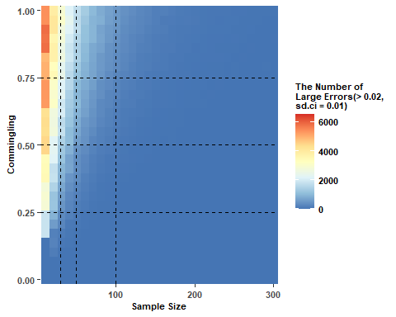

#### 8.3.1.5. Proportion of large error ~ sample size + commingling

plot5 <- ggplot(results_df_ci[results_df_ci$v == 0.01, ], aes(x = n, y = c, fill = prop_large_error)) +  
 geom_raster() +  
 geom_vline(xintercept = simulated_n, color = 'black', size = 0.5, linetype = 'dashed') +  
 geom_hline(yintercept = simulated_c, color = 'black', size = 0.5, linetype = 'dashed') +  
 color_scale_prop_large_error_ci +  
 xlab('Sample Size') +  
 ylab('Commingling') +  
 labs(fill = "Proportion of\  
Large Errors\  
(sd.ci = 0.01)") +  
 coord_cartesian(expand = FALSE) +  
 theme_bw() +  
 theme(panel.grid = element_blank(), panel.border = element_blank(),  
 axis.text = element_text(size = 8, face = 'bold'), # Adjust axis text size  
 axis.title = element_text(size = 8, face = 'bold'), # Adjust axis title size  
 legend.title = element_text(size = 8, face = 'bold'),  
 legend.text = element_text(size = 8, face = 'bold'))  
  
# Print  
plot5

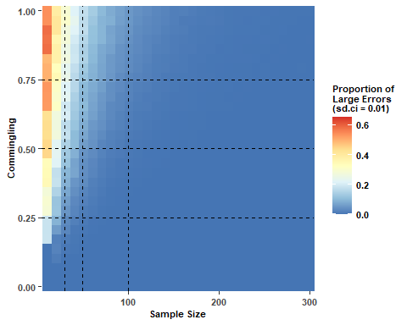

### 8.3.2. Variation = 0.02

#### 8.3.2.1. Mean error ~ sample size + commingling

plot6 <- ggplot(results_df_ci[results_df_ci$v == 0.02, ], aes(x = n, y = c, fill = mean_abs_error)) +  
 geom_raster() +  
 geom_vline(xintercept = simulated_n, color = 'black', linewidth = 0.5, linetype = 'dashed') +  
 geom_hline(yintercept = simulated_c, color = 'black', linewidth = 0.5, linetype = 'dashed') +  
 color_scale_mean_ci +  
 xlab('Sample Size') +  
 ylab('Commingling') +  
 labs(fill = "Mean Errors\  
(sd.ci = 0.02)") +  
 coord_cartesian(expand = FALSE) +  
 theme_bw() +  
 theme(panel.grid = element_blank(), panel.border = element_blank(),  
 axis.text = element_text(size = 8, face = 'bold'), # Adjust axis text size  
 axis.title = element_text(size = 8, face = 'bold'), # Adjust axis title size  
 legend.title = element_text(size = 8, face = 'bold'),  
 legend.text = element_text(size = 8, face = 'bold'))  
  
# Print  
plot6

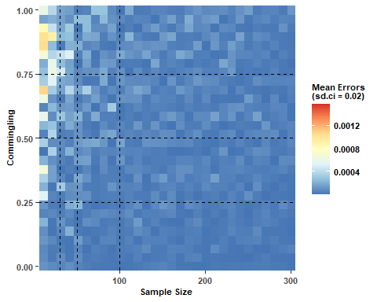

#### 8.3.2.2. Median absolute error ~ sample size + commingling

plot7 <- ggplot(results_df_ci[results_df_ci$v == 0.02, ], aes(x = n, y = c, fill = median_abs_error)) +  
 geom_raster() +  
 geom_vline(xintercept = simulated_n, color = 'black', size = 0.5, linetype = 'dashed') +  
 geom_hline(yintercept = simulated_c, color = 'black', size = 0.5, linetype = 'dashed') +  
 color_scale_median_ci +  
 xlab('Sample Size') +  
 ylab('Commingling') +  
 labs(fill = "Median Errors\  
(sd.ci = 0.02)") +  
 coord_cartesian(expand = FALSE) +  
 theme_bw() +  
 theme(panel.grid = element_blank(), panel.border = element_blank(),  
 axis.text = element_text(size = 8, face = 'bold'), # Adjust axis text size  
 axis.title = element_text(size = 8, face = 'bold'), # Adjust axis title size  
 legend.title = element_text(size = 8, face = 'bold'),  
 legend.text = element_text(size = 8, face = 'bold'))  
  
# Print  
plot7

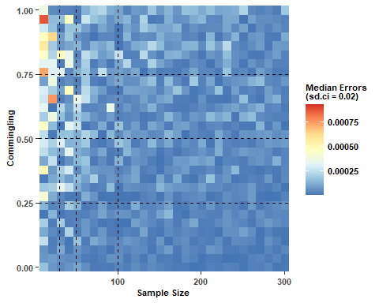

#### 8.3.2.3. Error 75% ~ sample size + commingling

plot8 <- ggplot(results_df_ci[results_df_ci$v == 0.02, ], aes(x = n, y = c, fill = percentile_75)) +  
 geom_raster() +  
 geom_vline(xintercept = simulated_n, color = 'black', size = 0.5, linetype = 'dashed') +  
 geom_hline(yintercept = simulated_c, color = 'black', size = 0.5, linetype = 'dashed') +  
 color_scale_percentile_75_ci+  
 xlab('Sample Size') +  
 ylab('Commingling') +  
 labs(fill = "75th Percentile\  
(sd.ci = 0.02)") +  
 coord_cartesian(expand = FALSE) +  
 theme_bw() +  
 theme(panel.grid = element_blank(), panel.border = element_blank(),  
 axis.text = element_text(size = 8, face = 'bold'), # Adjust axis text size  
 axis.title = element_text(size = 8, face = 'bold'), # Adjust axis title size  
 legend.title = element_text(size = 8, face = 'bold'),  
 legend.text = element_text(size = 8, face = 'bold'))  
  
# Print  
plot8

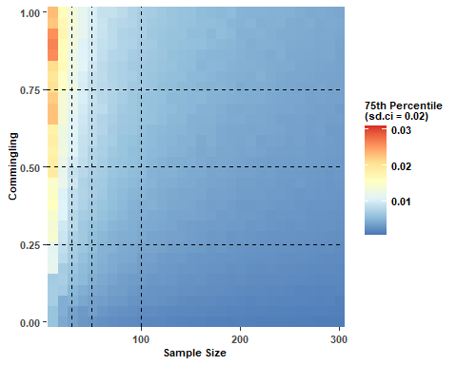

#### 8.3.2.4. Large error count ~ sample size + commingling

plot9 <- ggplot(results_df_ci[results_df_ci$v == 0.02, ], aes(x = n, y = c, fill = abs_error_count)) +  
 geom_raster() +  
 geom_vline(xintercept = simulated_n, color = 'black', size = 0.5, linetype = 'dashed') +  
 geom_hline(yintercept = simulated_c, color = 'black', size = 0.5, linetype = 'dashed') +  
 color_scale_no_large_error_ci +  
 xlab('Sample Size') +  
 ylab('Commingling') +  
 labs(fill = "The Number of\  
Large Error (> 0.02,\  
sd.ci = 0.02)") +  
 coord_cartesian(expand = FALSE) +  
 theme_bw() +  
 theme(panel.grid = element_blank(), panel.border = element_blank(),  
 axis.text = element_text(size = 8, face = 'bold'), # Adjust axis text size  
 axis.title = element_text(size = 8, face = 'bold'), # Adjust axis title size  
 legend.title = element_text(size = 8, face = 'bold'),  
 legend.text = element_text(size = 8, face = 'bold'))  
  
# Print  
plot9

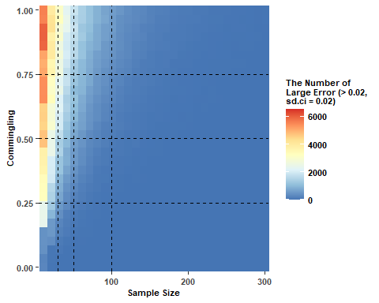

#### 8.3.2.5. Proportion of large error ~ sample size + commingling

plot10 <- ggplot(results_df_ci[results_df_ci$v == 0.02, ], aes(x = n, y = c, fill = prop_large_error)) +  
 geom_raster() +  
 geom_vline(xintercept = simulated_n, color = 'black', size = 0.5, linetype = 'dashed') +  
 geom_hline(yintercept = simulated_c, color = 'black', size = 0.5, linetype = 'dashed') +  
 color_scale_prop_large_error_ci +  
 xlab('Sample Size') +  
 ylab('Commingling') +  
 labs(fill = "Proportion of\  
Large Errors\  
(sd.ci = 0.02)") +  
 coord_cartesian(expand = FALSE) +  
 theme_bw() +  
 theme(panel.grid = element_blank(), panel.border = element_blank(),  
 axis.text = element_text(size = 8, face = 'bold'), # Adjust axis text size  
 axis.title = element_text(size = 8, face = 'bold'), # Adjust axis title size  
 legend.title = element_text(size = 8, face = 'bold'),  
 legend.text = element_text(size = 8, face = 'bold'))  
  
# Print  
plot10

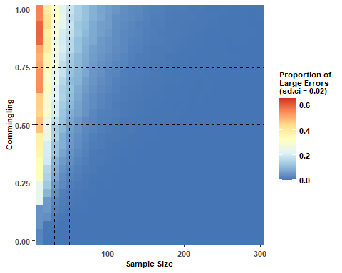

### 8.3.3. Variation = 0.05

#### 8.3.3.1. Mean error ~ sample size + commingling

plot11 <- ggplot(results_df_ci[results_df_ci$v == 0.05, ], aes(x = n, y = c, fill = mean_abs_error)) +  
 geom_raster() +  
 geom_vline(xintercept = simulated_n, color = 'black', linewidth = 0.5, linetype = 'dashed') +  
 geom_hline(yintercept = simulated_c, color = 'black', linewidth = 0.5, linetype = 'dashed') +  
 color_scale_mean_ci +  
 xlab('Sample Size') +  
 ylab('Commingling') +  
 labs(fill = "Mean Errors\  
(sd.ci = 0.05)") +  
 coord_cartesian(expand = FALSE) +  
 theme_bw() +  
 theme(panel.grid = element_blank(), panel.border = element_blank(),  
 axis.text = element_text(size = 8, face = 'bold'), # Adjust axis text size  
 axis.title = element_text(size = 8, face = 'bold'), # Adjust axis title size  
 legend.title = element_text(size = 8, face = 'bold'),  
 legend.text = element_text(size = 8, face = 'bold'))  
  
# Print  
plot11

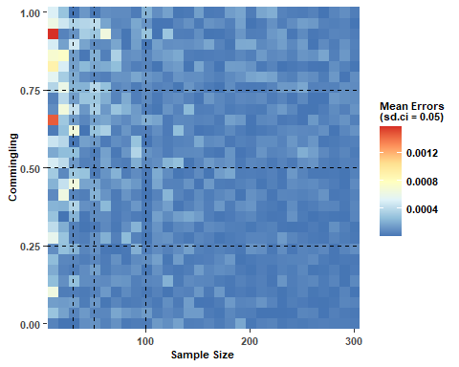

#### 8.3.3.2. Median absolute error ~ sample size + commingling

plot12 <- ggplot(results_df_ci[results_df_ci$v == 0.05, ], aes(x = n, y = c, fill = median_abs_error)) +  
 geom_raster() +  
 geom_vline(xintercept = simulated_n, color = 'black', size = 0.5, linetype = 'dashed') +  
 geom_hline(yintercept = simulated_c, color = 'black', size = 0.5, linetype = 'dashed') +  
 color_scale_median_ci +  
 xlab('Sample Size') +  
 ylab('Commingling') +  
 labs(fill = "Median Errors\  
(sd.ci = 0.05)") +  
 coord_cartesian(expand = FALSE) +  
 theme_bw() +  
 theme(panel.grid = element_blank(), panel.border = element_blank(),  
 axis.text = element_text(size = 8, face = 'bold'), # Adjust axis text size  
 axis.title = element_text(size = 8, face = 'bold'), # Adjust axis title size  
 legend.title = element_text(size = 8, face = 'bold'),  
 legend.text = element_text(size = 8, face = 'bold'))  
  
# Print  
plot12

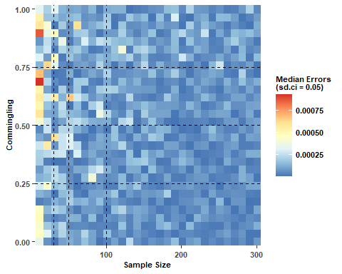

#### 8.3.3.3. Error 75% ~ sample size + commingling

plot13 <- ggplot(results_df_ci[results_df_ci$v == 0.05, ], aes(x = n, y = c, fill = percentile_75)) +  
 geom_raster() +  
 geom_vline(xintercept = simulated_n, color = 'black', size = 0.5, linetype = 'dashed') +  
 geom_hline(yintercept = simulated_c, color = 'black', size = 0.5, linetype = 'dashed') +  
 color_scale_percentile_75_ci +  
 xlab('Sample Size') +  
 ylab('Commingling') +  
 labs(fill = "75th Percentile\  
(sd.ci = 0.05)") +  
 coord_cartesian(expand = FALSE) +  
 theme_bw() +  
 theme(panel.grid = element_blank(), panel.border = element_blank(),  
 axis.text = element_text(size = 8, face = 'bold'), # Adjust axis text size  
 axis.title = element_text(size = 8, face = 'bold'), # Adjust axis title size  
 legend.title = element_text(size = 8, face = 'bold'),  
 legend.text = element_text(size = 8, face = 'bold'))  
  
# Print  
plot13

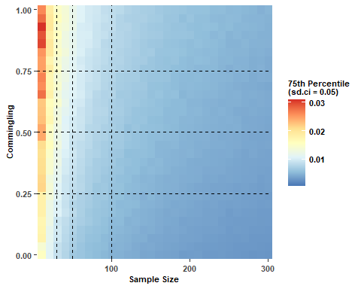

#### 8.3.3.4. Large error count ~ sample size + commingling

plot14 <- ggplot(results_df_ci[results_df_ci$v == 0.05, ], aes(x = n, y = c, fill = abs_error_count)) +  
 geom_raster() +  
 geom_vline(xintercept = simulated_n, color = 'black', size = 0.5, linetype = 'dashed') +  
 geom_hline(yintercept = simulated_c, color = 'black', size = 0.5, linetype = 'dashed') +  
 color_scale_no_large_error_ci +  
 xlab('Sample Size') +  
 ylab('Commingling') +  
 labs(fill = "The Number of\  
Large Error (> 0.02,\  
sd.ci = 0.05)") +  
 coord_cartesian(expand = FALSE) +  
 theme_bw() +  
 theme(panel.grid = element_blank(), panel.border = element_blank(),  
 axis.text = element_text(size = 8, face = 'bold'), # Adjust axis text size  
 axis.title = element_text(size = 8, face = 'bold'), # Adjust axis title size  
 legend.title = element_text(size = 8, face = 'bold'),  
 legend.text = element_text(size = 8, face = 'bold'))  
  
# Print  
plot14

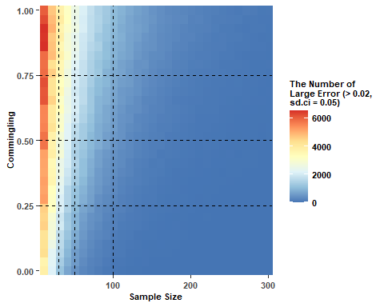

#### 8.3.3.5. Proportion of large error ~ sample size + commingling

plot15 <- ggplot(results_df_ci[results_df_ci$v == 0.05, ], aes(x = n, y = c, fill = prop_large_error)) +  
 geom_raster() +  
 geom_vline(xintercept = simulated_n, color = 'black', size = 0.5, linetype = 'dashed') +  
 geom_hline(yintercept = simulated_c, color = 'black', size = 0.5, linetype = 'dashed') +  
 color_scale_prop_large_error_ci +  
 xlab('Sample Size') +  
 ylab('Commingling') +  
 labs(fill = "Proportion of\  
Large Errors\  
(sd.ci = 0.05)") +  
 coord_cartesian(expand = FALSE) +  
 theme_bw() +  
 theme(panel.grid = element_blank(), panel.border = element_blank(),  
 axis.text = element_text(size = 8, face = 'bold'), # Adjust axis text size  
 axis.title = element_text(size = 8, face = 'bold'), # Adjust axis title size  
 legend.title = element_text(size = 8, face = 'bold'),  
 legend.text = element_text(size = 8, face = 'bold'))  
  
# Print  
plot15

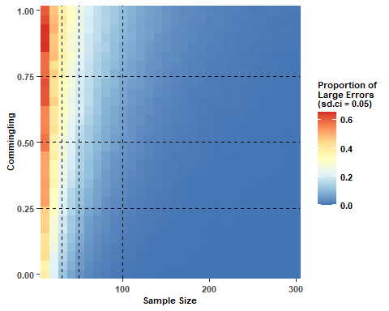

## 8.4. Combine the plots

### 8.4.1. Combine the BI plots

# Combine the plots using grid.arrange  
comb_bi <- grid.arrange(plot01, plot06, plot011,  
 plot02, plot07, plot012,  
 plot03, plot08, plot013, ncol = 3)

### 8.4.2. Combine the CI plots

# Combine the plots using grid.arrange  
comb_ci <- grid.arrange(plot1, plot6, plot11,  
 plot2, plot7, plot12,  
 plot3, plot8, plot13, ncol = 3)

### 8.4.2. Combine the BI and CI plots

# Combine the plots using grid.arrange  
comb_bc <- grid.arrange(plot05, plot5,  
 plot010,plot10,  
 plot015,plot15, ncol = 2)

