Archaeological_linear_mixed_models

DC

2024-11-30

# 0. Prepare the work envrionment

## Install necessary packages

# Install necessary packages  
required_packages <- c(  
 "tidyverse", "lme4", "MASS", "car", "lmerTest", "performance",   
 "splines", "brms", "elevatr", "raster", "ggplot2", "akima",   
 "fields", "sf", "sp", "RColorBrewer", "gstat", "broom.mixed"  
)  
  
# Install missing packages  
install_missing <- required_packages[!required_packages %in% installed.packages()[, "Package"]]  
if (length(install_missing) > 0) {  
 install.packages(install_missing)  
}  
  
# Load libraries  
lapply(required_packages, library, character.only = TRUE)

# 1. Import the dataset and prepare the data

ancient_chi_detail <- read_csv("data/ancient_chinese_detail_for_mixed_effects_july.csv")  
ancient_chi_detail <- ancient_chi_detail %>%   
 mutate(time_period = as.character(time_period),  
 Subsistence = as.character(Subsistence))

## Assign the climatic data

coordinates_ancient_detail <- ancient_chi_detail %>%  
 dplyr::select(longitude, latitude)   
  
# Convert to a spatial points object  
points_ancient_detail <- SpatialPoints(coordinates_ancient_detail)

### Extract raster values for each point

min_temp_values_ancient_detail <- extract(Min_temp, points_ancient_detail)  
max_temp_values_ancient_detail <- extract(Max_temp, points_ancient_detail)  
min_precip_values_ancient_detail <- extract(Min_precip, points_ancient_detail)  
max_precip_values_ancient_detail <- extract(Max_precip, points_ancient_detail)

### Add the extracted data back to the dataset

ancient_chi_detail <- ancient_chi_detail %>%  
 mutate(Min_temp = min_temp_values_ancient_detail,  
 Max_temp = max_temp_values_ancient_detail,  
 Min_precip = min_precip_values_ancient_detail,  
 Max_precip = max_precip_values_ancient_detail)

## Seperate males and females

ancient_chi_male <- ancient_chi_detail %>%  
 filter(sex == '0')  
ancient_chi_female <- ancient_chi_detail %>%  
 filter(sex == '1')

# 2. Influences from the environment and time periods

## Remove rows with missing values in the columns used in the models

### For FXL

ancient_chi_male_FXL <- ancient_chi_male %>%  
 filter(!is.na(FXL))  
ancient_chi_female_FXL <- ancient_chi_female %>%  
 filter(!is.na(FXL))

### For TXL

ancient_chi_male_TXL <- ancient_chi_male %>%  
 filter(!is.na(TXL))  
ancient_chi_female_TXL <- ancient_chi_female %>%  
 filter(!is.na(TXL))

### For HXL

ancient_chi_male_HXL <- ancient_chi_male %>%  
 filter(!is.na(ancient_chi_male$HXL))  
ancient_chi_female_HXL <- ancient_chi_female %>%  
 filter(!is.na(ancient_chi_female$HXL))

### For RXL

ancient_chi_male_RXL <- ancient_chi_male %>%  
 filter(!is.na(ancient_chi_male$RXL))  
ancient_chi_female_RXL <- ancient_chi_female %>%  
 filter(!is.na(ancient_chi_female$RXL))

### For FHD

ancient_chi_male_FHD <- ancient_chi_male %>%  
 filter(!is.na(FHD))  
ancient_chi_female_FHD <- ancient_chi_female %>%  
 filter(!is.na(FHD))

## 2.1 Basic Linear regression

### Fit the full linear model using lm

#### For FXL

lm_ancient_male_fxl_full <- lm(data = ancient_chi_male_FXL, FXL ~ altitude_range + Min_temp + Max_temp + Min_precip + Max_precip + time_period ) # using time_period rather than subsistence to keep independence of each predictor  
lm_ancient_female_fxl_full <- lm(data = ancient_chi_female_FXL, FXL ~ altitude_range + Min_temp + Max_temp + Min_precip + Max_precip + time_period )

#### For TXL

lm_ancient_male_txl_full <- lm(data = ancient_chi_male_TXL, TXL ~ altitude_range + Min_temp + Max_temp + Min_precip + Max_precip + time_period ) # using time_period rather than subsistence to keep independence of each predictor  
lm_ancient_female_txl_full <- lm(data = ancient_chi_female_TXL, TXL ~ altitude_range + Min_temp + Max_temp + Min_precip + Max_precip + time_period )

#### For FHD

lm_ancient_male_fhd_full <- lm(data = ancient_chi_male_FHD, FHD ~ altitude_range+ Min_temp + Max_temp + Min_precip + Max_precip + time_period ) # using time_period rather than subsistence to keep independence of each predictor  
lm_ancient_female_fhd_full <- lm(data = ancient_chi_female_FHD, FHD ~ altitude_range + Min_temp + Max_temp + Min_precip + Max_precip + time_period )

## 2.2 Mixed effects analyis

### Fit the full mixed effects model using lmer

#### For FXL

# Fit the model again with lmerTest loaded  
lme_male_fxl_full1 <- lmer(FXL ~ altitude_range + Min_temp + Max_temp + Min_precip + Max_precip + time_period + (1 | site_id), data = ancient_chi_male_FXL)  
lme_female_fxl_full1 <- lmer(FXL ~ altitude_range + Min_temp + Max_temp + Min_precip + Max_precip + time_period + (1 | site_id), data = ancient_chi_female_FXL)

#### Check the model

check_model(lme_male_fxl_full1, check = c("linearity", "homogeneity", "normality"))

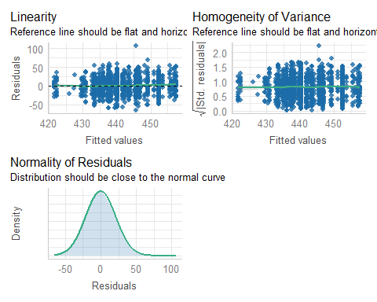

check_model(lme_female_fxl_full1, check = c("linearity", "homogeneity", "normality"))

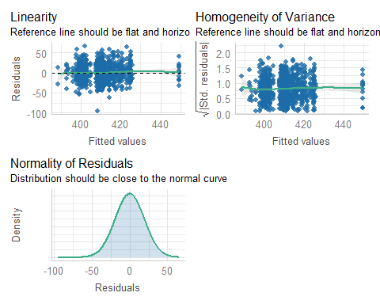

#### For TXL

# Fit the model again with lmerTest loaded  
lme_male_txl_full1 <- lmer(TXL ~ altitude_range + Min_temp + Max_temp + Min_precip + Max_precip + time_period + (1 | site_id), data = ancient_chi_male_TXL)  
lme_female_txl_full1 <- lmer(TXL ~ altitude_range + Min_temp + Max_temp + Min_precip + Max_precip + time_period + (1 | site_id), data = ancient_chi_female_TXL)

#### Check the model

check_model(lme_male_txl_full1, check = c("linearity", "homogeneity", "normality"))

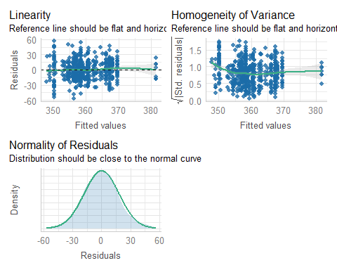

check_model(lme_female_txl_full1, check = c("linearity", "homogeneity", "normality"))

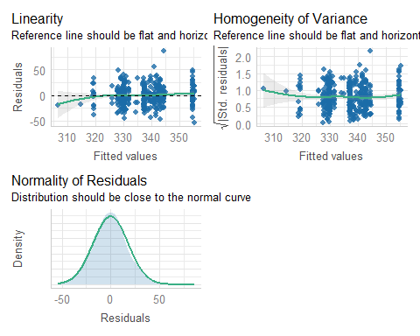

#### For HXL

# Fit the model again with lmerTest loaded  
lme_male_hxl_full1 <- lmer(HXL ~ altitude_range + Min_temp + Min_precip + Max_precip + time_period + (1 | site_id), data = ancient_chi_male_HXL)  
lme_female_hxl_full1 <- lmer(HXL ~ altitude_range + Min_temp + Min_precip + Max_precip + time_period + (1 | site_id), data = ancient_chi_female_HXL)

#### Check the model

check_model(lme_male_hxl_full1, check = c("linearity", "homogeneity", "normality"))

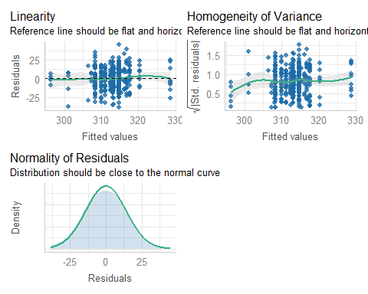

check_model(lme_female_hxl_full1, check = c("linearity", "homogeneity", "normality"))

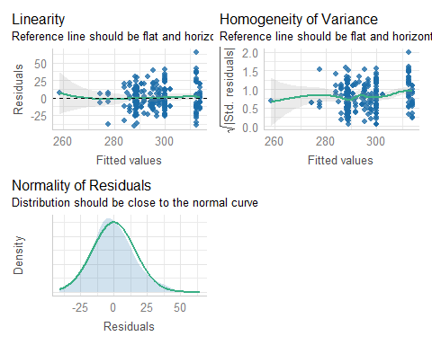

#### For RXL

# Fit the model again with lmerTest loaded  
lme_male_rxl_full1 <- lmer(RXL ~ altitude_range + Min_temp + Min_precip + Max_precip + time_period + (1 | site_id), data = ancient_chi_male_RXL)  
lme_female_rxl_full1 <- lmer(RXL ~ altitude_range + Min_temp + Min_precip + Max_precip + time_period + (1 | site_id), data = ancient_chi_female_RXL)

#### Check the model

check_model(lme_male_rxl_full1, check = c("linearity", "homogeneity", "normality"))

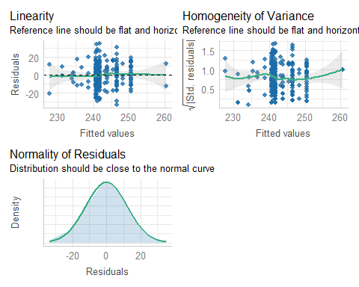

check_model(lme_female_rxl_full1, check = c("linearity", "homogeneity", "normality"))

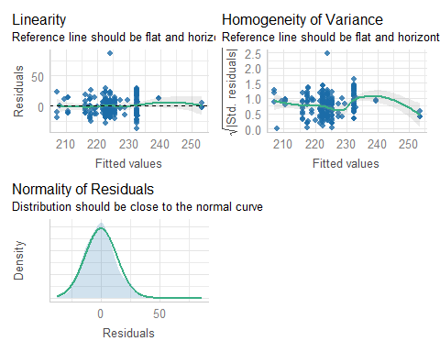

#### For FHD

# Fit the model again with lmerTest loaded  
lme_male_fhd_full1 <- lmer(FHD ~ altitude_range + Min_temp + Max_temp + Min_precip + Max_precip + time_period + (1 | site_id), data = ancient_chi_male_FHD)  
lme_female_fhd_full1 <- lmer(FHD ~ altitude_range + Min_temp + Max_temp + Min_precip + Max_precip + time_period + (1 | site_id), data = ancient_chi_female_FHD)

#### Check the model

check_model(lme_male_fhd_full1, check = c("linearity", "homogeneity", "normality"))

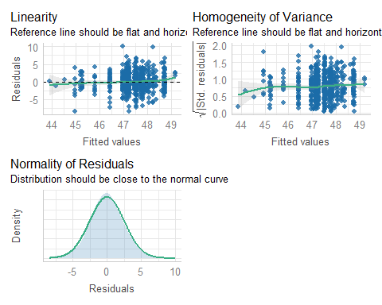

check_model(lme_female_fhd_full1, check = c("linearity", "homogeneity", "normality"))

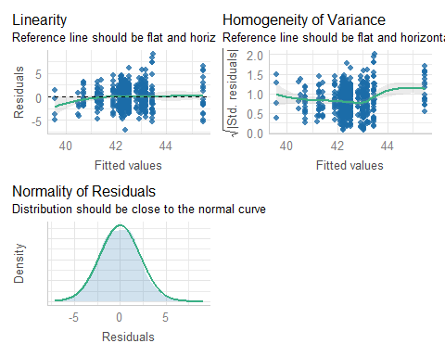

### Plot Coefficients for full models

#### FXL

# Tidy the model outputs and add model labels  
tidy_male_full_fxl <- tidy(lme_male_fxl_full1, effects = "fixed") %>%  
 mutate(model = "Male")  
tidy_female_full_fxl <- tidy(lme_female_fxl_full1, effects = "fixed") %>%  
 mutate(model = "Female")  
  
# Combine male and female outputs  
tidy_combined_full_fxl <- bind_rows(tidy_male_full_fxl, tidy_female_full_fxl) %>%  
 filter(term != "(Intercept)") %>% # Remove intercept  
 mutate(  
 sig = ifelse(p.value < 0.05, "Sig", "Not Sig"), # Add significance flag  
 ci_low = estimate - 1.96 * std.error, # Compute lower CI  
 ci_high = estimate + 1.96 * std.error # Compute upper CI  
 )  
  
# Reorder terms for plotting  
tidy_combined_full_fxl$term <- factor(tidy_combined_full_fxl$term, levels = unique(tidy_combined_full_fxl$term))  
  
# Enhanced plot with confidence intervals  
plot_full_fxl_coefficients <- ggplot(tidy_combined_full_fxl, aes(x = estimate, y = term, fill = interaction(model, sig))) +  
 geom_bar(stat = "identity", position = position_dodge(width = 0.7), width = 0.6) +  
 geom_errorbar(aes(xmin = ci_low, xmax = ci_high),   
 position = position_dodge(0.7), width = 0.2) +  
 labs(  
 y = "Predictor Variables",   
 x = "Coefficient Estimate (with 95% Confidence Interval)",   
 title = "Fixed Effects Coefficient Estimates for Male and Female Models (FXL)"  
 ) +  
 # Custom fill scale to distinguish significance  
 scale_fill_manual(values = c(  
 "Male.Sig" = "blue",   
 "Female.Sig" = "red",   
 "Male.Not Sig" = "lightblue",   
 "Female.Not Sig" = "pink"  
 )) +  
 theme_minimal() +  
 theme(  
 axis.text.y = element_text(angle = 0, hjust = 1, size = 16), # Readable y-axis text  
 axis.text.x = element_text(angle = 45, hjust = 1, size = 16), # Readable x-axis text  
 axis.title.y = element_text(size = 16), # Enlarged y-axis title  
 axis.title.x = element_text(size = 16), # Enlarged x-axis title  
 plot.title = element_text(hjust = 0.5, size = 18), # Centered and enlarged title  
 legend.position = "bottom", # Legend at bottom  
 legend.text = element_text(size = 16), # Enlarged legend text  
 legend.title = element_text(size = 16) # Enlarged legend title  
 ) +  
 coord_flip()

#### TXL

# Tidy the model outputs and add model labels  
tidy_male_full_txl <- tidy(lme_male_txl_full1, effects = "fixed") %>%  
 mutate(model = "Male")  
tidy_female_full_txl <- tidy(lme_female_txl_full1, effects = "fixed") %>%  
 mutate(model = "Female")  
  
# Combine male and female outputs  
tidy_combined_full_txl <- bind_rows(tidy_male_full_txl, tidy_female_full_txl) %>%  
 filter(term != "(Intercept)") %>% # Remove intercept  
 mutate(  
 sig = ifelse(p.value < 0.05, "Sig", "Not Sig"), # Add significance flag  
 ci_low = estimate - 1.96 * std.error, # Compute lower CI  
 ci_high = estimate + 1.96 * std.error # Compute upper CI  
 )  
  
# Reorder terms for plotting  
tidy_combined_full_txl$term <- factor(tidy_combined_full_txl$term, levels = unique(tidy_combined_full_txl$term))  
  
# Create the plot  
plot_full_txl_coefficients <- ggplot(tidy_combined_full_txl, aes(y = term, x = estimate, fill = interaction(model, sig))) +  
 geom_bar(stat = "identity", position = position_dodge(width = 0.7), width = 0.6) +  
 geom_errorbar(aes(xmin = ci_low, xmax = ci_high),   
 position = position_dodge(0.7), width = 0.2) +  
 labs(  
 y = "Predictor Variables",   
 x = "Coefficient Estimate (with 95% Confidence Interval)",   
 title = "Fixed Effects Coefficient Estimates for Male and Female Models (TXL)"  
 ) +  
 # Custom fill scale for significance and model interaction  
 scale_fill_manual(values = c(  
 "Male.Sig" = "blue",   
 "Female.Sig" = "red",   
 "Male.Not Sig" = "lightblue",   
 "Female.Not Sig" = "pink"  
 )) +  
 theme_minimal() +  
 theme(  
 axis.text.y = element_text(angle = 0, hjust = 1, size = 16), # Readable y-axis text  
 axis.text.x = element_text(angle = 45, hjust = 1, size = 16), # Readable x-axis text  
 axis.title.y = element_text(size = 16), # Enlarged y-axis title  
 axis.title.x = element_text(size = 16), # Enlarged x-axis title  
 plot.title = element_text(hjust = 0.5, size = 18), # Centered and enlarged title  
 legend.position = "bottom", # Legend at the bottom  
 legend.text = element_text(size = 16), # Enlarged legend text  
 legend.title = element_text(size = 16) # Enlarged legend title  
 ) +  
 coord_flip()

# Tidy the model outputs and add model labels  
tidy_male_full_fhd <- tidy(lme_male_fhd_full1, effects = "fixed") %>%  
 mutate(model = "Male")  
tidy_female_full_fhd <- tidy(lme_female_fhd_full1, effects = "fixed") %>%  
 mutate(model = "Female")  
  
# Combine male and female outputs  
tidy_combined_full_fhd <- bind_rows(tidy_male_full_fhd, tidy_female_full_fhd) %>%  
 filter(term != "(Intercept)") %>% # Remove intercept  
 mutate(  
 sig = ifelse(p.value < 0.05, "Sig", "Not Sig"), # Add significance flag  
 ci_low = estimate - 1.96 * std.error, # Compute lower CI  
 ci_high = estimate + 1.96 * std.error # Compute upper CI  
 )  
  
# Reorder terms for plotting  
tidy_combined_full_fhd$term <- factor(tidy_combined_full_fhd$term, levels = unique(tidy_combined_full_fhd$term))  
  
# Create the plot  
plot_full_fhd_coefficients <- ggplot(tidy_combined_full_fhd, aes(y = term, x = estimate, fill = interaction(model, sig))) +  
 geom_bar(stat = "identity", position = position_dodge(width = 0.7), width = 0.6) +  
 geom_errorbar(aes(xmin = ci_low, xmax = ci_high),   
 position = position_dodge(0.7), width = 0.2) +  
 labs(  
 y = "Predictor Variables",   
 x = "Coefficient Estimate (with 95% Confidence Interval)",   
 title = "Fixed Effects Coefficient Estimates for Male and Female Models (FHD)"  
 ) +  
 scale_fill_manual(values = c(  
 "Male.Sig" = "blue",   
 "Female.Sig" = "red",   
 "Male.Not Sig" = "lightblue",   
 "Female.Not Sig" = "pink"  
 )) +  
 theme_minimal() +  
 theme(  
 axis.text.y = element_text(angle = 0, hjust = 1, size = 16),  
 axis.text.x = element_text(angle = 45, hjust = 1, size = 16),  
 axis.title.y = element_text(size = 16),  
 axis.title.x = element_text(size = 16),  
 plot.title = element_text(hjust = 0.5, size = 18),  
 legend.position = "bottom",  
 legend.text = element_text(size = 16),  
 legend.title = element_text(size = 16)  
 ) +  
 coord_flip()