Contemporary_Chinese_groups

DC

2023-12-07

Table of Contents

# Install packages

# List of required packages  
required_packages <- c(  
 "tidyverse", # Data manipulation and visualization  
 "sf", # Handling spatial data  
 "raster", # Raster data operations  
 "ggmap", # Mapping and spatial visualization  
 "sp", # Spatial data classes and methods (supports sf)  
 "akima", # Interpolation of irregularly spaced data  
 "rnaturalearth", # Natural Earth map data  
 "car", # Companion to Applied Regression  
 "MASS", # Various statistical methods  
 "sandwich", # Robust covariance matrix estimators  
 "lmtest", # Testing linear regression models  
 "scales", # Scaling functions for ggplot2  
 "gstat" , # Geostatistical modeling and kriging  
 "terra"  
)  
  
# Identify missing packages and install them  
missing_packages <- setdiff(required_packages, rownames(installed.packages()))  
if (length(missing_packages) > 0) {  
 install.packages(missing_packages)  
}  
  
# Load all required libraries  
invisible(lapply(required_packages, library, character.only = TRUE))

# 1. Prepare the data

Read the group data on contemporary populations

groups <- read_csv("data/modern_multiple_groups.csv")

## Assign the climatic data

### Read the climatic data

# Load the TIFF file  
Min_temp <- raster("data/wc2.1_30s_bio_6.tif")  
Max_temp <- raster("data/wc2.1_30s_bio_5.tif")  
Min_precip <- raster("data/wc2.1_30s_bio_14.tif")  
Max_precip <- raster("data/wc2.1_30s_bio_13.tif")

### Assign the clmatic data to modern groups

coordinates <- groups %>%  
 dplyr::select(`Longitude (E)`, `Latitude (N)`) # Use backticks around column names with spaces  
  
# Convert to a spatial points object  
points <- SpatialPoints(coordinates)

# Extract raster values for each point  
min_temp_values <- extract(Min_temp, points)  
max_temp_values <- extract(Max_temp, points)  
min_precip_values <- extract(Min_precip, points)  
max_precip_values <- extract(Max_precip, points)

# Add the extracted data back to the dataset  
groups <- groups %>%  
 mutate(Min_temp = min_temp_values,  
 Max_temp = max_temp_values,  
 Min_precip = min_precip_values,  
 Max_precip = max_precip_values)

## Get China Map

shapefile_path <- "data/bou1_4p.shp"  
# Read the shapefile  
china_shape <- st_read(shapefile_path)

## Reading layer `bou1_4p' from data source   
## `C:\Users\83892\Long-Term-and-Geographic-Variation-in-Body-Size-Among-Chinese-Populations\data\bou1_4p.shp'   
## using driver `ESRI Shapefile'  
## Simple feature collection with 894 features and 5 fields  
## Geometry type: POLYGON  
## Dimension: XY  
## Bounding box: xmin: 73.44696 ymin: 6.318641 xmax: 135.0858 ymax: 53.55793  
## Geodetic CRS: Beijing 1954

# 2. Regression analysis

## Separate data by sex

# Use dplyr::filter() to avoid conflicts  
male_data <- dplyr::filter(groups, Sex == "M")  
female_data <- dplyr::filter(groups, Sex == "F")  
  
# Convert necessary columns to numeric  
male_data <- male_data %>%  
 mutate(Stature = as.numeric(Stature_cm),  
 Body_mass = as.numeric(Body_mass_kg),  
 Sitting_height = as.numeric(R_Sitting_ht),  
 Min_temp = as.numeric(Min_temp),  
 Max_temp = as.numeric(Max_temp),  
 Min_precip = as.numeric(Min_precip),  
 Max_precip = as.numeric(Max_precip))  
  
  
female_data <- female_data %>%  
 mutate(Stature = as.numeric(Stature_cm),  
 Body_mass = as.numeric(Body_mass_kg),  
 Sitting_height = as.numeric(R_Sitting_ht),  
 Min_temp = as.numeric(Min_temp),  
 Max_temp = as.numeric(Max_temp),  
 Min_precip = as.numeric(Min_precip),  
 Max_precip = as.numeric(Max_precip))

## 2.1 Ordinary linear regression

# Fit linear models for males  
male_stature_lm <- lm(Stature ~ Min_temp + Max_temp + Min_precip + Max_precip + Altitude_range + Time, data = male_data)  
male_sitting_lm <- lm(Sitting_height ~ Min_temp + Max_temp + Min_precip + Max_precip +Altitude_range+ Time, data = male_data)  
male_bodymass_lm <- lm(Body_mass ~ Min_temp + Max_temp + Min_precip + Max_precip + Altitude_range+ Time, data = male_data)  
  
# Fit linear models for females  
female_stature_lm <- lm(Stature ~ Min_temp + Max_temp + Min_precip + Max_precip + Altitude_range+ Time, data = female_data)  
female_sitting_lm <- lm(Sitting_height ~ Min_temp + Max_temp + Min_precip + Max_precip + Altitude_range+ Time, data = female_data)  
female_bodymass_lm <- lm(Body_mass ~ Min_temp + Max_temp + Min_precip + Max_precip + Altitude_range+ Time, data = female_data)

# Function to check model assumptions  
check_assumptions <- function(model) {  
 par(mfrow=c(2,2)) # Set up plot area for 4 diagnostic plots  
  
 # 1. Residuals vs Fitted: Check for linearity  
 plot(model, which=1, main="Residuals vs Fitted")  
  
 # 2. Normal Q-Q: Check for normality of residuals  
 plot(model, which=2, main="Normal Q-Q")  
  
 # 3. Scale-Location: Check for homoscedasticity (constant variance)  
 plot(model, which=3, main="Scale-Location")  
  
 # 4. Residuals vs Leverage: Check for influential points  
 plot(model, which=5, main="Residuals vs Leverage")  
}  
  
# Function to check multicollinearity  
check_vif <- function(model) {  
 vif(model) # VIF values above 5 indicate multicollinearity  
}  
  
# Check model assumptions and multicollinearity for males  
check_assumptions(male_stature_lm)

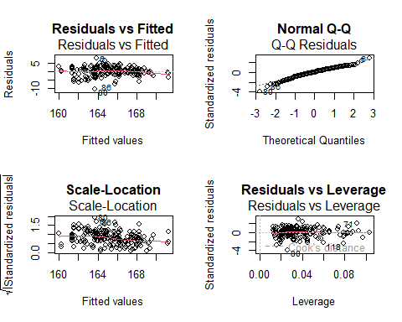

check_assumptions(male_sitting_lm)

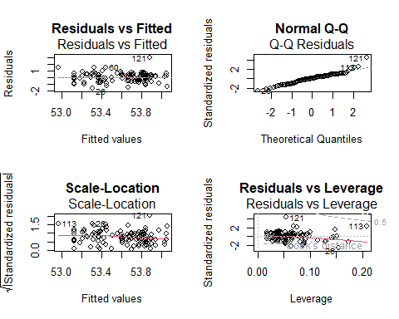

check_assumptions(male_bodymass_lm)

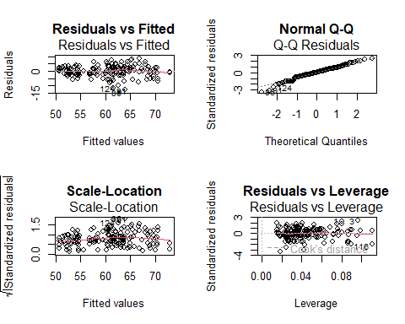

check_vif(male_stature_lm)

## Min_temp Max_temp Min_precip Max_precip Altitude_range   
## 3.293375 2.837753 2.078051 2.607430 2.126753   
## Time   
## 1.108396

check_vif(male_sitting_lm)

## Min_temp Max_temp Min_precip Max_precip Altitude_range   
## 3.466295 3.247964 2.167538 2.681191 2.210909   
## Time   
## 1.215219

check_vif(male_bodymass_lm)

## Min_temp Max_temp Min_precip Max_precip Altitude_range   
## 3.157643 2.910266 2.009243 2.504799 2.211443   
## Time   
## 1.113348

# Check model assumptions and multicollinearity for females  
check_assumptions(female_stature_lm)

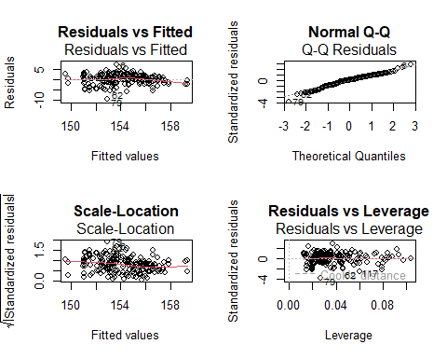

check_assumptions(female_sitting_lm)

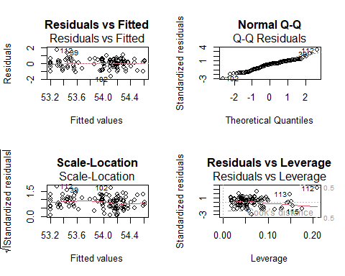

check_assumptions(female_bodymass_lm)

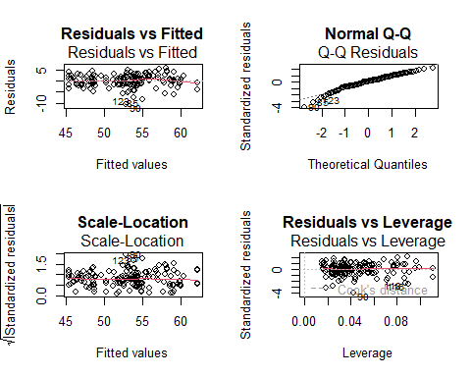

check_vif(female_stature_lm)

## Min_temp Max_temp Min_precip Max_precip Altitude_range   
## 3.304653 2.833088 2.110015 2.609744 2.127544   
## Time   
## 1.105196

check_vif(female_sitting_lm)

## Min_temp Max_temp Min_precip Max_precip Altitude_range   
## 3.463109 3.241161 2.193182 2.697624 2.211682   
## Time   
## 1.211224

check_vif(female_bodymass_lm)

## Min_temp Max_temp Min_precip Max_precip Altitude_range   
## 3.155644 2.905925 2.019718 2.510981 2.212148   
## Time   
## 1.111321

## 2.2 Robust regression

# Robust regression for male models  
male_stature_rlm <- rlm(Stature ~ Min_temp + Max_temp + Min_precip + Max_precip + Altitude_range +Time, data = male_data)  
male_sitting_rlm <- rlm(Sitting_height ~ Min_temp + Max_temp + Min_precip + Max_precip + Altitude_range +Time, data = male_data)  
male_bodymass_rlm <- rlm(Body_mass ~ Min_temp + Max_temp + Min_precip + Max_precip + Altitude_range +Time, data = male_data)  
  
# Robust regression for female models  
female_stature_rlm <- rlm(Stature ~ Min_temp + Max_temp + Min_precip + Max_precip + Altitude_range +Time, data = female_data)  
female_sitting_rlm <- rlm(Sitting_height ~ Min_temp + Max_temp + Min_precip + Max_precip + Altitude_range +Time, data = female_data)  
female_bodymass_rlm <- rlm(Body_mass ~ Min_temp + Max_temp + Min_precip + Max_precip + Altitude_range+Time, data = female_data)

### Plot coefficients

# Combine male and female data for plotting  
combined_data <- rbind(  
 data.frame(male_combined_data, Sex = "Male"),  
 data.frame(female_combined_data, Sex = "Female")  
)  
  
# Add a column for asterisks to indicate significant predictors  
combined_data$Significant_Asterisk <- ifelse(combined_data$Significance == "Significant", "*", "")  
  
combined_plot <- ggplot(combined_data, aes(y = Coefficient, x = Variable)) +  
 geom_bar(stat = "identity", position = "dodge", color = "black", fill = "lightblue") + # Uniform fill color  
   
 geom_errorbar(aes(ymin = Coefficient - 1.96 * Std_Error, ymax = Coefficient + 1.96 * Std_Error), width = 0.2, position = position_dodge(0.9)) +  
 geom_text(aes(label = Significant_Asterisk), color = "red", size = 5, vjust = -0.5, position = position_dodge(width = 0.9)) +  
 facet_grid(Model ~ Sex) +  
 geom_hline(yintercept = 0, linetype = "dashed", color = "black") + # Horizontal line at 0 on the y-axis  
 theme(axis.text.x = element_text(angle = 75, hjust = 1), legend.position = "bottom") + # Adjusted axis text for readability  
 labs(title = "Male and Female Model Coefficients (Robust Regression)", y = "Coefficient", x = "Variable")  
  
# Display the combined plot  
print(combined_plot)

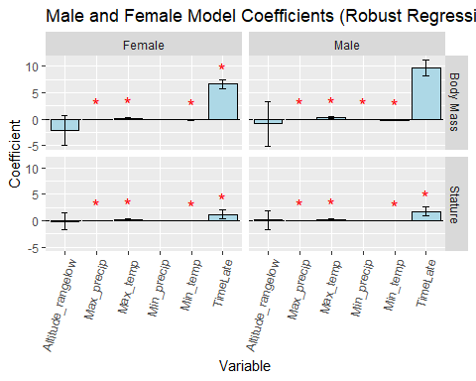

## 2.3 Compare the Han, Sherpa and Tibetan Groups

# Set the desired order for the Ethnic_Group factor  
filtered_data$Ethnic_Group <- factor(filtered_data$Ethnic_Group, levels = c("Han", "Tibetan", "Sherpa"))  
# Convert Longitude and Latitude to numeric  
filtered_data$Longitude_E <- as.numeric(filtered_data$Longitude_E)  
filtered_data$Latitude_N <- as.numeric(filtered_data$Latitude_N)

# Set the desired order for the Ethnic_Group factor, including all groups  
groups$Ethnic_Group <- factor(groups$Ethnic_Group, levels = unique(groups$Ethnic_Group))  
  
# Create a new column named 'ethnic_group_2' for the desired classifications  
groups <- groups %>%  
 mutate(ethnic_group_2 = case_when(  
 Ethnic_Group == "Tibetan" ~ "Tibetan",  
 Ethnic_Group == "Sherpa" ~ "Sherpa",  
 Ethnic_Group == "Han" & `Latitude (N)` > 34 ~ "Han (Northern)",  
 Ethnic_Group == "Han" & `Longitude (E)` <= 34 ~ "Han (Southern)",  
 TRUE ~ NA_character_  
 ))

# Plot with merged time periods for Body Mass with linear regression line using 'ethnic_group_2'  
body_mass_plot <- ggplot(groups_filtered, aes(x = Stature_cm, y = Body_mass_kg, color = Sex, shape = ethnic_group_2, linetype = ethnic_group_2)) +  
 geom_point() +  
 geom_smooth(method = "lm", se = FALSE) + # Add linear regression line  
 labs(x = "Stature (cm)", y = "Body Mass", title = "Stature vs Body Mass by Ethnic Group and Time Period", shape = "Ethnic group", linetype = "Group") +  
 theme(legend.position = "bottom") +  
 facet_grid(Sex ~ Time_period_merged) +  
 scale_shape_manual(values = c(1, 2, 3, 4)) + # Set different shapes for ethnic groups  
 scale_linetype_manual(values = c("solid", "dashed","twodash", "blank")) + # Set different line types for ethnic groups  
 guides(shape = guide_legend(nrow = 2), linetype = guide_legend(nrow = 2), color = guide_legend(nrow = 2))  
body_mass_plot

## `geom_smooth()` using formula = 'y ~ x'

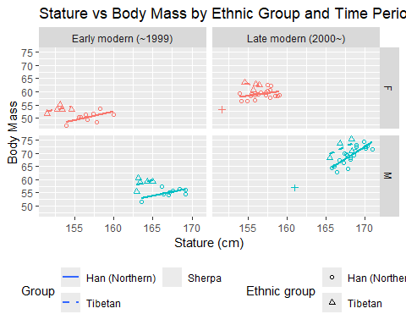

# 3 Interpolation over time and space

## 3.1 Stature

# Convert columns to numeric, replacing non-numeric values with NA  
convert_to_numeric <- function(df, columns) {  
 for (col in columns) {  
 df[[col]] <- as.numeric(df[[col]])  
 }  
 return(df)  
}  
  
# Apply the function to convert 'Body_mass(kg)' and 'R_Sitting_ht' to numeric  
groups <- convert_to_numeric(groups, c("Body_mass(kg)", "R_Sitting_ht"))  
  
# Function to subset data based on sex and time period  
subset_data <- function(df, sex, time_periods) {  
 subset(df, Sex == sex & Time_period %in% time_periods,  
 select = c(`Latitude (N)`, `Longitude (E)`, `Stature(cm)`, `Body_mass(kg)`, R_Sitting_ht,   
 Ethnic_Group, Time, Altitude_range, Relative_Living_Bi_iliaca_breadth))  
}  
  
# Subset data for each group  
ht_china_male_early <- subset_data(groups, "M", c(1, 2))  
ht_china_female_early <- subset_data(groups, "F", c(1, 2))  
ht_china_male_late <- subset_data(groups, "M", c(3))  
ht_china_female_late <- subset_data(groups, "F", c(3))

# Function to rename columns for all datasets  
rename_columns <- function(df) {  
 names(df) <- c("Latitude_N", "Longitude_E", "Stature_cm", "Body_mass_kg", "R_Sitting_ht","Ethnic_Group", "Time", "Altitude_range")  
 return(df)  
}  
  
# Apply the rename function to all datasets  
ht_china_male_early <- rename_columns(ht_china_male_early)  
ht_china_female_early <- rename_columns(ht_china_female_early)  
ht_china_male_late <- rename_columns(ht_china_male_late)  
ht_china_female_late <- rename_columns(ht_china_female_late)

# Define the IDW interpolation function  
perform_idw_interpolation <- function(df, filename) {  
 # Check if the dataframe has coordinates set properly  
 if (!("Longitude_E" %in% names(df)) || !("Latitude_N" %in% names(df)) || !("Stature_cm" %in% names(df))) {  
 stop("The data frame must contain 'Longitude_E', 'Latitude_N', and 'Stature_cm' columns.")  
 }  
   
 # Define the grid extent  
 xmin <- 70  
 xmax <- 140  
 ymin <- 6  
 ymax <- 60  
  
 # Set the number of cells in x and y dimensions to ensure equal cell size  
 cell_size <- (xmax - xmin) / 400 # Assuming 400 cells in the x-direction  
  
 # Create raster with equal horizontal and vertical resolution  
 htrChina <- raster(  
 xmn = xmin, xmx = xmax,  
 ymn = ymin, ymx = ymax,  
 res = cell_size, # Specify resolution to be the same in both x and y  
 crs = "+proj=longlat +datum=WGS84"  
 )  
  
 # Convert the raster to points to extract the coordinates  
 htrChina_points <- rasterToPoints(htrChina, spatial = TRUE)  
  
 # Set spatial coordinates for the input data frame  
 coordinates(df) <- ~ Longitude_E + Latitude_N  
  
 # Calculate distances between observation points and raster grid points  
 dists <- spDists(  
 x = coordinates(df),  
 y = coordinates(htrChina_points),  
 longlat = TRUE  
 )  
  
 # Inverse distance weighted interpolation  
 idp <- 2  
 inv.w <- (1 / (dists ^ idp))  
 z <- (t(inv.w) %*% matrix(df$Stature_cm)) / apply(inv.w, 2, sum)  
  
 # Update the raster with predicted values  
 htpred.China <- htrChina  
 values(htpred.China) <- z  
  
 # Export the data as a raster file in ASCII format  
 writeRaster(htpred.China, filename = filename, format = "ascii", overwrite = TRUE)  
}  
  
# Apply the function to each group  
# Interpolation for Early Female Population  
perform_idw_interpolation(ht_china_male_early, "HT_IDW2_China_male_early.asc")  
  
perform_idw_interpolation(ht_china_female_early, "HT_IDW2_China_female_early.asc")  
  
# Interpolation for Late Male Population  
perform_idw_interpolation(ht_china_male_late, "HT_IDW2_China_male_late.asc")  
  
# Interpolation for Late Female Population  
perform_idw_interpolation(ht_china_female_late, "HT_IDW2_China_female_late.asc")

htpred_male_early <- raster("HT_IDW2_China_male_early.asc")  
htpred_female_early <- raster("HT_IDW2_China_female_early.asc")  
htpred_male_late <- raster("HT_IDW2_China_male_late.asc")  
htpred_female_late <- raster("HT_IDW2_China_female_late.asc")  
  
# Convert the rasters to data frames  
htpred_male_early_df <- as.data.frame(htpred_male_early, xy = TRUE)  
colnames(htpred_male_early_df) <- c("Longitude", "Latitude", "Stature")  
  
htpred_female_early_df <- as.data.frame(htpred_female_early, xy = TRUE)  
colnames(htpred_female_early_df) <- c("Longitude", "Latitude", "Stature")  
  
htpred_male_late_df <- as.data.frame(htpred_male_late, xy = TRUE)  
colnames(htpred_male_late_df) <- c("Longitude", "Latitude", "Stature")  
  
htpred_female_late_df <- as.data.frame(htpred_female_late, xy = TRUE)  
colnames(htpred_female_late_df) <- c("Longitude", "Latitude", "Stature")

# Function to plot raster heatmap overlaid on the China base map with dataset points by Ethnic Group using shapes and colors  
plot_heatmap_with_points_on_china_map <- function(raster_df, points_df, title) {  
 # Determine the number of unique ethnic groups  
 unique_ethnic_groups <- unique(points_df$Ethnic_Group)  
 num_groups <- length(unique_ethnic_groups)  
  
 # Define shape values for each ethnic group  
 # Assign specific shapes to Han and Tibetan groups  
 shape_values <- rep(c(15:22), length.out = num_groups)  
 names(shape_values) <- unique_ethnic_groups  
 shape_values["Han"] <- 17 # Unify the Han group shape to a triangle  
 shape_values["Tibetan"] <- 16 # Unify the Tibetan group shape to a circle  
shape_values["Sherpa"] <- 15 # Unify the Tibetan group shape to a circle  
 ggplot() +  
 geom_sf(data = china_shape, fill = "white", color = "black") + # Plot the base map of China  
 geom_raster(data = raster_df, aes(x = Longitude, y = Latitude, fill = Stature), alpha = 0.7) + # Plot the heatmap  
 geom_point(data = points_df, aes(x = Longitude_E, y = Latitude_N, shape = Ethnic_Group, color = Ethnic_Group), size = 1) + # Plot points using different shapes and colors  
 scale_shape_manual(values = shape_values) + # Assign custom shapes, including unified Han and Tibetan group shapes  
 scale_color_viridis_d(option = "plasma") + # Assign colors using viridis color palette (option 'plasma' for variety)  
 scale_fill_viridis_c() + # Use viridis color scale for the heatmap  
 theme_minimal() +  
 labs(title = title,  
 x = "Longitude",  
 y = "Latitude",  
 fill = "Stature",  
 shape = "Ethnic Group",  
 color = "Ethnic Group") + # Include color legend for further differentiation  
 coord_sf() # Keep the coordinate reference consistent  
}  
  
# Plotting each dataset separately with the heatmap and the China base map  
  
# Plot heatmap for Early Male Population with points  
plot1 <- plot_heatmap_with_points_on_china_map(htpred_male_early_df, ht_china_male_early, "Heatmap with Points - Early Male Population")  
  
# Plot heatmap for Early Female Population with points  
plot2 <- plot_heatmap_with_points_on_china_map(htpred_female_early_df, ht_china_female_early, "Heatmap with Points - Early Female Population")  
  
# Plot heatmap for Late Male Population with points  
plot3 <- plot_heatmap_with_points_on_china_map(htpred_male_late_df, ht_china_male_late, "Heatmap with Points - Late Male Population")  
  
# Plot heatmap for Late Female Population with points  
plot4 <- plot_heatmap_with_points_on_china_map(htpred_female_late_df, ht_china_female_late, "Heatmap with Points - Late Female Population")

# Set global min and max stature values across datasets for consistent heatmap scale  
global_min <- min(htpred_female_early_df$Stature, na.rm = TRUE)  
global_max <- max(htpred_male_late_df$Stature, na.rm = TRUE)  
  
# Function to plot raster heatmap overlaid on the China base map with dataset points by Ethnic Group using shapes and colors  
plot_heatmap_with_points_on_china_map <- function(raster_df, points_df, title, group_name) {  
 # Determine the number of unique ethnic groups  
 unique_ethnic_groups <- unique(points_df$Ethnic_Group)  
 num_groups <- length(unique_ethnic_groups)  
  
 # Define shape values for each ethnic group  
 # Assign specific shapes to Han, Tibetan, and Sherpa groups  
 shape_values <- rep(c(1:14), length.out = num_groups)  
 names(shape_values) <- unique_ethnic_groups  
 shape_values["Han"] <- 15 # Unify the Han group shape   
 shape_values["Tibetan"] <-19 # Unify the Tibetan group shape  
 shape_values["Sherpa"] <- 17 # Assign specific shape for Sherpa group  
 shape_values["Mongols"] <- 18 # Assign specific shape for Mongols group  
 shape_values["Zhuang"] <- 20 # Assign specific shape for Zhuang group  
 shape_values["Uyghurs"] <- 21 # Assign specific shape for Uyghurs group  
 shape_values["Gelao"] <- 22 # Assign specific shape for Gelao group  
 # Create the plot with unified layout settings  
 p <- ggplot() +  
 geom_sf(data = china_shape, fill = "white", color = "black") + # Plot the base map of China  
 geom_raster(data = raster_df, aes(x = Longitude, y = Latitude, fill = Stature), alpha = 0.7) + # Plot the heatmap  
 geom_point(data = points_df, aes(x = Longitude_E, y = Latitude_N, shape = Ethnic_Group, color = Ethnic_Group), size = 1) + # Plot points using different shapes and colors  
 scale_shape_manual(values = shape_values) + # Assign custom shapes, including unified Han, Tibetan, and Sherpa group shapes  
 scale_color_viridis_d(option = "plasma") + # Assign colors using viridis color palette (option 'plasma' for variety)  
 scale_fill_viridis_c(limits = c(global_min, global_max)) + # Use viridis color scale for the heatmap with unified limits  
 theme_minimal() +  
 labs(title = title,  
 x = "Longitude",  
 y = "Latitude",  
 fill = "Stature(cm)",  
 shape = "Ethnic Group",  
 color = "Ethnic Group",  
 caption = group_name) + # Add the group name under the plot  
 theme(  
 plot.title = element_text(size = 10, face = "bold", hjust = 0.5), # Center the title and make it bold  
 axis.title = element_text(size = 10), # Standardize axis title font size  
 axis.text = element_text(size = 10), # Standardize axis label size  
 legend.position = "right", # Move the legend (scale) to the left  
 legend.title = element_text(size = 10),# Standardize legend title size  
 legend.text = element_text(size = 8), # Standardize legend text size  
 plot.margin = unit(c(1, 1, 1, 1), "cm") # Set consistent plot margins  
 ) +  
 coord_sf() # Keep the coordinate reference consistent  
  
 return(p)  
}  
  
# Plotting each dataset separately with the heatmap and the China base map  
  
# Plot heatmap for Early Male Population with points  
plot1 <- plot_heatmap_with_points_on_china_map(htpred_male_early_df, ht_china_male_early, "Heatmap with Points - Early Male Population", "Early Male Population")  
  
# Plot heatmap for Early Female Population with points  
plot2 <- plot_heatmap_with_points_on_china_map(htpred_female_early_df, ht_china_female_early, "Heatmap with Points - Early Female Population", "Early Female Population")  
  
# Plot heatmap for Late Male Population with points  
plot3 <- plot_heatmap_with_points_on_china_map(htpred_male_late_df, ht_china_male_late, "Heatmap with Points - Late Male Population", "Late Male Population")  
  
# Plot heatmap for Late Female Population with points  
plot4 <- plot_heatmap_with_points_on_china_map(htpred_female_late_df, ht_china_female_late, "Heatmap with Points - Late Female Population", "Late Female Population")

## 3.2 Body Mass

# Convert columns to numeric, replacing non-numeric values with NA  
convert_to_numeric <- function(df, columns) {  
 for (col in columns) {  
 df[[col]] <- suppressWarnings(as.numeric(df[[col]])) # Suppress warnings to avoid output clutter  
 }  
 return(df)  
}  
  
# Apply the function to convert columns to numeric  
groups <- convert_to_numeric(groups, c("Body_mass(kg)", "R_Sitting_ht"))  
  
# Function to subset data based on sex and time period  
subset_data <- function(df, sex, time_periods) {  
 subset(df, Sex == sex & Time_period %in% time_periods,  
 select = c(`Latitude (N)`, `Longitude (E)`, `Stature(cm)`, `Body_mass(kg)`, `R_Sitting_ht`,   
 Ethnic_Group, Time, Altitude_range, `Relative_Living_Bi_iliaca_breadth`))  
}  
  
# Subset data for each group  
ht_china_male_early <- subset_data(groups, "M", c(1, 2))  
ht_china_female_early <- subset_data(groups, "F", c(1, 2))  
ht_china_male_late <- subset_data(groups, "M", c(3))  
ht_china_female_late <- subset_data(groups, "F", c(3))  
  
# Function to rename columns for all datasets  
rename_columns <- function(df) {  
 names(df) <- c("Latitude_N", "Longitude_E", "Stature_cm", "Body_mass_kg", "R_Sitting_ht",   
 "Ethnic_Group", "Time", "Altitude_range", "Relative_Living_Bi_iliaca_breadth")  
 return(df)  
}  
  
# Apply the rename function to all datasets  
ht_china_male_early <- rename_columns(ht_china_male_early)  
ht_china_female_early <- rename_columns(ht_china_female_early)  
ht_china_male_late <- rename_columns(ht_china_male_late)  
ht_china_female_late <- rename_columns(ht_china_female_late)  
  
# Function to set spatial coordinates and plot points for each dataset  
plot_points <- function(df, title, color_function = heat.colors) {  
 # Set spatial coordinates  
 coordinates(df) <- ~ Longitude_E + Latitude_N  
   
 # Create a plot for the current dataset using a color function  
 df$color_index <- as.numeric(cut(df$Body_mass_kg, breaks = 10)) # Categorize Body_mass_kg into 10 bins  
 plot(df, col = color_function(10)[df$color_index], pch = 16, cex = 0.6, main = title)  
}  
  
# Set up the plotting area to have 2 rows and 2 columns  
par(mfrow = c(2, 2), mar = c(4, 4, 2, 1))  
  
# Plot each dataset  
plot_points(ht_china_male_early, title = "Early Male Population")  
plot_points(ht_china_female_early, title = "Early Female Population")  
plot_points(ht_china_male_late, title = "Late Male Population")  
plot_points(ht_china_female_late, title = "Late Female Population")

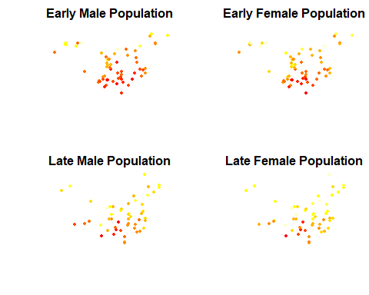

# Define the IDW interpolation function  
perform_idw_interpolation <- function(df, filename) {  
 # Check if the dataframe has coordinates set properly  
 if (!("Longitude_E" %in% names(df)) || !("Latitude_N" %in% names(df)) || !("Body_mass_kg" %in% names(df))) {  
 stop("The data frame must contain 'Longitude_E', 'Latitude_N', and 'Body_mass_kg' columns.")  
 }  
   
 # Remove rows with NA values in relevant columns  
 df <- df[!is.na(df$Longitude_E) & !is.na(df$Latitude_N) & !is.na(df$Body_mass_kg), ]  
   
 # Define the grid extent  
 xmin <- 70  
 xmax <- 140  
 ymin <- 6  
 ymax <- 60  
  
 # Set the number of cells in x and y dimensions to ensure equal cell size  
 cell_size <- (xmax - xmin) / 400 # Assuming 400 cells in the x-direction  
  
 # Create raster with equal horizontal and vertical resolution  
 htrChina <- raster(  
 xmn = xmin, xmx = xmax,  
 ymn = ymin, ymx = ymax,  
 res = cell_size, # Specify resolution to be the same in both x and y  
 crs = "+proj=longlat +datum=WGS84"  
 )  
  
 # Convert the raster to points to extract the coordinates  
 htrChina_points <- rasterToPoints(htrChina, spatial = TRUE)  
  
 # Set spatial coordinates for the input data frame  
 coordinates(df) <- ~ Longitude_E + Latitude_N  
  
 # Calculate distances between observation points and raster grid points  
 dists <- spDists(  
 x = coordinates(df),  
 y = coordinates(htrChina_points),  
 longlat = TRUE  
 )  
  
 # Inverse distance weighted interpolation  
 idp <- 2  
 inv.w <- (1 / (dists ^ idp))  
 z <- (t(inv.w) %*% matrix(df$Body_mass_kg)) / apply(inv.w, 2, sum)  
  
 # Update the raster with predicted values  
 htpred.China <- htrChina  
 values(htpred.China) <- z  
  
 # Export the data as a raster file in ASCII format  
 writeRaster(htpred.China, filename = filename, format = "ascii", overwrite = TRUE)  
}  
  
# Apply the function to each group  
perform_idw_interpolation(ht_china_male_early, "HT_IDW2_China_male_early.asc")  
  
# Interpolation for Early Female Population  
perform_idw_interpolation(ht_china_female_early, "HT_IDW2_China_female_early.asc")  
  
# Interpolation for Late Male Population  
perform_idw_interpolation(ht_china_male_late, "HT_IDW2_China_male_late.asc")  
  
# Interpolation for Late Female Population  
perform_idw_interpolation(ht_china_female_late, "HT_IDW2_China_female_late.asc")

# Load the interpolated rasters  
htpred_male_early <- raster("HT_IDW2_China_female_early.asc")  
htpred_female_early <- raster("HT_IDW2_China_female_early.asc")  
htpred_male_late <- raster("HT_IDW2_China_male_late.asc")  
htpred_female_late <- raster("HT_IDW2_China_female_late.asc")  
  
# Convert the rasters to data frames  
htpred_male_early_df <- as.data.frame(htpred_male_early, xy = TRUE)  
colnames(htpred_male_early_df) <- c("Longitude", "Latitude", "Body_mass_kg")  
  
htpred_female_early_df <- as.data.frame(htpred_female_early, xy = TRUE)  
colnames(htpred_female_early_df) <- c("Longitude", "Latitude", "Body_mass_kg")  
  
htpred_male_late_df <- as.data.frame(htpred_male_late, xy = TRUE)  
colnames(htpred_male_late_df) <- c("Longitude", "Latitude", "Body_mass_kg")  
  
htpred_female_late_df <- as.data.frame(htpred_female_late, xy = TRUE)  
colnames(htpred_female_late_df) <- c("Longitude", "Latitude", "Body_mass_kg")

# Calculate global min and max for Body_mass_kg across all datasets to unify the scale  
global_min <- min(c(min(htpred_male_early_df $Body_mass_kg, na.rm = TRUE),  
 min(htpred_female_early_df$Body_mass_kg, na.rm = TRUE),  
 min(htpred_male_late_df$Body_mass_kg, na.rm = TRUE),  
 min(htpred_female_late_df$Body_mass_kg, na.rm = TRUE)))  
  
global_max <- max(c(max(htpred_male_early_df$Body_mass_kg, na.rm = TRUE),  
 max(htpred_female_early_df$Body_mass_kg, na.rm = TRUE),  
 max(htpred_male_late_df$Body_mass_kg, na.rm = TRUE),  
 max(htpred_female_late_df$Body_mass_kg, na.rm = TRUE)))

# Function to plot raster heatmap overlaid on the China base map with dataset points by Ethnic Group using shapes and colors  
plot_heatmap_with_points_on_china_map <- function(raster_df, points_df, title, group_name) {  
 # Determine the number of unique ethnic groups  
 unique_ethnic_groups <- unique(points_df$Ethnic_Group)  
 num_groups <- length(unique_ethnic_groups)  
  
 # Define shape values for each ethnic group  
 # Assign specific shapes to Han, Tibetan, and Sherpa groups  
 shape_values <- rep(c(1:14), length.out = num_groups)  
 names(shape_values) <- unique_ethnic_groups  
 shape_values["Han"] <- 15 # Unify the Han group shape   
 shape_values["Tibetan"] <-19 # Unify the Tibetan group shape  
 shape_values["Sherpa"] <- 17 # Assign specific shape for Sherpa group  
 shape_values["Mongols"] <- 18 # Assign specific shape for Mongols group  
 shape_values["Zhuang"] <- 20 # Assign specific shape for Zhuang group  
 shape_values["Uyghurs"] <- 21 # Assign specific shape for Uyghurs group  
 shape_values["Gelao"] <- 22 # Assign specific shape for Gelao group  
 # Create the plot with unified layout settings  
 p <- ggplot() +  
 geom_sf(data = china_shape, fill = "white", color = "black") + # Plot the base map of China  
 geom_raster(data = raster_df, aes(x = Longitude, y = Latitude, fill = Body_mass_kg), alpha = 0.7) + # Plot the heatmap  
 geom_point(data = points_df, aes(x = Longitude_E, y = Latitude_N, shape = Ethnic_Group, color = Ethnic_Group), size = 1) + # Plot points using different shapes and colors  
 scale_shape_manual(values = shape_values) + # Assign custom shapes, including unified Han, Tibetan, and Sherpa group shapes  
 scale_color_viridis_d(option = "plasma") + # Assign colors using viridis color palette (option 'plasma' for variety)  
 scale_fill_viridis_c(limits = c(global_min, global_max)) + # Use viridis color scale for the heatmap with unified limits  
 theme_minimal() +  
 labs(title = title,  
 x = "Longitude",  
 y = "Latitude",  
 fill = "Body mass (kg)",  
 shape = "Ethnic Group",  
 color = "Ethnic Group",  
 caption = group_name) + # Add the group name under the plot  
 theme(  
 plot.title = element_text(size = 10, face = "bold", hjust = 0.5), # Center the title and make it bold  
 axis.title = element_text(size = 10), # Standardize axis title font size  
 axis.text = element_text(size = 10), # Standardize axis label size  
 legend.position = "right", # Move the legend (scale) to the left  
 legend.title = element_text(size = 10),# Standardize legend title size  
 legend.text = element_text(size = 8), # Standardize legend text size  
 plot.margin = unit(c(1, 1, 1, 1), "cm") # Set consistent plot margins  
 ) +  
 coord_sf() # Keep the coordinate reference consistent  
  
 return(p)  
}  
  
# Plotting each dataset separately with the heatmap and the China base map  
  
# Plot heatmap for Early Male Population with points  
plot1 <- plot_heatmap_with_points_on_china_map(htpred_male_early_df, ht_china_male_early, "Heatmap with Points - Early Male Population", "Early Male Population")  
  
# Plot heatmap for Early Female Population with points  
plot2 <- plot_heatmap_with_points_on_china_map(htpred_female_early_df, ht_china_female_early, "Heatmap with Points - Early Female Population", "Early Female Population")  
  
# Plot heatmap for Late Male Population with points  
plot3 <- plot_heatmap_with_points_on_china_map(htpred_male_late_df, ht_china_male_late, "Heatmap with Points - Late Male Population", "Late Male Population")  
  
# Plot heatmap for Late Female Population with points  
plot4 <- plot_heatmap_with_points_on_china_map(htpred_female_late_df, ht_china_female_late, "Heatmap with Points - Late Female Population", "Late Female Population")

## 3.3 Sitting height

# Convert columns to numeric, replacing non-numeric values with NA  
convert_to_numeric <- function(df, columns) {  
 for (col in columns) {  
 df[[col]] <- suppressWarnings(as.numeric(df[[col]])) # Suppress warnings to avoid output clutter  
 }  
 return(df)  
}  
  
# Apply the function to convert columns to numeric  
groups <- convert_to_numeric(groups, c("Body_mass(kg)", "R_Sitting_ht"))  
  
# Function to subset data based on sex and time period  
subset_data <- function(df, sex, time_periods) {  
 subset(df, Sex == sex & Time_period %in% time_periods,  
 select = c(`Latitude (N)`, `Longitude (E)`, `Stature(cm)`, `Body_mass(kg)`, `R_Sitting_ht`,   
 Ethnic_Group, Time, Altitude_range, `Relative_Living_Bi_iliaca_breadth`))  
}  
  
# Subset data for each group  
ht_china_male_early <- subset_data(groups, "M", c(1, 2))  
ht_china_female_early <- subset_data(groups, "F", c(1, 2))  
ht_china_male_late <- subset_data(groups, "M", c(3))  
ht_china_female_late <- subset_data(groups, "F", c(3))  
  
# Function to rename columns for all datasets  
rename_columns <- function(df) {  
 names(df) <- c("Latitude_N", "Longitude_E", "Stature_cm", "Body_mass_kg", "R_Sitting_ht",   
 "Ethnic_Group", "Time", "Altitude_range", "Relative_Living_Bi_iliaca_breadth")  
 return(df)  
}  
  
# Apply the rename function to all datasets  
ht_china_male_early <- rename_columns(ht_china_male_early)  
ht_china_female_early <- rename_columns(ht_china_female_early)  
ht_china_male_late <- rename_columns(ht_china_male_late)  
ht_china_female_late <- rename_columns(ht_china_female_late)  
  
# Function to set spatial coordinates and plot points for each dataset  
plot_points <- function(df, title, color_function = heat.colors) {  
 # Set spatial coordinates  
 coordinates(df) <- ~ Longitude_E + Latitude_N  
   
 # Create a plot for the current dataset using a color function  
 df$color_index <- as.numeric(cut(df$R_Sitting_ht, breaks = 10)) # Categorize R_Sitting_ht into 10 bins  
 plot(df, col = color_function(10)[df$color_index], pch = 16, cex = 0.6, main = title)  
}  
  
# Set up the plotting area to have 2 rows and 2 columns  
par(mfrow = c(2, 2), mar = c(4, 4, 2, 1))  
  
# Plot each dataset  
plot_points(ht_china_male_early, title = "Early Male Population")  
plot_points(ht_china_female_early, title = "Early Female Population")  
plot_points(ht_china_male_late, title = "Late Male Population")  
plot_points(ht_china_female_late, title = "Late Female Population")

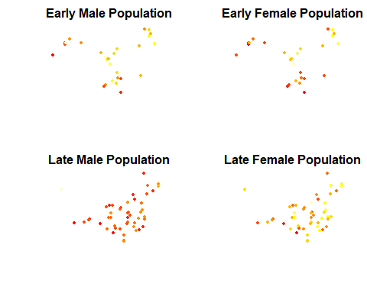

# Define the IDW interpolation function  
perform_idw_interpolation <- function(df, filename) {  
 # Check if the dataframe has coordinates set properly  
 if (!("Longitude_E" %in% names(df)) || !("Latitude_N" %in% names(df)) || !("R_Sitting_ht" %in% names(df))) {  
 stop("The data frame must contain 'Longitude_E', 'Latitude_N', and 'R_Sitting_ht' columns.")  
 }  
   
 # Remove rows with NA values in relevant columns  
 df <- df[!is.na(df$Longitude_E) & !is.na(df$Latitude_N) & !is.na(df$R_Sitting_ht), ]  
   
 # Define the grid extent  
 xmin <- 70  
 xmax <- 140  
 ymin <- 6  
 ymax <- 60  
  
 # Set the number of cells in x and y dimensions to ensure equal cell size  
 cell_size <- (xmax - xmin) / 400 # Assuming 400 cells in the x-direction  
  
 # Create raster with equal horizontal and vertical resolution  
 htrChina <- raster(  
 xmn = xmin, xmx = xmax,  
 ymn = ymin, ymx = ymax,  
 res = cell_size, # Specify resolution to be the same in both x and y  
 crs = "+proj=longlat +datum=WGS84"  
 )  
  
 # Convert the raster to points to extract the coordinates  
 htrChina_points <- rasterToPoints(htrChina, spatial = TRUE)  
  
 # Set spatial coordinates for the input data frame  
 coordinates(df) <- ~ Longitude_E + Latitude_N  
  
 # Calculate distances between observation points and raster grid points  
 dists <- spDists(  
 x = coordinates(df),  
 y = coordinates(htrChina_points),  
 longlat = TRUE  
 )  
  
 # Inverse distance weighted interpolation  
 idp <- 2  
 inv.w <- (1 / (dists ^ idp))  
 z <- (t(inv.w) %*% matrix(df$R_Sitting_ht)) / apply(inv.w, 2, sum)  
  
 # Update the raster with predicted values  
 htpred.China <- htrChina  
 values(htpred.China) <- z  
  
 # Export the data as a raster file in ASCII format  
 writeRaster(htpred.China, filename = filename, format = "ascii", overwrite = TRUE)  
}  
  
# Apply the function to each group  
# Interpolation for Early Female Population  
perform_idw_interpolation(ht_china_male_early, "HT_IDW2_China_male_early.asc")  
  
# Interpolation for Early Female Population  
perform_idw_interpolation(ht_china_female_early, "HT_IDW2_China_female_early.asc")  
  
# Interpolation for Late Male Population  
perform_idw_interpolation(ht_china_male_late, "HT_IDW2_China_male_late.asc")  
  
# Interpolation for Late Female Population  
perform_idw_interpolation(ht_china_female_late, "HT_IDW2_China_female_late.asc")

# Load the interpolated rasters  
htpred_male_early <- raster("HT_IDW2_China_female_early.asc")  
htpred_female_early <- raster("HT_IDW2_China_female_early.asc")  
htpred_male_late <- raster("HT_IDW2_China_male_late.asc")  
htpred_female_late <- raster("HT_IDW2_China_female_late.asc")  
  
# Convert the rasters to data frames  
htpred_male_early_df <- as.data.frame(htpred_male_early, xy = TRUE)  
colnames(htpred_male_early_df) <- c("Longitude", "Latitude", "R_Sitting_ht")  
  
htpred_female_early_df <- as.data.frame(htpred_female_early, xy = TRUE)  
colnames(htpred_female_early_df) <- c("Longitude", "Latitude", "R_Sitting_ht")  
  
htpred_male_late_df <- as.data.frame(htpred_male_late, xy = TRUE)  
colnames(htpred_male_late_df) <- c("Longitude", "Latitude", "R_Sitting_ht")  
  
htpred_female_late_df <- as.data.frame(htpred_female_late, xy = TRUE)  
colnames(htpred_female_late_df) <- c("Longitude", "Latitude", "R_Sitting_ht")

# Calculate global min and max for R_Sitting_ht across all datasets to unify the scale  
global_min <- min(c(min(htpred_male_early_df $R_Sitting_ht, na.rm = TRUE),  
 min(htpred_female_early_df$R_Sitting_ht, na.rm = TRUE),  
 min(htpred_male_late_df$R_Sitting_ht, na.rm = TRUE),  
 min(htpred_female_late_df$R_Sitting_ht, na.rm = TRUE)))  
  
global_max <- max(c(max(htpred_male_early_df$R_Sitting_ht, na.rm = TRUE),  
 max(htpred_female_early_df$R_Sitting_ht, na.rm = TRUE),  
 max(htpred_male_late_df$R_Sitting_ht, na.rm = TRUE),  
 max(htpred_female_late_df$R_Sitting_ht, na.rm = TRUE)))

# Function to plot raster heatmap overlaid on the China base map with dataset points by Ethnic Group using shapes and colors  
plot_heatmap_with_points_on_china_map <- function(raster_df, points_df, title, group_name) {  
 # Determine the number of unique ethnic groups  
 unique_ethnic_groups <- unique(points_df$Ethnic_Group)  
 num_groups <- length(unique_ethnic_groups)  
  
 # Define shape values for each ethnic group  
 # Assign specific shapes to Han, Tibetan, and Sherpa groups  
 shape_values <- rep(c(1:14), length.out = num_groups)  
 names(shape_values) <- unique_ethnic_groups  
 shape_values["Han"] <- 15 # Unify the Han group shape   
 shape_values["Tibetan"] <-19 # Unify the Tibetan group shape  
 shape_values["Sherpa"] <- 17 # Assign specific shape for Sherpa group  
 shape_values["Mongols"] <- 18 # Assign specific shape for Mongols group  
 shape_values["Zhuang"] <- 20 # Assign specific shape for Zhuang group  
 shape_values["Uyghurs"] <- 21 # Assign specific shape for Uyghurs group  
 shape_values["Gelao"] <- 22 # Assign specific shape for Gelao group  
 # Create the plot with unified layout settings  
 p <- ggplot() +  
 geom_sf(data = china_shape, fill = "white", color = "black") + # Plot the base map of China  
 geom_raster(data = raster_df, aes(x = Longitude, y = Latitude, fill = R_Sitting_ht), alpha = 0.7) + # Plot the heatmap  
 geom_point(data = points_df, aes(x = Longitude_E, y = Latitude_N, shape = Ethnic_Group, color = Ethnic_Group), size = 1) + # Plot points using different shapes and colors  
 scale_shape_manual(values = shape_values) + # Assign custom shapes, including unified Han, Tibetan, and Sherpa group shapes  
 scale_color_viridis_d(option = "plasma") + # Assign colors using viridis color palette (option 'plasma' for variety)  
 scale_fill_viridis_c(limits = c(global_min, global_max)) + # Use viridis color scale for the heatmap with unified limits  
 theme_minimal() +  
 labs(title = title,  
 x = "Longitude",  
 y = "Latitude",  
 fill = "Relative\nsitting height",  
 shape = "Ethnic Group",  
 color = "Ethnic Group",  
 caption = group_name) + # Add the group name under the plot  
 theme(  
 plot.title = element_text(size = 10, face = "bold", hjust = 0.5), # Center the title and make it bold  
 axis.title = element_text(size = 10), # Standardize axis title font size  
 axis.text = element_text(size = 10), # Standardize axis label size  
 legend.position = "right", # Move the legend (scale) to the left  
 legend.title = element_text(size = 10),# Standardize legend title size  
 legend.text = element_text(size = 8), # Standardize legend text size  
 plot.margin = unit(c(1, 1, 1, 1), "cm") # Set consistent plot margins  
 ) +  
 coord_sf() # Keep the coordinate reference consistent  
  
 return(p)  
}  
  
# Plotting each dataset separately with the heatmap and the China base map  
  
# Plot heatmap for Early Male Population with points  
plot1 <- plot_heatmap_with_points_on_china_map(htpred_male_early_df, ht_china_male_early, "Heatmap with Points - Early Male Population", "Early Male Population")  
  
# Plot heatmap for Early Female Population with points  
plot2 <- plot_heatmap_with_points_on_china_map(htpred_female_early_df, ht_china_female_early, "Heatmap with Points - Early Female Population", "Early Female Population")  
  
# Plot heatmap for Late Male Population with points  
plot3 <- plot_heatmap_with_points_on_china_map(htpred_male_late_df, ht_china_male_late, "Heatmap with Points - Late Male Population", "Late Male Population")  
  
# Plot heatmap for Late Female Population with points  
plot4 <- plot_heatmap_with_points_on_china_map(htpred_female_late_df, ht_china_female_late, "Heatmap with Points - Late Female Population", "Late Female Population")