TestGit

Dries Reynders

23 juni 2016

This is just a tiny document to illustrate Git with RStudio. The complete illustration contains:

* main.Rmd: the main rmarkdown-file
* child1.Rmd: the first child to include in the main-file
* child2.Rmd: the second child to include in the main-file
* functiesTestGit.R: an R-file containing some functions that are used

In the first chunk: just load some libraries, set some options and source the R-file for acces to the functions.

library(dplyr)

## Warning: package 'dplyr' was built under R version 3.2.5

##   
## Attaching package: 'dplyr'

## The following objects are masked from 'package:stats':  
##   
## filter, lag

## The following objects are masked from 'package:base':  
##   
## intersect, setdiff, setequal, union

library(pander)

## Warning: package 'pander' was built under R version 3.2.5

source("functiesTestGit.R")  
  
  
  
knitr::opts_chunk$set(fig.width=14, fig.height=8,  
 echo=TRUE, warning=FALSE, message=FALSE)

In the first child-file, some data from the R-data 'Iris' are plotted.

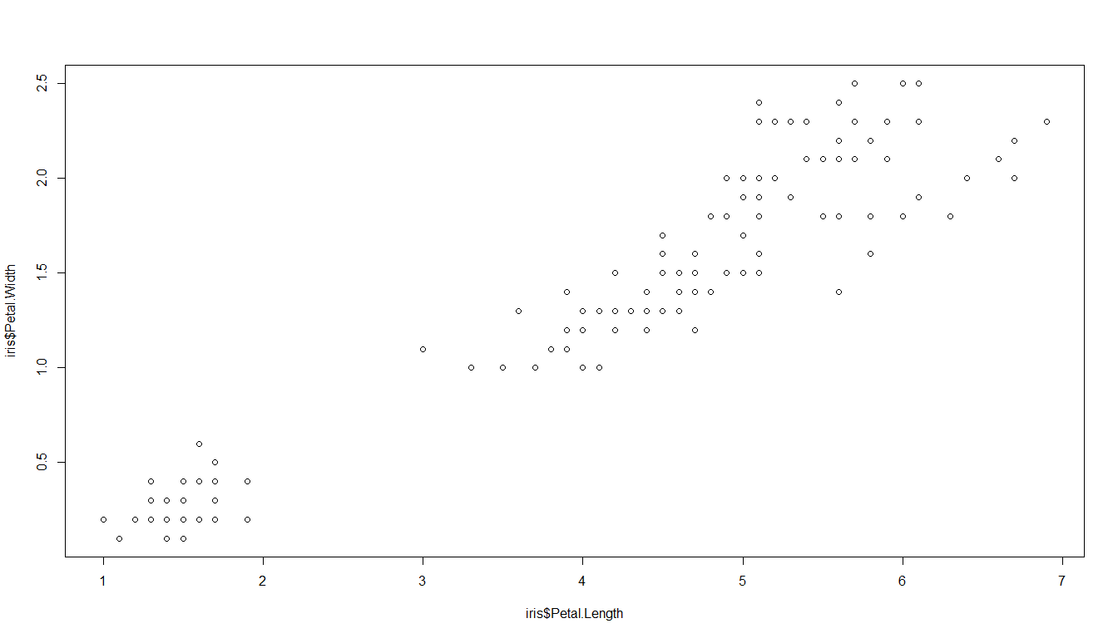

The second child-file, provides a summary table of the same dataset.

|  |  |  |  |  |  |  |  |  |  |  |
| --- | --- | --- | --- | --- | --- | --- | --- | --- | --- | --- |
| Variable | Species | n | missing | min | Q1 | median | mean | Q3 | max | sd |
| Sepal.Length | setosa | 50 | 0 | 4.3 | 4.8 | 5 | 5.006 | 5.2 | 5.8 | 0.3525 |
| Sepal.Length | versicolor | 50 | 0 | 4.9 | 5.6 | 5.9 | 5.936 | 6.3 | 7 | 0.5162 |
| Sepal.Length | virginica | 50 | 0 | 4.9 | 6.225 | 6.5 | 6.588 | 6.9 | 7.9 | 0.6359 |
| Sepal.Width | setosa | 50 | 0 | 2.3 | 3.2 | 3.4 | 3.428 | 3.675 | 4.4 | 0.3791 |
| Sepal.Width | versicolor | 50 | 0 | 2 | 2.525 | 2.8 | 2.77 | 3 | 3.4 | 0.3138 |
| Sepal.Width | virginica | 50 | 0 | 2.2 | 2.8 | 3 | 2.974 | 3.175 | 3.8 | 0.3225 |
| Petal.Length | setosa | 50 | 0 | 1 | 1.4 | 1.5 | 1.462 | 1.575 | 1.9 | 0.1737 |
| Petal.Length | versicolor | 50 | 0 | 3 | 4 | 4.35 | 4.26 | 4.6 | 5.1 | 0.4699 |
| Petal.Length | virginica | 50 | 0 | 4.5 | 5.1 | 5.55 | 5.552 | 5.875 | 6.9 | 0.5519 |
| Petal.Width | setosa | 50 | 0 | 0.1 | 0.2 | 0.2 | 0.246 | 0.3 | 0.6 | 0.1054 |
| Petal.Width | versicolor | 50 | 0 | 1 | 1.2 | 1.3 | 1.326 | 1.5 | 1.8 | 0.1978 |
| Petal.Width | virginica | 50 | 0 | 1.4 | 1.8 | 2 | 2.026 | 2.3 | 2.5 | 0.2747 |