Table of Contents

Size-matched benchmarking reveals genuine but modest ranking skill in end-point MM/PBSA for macrocyclic peptides
Carlos Liu¹, Joseph S. Brown¹
¹ Leslie Dan Faculty of Pharmacy, University of Toronto, Toronto, Ontario, Canada
Draft manuscript — prospective validation section is a registered plan, not yet executed.

Abstract
Macrocyclic peptides engage targets that small molecules cannot, but each analogue is expensive to make, so computational ranking has unusual leverage: a method that merely sorts candidates correctly saves real synthetic effort. Rigorous alchemical free-energy methods achieve this but cost GPU-days per compound. End-point methods such as MM/PBSA cost seconds, and a recent protocol reports strong performance on protein–cyclic-peptide complexes. Whether that performance reflects physics or molecular size has not been established.
Size is not a nuisance variable for peptide binding: larger peptides bury more interface and genuinely bind more tightly. On a five-target benchmark of 234 compounds with measured affinities, experimental ΔG tracks ligand heavy-atom count with a mean within-target Spearman ρ of −0.43, and the MM/PBSA score tracks it more strongly still (ρ = −0.55). Conventional benchmarking therefore cannot separate a scoring function from a ruler.
We resolve this by evaluating only within sets of peptides of identical heavy-atom count, where a size descriptor carries no information by construction. On decisive pairs, MM/PBSA selects the tighter binder in 60.1% of cases (95% CI 53.0–69.3), against 84.1% (75.6–91.2) for published FEP+ predictions on the same compounds and 50% for chance. The skill is real but modest and unevenly distributed: clearly above chance for PCSK9 (76.5%) and JAK2 (63.7%), indistinguishable from chance for Cyclin A/B, KRAS and MCL-1.
Three further results bear on how such benchmarks should be read. The apparent accuracy depends on the estimator: for KRAS, whose compounds span two receptor crystal forms, pooling gives ρ = +0.225 while averaging within forms gives −0.130, the pooled value being credit for separating two groups offset by 1.15 kcal/mol. The score is a ranking device rather than a free energy, sitting 45–75 kcal/mol from experiment with per-target regression slopes of 0.10–0.21. And on a sixth target held entirely outside development — 17 peptidomimetics against an antibody, affinities sealed before prediction — every method fell below chance and the size–affinity relationship reversed sign, showing that performance on five related targets is not sufficient evidence of transfer.
We apply the protocol to 212 designed macrocycles against the lipopolysaccharide transport protein LptA and register a prospective test with its power analysis stated in advance.
Keywords: macrocyclic peptides, MM/PBSA, binding affinity, benchmarking, ligand size bias, free energy perturbation

1. Introduction

1.1 Why ranking matters more than prediction here
Macrocyclic and cyclic peptides occupy a chemical space between small molecules and biologics, and they can engage shallow protein–protein interfaces that conventional drugs cannot. They are also expensive. A single non-canonical building block can cost on the order of a thousand dollars, synthesis is laborious, and a design campaign can propose hundreds of candidates against a budget of ten. The practical question is therefore not “what is the binding constant?” but “of these candidates, which should we make?”
That is a ranking problem, and ranking is a weaker requirement than prediction. A method that cannot produce a binding constant may still order candidates usefully. Conversely, a method with an impressive correlation coefficient may be useless if that correlation comes from something the chemist already knows.

1.2 The computational options
Free energy perturbation (FEP) is the rigorous approach: it simulates one ligand transforming into another and tracks the free-energy change. Applied to macrocycles with appropriate enhanced sampling, FEP+ achieves a global pairwise RMSE of 1.06 kcal/mol across more than 230 analogues spanning over 10 kcal/mol of experimental range. The cost is GPU-days per compound and a commercial licence.
End-point methods take the opposite trade. MM/PBSA evaluates the interaction energy of a single structure and subtracts an estimate of the desolvation cost, in seconds rather than days. Zhao and colleagues recently reported a fine-tuned MM/PBSA(GBSA) workflow for protein–cyclic-peptide complexes achieving a Pearson correlation of −0.732 against experimental affinity on a 50-complex dataset, roughly twice that of a conventional docking score, at about three seconds per prediction.
The gap between these is roughly three orders of magnitude in cost. What is given up is not well characterised for peptides.

1.3 The problem with the obvious benchmark
Scoring functions have a long-documented tendency to track molecular size. Jacobsson and Karlén found “a high to intermediate linear correlation between the score and the number of heavy atoms” for nine of ten scoring functions tested, and identified this ligand bias as a source of false positives in virtual screening. The standard responses are normalisation by molecular weight or heavy-atom count, ligand efficiency metrics, or matched-pair benchmark design.,
For peptides the problem is sharper, for a reason that is easy to miss. Size is not an artefact here. More residues bury more interface area, and buried area is a genuine driver of binding affinity. A size descriptor is therefore a mediator of the physics, not a confounder to be regressed away — and partialling it out over-corrects, removing exactly the signal a physics method is supposed to capture.
This creates a genuine methodological difficulty. Comparing a scoring function against a heavy-atom count across compounds of different sizes is unfair in both directions: the scoring function gets credit for re-reading size, and the control gets credit for real physics.

1.4 What we do
We hold size fixed. Within each target we compare only peptides of identical heavy-atom count, where a size descriptor has no information at all because there is no size difference to read, and ask the question a chemist actually asks: given two candidates, which binds tighter? This extends matched-pair benchmarking to macrocyclic peptides, where the size range is far wider than in small-molecule series and the synthesis stakes are higher.
We report: a replication of the Zhao protocol on an independent five-target cohort; the magnitude of the size confound; size-matched performance against a published FEP+ ceiling on identical compounds; the sensitivity of all of this to the choice of statistical estimator; and an application to a de novo design campaign against LptA, with a registered prospective test.
Box 1 — What a force field is, for readers new to this
A force field is a set of rules for computing the energy of an arrangement of atoms. It assigns each atom a partial electric charge and a size, and each bond a stiffness and a preferred length. Given the 3-D coordinates of a protein and a peptide, it returns a number: how favourable that arrangement is. It is classical physics — balls and springs — with parameters fitted to quantum calculations and experiment. It knows nothing about biology.
Standard amino acids have well-tested parameters. Non-canonical residues do not, and must be parameterised individually before anything can be computed (Section 2.3).

2. Methods

2.1 Benchmark cohort
Method development and all reported statistics use a published external benchmark: the five-target macrocycle and cyclic-peptide series of Awoonor-Williams and colleagues — KRAS, PCSK9, MCL-1, JAK2 and Cyclin A/B — comprising over 230 peptidic and non-peptidic analogues. We use the 241 compounds for which structures and labels could be assembled; 235 carry an experimental binding free energy and 234 survive quality control (Section 2.4). Analyses requiring unambiguous labels additionally exclude censored measurements, leaving 220.
Two properties make this the right cohort. The affinities were measured by a third party, so the evaluation cannot be tuned to them. And because FEP+ predictions were published alongside, a rigorous-method ceiling is available on exactly the same compounds, which is otherwise difficult to obtain.
Compounds are not independent within a target: two targets span more than one receptor crystal form (KRAS, two; PCSK9, three), giving eight receptor groups. All primary statistics are computed within receptor group and averaged with equal weight per target (Section 2.6).

2.2 Structure preparation
Receptor and peptide are cleaned with pdb4amber in two passes. The first retains prepared hydrogens so that histidine tautomer and cystine assignments carry into residue names; the second strips hydrogens so that tleap rebuilds them against its own templates. A single pass is insufficient because prepared files carry atoms (e.g. HXT) for which the older force fields have no type.
Cyclisation is imposed explicitly. Head-to-tail macrocycles receive an explicit bond in tleap; disulfide-cyclised peptides are detected geometrically (S–S < 2.5 Å) and left to the CONECT records written by pdb4amber, because re-issuing those bonds manually produces 1-4: cannot add bond errors. For macrocycles with uncharged termini, clearPdbResMap prevents tleap applying terminal templates to a molecule that has no termini.
Two preparation defects were found during validation, both of which produced plausible but wrong energies, and both of which are corrected here:
Spurious chain breaks. pdb4amber inserted TER records into continuous chains, each of which tleap capped, producing complexes with initial energies above 10¹⁷ kcal/mol. The problem affects 14 of 50 reference complexes, with 9 to 25 spurious records each (the remaining 36 are unaffected). TER records whose flanking C–N distance is below 2.0 Å are deleted. After the fix, atom counts of a reference complex match published values exactly.
Unrelieved steric clash. One compound (MCL_1__cpd_55) passed the pipeline’s own ok status while carrying a van der Waals term of +277,293 kcal/mol, against ≤ −50 kcal/mol for every other compound. A status check does not test for unrelieved overlap. Screening on VDWAALS > 0 is mandatory before any analysis and is applied throughout. Rank statistics are largely insensitive to this compound (macro Spearman 0.532 → 0.545), but the pooled Pearson correlation moves from −0.048 to +0.265 on removing it, and MCL-1’s Pearson r from −0.124 to +0.693. A single unrelieved clash was therefore enough to make the method look uncorrelated with experiment.

2.3 Force fields and non-canonical residues
component | assignment | reason
protein | oldff/leaprc.ff03 | the leaprc named by the source protocol; it takes terminal residues from all_amino{n,c}t94.lib and therefore carries NCYX/CCYX. leaprc.protein.ff03.r1 has neither and fails on 20 of 50 reference complexes whose terminal residue is a cystine
protein (comparison) | ff14SB, ff19SB | tested rather than assumed (Section 3.6)
phosphotyrosine | leaprc.phosaa10 | JAK2’s receptor carries a phosphotyrosine; without it tleap fails
ligands, ncAA side chains | GAFF2 with AM1-BCC charges | standard for non-protein chemistry
water (alchemical legs) | TIP3P | —
ff19SB is used off-label under implicit solvent: its CMAP correction was parameterised for OPC water and applies only to the 20 standard residues, so a GAFF2-hybrid non-canonical residue never receives it. This is reported rather than hidden.
Non-canonical residues. The LptA application required parameters for 170 non-standard residues. For each: the polymer-form rotamer is capped with ACE and NME, charges are derived with AM1-BCC on the neutral capped dipeptide, prepgen removes the caps and redistributes their charge to give a residue netting zero, and parmchk2 supplies missing GAFF2 terms. Capping matters because AM1-BCC on a free amino acid fits backbone charges in an environment (–NH₂ / –COOH) the residue never occupies; capping places the fit in a peptide-like context, the standard Amber construction.
The backbone is reassigned to protein atom types while the side chain remains GAFF2, because antechamber otherwise types the backbone as GAFF2 and tleap has no parameters across the peptide bond to a neighbouring standard residue. The alpha carbon is typed CT for ff03 and CX for ff14SB/ff19SB, so two parameter sets are maintained.
Every residue is validated by constructing ALA–X–ALA and requiring zero missing parameters; all 170 pass under both typings. This test is necessary because tleap writes a topology even when parameters are missing, substituting defaults.
Six defects were found during parameterisation, four of which produced silently wrong output. Most consequential: antechamber infers element from atom name, so every alpha carbon (CA) was read as calcium and 61 aromatic carbons named CL* as chlorine; and GAFF2 has no selenium, so antechamber silently retyped Se as sulfur while parmchk2 reported nothing missing. Two selenium-containing residues remain approximations and are flagged as such.

2.4 Energy minimisation
Minimisation follows the published settings — imin=1, maxcyc=5000, ncyc=2000, cut=1000.0, igb=2 — corresponding to 2000 steps of steepest descent then conjugate gradient in the Onufriev–Bashford–Case generalised Born model with no nonbonded cutoff.
Because the available AmberTools build does not ship pmemd.cuda, and sander requires hours per complex at cut=1000, minimisation is performed in OpenMM using OBC1 and NoCutoff, the direct equivalents. The two engines are not identical, so the OpenMM L-BFGS iteration count was calibrated against sander by structural drift: sander’s 5000 cycles move the complex 0.84 Å RMSD, an unrestricted OpenMM minimisation 1.25 Å. A cap of 500 iterations reproduces sander’s drift and is used throughout.
This calibration is load-bearing. On KRAS, removing the cap changes the correlation from +0.225 to +0.529, and the spread introduced by the stopping point (SD 3.60 kcal/mol) is as large as the entire between-compound signal (SD 3.53) — a ratio of 1.02. Removing the cap does not generalise: it improves KRAS by +0.304 and degrades PCSK9 by −0.280, for a net macro change of −0.009 (cluster bootstrap +0.110, 95% CI [−0.066, +0.230]).

2.5 Free-energy evaluation
MMPBSA.py is run single-trajectory, so receptor internal energy cancels exactly. Poisson–Boltzmann calculations use the internal solver with interior dielectric 2.0, exterior 80.0, and the LCPO nonpolar model (inp=1, cavity_surften=0.0072, cavity_offset=0). Arms at εᵢₙ = 1 and 4 and GB arms are computed in parallel for comparison. No entropy term is included, following the source protocol.
The intdiel keyword is silently ignored by both engines when passed through &pb. The dielectric is therefore set by writing use_sander=1, generating inputs with -make-mdins, injecting intdiel into the generated _MM_gb.mdin, and re-running with -use-mdins. Without this, every “different dielectric” arm silently returns identical numbers.
The protocol is single-structure: one minimised geometry is scored, not an ensemble. MMPBSA.py reports Calculations performed using 1.0 complex frames with zero standard error. This is the source protocol’s design, stated explicitly because “MM/PBSA” usually implies ensemble averaging. The choice is defensible on published evidence that MM/PBSA correlation does not generally improve with longer sampling because the limiting error is bias rather than variance; we tested it directly (Section 3.7).
Box 2 — What MM/PBSA actually computes
Take the structure of the peptide sitting in the protein’s binding site. Add up the electrostatic and van der Waals attraction between them: that is the gas-phase interaction energy, and it is always favourable. But in water, both surfaces are coated with ordered water molecules that must be stripped off before they can touch, and that costs energy. MM/PBSA estimates this desolvation penalty by solving the Poisson–Boltzmann equation, treating water as a continuous dielectric rather than individual molecules.
The binding score is attraction minus desolvation. What it omits is entropy — the freedom the peptide loses when it stops tumbling in solution and locks into one conformation. That omission is why the numbers are not free energies (Section 3.4).

2.6 Statistical evaluation
Primary estimator. Spearman’s ρ computed within receptor group and averaged across targets, each target weighted equally. Pooling compounds across targets is rejected: it rewards a method for knowing that one series is systematically more potent than another, which is not the question a design campaign asks. Section 3.2 quantifies the resulting inflation within our own data.
Size-matched pairwise accuracy — the primary measure. For each target we enumerate all compound pairs whose measured affinities differ by at least 0.5 kcal/mol (“decisive” pairs) and whose ligand heavy-atom counts are equal. For each pair we ask whether the method orders them correctly. Chance is 0.5. A size descriptor is undefined on these pairs, because the sizes are equal. We report the band |Δheavy| = 0 as the primary analysis and |Δheavy| ≤ 3 as a better-powered secondary.
Uncertainty. Bootstrap over pairs within each target (2,000 resamples) and over targets for macro values (5,000 resamples). Compounds within a receptor group are not independent, so where Spearman correlations are reported the bootstrap resamples receptor groups, not compounds.
Controls. Ligand heavy-atom count is computed on the same compounds with the same estimator throughout. Censored measurements are retained and flagged in correlation analyses and excluded from pairwise analyses where the ordering would be ambiguous.
Box 3 — How to read a pairwise accuracy
Hand the method two peptides whose measured affinities genuinely differ, and ask which binds tighter. Do that for every such pair. The fraction it gets right is the pairwise accuracy.
A coin gets 50%. A perfect method gets 100%. 60% means that in a head-to-head choice between two candidates, the method is right three times in five instead of one in two. That is a modest edge, but across a campaign of many such choices it is not nothing — and crucially it is measured here in a setting where the obvious shortcut, “pick the bigger one”, is unavailable.

2.7 Software
AmberTools 25/26 (tleap, antechamber, parmchk2, prepgen, cpptraj, MMPBSA.py); OpenMM 8 (CUDA, mixed precision); RDKit 2025.03/2026.03; ParmEd; NumPy, SciPy, pandas; UCSF ChimeraX 1.12 for visualisation. Hardware: NVIDIA RTX PRO 6000 Blackwell and NVIDIA H100 80GB.

3. Results

3.1 The protocol reproduces, with a caveat on what is being reproduced
Scoring the source protocol’s 50-complex Dataset I under ff03 with PB at εᵢₙ = 2 gives a Pearson correlation of −0.382, against the −0.545 reported for the equivalent arm. The headline −0.732 in that work is a two-step workflow that first re-ranks docked poses and then scores the selected pose; our evaluation scores the deposited pose directly, so the two numbers are not comparable and we do not treat the gap as a replication failure.
Transferring the protocol unchanged to the independent five-target cohort gives a macro Spearman ρ of +0.545 across 234 compounds (Figure 3; per-target values in Table 1).
Table 1. Per-target performance on the Awoonor-Williams cohort. Pearson r and Spearman ρ are computed within receptor group. “Slope” is the per-target regression slope of score on experiment; its reciprocal gives the factor by which ΔΔG spread is inflated.
target | n | MM/PBSA r | R² | MM/PBSA ρ | FEP+ ρ | slope | offset (kcal/mol)
Cyclin A/B | 21 | +0.609 | 0.371 | +0.591 | +0.791 | 0.202 | −59.4
JAK2 | 48 | +0.588 | 0.345 | +0.595 | +0.788 | 0.103 | −44.8
KRAS | 45 | +0.300 | 0.090 | +0.225 | +0.786 | 0.125 | −74.8
MCL-1 | 57 | +0.693 | 0.480 | +0.728 | +0.859 | 0.099 | −69.0
PCSK9 | 63 | +0.551 | 0.304 | +0.584 | +0.929 | 0.208 | −64.9
macro | 234 | +0.548 | 0.318 | +0.545 | +0.831 | — | —
Two things in Table 1 deserve emphasis. First, the commonly quoted “R” in such analyses is a correlation, not a coefficient of determination: r = 0.548 corresponds to R² = 0.318, so the protocol explains under a third of the variance, against 0.719 for FEP+. Second, the per-target slopes of 0.10–0.21 mean the score’s ΔΔG spread is inflated five- to tenfold, and the offsets of 45–75 kcal/mol are the signature of the omitted entropy term.

3.2 How you average changes the answer
Pooling compounds that come from different receptor structures inflates the apparent correlation, and KRAS shows this cleanly because its 45 compounds are split across two crystal forms.
Table 2. KRAS under two estimators. Pooling reverses the sign of the result.
KRAS | n | MM/PBSA ρ | FEP+ ρ
within form 7YUZ | 17 | −0.307 | +0.576
within form 8JJS | 28 | +0.046 | +0.782
macro over forms | 45 | −0.130 | +0.679
pooled over both | 45 | +0.225 | +0.786
The mechanism is explicit: the MM/PBSA score is offset by −3.05 kcal/mol between the two forms, in the same direction as a −1.15 kcal/mol offset in the experimental labels. The pooled +0.225 is therefore credit for separating two groups, not for ranking within either. FEP+ is far less affected (+0.679 versus +0.786), as expected of a method whose signal does not come from a group offset.
This matters beyond KRAS because it occurs inside what is conventionally reported as a within-family metric. Any benchmark of this kind must state which estimator it uses; we use within-receptor averaging throughout.

3.3 Size is a real driver of binding, and the score tracks it
Figure 2 quantifies the confound. Experimental ΔG tracks ligand heavy-atom count with a mean within-target Spearman ρ of −0.43 (panel A; negative because more atoms give more negative ΔG). The MM/PBSA score tracks heavy-atom count more strongly still, at −0.55 (panel B).
The first of these is physics, not bias: more residues bury more interface area. The second means the score and the trivial descriptor are substantially measuring the same thing. Under the conventional estimator, a heavy-atom count reaches ρ = 0.488 pooled in-family and 0.613 within receptor — numerically better than MM/PBSA’s 0.459 within receptor.
That comparison is not evidence that the physics is useless. It is evidence that the comparison is ill-posed. Both quantities partly measure size; the one that measures it more directly wins on a benchmark where size varies. Panel C shows that enough compounds share a heavy-atom count within each target to make a fair comparison possible.

3.4 Size-matched performance: the primary result
Restricting to pairs of peptides with identical heavy-atom count, where a size descriptor is undefined:
Table 3. Pairwise accuracy on decisive pairs (|ΔΔG| ≥ 0.5 kcal/mol). Chance = 0.500.
target | pairs | MM/PBSA | 95% CI | FEP+ | 95% CI
Cyclin A/B | 15 | 0.533 | [0.267, 0.800] | 0.867 | [0.667, 1.000]
JAK2 | 80 | 0.637 | [0.537, 0.738] | 0.900 | [0.838, 0.963]
KRAS | 56 | 0.518 | [0.393, 0.643] | 0.818 | [0.709, 0.909]
MCL-1 | 71 | 0.549 | [0.437, 0.662] | 0.671 | [0.557, 0.786]
PCSK9 | 115 | 0.765 | [0.687, 0.835] | 0.947 | [0.904, 0.982]
macro | — | 0.601 | [0.530, 0.693] | 0.841 | [0.756, 0.912]
The macro interval excludes chance, so the skill is real. Relaxing the matching to within three heavy atoms gives 0.624 [0.552, 0.693] for MM/PBSA and 0.839 [0.799, 0.886] for FEP+, on substantially more pairs, confirming the result is not an artefact of the strictest band.
The skill is also unevenly distributed. PCSK9 (0.765) and JAK2 (0.637) are clearly above chance; Cyclin A/B, KRAS and MCL-1 have intervals spanning 0.5.
One candidate explanation is interface polarity, since a continuum-solvent treatment should add most where desolvation dominates. PCSK9 does have much the most polar interface in the cohort (median buried-area polarity 42.2%, against 30.5% for the next-highest). But the explanation does not survive the second case: JAK2 is the fourth most polar of the five (23.8%) and the second-best performer, while KRAS is second most polar (30.5%) and indistinguishable from chance. Polarity alone therefore does not account for where the method works, and with five targets we cannot identify what does. We report the pattern without an explanation rather than offer one the data does not support.
The behaviour of the control across matching bands is itself informative. As the permitted size difference widens from zero to three to five heavy atoms to unrestricted, the heavy-atom count climbs from undefined, to 0.602, to 0.629, to 0.717, while MM/PBSA moves only from 0.601 to 0.738. The control gains almost all of its apparent performance from size variation; the scoring function does not.

3.5 What the score is not
With entropy omitted, the raw score is not a free energy. It sits 45–75 kcal/mol from experimental ΔG (Table 1), and matching the experimental scale requires fitting a slope and intercept within a target, which requires compounds already measured in that series. An RMSE of 1.11 kcal/mol is achievable only after that fit. It is not a prospective accuracy, and should not be quoted as one.

3.6 Force-field choice does not transfer
On the benchmark, ff03 outperforms ff19SB (0.545 versus 0.495 macro, winning four of five targets; only JAK2 prefers ff19SB, +0.604 versus +0.595). On the LptA design panel the ordering reverses, with ff19SB ≥ ff14SB > ff03 in every branch.
This inversion should not be over-read. The LptA designs have no measured affinities, so that comparison is scored against Rosetta dG_separated. We tested that reference directly on 239 benchmark compounds where measured affinities exist and found a macro Spearman of −0.149, wrong-signed on four of five targets, and below a heavy-atom count (+0.487). A reference standard that does not itself track experiment cannot establish which force field is better.
We report the comparison only as a caution: force-field selections made on one dataset should not be assumed to transfer, and we do not claim ff19SB is superior for these designs.

3.7 Longer sampling does not help
A natural objection to single-structure scoring is that an ensemble average would do better. We tested this on 40 KRAS compounds for which four independent 10 ns explicit-solvent replicas were available, scored over the 2–10 ns window at 81 frames per replica — 324 frames per compound.
The ensemble does not converge well enough for the averaging to help. The median replicate-to-replicate standard deviation of the ensemble score is 6.81 kcal/mol, while the standard deviation between compounds is 5.74 kcal/mol. The noise from which replicas you happened to run is therefore larger than the entire signal distinguishing one compound from another, a ratio of 1.19. Splitting by panel, the 20 confirmatory compounds give 5.60 against 5.54 (ratio 1.01) and the 20 primary compounds 8.70 against 4.88 (ratio 1.78); the conclusion does not depend on the subset.
Four 10 ns replicas is a substantial sampling budget for a system of this size, and it is not enough to make the ensemble score reproducible at the resolution the ranking requires. This is consistent with the general finding that MM/PBSA correlation does not improve reliably with longer sampling because the limiting error is bias rather than variance, and it supports the source protocol’s single-structure design on pragmatic grounds: a cheaper calculation that is reproducible is preferable to an expensive one that is not.

3.8 An external test on a sixth target
The five benchmark targets are congeneric medicinal-chemistry series against folded pockets, assembled by one group for one FEP+ campaign. They may resemble each other more than they resemble a new target. We therefore tested the pipeline on a sixth system held entirely outside development: 17 peptidomimetics against the anti-haemagglutinin antibody 12CA5, with binding measured by biolayer interferometry (7 binders spanning 0.21–77 nM, 10 non-binders). Affinities were sealed before any prediction was made.
Every method failed, and several inverted.
Table 4. Performance on the sealed 12CA5 panel. Directions were fixed before unblinding.
method | ρ vs pK_D (7 binders) | binder/non-binder AUC
heavy-atom count | −0.750 | 0.257
molecular weight | −0.750 | 0.271
chemical model (pAffinity) | −0.107 | 0.214
chemical model (rank score) | −0.306 | 0.200
Chance AUC is 0.5; every value is below it. The tightest binder (0.21 nM) was ranked 16th of 17 by every method, and top-5 overlap with the experimental top 5 was zero throughout.
Two findings matter for the present work. First, the size–affinity relationship reversed sign: heavy-atom count correlates at −0.750 here against +0.49 to +0.61 on the benchmark. Size is predictive in congeneric series elaborated into a pocket, and anti-predictive against a compact epitope groove where bulk is in the way. A method whose signal is partly size therefore carries a sign that is target-dependent and not knowable in advance without measurement — which is a further argument for evaluating at fixed size.
Second, MM/PBSA could not be scored reliably at all: 3 of 17 built poses carried positive van der Waals terms and were excluded by the screen of Section 2.2, one failed to score, and across the remainder the score correlated with the pose builder’s clash count at ρ = −0.891. Those peptidomimetics were threaded onto a template they do not match. The lesson is that end-point scoring inherits the quality of its input pose, and that pose provenance must be reported alongside any score (Section 4).
We present this as a limitation rather than a general claim: one external target with 17 compounds cannot establish how the method behaves on all new systems. It does establish that benchmark performance on five related targets is not sufficient evidence of transfer.

4. Application: a de novo design campaign against LptA
Lipopolysaccharide transport protein A (LptA) is the periplasmic component of the seven-protein Lpt bridge that moves lipopolysaccharide from the inner membrane to the cell surface in Gram-negative bacteria. The insect-derived antimicrobial peptide thanatin binds the N-terminal β-strand of LptA, disrupting both LptA–LptA dimerisation and the LptC–LptA interaction and causing LptA degradation. Because that β-strand edge is also the dimerisation interface, the site is a template for designed β-hairpin binders, and thanatin analogues optimised against carbapenem-resistant Enterobacteriaceae have been characterised structurally and thermodynamically.,
We applied the protocol to a panel of 212 designed macrocycles in three branches: 20 canonical head-to-tail cyclic peptides from generative backbone design followed by sequence design; 96 single-residue non-canonical substitutions on those canonical parents; and 96 single-residue non-canonical substitutions on a thanatin derivative-7 scaffold templated on a co-crystal structure. A total of 213 complexes were scored — the 212 designs plus the derivative-7 parent as a reference.
Pose quality. Unlike the benchmark, these poses are generated rather than crystallographic, which raises the question of whether scores read binding or pose-construction artefact. Across all 213 scored complexes the built poses contain zero interface heavy-atom contacts below 1.8 Å, and minimisation drift spans only 0.49–1.42 Å. For comparison, the 12CA5 panel of Section 3.8, whose peptidomimetics were threaded onto a non-matching template, showed 0–44 clashes per complex, backbone RMSD to 4.72 Å, and MM/PBSA scores correlating with clash count at ρ = −0.891 — that is, reading pose quality rather than chemistry. The LptA poses show no such pathology, which is a necessary condition for the scores to be interpretable, though not a sufficient one.
Size dependence differs by branch. The score’s correlation with ligand heavy-atom count is −0.668 for the 20 canonical de novo designs, −0.606 for their 96 non-canonical swaps, and only −0.291 for the 96 thanatin swaps. This follows from construction: single substitutions on a fixed 16-residue scaffold barely change size, whereas the de novo designs vary from 14 to 18 residues. The thanatin branch is therefore the least size-confounded, and by the argument of Section 3.4 it is the branch on which the protocol’s demonstrated skill is most likely to apply.
No measured affinities exist for any of these designs. All statements about them are computational, and the protocol has not demonstrated predictive skill on this system. Rankings are reported within branch only; the branches occupy different score ranges and pooling them produces a spurious correlation.

5. Prospective validation (registered plan — not yet executed)
This section describes a planned experiment. No results exist at the time of writing.
Everything above is retrospective, on compounds measured by others. We therefore register a forward test.
Design. Ten de novo LptA designs will be selected before any measurement, synthesised, and assayed. The ranking is frozen at registration and will not be adjusted afterwards.
Compound selection. The ten span a four-heavy-atom window (149–153 atoms) — essentially size-matched, which is the regime in which Section 3.4 establishes skill — while covering 34 kcal/mol of predicted score range (−104.0 to −69.8 kcal/mol). Spanning the predicted range rather than selecting predicted winners is deliberate: a set of predicted winners cannot falsify the ranking.
What ten compounds can and cannot establish. Power analysis by simulation, at the effect size measured here (ρ ≈ 0.30, corresponding to ~60% pairwise accuracy):
Table 5. Simulated power to detect a positive rank correlation at p < 0.05.
n | power at ρ = 0.30 | ρ = 0.50 | ρ = 0.75
10 | 0.12 | 0.28 | 0.67
20 | 0.22 | 0.58 | 0.96
40 | 0.43 | 0.88 | 1.00
Ten compounds cannot confirm the ranking: at the measured effect size the power is 12%, so a null result would be uninformative. We state this in advance rather than discovering it afterwards. Ten compounds can, however, do two useful things: detect a catastrophic inversion (66% power against ρ = −0.75), which is a live concern because exactly such a reversal occurred on the external target of Section 3.8; and supply ten measured anchors that permit within-series calibration.
This test is therefore registered as a sanity check and anchor acquisition, not as confirmatory validation. Confirmatory validation would require approximately 40 compounds, and we do not claim it here.

6. Discussion
The central finding is that end-point MM/PBSA retains genuine ranking skill on macrocyclic peptides when size is held fixed — 60.1% pairwise accuracy where chance is 50% and a size descriptor is undefined — at roughly a thousandth of the cost of rigorous free-energy simulation, which achieves 84.1% on the same pairs.
The methodological contribution is the comparison itself. Ligand size bias in scoring functions has been recognised for two decades, and matched-pair benchmarks are an established response in small-molecule work. Neither has been applied to macrocyclic peptides, where the size range within a series is far larger and where the usual correction — normalising by heavy-atom count or reporting ligand efficiency — is inappropriate because size is a mediator of the physics rather than a nuisance. Exact size matching sidesteps this: it requires no correction factor, makes no assumption about the functional form of the size dependence, and renders the control informative by construction.
The practical reading for a design campaign is that this protocol is a triage filter, not a ranking to defend. A 60% edge is worth having when the alternative is arbitrary selection and the cost of being wrong is a thousand-dollar synthesis, particularly at seconds per compound. It is not worth defending against a rigorous calculation when the decision is expensive enough to justify one. The natural workflow is end-point scoring to reduce hundreds of candidates to tens, then alchemical calculation on the shortlist.
Three cautions generalise beyond this work.
The estimator matters. Pooling compounds drawn from different receptor structures can invert the sign of a result, as it does for KRAS (Table 2), so benchmark numbers computed that way should be treated sceptically — including when the pooling is hidden inside what is reported as a within-family metric.
Pose provenance matters. Where poses are built rather than crystallographic, scores can track construction artefact: on the 12CA5 panel the score correlated with the pose builder’s clash count at ρ = −0.891. Any end-point score should be reported alongside evidence about the geometry it was computed on.
Reference standards must themselves be validated. We could not settle whether force-field choice transfers between our datasets, because the only available reference on the design panel was a computational score that we measured at ρ = −0.149 against experiment (Section 3.6). Agreement with an unvalidated reference is not evidence.

7. Limitations
- Five targets. Macro intervals rest on five values. Skill concentrates in PCSK9 and JAK2, and we could not identify why: interface polarity is the obvious candidate and it fails (Section 3.4). With five targets we cannot distinguish a chemical explanation from chance.
- Cyclin A/B is underpowered in the strictest size-matched band (15 pairs, CI spanning 0.267–0.800) and contributes little.
- Scores are not free energies (Section 3.5) and must not be quoted as predicted affinities.
- No measured affinities exist for the LptA designs. Section 4 is an application, not a validation, and Section 5 is a plan.
- Two selenium-containing non-canonical residues are approximations, GAFF2 having no selenium parameters.
- Single-structure scoring inherits whatever error the input pose carries. We verify pose quality explicitly (Section 4) but cannot certify that generated poses are correct.
- Censored measurements are excluded from pairwise analyses, which may bias the admitted set toward the measurable dynamic range.
- We evaluate the protocol as published, not an optimised variant. We did not re-tune the dielectric, solvation model or minimisation depth to maximise size-matched accuracy; doing so on five targets would overfit. The reported 60.1% is therefore a floor for this family of methods rather than the best achievable.

Author contributions
C.L. designed and executed the computational work, performed the analyses and wrote the manuscript. J.S.B. supervised the project and revised the manuscript. The prospective validation of Section 5 will be executed experimentally by the Brown laboratory.

Competing interests
The authors declare no competing financial interests.

Acknowledgements
Computations were performed on local GPU hardware and on the Digital Research Alliance of Canada national systems. We thank the authors of the two benchmark studies whose data made this evaluation possible.

Data and code availability
All code, computed scores, per-target statistics, bootstrap intervals and figures are available at https://github.com/Caroldorium/mmpbsa-macrocycle-benchmark under an MIT licence. scripts/size_matched_pairwise_accuracy.py reproduces Table 3 and the primary figure.
Two third-party sources are reproduced for reproducibility and cited in place: measured affinities and FEP+ predictions from Awoonor-Williams et al., and the reference protocol and dataset tables from Zhao et al. All MM/PBSA scores, statistics, figures and code were computed in this work.

References

Figures
Figure 1. Pipeline schematic and validation logic.
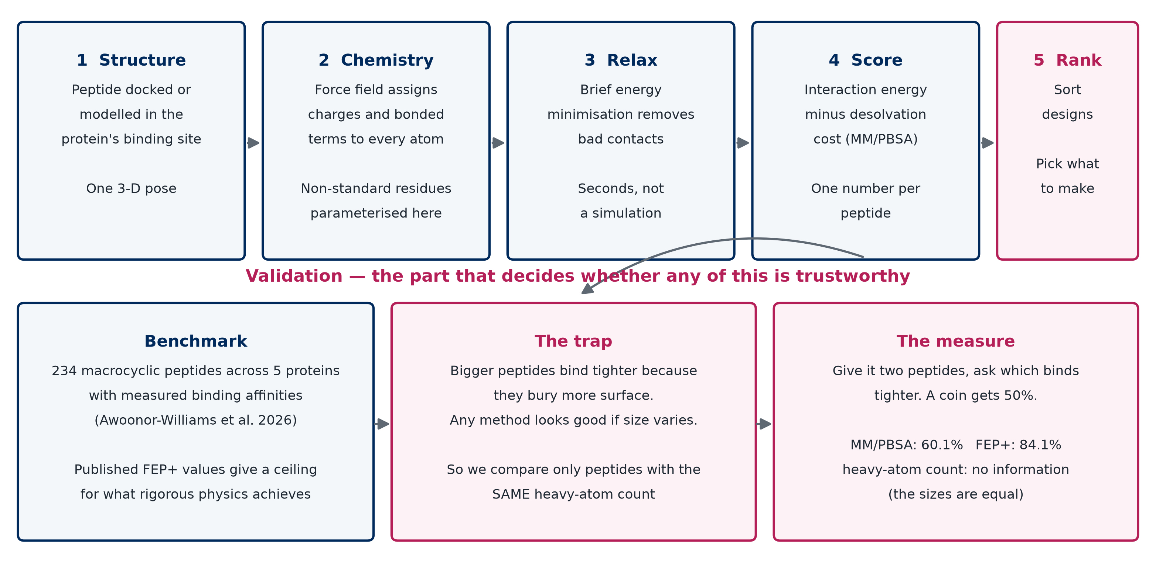
Pipeline and validation logic
Figure 2. The size confound. (A) Experimental ΔG tracks ligand heavy-atom count (mean within-target ρ = −0.43). (B) The MM/PBSA score tracks it more strongly (ρ = −0.55). (C) Within-target size distributions, showing that enough compounds share a heavy-atom count to permit direct comparison.
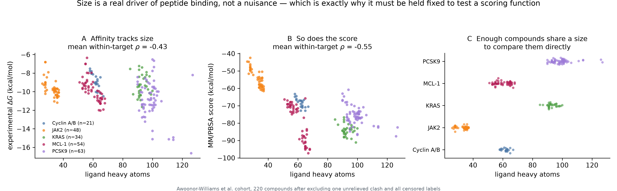
The size confound
Figure 3. Per-target parity for raw MM/PBSA, calibrated MM/PBSA and published FEP+ against experiment.
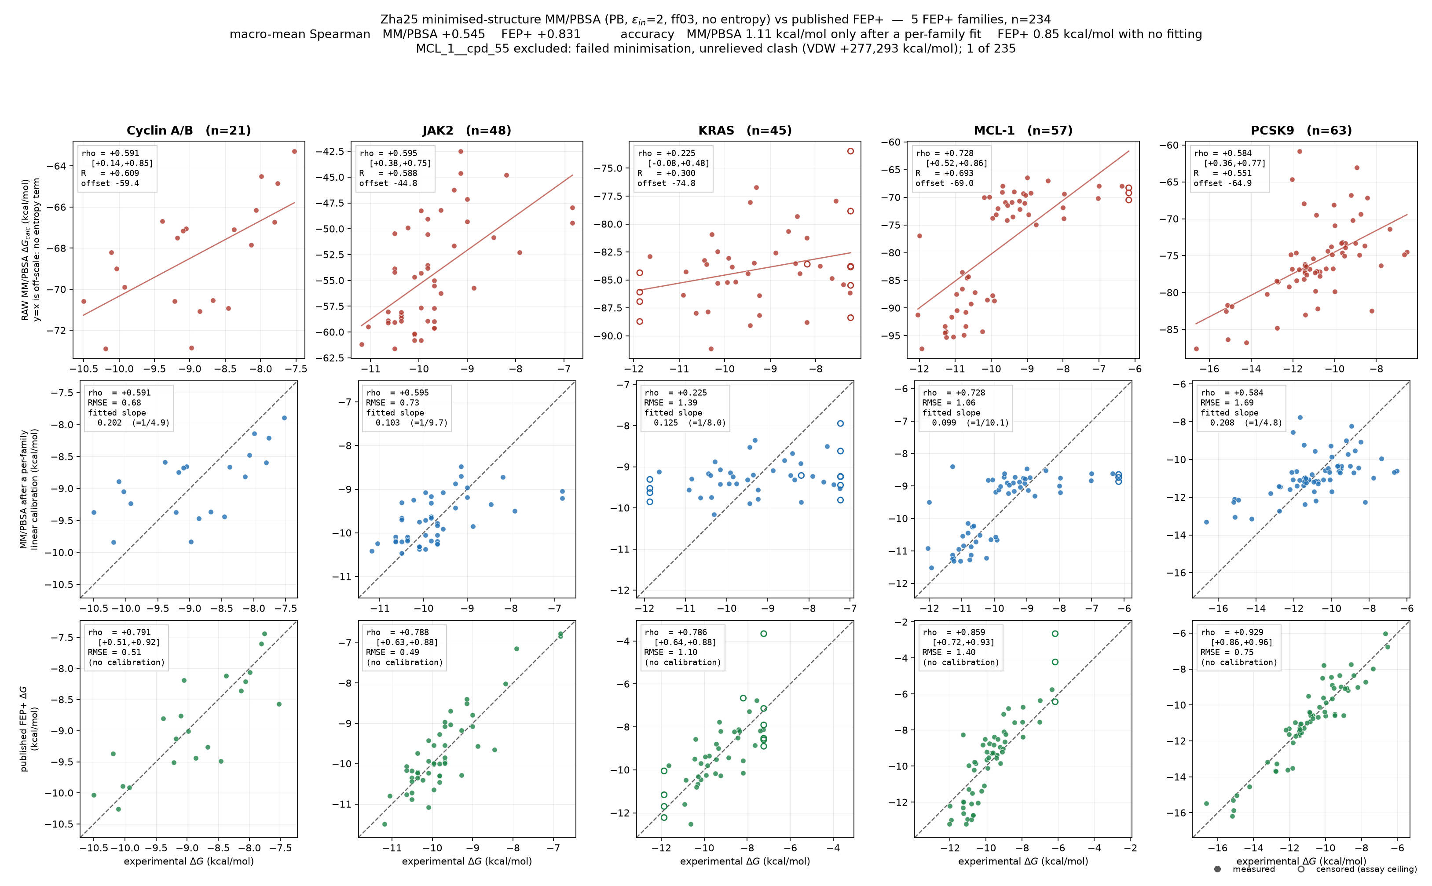
Per-target parity
Figure 4. Size-matched pairwise accuracy, at identical heavy-atom count (left) and within three heavy atoms (right), against the FEP+ ceiling. Chance is 0.5; a heavy-atom count is undefined in the left panel.
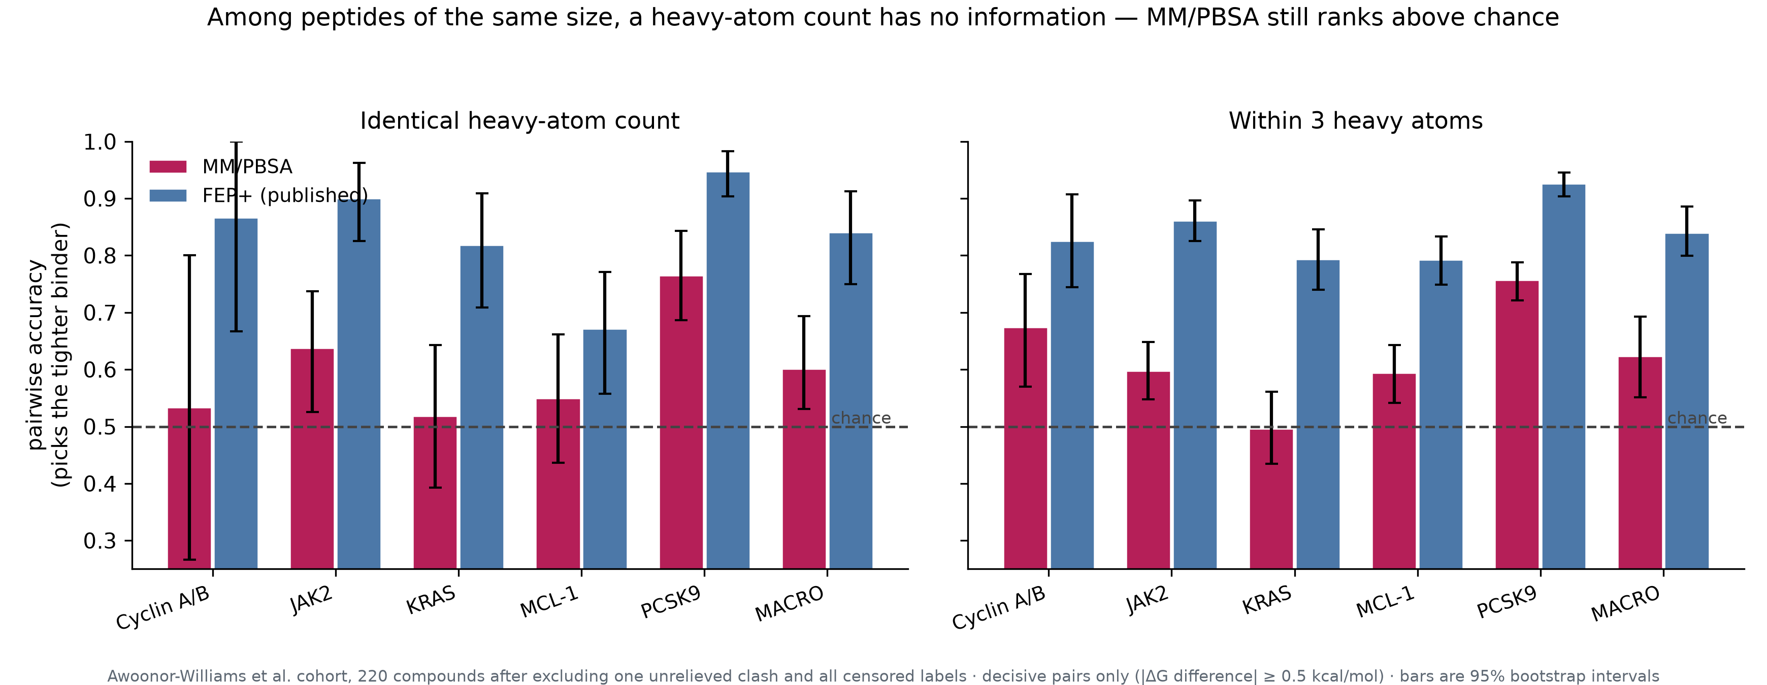
Size-matched pairwise accuracy

Vinogradov AA, Yin Y, Suga H. Macrocyclic peptides as drug candidates: recent progress and remaining challenges. J Am Chem Soc 2019;141(10):4167–4181. doi:10.1021/jacs.8b13178. PMID 30768253.
Awoonor-Williams E, Beautrait A, Petridis L, Hu X. Derisking affinity optimization for macrocycles and cyclic peptides: high-precision free energy simulations across five diverse targets. J Chem Inf Model 2026;66(14):8545–8560. doi:10.1021/acs.jcim.6c01122. PMID 42396675.
Genheden S, Ryde U. The MM/PBSA and MM/GBSA methods to estimate ligand-binding affinities. Expert Opin Drug Discov 2015;10(5):449–461.
Zhao H, Huang J, Weng G, Jiang D, Hu R, Kang Y, Hou T. Improving the predictive performance of binding affinities and poses for protein–cyclic peptide complexes through fine-tuned MM/PBSA(GBSA)-based methods. Brief Bioinform 2025;26(6):bbaf632. doi:10.1093/bib/bbaf632. PMID 41319044.
Jacobsson M, Karlén A. Ligand bias of scoring functions in structure-based virtual screening. J Chem Inf Model 2006;46(3):1334–1343. doi:10.1021/ci050407t. PMID 16711752.
Jacobsson M, Karlén A. Ligand bias of scoring functions in structure-based virtual screening. J Chem Inf Model 2006;46(3):1334–1343. doi:10.1021/ci050407t. PMID 16711752.
Kalinowsky L, Weber J, Balasupramaniam S, Baumann K, Proschak E. A diverse benchmark based on 3D matched molecular pairs for validating scoring functions. ACS Omega 2018;3(5):5704–5714. doi:10.1021/acsomega.7b01194. PMID 31458770.
Kalinowsky L, Weber J, Balasupramaniam S, Baumann K, Proschak E. A diverse benchmark based on 3D matched molecular pairs for validating scoring functions. ACS Omega 2018;3(5):5704–5714. doi:10.1021/acsomega.7b01194. PMID 31458770.
Awoonor-Williams E, Beautrait A, Petridis L, Hu X. Derisking affinity optimization for macrocycles and cyclic peptides: high-precision free energy simulations across five diverse targets. J Chem Inf Model 2026;66(14):8545–8560. doi:10.1021/acs.jcim.6c01122. PMID 42396675.
Maier JA, Martinez C, Kasavajhala K, Wickstrom L, Hauser KE, Simmerling C. ff14SB: improving the accuracy of protein side chain and backbone parameters from ff99SB. J Chem Theory Comput 2015;11(8):3696–3713.
Tian C, Kasavajhala K, Belfon KAA, et al. ff19SB: amino-acid-specific protein backbone parameters trained against quantum mechanics energy surfaces in solution. J Chem Theory Comput 2020;16(1):528–552.
Homeyer N, Horn AHC, Lanig H, Sticht H. AMBER force-field parameters for phosphorylated amino acids in different protonation states. J Mol Model 2006;12(3):281–289.
Wang J, Wolf RM, Caldwell JW, Kollman PA, Case DA. Development and testing of a general amber force field. J Comput Chem 2004;25(9):1157–1174.
Jakalian A, Jack DB, Bayly CI. Fast, efficient generation of high-quality atomic charges. AM1-BCC model: II. Parameterization and validation. J Comput Chem 2002;23(16):1623–1641.
Jorgensen WL, Chandrasekhar J, Madura JD, Impey RW, Klein ML. Comparison of simple potential functions for simulating liquid water. J Chem Phys 1983;79(2):926–935.
Cieplak P, Cornell WD, Bayly C, Kollman PA. Application of the multimolecule and multiconformational RESP methodology to biopolymers. J Comput Chem 1995;16(11):1357–1377.
Onufriev A, Bashford D, Case DA. Exploring protein native states and large-scale conformational changes with a modified generalized Born model. Proteins 2004;55(2):383–394.
Eastman P, Swails J, Chodera JD, et al. OpenMM 7: rapid development of high performance algorithms for molecular dynamics. PLoS Comput Biol 2017;13(7):e1005659.
Miller BR III, McGee TD, Swails JM, Homeyer N, Gohlke H, Roitberg AE. MMPBSA.py: an efficient program for end-state free energy calculations. J Chem Theory Comput 2012;8(9):3314–3321.
Genheden S, Ryde U. The MM/PBSA and MM/GBSA methods to estimate ligand-binding affinities. Expert Opin Drug Discov 2015;10(5):449–461.
Zhao H, Huang J, Weng G, Jiang D, Hu R, Kang Y, Hou T. Improving the predictive performance of binding affinities and poses for protein–cyclic peptide complexes through fine-tuned MM/PBSA(GBSA)-based methods. Brief Bioinform 2025;26(6):bbaf632. doi:10.1093/bib/bbaf632. PMID 41319044.
Genheden S, Ryde U. The MM/PBSA and MM/GBSA methods to estimate ligand-binding affinities. Expert Opin Drug Discov 2015;10(5):449–461.
Moura ECCM, Baeta T, Romanelli A, et al. Thanatin impairs lipopolysaccharide transport complex assembly by targeting LptC–LptA interaction and decreasing LptA stability. Front Microbiol 2020;11:909. doi:10.3389/fmicb.2020.00909. PMID 32477309.
Oi KK, Moehle K, Schuster M, Zerbe O. Early molecular insights into thanatin analogues binding to A. baumannii LptA. Molecules 2023;28(11):4335. doi:10.3390/molecules28114335. PMID 37298811.
Sinha S, Dhanabal VB, Sperandeo P, Polissi A, Bhattacharjya S. Linking dual mode of action of host defense antimicrobial peptide thanatin: structures, lipopolysaccharide and LptA binding of designed analogs. Biochim Biophys Acta Biomembr 2021;1864(3):183839. doi:10.1016/j.bbamem.2021.183839. PMID 34915021.
Jacobsson M, Karlén A. Ligand bias of scoring functions in structure-based virtual screening. J Chem Inf Model 2006;46(3):1334–1343. doi:10.1021/ci050407t. PMID 16711752.
Kalinowsky L, Weber J, Balasupramaniam S, Baumann K, Proschak E. A diverse benchmark based on 3D matched molecular pairs for validating scoring functions. ACS Omega 2018;3(5):5704–5714. doi:10.1021/acsomega.7b01194. PMID 31458770.
Awoonor-Williams E, Beautrait A, Petridis L, Hu X. Derisking affinity optimization for macrocycles and cyclic peptides: high-precision free energy simulations across five diverse targets. J Chem Inf Model 2026;66(14):8545–8560. doi:10.1021/acs.jcim.6c01122. PMID 42396675.
Zhao H, Huang J, Weng G, Jiang D, Hu R, Kang Y, Hou T. Improving the predictive performance of binding affinities and poses for protein–cyclic peptide complexes through fine-tuned MM/PBSA(GBSA)-based methods. Brief Bioinform 2025;26(6):bbaf632. doi:10.1093/bib/bbaf632. PMID 41319044.

