Caroline Nelson

Flex Technologies

In deciding whether to sell Flexible Herbert Screw to BioDevice after year two, the owner, Dr. William Krause needed to get an accurate valuation of his company. With a discount rate of 70%, a financial consultant valued it at just over $500,000, but with a 30% discount rate, it was valued at just under $4 million. With some provided data, I was able to do a Monte Carlo simulation to determine a more accurate valuation of the company (Figure 4). Ignoring the option to sell, and maintaining the 30% discount rate, I found the value to be about $853,529, which, with 10,000 simulated values, is the median of the simulated distribution (Figure 1). I chose the median because of the skew of the distribution; it seemed much more plausible to be valued at the median than the mean of $2.5 million. With the option to sell, he would only look at the valuation after the second year. If the valuation is below $1.5 million, the reasonable selling price before tax, he should sell the company to BioDevice, which turns out to be about 46.6% of the time (Figure 2). Looking at the tornado charts in the appendix (Figure 3), we see that the market share growth rate and initial market share have the largest impact on both analyses.

I would advise Krause to consider increasing the sales price and manufacturing costs for a higher quality product to bump up the overall value of the company if he is considering keeping it. If there is a company selling a similar, less quality product for $7,000 and making profits, he should be able to increase his selling price and manufacturing cost without a negative effect on its valuation or overall profits. He could also look into marketing to hospitals to increase his market share. The larger the market share, the larger the valuation and the better return on investment he will have.

Appendix

Figure 1: Full simulation of 10,000 values

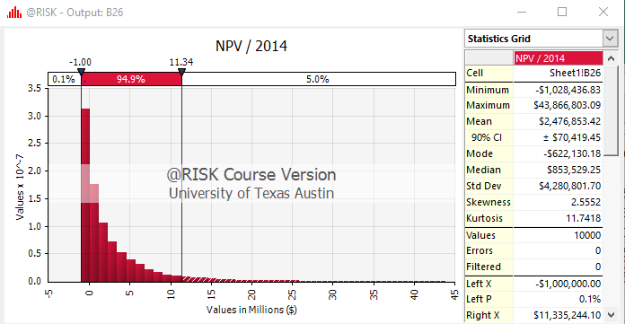

Figure 2: Simulation of only after 2 years

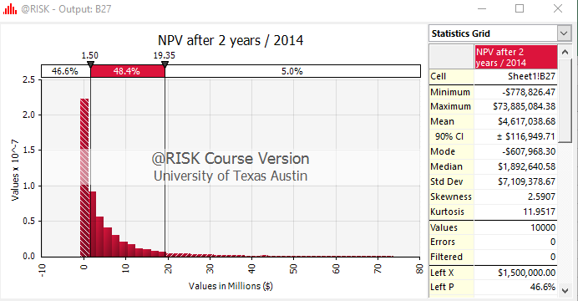

Figure 3: Tornado charts to look at most impactful inputs

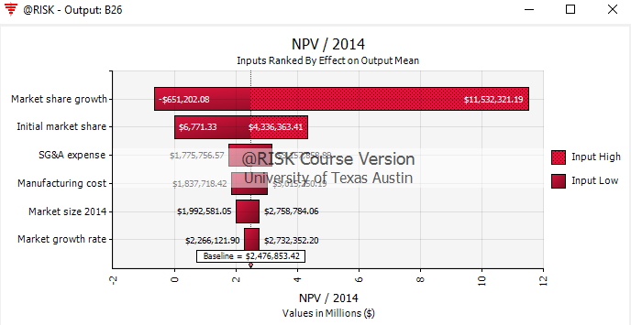

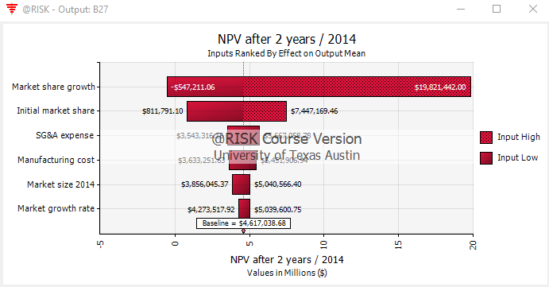

Figure 4: Excel formulas





