Caroline Nelson

Assignment 2

In this exercise, I conducted a Monte Carlo simulation using data from the North Star case. Lucinda sells T-shirts at sporting events and concerts; if the show is cancelled, she will absorb the cost of the order, and if the show goes on, she can resell the leftover shirts. She needs to decide if she should order 4000, 6000, or 8000 shirts for their respective fixed costs, given previous data about event attendance, the percentage of attendees who buy her T-shirts, and probability of a cancellation.

I assigned attendance a triangle distribution; in the case it mentioned that the 100,000-seat stadium would be filled at least one quarter, would at most be filled 90%, and would most likely be half-filled. There was also a range of how many attendees bought her T-shirts, from 5% of attendees to 18%, and most likely to be around 10%; I gave this variable a triangle representation as well. The number of T-shirts and their costs were represented as a discrete distribution, where each option is equally likely (1/3). The probability distribution of the concert being cancelled is binomial, where there is a 10% chance of a cancellation, given previous data from the case (5/50).

Simulating these numbers on 10,000 iterations as a function of profit, the distributions are shown in figures 2-4 of the appendix. From the insights gained from this simulation, I would recommend that Lucinda order 4,000 shirts, because on average, it would lead to the largest maximum profit and largest average profit. It would also be less costly if the concert were to be cancelled.

**Appendix**

Figure 1: Formulas before simulation

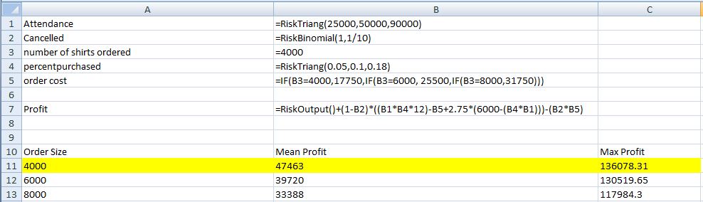

Figure 2: Simulation of 10,000 iterations with order size of 4000

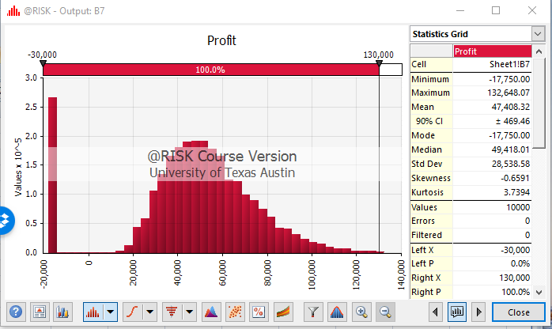

Figure 3: Simulation of 10,000 iterations with order size of 6000

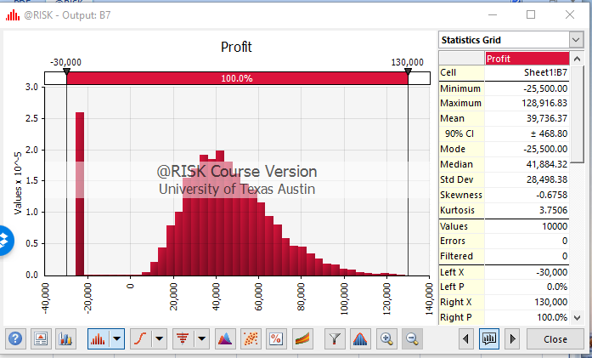

Figure 4: Simulation of 10,000 iterations with order size of 8000

