Caroline Nelson

Cn8764

Marketing Assignment 4

Given a vodka data set, with variables such as brand, price, advertising spending, and lag of price and lag of advertising, we were looking at predicting sales on a log-log scale.

1. 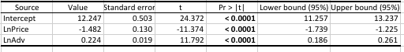

Elasticities for price and advertising are -1.482 and 0.224 respectively. As price increases by one percent, sales decrease by 1.48%; as advertising spending increases by one percent, sales increase by 0.22%.

2.

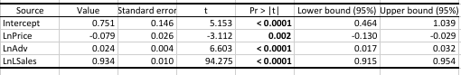

The new elasticities significantly increased with respect to price, and significantly decreased with respect to advertising when the lag of sales was included. This could be because log of lag of sales is correlated with log of sales, log of price, and log of advertising.

3. 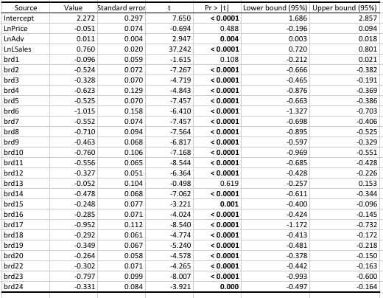

We can see from this result that the log price coefficient/elasticity became insignificant when the dummy variables were added, Smirnoff being brand 21. The elasticities of price and advertising did not move much from the previous model, but the price coefficient increased, while the advertising coefficient decreased. The variation of log of sales is mainly attributed to the log of lagged sales, log of advertising, and brands, excluding brands 1 and 13. The percent change in sales of each brand versus Smirnoff is represented in the coefficients. From this, we can see that, on average, Smirnoff has higher sales than the other brands.

4.

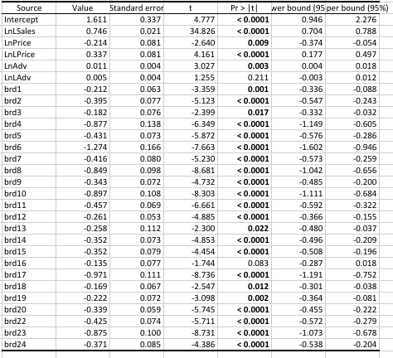

To capture the brand lifecycle, I added log of lag of price, and log of lag of advertising. When these variables are included, the elasticity of lag of advertising is insignificant, as well as the effect of brand 16, McCormick. This means that the brand’s effect on sales relative to Smirnoff is insignificant, and last year’s advertising spending has little effect on this year’s sales. The elasticity of advertising did not change from the third model, and the price elasticity significantly decreased, so log of lag of price and log of lag of advertising are uncorrelated with log of advertising.